**Title:** Peak Performance: vertical relief influences fish density and community assemblage structure across a heterogenous restoration reefscape.

**Authors:** James W. Sturges1,2,, Jeremy T. Claisse1,3

1 Biological Sciences Department, California State Polytechnic University, Pomona, California 91786 USA

2 Department of Earth and Environment, Institute of Environment, Florida International University, 11200 SW 8th Street Miami, FL 33199

3 Vantuna Research Group, Occidental College, Los Angeles, California 90041 USA

**Corresponding Author**: jstur015@fiu.edu

**Abstract**

To restore sections of temperate rocky-reef degraded by sedimentation, scour, and burial a large quarry rock reef, Palos Verdes Reef (PVR), was built with high-relief elements intended to increase fish biomass productivity and support a more diverse reef community. The large size and replicated design features within the PVR restoration area provided a unique opportunity to study effects of reef design on fish habitat selection patterns during early phases of reef succession. To determine how vertical relief and other design elements influence reef fish density, assemblage structure, and species or size-class specific habitat use patterns on PVR we conducted diver-operated stereo-video camera surveys on all 18 PVR modules 9-13 months post-construction during June and July of 2021. Video analyses suggest that sections of PVR with higher vertical relief typically supported greater fish densities, but species and size-class specific exceptions suggest that habitat heterogeneity is an ideal design element to support diverse reef fish assemblages and ontogenetic life history stages. We also found evidence of a spatial gradient in the restoration area suggesting that fish densities, especially for planktivorous species, tended to be higher on sections of PVR further offshore. Planktivorous fishes are known to mediate benthic-pelagic coupling on temperate rocky-reefs through consumer mediated nutrient transport which will likely influence rates of primary and secondary productivity across PVR. Future restoration efforts should include habitat heterogeneity to support more diverse taxa but should also consider how reef design may influence rates of productivity to meet restoration objections.

**Introduction**

Reef habitat degradation stems from several local, regional, and global drivers leading to adverse ecological and economic impacts. Reef degradation is known to reduce biodiversity, alter rates of productivity, and cause shifts in community assemblage structure in both temperate and tropical reef ecosystems (Holbrook et al. 1997; Stuart-Smith et al. 2022; Wilson et al., 2010). These adverse ecological effects reduce the benefits local stakeholders derive from ecosystem services, and as such there is a need to restore reef habitat and the biological communities that occupy them. To alleviate the adverse effects of reef degradation there is a growing number of viable management strategies including the construction of artificial reefs in areas where stressors persist, and natural habitat recovery is slow or limited (cite). Artificial reef structures are known to support high levels of fish biomass productivity (Claisse et al. 2014) but not all artificial reefs are effective at meeting restoration objectives and there is an ongoing effort to optimize the effectiveness of artificial reef design, application, and management (Baine 2001). Here we focus on reef design characteristics hereafter referred to as reef metrics and their influence on temperate rocky-reef fish assemblage structures.

Nearshore rocky-reefs between Bunker and Whites Point along the Palos Verdes Peninsula, California, United States are prone to sedimentation, scour, and burial from landslides perpetuated by anthropogenic activity (Kayen et al. 2002). Reef degradation from sedimentation persists on the natural nearshore rocky-reefs surrounding the peninsula after several years of improved coastal management prompting the necessity of artificial reef restoration. Between 11 May 2020 and 22 September 2022 construction of Palos Verdes Reef (PVR), an 18-module artificial quarry rock reef off the coast of Palos Verdes Peninsula began and concluded. The large size and replicated design features of module orientation relative to shore, module side, and habitat shared by all modules within the restoration area provided a unique opportunity to study effects of reef habitat characteristics on fish habitat selection patterns during early phases of reef succession. Each of the 18 modules is composed of 6 submodule mounds with varying levels of maximum vertical relief ranging from 1-4 m. For an as built description of PVR see (Williams et al. 2022). The inclusion of high-relief sections of reef on all PVR modules was intentionally included to minimize reef burial and the adverse effects of sedimentation (Pondella et al. 2018, Williams et al. 2022). We hypothesized that vertical relief is a metric of available essential fish habitat and anticipated that high-relief sections of PVR would support greater fish densities for all species within the fish community assemblage.

To determine how vertical relief and other reef metrics influence reef fish density, assemblage structure, and species-specific habitat use patterns on PVR we conducted diver-operated stereo-video camera surveys on all 18 PVR modules 9-13 months post-construction during June and July of 2021. Stereo-DOV technology is gaining traction as an efficient survey method but is still underutilized on temperate rocky reefs in California, with only a few published studies using the equipment (e.x., Jaco and Steele, 2020). Our study had three objectives. First, characterize fish community assemblage structure across module and submodule spatial scales. Then, determine whether patterns in fish density and diversity were driven by maximum vertical relief or other reef metrics. Finally, we aimed to quantify species-specific habitat use patterns to estimate habitat preferences driving trends in fish community assemblage structure.

**Methods & Materials**

*PVR Design*

The Palos Verdes Reef (PVR) restoration area consists of 18 modules, each with 6 submodules forming 16 x 16 m of quarry rock mounds ranging from 1-4 m in maximum vertical relief sitting at depths between 10–20 m. Modules are grouped in six sets of three blocks and at least one module per block was built within 30 m of existing natural rocky reef to create biological connectivity with the more extensive natural reef at shallower depths (Pondella et al. 2018). For an as built description of PVR see (Williams et al. 2022). All modules are roughly rectangular with three submodules in a row on each module side, with sides offset by 8 m, half the width of a submodule. Each of the longer module sides was classified as east or west and inshore or offshore depending on module orientation which could be perpendicular or parallel to shore (n = 6 & n =12 respectively). We classified submodule reef into 3 habitat types. High-relief submodules on a given module are either 3 or 4 m tall. PVR modules are split equally between those with either 3 m or 4 m (n = 9) high-relief submodules (Figure 1). Medium low-relief submodules are roughly 2 and 1 m tall respectively. Ecotone sections along the reef-sand interface were classified based on the height of the adjacent submodule. We classified ecotones into 3 additional habitat types of high, medium, and low ecotone. Multivariate analyses of focal fish assemblages were compared between modules and mean Bray-Curtis dissimilarity matrices averaged across 24 unique combinations of reef metrics including 6 habitat types, 2 orientations, and 4 sides possible on the 18 PVR modules.

*Stereo-DOV Specifications*

To quantify PVR fish densities and characterize fish assemblage structure we performed stereo-DOV fish surveys using a SeaGIS™ (https://www.seagis.com.au/) camera system equipped with two GoPro® Hero 7 cameras positioned 80 cm apart recording in 1080 p at 60 fps. The stereo-video camera system was calibrated prior to the start of data collection using a SeaGIS Calibration Cube™ and CAL software® in accordance with established protocols (Harvey & Shortis 1998). Prior to each module survey we created reference synchronization frames by performing a designated hand signal visible to both cameras simultaneously. All sampling was conducted on S.C.U.B.A. from 08:00 – 14:00 PST between 7 June 2021 and 19 July 2021, which was roughly 9-13 months post-construction depending on module construction date and survey date (Table 1). On any given sampling day, we haphazardly selected modules from different blocks while trying to vary reef metrics such as construction phase and relative position to shore to reduce effects of diel environmental variability in our analyses.

*Survey Patterns*

Modules surveys consist of a sequence of 4 consecutive, roughly 48 m long, stereo-DOV transect surveys that begin on the ecotone adjacent to the high-relief submodule on the west or offshore side of a module depending on orientation (Table 1). Divers would survey the three ecotone habitat types and then three submodule reef habitat types on the west or offshore side before repeating the process in the same order on east or inshore side of the same module. The lead diver would swim at a steady pace with the camera system facing forward approximately 1 m above the benthos. For ecotone transects, we centered the stereo-DOV system above the reef-sand interface. For submodule reef habitat type transects, divers attempted to swim the stereo-DOV system along the approximate center line of each submodule by traversing the peaks of each submodule. Transition points were used to visually identified transitions between habitat types. Using these transition signals we calculated survey duration for each habitat type and used fish observation time stamps to characterize fish assemblages by habitat type on each module. We standardized the length of ecotone habitat type surveys. From the elapsed survey duration, we estimated mean transect lengths across all high, medium, and low-relief reef submodule habitat types to be on average 21.8, 19.7, and 16.4 m respectively. To account for differences in swim rates and habitat type survey intensity we estimated comparable fish densitiesby dividing fish counts by the transect area, the product of stereo-video transect width (4 m) and the specific length of each habitat type on a given module. We converted fish density estimate values to be densities per 100 m2 to make them more visually intuitive.

*Video Analyses*

After completing stereo-DOV surveys for each module, we analyzed survey footage using SeaGIS EventMeasure® software. Fish were identified to the species level and total length TL estimates were made for all identified fish to the nearest millimeter when possible. Any unknown fish is not included in our analyses. In some instances, fish were identified to the species level but were unmeasurable due to their body position relative to the cameras. These fish were still included in in assemblage structure analyses. Additionally, TL measurements with a precision estimate beyond 20 mm were excluded from length-based analyses. The length estimates for three Blacksmith (*Chromis punctipinnis*) were implausible despite having precision estimates below 20 mm and were removed.

*Data Processing & Focal Fish Species*

All data processing, analyses and visualization were generated in R (v4.2.1; R Studio Team, 2023) using tidyverse functions where possible (Wickham et al. 2019). We designated the 11 most abundant fishes observed across all surveys to be the focal fish species used for module and submodule level fish assemblage analyses (bolded species in Table 2). These species represent most of the fish biomass observed on PVR and were each identified at least once on 12 or more of the 18 PVR modules with 5 species present on all modules (Table 2). We considered these species to be suitable candidates for characterizing fish assemblage structure and for evaluating species-specific habitat use patterns on PVR. Our stereo-DOV survey methods are not ideal for accurately quantifying density and habitat use patterns for rarer and cryptobenthic species, justifying our decision to use only the 11 focal fish species bolded in Table 2 (Harvey et al. 2002, Watson et al. 2005, 2010, Rolim et al. 2022).

**Results**

Within our adjusted stereo-DOV transect areas we identified 8,107 individual fish from 31 fish species (Table 2), and all but 240 of these fish could be measured to the nearest millimeter with EventMeasure® software. On module level spatial scales, we found no evidence in an NMDS ordination, nor a dendrogram, of mean 4th root transformed Bray-Curtis focal fish species assemblages (Supplemental Figures 1 & 2). An analysis with the vegan package (v2.6-4) function “adonis2” grouped by margin further confirmed the insignificance of module level reef characteristics that could have influenced PVR focal fish assemblages and fish densities (Pr(>F) = 0.4333 and 0.791 for maximum vertical relief and construction phase respectively).

On a finer spatial scale, we evaluated 24 unique combinations of reef metrics including 6 habitat types, 2 orientations, and 4 sides possible on PVR modules. An NMDS ordination of mean 4th root transformed Bray-Curtis focal fish species assemblage matrices across these 24 combinations revealed 6 distinct cluster groups (CGs) named for similar habitat characteristics (Figure 3). Note that CGs 1 and 2 consist a of single combination of habitat type, module orientation, and module side and were the most dissimilar mean focal fish assemblages within our analysis. CG names are as follow: CG 1 (gold) Perpendicular West High Relief, CG 2 (black) Perpendicular East High Ecotone, CG 3 (purple) Sheltered Inshore Parallels, CG 4 Low Relief & Ecotones, CG 5 Intermediate Density, CG 6 High Density (Figure 3). We tested each focal fish species within the assemblage matrix for significant (p ≤ 0.05) influence on ordination distributions across the 24 unique combinations reef metrics and found that 7 species significantly influenced the NMDS ordination. These species include Blacksmith (*Chromis punctipinnis*), Señorita (*Oxyjulus californica*), Kelp Bass (*Paralabrax Chlathratus*), California Sheephead (*Semicossyphus pulcher*), Black Perch (*Embiotica jacksoni*), Barred Sand Bass (*Paralabrax nebulifer),* Opaleye (*Girella nigricans*), and Rock Wrasse (*Halichoeres semicinctus*). The magnitude of significance is represented by arrow length in Figure 3, and species-specific values are available in the online supplemental data repository.

The most dissimilar mean focal fish assemblages across 24 combinations of reef metrics were CG 1 and 2 which consist of only a single representative of module orientation, side, and habitat type. Low focal fish species diversity with 3 absent species (CG 1) and exceptionally high densities of Blacksmith and Señorita (CG 2) likely drive separation in NMDS ordination space for these groups. The other 4 cluster groups consist of 4 or more mean focal fish assemblages from the 24 possible combinations of reef metrics. CG 3 consists of four mean focal fish assemblages, the fewest or CGs with more than one mean assemblage. CG 3 is entirely composed of focal fish assemblages on the inshore side of parallel modules. CG 4 contains five mean focal fish assemblages with one of each ecotone habitat type and two mean focal fish assemblages representative of low-relief reef submodule habitat type. CG 5 was the largest grouping with seven mean focal fish assemblages contributing to its ordination distribution. The assemblages within CG 5 typically had intermediate mean focal fish densities for most species and contains representatives are all defined habitat types except ecotone adjacent to high-relief submodules (Figure 3). CG 6 consists of the mean focal fish assemblages of the final 6 combinations of module orientation, module side, and habitat type. CG 6 assemblages include four high and medium-relief reef submodule habitat types and 2 high and medium ecotones adjacent to them.

A heatmap of mean focal fish species densities averaged within each of the 6 cluster groups indicates that planktivorous fishes such as Blacksmith (*Chromis punctipinnis*) and Señorita (*Oxyjulis califorinica*) were the most abundant focal fish species used to evaluate assemblage structure patterns even with strong statistical adjustments to account for differences in magnitude between observed species counts (Figure 4). Besides the standalone high-density values reported CG 2, the mean focal fish assemblages in CG 6 had the highest recorded densities for 6 of the 11 focal fish species (Figure 4).To determine if our cluster groups identified in the NMDS ordination were significant at explaining multivariate drivers of focal fish assemblages and further explain habitat use patterns observed on PVR we conducted an analysis of mean focal fish assemblages across the 24 unique combinations of reef metrics using the “adonis2” function in the vegan package (v2.6-4). We evaluated the statistical significance (Pr(>*F*)) of 3 factors (habitat type, orientation + side, and cluster group) with the “group_by = margin” function to determine the significance of each factor after accounting for the variance explained by the other two factors. Thus, our *F*-values are a conservative estimate of significance. We found that habitat type alone was not a significant factor after accounting for variance explained by the other factors (*F* = 0.444). Orientation with side, was significant (*F* = 0.026) and cluster group was the most significant factor even after accounting for other reef metrics (*F* = 0.001). All species-specific analysis of reef metrics at the submodule spatial scale are available in the online GitHub repository, but here we focus on three species, Blacksmith, Señorita, California Sheephead.

Blacksmith were the most abundant fish species observed on the PVR, representing of the 74.4% of the total number of fish observed and were present on all 18 modules (Table 2). The highest mean density for blacksmith occurred in CG 2: Perpendicular West High-Relief and there is an increasing trend in mean Blacksmith densities across CGs 3-6. CG 6 (Figure 5). Blacksmith and another planktivorous fish species, Señorita, densities were relatively low on inshore sides of parallel modules.

Kelp Bass were the most abundant piscivorous fish species, the 3rd most abundant species overall, represented 6% of the of the total number of fish observed, and were present on all 18 modules (Table 2). The highest mean densities of Kelp Bass averaged across reef metric combinations was seen on offshore medium-relief sections of modules oriented parallel to shore. Kelp bass densities also show an increasing trend in mean density estimates across CGs 3-6 with lower densities on ecotone sections compared to reef habitat types in the intermediate density CG 5 (Figure 6). CG 6, the highest for mean Kelp Bass densities averaged across CGs, includes reef submodules with high and medium-relief and ecotone habitat adjacent to them. (Figure 6).

California Sheephead were the 4th most abundant species observed on the PVR, represented 3.9% of the of the total number of fish observed, and were present on all 18 modules (Table 2). California Sheephead densities also show an increasing trend in mean density estimates across CGs 3-6 with lower densities on reef submodule habitat types compared to sections compared to ecotone habitat types in the intermediate density CG 5 (Figure 7). The highest densities of California Sheephead averaged across reef metrics was observed on the west side of medium-relief habitat types of modules oriented perpendicular to shore (Figure 7).

**Discussion**

Using stereo-video camera surveys we were able to quantify fish assemblage structure from density estimates of 11 focal fish species at module and submodule spatial scales. We anticipated that construction phase and differences between the maximum vertical relief of high-relief submodules would influence fish assemblage structure at the module scale, but we found no evidence to support that hypothesis. This could indicate that PVR focal fish assemblages were relatively uniform across the restoration area with each module consistently occupied by most focal fish species. Studies suggest that fish communities can converge even within five months of construction on artificial reef habitat (Paxton et al. 2018). We consider this evidence for the effectiveness of our stereo-DOV survey methods at identifying these focal species and justification for not using rarer and cryptobenthic species that may not be as accurately counted and measured by our survey methods (Harvey et al. 2002, Watson et al. 2005, 2010). Dive time and survey dates could have strongly influenced our results however, we attempted to minimize those effects and consider these data to be an accurate snapshot of PVR module and submodule focal fish assemblages during the summer of 2021.

Video analyses suggest that sections of PVR with higher vertical relief typically supported greater fish densities, but species-specific exceptions were observed in Barred Sand Bass and Rock Wrasse that preferred ecotone over submodule reef habitat types. This echoes other studies that show evidence of habitat heterogeneity influencing species diversity patterns and reef fish density in other temperate rocky reef ecosystems (Mikheev et al. 2010, Bartolino et al. 2011, Yeager et al. 2011). Reef relief is likely a metric of essential fish habitat availability similar to other studies of artificial restoration reefs that indicate the proportional amount of benthic substrate covered by reef material has a positive correlation with fish density and species diversity on the Wheel North Reef (Reed et al. 2006). Taller modules could induce similar effects with effectively greater amounts of essential fish habitat available over the same unit of seafloor even though the entire benthos is covered for all PVR submodules. High and medium-relief sections of reef, referred to as crest and slope sections, have also historically supported greater fish biomass densities for of most, but not all, species on the single high-relief module structure that forms the Torrey Pines Artificial Reef (Johnson et al. 1994).

Our findings support island biogeographic theory (Simberloff & Abele 1976) if we view fish occupation patterns of PVR modules and submodules as islands of various sizes and distances to natural reef. When fish relocated to PVR post-construction from adjacent natural reefs, taller submodules may be viewed as larger islands in an island biogeography model with roughly equidistant low-relief island sections that may be less desirable for most fish species. If these taller design features indeed function like islands, we would anticipate greater total fish counts, biomass density, and diversity on high-relief submodules. This seems to be supported by our analyses of submodule focal fish assemblage patterns. These patterns in fish occupation could have long-term effects on PVR productivity and may ultimately contribute to its effectiveness at meeting restoration objectives.

Planktivorous fishes are known to mediate benthic-pelagic coupling on temperate rocky-reefs through consumer mediated nutrient transport which will likely influence rates of primary and secondary productivity across PVR (Bray et al. 1981). This could have implications for long-term productivity patterns across PVR. Hydrological models of high-relief artificial reefs in Australia suggest that vertical structures alter water flow and may aggregate plankton around module peaks, increasing the likelihood of piscivorous fish foraging around high-relief structures by higher trophic level consumers (Holland et al. 2021). This creates so called “sweet spots” of high primary production could lead to aggregations of important fisheries species for local stakeholders.

Rates of production and consumer mediated nutrient transport metrics were beyond the scope of this study, but future studies within the restoration area should quantify them. PVR fish assemblages may benefit from high-relief features but further evidence over an extended time series is needed to determine how these structures truly contribute to fish density and diversity patterns across the restoration area. Providing suitable habitat for multiple species and all stages of ontogenetic development is essential and fish recruitment of young-of-year fish on PVR may depend on the availability of habitat capable of supporting these recruits (Rilov & Benayahu 2002, Bartolino et al. 2011). Greater survey replication and better seasonal coverage would be needed to evaluate recruitment patterns on PVR as our sampling effort was not designed to observe temporal trends in fish recruitment.

Low focal fish species densities were observed on low-relief and ecotone sections of PVR perhaps suggesting that adverse effects of sedimentation persist on sections of reef with ≤ 1 m of vertical relief as observed on natural reef in the area for several consecutive years (Pondella et al. 2018). Lower fish densities could also be explained by spatial gradients in primary and secondary productivity driven by consumer mediated nutrient transport. The inclusion of vertical relief to restore degraded reef habitat has been advocated for on tropical reefs for its ability to support more diverse fish communities with higher fish biomass densities (Rilov & Benayahu 1998) and here we provide evidence for similar support of high-relief reef design elements on a large-scale temperate rocky reefs with replicated heterogenous reef metrics. High-relief sections appear to provide more essential fish habitat per unit of seafloor which will increase the likelihood of meeting fish biomass production restoration goals. Future restoration efforts should include habitat heterogeneity to support more diverse taxa but should also consider how high-relief reef designs may influence rates of productivity to meet restoration objections reach peak performance.

**Table 1**: Module names and design features including orientation relative to shore, construction phases when modules were completed, and the approximate maximum vertical relief of 18 Palos Verdes Reef (PVR) modules within the restoration area. Additionally, relevant times to stereo-DOV camera surveys conducted between June and July of 2021, roughly 9-13 post-construction of each PVR module depending on construction date and survey time are reported. For an as built description PVR see (Williams et al., 2022).

| Module | Orientation | Construction Phase | Max Submodule Relief | Construction Date | Survey Datetime (DD MON YYYY:HH:MM) | |
| --- | --- | --- | --- | --- | --- | --- |
| 2A | Perpendicular | 1 | 4 | 11 May 2020 | | 19 Jul 2021:11:23 |
| 2B | Parallel | 1 | 4 | 22 May 2020 | | 07 Jun 2021:12:00 |
| 2C | Parallel | 1 | 4 | 21 May 2020 | | 21 Jun 2021:08:54 |
| 4B | Parallel | 1 | 3 | 29 May 2020 | | 28 Jun 2021:10:23 |
| 4C | Parallel | 1 | 3 | 30 May 2020 | | 14 Jun 2021:08:40 |
| 4D | Parallel | 1 | 3 | 28 May 2020 | | 19 Jul 2021:10:01 |
| 5A | Parallel | 1 | 3 | 02 Jun 2020 | | 19 Jul 2021:12:14 |
| 5B | Parallel | 1 | 3 | 03 Jun 2020 | | 07 Jun 2021:10:30 |
| 5C | Parallel | 2 | 3 | 31 Aug 2020 | | 12 Jul 2021:08:47 |
| 6A | Parallel | 2 | 4 | 10 Sep 2020 | | 19 Jul 2021:13:39 |
| 6C | Parallel | 2 | 4 | 01 Sep 2020 | | 21 Jun 2021:10:13 |
| 6D | Parallel | 2 | 4 | 02 Sep 2020 | | 14 Jun 2021:10:15 |
| 7A | Parallel | 2 | 3 | 11 Sep 2020 | | 07 Jun 2021:13:15 |
| 7B | Perpendicular | 2 | 3 | 11 Sep 2020 | | 21 Jun 2021:11:47 |
| 7C | Perpendicular | 2 | 3 | 14 Sep 2020 | | 19 Jul 2021:08:45 |
| 8A | Perpendicular | 2 | 4 | 16 Sep 2020 | | 14 Jun 2021:11:20 |
| 8B | Perpendicular | 2 | 4 | 18 Sep 2020 | | 12 Jul 2021:11:37 |
| 8C | Perpendicular | 2 | 4 | 22 Sep 2020 | | 28 Jun 2021:08:53 |

**Table 2**. Species and common names of all fishes identified on Palos Verdes Reef (PVR) during diver operated stereo-video (stereo-DOV) camera surveys of all 18 modules within the reef restoration area. The “Mod” column is the number of modules a species was identified on, “n” is the total number of individual fish identified to species level and “Measured” is the number of those identified fish that could be confidently measured to the nearest millimeter in EventMeasure® software across all surveys. 11 bolded focal species represent most of the fish biomass observed on in our study and were the only species used in fish community assemblage structure and size-class specific analyses. For species with measured individuals, the minimum, median, max, mean, and standard deviation of size estimates is reported if n >1.

|  |  |  |  |  |  |  |  |  |  |
| --- | --- | --- | --- | --- | --- | --- | --- | --- | --- |
| **Species Name** | **Common Name** | **Mod** | **n** | **Measured** | **Total Length (mm)** | | | | |
| **Min** | **Median** | **Max** | **µ** | **σ** |
| ***Chromis punctipinnis*** | **Blacksmith** | 18 | 6,030 | 6,006 | 63 | 146 | 232 | 145 | 17 |
| ***Paralabrax clathratus*** | **Kelp Bass** | 18 | 482 | 422 | 130 | 271 | 462 | 278 | 54 |
| ***Oxyjulis californica*** | **Senorita** | 15 | 476 | 461 | 103 | 167 | 224 | 169 | 21 |
| ***Semicossyphus pulcher*** | **California Sheephead** | 18 | 313 | 284 | 45 | 248 | 671 | 260 | 78 |
| ***Embiotoca jacksoni*** | **Black Perch** | 18 | 191 | 162 | 54 | 158 | 260 | 160 | 30 |
| ***Hypsurus caryi*** | **Rainbow Seaperch** | 15 | 117 | 106 | 98 | 141 | 197 | 146 | 22 |
| ***Paralabrax nebulifer*** | **Barred Sand Bass** | 18 | 109 | 97 | 153 | 262 | 408 | 264 | 54 |
| ***Girella nigricans*** | **Opaleye** | 17 | 87 | 70 | 141 | 290 | 457 | 296 | 63 |
| ***Damalichthys vacca*** | **Pile Perch** | 17 | 73 | 60 | 136 | 176 | 288 | 186 | 38 |
| ***Sebastes serranoides*** | **Olive Rockfish** | 13 | 58 | 50 | 124 | 164 | 197 | 162 | 14 |
| ***Halichoeres semicinctus*** | **Rock Wrasse** | 12 | 31 | 28 | 186 | 224 | 283 | 225 | 21 |
| *Hyperprosopon ellipticum* | Silver Surfperch | 6 | 22 | 22 | 145 | 170 | 252 | 173 | 23 |
| *Sebastes miniatus* | Vermilion Rockfish | 8 | 22 | 20 | 47 | 61 | 83 | 63 | 11 |
| *Medialuna californiensis* | Halfmoon | 4 | 16 | 16 | 195 | 233 | 306 | 239 | 33 |
| *Rhacochilus toxotes* | Rubberlip Seaperch | 3 | 15 | 10 | 217 | 302 | 359 | 302 | 42 |
| *Caulolatilus princeps* | Ocean Whitefish | 7 | 11 | 10 | 229 | 329 | 439 | 326 | 71 |
| *Hypsypops rubicundus* | Garibaldi | 7 | 10 | 9 | 162 | 202 | 323 | 218 | 55 |
| *Oxylebius pictus* | Painted Greenling | 5 | 8 | 6 | 76 | 118 | 159 | 116 | 39 |
| *Brachyistius frenatus* | Kelp Perch | 2 | 6 | 4 | 55 | 68 | 132 | 81 | 36 |
| *Cymatogaster aggregata* | Shiner Perch | 2 | 5 | 5 | 105 | 124 | 149 | 128 | 18 |
| *Hermosilla azurea* | Zebraperch | 3 | 5 | 4 | 135 | 149 | 172 | 152 | 18 |
| *Anisotremus davidsonii* | Sargo | 2 | 4 | 4 | 167 | 238 | 307 | 238 | 59 |
| *Embiotoca lateralis* | Striped Seaperch | 2 | 3 | 3 | 260 | 305 | 324 | 296 | 33 |
| *Paralabrax maculatofasciatus* | Spotted Sand Bass | 3 | 3 | 1 | 222 | 222 | 222 | 222 | _ |
| *Cheilotrema saturnum* | Black Croaker | 2 | 2 | 2 | 118 | 174 | 231 | 174 | 80 |
| *Hyperprosopon argenteum* | Walleye Surfperch | 2 | 2 | 2 | 168 | 171 | 174 | 171 | 5 |
| *Rhinogobiops nicholsii* | Blackeye Goby | 2 | 2 | 0 | _ | _ | _ | _ | _ |
| *Artedius corallinus* | Coralline Sculpin | 1 | 1 | 1 | 198 | 198 | 198 | 198 | _ |
| *Sebastes dallii* | Calico Rockfish | 1 | 1 | 1 | 182 | 182 | 182 | 182 | _ |
| *Sebastes melanops* | Black Rockfish | 1 | 1 | 0 | _ | _ | _ | _ | _ |
| *Sebastes mystinus* | Blue Rockfish | 1 | 1 | 1 | 39 | 39 | 39 | 39 | _ |

**Figures**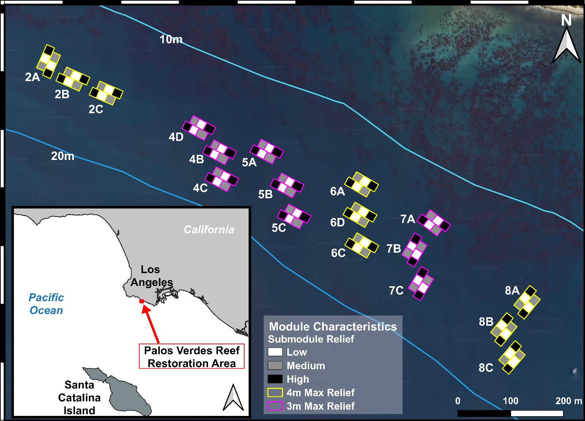

Figure 1: Map of 18 quarry rock module positions within the Palos Verdes Reef (PVR) restoration area between Bunker and Whites Point along the Palos Verdes Peninsula, California, United States. Each module includes 6 submodules with varying levels of vertical relief. We classified submodules as either low, medium, or high-relief habitat types (grey-scale squares) which are 1, 2, and 3 or 4 m tall from lighter to darker fill. The height of both high-relief submodules on a given module is either 3 or 4 m (module outline color). Modules are positioned in groups of 3 known as blocks named here with numbers in the text labels. All PVR reef habitat sits within the 10-20 m isobath.

Figure 2. Stereo-DOV survey patterns swam on all Palos Verdes Reef (PVR) modules which slightly varied with perpendicular and parallel orientations of modules relative to shore. There are 18 PVR modules each with two longer sides we classified as east/west and inshore/offshore depending on orientation. Submodules (grey squares) are roughly 16 x 16 m mounds of boulder sized quarry rock with vertical relief ranging from 1-4 m. We classified submodules into 3 habitat types. High-relief (HR) submodules on a given module are either 3 or 4 m tall. Medium-relief (MR) and low-relief (LR) submodules are roughly 2 and 1 m tall respectively. Ecotone representing a reef-sand interface (tan areas) was classified based on the height of the adjacent submodule. We classified ecotones into 3 additional habitat types of high, medium, and low ecotone depending on the adjacent submodule habitat type (HE, ME, LE respectively). Black text on the submodules and ecotones defines 6 unique habitat types common to all modules. Darker shaded sections of each habitat type represent the 4 m wide video transect width we restricted fish observations to. Red numbers and black arrows show the starting position and sequence of 4 consecutive roughly 48 m long stereo-DOV survey paths. Multivariate analyses of focal fish assemblages were performed across 24 unique combinations of design features and reef characteristics including 6 habitat types, 2 orientations, and 4 sides possible on PVR modules.

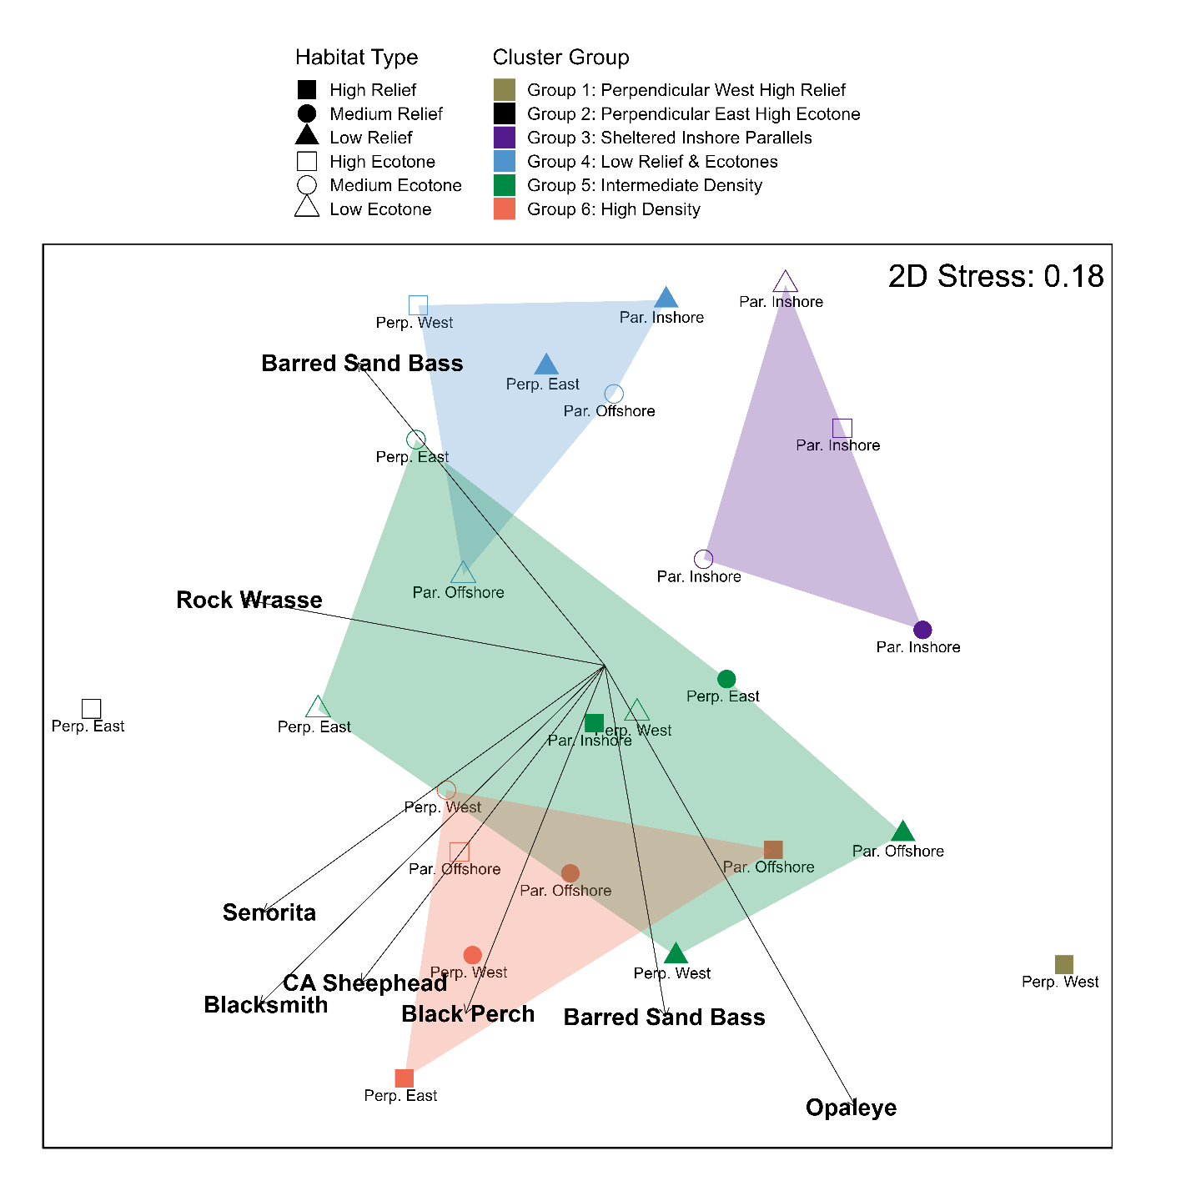

Figure 3. NMDS ordination of mean Bray-Curtis dissimilarity matrices of focal fish species assemblages grouped by 24 unique combinations of design features and reef characteristics including 6 habitat types, 2 orientations, and 4 sides possible on PVR modules. We identified 6 cluster groups (CGs) indicated by the minimum convex polygon shadings. Group names attempt to describe common reef metrics within cluster groups. Note that CGs 1 and 2 consist a of single combination of habitat type, module orientation, and side. CG names are as follow: CG 1 (gold) Perpendicular West High Relief, CG 2 (black) Perpendicular East High Ecotone, CG 3 (purple) Sheltered Inshore Parallels, CG 4 (blue) Low Relief & Ecotones, CG 5 (green) Intermediate Density, CG 6 (red) High Density

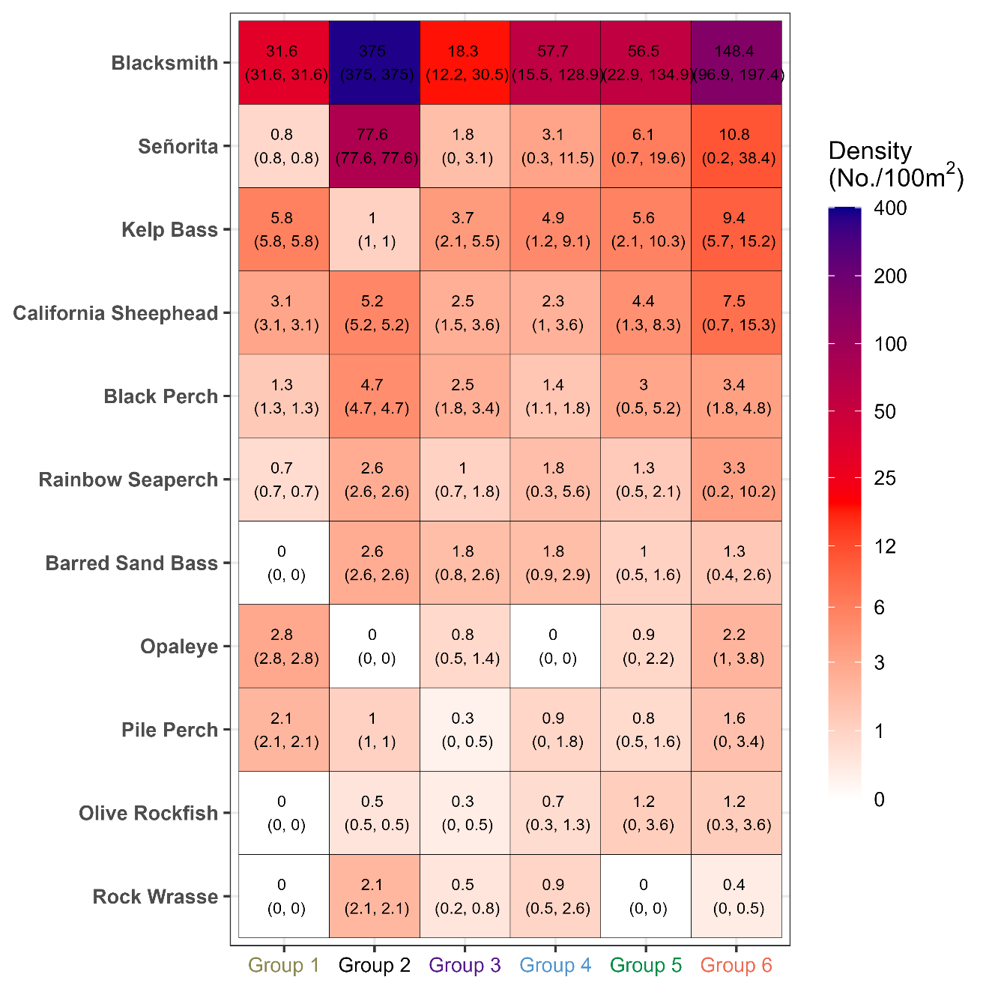

Figure 4: Heatmap of mean focal fish species densities (No./100m2 number of fish per 100m2) for the cluster groups identified in the NMDS ordination. Note that CGs 1 and 2 consist a of single combination of habitat type, module orientation, and side. CG names are as follow: CG 1 (gold) Perpendicular West High Relief, CG 2 (black) Perpendicular East High Ecotone, CG 3 (purple) Sheltered Inshore Parallels, CG 4 (blue) Low Relief & Ecotones, CG 5 (green) Intermediate Density, CG 6 (red) High Density

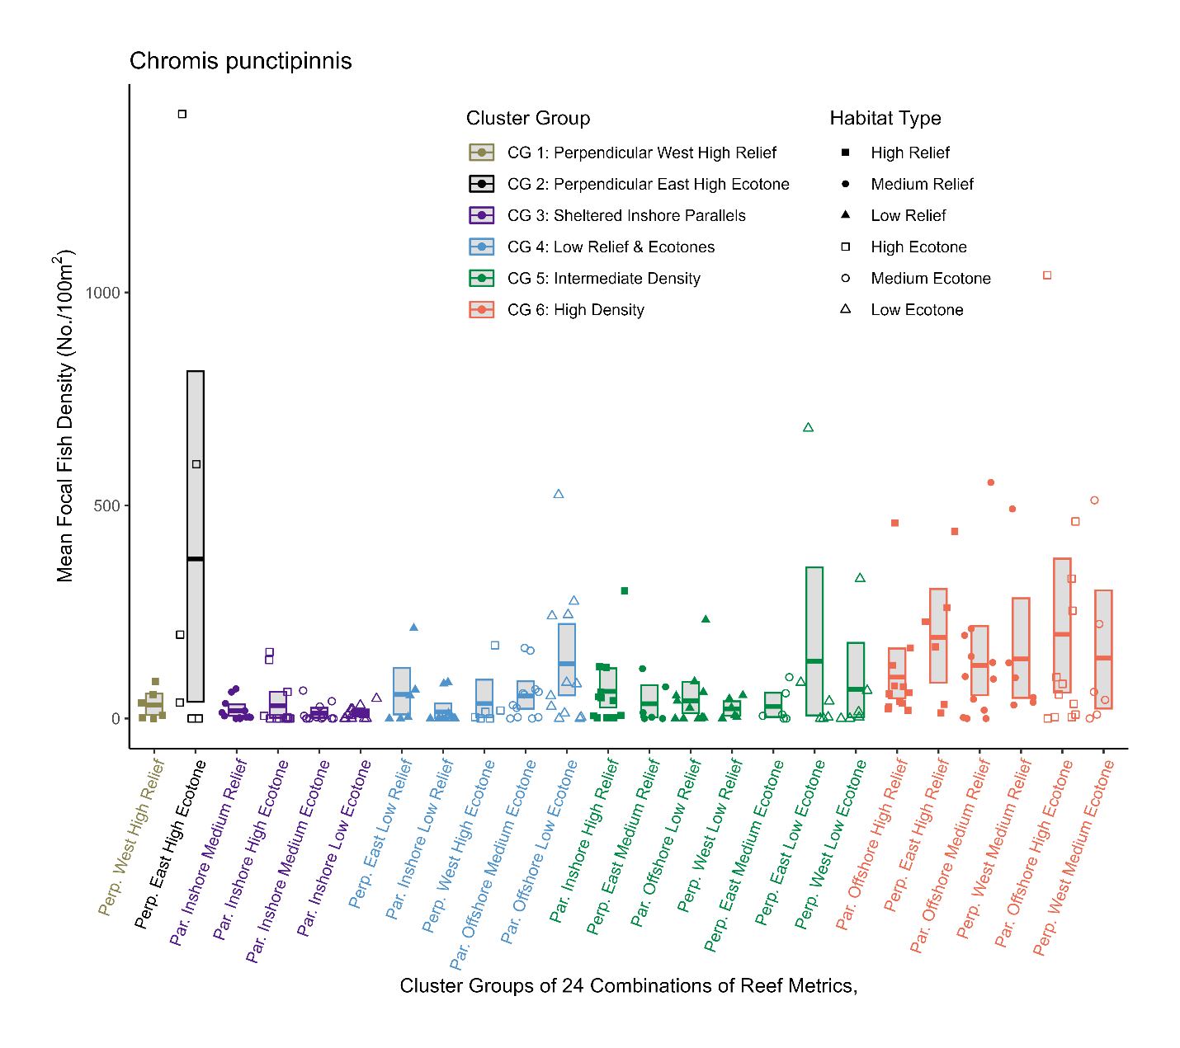

Figure 5: Mean densities of Blacksmith (*Chromis punctipinnis*) across each replicate survey of 24 unique combinations of design features and reef characteristics including 6 habitat types, 2 orientations, and 4 sides possible on PVR modules. Order and box plot labels along the x-axis and point color correspond to six cluster groups identified in the NMDS ordination. Habitat type for each replicate point is a combination of the shape and fill with shaded and unshaded squares, circles, and triangles corresponding to high, medium, or low submodule reef or ecotone focal fish species assemblages.

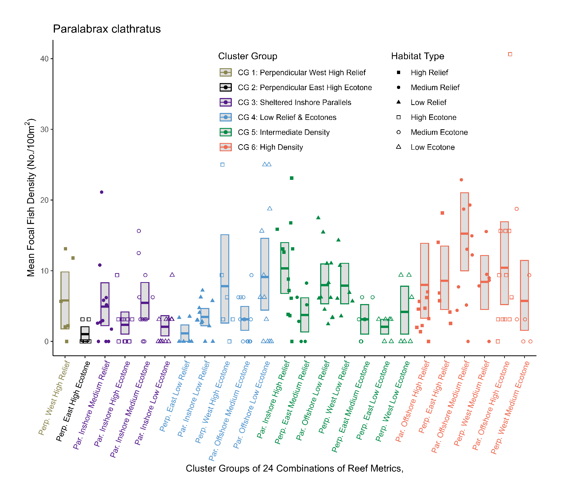

Figure 6: Mean densities of Kelp Bass (*Paralabrax clathratus*) across each replicate survey of 24 unique combinations of design features and reef characteristics including 6 habitat types, 2 orientations, and 4 sides possible on PVR modules. Order and box plot labels along the x-axis and point color correspond to six cluster groups identified in the NMDS ordination. Habitat type for each replicate point is a combination of the shape and fill with shaded and unshaded squares, circles, and triangles corresponding to high, medium, or low submodule reef or ecotone focal fish species assemblages.

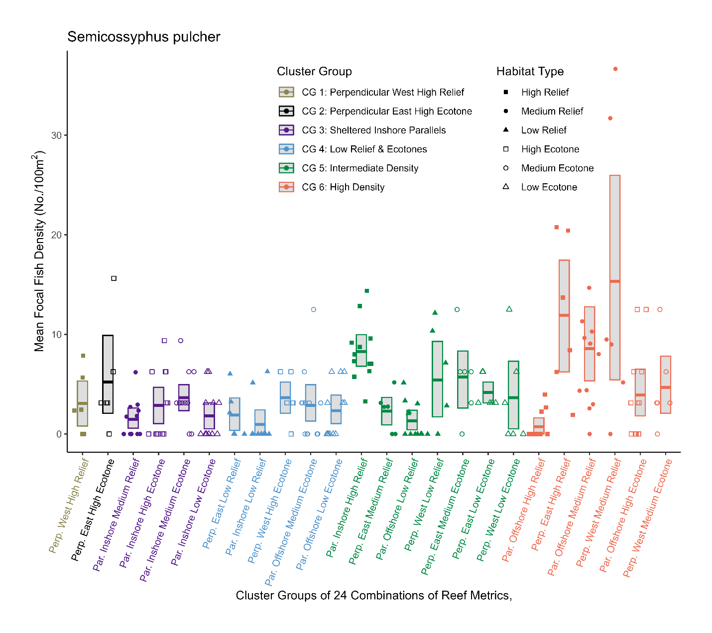

Figure 7: Mean densities of California Sheephead (*Semicossyphus pulcher*) across each replicate survey of 24 unique combinations of design features and reef characteristics including 6 habitat types, 2 orientations, and 4 sides possible on PVR modules. Order and box plot labels along the x-axis and point color correspond to six cluster groups identified in the NMDS ordination. Habitat type for each replicate point is a combination of the shape and fill with shaded and unshaded squares, circles, and triangles corresponding to high, medium, or low submodule reef or ecotone focal fish species assemblages.

Baine M (2001) Artificial reefs: a review of their design, application, management and performance. Ocean & Coastal Management 44:241–259.

Bartolino V, Ciannelle L, Bacheler NM, Chan K-S (2011) Ontogenetic and sex-specific differences in density-dependent habitat selection of a marine fish population. Ecology 92:189–200.

Claisse JT, Pondella DJ, Love M, Zahn LA, Williams CM, Williams JP, Bull AS (2014) Oil platforms off California are among the most productive marine fish habitats globally. Proc Natl Acad Sci USA 111:15462–15467.

Edgar GJ, Stuart-Smith RD, Heather FJ, Barrett NS, Turak E, Sweatman H, Emslie MJ, Brock DJ, Hicks J, French B, Baker SC, Howe SA, Jordan A, Knott NA, Mooney P, Cooper AT, Oh ES, Soler GA, Mellin C, Ling SD, Dunic JC, Turnbull JW, Day PB, Larkin MF, Seroussi Y, Stuart-Smith J, Clausius E, Davis TR, Shields J, Shields D, Johnson OJ, Fuchs YH, Denis-Roy L, Jones T, Bates AE (2023) Continent-wide declines in shallow reef life over a decade of ocean warming. Nature 615:858–865.

Harvey E, Fletcher D, Shortis M (2002) Estimation of reef ﬁsh length by divers and by stereo-video A ﬁrst comparison of the accuracy and precision in the ﬁeld on living ﬁsh under operational conditions. Fisheries Research:11.

Harvey ES, Shortis MR (1998) Calibration Stability of an Underwater Stereo Video System: Implications for Measurement Accuracy and Precision. 27.

Holbrook SJ, Schmitt RJ, Stephens Jr. JS (1997) Changes in an Assemblage of Temperate Reef Fishes Associated with a Climate Shift. Ecological Applications 7:1299–1310.

Holland M, Becker A, Smith J, Everett J, Suthers I (2021) Fine-scale spatial and diel dynamics of zooplanktivorous fish on temperate rocky and artificial reefs. Mar Ecol Prog Ser 674:221–239.

Jaco EM, Steele MA (2020) Pre‐closure fishing pressure predicts effects of marine protected areas. J Appl Ecol 57:229–240.

Johnson TD, Barnett AM, DeMartini EE, Craft LL, Ambrose RF (1994) FISH PRODUCTION AND HABITAT UTILIZATION ON A SOUTHERN CALIFORNIA ARTIFICIAL REEF. 55.

Kayen RE, Lee HJ, Hein JR (2002) Influence of the Portuguese Bend landslide on the character of the effluent-affected sediment deposit, Palos Verdes margin, southern California. Continental Shelf Research 22:911–922.

Mikheev VN, Afonina MO, Pavlov DS (2010) Habitat heterogeneity and fish behavior: Units of heterogeneity as a resource and as a source of information. J Ichthyol 50:386–395.

Paxton AB, Revels LW, Rosemond RC, Van Hoeck RV, Lemoine HR, Taylor JC, Peterson CH (2018) Convergence of fish community structure between a newly deployed and an established artificial reef along a five-month trajectory. Ecological Engineering 123:185–192.

Pondella DJ, Williams JP, Williams CM, Claisse JT, Witting D (2018) Restoring a Nearshore Rocky Reef Ecosystem in the Challenge of an Urban Setting. 22.

Reed DC, Schroeter SC, Huang D, Anderson TW, Ambrose RF (2006) Quantitative Assessment of Different Artificial Reef Designs in Mitigating Losses to Kelp Forest Fishes. Bulletin of Marine Science 78:19.

Rilov G, Benayahu Y (2002) Rehabilitation of coral reef-fish communities: The importance of artificial-reef relief to recruitment rates. BULLETIN OF MARINE SCIENCE 70.

Rilov G, Benayahu Y (1998) Vertical artificial structures as an alternative habitat for coral reef fishes in disturbed environments. Marine Environmental Research 45:431–451.

Rolim FA, Rodrigues PFC, Langlois T, Neves LM, Gadig OBF (2022) A comparison of stereo-videos and visual census methods for assessing subtropical rocky reef fish assemblage. Environ Biol Fish 105:413–429.

Simberloff D, Abele L (1976) Island Biogeography Theory and Conservation Practice. Science 191.

Stuart-Smith RD, Edgar GJ, Clausius E, Oh ES, Barrett NS, Emslie MJ, Bates AE, Bax N, Brock D, Cooper A, Davis TR, Day PB, Dunic JC, Green A, Hasweera N, Hicks J, Holmes TH, Jones B, Jordan A, Knott N, Larkin MF, Ling SD, Mooney P, Pocklington JB, Seroussi Y, Shaw I, Shields D, Smith M, Soler GA, Stuart-Smith J, Turak E, Turnbull JW, Mellin C (2022) Tracking widespread climate-driven change on temperate and tropical reefs. Current Biology 32:4128-4138.e3.

Watson DL, Harvey ES, Anderson MJ, Kendrick GA (2005) A comparison of temperate reef fish assemblages recorded by three underwater stereo-video techniques. Marine Biology 148:415–425.

Watson DL, Harvey ES, Fitzpatrick BM, Langlois TJ, Shedrawi G (2010) Assessing reef fish assemblage structure: how do different stereo-video techniques compare? Mar Biol 157:1237–1250.

Wickham H, Averick M, Bryan J, Chang W, McGowan L, François R, Grolemund G, Hayes A, Henry L, Hester J, Kuhn M, Pedersen T, Miller E, Bache S, Müller K, Ooms J, Robinson D, Seidel D, Spinu V, Takahashi K, Vaughan D, Wilke C, Woo K, Yutani H (2019) Welcome to the Tidyverse. JOSS 4:1686.

Williams JP, Williams CM, Pondella DJ, Scholz ZM (2022) Rebirth of a reef: As-built description and rapid returns from the Palos Verdes Reef Restoration Project. Front Mar Sci 9:1010303.

Yeager LA, Layman CA, Allgeier JE (2011) Effects of habitat heterogeneity at multiple spatial scales on fish community assembly. Oecologia 167:157–168.