Ludo Game

Caillier Paul

Trombini Quentin

SUMMARY :

Summary……………………………………………………………………………………………………………………………………..page 1.

Subject and Objective………………………………………………………………………………………………………………….page 2.

Subject and objective

Our objective was to create a ludo game using the following rules:

* All horses start the game at home.
* Your horses can only leave the house if you made a six.
* If a horse goes in the same case as one of another colours it will send him back to home.
* There is “safe” case in which the previous does not apply.
* If two Horses are on the same case the other can’t send them to home or pass them.
* Implement a GUI

After this we want to implement the 1 player mod:

In this mod you can play alone, and the computer play the 3 other players, they will respect the rule and play optimally.

Then the ludo game is a race, so we were inspired by the Mario kart game and want to implement cases which give you usable item and a button that allow you to use them (item like double speed, portable safe case, etc…).

Conception

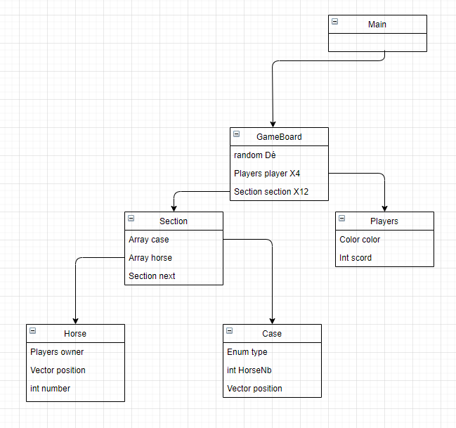

First

Application

gdg