User Manual

Multiscale Cardiac cell Workflow

**Table of Contents**

*Chapter 1: Introduction and Tool Description* 3

*Chapter 2: Installation and Program Requirement* 4

Installing bioKepler: 4

*Chapter 3: Downloading the Multiscale Cardiac Cell workflow* 5

*Chapter 4: Step-by-Step Tutorial* 6

1. Setting up input folders: 6

2. Running the Multiscale workflow through GUI Interface: 7

a. Local Execution mode: 8

b. Remote Execution mode: 8

3. Running the Multiscale workflow through Commandline interface: 8

a. Local Execution mode: 8

b. Remote Cluster Submission mode: 9

Step 1. Creating id_rsa.pub files: 9

Step 2. Preparing for job submission in a remote cluster: 10

Step 3. Running Multiscale Workflow on a Remote cluster 11

4. Checking the Multiscale Cardiac simulation output data: 11

Initial check 11

*Chapter 5: For Advanced Users* 13

1. Configuring Kepler for multiple workflow executions through command line 13

Step 1. *Close the Kepler GUI, if open* 13

Step 2. *Edit DB Host parameter in configuration. file* 13

Step 3. *Start HSQL* 13

Step 4. *Run multiple workflows through the command line* 13

Step 5. *Stop HSQL when you are done* 14

# *Chapter 1: Introduction and Tool Description*

We have developed a Kepler based workflow for multiscale cardiac electrophysiology. Figure 1 exhibits the automated computational workflow that can perform simulations to generate user defined instances and configurations of a single-cell cardiac action potential, conduction of a cardiac action potential in a 1-dimensional (1D) or 2-dimensional (2D) tissue representation and generation of a signal average of electrical activity in time and space to represent a pseudo-ECG.

# 

Figure : Multiscale Cardiac Cell Workflow

# The approach enables modularity, reuse, reproducibility, portability and scalability. The workflow concept also allows a model execution platform that allows the reuse of code, reproduction of reported in silico predictions, as well as a way to run simulations in an efficient, expandable, modular and portable manner.*Chapter 2: Installation and Program Requirement*

The Multiscale Cardiac Cell workflow requires users to have Java 8 or newer, Kepler-2.5, bioKepler-1.2, Python, and necessary input scripts installed on their local machines (2-4).

bioKepler – bioKepler is a suite of add-on modules that includes Kepler. The bioKepler suite adds Provenance module, Reporting module, the Data Distributed Pattern (DDP) module and bioActors to the Kepler suite. Users can find more information about Kepler (<https://kepler-project.org/>) and bioKepler (<https://www.biokepler.org>).

C++ compiler - Coding Language for the cardiac models is C++. For more information, please check out Intel developer website (<https://software.intel.com/en-us/intel-compilers>). The Multiscale Cardiac workflow compiles the models in real-time on local or a remote cluster depending on user execution choice. Users can compile using the source code using either ICC or GCC compiler.

## Installing bioKepler:

## Users can download the latest bioKepler software from the following link:

<https://www.biokepler.org/bioKepler-Dec-2018-Build>

* **For Linux** and **Mac OS X** - Simply untar bioKepler-Dec2018-build.tar.gz at a location of your choice, which will generate a folder named bioKepler-Dec2018-build. This is the command line command to untar a tar.gz file:

***tar -zxvf bioKepler-Dec2018-build.tar.gz***

* **For Windows**
* Select the Windows installer and save the install file to your computer.
* Double-click the install file to open the install wizard.
* Follow the steps presented to complete the Kepler installation process. Once the installation process is complete, a Kepler shortcut icon will appear on your desktop and/or in the Start Menu.

For Microsoft Windows, install Cygwin with openssh and openssl package.

For the following tutorial, we will work on a Linux platform as an example. Mac OS X and Windows follow similar steps.

# 

# *Chapter 3: Downloading the Multiscale Cardiac Cell workflow*

The Multiscale Cardiac workflow is prepared to run on the Kepler platform. The workflow itself is a product developed by NBCR (<http://nbcr.ucsd.edu>) and WorDS (<http://words.sdsc.edu/>).

The Multiscale Cardiac Cell workflow, this manual, and sample inputs can be downloaded from github.

Multiscale workflow Github Repository - <https://github.com/ClancyLabUCD/Workflow_Kepler>

# *Chapter 4: Step-by-Step Tutorial*

## Setting up input folders:

Before running the workflow, you need to set up and organize input folders in a specific required format. Inside the input directory, there are two required sub-directories: “Single_Cell” and “1D2D” that contain source code, dependent code files and input file. Users can also find the sample input folder here ([LINK HERE - Rabbit_0D1D2DWF](https://github.com/ClancyLabUCD/Workflow_Kepler)).

|  |  |
| --- | --- |
| 1D2D: | Single_Cell: |
|  |  |
| ECG_1D.py | stim_param.txt |
| README.docx | README.md |
| README.md | README.txt |
| snapshot2D.py | SS_rabbit_varNames.txt |
| initial_WTstates.txt | initial_WTstates.txt |
| integrate_rk2.h | integrate_rk2.h |
| masterCompute.cpp | masterCompute.cpp |
| masterCompute_1D.h | plotall.py |
| masterCompute_2D.h | soltis_biophysJ2010_BARsignalling_odefile.h |
| soltis_biophysJ2010_BARsignalling_odefile.h | soltis_biophysJ2010_CaMKII_signaling_ODEfile.h |
| soltis_biophysJ2010_CaMKII_signaling_ODEfile.h | soltis_biophysJ2010_camODEfile.h |
| soltis_biophysJ2010_camODEfile.h | soltis_biophysJ2010_eccODEfile.h |
| soltis_biophysJ2010_eccODEfile.h | soltis_biophysJ2010_eccODEfile_old.h |
| soltis_biophysJ2010_masterODEfile.h | soltis_biophysJ2010_masterODEfile.h |
| spiralwave_mov_2D.m | MSWF-KeyValueParser.py |
| stim_param.txt |  |

Download the files and create a new directory.

***mkdir Workflow_Sample***

Then, move the zip file into the new directory.

***mv ~/Downloads/Workflow_Kepler-master.zip Workflow_Sample***

Unzip the Workflow_Kepler-master.zip file and then remove it from the directory.

***cd Workflow_Sample***

***unzip Workflow_Kepler-master.zip***

***rm Workflow_Kepler-master.zip***

One workflow XML file “DBP-1D2D-WF.xml” and two Input folders named, 1D2D and Single-Cell, will now appear in the empty directory.

Now, you are ready to run the workflow. Users can execute workflow through GUI or commandline interface. There are two modes of execution and we will go over each of them in the next section: **local execution**, and execution on a **Remote cluster**.

## Running the Multiscale workflow through GUI Interface:

In your local computer, go to the directory where bioKepler is installed and where kepler.sh is located.

**cd /PATH/bioKepler-Dec2018**

The general command to start Kepler through command prompt is

**./kepler.sh**

* In Menu bar, go to “File” tab and select “Open” option and open the desired workflow file (DBP-1D2D-WF.xml).
* Customize workflow parameters, for example, ExecutionChoice, input folder paths, compilerProgram and other Shared Parameters and Execution Choice specific parameters.
* From the Toolbar, select the Run button. 
* The workflow will execute and produce the specified output files.

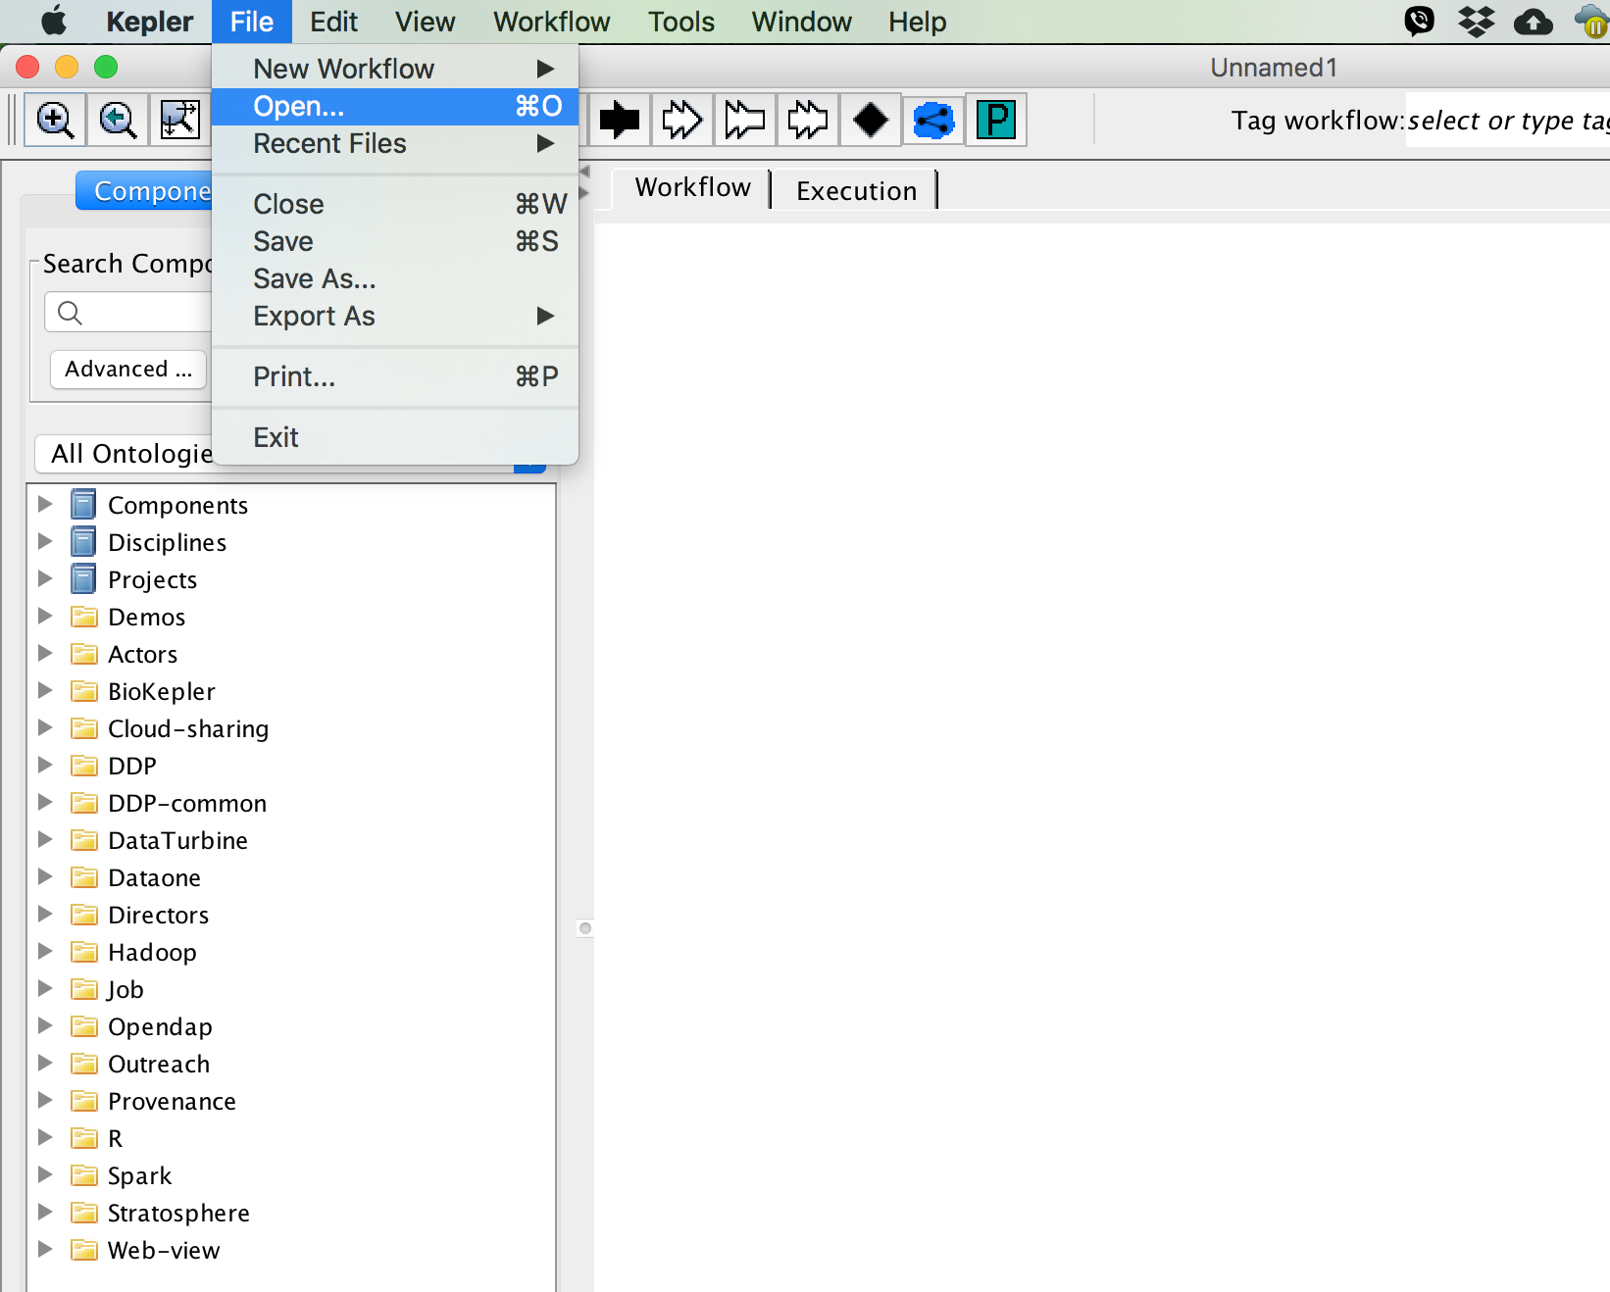

## Local Execution mode through GUI:

Parameters: Please find brief description of the parameters specific to local execution below. Please customize below parameters for your execution:

* ExecutionChoice - This parameter gives option to run same workflow on a local machine or a remote Cluster. For local execution: LocalExecution
* compilerProgram – C++ compiler on your local machine. For example, ICC or GCC.
* input0D - The inputFolder path for singlecell on your local machine. For example: /Path/to/Single-Cell
* input1D2D - The inputFolder path for 1D2D on your local machine. For example:

/Path/to/1D2D

## Remote Execution mode through GUI:

Create and setup Public Key Authentication for SSH. Please follow the steps here.

Please find brief description of the parameters below. Customize below parameters for your execution:

Remote Parameters:

* ExecutionChoice – This parameter gives option to run same workflow on a local machine or a remote Cluster. For remote execution: kividCluster
* compilerProgram – C++ compiler on the remote cluster. For example, ICC or GCC.
* TargetHost - Username@host. For example: [username@kivid.ucsd.edu](mailto:username@kivid.ucsd.edu)
* IdentityFile - The identity File to make SSH and SCP password less. For example: /Users/username/.ssh/id_rsa
* input0D - The inputFolder path for singlecell on your local machine. For example: /Path/to/Single-Cell
* input1D2D - The inputFolder path for 1D2D on your local machine. For example:

/Path/to/1D2D

* remoteDir - Work Directory on the remote cluster. For example: /home/username/Workflow_Sample
* cpuModulesToLoad – Modules dynamically modifies a user’s execution environment to configure the shell for an application. The parameter “cpuModulesToload” prepares execution environment on CPU nodes. For example, SDSC comet requires intel module to be loaded (module load intel) on a CPU node to access intel compilers in the execution environment. Accepted value is “module load intel”
* Scheduler – The workflow creates script and submits jobs to a remote cluster. The user parameter states which scheduler is on the remote cluster, for example, PBS, SGE or SLURM etc.
* SchedulerConfiguration - Users can further configure scheduler of remote cluster using the SchedulerConfigration parameter. Example value: “-V -N MSanalysis -e MSanalysisErrorFile.err -o MSanalysisOutFile.out -cwd -S /bin/bash”

## Running the Multiscale workflow through Commandline interface:

## Local Execution mode:

In your local computer, go to the directory where Kepler was installed and where kepler.sh is located.

**cd /PATH/bioKepler-Dec2018**

And type the following command line in that directory to start the multiscale workflow. Users will need to modify the command based on their needs. The definition for each parameter is listed below. An **ABSOLUTE** path is need when running Kepler. If an absolute path is not specifically typed out in command prompt, Kepler won’t be able to find the files or folders of interest and it will throw an error message.

The general command to run Kepler through command prompt is

**./kepler.sh –runwf -nogui -parameters values /PATH/workflow.xml**

Here is an example of how Kepler can be run for our test case:

**./kepler.sh -runwf -nogui -ExecutionChoice LocalExecution -input0D /PATH/Single_Cell -input1D2D /PATH/1D2D /PATH/Workflow.xml**

For more information about each parameter, please check the parameters (see section below).

**Parameters:**

ExecutionChoice: This parameter gives option to run same workflow on a local machine or a remote Cluster. For local execution: LocalExecution

input0D: The inputFolder path for singlecell on your local machine. For example: /Path/to/Single-Cell

input1D2D: The inputFolder path for 1D2D on your local machine. For example:

/Path/to/1D2D

## Remote Cluster Submission mode:

|  |
| --- |
| Step 1. |

### Creating id_rsa.pub files:

(Skip to step 3 if the user has already configured the SSH key.)

Most remote clusters require login authentications and passwords. In order to connect to the remote cluster through the command-line interface without having to type in password for each submission step, the easiest way is to generate an SSH key. To run Kepler from the command prompt smoothly, we will create SSH keys for logging into a remote cluster without password.

First, create an .ssh directory in your home directory in your local computer. If users already have an .ssh directory in their home directory, they can skip this step.

**mkdir ~/.ssh**

Then, in the .ssh directory, generate the public/private RSA key pairs with the below command line:

**cd ~/.ssh**

**ssh-keygen -t rsa**

The system will ask you the following questions:

Generating public/private rsa key pair.

Enter file in which to save the key (/Users/*you*/.ssh/id_rsa): *[Press enter]*

Enter passphrase (empty for no passphrase): *[Press enter]*

Enter same passphrase again: *[Press enter]*

Your identification has been saved in /Users/*you*/.ssh/id_rsa.

Your public key has been saved in /Users/*you*/.ssh/id_rsa.pub.

The key fingerprint is: # *01:0f:f4:3b:ca:85:d6:17:a1:7d:f0:68:9d:f0:a2:db (random codes)*

|  |
| --- |
| Step 2. |

### Preparing for job submission in a remote cluster:

Log in to the remote cluster of your choice, for example, the NBCR Kivid Cluster.

**ssh username@kivid.ucsd.edu**

Type in the password. Go to the home directory and create an .ssh folder in the remote cluster. (The .ssh directory may already be there, which is fine; ignore this step).

**cd**

**mkdir -p ~/.ssh**

**logout**

Then, in your local computer, append the public key to your remote cluster.

**cat ~/.ssh/id_rsa.pub | ssh username@kivid.ucsd.edu 'cat >> ~/.ssh/authorized_keys'**

Now you should be able to log into the remote cluster from your local computer without needing to type your password.

Log in to the remote cluster and create a folder. This folder is the working directory in the remote cluster where users will run their simulation jobs

**ssh** [**username@kivid.ucsd.edu**](mailto:username@remotecluster.edu)

**mkdir Workflow_Sample**

You are ready to run the workflow.

|  |
| --- |
| Step 3. |

### Running Multiscale Workflow on a Remote cluster

1. *Running the workflow using NBCR Kivid Cluster:*

In your local computer, go to the directory where Kepler was installed and where kepler.sh is located.

**cd /PATH/WHERE/KEPLER/IS/INSTALLED/bioKepler-Dec2018**

And type the following command line in that directory to start the workflow. Users will need to modify the command based on their needs. The definition for each parameter is listed below. An **ABSOLUTE** path for each file is need when running Kepler. If an absolute path is not typed out, Kepler won’t be able to find the files or folders of interest and throw an error message.

The general command to run Kepler through command prompt is

**./kepler.sh -runwf -nogui -parameters values /PATH/workflow**

Here is an example of how Kepler can be run for our test case.

**./kepler.sh -runwf -nogui -ExecutionChoice kividCluster -TargetHost username@kivid.ucsd.edu -IdentityFile /Users/username/.ssh/id_rsa -input0D /Path/to/Single-Cell -input1D2D /Path/to/1D2D -remoteDir /data/username/Workflow_Sample /path/to/DBP-1D2D-WF.xml**

## Checking the Multiscale Cardiac simulation output data:

### Initial check

The outputs contain an output directory for each set of simulations (Single-Cell/outputFolder, 1D2D/output1DFolder, and 1D2D/output2DFolder). Inside each output folder, the following files can be found:

|  |  |
| --- | --- |
| **Single-Cell/outputFolder** | **1D2D/output1DFolder** |
| apds_1Hz.txt | ECG.png |
| vm_1Hz.txt | y_1D.txt |
| allresult_1Hz.txt | ECGs.txt |
| RyR.png |  |
| I_NCX.png |  |
| Na.png | **1D2D/output2DFolder** |
| IKr_IK1.png |  |
| IKs_ICFTR.png | ap*.dat files |
| INa.png | apt*.png |
| Ito.png |  |
| Cai.png |  |
| CaSRT_Caj.png |  |
| ICa.png |  |
| vm.png |  |

# *Chapter 5: For Advanced Users*

## Configuring Kepler for multiple workflow executions through command line

|  |
| --- |
| Step 1. |

### *Close the Kepler GUI, if open*

Go to KeplerData directory. It is usually located in the user’s home directory

**cd /home/username/KeplerData**

**or**

**cd ~/KeplerData**

|  |
| --- |
| Step 2. |

### *Edit DB Host parameter in configuration. file*

**vi modules/provenance/resources/configurations(latest)/configuration.**

In configuration file: provide DB Host value as “localhost” and save changes.

***<!-- host name running the database -->***

***<pair>***

***<name>DB Host</name>***

***<value>localhost</value>***

***</pair>***

|  |
| --- |
| Step 3. |

### *Start HSQL*

Go to the directory where Kepler is installed. Start HSQL.

**cd /PATH/WHERE/KEPLER/IS/INSTALLED/kepler-2.5**

**kepler.sh -hsql start**

|  |
| --- |
| Step 4. |

### *Run multiple workflows through the command line*

**./kepler.sh -runwf -nogui -parameters values /PATH/workflow1.**

**./kepler.sh -runwf -nogui -parameters values /PATH/workflow2.**

**./kepler.sh -runwf -nogui -parameters values /PATH/workflow3.**

**./kepler.sh -runwf -nogui -parameters values /PATH/workflow4.**

|  |
| --- |
| Step 5. |

### *Stop HSQL when you are done*

**kepler.sh -hsql stop**