Members (A2) :
- Akli Merouane
- El Mokretar Akram
- Saibi Mohamed Abdelilah
- Akboudj Anis Mohammed Nassim
- Messikh Mohammed Yahia
- Namane Haithem
- Bennacer Sami Fares
Track 1 — The Laser Grid (Plane Mirrors)
1. Physics Principle
Geometric optics assumption:
Light propagates along straight rays in a homogeneous medium.
Law of reflection (plane mirror):
$$\boxed{i=r}$$
Angles are measured with respect to the normal to the mirror.
Incident ray, reflected ray, and normal lie in the same plane.

2. Analytical Geometry of the Setup
Two perpendicular plane mirrors (M1 on the ceiling, M2 on the wall).
First reflection (M1)
Given:
$$i_{1}={30}^{∘}⇒r_{1}={30}^{∘}$$
Angle between reflected ray and mirror surface:
$${90}^{∘}-{30}^{∘}={60}^{∘}$$
Second reflection (M2)
From triangle geometry:
$$i_{2}={90}^{∘}-{30}^{∘}={60}^{∘}⇒r_{2}={60}^{∘}$$

3. Total Deviation
Deviation caused by one mirror:
$$δ={180}^{∘}-2i$$
Total deviation:
$$D=({180}^{∘}-2i_{1})+({180}^{∘}-2i_{2})$$
Since:
$$i_{1}+i_{2}={90}^{∘}⇒D={180}^{∘}$$
Result:
The exiting ray is parallel to the incident ray and travels in the opposite direction.

4. Mathematical Ray Model
A ray is written as:
$$\vec{r}(t)=\vec{O}+t\vec{d}$$
Reflection using vectors:
$$\boxed{\vec{d_{r}}=\vec{d}-2(\vec{d}⋅\vec{n})\vec{n}}$$
This formula strictly enforces $i=r$.

5. Programming Implementation (Python)
Vector reflection:
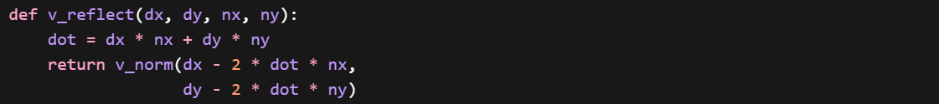
Incidence angle calculation:

