渥瑞达北美IT培训

iPhone应用程序开发教程
（Objective-C 程序设计）

Chapter 1 Get Started 1
§ 1. Introduction 1
§ 2. Your First Program 4
§ 3. Using Xcode Debugger 8
Chapter 2 Classes 15
§ 1. Class Definition 16
§ 2. Class Implementation 17
§ 3. Message Expressions 20
§ 4. Overloading 21
§ 5. Property Declarations 22
§ 6. Composition 27
Chapter 3 Memory Management 34
§ 1. The Autorelease Pool 35
§ 2. Reference Counting 38
§ 3. Allocation, Initialization and Destruction 40
Chapter 4 Inheritance 49
§ 1. It All Begins at the Root 49
§ 2. Finding the Right Method 52
§ 3. Adding New Methods 53
§ 4. Overriding Methods 57
§ 5. Adding New Instance Variables 62
§ 6. Downcasting and Dynamic Binding 64
§ 7. id Type 66
Chapter 5 Special Features 68
§ 1. Protocols 68
§ 2. NSCopying 71
§ 4. Categories 74
§ 5. Summry of Memory-Management Rules 81
§ 6. Other Special Features 83
§ 7. C++ specific features 88
Chapter 6 Foundation Framework 90
§ 1. Overview 90
§ 2. Foundation Framework Classes 91
Chapter 7 Numbers、Strings and Collections 97
§ 1. Number Objects 97
§ 2. String Objects 100
§ 3. Array Objects 107
§ 4. Dictionary Objects 112
Chapter 8 Working with Files 114
§ 1. NSCoding 114
§ 2. Managing Files and Directories 117
§ 2. Working with Paths 120
§ 3. Basic File Operations 122

Chapter 1 Get Started

§ 1. Introduction
Dennis Ritchie at AT&T Bell Laboratories pioneered the C language in the early 1970s. UNIX operating system was written almost entirely in C.
（在20世纪70年代初 丹尼斯.里奇 在AT＆T贝尔实验室开创的C语言。 UNIX操作系统几乎全部是用C写的。）

Brad J. Cox designed the Objective-C language in the early 1980s.The language was based on a language called SmallTalk-80 and was layered on top of the C language.
（在20世纪80年代，布莱德. 确斯 发明了Objective-C 语言。OC是基于一种叫SmallTalk-80的语言，并且是在C语言之上的。）

NeXT Software licensed the Objective-C language in 1988 and developed its libraries and a development environment called NEXTSTEP. Most Cocoa classes begin with NS, like NSString, since they were initiated under NEXTSTEP.
（NeXT软件公司在1988年发放Objective-C的许可，并且开发了它的一些库和开发环境起名叫做NEXTSTEP。绝大多数的Cocoa类都用NS打头，如NSString，因此他们加入NEXTSTEP的开发）

On December 20, 1996, Apple Computer announced that it was acquiring NeXT Software, and the NEXTSTEP/OPENSTEP environment became the basis for the next major release of Apple’s operating system, OS X. Apple’s version of this development environment was called Cocoa. With built-in support for the Objective-C language, coupled with development tools such as Project Builder (or its successor Xcode) and Interface Builder, Apple created a powerful development environment for application development on Mac OS X.
（1996年12月20日，在苹果公司宣布收购了NeXT软件公司基础上，NEXTSTEP / OPENSTEP环境成为了苹果操作系统的下一个主要版本，苹果公司的OS X 这个开发环境的版本被称为Cocoa。内置支持Objective - C语言与开发工具，如项目构建器（或它的后继者的Xcode）和Interface Builder，再加上苹果Mac OS X上创建一个强大的开发环境，用于应用程序开发）
后来，NeXT公司被苹果公司收购，NEXTSTEP开发环境更名为Cocoa，成为苹果电脑操作系统 Mac OS X的基础，包括 Xcode、Interface Builder等开发工具。

In 2007, Apple released（发布） an update to the Objective-C language and labeled it Objective-C 2.0.

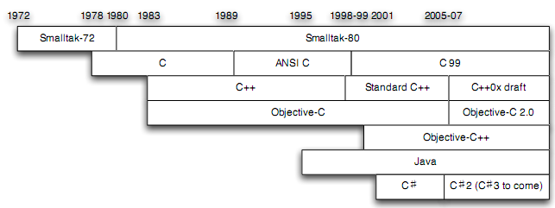
Timeline of C, C++ and Objective-C
Objective-C is a reflective(成熟的), object-oriented programming （面向对象的）language which adds Smalltalk-style messaging（消息机制） to the C programming language.

Objective-C is a thin layer on top of C, and moreover is a strict superset of C; it is possible to compile any C program with an Objective-C compiler, and to freely include C code within an Objective-C class.
（oc是基于c之上的，扩展的c。）

Objective-C derives its object syntax from Smalltalk. All of the syntax for non-object-oriented operations (including primitive variables, preprocessing, expressions, function declarations, and function calls) are identical to that of C, while the syntax for object-oriented features is an implementation of Smalltalk-style messaging.
（Objective - C从Smalltalk得到对象的方法及语法。所有的非面向对象的操作（包括原始变量，预处理，表达式，函数声明和函数调用）的语法和C语言相同，而面向对象的特性的语法是Smalltalk消息机制。）

Today, Objective-C is used primarily(主要是) on Apple's Mac OS X and iOS. It is the only language in which you can write applications for the iPhone or iPad.

Objective-C is now one of top ten languages in use. It was ranking(排名) 47 and 37 in Jan. 2008 and Jan. 2009. It was the language increased most rapidly in recent years. (http://www.tiobe.com/index.php/content/paperinfo/tpci/index.html)
编程语言排行榜
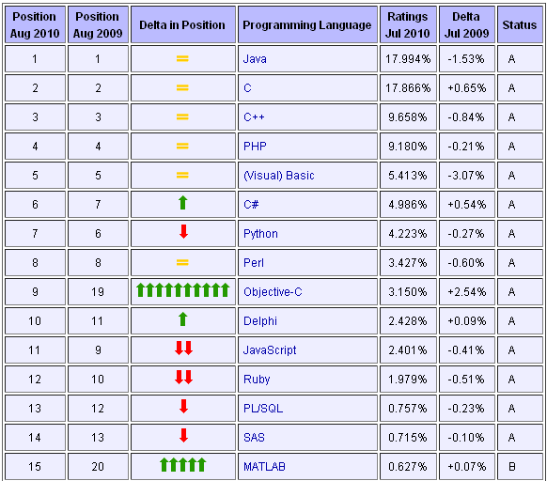
TIOBE Programming Community(社区) Index for August 2010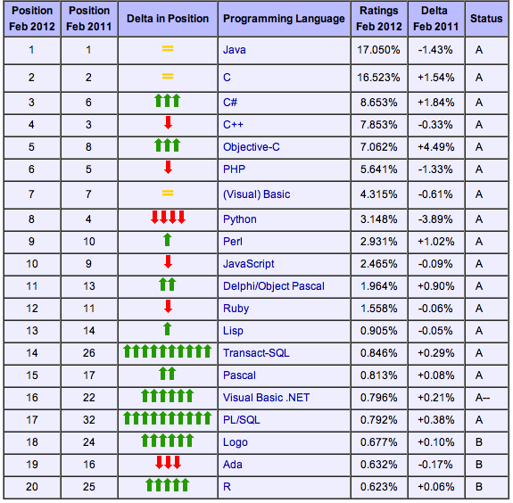
TIOBE Programming Community Index for August
2012

§ 2. Your First Program
Using Xcode：使用Xcode编写

Xcode is located in the Developer folder inside a subfolder called Applications.
Start Xcode. Under the File menu, select New Project. Select Command Line Tool, click Choose. Name your first program HelloWorld and choose a directory to store project.

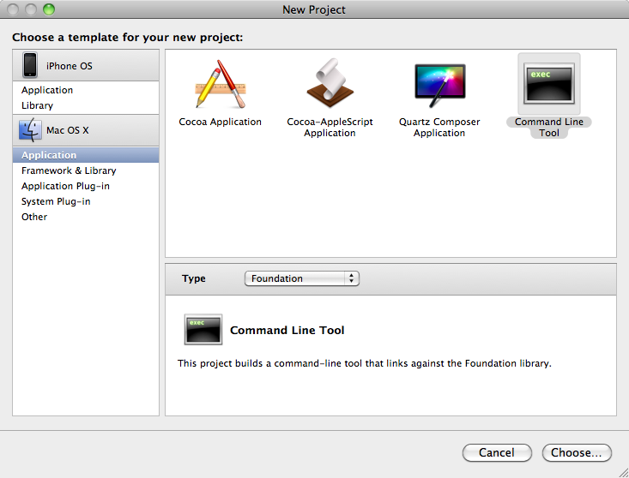
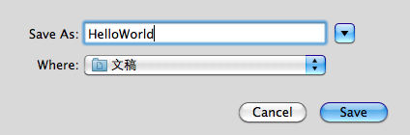

Create new project with Xcode
（使用Xcode创建一个新项目）

Click Save button to create new project. The Xcode project window will show. Some files and codes were already created.

Objective-C source file use .m(源文件) as the extension of the filename, while .h(头文件) for header files.
m:message 消息发送

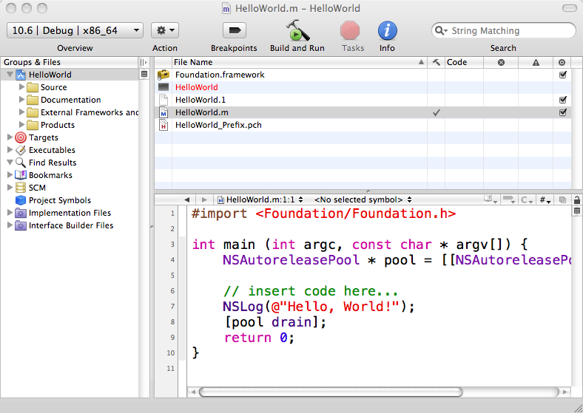
Xcode HelloWorld project window
NSString* string = @”Hello,Wrold!”;
NSLog(string);
给讲讲下面的图片内容
HelloWorld.m contains the following lines:
#import <Foundation/Foundation.h>
头文件包含,自动防止重复包含,不用写#ifndef

int main (int argc, constchar * argv[]) {
NSAutoreleasePool * pool = [[NSAutoreleasePool alloc] init];//函数链
alloc:给对象分配空间
init:初始化对象,类似于构造函数
oc中创建一个对象

// insert code here...
NSLog(@"Hello, World!");
//类似与printf,格式化输出.
@ +”c字符串” = NSString*对象,oc的字符串常量

[pool drain];
return 0;
}

OC函数(方法)调用的方式:
[类名 方法名]; //类方法（大致相当于，静态成员函数）
eg . +(void)fun;
[对象名 方法名];//实例方法（非静态成员函数）
eg.-(void)fun;
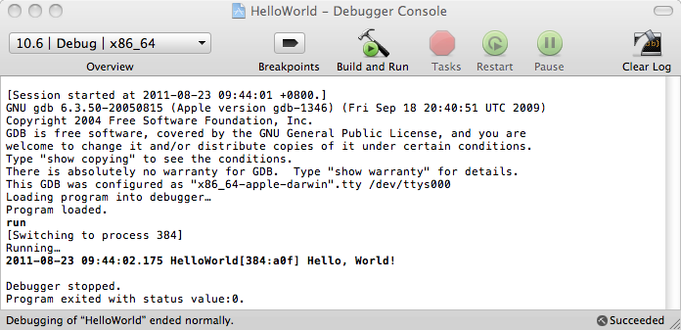
Then, press Shift + Command + R to start Debugger Console. Build and run your application by selecting Build → Build and Run, or by clicking the Build and Go Button. You will see results in the Debugger Console window something as below:

时间戳

Using Terminal：使用命令行（终端）编译
先cd到main.m的目录下
Gcc –framework Foundation main.m –o helloworld(项目名称)
./helloworld
You can also use command-line tools to edit, compile and run your programs.
Start the Terminal application on your Mac. The Terminal application is located in the Applications folder, stored under Utilities.
After have entered your codes by vi, emacs（一种文本编辑器） or any other editor, you can use the GNU Objective-C compiler, which is called gcc, to compile and link your program. This is the general format of the gcc command:

gcc –framework Foundation files –o progname
./ progname

Then, you can run the application and see the results.
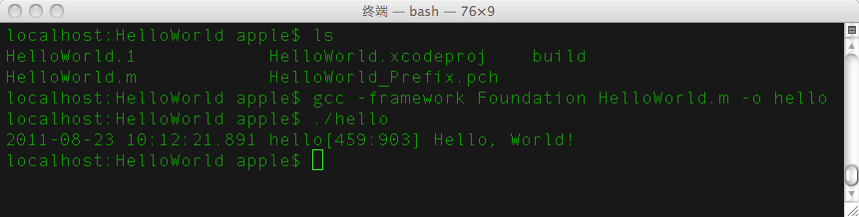

§ 3. Using Xcode Debugger 调试器
Debugging is one of the most creative and intellectually challenging aspects of programming. It can also be one of the most frustrating.
（调试是编程的最有创造性和智力挑战的方面之一。它也是最费力的方面之一）

Because debugging is a difficult but nonetheless critical task, it is important to learn the tricks of the trade. The most important of these tricks is to get the computer to show you what it’s doing, which is the key to debugging.
（由于调试是一个困难但却关键的的任务，重要的是要学习调试的技巧。这些技巧中最重要的是让计算机向您展示它在做什么，这个关键是debugging.）

Modern programming environments usually come equipped with a debugger, which is a special facility for monitoring a program as it runs. By using the Xcode Debugger, for example, you can step through the operation of your program and watch it work. Using the debugger helps you build up a good sense of what your program is doing, and often points the way to the mistake.
（现代编程环境通常都配备了一个调试器，调试器是一个特殊的用来管理程序运行时的设备。例如，通过使用Xcode的调试器，你可以通过你的程序的操作步骤，并且看着它的工作。使用调试器，可以帮助你建立一个你的程序是做什么的良好意识，并经常点的方式错误）

The Xcode debugger is a complicated environment, but with a little patience, you should be able to learn it to the point where you code more efficiently and productively.

Under the Build menu, there are two menu items for executing your code: the Build and Run (Cmd-R) （编译并执行）option and the Build and Debug (Cmd-Y) （编译并调试）option. So far you've probably been using Build and Run, which sets up and runs your program on its own until it completes successfully or halts abnormally because of a fatal error. The Build and Debug option, on the other hand, will set up and run your program in the context of the debugger.
The debugger gives you the ability to stop your program mid-stream, poke around and examine the values of variables, and investigate the aftermath after a fatal error to understand what happened. When you choose the Build and Debug menu item and set breakpoint at statement you want by click the left of the statement, it sets up your program and stop at the statement you set.

---------------------------------------------------
（函数调用栈稍后讲）
Click Debugger button, the debugger window will popup. At this point, you can control the execution of the program manually using the buttons on the debugger window. You can choose to step through the code line-by-line, run until you get to certain points, and so on.

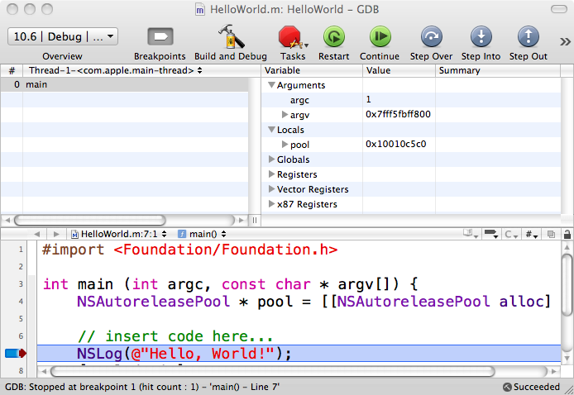
左上:函数调用栈,栈顶是当前执行的函数.
右上:对应左边高亮的函数，相关的变量的当前值.
At a stopped point, there are three panes in the window filled with information. The left pane show the current stack frame（函数调用栈）. Here we see what calls have been made that have led to the current call. The most recent call is listed at the top.
( 左的窗格显示当前堆栈 frame)

When we click on a function listed in this pane, the frames on the right and bottom will update to show the values and information for the selected function. This essentially allow you to look at the entire state of your program, not just the current function, at any time the program is stopped.
The right pane contains all variables and associated values contained in the stack frame highlighted in the left pane. Note that some variable types (such as structs, classes, and pointers) have an arrow to the left of them. This means that there is more information pertaining to this data type that can be viewed.
(右窗格包含在左窗格中突出显示的堆栈帧所有变量和关联的值。)

In Xcode, when a variable changes values it is highlighted in red, so as to inform you of the update. A highlighted value returns to black once the next call is executed.
The bottom pane contains the program’s code with breakpoint information and current point of execution. The red arrow in the bottom frame indicates the next line of code to be executed. Clicking on functions listed in the stack frame will adjust this window accordingly and change the red arrow to indicate the next statement to be executed for that particular function.
(底部窗格包含断点信息和当前的执行点的程序代码。)
---------------------------------------------------
The toolbar icons you should become familiar with are Build and Debug, Terminate, Restart, Pause, Continue, Step Over, Step Into, and Step Out.

 | Runs the program, which continues until you choose Stop or the program encounters a breakpoint. The shortcut key for this is Cmd-Y. 编译并调试
 | Stops the program and debugger immediately. 停止调试
 | Starts the program over. This is most useful if you have made some changes to the code and want to see how they affect the program’s execution. 重启调试
 | Stops the program wherever it happens to be. 停止程序
 | Starts the program running again after it has been stopped at a breakpoint. Use this if you are finished looking at the area of code and want the program to proceed without stopping at each line as it does with “step” buttons. 执行到下一个断点
 | Executes one step in the program, at the current level. If the program calls a function, that function is executed all at once, rather than by stepping through it. 单步调试
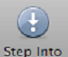 | Stops at the first line of the first function called on this line.  跳进函数
 | Runs the program until the current function returns.  跳出函数

- Thread Switching （线程切换）
Occasionally, when you get an error or press the Pause button, the stack trace will be something that looks totally unlike any code you’ve written. This is because the compiler is actually running a few other threads of code other than your own to enable the code to run properly. If you get such stack trace, click on the name of the thread:

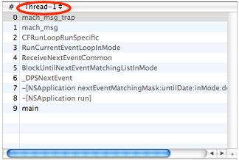

You will get a list of different threads. Select different ones until you get one that looks like your code (usually it will be Thread-2).
(你将得到不同的线程的列表。选择不同的，直到你查找得到一个喜欢的代码 （通常将为线程-2）。)

- Using breakpoints (使用断点)
Clicking in the narrow column to the left of the code displayed in the bottom pane sets a breakpoint at the indicated line. A second or two after you click on the side, a blue pentagon sign appears to indicate that there is a breakpoint set on that line. When the program is started by the Build and Debug command, it checks to see whether there is a breakpoint on each line that it executes. If there is, the program stops at that point. Clicking on the pentagon removes the breakpoint.
Breakpoints are an essential component of debugging(断点是调试不可缺少的一部分). A general strategy is to set a few breakpoints throughout your program; usually around key spots that you know may be bug prone, such as computationally-intensive or pointer-intensive areas. Then, run your program until you get to a breakpoint. Step over things for a few lines, and look at your variable values. Maybe step out to the outer context, and take a look to see that the values of your variables are still what they should be. If they're not, then you have just executed over code that contains one or more bugs. If things look well, continue running your program until you hit the next breakpoint.

NSLog （打印函数）
Logging messages to the console in Objective-C is very simple and is a good way of debugging. In fact, the NSLog() function is nearly identical to the C printf() function, except there's an additional %@ token for objects.

NSLog ( @"The current date and time is: %@", [NSDate date] );

The NSLog function calls the description method on the object, and prints the NSString which is returned. You can override the description method in your class to return a custom string.

NSLog format specifiers: 格式控制符

%@ | Object 输出对象,调用对象的description方法
%d, %i | signed int 有符号32位整数
%u | unsigned int 无符号32位整数
%f | float/double
%p | Pointer 打印指针
%c | Character ASCII字符
%C | Unichar 每个unichar是用2个bytes来存储的, 代表unicode的一个字符
%s | C string (bytes) c字符串
%S | C string (unichar)
%ld, %li | long int 长整型
%lld | long long %lld 有符号64位整数，至少8个字节
%llu | unsigned long long 是64位无符号整数
%Lf | long double 长浮点型数据输出格式

Example Codes:
void testNSLog(){
// %@ : Object
NSString * str = @"Hello world";
NSLog(@"NSString: %@", str); // NSString
NSNumber* num = [NSNumber numberWithInt:100];
//[类名 方法名:参数];
NSLog(@"NSNumber: %@", num); // NSNumber is a class!
//AddressCard* card = [[AddressCard alloc]initWithName:@"Tom"
//andEmail:@"Tom@gmail.com"];
//NSLog(@"AddressCard: %@", card); // Using description method
//[card release];

// %d : signed int
int intValue = -100;
// NSInteger is int type, not class!
//是基本数据类型的typedef，不是类。
//平台不同，NSInteger对于的类型也不同。
//跨平台,可移植性
NSInteger intValue2 = -999;
NSLog(@"int : %d, %d", intValue, intValue2 );

// %u : unsigned int
unsigned int uintValue = 100;
unsigned int uintValue2 = -100;
NSLog(@"unsigned int : %u %u", uintValue, uintValue2 );

// %f : float/double
float floatValue = 20.20;
double doubleValue = 50.55;
NSLog(@"float: %f double: %f", floatValue, doubleValue);

// %p : pointer
char* p = "test pointer";
NSLog(@"pointer : %p", p);//打印指针地址
NSLog(@"char * p : %s", p);//打印字符串内容

// %c : char; %C : unichar
char aChar = 'G'; //char型,1个字节
char bChar = 0x61;// char型'a'
unichar aUnichar = 0x4f60; // L'你' //unichar,两个字节
NSLog(@"char: %c", aChar);
NSLog(@"unichar: %C", aUnichar);

// %s : C string(bytes); %S : C String(unichar)
NSLog(@"C string(bytes) : %s", p);
unichar pUnichar[] = {L'你',L'好', 0x0000};//相当于’\0’ NSLog(@"C string(unichar) : %S", pUnichar);

// %lld : long long; %llu : unsigned long long; %Lf : long double
long int longint1 = 1213232490;
NSLog(@"%ld = ",longint1);
long long verylong = -12345678901234567;
NSLog(@"long long : %lld", verylong);
unsigned long long uVeryLong = 123456789012345564;
NSLog(@"unsigned long long : %llu", uVeryLong);
long double aLongDouble = 1233242423123.234242342445;
NSLog(@"long double : %Lf", aLongDouble);
}

//输出结果
Hello, World!
Today is: 2012-04-25 18:07:43 +0800
NSString: This is a NSString!
NSNumber: 100
int: -100,-999
unsigned int:100,4294967196
float: 20.200001; double: 50.550000
pointer: 0x100000e0e
char * p: test point
Char: G;a
unichar: 你
C string(bytes): test point
C string(unichar): 你好
long long :1234567890
long long : -1234567890987654321
unsingned long long : 1234567890987654321
long double : 123456789.987650

Chapter 2 Classes 类

Objective-C is an object-oriented language: it manages classes and objects. Objective-C uses a strict(严格的) object model.
OC是一个面向对象的语言，他管理着类和对象。

Like in C++, it is useful to split the code between interface and implementation for each class. Objective-C uses .h ﬁles for headers, and .m ﬁles for the code. Objective-C introduces the #import具有防止重复包含的作用 directive to replace #include. Indeed(事实上), every C header should use compilation guards(编译头向导) to prevent(防止) multiple inclusions(多个包被包括). This is automatic(自动的) when using #import. #import keeps track of which headers have already been included and is ignored if a header is imported more than once in a compilation unit. This makes it unnecessary(没有必要) to use header guards. Below is a typical(典型的) interface/implementation example. The Objective-C syntax is explained later.

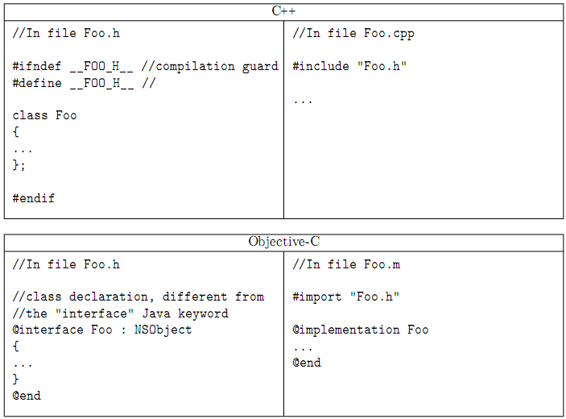

§ 1. Class Definition 类的声明
Interface Section 接口部分（.h文件）

General Format:
父类 <类所遵循的协议（多继承）>
@interface className : parentClass <protçocol, …>{
instanceVariable Declarations
实例变量的声明(C++的成员变量)
}
method Declarations //方法的声明(C++的成员函数)
...
@end

操作一下教教他们怎样创建一个类

Objective-C defines a root class: NSObject. Every new class should be a descendant of the NSObject class. It provides a huge number of facilities for the run-time system.
(Objective - C的定义一个根类：NSObject。每一个新的类，应该是一个NSObject类的子类。它提供了一个运行时系统的大量的方法。)

Strictly speaking, every object should be of type NSObject, and every pointer to an object could be declared as NSObject*. In fact, one can use the type id instead. This is a short and handy way to declare a pointer to any object, and provides dynamic type-checking instead of static type-checking. It is very useful for some weak typing on generic methods.
(也就是说，每一个对象的类型都是NSObject,每一个指针指向对象的指针都可以被声明为NSObject*.事实上我们可以使用id这个类型来代替。这就是一个声明一个对象或指针的简单的方法，并且支持动态类型检查来代替静态类型检查。)

Method Declarations 方法声明

General Format:
#import””
mType (returnType) name1:(type1)param1 name2:(type2)param2...
方法类型(返回值类型) 方法名1:(参数1类型)参数名 方法名2:(参数2类型)参数2名称..
方法需要参数时,方法名后要有冒号
方法名的每一部分:标签
冒号前面是标签,冒号后面是参数类型和参数名
The method name1:name2:… is declared, which returns a value of type returnType and has formal parameters param1, param2, …. param1 is declared to be of type type1, param2 is declared to be of type type2, and so on.
tpye2 can be omitted.

Colons (:) are parts of the method name.

If mType is +, a class method(类方法) declared, but if mType is -, an instance method (实例方法)is declared.
+ 类方法(C++静态成员函数),用类名调用;
- 实例方法(C++非静态成员函数),用对象名调用;

Sample:
/*******Circle.h*******/

static int sum = 5;//静态全局变量
OC不支持静态成员变量,通过静态全局变量来实现静态成员变量的功能.

-(void) print;
-(void) setR:(int) _r andX:(int) _x andY:(int) _y ;
+(int) allNum;
@end

- 在一个已有工程里，添加一个类。演示给他们看

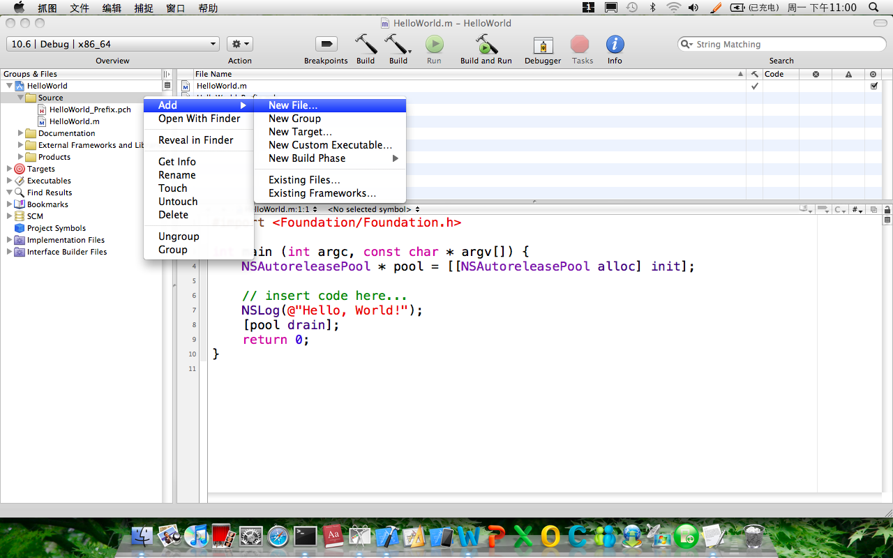

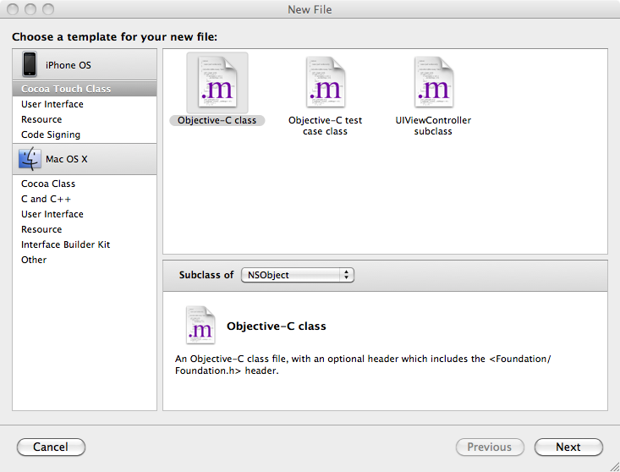

§ 2. Class Implementation 类的实现
Implementation Section

General Format:

@implementation className 类代码实现的开始
Synthesized Property @synthesize 指示符来为类的属性生成setter和getter函数的
methodDefinition 方法的实现
methodDefinition
...
@end 类代码编写的结束

Unless the methods for a category（类别） are being implemented, all the methods declared in the interface section must be defined in the implementation section.
（除非是一个类别的方法要被立刻实现，所有的方法声明在interface部分，必须在implementation部分定义。）

If one or more protocols were listed in the interface section, all the protocols’ methods must be defined.

Method Definition //方法实现

General Format:

mType (returnType) name1:(type1)param1 name2:(type2)param2…{
variableDeclarations
programStatements
...
Return expression;返回一个定义的类型数
}
This method declaration must be consistent with the corresponding method declaration from the interface section or from a previously defined protocol definition.
（这种方法的实现必须从interface部分，或从先前定义的协议声明的相应的方法声明一致。）

An instance method can reference the class’s instance variables and any variables it has inherited directly by name. If a class method is being defined, it cannot reference any instance variables.

The identifier self can be used inside a method to reference the object on which the method was invoked.
（Self可以用作当前对象的引用，来调用当前对象的方法）

Example Codes

/******Circle.m ******/
#import “Circle.h”
@implementation Circle
-(void) print
{
NSLog(@"Radius:%d X:%d Y:%d",radius,x,y);
}

-(void) setR:(int) _r andX:(int) _x andY:(int) _y
{
radius = _r;
x = _x;
y = _y;
}

+(int)allNum
{
return sum;
}
@end

[加上main函数,调用Circle类的方法]

§ 3. Message Expressions 消息机制
Objective-C is a superset of C, so that functions match the same syntax and semantics as C for declaration, implementation and call.
（OC支持c，所以函数的匹配和c的语法实现是一样的。）

On the contrary, methods, which do not exist in C, have a special syntax, which includes square brackets. Moreover, the difference is not only in the syntax, but also the meaning: this is not a method call, this is sending a message.
（相反，方法的调用，在c里面是不存在的一种调用方法，有一种特殊的语法，其中包括方括号。此外，这不是一个方法调用，这是发送消息。）

C++ 对象调用函数
OC 向对象发送消息,对象收到消息做出响应(respond),
接收消息的对象称为receiver,发送的消息称为selector.

- Format :
[receiver name]; // if no arguments
or
[receiver name1:arg1 name2:arg2 name3:arg3 ...];

Objective-C does not allow a default value to be specified for the parameters of functions or methods.
（OC里不允许函数的参数有指定的默认值）

If receiver is a class object (which can be created by simply specifying the class name), the specified class method is invoked.
（如果接受者是一个类，被指定的这个类的方法将被调用。）
［类名 类方法］；

Otherwise, receiver is an instance of a class, and the corresponding instance method is invoked.
（否则，接受者是一个类的实例，相应的实例的方法将会被调用）
［实例对象 实例方法］；

#import <Foundation/Foundation.h>
#import "Circle.h"

int main (int argc, const char * argv[]) {
NSAutoreleasePool * pool = [[NSAutoreleasePool alloc] init];

Circle * c =[[Circle alloc] init]; 初始化一个实例对象
[c setR:3 andX:4 andY:5]; 实例对象调用实例方法
[c print];

NSLog(@"%d",[Circle allNum]);

[pool drain];
return 0;
}

If the same method is defined in more than one class (either by explicit definition or from inheritance), the compiler checks for consistency for argument and return types among the classes.
（如果有同名的多个方法被声明在一个类里。编译器要检查它们的参数和返回值得类型。）
（c++里面重载与oc里面重载的不同）

§ 4. Overloading 重载
One must take care when using overloading. C++ and Objective-C use opposite ways to differentiate prototypes. The ﬁrst is based on parameters types, while the second is based on parameter labels!
（当我们使用重载时必须要注意，c++重载和oc的重载有不同的特性。前者是基于参数的类型，而后者是基于参数的标签）

C++函数重载:参数类型不同;
OC方法重载: 参数标签不同.

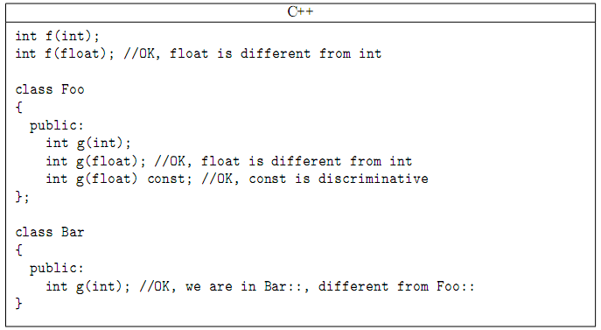
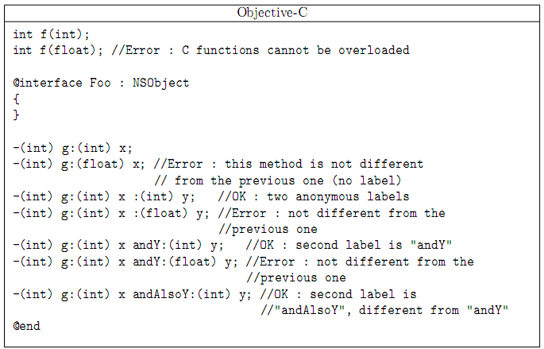
OC里标签可以匿名.

§ 5. Property Declarations 属性声明
- 自动生成set get函数(两步)
As of Objective-C 2.0, you can have your setter and getter methods automatically generated for you. It’s a nice convenience provided in the language.

The first step is to use @property directive in interface section to identify properties. Then simply by using @synthesize directive in the implementation section. The Objective-C compiler will automatically generate these methods for you.

Property General Format:

@property type name; 头文件
告诉编译器:这些实例变量需要生成set get函数.

Synthesize General Format:

@synthesize property_1;//, property_2, ...;//源文件
@synthesize property_2；
//
This specifies that methods should be synthesized for the listed properties property_1, property_2, ….

- 调用get函数的两种方式
- Usage Format 1:
receiver.property 对象名 . 实例变量;

This calls the getter method (by default property) for receiver, unless this expression is used as an lvalue (see Format 2). The getter method name can be changed with an @property directive, in which case that will be the method that gets called. If the default getter method name is used, then the previous expression is equivalent to the following:
[receiver property]; [对象名 实例变量名];

- 调用set函数的两种方式

- Usage Format 2:
receiver.property = expression
对象名 . 实例变量名 = 表达式;
This calls the setter method associated with the property property, passing as its argument the value of expression. By default, the setter method setProperty: gets called, unless another setter method name was assigned to the property using a prior @property directive. If the default setter property name is used, the previous expression is equivalent to writing the following:
[receiver setProperty: expression];
set后跟的实例变量的首字母,默认要用大写.

Example Codes
/*****Circle.h*****/
@interface Circle:NSObject
{
int radius;
int x;
int y;
}
编译器自动生成的set get方法,默认支持多线程.
nonatomic:该方法不需要多线程保护.节省开销.
@property (nonatomic)int radius,x;
@property (nonatomic)int y;
@end

/*****Circle.m*****/
#import "Circle.h"
@implementation Circle
@synthesize radius,x,y;
@end

/*****main.m*****/
#import <Foundation/foundation.h>
#import "Circle.h"

int main()
{
NSAutoreleasePool * pool = [[NSAutoreleasePool alloc] init];

Circle *c = [[Circle alloc] init];
c.radius = 3;
c.x = 4;
c.y = 5;

NSLog(@"Radius:%d X:%d Y:%d",c.radius,c.x,c.y);
int _radius = c.radius;//[c radius]
int _x = c.x;
int _y = c.y;
NSLog(@"Radius:%d X:%d Y:%d",_radius,_x,_y);

//增加下列四行代码
[c setRadius:6];
[c setX:7];
[c setY:8];
NSLog(@"radius:%d, x:%d, y:%d",[c radius],[c x],[c y]);

[c release];//释放对象内存. 把该对象的引用计数器减1.
[pool drain];
return 0;
}

Property Format can:
@property (attributes) type name;

If they are not given, the attributes have a default value; otherwise, they can be redeﬁned. They can be:

- readwrite (default) or readonly(只读,只有get方法) to tell if the property should have both getter/setter or only the getter;
- assign (default), retain or copy, to tell how the value is stored internally;

assing: 直接赋值。适用于基本数据类型的实例变量

retain：赋值 + retain（两个指针指向一个对象，使用引用计数器）。节省内存。

copy: 开辟新空间，生成新对象，两个指针指向不同的对象。

- nonatomic to prevent thread-safety guards to be generated. They are generated by default. (There is no atomic keyword);
非原子化操作

- getter=..., setter=... to change the default name of the accessors.
指定get 和set方法的名字.

Example：
@interface MyClass : NSObject {
MyObject * _myObject;
}
@property (nonatomic, retain) MyObject *myObject;
@end

get方法是:
-(MyObject*)myObject{
return _myObject;
}
Set方法是:
// assign
-(void)setMyObject:(id)newValue{
_myObject = newValue;
}
// retain
-(void)setMyObject:(id)newValue{
if (_myObject != newValue) {
[_myObject release];
_myObject = [newValue retain];
}
}
// copy
-(void)setMyObject:(id)newValue{
if (_myObject != newValue) {
[_myObject release];
_myObject = [newValue copy];
}
}

Inside the setter, the behaviours assign, retain or copy are affecting the way the data member is modiﬁed.
For example, in a -(void) setFoo:(Foo*)value method, the three ways are:

简单的整数类型。。赋值
foo = value ;

指针指向同一块空间
foo = [value retain];

开辟另外一块地址
foo = [value copy];

Example Codes : attributes getter setter

/*****Circle.h*****/

#import <Foundation/Foundation.h>

@interface Circle : NSObject {
int radius;
int x;
int y;
}

@property(nonatomic, getter=gr, setter=sr:) int x;
-(void) print;

@end

/*****Circle.m*****/
#import "Circle.h"
@implementation Circle
@synthesize x;
@end

/*****main.m*****/
#import <Foundation/Foundation.h>
#import "Circle.h"

int main (int argc, const char * argv[])
{
Circle * c =[[Circle alloc] init];

int i = c.gr;
int j = [c gr];//使用指定名字的get方法
int k = c.x;
NSLog(@"%d %d %d",i,j,k);

// c.sr = 9; error
[c sr:9];
[c print];
c.x = 8;
[c print];

return 0;
}

成员变量的名字替换
The notation property = instance_var can be used in the list to specify that property will be associated with the instance variable instance_var. The synthesized methods will have characteristics based on attributes declared for the property through a prior @property directive.

Example Codes :

/*****Circle.h*****/
@interface Circle:NSObject
{
int radius;
int x;
int y;
}
@property int _radius;
@end

/*****Circle.m*****/
#import “Circle.h”
@implementation Circle
@synthesize _radius=radius;
@end

/*****main.m*****/
#import <Foundation/foundation.h>
#import “Circle.h”

int main()
{
NSAutoreleasePool * pool = [[NSAutoreleasePool alloc] init];

Circle * c = [[Circle alloc] init];
c._radius = 3;
c.radius = 3;//error
NSLog(@“Radius:%d”,c._radius);

int _radius = c._radius;

NSLog(@“Radius:%d ”,_radius);

[c release];
[pool drain];
return 0;
}

§ 6. Composition 组合、复合（has a）
A circle has a center. You could store(存储) the x, y coordinate(坐标) of the center’s as two separate(单独的) values. Or you might realize(意识到) that, in the development of your graphics application, you’ll have to deal with a lot of coordinates and, therefore, decide to define(定义) a class called XYPoint.

#import <Foundation/Foundation.h>

@interface XYPoint: NSObject
{
int x;
int y;
}

@property int x, y;
-(void) setX: (int) xVal andY: (int) yVal;
@end

//XYPoint.m
#import “XYPoint.h”

@implementation XYPoint
@synthesize x, y;

-(void) setX: (int) xVal andY: (int) yVal
{
x = xVal;
y = yVal;
}
@end

//Circle.h
#import <Foundation/Foundation.h>
#import “XYPoint.h”

@class XYPoint; //前向声明（提高程序运行的效率）

@interface Circle: NSObject
{
int radius;
XYPoint *origin; //定义类XYPoint的对象，作为类Circle的实例变量
}

@property int radius;
//@property(nonatomic ,retain) XYPoint *origin;
-(XYPoint *) origin; //get方法，返回类类型的实例变量origin
-(void) setOrigin: (XYPoint *) pt;
//自己实现类类型实例变量的get和set函数,不用@property指令

-(int) area; //计算面积方法
-(int) perimeter; //计算周长方法
@end

// Rectangle.m
#import “Circle.h”
@implementation Circle
@synthesize radius;

-(void) setOrigin: (XYPoint *) pt //function name must be this
{
origin = pt; //形参pt为实例对象origin赋值
}

-(XYPoint *) origin//to use .origin, this func must provide
{
return origin;//返回实例变量
}

-(int) area
{
return radius*radius*3.14;
}
-(int) perimeter
{
return radius*3.14*2;
}
@end

It seems reasonable to add a method to set the rectangle’s(矩形的) Circle’s origin(源) and to retrieve(检索) it. To illustrate(说明) an important point, we’re won’t synthesize(综合) the accessor(访问) methods for the origin now. Instead(相反), we’ll write them ourselves.

First, let’s take a complete look at your Circle.h interface file: we used a new directive(指令) in the Rectangle.h header file: @class XYPoint; You needed this because the compiler needs to know what an XYPoint is when it encounters it as one of the instance variables defined for a Rectangle Circle .
You do have another choice. You can import the header file instead, like so: #import “XYPoint.h”
前向声明比头文件包含，执行效率高。
如果需要在Circle类，访问XYPoint的方法，则还要包含头文件。
Using the @class directive is more efficient(高效) because the compiler(编译器) doesn’t need to process the entire(整个) XYPoint.h file (even though it is quite small); it just needs to know that XYPoint is the name of a class (它只需要知道 XYPoint 是一类的名称。).If you need to reference one of the XYPoint classes methods, the @class directive(指令) does not suffice(够) because the compiler would need more information; it would need to know how many arguments(参数) the method takes, what their types(类型) are, and what the method’s return type is(方法的返回类型).

// Test Program
#import “Circles.h”
#import “XYPoint.h”
int main (int argc, char *argv[])
{
NSAutoreleasePool * pool = [[NSAutoreleasePool alloc] init];
Circle *myCircle = [[Circle alloc] init];
XYPoint *myPoint = [[XYPoint alloc] init];
myCircle.radius = 5;
[myPoint setX: 100 andY: 200]; //(100,200)

myCircle.origin = myPoint;
//[myCircle setOrigin:myPoint];
NSLog(@”Circle radius = %i”,myCircle.radius);

NSLog (@”Origin at (%i, %i)”,
myCircle.origin.x, myCircle.origin.y);
//函数链，调用了两次get函数。
Q：能否用传消息的方式实现？（可以）
[[myCircle origin]x],[[myCircle origin]y]

[myCircle release];
[myPoint release];

[pool drain];
return 0;
}

Output
Rectangle w = 5, h = 8
Circle radius = 5;
Origin at (100, 200)
Area = 78, Perimeter = 31

Inside the main routine(在主程序中), you allocated and initialized a circle identified as myCircle and a point called myPoint. Using the setX:andY: method, you set myPoint to (100, 200). After setting the radius of the radius to 5, respectively, you invoked(调用) the setOrigin method to set the Circle’s origin to the point indicated by myPoint. The expression myCircle.origin.x takes the XYPoint object returned by the accessor method origin method and applies the dot operator to get the x-coordinate of the rectangle’s origin. In a similar manner, the following expression retrieves the y-coordinate of the circle’s origin: myCircle.origin.y.

Explain the output ? (解释输出结果)

#import “Rectangle.h”
#import “Circle.h”
#import “XYPoint.h”

int main (int argc, char *argv[])
{
NSAutoreleasePool * pool =
[[NSAutoreleasePool alloc] init];

Circle *myCircle = [[Circle alloc] init];
XYPoint *myPoint = [[XYPoint alloc] init];

[myPoint setX: 100 andY: 200];
[myCircle setRadius: 5];
//myCircle.origin = myPoint;
[myCircle setOrigin:myPoint];
NSLog (@”Origin at (%i, %i)”,
myCircle.origin.x, myCircle.origin.y);

[myPoint setX: 50 andY: 50];
NSLog (@”Origin at (%i, %i)”,
myCircle.origin.x, myCircle.origin.y);
为什么我设置myPoint的值，而myCircle下得origin的x和y会随着发生改变呢？因为在上面写的是origin = p;两个对象指向的是同一块空间。

[myCircle release]; //再释放实例变量所属的对象。
[myPoint release];

[pool drain];
return 0;
}

Output
Origin at (100, 200)
Origin at (50, 50)

You changed myPoint from (100, 200) in the program to (50, 50), and apparently it also changed the rectangle’s origin! But why did that happen? You didn’t explicitly (显示)reset(重置) the circle’s origin, so why did the circle’s origin change? If you go back to the definition of your setOrigin: method, perhaps you’ll see why:
-(void) setOrigin: (XYPoint *) pt
{
origin = pt;//两个指针指向一个对象
}
When the setOrigin: method is invoked(被调用) with the expression myCircle.origin = myPoint; the value of myPoint is passed as the argument to the method. This value points to where myPoint is stored in memory (此值指向 myPoint 存储在内存中的位置。) .That value stored(被存储) inside myPoint, which is a pointer into memory, is copied into the local variable pt as defined inside the method(这是指向内存的指针，在方法内定义复制到本地变量 pt中。). Now both pt and myPoint reference the same data stored in memory.(现在 pt 和 myPoint 引用内存中相同的数据。)

Because myPoint and the origin variable stored in myCircle reference the same area in memory (as does the local variable pt), when you subsequently change the value of myPoint to (50, 50), the Circle’s origin is changed as well.
(因为 myPoint 和存储在 myCircle 中的起源变量引用内存中的相同区域 （像一样本地变量 pt），随后改变了 myPoint 的值为（50，50），同时圆的起源也改变了。)

You can avoid(避免) this problem by modifying(修改) the setOrigin: method so that it allocates its own point and sets the origin to that point(分配自己的点并将原点设置为该点). This is shown here:
-(void) setOrigin: (XYPoint *) pt
{
origin = [[XYPoint alloc] init]; //开辟新空间

[origin setX: pt.x andY: pt.y]; //把参数的x和y的值，赋给 新对象origin的x和y
}
The method first allocates and initializes a new XYPoint. The message expression [origin setX: pt.x andY: pt.y]; sets the newly allocated XYPoint to the x, y coordinate of the argument to the method.
(该方法首先分配和初始化新的 XYPoint对象。消息表达[origin setX: pt.x andY: pt.y]；将新分配的 XYPoint 设置为 x、 y 坐标值的方法的参数。)

The change to the setOrigin: method means that each Circle instance(实例) now owns its origin XYPoint instance. Even though it is now responsible for allocating the memory for that XYPoint, it should also now become responsible for releasing that memory. In general(一般情况下), when a class contains(包含) other objects, at times you will want to have it own some or all of those objects. In the case of a circle, it makes sense for the Circle class to own its origin because that is a basic attribute of a circle.
(setOrigin：方法的改变意味着每个Circle实例现在拥有自己的 XYPoint 实例。既然现在它负责为XYPoint 分配内存，所以还应负责释放该内存。
---------------------------------------------------

But how do you release the memory used by your origin? Releasing the circle’s memory does not also release the memory you allocated for the origin. One way to release the memory is to insert a line such as the following into main:
(但是，你如何释放origin所占用的内存？释放圆的内存并不同时释放你为原点分配的内存。释放内存的一种方法是将类似如下的行插入到主函数：)

[[myCircle origin] release];

This releases the XYPoint object that the origin method returns. You must do this before you release the memory for the Circle object itself because none of the variables contained in an object is valid after an object’s memory is released. So the correct code sequence would be as follows:
(这将释放由原点方法返回的 XYPoint 对象。但必须在释放圆对象本身的内存之前释放XYPoint对象，因为在对象释放内存后它包含的所有实例都是无效的。因此，正确的代码序列将如下所示：)

[[myCircle origin] release];
[myCircle release];

It’s a bit of a burden to have to remember to release the origin’s memory yourself. After all, you weren’t the one who allocated it; the Circle class did. In the next section, you learn how to have the Circle release the memory.
(要记住去释放origin’s内存是有点负担的。毕竟，不是你为原点分配的内存，而是由Circle 类分配的。在下一节“重载方法”中，您将了解如何释放Circle的内存。)

With your modified method, recompiling and rerunning the program produces the error messages. Oops! The problem here is that you’ve used some methods from the XYPoint class in your modified method, so now the compiler needs more information about it than the @class directive provides. In this case, you must go back and replace that directive with an import instead, like so:
(你修改方法后，重新编译和重新运行该程序生成的错误消息。糟糕，这么多问题 ！这里的问题是由于在修改后的方法中使用了 XYPoint 类的一些方法，所以现在编译器需要的信息多于 @class指令能提供的。在此情况下，你必须返回并用import导入该指令，像这样：)
#import “XYPoint.h”
输出结果：
Origin at (100, 200)
Origin at (100, 200)

That’s better. This time, changing the value of myPoint to (50, 50) inside main had no effect on the circle’s origin because a copy of the point was created inside the Circle’s setOrigin: method.
(这样就好多了。这次在main中将myPoint的值更改为(50,50)对圆形的原点没有影响，因为在圆的 setOrigin:方法中创建了该点的副本。)

Incidentally(顺便说一下), we didn’t synthesize(合成) the origin methods here because the synthesized(被合成的) setter setOrigin: method would have behaved(表现的) just like the one you originally(原来的) wrote. That is, by default, the action of a synthesized setter is to simply copy the object pointer, not the object itself.
(默认情况下，被合成的setter方法只是简单地复制对象指针，而不是对象本身。)
系统默认实现的set方法，是浅拷贝。

One issue remains: If you set the origin of a single Circle object to different values during the execution of your program, you must release the memory taken up by the old origin before you allocate and assign the new one.
（仍然有一个问题：如果在程序在执行期间将单个Circle对象的原点设置为不同的值，那么在分配和指定新的原点之前你必须释放旧原点所占的内存。）
For example, consider the following code sequence:
(例如：请考虑下面的代码序列：)

myCircle.origin = startPoint;
myCircle.origin = endPoint;
[startPoint release];
[endPoint release];
[myCircle release];

The copy of the XYPoint startPoint stored(存储) in the origin member of myCircle will not be released because it is overwritten(被重写了) by the second origin (endPoint) that is stored there. That origin is released properly(正确地) when the Circle itself is released, based on your new release method. You would have to ensure that, before you set a new origin in your circle, the old one was released.
(必须确保你在你的圆中设置新的原点之前，旧对象被释放。)
You could handle this in the setOrigin: method, as follows:
//类类型实例变量的set函数可以如下进行处理,分三步。（和赋值运算符重载的2、3、4步一样）
-(void) setOrigin: (XYPoint *) pt
{
if (origin) //释放旧对象
[origin release];
origin = [[XYPoint alloc] init]; //开辟新空间
[origin setX: pt.x andY: pt.y];
}

Chapter 3 Memory Management内存管理

OC里也有垃圾回收机制，但只限于mac机，在移动设备iPhone ipad无效。需要程序员手工管理。
Objective-C 2.0 has a garbage collector, but it’s not available on the iPhone. So if you’re writing iPhone applications, you’ll need to manage your own memory. And it’s especially important on the iPhone, where resources are constrained, that you clean up after yourself.
(Objective-C 2.0 中有垃圾回收器mac上，但在 iPhone 上不可。)现在的版本是用arc的，和自己释放是大同小异的。
We emphasize the importance of paying attention to memory management, to teach good programming practice and to develop leak-free programs.
(我们强调要重视内存管理的重要性。养成较好的编程习惯和开发无泄漏的程序)
Depending on the type of application you’re writing, judicious use of memory can be critical. It’s your responsibility to intelligently manage resources and free them when they’re no longer needed. This means freeing resources during the program’s execution instead of just waiting until the end.
(明智地使用内存可能非常重要, 主要取决于你在写的应用程序的类型。它是你的责任智能地管理资源，同时在不再需要时释放它们。这意味着该程序的执行，而不是只等待直到结束的过程中释放资源。)
The C++ keywords new and delete(运算符) do not exist in Objective-C (new exists as a method, but it is just a deprecated shortcut for alloc+init). They are respectively replaced by calls to alloc and release.
C++中是new一块空间，在进行构造函数
OC中是先alloc（开辟空间，并且成员变量值为0），再init（初始化）
最后还要把alloc的空间进行release

§ 1. The Autorelease Pool 自动释放池
自动释放池，是一个对象的容器。
如果一个对象被添加到自动释放池，当自动释放池本身被释放时，其中的所有对象也将被释放。

Each time an object receives autorelease, it is only registered into an “autorelease pool”. When the pool is destroyed, the object receives a real release.
(每当一个对象接收 autorelease，每次只注册到"autorelease 池"。当池被释放时，对象会收到一个真正的释放。)
There is not a single answer: if you use Cocoa for an application with a graphical interface, most of the time there is nothing to do. Otherwise, you would have to create and destroy the pool yourself.

对象调用autorelease方法后，对象的引用被加入自动释放池。
自动释放池本身被释放，即发送drain消息来释放它使用的内存。
自动释放池将向池中所有对象发送release消息，使其引用计数器减1。

autorelease：延缓释放。

NSAutoreleasePool* pool = [[NSAutoreleasePool alloc]init];
...
[pool drain]; 池释放所有的对象.

An application with a graphical interface generally uses an event loop. Such a loop waits for actions from the user, then wakes up the program to perform the action, then goes back to sleep until the next event. When you create a graphical application with Cocoa, an autorelease pool is automatically created at the beginning of the loop and destroyed at the end.
(具有图形界面的应用程序通常使用事件循环。这种循环等待用户，执行操作再醒来的程序执行的操作，然后追溯睡眠状态，直到下一个事件。cocoa与创建一个图形应用程序时，autorelease 池自动创建循环的开始和结束时被销毁。)
Temporary objects are created, then destroyed, since they do not have to be kept for the next event. If some of them must be persistent, the developer must use retain as necessary.
On the other hand, when there is no graphical interface, you have to create an autorelease pool around the code that needs it. When an object receives autorelease, it knows how to find the closest autorelease pool. Then, when it is time to empty the pool, you can just destroy it with a simple release. Typically, a command-line Cocoa program contains the following code:
(另一方面，没有图形界面时，你要创建一个 autorelease 池。当一个对象接收 autorelease 时，它知道如何查找最接近的 autorelease 池。然后，当空池的时候，你可以只是释放它提供一个简单的release。通常情况下，命令行的Cocoa程序包含以下代码：)
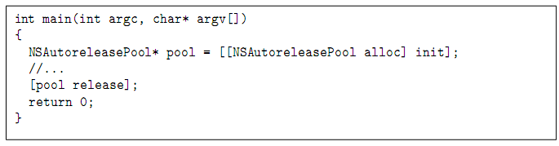

To simplify, let us say that sending autorelease to an object means that it is sent a release that will be performed “later”. But “later” does not mean “at any time”.
(为了简化，让我们说该发送的 autorelease 对象它是指发送将"稍后"执行的释放。但是"后来"并不意味着"在任何时间"。)看下面的代码

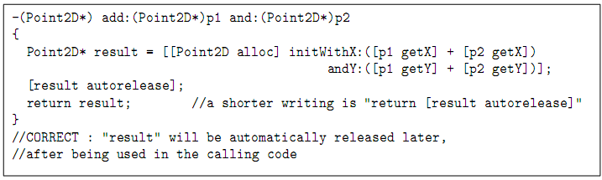

There some notes about autolease:
- First, sending more autorelease calls than necessary is similar to sending too many release calls: it triggers a memory fault when emptying the pool;
- Then, even if it is true that any release message can be replaced by autorelease, this would be a performance hit, since the autorelease pool is more work than a normal release.
- Moreover, delaying all deallocations can lead to useless and irrelevant peaks of memory consumption.
When calling a convenience constructor, you are not explicitly calling alloc, so you are not in charge of the release. However, when creating such a constructor, you are writing alloc, and you must not forget the autorelease.
(在调用时方便的构造函数时，您不显式呼叫alloc，所以你不需要去释放。但是，当创建此类的构造函数，您正在用到alloc，此时你不应该忘记 autorelease。)
The autorelease pool provides for the automatic release of objects when the pool itself is released. The system does this by sending a release message to each object in the pool for each time it was autoreleased. Each object in the autorelease pool whose reference count goes down to 0 is sent a dealloc message to destroy the object
(autorelease pool本身释放时提供自动释放的对象。系统会通过对每一次它被 autoreleased 在池中的每个对象发送一条release消息 。每个对象的引用计数变为0 ,autorelease pool中就会发送 dealloc 消息，销毁该对象)后面会讲dealloc
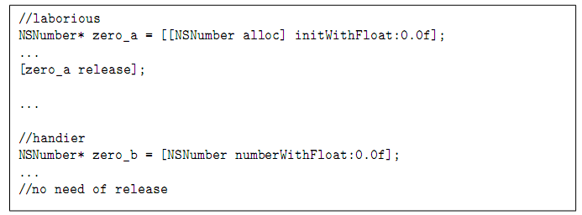
当一个对象调用的是类方法的时候，就自动调了自动释放池，不必做多的，记住类方法返回的对象都是调用了autorrelease
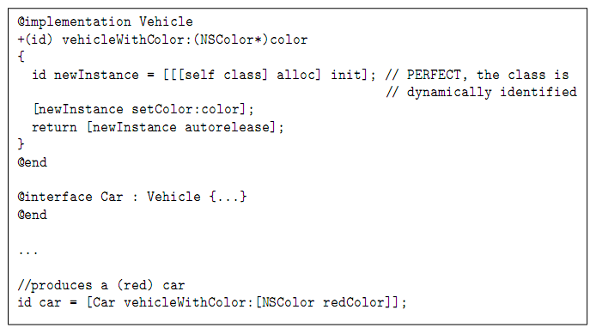
上面的slef，它要看是基类还是派生类来调用的，基类调用self就是基类，派生类self就是派生类

§ 2. Reference Counting 引用计数
When we talked about the basic Objective-C object class NSObject, we noted that memory is allocated with the alloc method and can subsequently be released with release message.
当我们谈到基本的Objective-C对象类NSObject时，注意到可以使用alloc方法进行内存分配，并且随后可以使用release消息来释放分配的内存。
Unfortunately, it’s not always that simple. A running application can reference an object that you create in several places; an object also can be stored in an array or referenced by an instance variable someplace else, for example. You can’t free up the memory an object uses until you are certain that everyone is done using that object.
遗憾地是，事情并不总是这么简单，例如：正在运行地应用程序可以在多个位置引用你所创建的对象；该对象可能存储在数组中，也可能被其他的实例变量引用。只有在确定使用该对象的每个人都使用完之后，才能释放它所占有的内存。
一个对象,可能在程序中多个地方被引用:
对象可能存储在数组里，或者被其它实例变量引用.
【Q:该对象由谁、在何时被释放？】
必须确保每一个引用该对象的使用者,都不再使用该对象,才可以释放对象的内存.

Memory management in Objective-C is one of the most important parts of the language. In C or C++, a memory area is allocated once and freed once. It can be referenced with as many pointers as desired, but only one pointer will be given the delete call.
（C++里:也有多个指针指向一个对象的情况,但是只有一个指针能调用delete函数来析构该对象.）

On the other hand, Objective-C implements a reference counting scheme. An object knows how many times it is referenced.
Objective-C里:引用计数器(reference counter),记录该对象被引用的次数.

More technically, the reference counter of a newly created object is set to 1. If a part of the code needs to reference that object, it can send it a retain message, which will increase the counter by one. When a part of the code does not need the object any more, it can send it a release message, which will decrease the counter by 1.
创建对象时,引用计数器为1; Cirlce * c = [[Circle alloc]init];
对象调用retain方法,引用计数器加1; [c retain]; 1+1=2
对象调用release方法,引用计数器减1; [c release]; 2-1 = 1

Some of the methods in the Foundation framework also increment or decrement reference count, such as when an object is added to or removed from an array.
Foundation框架提供的其他的一些方法可以增加或减少对象的引用次数，例如把对象添加到数组或把对象从数组中移除。

AClass* anObject = [[AClass alloc] init];
// reference count = 1 after alloc
[anObject retain]; // reference count += 1 after retain //2
[anObject release]; // reference count -= 1 after release //1
[anObject release]; // reference count == 0 then dealloc //0
当reference count为0的时候，对象就会被自动的释放掉
Indeed, these are the three ways to increment the reference counter. It also means that you should take care of releasing an object in only a limited number of cases:
事实上，这些都是递增引用计数器的三种方式。这也意味着，你release 一个对象应该注意以下几种限制

有三个方法将使得引用计数器的值加1: alloc copy retain

- when you explicitly instantiate an object with alloc;
(当你确实要实例化一个对象用alloc)
- when you explicitly clone the object with copy[WithZone:] or mutableCopy[WithZone:] (whatever the copy is a real or a pseudo-clone);
(当你确实要复制一个对象时，用copy[WithZone:]或者mutableCopy[WithZone:])新对象的引用计数器+1

- when you explicitly use retain.

当引用计数器的值减至0时,即该对象没用了。
系统将自动调用dealloc方法销毁对象.

[Q:如何验证?]

不要自己调用dealloc方法. //析构函数

An object can receive as many retain and release messages as needed, as long as the reference counter has a positive value. As soon as it falls to 0, the destructor dealloc is automatically called.
(一个对象可以受到多个retain和release的消息，引用计数器的值可能会变化。而一当引用计数器的值变为0，析构函数dealloc会被自动调用)

如果向一个引用计数器为0的对象发送消息,程序将崩溃.

Sending release again to the address of the object, which is now invalid, triggers a memory fault.
（向这个对象的地址再次发送release消息，现在是无效的，触发内存故障。）
retainCount方法,返回对象的引用计数器的当前值.

The retainCount message can be sent to an object to obtain its reference count. You will normally never need to use this method, but it’s useful to understand how reference count changes when alloc, retain and release.
(给一个对象发送retainCount消息能够获取该对象的retainCount值。通常你很少去使用这个方法，但是它有助于理解当一个对象alloc retain 和release时，引用计数器是如何变化的。)

之前接触了autorelease（事件结束释放）现在看看release（马上释放）？
所以写代码的时候有这个非常好的习惯，尽量都用release，不要用autorelease。对内存的使用是用完之后，马上释放内存。手机对这个要求还是比较高的。这不代表着不能用哈。

§ 3. Allocation, Initialization and Destruction
分配内存，初始化和析构
alloc init dealloc

alloc and init

In C++, allocation and initialization of an object are mixed when calling the constructor. In Objective-C, they are two different methods. Allocation is handled by the class method alloc, which also initializes all instance data. Instance data are set to 0, except the isa (is-a) pointer of NSObject, which value describes the exact type of the newly created object at run-time.
在C + +，分配内存和初始化一个对象调用构造函数时是同时完成的（或者说是在一起的）。在Objective - C，它们是两个不同的方法。分配内存的是alloc，也就是初始化所有的实例数据（数据成员）。实例数据设置为0。

alloc: 类方法，作用：分配内存。
原型：+ (id)alloc
为对象开辟内存空间，返回所创建对象的指针，并将所有实例变量置为0.

id: 一种数据类型,可以指向任何类型的对象。

Should instance data be set to a particular value, depending on the parameters of construction, then the corresponding code is deported inside an instance method. Its name usually begins with init. Therefore, the construction is clearly divided into two steps: allocation and initialization.
初始化数据为特定的值，它取决于构造函数的参数，那么相应的代码是放在一个实例方法内。它的名字通常开始使用init。因此，构造显然是分为两个步骤：分配和初始化。

init…：实例方法，初始化。//构造函数
原型：-(id)init
作用：将alloc所创建的对象的实例变量，初始化为指定的值，。

new Circle;
[[Circle alloc] init];

The alloc message is sent to the class, and the init... message is sent to the object newly instantiated by alloc. The initialization step is not optional, and alloc should always be followed by init; with successive calls to superclass initializers, this must end in calling the init method of NSObject, which performs important work.
Alloc消息被发送到类，init 消息被发送到新的被alloc出来实例化了的对象。初始化步骤不是可选的，alloc后面始终跟着init ;连续调用父类的初始化，在alloc结束时调用NSObject的init方法。
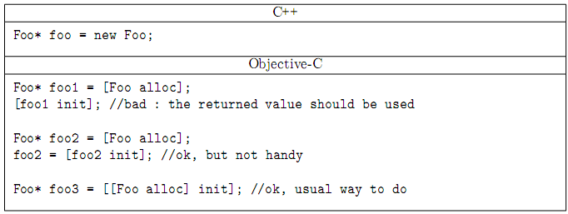
In Objective-C, the initializer is a method like any other, and the init preﬁx is traditional but not mandatory(强制性的). However, you are strongly encouraged to follow a rule: the name of an initialization method must begin with“init”.
在Objective - C，初始化一个方法强烈建议您遵循一个规律：一个初始化方法的名称必须以“init“打头。
The constraints for a correct initializer are:
对于正确的初始值设定项约束：

上面是系统的init，看下面自己写的init
- its name begins with init; 函数名字必须以init打头
- it returns the object to use; 函数返回一个对象来使用
返回初始化的对象的指针
（C++构造函数没有返回值）
- it calls some init method of the superclass, so that init of NSObject will ﬁnally be called
函数调用父类的init方法，因此NSObject的init方法最后将被调用
- it takes account the value returned by [super init...];
函数要检查父类init的返回值，看基类的是否成功
- it handles correctly the construction errors, whether they are voluntary or inherited.
函数要正确的处理构造的错误，无论是自己的还是继承的，都要考虑［super init］的返回值

self & super

There are two particular targets for a message: self and super. self is the current object (like this in C++), super is the parent class. The keyword this does not exist in Objective-C. It is replaced by self.
对于一个消息来讲有两个特殊的标示：self和super。self是当前的对象（像c++中的this），super是指父类。在Object-C中没有this，用self来代替它。
Super基类
self is not a real keyword, it is a hidden parameter that each method receives, the value of which is the current object. Its value can be changed, unlike C++’s this keyword. However, this is only useful in constructors.
看怎样写一个init的方法
-(id)initWithX:(int)_x andY:(int)_y;
-(id)initWithX:(int)_x andY:(int)_y
{
if(self=[super init])先初始化基类，不成功就是返回的一个0，成功就是对象的初始化地址
{
x = _x;
y = _y;
}
return self;
}
Circle* clrcle = [[Circle alloc]initWithX:8 andY:10];

Handle Initialization Errors 处理初始化错误

When constructing an object (initializing it fact), an error may happen, or being triggered, in three different places:
当构造一个对象（实例化它）时，可能有一个错误会发生，或者被触发，在以下三个地方：

- #1: before the call(调用) to [super init...]:
if the construction parameters are considered invalid, the initialization must be stopped as soon as possible
如果构造函数的参数被认定是无效的，一旦有这种情况发生，初始化必须停止。

- #2: with the call to [super init...]:
if the super-class fails, we should abort the current one;
如果父类的init方法失败，我们应当放弃当前的初始化操作

- #3: after the call to [super init...]:
if an additional resource allocation fails, for instance.
如果（在当前的构造函数里）如果额外资源分配失败

In every case, nil must be returned, and deallocating the current object must be done by the one who triggered the error. Here, we are responsible of cases 1 and 3, but not of case 2. To deallocate the current object, one just have to call [self release].
例如。在每一种（出错）情况，必须要返回nil。我们要负责第一种情况和第三种情况，但是不包括第二种情况。要dealloc 当前的对象，必须要调用【self release】。

总结：
- 初始化方法发生错误的三种情况：
#1 调用[super init…]之前：
init方法的参数无效
#2 调用[super init…]之时：
父类的init方法出错，即[super init]返回空指针。
#3 调用[super init…]之后：
当前对象申请资源失败（如内存不足）

- 初始化方法发生错误的应对措施：
(a). 释放当前对象的内存
[self release];
(b). init函数返回空指针
return nil;

Here is a sample of handling initialization errors:
（这里是处理初始化错误的示例：）

-(id) initWithN:(unsigned int) value {
//case #1 对形参判断（不是必须的）
if( value <= 0 ) {
[self release];
return nil;
}

//case #2 对基类成员初始化
if( !(self = [super init] ) )
//(self = [super init]) == nil
return nil;

Q：为什么#2不需要[self release];？没有dealloc当前的对象

//case #3 对自己特有的数据成员初始化
//void* p = malloc(value);
NSObject * p = [[NSObject alloc] init];开辟一块空间出了问题
if( !p ) {
[self release];
return nil;
}
return self;
}

Note: You must assign the result back to self because an initializer has the right to change or move the object in memory.
注意：你必须分配要返回的结果给self。

nil 空指针

The nil is the equivalent of NULL for a pointer to an object. But nil and NULL should not be interchangeable（通用）. A normal C pointer can be set to NULL, but nil was introduced in Objective-C for pointers to objects.
nil是相当于对一个指向对象的指针为NULL。但nil和NULL不应该互换。一个普通的C指针可以设置为NULL，但nil说明是Objective - C中指向一个对象的指针（空对象指针）。
NULL和nil的区别：
C++：用NULL（空指针）调用函数，是非法的，程序将崩溃。
Objective-C：向nil空指针发送消息是合法的，该消息将被忽略。

If receiver is a null object pointer—that is, nil—it can be sent messages. If the method associated with the message returns an object, the value of the message expression is nil. If the method does not return an object, the value of the expression is not defined. By default, it is legal to send a message (call a method) to nil. The message is just ignored. The code can be greatly simpliﬁed by reducing the number of tests usually made with the null pointer.

Example Codes
/****** MyPoint.h ******/

#import <Foundation/Foundation.h>

@interface MyPoint : NSObject {
int x;
int y;
}
@property (nonatomic) int x,y;
-(void) setMyPoint:(int)_x andY:(int)_y;

@end

/****** MyPoint.m ******/

#import "MyPoint.h"

@implementation MyPoint
@synthesize x,y;
-(void) setMyPoint:(int)_x andY:(int)_y{
x = _x;
y = _y;
}
@end

/****** Circle.h ******/

#import <Foundation/Foundation.h>
#import "MyPoint.h"

@interface Circle : NSObject{
MyPoint * p;
int radius;

}
@property (nonatomic,retain) MyPoint *p;
-(id) initP:(MyPoint *)_p andRad:(int)_r;

@end

/****** Circle.m ******/

#import "Circle.h"

@implementation Circle
@synthesize p;

//初始化方法：用已有的MyPoint对象和半径，来初始化一个Circle对象。
-(id) initP:(MyPoint *)_p andRad:(int)_r
{
//初始化第一步
if(_r<0)
{
radius = 1;
}

if(_p == nil)//#1
{
[self release];
return nil;
}

//初始化第二步
if(!(self = [super init]))//#2
return nil;

//初始化第三步
第二个方法看这个方法就先看下面红色字
// [_p retain];
// p = _p;
第一个方法
if(p)
[p release];
p =[[MyPoint alloc] init];
[p setMyPoint:_p.x andY:_p.y];

radius = _r;

return self;
}

@end

/****** Classes.m ******/

#import <Foundation/Foundation.h>
//#import "MyPoint.h"
#import "Circle.h"

int main (int argc, constchar * argv[]) {

MyPoint *p = [[MyPoint alloc] init];
NSLog(@”%d”,[p retainCount]); //1

Circle *c =[[Circle alloc] init];
c.p = p;
NSLog(@”%d”,[p retainCount]); //2

Circle *c1 =[[Circle alloc] initP:p andRad:3];
NSLog(@”%d”,[p retainCount]); //2

[p release];
NSLog(@”%d”,[p retainCount]); //1

[c release];
NSLog(@”%d”,[p retainCount]); //1, 最终＝0
[c1 release];
//NSLog(@”%d”,[p retainCount]); //1

return 0;
}
让你们看看这个get set的内部实现的原理
@interface MyClass:NSObject
{
MyObject* myObject;
}
@property(nonatomic)MyObject* myObject;
get:
-(MyObject*)myObject
{
return myObject;
}
set
assign
-(void)setMyObject:(id)newValue
{
myObject = newValue;
}
retain
void)setMyObject:(id)newValue
{
if(myObject != newValue)
{
[myObject release];
myObject = [newValue retain];
}
}
copy
-(void)setMyObject:(id)newValue
{
myObject = newValue;
}
retain
void)setMyObject:(id)newValue
{
if(myObject != newValue)
{
[myObject release];
myObject = [newValue copy];
}
}这里为什么可以使用copy，他必须要准许NSCopy的协议，以后会详细介绍
C++构造函数和类型相同
OC的构造函数是init，系统有一个init我们也可以自己写一个init
C++析构函数~+类名
OC：
Dealloc 析构方法

当一个对象的引用计数器为0时，系统自动调用dealloc方法，销毁对象。而不是说当你一调用release或者autorelease就马上调用析构函数。
看Circle和MyPoint组合的那个代码，就是上面的那个代码
OC一个原则：谁使用，谁拥有，谁拥有谁retain，谁retain谁release

In C++, the destructor, like the constructor, is a specific method that can be redeﬁned. In Objective-C, it is an instance method named dealloc.
在C++中，析构函数，像构造函数一样，是一个特定的方法，可以重新定义。在Objective - C，它是一个实例方法函数名dealloc

In C++, the destructor is called automatically when an object is freed; it is the same with Objective-C; The destructor should never be called explicitly.
在C++里当一个对象被释放时会自动的调用它的析构函数，这一点与Objective – C是相同的;析构函数不应该被显示的调用。

let’s learn a better approach to releasing the memory occupied by the origin. The approach used before was to have main release that memory with a statement such as follows: [[myRect origin] release];
让我们学习一个更好的方法，以释放占用的内存。使用该方法主要释放内存的语句，如下：[[myRect origin] release];

The setOrigin: method allocates its own XYPoint origin object, and Circle are responsible for releasing its memory. So override dealloc.

覆盖dealloc方法

Note //注意
You don’t override the release method—you override dealloc instead. release sometimes gives up the memory an object used, and sometimes it doesn’t. It gives up the memory taken by an object only if no one else is referencing that object. And it does this by invoking the object’s dealloc method, the method that actually releases the memory.
如果一个对象的内存没有其它的对象来引用它，就会放弃这个对象的内存。通过调用对象的dealloc方法，实际上释放了这个内存。

when overriding dealloc, you also have to be sure to release the memory taken up not only by your own instance variables, but by any inherited ones as well. To do this, you need to take advantage of the special keyword super, which refers to the parent class of the message receiver. You can send a message to super to execute an overridden method. This is the most common use for this keyword. So the message expression [super release]; when used inside a method invokes the release method that is defined in (or inherited by) the parent class. The method is invoked on the receiver of the message—in other words, on self.
当重写的dealloc方法的时候，必须确保不仅要释放自己的实例变量所占用的内存，而且释放继承的变量所占用的内存。为此，你需要采取特殊的关键字super，它引用消息接受者的父类。你可以向super传递消息来执行重写的方法。这就是此关键字最常见的用途。因此，在方法内部使用消息表达式[super release] 时，调用定义在父类中的（或者是父类继承的）release方法，此方法是对消息的接受者调用的。换言之，是对self调用.

Therefore, the strategy for overriding the dealloc method for your Cirlce class is to first release the memory taken up by your origin and then invoke the dealloc method from the parent class to complete the job. This releases the memory taken up by the Circle object itself. Here is the new method:
因此，重写你的Cirlce类的dealloc方法的策略是首先释放origin的内存，然后调用从父类的dealloc方法来完成此工作。这样就释放Circle对象本身占用的内存。下面是这个新方法：

-(void) dealloc
{
if (origin) //XYPoint * 即 origin != nil
[origin release]; //引用计数值减1
[super dealloc]; //释放父类的实例变量
}

The dealloc method is defined to have no return. You know this by looking inside the header file <NSObject.h> where it is declared. Inside the dealloc method, a test is made to see if origin is nonzero before releasing it. The origin of the rectangle possibly was never set; in this case, it has its default value of zero. Then we invoke the dealloc method from the parent class, which is the same method the Circle class would have inherited if it had not been overridden.

You can also write the dealloc method more simply as :
(你也可以编写 dealloc 方法更简单如下：)
-(void) dealloc
{
[origin release]; //self.origin = nil;
[super dealloc];防止非法性的操作
}

because it’s okay to send a message to a nil object. Also, you’re careful to release origin and not dealloc it here. If no one else is using the origin, the release will end up invoking the dealloc method on the origin anyway to free up its space.
因为给一个nil的对象发送消息是合法的。你要注意的是release origin 并没有在这里dealloc。如果没有别的对象使用将会调用dealloc方法来释放origin的内存空间

With your new method, the two release messages will now suffice to release all the objects you allocated in the program.
(有了这个新方法，现在只需要释放分配了内存的对象，而无须担心其中包含的XYPoing对象。)

[myRect release];
[myPoint release];

两个释放消息现在就足以释放您分配程序中的所有对象，包括setOrigin所创建的XYPoing对象。

现在看看你刚上面的代码有什么问题没有。C和c1的p？看文件夹中内存管理的代码，有一个copy
一般把一个对象释放之后还要把对象指向nil。

Chapter 4 Inheritance 继承

§ 1. It All Begins at the Root 所有类都开始于基类
A class can have a parent, a parent class can itself have a parent. The class that has no parent is at the top of the hierarchy and is known as a root class. In Objective-C, you have the capability to define your own root class, but it’s something you normally won’t want to do. Instead, you’ll want to take advantage of existing classes. All the classes we’ve defined up to this point are descendants of the root class called NSObject, which you specified in your interface file like this:
一个类可以有一个父类，父类本身也可以有一个父类。没有父类的类位于类层次结构的顶层，称为根（root）类。在Objective – C中，允许定义自己的根类，但是通常不会这样自己来写。相反，你会希望利用现有的类。至此我们所定义的类都属于名为NSObject 的根类的派生类。这个类通常如下在接口文件(.h)中声明：
NSObject
根类
@interface Fraction: NSObject
Fraction继承至NSObject
Fraction
子类
@end

From a terminology(术语) point of view, we can speak of classes, child classes, and parent classes. Analogously(类似的), we can talk about classes, subclasses, and superclasses. You should become familiar with both types of terminology.
从一个术语的角度来讲，我们可以将类称作子类和父类。类似地，我们可以将类称作子类和超类。你应该熟悉两种术语。

Whenever a new class (other than a new root class) is defined(被声明), the class inherits(继承) certain properties. For example, all the instance variables(实例变量) and the methods from the parent implicitly(隐式地) become part of the new class definition(定义). That means the subclass can access these methods and instance variables directly, as if they were defined directly within the class definition.
每当定义一个新类（不是一个新的根类），该类都会继承一些属性。例如，很明显父类的所有实例变量和方法都隐式地成为新类的一部分。这意味着子类可以直接访问这些方法和实例变量，就像直接在类中定义了这些子类一样。

A simple example, albeit contrived, helps to illustrate(阐明) this key concept of inheritance(继承).

#import <Foundation/Foundation.h>

// ClassA declaration(声明) and definition(定义)
@interface ClassA: NSObject
{
int x;
}
-(void) initVar;
@end

@implementation ClassA
-(void) initVar
{
x = 100;
}
@end

// Class B declaration and definition
@interface ClassB : ClassA //ClassB继承自ClassA，同时ClassB也继承自NSObject
-(void) printVar;
@end

@implementation ClassB
-(void) printVar
{
NSLog (@”x = %i”, x);
}
@end

#import “ClassB.h”
int main (int argc, char *argv[])
{
ClassB *b = [[ClassB alloc] init];

[b initVar]; 继承自父类方法
[b printVar]; 子类扩展的方法

[b release];
b = nil;
return 0;
}

Output
x = 100

The line @interface ClassB: ClassA says that instead of ClassB being a subclass of NSObject, ClassB is a subclass of ClassA.
(ClassA替代了ClassB所继承的NSObject，ClassB成为了ClassA的对象)

The printVar method prints the value of the instance variable x, yet you haven’t defined any instance variables in ClassB. That’s because ClassB is a subclass of ClassA— therefore, it inherits all of ClassA’s instance variables.
(printVar 方法将打印的实例的变量 x 的值， 因此，它将继承 ClassA 所有的实例变量。)
Note We briefly mentioned it up to this point, but alloc and init are methods you have used all along that are never defined in your classes. That’s because you took advantage of the fact that they were inherited methods.
请注意我们简要地提到这一点，但alloc和init是你一直使用的方法，从来没有在你的类中定义。那是因为你注意到这一事实，他们都是被继承的方法（继承自NSObject类）

After sending the initVar message to b, you invoke the printVar method to display the value of the instance variable x. The output of x = 100 confirms that printVar was capable of accessing this instance variable. That’s because, as with the initVar method, it was inherited.
Remember that the concept of inheritance works all the way down the chain. So if you defined a new class called ClassC, whose parent class was ClassB, like so
initVar消息发送给b以后，调用printVar的方法显示的实例变量x的值。输出X = 100，printVar能够访问这个实例变量。这是因为，作为与initVar方法，它是继承。请记住，继承的概念是一路继承下来（单继承）。所以，如果你定义一个新类称为Class C，它的父类是B，像这样写

@interface ClassC: ClassB

@end
then ClassC would inherit all of ClassB’s methods and instance variables, which in turn inherited all of ClassA’s methods and instance variables, which in turn inherited all of Object’s methods and instance variables.
此时Class C会继承ClassB的所有方法和实例变量，（ClassB同时又）继承了ClassA的方法和实例变量，（ClassA又）继承了所有NSObject的方法和实例变量。

§ 2. Finding the Right Method 找出正确的方法
OC里的方法都是虚方法。

When you send a message to an object, you might wonder how the correct method is chosen to apply to that object. The rules are actually quite simple. First, the class to which the object belongs is checked to see whether a method is explicitly defined in that class with the specific name. If it is, that’s the method that is used. If it’s not defined there, the parent class is checked. If the method is defined there, that’s what is used. If not, the search continues.
当调用一个方法的时候，会现在当前类中寻找方法，如果没有找到，那么就会到它的父类中找，如果父类中还没有，那么再去父类的父类中寻找，如果一直没有找到，那么程序有错误。
尝试一下，把main中的函数名该了，看会不会出错。
[classB print];//因为在ClassA和ClassB中都没有定义print方法，崩溃

While parent classes are checked , one of two things may happen: Either you find a class that contains the specified method or you don’t find the method after going all the way back to the root class. If the first occurs, you’re all set; if the second occurs, you have a problem, and a warning message is generated that looks like this:
warning: ‘ClassB’ may not respond to ‘-inity’ . In this case, you inadvertently are trying to send a message called inity to a variable of type class ClassB. The compiler told you that variables of that type of class do not know how to respond to such a method. Again, this was determined after checking ClassB’s methods and its parents’ methods back to the root class.

§ 3. Adding New Methods 添加新方法（继承扩展）
Inheritance often is used to extend a class. As an example, let’s assume that you’ve just been assigned the task of developing rectangles.
继承往往是用来扩展一个类。举一个例子，让我们假设你刚刚接受了一项任务来扩展的矩形（rectangle)类。

@interface Rectangle: NSObject //矩形类
{
int width;
int height;
}

@property (nonatomic)int width, height;
-(int) area; //面积
-(int) perimeter; //周长
@end

You’ll have synthesized methods to set the rectangle’s width and height and to return those values, and your own methods to calculate its area and perimeter. Let’s add a method that will allow you to set both the width and the height of the rectangle with the same message call, which is as follows:
你将用synthesize的方法来设置该rectangle的width和height，并返回这些值，和你自己的方法来计算它的面积和周长。让我们添加一个方法，可以让你用相同的消息来调用来设置width和height，如下：

-(void) setWidth: (int) w andHeight: (int) h;

Assume that you typed this new class declaration into a file called Rectangle.h. Here’s what the implementation file Rectangle.m might look like:
这里是Rectangle.m的实现，可能是这样：

#import “Rectangle.h”
@implementation Rectangle
@synthesize width, height;

-(void) setWidth: (int) w andHeight: (int) h
{
width = w;
height = h;
}

-(int) area
{
return width * height;
}

-(int) perimeter
{
return (width + height) * 2;
}
@end
Each method definition is straightforward enough. Below shows a main routine to test it.
每个方法的定义很直观。下面显示了一个主要的程序来测试它。

#import “Rectangle.h”
int main (int argc, char *argv[])
{
NSAutoreleasePool * pool =
[[NSAutoreleasePool alloc] init];
Rectangle *myRect = [[Rectangle alloc] init];

//[myRect setWidth: 5 andHeight: 8];
myRect.Width=5;
myRect.Height = 8;
NSLog (@”w = %i, h = %i”, [myRect width], myRect.height);
NSLog (@”Area = %i,Perimeter = %i”,
[myRect area], [myRect perimeter]);
[myRect release];

[pool drain];
return 0;
}

Output
Rectangle: w = 5, h = 8
Area = 40, Perimeter = 26

Suppose that you now need to work with squares(正方形). You could define a new class called Square and define similar methods in it as in your Rectangle class. Alternately, you could recognize the fact that a square is just a special case of a rectangle whose width and height just happen to be the same.
假设你现在需要处理正方形squares。你可以定义一个新类称为square并且继承自你的Rectangle类。另外，你可能认识到一个事实，square是rectangle的一个特殊的实例，只是width和height恰好相同。

Below shows the interface and implementation files for your new Square class.
Square.h Interface File
#import “Rectangle.h”

@interface Square: Rectangle //正方形
-(void) setSide: (int) s; //set边长
-(int) side; //get边长
@end

// Square.m
#import “Square.h”

@implementation Square: Rectangle

-(void) setSide: (int) s
{
[self setWidth: s andHeight: s];
}

-(int) side
{
return width;
}
@end

Notice what you did here. You defined your Square class to be a subclass of Rectangle, which is declared in the header file Rectangle.h. You didn’t need to add any instance variables here, but you did add new methods called setSide:.
请注意您在这里做了什么。你定义的Square类是Rectangle的一个子类，你并没有添加任何实例变量，但添加新的方法setSide：

Below shows the test program and output for your new Square class.
下面显示的测试程序，并为你输出新建的Square类。

#import “Square.h”
#import <Foundation/Foundation.h>
int main (int argc, char *argv[])
{
NSAutoreleasePool * pool =
[[NSAutoreleasePool alloc] init];

Square *mySquare = [[Square alloc] init];

[mySquare setSide: 5];

NSLog (@”Square s = %i”, [mySquare side]);
NSLog (@”Area = %i, Perimeter = %i”,
[mySquare area], [mySquare perimeter]);

[mySquare release];

[pool drain];
return 0;
}

The way you defined the Square class is a fundamental technique of working with classes in Objective-C: extending what you or someone else has already done to suit your needs. In addition, a mechanism known as categories enables you to add new methods to an existing class definition in a modular fashion, we will discuss later.

§ 4. Overriding Methods 覆盖、重写

OC中没有virtual这个关键字，OC中的所有函数都是虚函数。
您不能删除或减去通过继承来的方法。但是，您可以通过重写它继承的方法。回到你的两个类，ClassA和ClassB，假设你想要写你自己的ClassB的in​​itVar方法。你已经知道，ClassB的继承在ClassA的定义的initVar方法，但你可以写一个新的方法具有相同的名称，以取代继承的方法吗？答案是肯定的。很简单，你只是写一个同父类里方法名相同的方法就可以了。定义一个和父类里同名的方法来替换或者重写继承的方法。你新写的方法必须要有相同的方法名，相同的返回类型和相同的参数，这样才能实现一个方法的重写。

A simple example to illustrate this concept.
// Overriding Methods

#import <Foundation/Foundation.h>

@interface ClassA: NSObject
{
int x;
}
-(void) initVar;
@end

@implementation ClassA
-(void) initVar
{
x = 100;
}
@end

@interface ClassB: ClassA
-(void) initVar;
-(void) printVar;
-(void)description; 重写NSObject类中的description方法
@end

@implementation ClassB
-(void) initVar
{
x = 200;
}

-(void) printVar
{
NSLog (@”x = %i”, x);
}

-(NSString*)description
{
NSLog(@”11111111”);
Return @”123”;
}

@end

int main (int argc, char *argv[])
{
NSAutoreleasePool * pool = [[NSAutoreleasePool alloc] init];

ClassB *b = [[ClassB alloc] init];
NSLog(@”%@”,b);// 打印这个对象的对象名和对象的地址值<ClassB: 0x10010cb50>
NSLog(@”%@”,[b description]);同上

NSLog(@“%@”,[b class]);输出对象所属的类名ClassB
[b initVar]; 重写

[b printVar];
[b release];

[pool drain];
return 0;
}

Output
x = 200
Clearly, the message [b initVar]; causes the initVar method defined in ClassB to be used, and not the one defined in ClassA, as was the case with the previous example.显然，该消息[b initVar];原因是（调用的）initVar是在ClassB的定义的方法，而不是在ClassA的定义的方法。
Which Method Is Selected?
We covered how the system searches up the hierarchy for a method to apply to an object. If you have methods in different classes with the same name, the correct method is chosen based on the class of the receiver of the message.

A Sample uses the same class definition for ClassA and ClassB as before.
#import <Foundation/Foundation.h>

// insert definitions for ClassA and ClassB here

int main (int argc, char *argv[])
{
NSAutoreleasePool * pool = [[NSAutoreleasePool alloc] init];

ClassA *a = [[ClassA alloc] init];
ClassB *b = [[ClassB alloc] init];

[a initVar]; uses ClassA method
[a printVar]; error ClassA中没有printVar方法

[b initVar]; use overriding ClassB method
[b printVar]; reveal value of x;
[a release];
[b release];
[pool drain];
return 0;
}

You’ll get this warning message when you build this program:
warning: ‘ClassA’ may not respond to ‘-printVar’

What happened here? We talked about this in an earlier section. Take a look at the declaration for ClassA: 看下面

// ClassA declaration and definition

@interface ClassA: NSObject
{
int x;
}

-(void) initVar;
@end
Notice that no printVar method is declared. That method is declared and defined in ClassB. Therefore, even though ClassB objects and their descendants can use this method through inheritance, ClassA objects cannot because the method is defined farther down in the hierarchy.
注意，没有printVar方法。这种方法被声明是在ClassB的定义里。因此，即使ClassB的对象和他们的子类通过继承可以使用这种方法，ClassA的对象不能，是因为该方法被定义在较远的层次结构中。

Returning to our example, let’s add a printVar method to ClassA so you can display the value of its instance variables:
回到我们的例子，让我们给类A增加一个printVar的方法来显示实例化变量的值。

// ClassA declaration and definition

@interface ClassA: NSObject
{
int x;
}

-(void) initVar;
-(void) printVar;
@end

@implementation ClassA
-(void) initVar
{
x = 100;
}

-(void) printVar
{
NSLog (@”x = %i”, x);
}
@end
ClassB’s declaration and definition remain unchanged. Let’s try compiling and running this program again.

Output
x = 100
x = 200

Now we can talk about the actual example. First, a and b are defined to be ClassA and ClassB objects, respectively. After allocation and initialization, a message is sent to a asking it to apply the initVar method. This method is defined in the definition of ClassA, so this method is selected. The method simply sets the value of the instance variable x to 100 and returns. The printVar method, which you just added to ClassA, is invoked next to display the value of x.
现在我们可以谈实际的例子。首先，A和B的定义，分别被声明为ClassA和ClassB的对象。分配和初始化后，发送一个消息发送到要求它调用initVar方法。这种方法是在ClassA的声明定义的，因此这种方法被选中。该方法简单地把实例变量x的set了到100并返回。 printVar方法，您刚才添加到ClassA的，是显示x的值。

As with the ClassA object, the ClassB object b is allocated and initialized, its instance variable x is set to 200, and finally its value displayed.
作为与类A的对象，类B的对象alloc和init时，它的实例化变量x被set为200，并且在最后显示它的值。

Be sure that you understand how the proper method is chosen for a and b based on which class they belong to. This is a fundamental concept of object-oriented programming in Objective-C.
要确保您理解如何选择正确的方法是A和B他们属于哪一个类的。这是一个在Objective - C的面向对象编程的基本概念。

As an exercise, consider removing the printVar method from ClassB. Would this work? Why or why not?

§ 5. Adding New Instance Variables 添加一个实例变量
Not only can you add new methods to effectively extend the definition of a class, but you can also add new instance variables. In both cases, the effect is cumulative. You can never subtract methods or instance variables through inheritance; you can only add or, in the case of methods, add or override.
您不仅可以添加新的方法有效地扩展一个类的定义，但你也可以添加新的实例变量。在这两种情况下，效果是累积的。你永远不能减去通过继承或实例变量的方法，你只能在这些方法的情况下，添加或覆盖。

Let’s return to your simple ClassA and ClassB classes and make some changes. Add a new instance variable y, to ClassB, like so:
@interface ClassB: ClassA
{
int y;
}
-(void) printVar;
@end

Even though ClassB might appear to have only one instance variable, called y, based on the previous declaration, it actually has two: It inherits the variable x from ClassA and adds its own instance variable y.
(即使ClassB可能显示了仅有一个实例变量y，但是事实上它有两部分组成：一个是来自于ClassA中的实例变量，一个是它自己的实例变量y。)
Note
Of course, it also has instance variables that it inherits from the NSObject class, but we choose to ignore(忽略) this detail(细节) for now.

// Extension of instance variables

#import <Foundation/Foundation.h>

// Class A declaration and definition

@interface ClassA: NSObject
{
int x;
}
-(void) initVar;
@end

@implementation ClassA
-(void) initVar
{
x = 100;
}
@end

// ClassB declaration and definition

@interface ClassB: ClassA
{
int y;
}
-(void) initVar;
-(void) printVar;
@end

@implementation ClassB
-(void) initVar
{
x = 200;
y = 300;
}

-(void) printVar
{

NSLog (@”x = %i”, x);
NSLog (@”y = %i”, y);
}
@end

int main (int argc, char *argv[])
{
NSAutoreleasePool * pool = [[NSAutoreleasePool alloc] init];

ClassB* b = [[ClassB alloc] init];
[b initVar];
[b printVar]; // reveal values of x and y;
[b release];
[pool drain];
return 0;
}

Output
x = 200
y = 300

The ClassB object b is initialized by invoking the initVar method defined within ClassB. Recall that this method overrides the initVar method from ClassA. This method also sets the value of x (which was inherited from ClassA) to 200 and y (which was defined in ClassB) to 300. Next, the printVar method is used to display the value of these two instance variables.
(ClassB对象初始化的b是通过调用的定义在ClassB initVar方法。记得,该initVar方法覆盖了ClassA中的initVar方法。 该方法也可设定x的值(这是继承ClassA)为200和y(这是定义在ClassB)为300。其次,printVar方法被用来显示这两个实例变量的值。)
Many more subtleties surround the idea of choosing the right method in response to a message, particularly when the receiver can be one of several classes. This is a powerful concept known as dynamic binding, and it is the topic of the next chapter.
#import<Cocoa/Cocoa.h>
@interface ClassA:NSObject
{
int x;
}
@property(nonatomic)int x;
-(id)initWithX:(int)_x;

-(id)initWithX:(int)_x
{
if(self = [super init])
{
x = _x;
}
return self;
}
同样ClassB
-(id)initWithX:(int)_x andY:(int)_y
{
if(self = [super init])
{
x = _x;
y = _y;
}
return self;
}

-（NSString*）description
{
return “aaaaa”;
}
int main()
{
ClassA* a = [[Class alloc]initWithx:10];
NSLog(“%@”,a);
NSLog(“%@”,[a description]);
NSLog(“%@”,[a class]);
return 0;
}

int main()
{
ClassA* a[2];
a[0] = [[ClassA alloc]initWithX:10];
a[1] = [[ClassB alloc]initWithX:10 andY:20];
[a[0] print];
[a[1] print];
[a[0] release];析构基类
[a[1] release];析构子类
return 0;
}

§ 6. Downcasting and Dynamic Binding向下转型和动态绑定

Downcasting is needed in C++ to call methods on a subclass, when only a parent class pointer is known, this is made possible using dynamic_cast. In Objective-C, this practice is not necessary, since a message can be sent to an object event if it seems that the object cannot handle it. However, to avoid a compiler warning, one can simply cast the type of the object; there is no explicit downcasting operator in Objective-C, the traditional cast syntax of the C language can be used.

dynamic_cast（主要用于C＋＋）
dynamic_cast < type-id > ( expression )
该运算符把expression转换成type-id类型的对象。Type-id必须是类的指针、类的引用或者void*；
如果type-id是类指针类型，那么expression也必须是一个指针，如果type-id是一个引用，那么expression也必须是一个引用。

动态绑定
面向对象编程的动态绑定是到程序运行时才决定调用的方法。
尽管不是所有的面向对象语言都支持动态绑定，但是动态绑定通常可以通过消息来实现。消息并不是直接地调用方法的。每个消息都会关联到一个方法调用。消息机制将会检查消息接收者的类型，并且在消息接收者的类的实现中查找对应消息的方法实现。当这一切在运行时完成时，方法和消息就是动态绑定的。如果是在编译期完成，就是静态绑定。
即使没有动态类型识别，动态绑定也是可行的，但是这没有什么意义。如果消息接收者的类能被编译器所确定，则动态绑定没有任何好处，因为编译器链接的方法和运行时绑定的没有任何区别。
然而，如果消息接收者的类型是动态的，则编译器不可能在编译的时候就能链接到正确的方法，只有在运行时，消息接收者的类型已知的情况下，才可能确定应该调用的方法。因此，动态类型识别催生了动态绑定。
动态类型识别使得消息的结果随消息接收者类型的不同而不同成为可能。运行时的因素从而能影响消息接收者的选择和消息的输出。
动态类型识别和动态绑定使得您在代码里可以发送消息一个还未确定的对象。如果该对象的类型可以到运行时再确定，其它的程序员就可以自由的设计自己类和数据类型，并且响应您所发送的消息，只要你们对消息协议而不是数据类型达成一致。

但是在OC中，只有强制转换

//t1.h
#import <Foundation/Foundation.h>

@interface t1 : NSObject {
int x;
}
@end

//t1.m
#import "t1.h"

@implementation t1

@end

//t2.h
#import <Foundation/Foundation.h>

#import "t1.h"
@interface t2 : t1 {

}
-(void)print;//扩展的方法
@end

//t2.m
#import "t2.h"
@implementation t2
-(void) print{
NSLog(@"t2 t2");
}
@end

//test.m
#import <Foundation/Foundation.h>
#import "t1.h"
#import "t2.h"
int main (int argc, const char * argv[]) {
NSAutoreleasePool * pool = [[NSAutoreleasePool alloc] init];

t1* t =[[t2 alloc] init]; 父类指针指向子类对象
[t print] 执行t2 中的print方法
[t print]; 在OC中是可以的，但是会出现警告，C++是不可以的。
[(t2*)t print];

[pool drain];
return 0;
}
You will get a message
（子类转型成父类是向上转型。向上转型是安全的；
父类转型成子类就是向下转型。向下转型几乎是不安全的。然而向下转型并非彻底是危险的，因为如果你向下转型为错误的类型，你会得到被称为异常的运行时刻错误。）

§ 7. id Type 任何类型，void指针

The id type is a generic object type. That is, id can be used for storing objects that belong to any class. The real power of this data type is exploited when it’s used this way to store different types of objects in a variable during the execution of a program.
(id类型是一个通用的对象类型。那就是说,我可以用来存放很多对象,这些对象可以是属于任何类型的。在执行一个程序的时候，当使用这种方式去存储不同类型的对象时这个数据类型真正的权力被发挥出来)

But if id type can store any type of object, how dose the system know which method to invoke? That is, when it encounters the message expression [idType method]; how does it know which method to invoke?
(但id类型可以储存任何类型的对象,系统又如何知道哪个方法去调用呢?也就是说,当它碰到[idType method]这样的信息表达式时；它是怎样知道哪种方法调用?)

The answer lies in the fact that the Objective-C system always keeps track of the class to which an object belongs. It also lies in the concepts of dynamic typing and dynamic binding. That is, the system makes the decision about the class of the object, and, therefore, which method to invoke dynamically, at runtime instead of at compile time.
(答案在于：事实是Objective-C系统总是保持着一个对象是属于哪个类的。它也是动态类型和动态绑定的概念。这就是说,系统对这类对象作出决定,因此, 哪一种方法被动态地调用呢，程序会在运行时,而不是在编译时做出选择。)

So during execution of the program, before the system sends the method message to idType, it first checks the class of the object stored inside idType.
(因此,在执行程序之前, 系统将对id类型的方法发送消息时,编译器首先必须检查这类对象存储在id里面的类型)
// Class A declaration and definition

@interface ClassA: NSObject
{
int x;
}
-(void) initVar;
-(void) printVar;
@end

@implementation ClassA
-(void) initVar
{
x = 100;
}
-(void) printVar
{
NSLog(@”x in A is: %d”,x);
}

@end

// Class A declaration and definition

@interface ClassB: NSObject
{
int x;
}
-(void) initVar;
-(void) printVar;
@end

@implementation ClassB
-(void) initVar
{
x = 200;
}
-(void) printVar
{
NSLog(@”x in B is: %d”,x);
}

@end

//main.m
#import “ClassA.h”
#import “ClassB.h”
int main (int argc, char *argv[])
{
NSAutoreleasePool * pool =
[[NSAutoreleasePool alloc] init];

id dataValue; id类型的对象，通用指针，定义了一个id类型的局部变量dataValue

ClassA *f1 = [[ClassA alloc] init];
ClassB *c1 = [[ClassB alloc] init];

dataValue = f1; 指针的赋值 指向同一块空间
[dataValue initVar]; ClassA 调用ClassA中的initVar方法
[dataValue printVar]; ClassA 调用ClassA中的printVar方法

dataValue = c1;
[dataValue initVar]; ClassB 调用ClassB中的initVar方法
[dataValue printVar]; ClassB调用ClassB中的printVar方法

[c1 release];
[f1 release];

[pool drain];
return 0;
}

If receiver is an id Type, it don’t produce a warning message from the compiler because the compiler doesn’t know what type of object is stored inside id Type when processing your source file. The type of object stored inside an id variable can be indeterminate at run time, that is, while the program is executing.
如果接收者是一个id类型，编译器它不会产生警告消息，因为编译器不知道对象的类型，也不知道id类型包含的 id（消息）。在运行时，当程序执行时，id里保存的变量的类型才是会被确定的。

An error message is reported until you run the program containing these lines if the object does not that method.
如果对象没有这个方法，直到程序运行时才响应一个错误。动态绑定

Chapter 5 Special Features

§ 1. Protocols 协议
Protocol
Objective-C does not implement multiple inheritances, but brings other concepts, the protocols and the categories.
Objective - C中不支持多重继承（如果有多重继承，所有的类都是从NSObject继承而来，祖先问题怎么搞？），但它有其他的，协议和分类。

In Objective-C, all methods are virtual. Hence, the virtual keyword does not exist and has no equivalent.
Oc所有的方法都是虚方法。virtual因此virtual关键字不存在，并且也不是等价的。

Java and C# ﬁx the lack of multiple inheritance by the notion of interface. In Objective-C, the same notion is used, and is called a protocol. In C++, this would be an abstract class.
Java和c#没有多重继承，有接口的概念。在Objective-C,相同的理念是被使用,被称为一个协议。在c++里,这将是一个抽象类。

各种语言实现多重继承的方式：
Java和C#： 接口（interface）
Objective-C：协议（protocol）

A protocol is not a real class: it can only declare methods and cannot hold any data. There are two types of protocols: formal and informal.
一个协议不是一个真正的类:它只能声明方法而且不能有任何数据成员。它的分类有两种类型:正式和非正式的协议。

协议（protocols）：只有方法的声明，没有实现。没有实例变量。
virtual void print() = 0;//C++中的纯虚函数

遵循（conform）：若一个类实现了某协议中的方法，则称这个类遵循（conform）、遵守、采用（adopt）了该协议。

两种协议
- Formal protocol //正式协议
在遵循正式协议的类中，方法必须实现。
A formal protocol is a set of methods that MUST be implemented in any conforming class. This can be seen as a certiﬁcation regarding a class, ensuring that it is able to handle everything that is necessary for a given service. A class can conform to an unlimited number of protocols.
一个正式的协议在任何一个遵循该协议的类里，它定义的方法都必须要实现。

- Informal protocol //非正式协议
方法可以不实现。
An informal protocol is a list of methods which a class can opt to implement. An immediate solution would be to split a formal protocol into multiple ones, and then make the class conform to a subset of these protocols. This is not very handy. Cocoa brings a solution in the notion of informal protocols. With Objective-C 2.0, the new keywords @optional and @required can make the difference between optional and required methods.
一个非正式的协议是一个类可以选择实现的方法的列表。
正式协议下：在Objective-C 2.0里，加新的关键字@optional和@required，可以在可选和必需的方法之间进行区分。

General Format:（声明一个协议的一般格式）

本协议有可能遵循其它协议。多个协议用逗号分隔。
@protocol protocolName <protocol, ...>协议可以继承其他协议
requiredMethodDeclarations
默认是正式协议，它定义的方法都必须要实现
@optional 非正式协议，方法可以不实现。
optionalMethodDeclarations
@required 正式协议，方法必须实现。
requiredMethodDeclarations
@end

The @optional directive can precede a list of methods whose implementation is optional. The @required directive can subsequently be used to resume the list of required methods that must be implemented for conformance to the protocol.
关键字@optional说明，方法是可以选择实现的。@required后面的方法说明是要求必须要实现的。

Protocols are often not associated with any particular class but provide a way to define a common interface that is shared among classes.
协议通常是不与任何特定的类关联的，而是提供了一种来定义很多类之间共享一个相同的接口的这么一个方法。

Example Codes:
// NSCoding protocol declared in NSObject.h
/****** NSObject.h ******/
@protocol NSCoding 一个NSCoding协议，下面两行是把一个对象转成data保存到文件中，和返回。

- (void)encodeWithCoder:(NSCoder *)aCoder;
- (id)initWithCoder:(NSCoder *)aDecoder;

@end
后面详细说这个NSCoding协议

// NSString implement NSCoding protocol
/****** NSString.h ******/
@interface NSString : NSObject <NSCoding,...>
NSString类继承NSObject，和遵循NSCoding这样不称为多重继承
...

@end

不需要再在头文件声明协议的方法，直接在 .m文件实现即可。

自己写一个协议：
#import<Foundation/Foundation.h>
@protocol ProtocolB
-(void)print; 正式协议
@end
@interface ClassA:NSObject <ProtocolB>
{
int x;
}
-(void)initVar:(int)_x;
@end

#import”ClassA.h”
@implementtation ClassA
-(void)initVar:(int)_x
{
x = _x;
}
-(void)print
{
nslog(“%d”,x);
}
这个协议和C++中的纯虚函数一样

§ 2. NSCopying 系统的Copy协议NSCopying
If you try to use the copy method on one of your own classes—for example, on your address book, as follows NewBook = [myBook copy];
you’ll get an error message that looks something like this:
（如果你试图去copy你自己的类中的方法——例如：NewBook = [myBook copy];你将收到类似于如下的错误消息：编译器未识别，未捕获的异常）
*** -[AddressBook copyWithZone:]: selector not recognized *** Uncaught exception:
*** -[AddressBook copyWithZone:]: selector not recognized
Q：程序里并没有调用copyWithZone:方法，是谁调用的？
A:copy方法调用的。
例如：
XYPoint * point2 = [point1 copy];
过程：旧对象point1 → copy方法 → copyWithZone方法 → 返回新创建的对象给copy → copy方法返回给新对象point2。

As noted, to implement copying with your own classes, you have to implement one or two methods according to the <NSCopying> protocol.
(正如要指出，要实现复制您自己的类，您必须根据NSCopying协议实现一个或两个方法。)

Here’s what the @interface directive(指令) should look like:
@interface Fraction: NSObject <NSCopying>
Fraction is a subclass of NSObject and conforms to the NSCopying protocol.
In the implementation file XYPoint.m, add the following definition for your new method: (在实现文件 XYPoint.m 中，为您的新方法添加下面的定义：)
-(id) copyWithZone:(NSZone *) zone //NSCoping协议中的正式方法
{
XYPoint * newPoint =[[XYPoint allocWithZone: zone] init];

[newPoint setX: x andY: y];//将旧对象的实例变量拷贝到新对象中
//x和y：是要被拷贝的旧对象的实例变量。

return newPoint;//返回新对象
}

The zone argument has to do with different memory zones that you can allocate and work with in your program.You need to deal with these only if you’re writing applications that allocate a lot of memory and you want to optimize the allocation by grouping them into these zones.You can take the value passed to copyWithZone: and hand it off to a memory allocation method called allocWithZone:.This method allocates memory in a specified zone.
Zone参数处理你alloc出来的不同内存区域，如果你写的应用程序alloc了大量的内存，并且你又想优化你的内存区域。你可以给copywithzone传值，调用allocwithzone来alloc内存：这个方法可以在指定的区域alloc内存。

After allocating a new XYPoint object, you copy the receiver’s x and y variables into it.The copyWithZone: method is supposed to return the new copy of the object, which you do in your method.

//XYPoint.h
#import <Foundation/Foundation.h>

@interface XYPoint : NSObject <NSCopying>{
int x;
int y;
}
-(void)print;
-(void) setX:(int)_x andY:(int)_y;

@end

//XYPoint.m
@implementation XYPoint
-(void)print
{
NSLog(@"%d %d",x,y);
}
-(void) setX:(int)_x andY:(int)_y
{
x = _x;
y = _y;
}
-(id) copyWithZone:(NSZone *) zone
{
XYPoint *newPoint =[[XYPoint allocWithZone:zone] init];
[newPoint setX:x andY: y];
return newPoint;
}
@end

//test.m
int main (int argc, const char * argv[]) {
NSAutoreleasePool * pool = [[NSAutoreleasePool alloc] init];

XYPoint * point1 = [[XYPoint alloc] init];
[point1 setX:3 andY:5];

//使用copy就要去调用copyWithZone:方法
XYPoint * point2 = [copy point1];
[point2 setX:1 andY:2];

//Q: copy之后，point1的引用计数器是否会增加？不会
// point2的引用计数器是几？1

//Q：point1和point2这两个指针，是指向一个对象，还是两个对象？
//A:有几个对象指向同一个实例，计数器的值就是几，所以两个对象指向的是个自的不同实例。计数器的值就为1
[point1 print];
[point2 print];

[point1 release];
[point2 release];

[pool drain];
return 0;
}
如果XYPoint有子类，如ThreeDPoint，则方法copyWithZone:中的语句
XYPoint *newPoint =[[XYPoint allocWithZone:zone] init];
应重新实现为：
XYPoint *newPoint =[[[self class] allocWithZone:zone] init];

Why？
class方法返回的是一个对象所属的类的信息。

总结：如果对数据成员实行copy属性，那么这个类就要遵循这个协议

§ 3. Categories 分类（category）

作用：在不修改原有类，不用派生类的情况下，为原有类增加新的方法。(不能定义数据成员，只能定义方法)

A category declared on superclass with no corresponding implementation is another way to implement informal protocol.
在父类里声明一个类别而没有实现是另外一种方式来实现非正式协议。

Creating categories for a class is a way to split its implementation into several parts. Each category is a part of the class. A class can use an arbitrary number of categories, but none can add instance data.
为一个类创建一个类别，就是把它的实现分成几部分的一种方法。每个类别都是类的一部分。一个类可以使用任意多的类别，但是不能给它增加实例化的数据。

可以用分类，为一个已有类增加方法，但是不能增加属性(即实例变量)。

Categories enables you to add new methods to an existing class definition in a modular fashion—that is, without having to constantly add new definitions to the same interface and implementation files. This is particularly handy when you want to do this to a class for which you don’t have access to the source code.
类别允许你给一个已经存在的类添加一个新的方法，不需要在interface里声明和在implentation实现。

General Format: (声明一个分类)

@interface 所扩展的类名 (分类名) <protocol,...>
-(void)print;
@end

分类的声明，不能包含继承的成分。
@interface className (categoryName) <protocol,...>
methodDeclaration给原有类增加的新方法
methodDeclaration或：覆盖原有类已有的方法（不推荐，为什么？）
OC子类里可以调用被覆盖的父类版本的方法，用[super 方法名]
但被分类覆盖的方法没法再调用到。

//-(void)print;
如果确实需要覆盖旧有类的方法，推荐用继承。

...
@end
分类和继承很像，区别是分类不能增加成员变量，分类和类名一样
一个分类，由“类名/分类名对”来指定。

You can define as many categories as you want in as many different source files as you want. The listed methods become part of the class and are inherited by subclasses.
你想要生成多少类别都可以。（类别生成的方法）成为类的一部分，将由子类继承。

Categories are uniquely defined by className/categoryName pairs. For example, in a given program there can be only one NSArray (Private) category. However, individual category names can be reused. So, a given program can include an NSArray (Private) category and an NSString (Private) category, and both categories will be distinct from each other.
类别的定义是唯一的，是由类名/类别名成对组成的。例如，在一个给定的程序仅仅有一个NSArray（Private）的类别。然而，个别类别的名称可以被重用。因此，一个给定的程序可以包括一个NSArray（Private）的类别和一个NSString（Private）的类别，两个类别将有别于对方。

You do not need to implement the methods defined in a category that you do not intend to use. A category can only extend the definition of a class with additional methods, or it can override existing methods in the class. It cannot define any new instance variables for the class.
你不使用一个类别的话，你不需要实现类别里声明的方法。一个类别能够扩展类的方法或者重写这个类里已经存在的方法。它不能给这个类声明实例化的变量。

If more than one category declares a method with the same name for the same class, it does not define which method will be executed when invoked.
如果多个类别声明具有相同的名称相同的类的方法，当调用时它并不知道将执行哪一种方法。
//MyPoint.h
#import <Foundation/Foundation.h>

@interface MyPoint : NSObject {
int x;
int y;
}
@property (nonatomic)int x,y;
-(void)print;
@end

//MyPoint.m
#import "MyPoint.h"

@implementation MyPoint
-(void)print
{
NSLog(@"X:%d Y:%d",x,y);
}
@end

//NewPoint.h
#import "MyPoint.h"
@interface MyPoint (Rel)
-(void) moveTo:(int)_x :(int)_y;
@end
//NewPoint.m
#import "NewPoint.h"
@implementation MyPoint (Rel)
-(void) moveTo:(int) _x:(int)_y
{
x = _x;
y = _y;
}
@end

//test.m
int main (int argc, const char * argv[]) {
NSAutoreleasePool * pool = [[NSAutoreleasePool alloc] init];

MyPoint * p = [[MyPoint alloc] init];

[p moveTo:3 :5];

[p print];
Q:是否可以在分类中重新实现旧类中已有的方法？
答案：可以

OC子类里可以调用被覆盖的父类版本的方法，用[super 方法名]
但被分类覆盖的方法没法再调用到。

[p release];
[pool drain];
return 0;
}

It brings the following beneﬁts:(分类带来的好处)
- For the meticulous developer, it is possible to make groups of methods. For a very rich class, its different roles can be cleanly separated;
对于分工比较细的开发，分组来实现这些方法是可能的。对于一个复杂的类来讲，可以被分成不同的任务分组来实现。

把一个方法很多的类，分解成多个模块。

- It is possible to compile them separately, making collaborative work possible on the same class;
尽可能的可以分开编译它们，使他们可以在同一类中协同工作。

- If the interface of a category and its implementation are present in some implementation ﬁle (.m ﬁle), it is very easy to deﬁne private methods, which are only visible inside the ﬁle (even if anybody who knows the prototype can use them, there is no calling restriction);

可以用分类声明一些“私有”方法。

- A class can be extended differently in different applications, without duplicating the common code. Any class can be extended, even existing Cocoa classes.
一个类可以在不同的应用程序里进行不同的扩展，没有重复相同的代码。任何类都可以扩展，甚至现有的Cocoa类。
可以在不同的程序里，用分类对同一个类进行不同的扩展。

The last point is important: each developer would have their preference to extend a standard class with the methods that are useful for them.
最后一点是很重要的：每个开发人员根据有自己的兴趣，对他们非常有用的方法来扩展一个标准的类。

开发者可以对库提供的标准类做扩展。

This is not a real problem: inheritance is a way to do that. However, in the context of simple inheritance, this can lead to a heavy subclassing scheme. Moreover, it can seem a disproportional export to make a subclass for a single method. The class categories are an elegant solution to this problem.

字符串的分类： 领着让他们看看NSString
/****** NSString.h ******/
@interface NSString (NSStringExtensionMethods)

- (NSString *)substringFromIndex:(unsigned)from;
- (NSString *)substringToIndex:(unsigned)to;
- (NSString *)substringWithRange:(NSRange)range;

...

@end

The only restriction in the joint speciﬁcation of protocols, categories and derivation, is that a subclass and a category cannot be declared concurrently; two steps are needed.
有一个限制：类别和继承不能同时声明。需要分两步。

即子类和分类，不能同时声明，必须分为两个阶段。

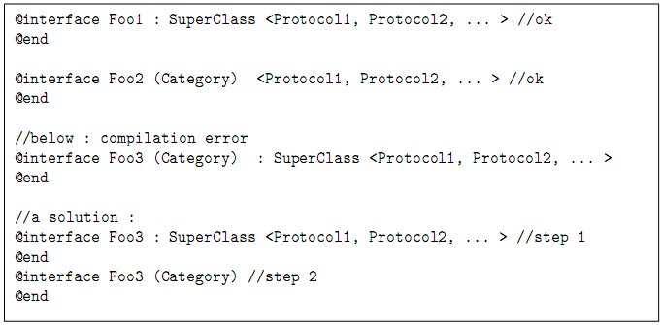

----------------------------------------------------------------------------------------------

Example Codes:

/****** AddressCard.h ******/
实现NSCoding协议，可以持久化对象（存到文件里）。
@interface AddressCard : NSObject <NSCoding>
...
@end

/****** AddressCard.m ******/
-(void) encodeWithCoder:(NSCoder *)aCoder{
[aCoder encodeObject:name forKey:@"name"];
[aCoder encodeObject:email forKey:@"email"];
}

-(id)initWithCoder:(NSCoder *)aDecoder{
if (self = [super init]) {
从aDecoder中读取数据
self.name = [aDecoder decodeObjectForKey:@"name"];
self.email = [aDecoder decodeObjectForKey:@"email"];
}
return self;
}

/****** AddressCardCategory.h ******/
#import "AddressCard.h"

@interface AddressCard (Category) AddressCard的分类，分类名称为Category

-(void) uppercaseName; 定义方法uppercaseName：将Name转换为大写字符串
@end

/****** AddressCardCategory.m ******/
#import "AddressCardCategory.h"

@implementation AddressCard(Category)

-(void) uppercaseName{
self.name = [name uppercaseString]; 转换为大写字符串
}

@end

/****** Classes.m ******/
#import "AddressCardCategory.h"

int main (int argc, const char * argv[]) {
...
// Using NSCoding protocol: Write to file
[NSKeyedArchiver archiveRootObject:card1
toFile:@"/tmp/AddressCard.txt"];

// Using NSCoding protocol: Read from file
AddressCard* card4 = [NSKeyedUnarchiver
unarchiveObjectWithFile:@"/tmp/AddressCard.txt"];
NSLog(@"card4 %@",card4);

// Using Category
[card4 uppercaseName];
NSLog(@"card4 %@",card4);
...
}

OC基本语法结束，后面主要讲foundation框架的一些东西：NSString,NSNumber…..

§ 4. Summry of Memory-Management Rules
Objective-C内存管理规则
Let’s summarize what you’ve learned about memory management:

- The basic rule to apply is everything that increases the reference counter with alloc, [mutable]copy[WithZone:] or retain is in charge of the corresponding [auto]release.
基本规则：当我们使用alloc， copy 或者retain 会使对象的引用计数器加1，当我们使用release或者autorelease时，对象的引用计数器的值会减1,release和autorelease区别？

alloc、copy、retain的对象，一定记得release/autorelease.
assing: 直接赋值。适用于基本数据类型的实例变量

alloc：为对象开辟内存空间，返回所创建对象的指针，并将所有实例变量置为0.

retain：赋值 + retain（两个指针指向一个对象，使用引用计数器）。节省内存。

copy: 开辟新空间，生成新对象，两个指针指向不同的对象。

- Releasing an object can free up its memory, which can be a concern if you’re creating many objects during the execution of a program. A good rule is to release objects you’ve created or retained when you’re done with them.
Release一个对象可以释放它所占用的内存，如果你的应用程序在执行期间创建了很多的对象，应该关注对象的释放。良好的规则是，不再使用创建或保持的对象时，就释放他们。

- Sending a release message does not necessarily destroy an object. When an object’s reference count is decremented to 0, the object is destroyed. The system does this by sending the dealloc message to the object to free its memory.
发送一个release消息给一个对象不一定能销毁这个对象。只有当一个对象的引用计数器的值为0时，这个对象才会被销毁。系统通过向该对象发送一条dealloc的消息来释放该对象占用的内存。

- The autorelease pool provides for the automatic release of objects when the pool itself is released. The system does this by sending a release message to each object in the pool for each time it was autoreleased. Each object in the autorelease pool whose reference count goes down to 0 is sent a dealloc message to destroy the object.
自动释放池用于在释放池本身时自动释放池中的对象。每次释放池时，系统通过向池中的每个对象发送一条release消息来实现这个功能。同时，系统会向池中每个引用计数为0的对象发送一条 dealloc消息来销毁该对象。

- If you no longer need an object from within a method but need to return it, send it an autorelease message to mark it for later release. The autorelease message does not affect the reference count of the object. So it enables the object to be used by the message sender but still be freed up later when the autorelease pool is released.
如果你在一个方法里不再需要一个对象，但需要返回它，那么给它发送autorelease消息，将它标记为以后释放。 autorelease消息并不会影响对象的引用计数的值。因此，它允许消息的发送者使用该对象，然而仍然在以后当自动释放池时,释放这些对象。

- When your application terminates, all the memory your objects take up is released, regardless of whether they were in the autorelease pool.
无论对象是否添加到自动释放池，应用程序终止时，都会释放程序中对象所占用的所有内存。

- When you develop more sophisticated applications (such as Cocoa applications), autorelease pools can be created and destroyed during execution of the program (for Cocoa applications, that happens each time an event occurs). In such cases, if you want to ensure that your object survives automatic deallocation when the autorelease pool itself is released, you need to explicitly retain it. All objects that have a reference count greater than the number of autorelease messages they have been sent will survive the release of the pool.
当你开发更复杂的应用（如Cocoa应用程序），可以在程序运行期间创建和销毁自动释放池（对Cocoa应用程序，即在每次发生事件时就会产生这种情况）。在这种情况下，如果想要保证在自动释放池被释放时对象仍然存在，则应该显示的保持它。如果对象的​​引用计数大于收到的outorelease消息数目，则在池被释放时会保留下来。

- If you directly create an object using an alloc or copy method (or with an allocWithZone:, copyWithZone:, or mutableCopy method), you are responsible for releasing it. For each time you retain an object, you should release or autorelease that object.
如果你使用alloc或者copy的方法（或使用用allocwithzone，copywithzone，或者mutableCopy）直接创建对象，则你要负责释放它。每次retain对象时，应该release或autorelease这个对象。

- You don’t have to worry about releasing objects that are returned by methods other than those noted in the previous rule. It’s not your responsibility; those methods should have autoreleased those objects. That’s why you needed to create the autorelease pool in your program in the first place. Methods such as stringWithString: automatically add newly created string objects to the pool by sending them autorelease messages. If you don’t have a pool set up, you get a message that you tried to autorelease an object without having a pool in place.
除了上述规则提到的方法之外，你不必费心地释放其他方法返回的对象。这不是你的责任; 这些对象应该被他们地方法自动释放。这就是为什么首先需要在你的程序中创建自动释放池的原因。有些方法，如stringWithString：之类的方法自动向新创建的字符串对象发送一条outorelease消息，把他们添加到自动释放池。如果事先没有创建自动释放池，你就会收到一条出错的消息，这个消息通知你在没有池的情况下尝试自动释放对象。

§ 5. Other Special Features
其他的一些
nil
In Objective-C, classes are also objects (meta-class instances), and it is possible to declare a pointer to a class. Their null value is Nil.
在Objective -c 中，很可能声明一个指针，指向一个类。他们的空值是Nil。
C++:deldelete NULL没有问题，但是用NULL指针调用函数出错
OC:nil指针调用函数没有问题，被忽略。

BOOL Type
In C++, the boolean type is bool. In Objective-C, it is BOOL, which can be set to YES or NO（宏定义）. Note that it’s not true or false.
在 c + +，布尔类型为 bool。在Objective-C中，它是BOOL，可以设置为YES或 NO(宏定义)。注意不是 true 或 false。

Selector 选择器，相当于C语言的函数指针。是SEL类型。
In Objective-C, a new type has been introduced. Such a “pointer to a method” is called a selector. It is not technically a real pointer to a function.
（在Objective-C中，引入了一个新的类型。这种"指向函数的指针"称为一个选择器。）
Its type is SEL and its value is computed using @selector on the exact name of the method (with labels of parameters:).
(其类型是 SEL 和其值计算方法是在确切的方法名字上使用 @selector(带参数的标签的函数))

SEL：
selector相当于指向成员函数的指针，需要指定 方法才可以调用。

Calling the method can be done using the class NSInvocation.
（调用此方法可以完成使用 NSInvocation 类）
#import <Foundation/Foundation.h>

@interface PT : NSObject {
int x;
}
-(void)sx:(int)_x;
-(void)print;
@end

#import "PT.h"

@implementation PT
-(void)sx:(int)_x
{
x = _x;
}
-(void)print
{
NSLog(@"%d",x);
}
@end

#import <Foundation/Foundation.h>
#import "PT.h"
int main (int argc, const char * argv[]) {
NSAutoreleasePool * pool = [[NSAutoreleasePool alloc] init];

PT* pt=[[PT alloc] init];
int i = 3;

SEL selector = @selector(sx:); 给函数指针赋值
@selector(要指向的函数名:)

NSMethodSignature* sig =
[[pt class] instanceMethodSignatureForSelector:selector];
测试函数指针selector所指向的函数，是否属于pt对象所在的类。
NSMethodSignature对象记录方法签名（函数原型）的信息。

if(sig != nil){

NSInvocation包含了一个（成员）方法的所有信息：
方法名、方法的发送对象、传递的参数、返回值。
NSInvocation* invocation =
[NSInvocation invocationWithMethodSignature: sig];
用一个函数签名初始化NSInvocation对象。

[invocation setSelector:selector];设置方法名，selector又指向sx：
[invocation setTarget:pt]; 设置方法要发送的对象，即pt
[invocation setArgument:&i atIndex:2]; 设置参数

setArgument:传递给函数的实参。 Q:i为何加取地址符号？(指针指向参数的地址)
atIndex: 当函数需要多个参数时，指定参数的索引。
即实参赋值给第几个形参。
索引的0和1预留。
0 for target（消息点接收者）, 1 for SEL（selector）
所以，参数的索引从2开始，索引2对应第1个形参。

[invocation invoke];真正调用函数指针 Q：相当于如何调用方法？
Q: [pt sx: i andY: j];
}
[pt print];

实现多态：

[pt release];
[pool drain];
return 0;
}

Most of the time, utility methods of the performSelector: family (inherited from NSObject) are handier, but a little restrictive.

The simplest three ones are: (直接用函数所属类的对象调用即可)
-(id) performSelector:(SEL)aSelector;//不带参数的
-(id) performSelector:(SEL)aSelector
withObject:(id)anObjectAsParameter //带一个参数
-(id) performSelector:(SEL)aSelector //两个参数
withObject:(id)anObjectAsParameter
withObject:(id)anotherObjectAsParameter
看刚才的那个例子

Example Codes:
void testSelector(){
SEL msg = @selector(compareName:);
AddressCard* card1 = [[AddressCard alloc]initWithName:@"Tom"
andEmail:@"Tom@gmail.com"];
AddressCard* card2 = [[AddressCard alloc]initWithName:@"Tom"
andEmail:@"Tom@gmail.com"];
AddressCard* card3 = [[AddressCard
alloc]initWithName:@"Jacky" andEmail:@"Jacky@gmail.com"];

// using performSelector method of NSObject
if( [card1 performSelector:msg withObject:card2]
== NSOrderedSame )
NSLog(@"card1 and card2 are same.");

if( [card1 performSelector:msg withObject:card3]
!= NSOrderedSame )
NSLog(@"card1 and card3 are different.");

[card1 release];
[card2 release];
[card3 release];
}

//
// AddressCard.m
// SpecialFeatures
//
// Created by user on 14-6-18.
// Copyright 2014 __MyCompanyName__. All rights reserved.
//

#import "AddressCard.h"

@implementation AddressCard

@synthesize name;
@synthesize email;

-(id)initWithName:(NSString*)_name andEmail:(NSString*)_email
{
if(self = [super init])
{
name = _name;
email = _email;
}
return self;
}

-(void)print
{
NSLog(@"name = %@",name);
NSLog(@"email = %@",email);
}

-(int)Complate:(AddressCard*)add1
{
if(self.name==nil||add1.name==nil)
if(self.name>add1.name)
{
return 1;
}
else {
return 0;
}

}
@end

Exceptions 异常
Exception handling in Objective-C is closer to Java than to C++, particularly because of the @finally keyword. finally is known in Java but not in C++. It is an additional (but optional) part of a try()...catch() block, containing code that will always be executed, whether an exception is caught or not. This is useful to write short and clean code that properly frees resources.
在Objective - C的异常处理比c++更接近于Java，特别是因为@ finally关键字。finally是在Java里，但不是在C++里。它是增加到try()…catch块里的，（它是可选的），不管异常是否被捕获，它里面包含的代码总是被执行。这对于写一些短小的释放内存资源的代码来讲是非常有用的。

OC与C++异常机制的不同之处：
1.多了一个finally块；
2.throw语句，只能抛出OC对象(即NS….)，不能抛出基本数据类型(int等)。

@try{
dangerousAction();
}
@catch (MyException* e) {
doSomething();
}
@catch (NSException* e) {
doSomethingElse();
@throw
}
@finally {
cleanup();其实这里可以做C++中比较麻烦的内存释放
}

@finally语句块的作用：
1.无论是否出现异常，都将执行finally块里的语句。
2.一般用来释放资源

Apart from that, the behaviour of @try...@catch...@finally in Objective-C is very classical; however, only objects can be thrown (unlike C++).
(除此之外，在Objective-C中,@try...@catch...@finally 的行为是很经典的 ；但是，只有对象可被thrown（抛出）（不同于 C++）。)

void exceptionFunc()
{
P* p = [[P alloc] init];
@throw p;
}

int main (int argc, const char * argv[]) {
NSAutoreleasePool * pool = [[NSAutoreleasePool alloc] init];
@try
{
exceptionFunc();
}

@catch(P * p1)
{
[p1 release];

}
@finally {

}
…..
[pool drain];
return 0;
}

Please note that an NSException class exists in Cocoa, and that you are encouraged to use it as mother class of what you throw. Thus, a @catch(NSException* e) should be equivalent to catch(...).
(请注意，NSException 类存在于Cocoa中,你被鼓励使用它作为你的mother class去throw。因此， @catch(NSException* e)等效于@catch(...)。)
抛出异常，如果没有扑捉到，那么程序会退出

Example Codes:
void testException(){
@try {
[NSException raise:@"wrong!"
format:@"Some thing happened."];
//raise:抛出异常，（异常的名字）
//format:异常的原因
}
@catch (NSException * e) {//捕获的异常类型
NSLog(@"Exception name:%@ reason:%@",
[e name],[e reason]);
name：返回异常的名字
reason：返回异常的原因。
}
@finally {
NSLog(@"finally");
}
}

2011-09-06 06:09:53.355 Classes[423:a0f] -[NSAutoreleasePool aaa]: unrecognized selector sent to instance 0x10010c840
2011-09-06 06:09:53.493 Classes[423:a0f] *** Terminating app due to uncaught exception 'NSInvalidArgumentException', reason: '-[NSAutoreleasePool aaa]: unrecognized selector sent to instance 0x10010c840'
*** Call stack at first throw:
(
0 CoreFoundation 0x00007fff86bfbd24 __exceptionPreprocess + 180
1 libobjc.A.dylib 0x00007fff8219f0f3 objc_exception_throw + 45
2 CoreFoundation 0x00007fff86c55160 +[NSObject(NSObject) doesNotRecognizeSelector:] + 0
3 CoreFoundation 0x00007fff86bcdd3f ___forwarding___ + 751
4 CoreFoundation 0x00007fff86bc9e88 _CF_forwarding_prep_0 + 232
5 Classes 0x00000001000017b2 main + 90
6 Classes 0x0000000100001750 start + 52
7 ??? 0x0000000000000001 0x0 + 1
)
terminate called after throwing an instance of 'NSException'

§ 6. C++ specific features C++中特定的功能
References (&) do not exist in Objective-C. Memory management using reference counting and autorelease makes it less useful. Since the objects are always dynamically created, they are only referenced as pointers.
在Objective - C，引用（＆）不存在。内存管理使用使用引用计数，并能自动释放。使得它用处不大。因为对象总是被动态的创建，他们仅仅作为指针来引用。

1.OC里没有C++里的引用（&）。
OC里的“引用”：指针指向一个对象。
引用计数：有几个指针指向同一个对象。

Objective-C does not implement inlining.
2.OC没有实现内联（inline）

Templates are a kind of alternative to inheritance and virtual methods, designed for efficiency, but clearly far from pure object model principles. (Did you know that a subtle use of templates can give public access to private members?). Objective-C does not implement templates, and it would be very difficult because of the rules about method names overloading and selectors.
Templates是替代继承和虚函数，为提高效率而设计的，但显然远离了单纯的对象模型的原则。 （你知道的巧妙运用模板，能通过public来访问私有成员？）。 Objective - C的不实现模板，因为方法名字的重载和选择器的规则，将会是非常困难的。
3.OC没有实现模板（template）。

Objective-C does not implement operator overloading.
4.OC没有实现运算符重载。
OC用方法来实现对象的比较和拷贝。
比较对象：NSComparisonMedhods(分类)
拷贝对象：NSCopying（协议）

There is no friend notion in Objective-C.
5.在OC中没有友元（friend）//C++中友元是用来访问私有成员的

Methods cannot be declared const in Objective-C. Therefore, the mutable keyword does not exist.
6.在OC中没有const函数。

Chapter 6 Foundation Framework
这章可以不讲了。

§ 1. Overview 概述
框架：（framework），一个由类、方法、函数、文档组成的集合。
A framework is a collection of classes, methods, functions, and documentation logically grouped together to make developing programs easier. On Mac OS X, more than 80 frameworks are available for developing applications so that you can easily work with the Mac’s Address Book structure, burn CDs, play back DVDs, play movies with QuickTime, play songs, and so on.
(一个框架是由一个类的集合、 方法、 函数和文档逻辑地组合在一起的，使得发展程序更容易一些。在 Mac OS X，超过了 80个框架都是可供开发的应用程序所使用，使您可以轻松地使用 Mac 的通讯簿的结构, 刻录 CD、 播放DVD、 播放 QuickTime 的电影、 播放歌曲，等等。)

The framework that provides the base or foundation for all your program development is called the Foundation framework. This framework enables you to work with basic objects, such as numbers and strings, and with collections of objects, such as arrays, dictionaries, and sets. Other capabilities provide for working with dates and times, using automated memory management, working with the underlying file system, storing (or archiving) objects, and working with geometric data structures such as points and rectangles.
(为您的所有程序开发提供最基本得或基础的框架调用称为Foundation framework(基础框架)。这一框架，使您能够使用基本的对象，如numbers（数字）和strings（字符串），和对象的集合如arrays，dictionaries，和sets。其他功能提供了有关使用dates(日期)和times（时间），使用了被自动管理的内存，随着底层文件系统、 存储 （或存档） 对象，和几何数据结构如点和矩形进行来进行工作。)

The Application Kit framework contains an extensive collection of classes and methods to develop interactive graphical applications. These provide the capability to easily work with text, menus, toolbars, tables, documents, the pasteboard, and windows.
(Application Kit(应用程序套件)框架包含广泛的类的集合和方法去开发交互式图形应用程序。这些提供了对文本、工具栏、菜单、表、文档、粘贴板和窗口轻松工作的能力。)

In Mac OS X, the term Cocoa collectively refers to the Foundation framework and the Application Kit framework. The term Cocoa Touch collectively refers to the Foundation framework and the UIKit framework.
(在Mac OS X 中，Cocoa集体指的是Foundation（基础架构）框架和Application Kit（应用程序套件）框架。Cocoa Touch集体指的是基础框架和 UIKit (Xcode) 框架来编译的。)

Cocoa:用于Mac台式机和笔记本。Foundation + Application Kit
Cocoa Touch:用于iphone、ipad、ipod Touch。Foundation + UIKit
Foundation:不包含GUI控件的基础类。
Application Kit/ UIKit：各种GUI控件。

The Foundation header files are stored on your system. They are kept in the following directory:
(Foundation的头文件存储在您的系统上。它们保持在以下目录中：)
/System/Library/Frameworks/Foundation.framework/Headers
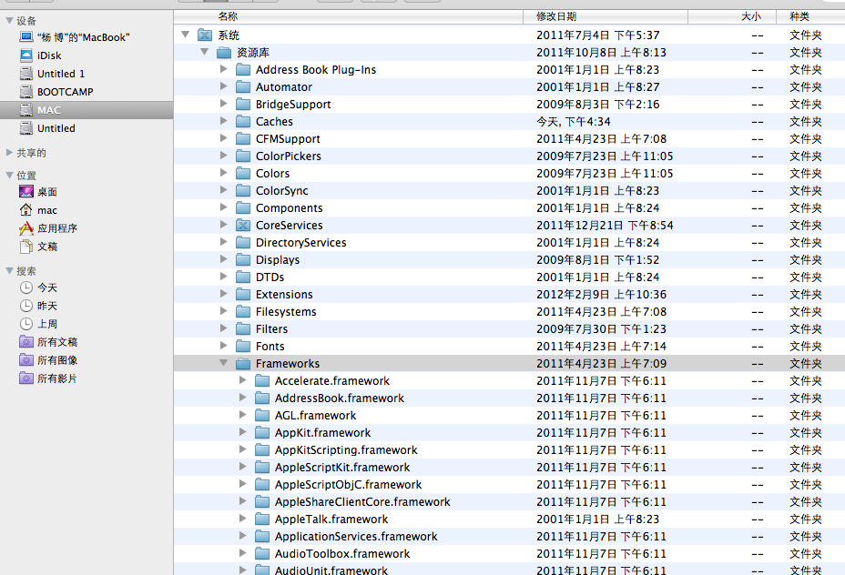

If you’re editing a file in Xcode and you want to get immediate access to the documentation for a particular header file, method, or class, you can simply highlight the text in your editor window and right-click it. From the menu that appears, you can select Find Selected Text in Documentation. Xcode will search the documentation library and display the results that match your query.
(如果您编辑 Xcode 中的一个文件，你想立即访问特定头文件、 方法或类的文档，只需在编辑器窗口中显示突出的文本并右键单击它。会从菜单中出现，您可以在文档中选择“Find Selected Text in Documentation”（即查找选定的文本）。Xcode 将搜索文档库，并显示你所查询匹配的结果。)

苹果开发者联盟 http://www.apple.com.cn/developer/

§ 2. Foundation Framework Classes
Foundation框架中的类

Foundation Framework Goals 基础框架
The Objective-C Foundation Classes is an Objective-C library. It contains general purpose classes for easier development of applications, in areas such as data types, collections, network, C library wrappers, and compound classes.
(Objective-C基础类是一个Objective-C库。它为更加容易开发程序包含了一般用途的类，例如数据类型、 收藏集、 网络、 C 库包装，和复合类。)

The Foundation framework includes the root object class, classes representing basic data types such as strings and byte arrays, collection classes for storing other objects, classes representing system information such as dates, and classes representing communication ports.
(基础框架包括根对象类，代表基本数据类型，如字符串和字节数组，用于存储其他对象的集合类，表示系统信息的类，例如日期，和表示通信端口的类。)

Note: In the following class-hierarchy diagrams, dark-shaded areas include classes that are available in Mac OS X and iOS; light-shaded areas include classes that are available in Mac OS X only.
(注意：下面的类层次结构关系图，黑暗阴影的区域包括的类在 Mac OS X 和 iOS中可用;光亮区域包括的类仅在 Mac OS X 中可用。)

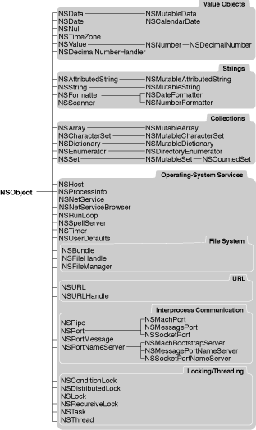
基础框架类继承关系－ Objective-C （第一部分）

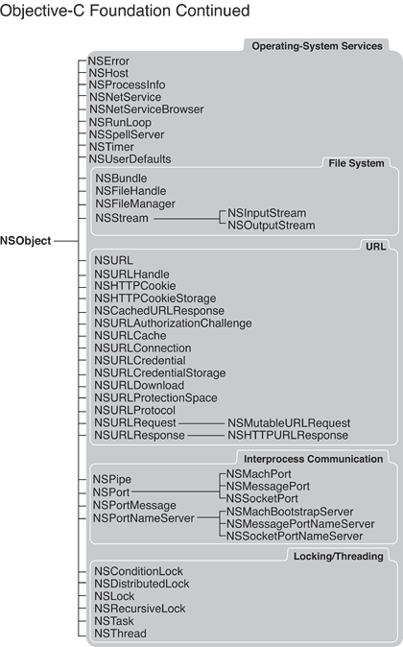
基础框架类继承关系－ Objective-C （第二部分）
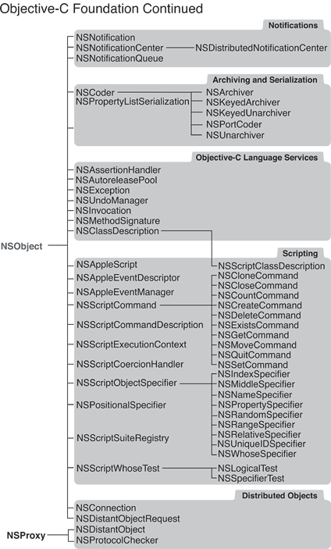
基础框架类继承关系－ Objective-C （第三部分）

Foundation 框架的主要功能类

- Data storage 数据存储类
NSData and NSString provide object-oriented storage for arrays of bytes. NSValue and NSNumber provide object-oriented storage for arrays of simple C data values. NSArray, NSDictionary, and NSSet provide storage for Objective-C objects of any class.
(NSData 和 NSString 提供面向对象存储的字节数组。NSValue 和 NSNumber 为简单的C的数组中数据的值提供面向对象的数组。NSArray、 NSDictionary 和 NSSet 提供为Objective-C 中的任何类提供数据的存储。)

- Text and strings文本和字符串类
NSCharacterSet represents various groupings of characters that are used by the NSString and NSScanner classes. The NSString classes represent text strings and provide methods for searching, combining, and comparing strings. An NSScanner object is used to scan numbers and words from an NSString object.
NSString,NSMutableString,这个NSScanner是从NSString中查找一些单词或者是字符等。

- Dates and times 日期和时间类
The NSDate, NSTimeZone, and NSCalendar classes store times and dates and represent calendrical information. They offer methods for calculating date and time differences. Together with NSLocale, they provide methods for displaying dates and times in many formats, and for adjusting times and dates based on location in the world.
(NSDate、NSTimeZone 和 NSCalendar 类存储时间和日期和代表 calendrical 的信息。他们提供方法计算日期和时间的差异。与NSLocale一起，他们提供在许多格式中显示日期和时间的方法，用于在世界中的位置上调整时间和日期。)

- Application coordination and timing 应用程序协调和时间安排
NSNotification, NSNotificationCenter, and NSNotificationQueue provide systems that an object can use to notify all interested observers of changes that occur. You can use an NSTimer object to send a message to another object at specific intervals.
(NSNotification、NSNotificationCenter 和 NSNotificationQueue 提供一个对象可以使用通知所有感兴趣的观察者发生变化的系统。你可以使用 NSTimer 类的对象在特定的时间间隔将消息发送到另一个对象。)

- Object creation and disposal 对象的创建和处理
NSAutoreleasePool is used to implement the delayed-release feature of the Foundation framework.
(NSAutoreleasePool 类是用于实现延迟释放功能的基础框架。)

- Object distribution and persistence 对象的分配和持久性
The data that an object contains can be represented in an architecture-independent way using NSPropertyListSerialization. The NSCoder and its subclasses take this process a step further by allowing class information to be stored along with the data. The resulting representations are used for archiving and for object distribution.
NSPropertyListSerialization和NSCoder都是对数据的存储

- Operating-system services 操作系统服务
Several classes are designed to insulate you from the idiosyncrasies of various operating systems. NSFileManager provides for file operations (creating, renaming, deleting, and so on). NSThread and NSProcessInfo let you create multithreaded applications and query the environment in which an application runs.
NSFileManager类为文件操作提供了一致的界面（创建、 重命名、 删除，等等）。NSThread类和 NSProcessInfo类让您创建多线程应用程序以及查询应用程序的运行的环境。

- URL loading system URL加载系统
A set of classes and protocols provide access to common Internet protocols.
(一组类和协议提供访问常用的互联网协议。)

Chapter 7. Numbers、Strings and Collections
数字、字符串、容器（集合）

This chapter describes how to work with some of the basic objects provided in the Foundation framework. These include numbers, strings, and collections, which refers to the capability to work with groups of objects in the form of arrays and dictionaries.
(本章介绍如何使用Foundation框架提供的一些基本对象。这些对象包括数字、 字符串和集合。集合指的是能够以数组、字典和集的形式使用成组对象的能力)。

The Foundation framework contains a plethora of classes, methods, and functions for you to use. Approximately 125 header files are available under Mac OS X. As a convenience, you can simply use the following import:
(基础框架包含过多的类、 方法和要使用的功能。在 Mac OS X 下大约有 125个可用的头文件。为了方便，您可以简单地使用下面的导入包：)

#import <Foundation/Foundation.h>就是一个头文件，可以看一看里面都有多少个头文件。。。

Because the Foundation.h file imports virtually all the other Foundation header files, you don’t have to worry about whether you are importing the correct header file. Xcode automatically insert this header file into your program.
(Foundation.h 文件的接口几乎所有其他基础头文件，因为您不必担心是否要导入的正确的头文件。Xcode 自动将此头文件插入您的程序。)

§ 1. Number Objects 数字对象
NSNumber:把简单数值类型（如NSIngeter、double），转换为对象。

Q:有了NSInteger等，为何还需要NSNumber类？
A:基本数据类型，不能调用方法。NSNumber 是类，有成员变量和方法可以调用。

All the numeric data types we’ve dealt with up to now, such as integers, floats, and longs, are basic data types in the Objective-C language—that is, they are not objects. For example, you can’t send messages to them.
(所有数字数据类型我们到目前为止已经处理过了，例如整数、 浮点数和长整型，那就是是Objective-C 语言中的基本数据类型，他们不是对象。例如，您不能向他们发送消息。)

Sometimes, you need to work with these values as objects. For example, the Foundation object NSArray enables you to set up an array in which you can store values. These values have to be objects, so you can’t directly store any of your basic data types in these arrays. Instead, to store any of the basic numeric data types (including the char data type), you can use the NSNumber class to create objects from these data types.
(有时，您需要使用这些值作为对象。例如，NSArray 使您能够设置基础的对象，您可以在其中存储数组的值。这些值必须是对象，因此在这些阵列中您不能直接存储您的任何基本数据类型。相反，要存储任何的基本的数字数据类型 （包括 char 数据类型），从这些数据类型中可以使用 NSNumber 类创建要使用的对象。)

The NSNumber class contains many methods that allow you to create NSNumber objects with initial values:
(NSNumber 类包含很多方法，允许您创建 NSNumber 对象的初始值：)

//NSInteger intNum = 100;
NSNumber* intNumber = [NSNumber numberWithInteger: 100];
用一个整数，创建并初始化一个NSNumber对象。类方法or实例方法？
把一个整数包装成一个对象。

The value retrieved from an NSNumber object must be consistent with the type of value that stored in it.
(NSNumber 对象中检索到的值必须与存储在它的值的类型一致。)

NSInteger myInt = [intNumber integerValue];
从一个NSNumber对象中，获得整数值。NSInteger 是一个基本的整数类型，相当于int.

Note that NSInteger is not an object, but a typedef for basic date type. It is typedefed either to a long for 64-bit builds or to an int for 32-bit builds.
(请注意 NSInteger 不是对象，但它是一个定义日期的基本类型。它是被定义为64-bit的类型或32-bit 位的int类型。)

For each basic value, a class method allocates an NSNumber object and sets it to a specified value. These methods begin with numberWith followed by the type, as in numberWithLong:, numberWithFloat:, and so on.
（对于每个基本的数值，一个类方法分配了一个 NSNumber 类对象，并将其设置为指定的值。这些方法以numberWith：方法开头后跟类型，如在 numberWithLong：，numberWithFloat：，依此类推。）

In addition, instance methods can be used to set a previously allocated NSNumber object to a specified value. These all begin with initWith, as in initWithLong: and initWithFloat:.
(此外，实例方法可用于将先前分配的 NSNumber 对象设置为指定的值。这些都以initWith开始，如 initWithLong：和 initWithFloat：。)

NSNumber* intNumber = [[NSNumber alloc] initWithInt: 100];
...
[intNumber release];

Common NSNumber methods:
NSNumber对象的两种初始化方法：
numberWith + 基本数值类型名：类方法，创建一个NSNumber对象，并用各种基本数值类型（如char、short、int……）初始化该对象。
initWith + 基本数值类型名：实例方法, 用各种基本数值类型（如char、short、int……）初始化NSNumber对象。
基本数值类型名 + Value：返回NSNumber存储的基本数据类型的值。（getter）
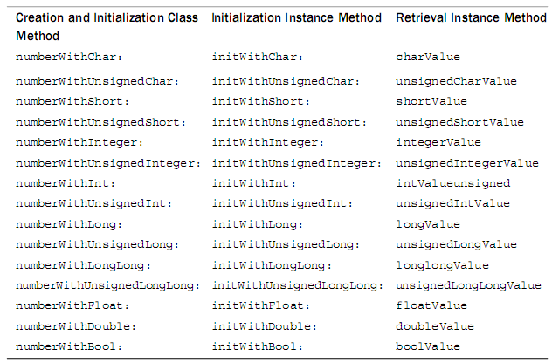
get时候，类型要和init时的类型一致。看看下面

Notice what happens after you create a double object and then try to (incorrectly) retrieve an integer value.
(请注意您创建一个双重的对象，然后尝试着去（错误地）检索整数值后会发生什么。)看英文
保证类型一致

NSNumber* myNumber = [NSNumber numberWithDouble: 123e+15];
科学计数法：１２３*１０^15 ＝ １.２３e＋１７
NSLog( @”%i”, [myNumber integerValue] );

You get this output: 727678976!!! You get no error message from the system. In general, it’s up to you to ensure that if you store a value in an NSNumber object, you retrieve it in a consistent manner.
(你得到如下的输出： 727678976 ！！！您从系统获取任何错误消息。一般情况下，它是您确保如果将值存储在一个 NSNumber 对象，则它以一致的方式检索你的值。)

You can use the isEqualToNumber: method to numerically compare two NSNumber objects. Or you can use the compare: method to test whether one number value is numerically less than, equal to, or greater than another.
(您可以使用 isEqualToNumber： 数值比较两个对象的方法。或者，您可以使用NSNumber: 方法比较测试是否一个数字值是小于、等于或大于另一个数字。)

[intNumber isEqualToNumber: myNumber];
比较两个NSNumber对象是否相等，返回YES或NO。

[intNumber compare: myNumber];
比大小:
大于：返回NSOrderedDescending,1(枚举值),降序
等于：返回NSOrderedSame,0
小于：NSOrderedAscending,-1,升序

Note that you can’t reinitialize the value of a previously created NSNumber object. For example, you can’t set the value of an integer already stored in the NSNumber object.
(请注意，您无法重新初始化以前创建的 NSNumber 对象的值。例如，您不能设置已存储在 NSNumber 对象中的整数的值。)

NSNumber* intNumber = [NSNumber numberWithInteger: 100];
[intNumber initWithInt: 1000]; // ERROR!
The statement generates an error when it is executed.
All number objects must be newly created.

但可以指向另外一个NSNumber对象。
[intNumber release]；
intNumber = nil;
intNumber = [NSNumber numberWithInteger: 200];//可以

#import <Foundation/Foundation.h>

int main (int argc, const char * argv[]) {
NSAutoreleasePool * pool = [[NSAutoreleasePool alloc] init];
/*
//类方法
NSNumber * intNumber = [NSNumber numberWithInteger:100];
NSLog(@"NSNumber:%@",intNumber);

NSInteger myInt = [intNumber integerValue];
NSLog(@"NSInteger:%d",myInt);
*/
//实例方法
NSNumber * intNumber = [[NSNumber alloc] initWithInt:100];
NSLog(@"NSNumber:%@",intNumber);

NSNumber * myNumber = [NSNumber numberWithDouble:123e+15];
NSLog(@"%i",[myNumber integerValue]); //error 存取什么样的类型获取什么样的类型
NSLog(@"%f",[myNumber doubleValue]); //OK

//看两个对象所指向空间的值是否相同
BOOL result = [intNumber isEqualToNumber:myNumber];
if (result == YES) {
NSLog(@"%@ is EqualToNumber %@",intNumber,myNumber);
} else {
NSLog(@"%@ is not EqualToNumber %@",intNumber,myNumber);
}

//两个对象存储的值进行比较
NSComparisonResult comparison = [intNumber compare:myNumber];
switch (comparison) {
case -1: //NSOrderedAscending:
NSLog(@"%@ Ascending %@",intNumber,myNumber);
break;
case 0: // NSOrderedSame:
NSLog(@"%@ Same %@",intNumber,myNumber);
break;
case 1: //NSOrderedDescending:
NSLog(@"%@ Descending %@",intNumber,myNumber);
break;
default:
break;
}
[intNumber release];

//不能重新初始化一个NSNumber对象,但可以指向另外一个NSNumber对象。
NSNumber * aNumber = [NSNumber numberWithInteger:100]; //类对象
NSLog(@"aNumber1：%@",aNumber);
//aNumber = [aNumber initWithInt:1000]; //error！类对象不能调用实例方法
aNumber = [NSNumber numberWithInteger:200];
NSLog(@"aNumber2：%@",aNumber);

[pool drain];
return 0;
}

§ 2. String Objects 字符串
The Foundation framework supports a class called NSString for working with character string objects.
(基础架构支持一个用来处理字符的字符串对象的类，这个类被称为NSString 类。)

Whereas C-style strings consist of char characters, NSString objects consist of unichar characters. A unichar character is a multibyte character according to the Unicode standard. This enables you to work with character sets that can contain literally millions of characters.
(而 C 样式字符串由 char 字符组成，则 NSString 对象由 unichar 字符组成。Unichar 字符是以 Unicode(至少2个字节) 多字节字符为标准的。这使您能够使用可以包含数百万个字符的字符集。)
unichar也是可以转成utf-8格式的(这样可以节省内存空间)
C字符串由char字符组成，NSString由unichar字符组成。
Luckily, you don’t have to worry about the internal representation of the character in your strings because the NSString class automatically handles this for you. By using the methods from this class, you can more easily develop applications that can be localized – that is, made to work in different languages all over the world.
(幸运的是，你不必担心你的字符串中字符的内部表示形式，因为 NSString 类将自动为您处理。通过使用此类的方法，您可以更轻松地开发应用程序可以本地化 — — 因此，它是在世界各地以不同的语言工作。)

The printf function of the C language has not been extended to support NSString objects. NSLog can be used instead, and that accepts a formatted-string like printf. For an NSString object, the format to use is not “%s” but “%@”. And more generally, “%@” can be used on any object because it is in fact using the returned value of a call to -(NSString*) description,which is inherit from NSObject.
(C 语言的 printf 函数不支持 NSString 对象。NSLog 可以用来代替，并像printf 一样接受格式化字符串。一个NSString 对象，要使用的格式不是"%s"而"%@"。更普遍而言，"%@"可以使用在任何对象上，因为它使用的是-(NSString*) description方法（继承自NSObject类)。

Moreover, an NSString can be converted into a C-like string with the UTF8String method.
(UTF8String: 把NSString对象转换为C字符串，可用%s打印。)

You can use the length method to count the number of characters in a string. It returns an unsigned integer value of type NSUInterger.
(可以用length方法来计算的字符串中的字符数长度。它返回类型是 NSUInterger无符号的整数值。)

The NSString class deals with immutable strings. It means you can’t change any characters within the string.
(NSString 类涉及了恒不变的字符串。这意味着您不能更改字符串内的任何字符。)

NSString：不可变字符串。
Q: NSString *是哪种指针？A:指向常量的指针。// 相当于const char *

Create a String 创建字符串
By putting the @ character in front of the string of double-quoted characters, you can create a constant character string object in Objective-C.
(通过将@放到双引号字符的字符串的前面的字符，您就可以创建Objective-C常量字符串对象).

NSString* str1 = @”Hello World”; //字符串常量
NSLog( @”%@”, str1 );

The string such as @”Constant string” is an NSConstantString object. Space for constant strings is allocated differently in memory than for other objects. Constant strings have no reference-counting mechanism because they can never be released. When the retainCount message is sent to these strings, it returns a value of 0xffffffff.
(字符串如@"常量字符串"是一个 NSConstantString 对象。常量字符串空间是在内存中以不同的方式与其他对象分配。常量字符串没有引用计数的机制，因为他们永远不会被release。当 retainCount 消息机制发送这些字符串时，它将返回值为 0xffffffff。)
//-1
常量字符串没有使用引用计数的机制，不能对其release。
其引用计数器值为0xffffffff

The stringWithString: method creates a new immutable string with the contents of another. An actual copy of the string contents is made here, not just another reference to the same string in memory. That means that str1 and str2 refer to two different string objects, which is different than simply performing a simple assignment that simply creates another reference to the same object in memory.
(StringWithString：方法是创建一个新的另一个内容不可变的字符串的方法 )

NSString* str2 = [NSString stringWithString:str1];
//str２指向另一个字符串常量，内容与str１指向的那个相同。
NSString* str3 = str1; // str3 and str1 are same one object
//两个指针指向同一个字符串常量。
Q:如何验证？不用retainCount. 可以打印地址看看啦

The stringByAppendingString: method can join two character strings. It creates a new string object that consists of the characters str1 followed by str2. The original string objects, str1 and str2, are not affected by this operation (they can’t be because they’re both immutable string objects).
(StringByAppendingString： 方法可以联接两个字符的字符串。它创建一个新的字符串对象。由 str2 跟着的字符 str1 组成。)

NSString* str4 = [str1 stringByAppendingString: str2];
//连接两个字符串，创建一个新字符串

The stringWithFormat: method can make a string with a specified format.
用指定的格式，创建一个字符串。

NSString* str5 = [[NSString stringWithFormat:@"Now is %@”,
[NSDate date]];//返回系统时间

Compare Strings 比较字符串
The isEqualToString: method is used to see whether two character strings are equal.
(isEqualToString： 方法用来看看两个字符串是否相等。)
You can use the compare:（按照字符串的编码比较字符串大小） method instead if you need to determine the ordering of two character string. The result of the comparison is NSOrderedAscending, NSOrderedSame or NSOrderedDescending. If you don’t want to perform a case-sensitive(大小写敏感) comparison, use caseInsensitiveCompare: (比较时忽略大小写敏感) method instead of compare: to compare two strings.
(如果您需要确定的两个字符的字符串，您可以使用compare： 方法。比较的结果是 NSOrderedAscending、NSOrderedSame 或 NSOrderedDescending。如果您不需计较大小写，请使用 caseInsensitiveCompare：（比较时忽略大小写敏感）的方法，去替代比较两个字符串。)

A a

tom@Gmail.com
TOM@gmail.com
Q:登录网站时，比较邮箱名和密码是否正确，分别用哪个比较函数？

The uppercaseString字符串所有字符都转换成大写//Hello , HELLO
and lowercaseString字符串所有字符都转换成小写// Hello, hello

are the two NSString methods used to convert strings to upper case and lower case, respectively. Again, the conversion does not affect the original strings.
(将字符串转换为大写和小写，分别使用uppercaseString和lowercaseString 两个 NSString 方法。再次，转换不会影响原始字符串。)

Substrings 求子串

The substringToIndex:
返回一个子串，从首字符到index-1,
helloworld substringToIndex:5->hello
method returns a substring from the leading characters in a string up to but not including the specified index number. Because indexing begins at 0, the argument of 3 extracts characters 0, 1, and 2 from the string. For any of the string methods that take an index number as one of their arguments, you get a “Range or index out of bounds” error message if you provide an invalid index number in the string.
(返回子字符串的开头的字符的字符串，但不是包括指定的索引号。因为索引从 0 开始，3 的参数从字符串中提取字符 0、 1 和 2。对于任何以索引号为它们的一个参数的字符串方法，获得"范围或索引超出界限"的错误消息如果您提供的字符串中无效的索引号。)

The substringFromIndex:
返回一个子串，从index位置，到结尾。
Helloworld
substringFromIndex: 5 ->world
method returns a substring from the receiver beginning with the character at the specified index and up through the end of the string.
(方法返回子字符串的指定索引位置的字符开头的接收器，穿过字符串的末尾。)

NSString *string = @”Hello, World”;
NSString *sub1 = [string substringToIndex:5]; //”Hello”
NSString *sub2 = [string substringFromIndex:7]; //”World”

Some methods require that you identify a substring by specifying a range. A range consists of a starting index number plus a character count. Some methods of the NSString class use the special data type NSRange to create a range specification. It is defined in <Foundation/NSRange.h> and is actually a typedef definition for a structure that has two numbers, location and length, each of which is defined as type NSUinteger.
(这种方法要求您确定通过指定一系列的子字符串。范围包括起始索引号加字符数。NSString 类的一些方法来创建范围规范使用 NSRange 的特殊的数据类型。它在<Foundation/NSRange.h> 中被定义和实际上它是一种有两个数字、 位置和长度的结构，每一个都定义为NSUinteger 的类型.)

/****** NSRange.h ******/
typedef struct _NSRange
{
unsigned int location;//起始的下标
unsigned int length;// 范围的长度
} NSRange;

结构体， 可以读取成员。

The substringWithRange: method returns a character string in the specified range. The special function NSMakeRange creates a range from its argument.
(SubstringWithRange：方法返回指定范围中的一个字符的字符串。NSMakeRange 的特殊功能是从其参数创建一个范围。)

NSString* substr = [str substringWithRange: NSMakeRange(8,6) ];

To locate one string inside another, you can use the rangeOfString: method. If the specified string is found inside the receiver, the returned range specifies precisely where in the string it was found. Howere, if the string is not found, the range that is returned has its location member set to NSNotFound.
（要到一个字符串里找另一个字符串，可以使用的rangeOfString方法。如果指定的字符串在接收者（字符串）里找到，返回指定字符串的range。如果未找到字符串，将返回的location member设置为NSNotFound。）

字符串中查找字符串
NSRange subRange = [str rangeOfString: @”SubString”];
if(subRange.location == NSNotFound)
{}
讲课：
NSString* str1 = @”Hello World”;
NSLog(“%@ = %@ = %lu”,str1,[str1 description],[str1 retainCount]);
NSString* str2 = @”nihao”；
NSLog(“%@ length = %lu”,str2,[str2 length]);
Const char* str3 = [str1 UTF8String];
NSLog(“%s”,str3);
NSString* str4 = [NSString stringWithString:str1];
NSString* str5 = [str4 stringByAppendingString:str2];

NSString* str6 = [NSString stringWithFormat:@”now id%@”,[NSDate date]];
If([str1 isEqutoString:str4])
{
NSLog(@”111111111”);
}

if([str1 compare:str2] != NSOrderedSame)
{
NSLog(@”111111111”);
}

if([str1 caseInsensitiveCompare:@”hello WORLD”]==NSOrderSame)
{
NSLog(@”111111111”);
}
NSString* str8 = [str1 uppercaseString];
NSString* str9 = [str1 lowercaseString];

NSString* str10 = [str1 substringToIndex:5];
NSString* str11 = [str1 substringFromIndex:4];
NSString* str12 = [str1 substringWithRange:NSMakeRange(3,5)];

NSRange range = [str1 rangeOfString:@”lo”];
NSLog(“%lu %lu”,range.location,range.length);

扩展：
void TextNSString(){
/*
//1、创建常量字符串。
NSString *astring = @"This is a String!";
NSLog(@"%@",astring);
*/

/*
//2、创建空字符串，给予赋值。
NSString *astring = [[NSString alloc] init];
if (astring == nil) {
NSLog(@"astring is nil");
}
astring = @"This is a String!";
NSLog(@"%d",[astring retainCount]);

[astring release];
NSLog(@"%d",[astring retainCount]);
NSLog(@"astring:%@",astring);

astring = @"This is a String!";
NSLog(@"0x%.8x", astring); //％x int类型

[astring release];
NSLog(@"%d",[astring retainCount]);
NSLog(@"astring:%@",astring);
*/
/*
//3、在以上方法中，提升速度:initWithString方法
NSString *astring = [[NSString alloc] initWithString:
@"This is a String!"];
NSLog(@"astring:%@",astring);
[astring release];
*/
/*
//4、用标准c创建字符串:initWithCString方法
char *Cstring = "This is a String!";
NSString *astring = [[NSString alloc]
initWithCString:Cstring];
NSLog(@"astring:%@",astring);
[astring release];
*/
/*
//5、创建格式化字符串:占位符（由一个%加一个字符组成）
int i = 1; int j = 2;
NSString *astring = [[NSString alloc] initWithString:
[NSString stringWithFormat:@"%d.This is %i string!",i,j]];
NSLog(@"astring:%@",astring);
[astring release];
*/
/*
//6、创建临时字符串
const char* cs = "This is a temporary string";
NSString * astring = [NSString stringWithCString:cs];
NSLog(@"astring:%@",astring);
*/
/*------------写字符串到文件:writeToFile方法-------------*/
/*
NSString *astring = [[NSString alloc] initWithString:
@"This is a String!"];
NSLog(@"astring:%@",astring);
NSString *path = @"astring.text";
[astring writeToFile:path atomically:YES encoding:NSUTF8StringEncoding error:nil];
//[astring writeToFile: path atomically: YES];
[astring release];
*/

/*------从文件读取字符串:initWithContentsOfFile方法-------*/
/*
NSString *path = @"astring.text";
NSString *astring = [[NSString alloc]
initWithContentsOfFile:path];
NSLog(@"astring:%@",astring);
[astring release];
*/

/*----------------比较两个字符串----------------*/
/*
//用C比较:strcmp函数
char string1[] = "string!";
char string2[] = "string!";
if(strcmp(string1, string2) == 0)
{
NSLog(@"1");
}
*/
/*
//isEqualToString方法
NSString *astring01 = @"This is a String!";
NSString *astring02 = @"This is a String!";
BOOL result = [astring01 isEqualToString:astring02];
NSLog(@"result:%@",result?@"YES":@"NO");
*/
/*
//compare方法(comparer返回的三种值)
NSString *astring01 = @"This is a String!";
NSString *astring02 = @"This is a String!";
BOOL result = ([astring01 compare:astring02] == NSOrderedSame);
NSLog(@"result:%@",result?@"YES":@"NO");
*/
/*
//NSOrderedSame判断两者内容是否相同
NSString *astring01 = @"This is a String!";
NSString *astring02 = @"this is a String!";
BOOL result = [astring01 compare:astring02] == NSOrderedSame;
NSLog(@"result:%@",result?@"YES":@"NO");
*/
/*
//NSOrderedAscending判断两对象值的大小(按字母顺序进行比较，astring02大于astring01为真)
NSString *astring01 = @"this is a String!";
NSString *astring02 = @"This is a String!";
BOOL result = [astring01 compare:astring02] == NSOrderedAscending;
NSLog(@"result:%@",result?@"YES":@"NO");
*/
/*
//NSOrderedDescending判断两对象值的大小(按字母顺序进行比较，astring02小于astring01为真)
//不考虑大小写比较字符串1
NSString *astring01 = @"this is a String!";
NSString *astring02 = @"This is a String!";
BOOL result = [astring01 caseInsensitiveCompare:astring02] == NSOrderedDescending;
NSLog(@"result:%@",result?@"YES":@"NO");
*/
/*
//NSOrderedDescending判断两对象值的大小(按字母顺序进行比较，astring02小于astring01为真)
//不考虑大小写比较字符串
NSString *astring01 = @"this is a String!";
NSString *astring02 = @"This is a String!";
BOOL result = [astring01 compare:astring02
options:NSCaseInsensitiveSearch | NSNumericSearch] == NSOrderedSame;
NSLog(@"result:%@",result?@"YES":@"NO");
//NSCaseInsensitiveSearch:不区分大小写比较
//NSLiteralSearch:进行完全比较，区分大小写
//NSNumericSearch:比较字符串的字符个数，而不是字符值。
*/

/*-----------改变字符串的大小写------------*/
/*
NSString *string1 = @"A String";
NSString *string2 = @"String";
NSLog(@"string1:%@",[string1 uppercaseString]);//大写
NSLog(@"string2:%@",[string2 lowercaseString]);//小写
NSLog(@"string2:%@",[string2 capitalizedString]);//首字母大小
*/
/*------------ Substrings-在串中搜索子串----------------*/
/*
NSString *string1 = @"This is a string";
NSString *string2 = @"string";
NSRange range = [string1 rangeOfString:string2]; //string2在string1中的位置
int location = range.location; //起始位置
int leight = range.length; //长度
NSString *astring = [[NSString alloc] initWithString:
[NSString stringWithFormat:@"Location:%i,Leight:%i",
location,leight]];
NSLog(@"astring:%@",astring);
[astring release];
*/

/*----------------抽取子串 ----------------*/
/*
//-substringToIndex: 从字符串的开头一直截取到指定的位置，但不包括该位置的字符
NSString *string1 = @"This is a string";
NSString *string2 = [string1 substringToIndex:3];
NSLog(@"string2:%@",string2);
*/
/*
//-substringFromIndex: 以指定位置开始（包括指定位置的字符），并包括之后的全部字符
NSString *string1 = @"This is a string";
NSString *string2 = [string1 substringFromIndex:3];
NSLog(@"string2:%@",string2);
*/
/*
//-substringWithRange: //按照所给出的位置，长度，任意地从字符串中截取子串
NSString *string1 = @"This is a string";
NSString *string2 = [string1 substringWithRange:
NSMakeRange(0, 4)];
NSLog(@"string2:%@",string2);
*/
/*
//扩展路径
NSString *Path = @"~/NSData.txt";
//返回一个新字符串,扩大其完整的路径值。
NSString *absolutePath = [Path stringByExpandingTildeInPath];
NSLog(@"absolutePath:%@",absolutePath);
//返回一个新字符串，路径与当前用户的主目录的完整路径相同，用波状符号取代（～ ）代表接收。
NSLog(@"Path:%@",[absolutePath stringByAbbreviatingWithTildeInPath]);
*/
/*
//文件扩展名
NSString *Path = @"~/NSData.txt";
NSLog(@"Extension:%@",[Path pathExtension]);
*/
}

Mutable Strings 可变字符串

The NSMutableString class can be used to create string objects whose characters can be changed. Because this class is a subclass of NSString, all NSString’s methods can be used as well.
(NSMutableString 类可用于创建可更改其字符的字符串对象。因为此类是 NSString 的子类， 所以可以使用所有 NSString的方法。)

NSMutableString* mstr = // NSSring的子类
[NSMutableString stringWithString:otherStr];
When the stringWithString: method is sent to the NSMutableString class, a mutable string object is returned.
(当 stringWithString：方法发送到 NSMutableString 类，则返回一个可变的字符串对象。)

The appendString: method inserts one character string at the end of another.
在已有的字符串结尾追加。

The insertString: atIndex: invocation uses to insert a string at specified position of receiver.
在指定的位置，插入一个字符串。

By using the deleteCharactersInRange: method, you can remove a specified number of characters from a string.
把制定范围内的字符子串删除。

You can use the setString: method to directly set the contents of a mutable string object.
直接修改字符串的内容。

The replaceCharactersInRange: withString: method replaces some of characters in the string with another string.
把制定范围内的字符子串，替换为withString指定的字符串。

The NSMutableString class contains a method called
replaceOccurencesOfString: withString: options: range: that you can use to do a search-and-replace-all on a string.
(NSMutableString类包含调用 replaceOccurencesOfString: withString: options: range：方法，你可以使用它做搜索和替换一个字符串。)
即在指定范围内，查找替换。

mstr replaceOccurencesOfString: searchStr
withString: replaceStr
options: nil 不区分大小写
range: NSMakeRange(0,[mstr length]) ];

options: // 参数类型NSStringCompareOptions
If opts is NSBackwardsSearch(反向查找), the search is done from the end of the range. If opts is NSAnchoredSearch(实例替换查找), only anchored (but potentially multiple) instances are replaced. NSLiteralSearch(精确字符等价查询) and NSCaseInsensitiveSearch (区分大小写查找)also apply.
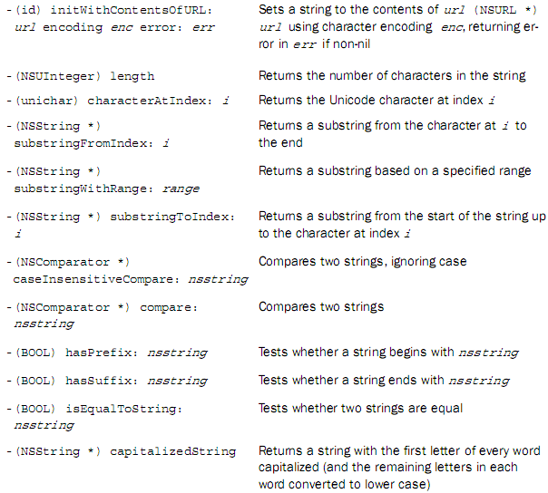
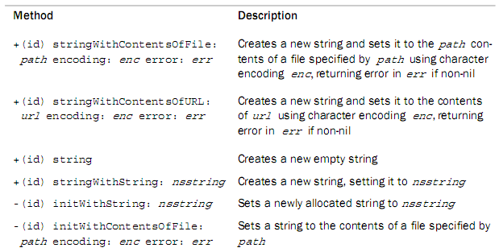
Common NSString Methods

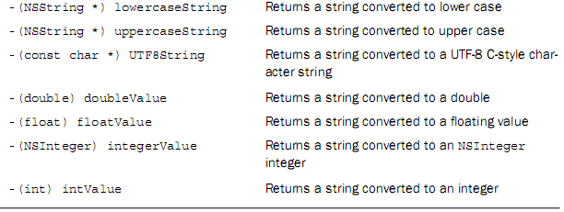

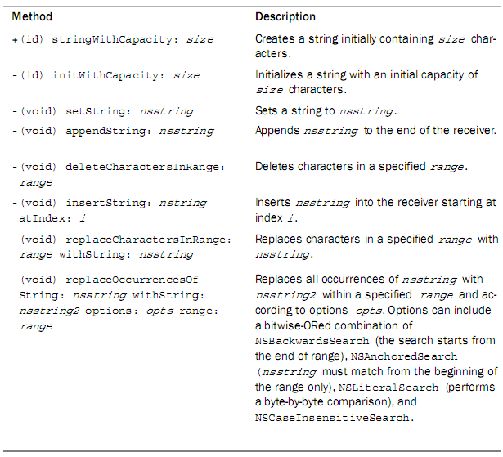
Common NSMutableString Methods

例子：
NSString* str1 = @”Hello World”;
NSMutableString* mstr = [NSMutableString stringWithString:str1];
[mstr appendString:str1];
[mstr insertString:@”,” atIndex:11];
[mstr deleteCharactersInRange:NSMakeRange(5,1)];
[mstr setString:str1];
[mstr replaceCharactersInRange:NSMakeRange(5,1) withString:@”h”];
[mstr replaceOccurrencesOfString:@”0” withString:@”000” options:NSCaseInsensitiveSearch （不区分大小写）range:NSMakeRange(0,[mstr length])];

扩展：
void TextNSMutableString(){
//*---------------给字符串分配容量----------------*/
/*
//stringWithCapacity:
NSMutableString *String;
String = [NSMutableString stringWithCapacity:40];
NSLog(@"%d",sizeof(String));
*/
/*---------------在已有字符串后面添加字符----------------*/
/*
//appendString: and appendFormat:
NSMutableString *String1 = [[NSMutableString alloc] initWithString:@"This is a NSMutableString"];
NSLog(@"%@",String1);
[String1 appendString:@", I will be adding some character"];
[String1 appendFormat:[NSString stringWithFormat:@", I will be adding some character"]];
NSLog(@"String1:%@",String1);
*/
/*--------在已有字符串中按照所给出范围和长度删除字符------*/
/*
//deleteCharactersInRange:
NSMutableString *String1 = [[NSMutableString alloc]
initWithString:@"This is a NSMutableString"];
[String1 deleteCharactersInRange:NSMakeRange(0, 5)];
NSLog(@"String1:%@",String1);
*/
/*--------在已有字符串后面在所指定的位置中插入给出的字符串------*/
/*
//-insertString: atIndex:
NSMutableString *String1 = [[NSMutableString alloc]
initWithString:@"This is a NSMutableString"];
[String1 insertString:@"Hi! " atIndex:0];
NSLog(@"String1:%@",String1);
*/
/*--------将已有的空符串换成其它的字符串------*/
/*
//-setString:
NSMutableString *String1 = [[NSMutableString alloc]
initWithString:@"This is a NSMutableString"];
[String1 setString:@"Hello Word!"];
NSLog(@"String1:%@",String1);
*/
/*--------按照所给出的范围，和字符串替换的原有的字符------*/
/*
//-replaceCharactersInRange: withString:
NSMutableString *String1 = [[NSMutableString alloc] initWithString:@"This is a NSMutableString"];
[String1 replaceCharactersInRange:NSMakeRange(0, 4) withString:@"That"];
NSLog(@"String1:%@",String1);
*/
/*----------判断字符串内是否还包含别的字符串(前缀，后缀)-------------*/
/*
//01：检查字符串是否以另一个字符串开头
//- (BOOL) hasPrefix: (NSString *) aString;
NSString *String1 = @"NSStringInformation.txt";
[String1 hasPrefix:@"NSString"] == 1 ? NSLog(@"YES") : NSLog(@"NO");
[String1 hasSuffix:@".txt"] == 1 ? NSLog(@"YES") : NSLog(@"NO");
//02：查找字符串某处是否包含其它字符串
//- (NSRange) rangeOfString: (NSString *) aString
//，这一点前面在串中搜索子串用到过;
*/

}

§ 3. Array Objects 数组
Obviously, Cocoa does things in the object-oriented way: a container is not a template, it can only contain objects. At the time of writing, the available containers are:
(很明显，Cocoa做事的面向对象的方式不是模板，而是一个容器，它只能包含对象。在写作时，可用的容器是：)

Objective-C的集合类的共性：
1.带Mutable的类，都是前者的可变子类.
2.对集合中的对象只能保持（retain），即保存对象的指针，
所保存对象的引用计数器的值加1

包括：
- NSArray(不可变数组) and NSMutableArray(可变数组) for ordered collections;
数组：功能上像C++的Vector。保存排序的对象。

- NSDictionary and NSMutableDictionary for key/value associating collections;
字典：保存键值对。（C＋＋的map）

- NSSet(不可变集合) and NSMutableSet(可变集合) for unordered collections;
集合：未排序

- NSHashTable as hash table
哈希表

Immutable Arrays 不可变数组
A Foundation array is an ordered collection of objects. Most often, elements in an array are of one particular type, but that’s not required.
(Foundation数组是有序的对象集合。大多数情况下，一个数组中的元素都是一个特定的类型，但这不是必需的。)

Just as there are mutable and immutable strings, are there mutable and immutable arrays. Immutable array are handled by the NSArray class, whereas mutable ones are handled by NSMutableArray. The latter is a subclass of the former, which it means it inherits its methods.
(就像可变的字符串和不可变的字符串，同样也存在可变数组和不可变数组。而在类中可变的则由 NSArray 处理，不可变的数组由 NSMutableArray 处理。后者是前者的子类，这就意味着它将继承其方法。)

You can use the class method arrayWithObjects: to create an array with a list of objects as its elements. In such a case, the objects are listed in order and are separated by commas. This is a special syntax used by methods that can take a variable number of arguments. To mark the end of the list, nil must be specified as the last value in the list – it isn’t actually stored inside the array.
(类方法 arrayWithObjects：可以创建使用一列对象作为元素的数组。在这种情况下，对象顺序列出并以逗号分隔。这是方法使用的特殊语法，这个方法可以接受可变数目的参数。将要标记列表的结束，必须指定列表最后一个值为nil，它实际上并不存储在数组内部。)

用若干个对象，初始化一个数组。用nil结尾，表示结束。
//nil的作用就像C字符串的结尾处的’\0’

NSArray *monthNames = [NSArray arrayWithObjects:
@”January”, @”Febrary”, @”March”, @”April”, @”May”,
@”June”, @”July”, @”August”, @”September”,
@”October”, @”November”, @”December”, nil];

Elements are identified in an array by their index numbers. Similar to NSString objects, indexing begins with zero. To retrieve an element of an array using its index number, you use the objectAtIndex: method.
(通过索引号标识在数组中的元素。索引从零开始，类似于 NSString 对象。检索的元素的数组要使用其索引号，您可以使用 objectAtIndex：方法。)

获取指定下标位置的对象。
NSLog( @”%@”, [monthNames objectAtIndex: i]);
You can simply execute a for loop to extract each element from the array using the objectAtIndex: method.
(你可以使用 objectAtIndex for 循环：方法简单地执行的每个元素提取数组 。)
for(int i=o;i<[monthName count];i++)
[monthName objectAtIndex:i];

The indexOfObject: method can searches the array for the object specified and returns the lowest index whose corresponding array value is equal to the object.
(IndexOfObject：方法可以搜索指定的对象数组，并返回其相应的数组值等于该对象的最低指数。)

查找指定对象在数组里的下标，返回第一个匹配的下标。
如果没找到，返回NSNotFound
enum {NSNotFound = NSIntegerMax};

Objects are considered equal is isEqual: return YES. If none of the objects in the array is equal to the object, returns NSNotFound.
(对象被视为相等是 isEqual： 返回 YES。如果数组中的对象都不等于该对象，则返回 NSNotFound。)

NSArray can hold only objects. So you can’t directly store such as int values inside an array. You need to store NSNumber integer objects instead.
(NSArray 可容纳只有对象。所以你不能直接存储如 int 数组内的值。相反您需要存储 NSNumber 整数对象。)

数组只能装对象，如果是基本数据类型，转换成NSNumber再装入。
同一个数组，可以加入不同类型的对象。
Q:C++里可以吗？ Vector<int> v1；
例子：
NSArray* array1 = [NSArray arrayWithObjects:@”January”,@”Febrary”,@”March”,@”April”,@”May”,@”June”,@”July”,@”Augest”,@”September”,@”October”,@”November”,@”December”,nil];
[array1 objectatIndex:5];
[array1 indexOfObject:@”July”];
[array1 indexOfObject:@”AAAA”];

NSArray* array2 = [NSArray arrayWithObjects:[NSNumber numberWithInt:30],[NSNumber numberWithInt:40],@”test”,nil];

扩展：
void TextNSArray(){
/*---------------------创建数组------------------------------*/
/*
NSArray *array = [[NSArray alloc] initWithObjects:@"One",@"Two",@"Three",@"Four",nil];
NSArray * dataArray = array;
NSLog(@"%@",dataArray);

//- (NSUInteger)count;数组所包含对象个数；
NSLog(@"dataArrayCound is: %d",[dataArray count]);

//- (id)objectAtIndex:(NSUInteger)index;获取指定索引处的对象;
NSLog(@"dataArrayCound 2 is:%@",[dataArray objectAtIndex:2]);
[array release];
*/
/*-------从一个数组拷贝数据到另一数组(可变数级)---------------*/
/*
//+ (id)arrayWithArray:(NSArray *)array;
NSArray *array = [NSArray arrayWithObjects:@"a",@"b",@"c",nil];
NSLog(@"array:%@",array);
NSMutableArray * MutableArray = [NSMutableArray arrayWithArray:array];
NSLog(@"MutableArray:%@",MutableArray);
NSArray *array1 = [NSArray arrayWithArray:array];
NSLog(@"array1:%@",array1); //Copy
id obj;
NSMutableArray *newArray = [[NSMutableArray alloc] init];
NSArray *oldArray = [NSArray arrayWithObjects:
@"a",@"b",@"c",@"d",@"e",@"f",@"g",@"h",nil];
NSLog(@"oldArray:%@",oldArray);
for(int i = 0; i < [oldArray count]; i++)
{
obj = [[oldArray objectAtIndex:i] copy];
[newArray addObject: obj];
[obj release];
}
NSLog(@"for循环：\n newArray:%@", newArray);
[newArray release];
*/
/*
//快速枚举
NSMutableArray *newArray = [[NSMutableArray alloc] init];
NSArray *oldArray = [NSArray arrayWithObjects:
@"a",@"b",@"c",@"d",@"e",@"f",@"g",@"h",nil];
NSLog(@"oldArray:%@",oldArray);
for(id obj in oldArray) {
[newArray addObject: obj];
}
NSLog(@"Fast Enumeration:\n newArray:%@", newArray);
[newArray release];
*/
/*
//Deep copy
NSMutableArray *newArray = [[NSMutableArray alloc] init];
NSArray *oldArray = [NSArray arrayWithObjects:
@"a",@"b",@"c",@"d",@"e",@"f",@"g",@"h",nil];
NSLog(@"oldArray:%@",oldArray);
newArray = (NSMutableArray*)CFPropertyListCreateDeepCopy(kCFAllocatorDefault,
(CFPropertyListRef)oldArray,
kCFPropertyListMutableContainers
);
NSLog(@"Deep copy:\n newArray:%@", newArray);
[newArray release];
*/
/*
//Copy and sort
NSMutableArray *newArray = [[NSMutableArray alloc] init];
NSArray *oldArray = [NSArray arrayWithObjects:
@"b",@"a",@"e",@"d",@"c",@"f",@"h",@"g",nil];
NSLog(@"oldArray:%@",oldArray);
NSEnumerator *enumerator;//NSEnumerator是一个抽象类，其子类的实例列举的其他对象的集合，如数组和字典，
enumerator = [oldArray objectEnumerator];
id obj;
while(obj = [enumerator nextObject]) {
[newArray addObject: obj];
}
[newArray sortUsingSelector:@selector(compare:)];
NSLog(@"Copy and sort:\n newArray:%@", newArray);
//将数组中的对象写入文件
//- (BOOL)writeToFile:(NSString *)path atomically:(BOOL)useAuxiliaryFile;
[newArray writeToFile:@"NSArray.txt" atomically:YES];
//从指定文件中获取数组对象
//+ (id)arrayWithContentsOfFile:(NSString *)path;
//- (id)initWithContentsOfFile:(NSString *)path;
//NSArray* aArray = [NSArray arrayWithContentsOfFile:@"NSArray.txt"];
NSArray *aArray = [[NSArray alloc] initWithContentsOfFile:@"NSArray.txt"];
NSLog(@"aArray:%@",aArray);
[aArray release];
[newArray release];
*/
/*---------------------------切分数组------------------------------*/
/*
//从字符串分割到数组:－ componentsSeparatedByString:
NSString *string = [[NSString alloc] initWithString:@"One,Two,Three,Four"];
NSLog(@"string:%@",string);
NSArray * array = [string componentsSeparatedByString:@","];
NSLog(@"array:%@",array);
[string release];
*/
/*
//从数组合并元素到字符串:- componentsJoinedByString:
NSArray *array = [[NSArray alloc] initWithObjects:@"One",@"Two",@"Three",@"Four",nil];
NSLog(@"array:%@",array);
NSString *string = [array componentsJoinedByString:@","];
NSLog(@"string:%@",string);
[array release];
*/
}

Mutable Arrays 可变数组
The NSMutableArray class declares the programmatic interface to objects that manage a modifiable array of objects. This class adds insertion and deletion operations to the basic array-handling behavior inherited from NSArray.
(NSMutableArray 类声明的编程接口管理可修改的对象数组的对象。此类将添加到继承自 NSArray 的基本阵列，用来处理插入和删除操作。)

NSMutableArray can be allocated using the arrayWithCapacity: method. The argument that you give specifies the initial capacity of the array; a mutable array’s capacity automatically increases as necessary while the program is running.
(可以使用 arrayWithCapacity：方法来分配你给 NSMutableArray 的参数指定的初始容量的数组；运行程序时可变阵列容量必要时自动增加。)

用指定的容量创建一个数组，容量会自动按需增加。

The addObject: method adds an object to the end of an array.
(addObject:方法是把一个对象，加入到数组的结尾处。)

To insert an object at specified index, the insertObject:atIndex: can be used. If index is already occupied, the objects at index and beyond are shifted by adding 1 to their indices to make room. The index cannot be greater than the number of elements in the array.
(要插入对象指定的索引位置，可以使用insertObject: atIndex：方法。如果索引已被占用，对象索引处及以后格向及其指标，使容量加 1。索引不能大于数组中元素的数目。)
在指定的位置，加入一个元素。

如果加入空指针，抛出NSInvalidArgumentException异常。
如果下标越界，抛出NSRangeException异常。
An Object receives a retain message as it’s added to the array. This method raises an NSInvalidArgumentException if anObject is nil and raises an NSRangeException if index is greater than the number of elements in the array.
(对象接收保留的消息，同时将它添加到数组。如果对象为nil，并且索引大于数组中元素的数目，则会引发 NSRangeException异常，此方法将引发 NSInvalidArgumentException。)

NSMutableArray* monthNames =
[NSMutableArray arrayWithCapacity: 12];
[monthNames addObject: @” Febrary”];
[monthNames insertObject: @”January” atIndex:0];

The removeObjectAtIndex: method can uses to remove the object at index and moves all elements beyond index by subtracting 1 from their indices to fill the gap.
(RemoveObjectAtIndex： 方法可以使用删除索引处的对象，并从他们的索引之外将索引的所有元素都移动减去 1，以填补差距。)
[monthNames removeObjectAtIndex:1];
删除指定位置的元素。

当把一个对象加入数组时，引用计数器会加１.
当从数组中删除一个对象时，对象将会接到一个release消息，使得其引用计数器减1。

When an object is removed from a mutable array, it receives a release message. If there are no further references to the object, the object is deallocated. Note that if your program keeps a reference to such an object, the reference will become invalid unless you remember to send the object a retain message before it’s removed from the array.
(当从一个可变的数组中删除对象时，它将接收一个release消息。如果没有进一步对对象引用，该对象将被释放。请注意是否您的程序保持这种对象的引用，该引用将成为无效，除非你记得它从数组中删除之前保留后将消息发送该对象。)

id anObject = [[anArray objectAtIndex:0] retain];
[anArray removeObjectAtIndex:0];
[anObject someMessage];
[anObject release];

Fast Enumeration(快速遍历)
Fast enumeration is a new feature of Objective-C 2.0. You can fast iterate through collections (array, dictionary, etc) with easy way.
(快速枚举是Objective-C 2.0 中的新功能。用简单的方法，可以快速循环访问集合（数组、字典等）。)

The syntax is of the form://窗体中是语法
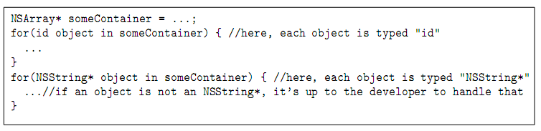
It results in code that looks better and runs faster.
它会使得代码看起来更好、运行速度更快。

Example Codes:
void testFastEnumeration(){
NSArray* array = [NSArray arrayWithObjects:
@"first", @"second", @"third", nil];
for(int i=0;i<[array count];i++)
{
nslog(“%@”,[array objectAtIndex:i]);
}
array:要遍历的数组名
in：关键字
id elem：遍历出的当前元素。
for( id elem in array )
NSLog(@"%@", elem );
}

Sorting 排序
实现数组元素排序的前提：实现了元素的compare方法，即可以比较元素大小。
By taking advantage of an NSMutableArray method called
sortUsingSelector: , you can sort a array easily. The argument is a selector which uses to compare two elements. The result returned from that selector method is to be of type NSComprisonResult.
(通过利用一种名为 sortUsingSelector: 的 NSMutableArray 方法，你可以轻松地进行数组排序。)

It should return NSOrderedAscending（上升） if you want the sorting method to place the first element before the second in the array, return NSOrderedSame (相等)if the two elements are considered equal, or return NSOrderedDescending（下降） if the first element should come after the second element in the sorted array.
(NSOrderedAscending 升序返回。如果两个元素被视为相等，则返回 NSOrderedSame 的排序方法， NSOrderedDescending降序返回)

[anArray sortedArrayUsingSelector:
@selector(compareMethod:)];

NSArray* array1 = [NSArray arrayWithObjects:@"one",@"two",@"three",nil];
NSArray*array2;
array2 = [array1 sortedArrayUsingSelector:@selector(compare:)];
NSLog(@"%@",array2);

NSMutableArray* array3 = [NSMutableArray arrayWithObjects:@"a",@"s",@"d",nil];
[array3 sortUsingSelector:@selector(compare:)];
NSLog(@"%@",array3);

The compareMethod: may declare as follow:
compareMethod: 方法可声明如下：

- (NSComparisonResult) compareMethod: (id) element;

Note that the default sort is an ascending one. However, you can easily perform a descending sort by modifying the compareMethod: method to reverse the sense of the values that are returned.
(请注意默认排序是ascending升序。但是，您可以轻松地通过修改 compareMethod: 返回值的方法，按降序排序。)

Common Methods 常见的方法

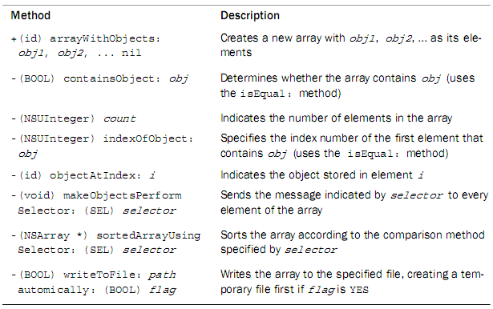
Common NSArray Methods:

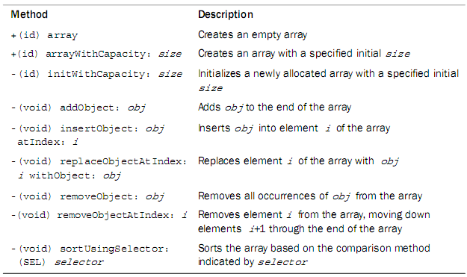
Common NSMutableArray Methods:

§ 4. Dictionary Objects 字典
A dictionary is a collection of data consisting of key-object pairs. Just as you would look up the definition of a word in a dictionary, you obtain the value (object) from an Objective-C dictionary by its key.
(字典是由一对键值对对象所组成的数据的集合。正如您将在词典中查找单词的定义，您从Objective-C 词典由它（对象）的键获得的值。)

The keys in a dictionary must be unique, and they can be of any object type, although they are typically strings. The value associated with the key can also be of any object type, but it cannot be nil.
(字典中的键必须是唯一的，它们可以是任何类型的对象，虽然它们通常是字符串。与键关联的值，也可以是任何对象类型的值，但它不能为nil。)

Dictionaries can be mutable or immutable; mutable ones can have entries dynamically added and removed. Dictionaries can be searched based on a particular key, and their contents can be enumerated.
(词典可以是可变或不可变的 ；可变的字典可以有动态地添加和删除。可以根据特定的键，搜索词典；它们的内容可以被枚举列出来。)

You can add key-value pairs to the dictionary using the
setObject: forKey: method.
增加一个object-key对。

After the dictionary has been constructed, you can retrieve the value for a given key using the objectForKey: @”name”method.
用指定的key，查找对应的值。

A dictionary can be defined with initial key-value pairs using the dictionaryWithObjectsAndKeys: method. The argument is a list of object-key pairs, each separated by a comma. The list must be terminated with the special nil object.
(一本字典可以被定义与使用的 dictionaryWithObjectsAndKeys:方法 初始化键-值对。该参数是对象密钥对的列表，每个以逗号分隔。列表中必须以特殊nil的对象终止。)

NSDictionary *bookmark
= [NSDictionary dictionaryWithObjectsAndKeys:
@"url", @"URL",
@"favicon", @"FAVICON",
@"title", @"TITLE", nil];

A fast enumeration loop can be used to retrieve each element from a dictionary one key at a time.
(快速枚举循环可以被用于从字典一键一次检索每个元素。)

- (NSArray *)allKeys; 枚举所有的key
- (NSArray *)allValues;枚举所有的value
NSDictionary* dic = [NSDictionary dictionaryWithObjectAndKey:@”tom”,@”name”,nil];
[dic allKeys];
[dic allValues];
[dic objectForKey:@”name”];

NSMutableDictionary* mdic = [NSMutabledictionary dictionaryWithDictionary:dic];
[mdic setObject:@”male” forKey:@”sex”];
[mdic setObject:@”44”forKey:@”age”];
[mdic removeObjectForKey:@”name”];
Nslog(“%@”,keysSortedbyValueUsingSelector:@selector(compare:));
Unlike array objects, dictionary objects are not ordered, so the first key-object pair placed in a dictionary might not be the first key extracted when the dictionary is enumerated.

If you want to order a dictionary, the keysSortedByValueUsingSelector: method does half of the work for you, returning the sorted keys in an array based on your sorting criteria.
返回一个字典的key数组，该数组已经按照selector指定的比较方法排好序。

Common NSDictionary Methods:字典方法
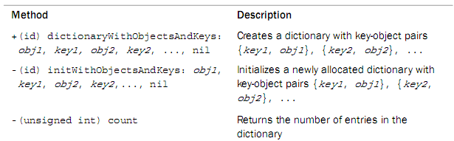
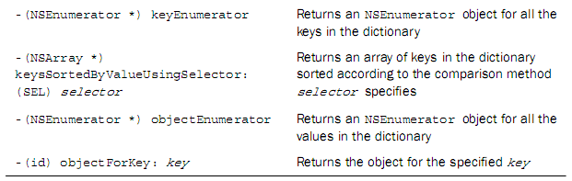

Common NSMutableDictionary Methods:可变字典方法
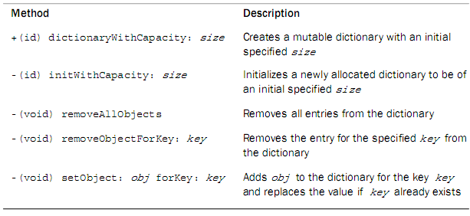

eg:
NSDictionary* dictionary = [[NSDictionary alloc] initWithObjectsAndKeys:
@"One",@"1",
@"Two",@"2",
@"Three",@"3",
nil];
NSLog(@"dictionary:%@",dictionary);
NSString *stringObject = [dictionary objectForKey:@"1"];
NSLog(@"string:%@",stringObject);
NSString *stringValue = [dictionary valueForKey:@"2"];
NSLog(@"string:%@",stringValue);
//获取字典中元素的个数
NSLog(@"dictionary Count:%d",[dictionary count]);
//遍历字典中的键
NSEnumerator * enumerator;//NSEnumerator是一个抽象类，其子类的实例列举的其他对象的集合，如数组和字典，
enumerator = [dictionary keyEnumerator];//列举字典中的键
id object;
while (object = [enumerator nextObject]) {
NSLog(@"keyEnumerator:%@ %@",object,[dic objectForKey:object]);
}
//遍历字典中的值（对象）
enumerator = [dictionary objectEnumerator];//列举字典中的值
while (object = [enumerator nextObject]) {
NSLog(@"objectEnumerator:%@",object);
}
//字典中的元素排序（默认升序NSOrderedAscending）
[dictionary keysSortedByValueUsingSelector:@selector(compare:)];比较的时候要记住那个nsnumber
NSLog(@"%@",dictionary);
[dictionary release];
===============================================
NSMutableDictionary *dictionary = [NSMutableDictionary dictionaryWithCapacity:5];

//添加字典
[dictionary setObject:@"One" forKey:@"1"];
[dictionary setObject:@"Two" forKey:@"2"];
[dictionary setObject:@"Three" forKey:@"3"];
[dictionary setObject:@"Four" forKey:@"4"];
NSLog(@"dictionary:%@",dictionary);
//删除指定的字典
[dictionary removeObjectForKey:@"3"];
NSLog(@"dictionary:%@",dictionary);
//删除字典中所有的键值对
[dictionary removeAllObjects];
NSLog(@"dictionary:%@",dictionary);

Chapter 8 Working with Files
文件：一般存储小型数据，SBjson，xml，对象等都可以存储
数据库：一般存储大型数据
A file or directory is uniquely identified to NSFileManager using a pathname to the file. A pathname is an NSString object that can either be a relative or full pathname.
使用NSFileManager类可以用来标识一个文件的目录，这个路径名是一个NSString。

A relative pathname is one that is relative to the current directory. So, the filename copy1.m would mean the file copy1.m in the current directory. Slash characters separate a list of directories in a path. The filename ch16/copy1.m is also a relative pathname.
(相对路径名是一种相对于当前目录的路径。所以，文件名 copy1.m 将意味着当前目录中的文件 copy1.m。 文件名 ch16/copy1.m 也是相对路径名。)

Full pathnames, also known as absolute pathnames, begin with a leading /. Slash is actually a directory, called the root directory.
(完整的路径名，也称为绝对路径名，以斜线／开始，斜线实际上就是一个目录，称为根目录。)
进入根目录： cd ／
The special tilde character (~) is used as an abbreviation for a user’s home directory. ~linda would, therefore, be an abbreviation for the user linda’s home directory, which might be the path /Users/linda. A solitary tilde character indicates the current user’s home directory, meaning the pathname ~/copy1.m would reference the file copy1.m stored in the current user’s home directory.
(特殊符 (~) 用作用户的主目录的缩写。因此~linda表示用户linda的主目录，该目录的路径可能是路径 /Users/linda 的缩写。单个字符表示当前用户的主目录，意味着路径名 ~/copy1.m 是主目录中的文件 copy1.m。)

Other special UNIX-style pathname characters, such as “.” for the current directory and “..” for the parent directory, should be removed from pathnames before they’re used by any of the Foundation file-handling methods. Assortments of path utilities are available that you can use for this.
(其他特别的 UNIX 样式路径名的字符如"."表示当前目录和".."为父目录（上一级目录）)

You should try to avoid hard-coding pathnames into your programs. As you’ll see, methods and functions are available that enable you to obtain the pathname for the current directory, a user’s home directory, and a directory that can be used for creating temporary files. You should avail yourself of these as much as possible.

§ 1. NSCoding 协议
The NSCoding protocol declares the two methods that a class must implement so that instances of that class can be encoded and decoded. This capability provides the basis for archiving (where objects and other structures are stored on disk) and distribution (where objects are copied to different address spaces).
（类的声明中有NSCoding 协议的，必须实现该协议的编码和解码这两种实例方法。此功能提供了基础的归档 （对象和其他结构存储在磁盘） 和解档 （对象都复制到不同的地址空间）功能。）

若将对象存入文件，该类必须遵循NSCoding协议，实现两个方法。

/****** NSObject.h ******/

- (void)encodeWithCoder:(NSCoder *)aCoder;
编码一个对象（以存入磁盘文件）
- (id)initWithCoder:(NSCoder *)aDecoder;
解码并初始化一个（来自磁盘文件的）对象
@end

Methods

encodeWithCoder:
Encodes the receiver using a given archiver.
从coder中读取数据，保存到相应的文件中，即反序列化数据
-(void)encodeWithCoder:(NSCoder *)encoder

initWithCoder:
Returns an object initialized from data in a given unarchiver.
读取文件中内容，并把这些数据写到实例中去。序列化数据
- (id)initWithCoder:(NSCoder *)decoder

NSCoder 是将支持 NSCoding 协议的 对象 状态 序列化成二进制的 NSData ,这样 data就能存到硬盘上.那么再次启动的时候如果硬盘上有这个data就可以通过反向decoder 来获得上次保存的状态.
但是,支持NSCoding协议的类是有限的 比如 UIImage 就不支持这个协议。

NSCoder 是一个抽象类，抽象类不能被实例话，只能提供一些想让子类继承的方法。
NSKeyedArchiver 把对象写到二进制流中去。
NSKeyedUnarchiver 从二进制流读取对象。

Example Codes:

/****** AddressCard.h ******/
@interface AddressCard : NSObject <NSCoding,NSCoping> {
NSString* name;
NSString* email;
}

@property (nonatomic,copy) NSString* name;
@property (nonatomic,copy) NSString* email;
@end
/****** AddressCard.m ******/
@implementation AddressCard

@synthesize name, email;

存档（将数据存入文件）
-(void) encodeWithCoder:(NSCoder *)aCoder{
[aCoder encodeObject:name forKey:@"name"];
[aCoder encodeObject:email forKey:@"email"];
}

解档并初始化（读取文件中的数据）
-(id)initWithCoder:(NSCoder *)aDecoder{
if (self = [super init]) {
self.name = [aDecoder decodeObjectForKey:@"name"];
self.email = [aDecoder decodeObjectForKey:@"email"];
}
return self;
}
@end
/****** Classes.m ******/
#import "AddressCardCategory.h"

int main (int argc, const char * argv[]) {
AddressCard* card1 = [[AddressCard alloc]init];

card1.name = @"Tom";
card1.email = @"Tom@gmail.com";

归档类：把对象card1归档到此文件中去（此时系统会自动调用协议中的归档方法）
[NSKeyedArchiver archiveRootObject:card1
toFile:@"/tmp/AddressCard.txt"];

解档类：把对象card1从此文件中去取出（此时系统会自动调用协议中的解档方法）

AddressCard* card4 = [NSKeyedUnarchiver
unarchiveObjectWithFile:@"/tmp/AddressCard.txt"];
NSLog(@"card4 %@",card4);
return 0;
}

总结：在自己的类中实现NSCoding协议作用是使自己的类支持“由类转换到NSData”的功能（仅是添加支持）。而真正实现此功能的是NSKeyedUnarchiver的unarchiveObjectWithData和NSKeyedArchiver的archivedDataWithRootObject。（类到NSData的转化）

§ 2. Managing Files and Directories 管理文件和目录

Working with the NSData Class 读写文件时用的内存缓冲区buffer
When working with files, you frequently need to read data into a temporary storage area, often called a buffer. When collecting data for subsequent output to a file, a storage area is also often used. Foundation’s NSData class provides an easy way to set up a buffer, read the contents of the file into it, or write the contents of a buffer out to a file.
(使用文件时，您需要频繁地将一个数据读入一个临时地存储区，通常称它为缓冲区。随后收集数据输出到文件中时，也经常使用存储区。Foundation的 NSData类中提供了简单的方法用来设置缓冲区，文件的内容读入缓冲区，或读出缓冲区的内容将它写入一个文件。)

And just in case you’re wondering, for a 32-bit application, an NSData buffer can store up to 2GB. For a 64-bit application, it can hold up to 8EB or 8000GB of data.
(有一点不要奇怪，对于32 bit应用程序，NSData 缓冲区最多可以存储2 GB的数据。对于64 bit应用程序，它可以保存最 8EB(80亿GB) 或 8000GB 的数据。)

把磁盘文件的数据，写入缓冲区NSData。
NSData* data2 = [NSData dataWithContentsOfFile:@"/tmp/AddressCard.txt"];
NSLog(@"%@",data2);

把缓冲区的数据，写入文件。
[data2 writeToFile:@"/tmp/AddressCard4.txt" atomically:YES];文件不存在就创建一个

As you would expect, you can define either immutable (NSData,不可变缓冲区) or mutable (NSMutableData,可变缓冲区) storage areas.
(正如你所期望的你可以定义不变的缓冲区（NSData，不可变缓冲区)或可变 （NSMutableData，可变缓冲区）缓冲区。)

The Foundation framework enables you to get access to the file system to perform basic operations on files and directories. This is provided by NSFileManager, whose methods include the capability to:

NSFileManager 文件管理类，提供了对文件和目录的基本操作：创建、改名、移动、删除、测试是否存在……

- Create a new file 创建一个新文件
- Read from an existing file 从现有文件中读取
- Write data to a file 向文件中写入数据
- Rename a file 重命名文件
- Remove (delete) a file 删除文件
- Test for the existence of a file 测试文件的存在
- Determine the size of a file as well as other attributes确定文件的大小，以及其他属性
- Make a copy of a file 复制一个文件
- Test two files to see whether their contents are equal 测试以查看两个文件内容是否相等
Many of these operations can also be performed on directories. For example, you can create a directory, read its contents, or delete it.
(上述多数操作可以直接在目录上执行。例如，可以创建一个目录、 读取其中的内容，删除目录。)

Working with Files
Each of the file methods is invoked on an NSFileManager object that is created by sending a defaultManager message to the class.
(每个文件是通过发送NSFileManagerle类创建的对象调用 defaultManager的方法获取的。)

创建一个NSFileManager对象
NSFileManager* fm = [NSFileManager defaultManager];

The attributesOfItemAtPath:error: method returns a dictionary containing the specified file’s attributes.
通过attributesOfItemAtPath:error:返回一个字典属性，包含了文件的各种属性。
The attributes dictionary includes information such as the file’s owner, its size, its creation date, and so on. Each attribute in the dictionary can be extracted based on its key, all of which are defined in <Foundation/NSFileManager.h>.
（字典的属性包括一些信息,例如文件的主人,它的大小,它的创作日期等等。文件中每个属性可提取它自己的键,所有这一切都是定义在<Foundation/NSFileManager.h>.中的）

For example, NSFileSize is the key for a file’s size.
NSFileSize是用于一个文件大小的键

NSError* err = nil;定义一个错误对象
NSDictionary* attr = [fm attributesOfItemAtPath:@”filepath”error:&err];@”filepath”是一个文件路径

从属性字典里取出一个特定属性：文件大小
int filesize = [[attr objectForKey:NSFileSize] intValue];

The contentsAtPath: method simply takes a pathname and reads the contents of the specified file into a storage area that it creates, returning the storage area object as the result or nil if the read fails.
（contentsAtPath:方法简单地需要一个路径并读取指定文件的内容到一个存储区域,结果是返回存储区域的对象或如果读取失败返回nil。）

NSData* data = [fm contentsAtPath:@"/tmp/AddressCard.txt"];
AddressCard* card1 = [NSKeyedUnarchiver unarchiveObjectWithData:data];
NSLog(@"card1 %@",card1); 分两步实现，上面只需要一步就完成data自己的方法。

The createFileAtPath:contents:attributes: method creates a file with the specified attributes (or uses the default if nil is supplied for the attributes argument). The contents of the specified NSData object are then written to the file.
（createFileAtPath:contents:attributes: 方法创建了一个文件与指定的属性(或使用用默认属性参数nil)。然后写入NSData对象的内容到所指定文件。）
也可以用上面的writetofile直接写入到文件
The attributes dictionary enables you to specify the permissions for a file you are creating or to obtain or change information for an existing file. For file creation, if you specify nil for this parameter, the default permissions are set for the file.

Nil默认权限
[fm createFileAtPath:@"/tmp/AddressCard2.txt" contents:data attributes:nil];

Common NSFileManager File Methods:
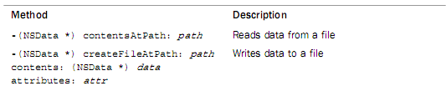
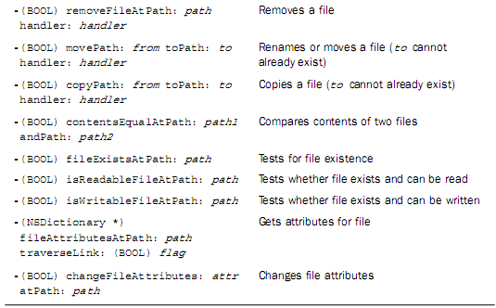

Working with Directories 目录
目录的枚举：列出目录的文件（ls命令）
显示目录的两个方法
Sometimes you need to get a list of the contents of a directory. This enumeration process can be accomplished using either the enumeratorAtPath:(递归枚举，还枚举子目录的内容) or the directoryContentsAtPath: （非递归枚举，只枚举当前目录的内如）method.
（有时你需要一个目录列表内容。这时可以使用枚举的方法完成，使用enumeratorAtPath: 或 directoryContentsAtPath:方法）

An NSDirectoryEnumerator object gets returned by the
enumeratorAtPath: method. Now, each time you send a nextObject message to this object, you get returned a path to the next file in the directory you are enumerating. When no more files are left to enumerate, you get nil returned.
（NSDirectoryEnumerator(字典枚举数)对象通过enumeratorAtPath：方法，你会的得到一个被返回的路径，你会返回一个到下一个目录中的文件,这是列举，当没有文件被列举的时候，你将会得到返回nil）
NSDirectoryEnumerator* dirEnum =
[fm enumeratorAtPath:@"/tmp"];
NSMutableArray* subpath;
while( (subpath = [dirEnum nextObject]) != nil )
NSLog(@”%@”, subpath);返回所有该路径下的文件

In the case of directoryConentsAtPath: the contents of the specified directory are enumerated, and the file list is returned in an array by the method. If any of the files contained in a directory is itself a directory, its contents are not recursively enumerated by this method.
（一旦使用directoryConentsAtPath：方法，被指定的路径就会被列举，这些文件的列表还是在数组中。）

系统内部实现的方法是：
-(NSArray) contentsOfDirectoryAtPath: (NSString )
patherror: (NSError**)error
Return Value
An array of NSString objects identifying the directories and files (including symbolic links) contained in path. Returns an empty array if the directory exists but has no contents. Returns nil if the directory specified at path does not exist or there is some other error accessing it.
（一个字符串数组对象被包含在标识的目录和文件的路径中。如果指定的目录存在,但没有内容，返回一个空的数组。如果目录路径不存在或其它错误指定返回nil。）

Common NSFileManager directories Methods:
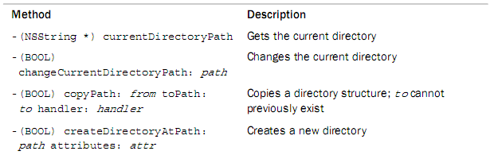
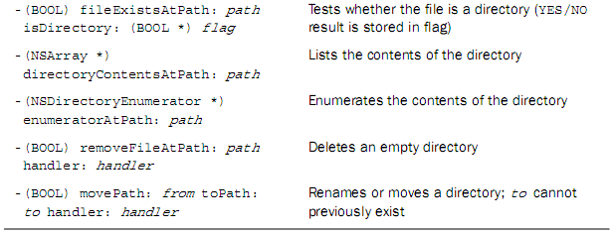

void testFile(){

// using NSData 把磁盘中文件AddressCard.txt的数据写入缓存区NSData中
NSData* data2 = [NSData dataWithContentsOfFile:@"/tmp/AddressCard.txt"];
NSLog(@"%@",data2);

//把缓冲区的数据，写入文件AddressCard4.txt中。
[data2 writeToFile:@"/tmp/AddressCard4.txt" atomically:YES];

//创建一个NSFileManager对象（初始化固定）
NSFileManager* fm = [NSFileManager defaultManager];

// read data from a file 读取文件的内容到缓存区data
NSData* data = [fm contentsAtPath:@"/tmp/AddressCard.txt"];
NSLog(@"%@",data);

//读取文件的内容到对象
AddressCard* card1 = [NSKeyedUnarchiver unarchiveObjectWithData:data];
NSLog(@"card1 %@",card1); //card1 name:Tom email:Tom@gmail.com

// write data to a file 创建一个文件AddressCard2.txt，将data中的数据写入到新创建的文件中
[fm createFileAtPath:@"/tmp/AddressCard2.txt" contents:data attributes:nil];
AddressCard* data1 = [NSKeyedUnarchiver unarchiveObjectWithFile:@"/tmp/AddressCard2.txt"];
NSLog(@"AddressCard2:%@",data1);

NSError* err=nil;
// rename file 移动文件AddressCard2.txt 到 AddressCard3.txt
[fm moveItemAtPath:@"/tmp/AddressCard2.txt" toPath:@"/tmp/AddressCard3.txt" error:&err];

// test for file existence 测试文件AddressCard3.txt是否存在
if( [fm fileExistsAtPath:@"/tmp/AddressCard3.txt"] ){
//contentsAtPath:方法读取指定文件中的内容
NSLog(@"AddressCard3:%@",[fm contentsAtPath:@"/tmp/AddressCard3.txt"]);
// remove file
[fm removeItemAtPath:@"/tmp/AddressCard3.txt" error:&err];
NSLog(@"AddressCard3:%@",[fm contentsAtPath:@"/tmp/AddressCard3.txt"]);
}

// attributes 获得指定目录下的文件中的属性（通过键值对获取）
NSDictionary* attr = [fm attributesOfItemAtPath:@"/tmp/AddressCard.txt" error:&err];
NSInteger filesize = [[attr objectForKey:NSFileSize] integerValue];
NSLog(@"file size = %d", filesize);

// dictionary
NSLog(@"%@", [fm currentDirectoryPath]); //返回字典的路径

//把@"/tmp"路径下的内容提取出来,保存在dirEnum中
NSDirectoryEnumerator* dirEnum = [fm enumeratorAtPath:@"/t "];
NSString* subpath;
NSMutableArray * mSubPath = [NSMutableArray arrayWithCapacity:10];
while ((subpath = [dirEnum nextObject]) != nil) {
[mSubPath addObject:subpath];
}
NSLog(@"enumeratorAtPath:%@", mSubPath);//返回所有该路径下的文件

//把@"/tmp"路径下的内容提取出来,不递归的保存在arr中
NSArray * arr = [fm directoryContentsAtPath:@"/tmp"];
NSLog(@"directoryContentsAtPath:%@",arr);

//以数组的形式返回字典中所指向的内容
NSArray * array = [fm contentsOfDirectoryAtPath:@"/tmp" error:&err];
NSLog(@"contentsOfDirectoryAtPath:%@",array);

}

§ 3. Working with Paths
用“分类Category”的方式，对NSString方法的扩展，专门操作路径的字符串。

NSPathUtilities.h includes functions and category extensions to NSString to enable you to manipulate pathnames. You should use these whenever possible to make your program more independent of the structure of the file system and locations of particular files and directories.
（NSPathUtilities.h文件包括功能和类别扩展,使你能够对NSString类操纵路径。）

NSTemporaryDirectory返回一个临时文件夹的路径
The function NSTemporaryDirectory returns the pathname of a directory on the system you can use for the creation of temporary files.

NSHomeDirectory 返回用户的主目录
NSHomeDirectoryForUser:返回指定用户的主目录
The NSHomeDirectory function returns the home directory for the current user. You can get the home directory for any particular user by using the NSHomeDirectoryForUser: function instead, supplying the user’s name as the argument to the function.

lastPathComponent返回的是最后路径下的文件夹
The lastPathComponent method extracts the last file in a path. This is useful when you have an absolute pathname and just want to get the base filename from it.

stringByAppendingPathComponent:方法是在该路径下追加一个路径（不需添加‘/’）
The stringByAppendingPathComponent: is useful for tacking on a filename to the end of a path. If the pathname specified as the receiver doesn’t end in a slash, the method inserts one in the pathname to separate it from the appended filename.
By combining the currentDirectory method with the method stringByAppendingPathComponent:, you can create a full pathname to a file in the current directory.
(currentDirectory方法是与stringByAppendingPathComponent: 相结合的方法,你可以在当前目录创造出完整的一个文件到路径。)
The pathExtension method gives the file extension for the provided pathname. If the file does not have an extension, the method simply returns an empty string.
（方法pathExtension给出了所提供的路径下文件后缀。如果文件没有延长的,简单的方法将返回一个空字符串。）

pathComponents方法以数组的形式返回一个指定路径下的每一个部分
The pathComponents method returns an array containing each of the components of the specified path.

Sometimes pathnames contain tilde (~) characters. The NSFileManager methods accept ~ as an abbreviation for the user’s home directory or ~user for a specified user’s home directory. If your pathnames might contain tilde characters, you can resolve them by using the stringByStandardizingPath（去除路径有~等的特殊符号路径） method. This method returns a path with these special characters eliminated, or standardized. You can also use the stringByExpandingTildeInPath(只有一个~的路径) method to expand just a tilde character if it appears in a pathname.
Common Methods for Working with Paths:
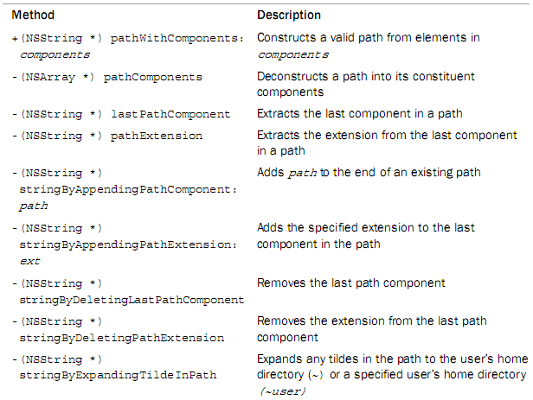
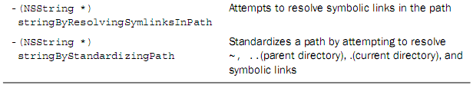
Common Path Utility Functions
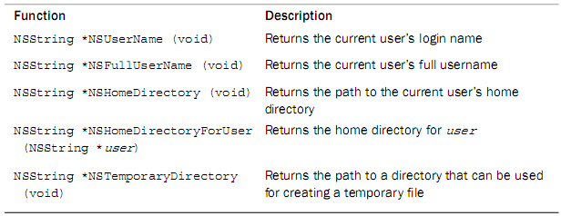
void testPath(){
NSLog(@"%@", NSTemporaryDirectory()); // 返回一个临时的目录:/var/folders/JQ/JQI9aqFUFHyeASzXNQPCUU+++TI/-Tmp-/

NSLog(@"%@", NSHomeDirectory()); //返回用户的主目录 /Users/mac

NSString* path = @"/tmp/AddressCard.txt";
NSLog(@"%@",path);

NSLog(@"%@", [path lastPathComponent]); //返回最后目录下的文件

NSLog(@"%@", [path stringByAppendingPathComponent:@"test"]);//在最后的目录下追加一个名为“test”的目录（不需添加‘／’）

NSLog(@"%@", [path pathExtension]);
NSArray* arr = [path pathComponents];//以数组的形式返回指定路径下的每一个元素
NSLog(@"%@", arr);

NSLog(@"%@", [@"~/.." stringByStandardizingPath]);//返回标准的用户的主目录

NSLog(@"%@", [@"~/tmp/AddressCard.txt" stringByExpandingTildeInPath]);//返回用户的主目录以及后缀字符

}

§ 4. Basic File Operations 基本文件的操作NSFileHandle:文件句柄（C＋＋里fstream）：
对单个文件，操作文件内部的数据。对文件的一部分，进行读写。
只能操作文件，不能操作目录。
NSFileManager:把文件作为整体进行操作管理。
To open a file and perform multiple read-and-write operations on the file, you use the methods provided by NSFileHandle. The methods in this class enable you to:
(你可以使用NSFileHandle所提供的方法，打开一个文件和在文件上执行多个read-and-write操作,。在这堂课你尽可能的去使用它做以下几点：)
- Open a file for reading, writing, or updating (reading and writing)
为阅读,写作,或者更新(读与写的能力) 打开文件
- Seek to a specified position within a file
寻求在文件指定位置
- Read or write a specified number of bytes from and to a file
从一个文件中读或写一个指定的字节数

In general follow these three steps when working with a file:
使用文件句柄的三个步骤：

- Open the file and obtain an NSFileHandle object to reference the file in subsequent(随后的) I/O operations. 用文件句柄打开一个文件
- Perform your I/O operations on the open file. 读写操作
- Close the file. 关闭文件

Common NSFileHandle Methods:
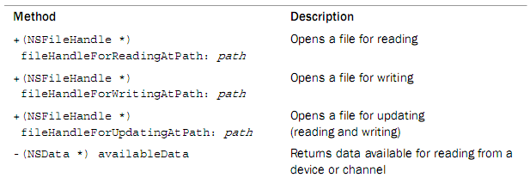
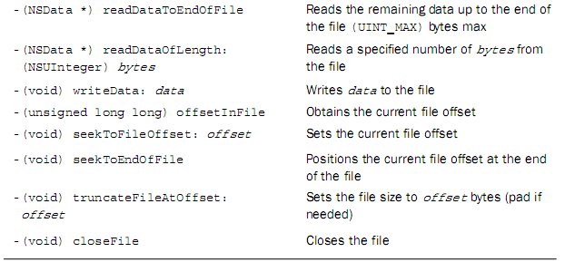

You should note that the FileHandle class does not provide for the creation of files. That has to be done with NSFileManager methods. So, both fileHandleForWritingAtPath: and fileHandleForUpdatingAtPath: assume the file exists and return nil if it doesn’t. In both cases, the file offset is set to the beginning of the file, so writing (or reading for update mode) begins at the start of the file.
（注意FileHandle类不能提供创建文件。是通过NSFileManager类得方法去完成的。因此fileHandleForWritingAtPath: 和 fileHandleForUpdatingAtPath:两个方法都是假设文件存在的，如果不存在则返回nil。在这两种情况下,文件是从头开始管理的，所以开始于文件的写入(或为更新模式读取)。

The method readDataToEndOfFile: reads up to UINT_MAX bytes of data at a time, which is defined in <limits.h> and equal to 0xFFFFFFFF. This will be large enough for any application you’ll have to write.
（每一次该方法readDataToEndOfFile:读字节的数据到文件结束,这是定义在<limits.h>中的，等于0 xFFFFFFFF。这将是大到足可以去写任何程序的地步。）

You can also break up the operation to perform smaller-sized reads and writes. You can even set up a loop to transfer a buffer full of bytes between the files at a time, using the readDataOfLength: method.
使用readDataOfLength:方法读取缓存中所指定的字节长度（默认从头读取）。

If a read method reaches the end of the file without reading any data, it returns an empty NSData object (that is, a buffer with no bytes in it). You can apply the length method to the buffer and test for equality with zero to see whether any data remains to be read from the file.
（如果一个读取方法达到文件的末尾没有读取任何数据,它返回一个空NSData对象(即一个没有字节的缓冲区)。你可以申请一个length方法去缓存区，测试它的值是否为0，看看是否有一些残余数据。）

If you open a file for updating, the file offset is set to the beginning of the file. You can change that offset by seeking within a file and then perform your read or write operations on the file.
（如果你为了更新打开一个文件,文件的偏移是从头开始的。你可以改变它的偏移,通过寻求一个文件然后对文件执行你的读或写操作。）

[fileHandle seekToFileOffset: 10]; //改变文件偏移从10开始

Relative file positioning is done by obtaining the current file offset and then adding to or subtracting from it.
（相应的文档是由获得当前文件偏移定位,然后增加或减少而得到的。）

Sampler Codes:
NSFileHandle* handleR =
[NSFileHandle fileHandleForReadingAtPath:
@"/tmp/AddressCard.txt"];读文件

// test for file existence
NSFileManager* fm = [NSFileManager defaultManager];
看文件是否存在
if( ![fm fileExistsAtPath:@"/tmp/AddressCard5.txt"] ){
[fm createFileAtPath:@"/tmp/AddressCard5.txt"
contents:nil attributes:nil];
}
NSFileHandle* handleW =
[NSFileHandle fileHandleForWritingAtPath:
@"/tmp/AddressCard5.txt"];打开一个写的句柄
[handleW seekToEndOfFile];到文件的末尾

NSData* data = nil;
while ([(data = [handleR readDataOfLength:100]) length] > 0) {
[handleW writeData:data];
}

[handleR closeFile];
[handleW closeFile];

9.Block
Block:
Block是由一堆可执行的程式组成，也可以看做没有名字的Function。
Apple有一个叫做GCD(Grand Central Dispach)的新功能，用在同步处理的环境下由更好的效率。Block语法产生的动机就是来自于GCD，用Block包好一个工作量交给GCD，GCD有一个宏观的视野可以分配CPU，而来做最好的决定。
Block其实和Function很像。
Block实体会长成这样
^(传入参数列表){行为主体};
Block实体开头是^,接着是由小括号所包起来的参数列表(比如int a,int b,float c),行为的主体由大括号包起来，专有名词叫做block literal。行为主体可以用return来返回值，如果没有参数列表是这样写(void)。

^(int a){return a*a;};
int result = ^(int a){return a*a;}(5);
NSLog(@”%d”,result);
后面小括号里面的5会被当成a的输入值，然后由block输出5*5=25指定给result这个变量。

Block Pointer是这样宣告的
返回值（^名字）（参数列表）；
int (^square)(int);
有一个叫square的Block Pointer，其所指向的Block是有一个int输入和int输出的Block
square = ^(int a){return a*a;};
int result = square(5);

接下来我们看看block相关的行为和特色:
首先是来看下block里面存取外部变量的方法：
- 存取变量：
{
int outA = 8;
int(^myPtr)(int)=^(int a){return outA*a;};
int result = myPtr(3); //24
}
再来看一个
{
int outA =8;
int(^myPtr)(int) =^(int a){return outA*a;};
outA = 3;
int result = myPtr(5); //15
}

看
{
NSMutableArray* mutableArray = [[NSMutableArray arrayWithObjects:@”one”,@”two”,@”three”,nil]];
Int result = ^(int a){[mutableArray removeLastObject];return a*a;}(5);
Nslog(@”test array = %@”,mutableArray);
}
- 直接存取static的变量
{
static int outA = 8;
int(^myPtr)(int)=^(int a){return outA+a;};
outA = 5;
int result = myPtr(3); //8
}或者
{
static int outA=8;
int(^myPtr)(int) =^(int a){outA =5;return outA+a;};
int result = myPtr(3); //8
}
- block variable
如果在一个变量前加上两个__，那么可以在块内更改变量的值
{
__block int num = 5;//类似于static
int(^myPtr)(int)=^(int a){return num++;};
int(^myPtr2)(int)=^(int a){return num++;};
int result = myPtr(0);
result = myPtr2(0);
}

生命周期和记忆体管理
因为block也是继承自NSObject，所以其生命周期和记忆体的管理也非常重要。
Block一开始被放在stack里面，换句话说其生命周期随着方法或函数结束就会被回收，和一般变量的生命周期一样。
关于记忆体的管理请遵循这几个要点
- block pointer的实体会再方法或函数结束后就被清理
- 如果要保持block pointer的实体要用-copy指令，这样block pointer就会被放到head里面
（11）block主体里用到的block variable也会被搬到heap而有新的记忆位置，且一并更新有用到这个block variable的block都指到新的位置
(22)一般的variable值会被copy
(33)如果主体里用到的variable是object的话，此object会被retain，block release时也会被release
(44)block variable里面用到的object是不会被retain的
typedef int (^MyBlock)(int);
MyBlock genBlock()
{
int a=3;
MyBlock inBlock=^(int n){
return n*a;
};
return inBlock;
}
MyBlock outBlock = genBlock();
int mm = outBlock(5);
NSLog(@"..%d",mm);
NSLog(@"%d",[outBlock retainCount]);
这个时候运行程序是崩溃的，因为inBlock没有被记忆，
MyBlock genBlock()
{
int a=3;
MyBlock inBlock=^(int n){
return n*a;
};
return [inBlock copy];
}这个时候inBlock被记忆了，就可以直接运行
因为inBlock被copy，所以一定要release。
MyBlock outBlock = genBlock();
int mm = outBlock(5);
NSLog(@"..%d",mm);
NSLog(@"%ld",[outBlock retainCount]);
[outBlock release];
如果返回值之后就不再需要这个值了可以
return [[inBlock copy]autorelease];

本地数组
MyBlock genBlock()
{
int a=3;
NSMutableString* myString = [[NSMutableString alloc] initWithString:@"a"];
MyBlock inBlock = ^(int n){
NSLog(@".....%ld",[myString retainCount]);
return a*a;
};
return [inBlock copy];
}
再看
MyBlock genBlock()
{
int a=3;
__block NSMutableString* myString = [[NSMutableString alloc] initWithString:@"a"];
MyBlock inBlock = ^(int n){
NSLog(@".....%ld",[myString retainCount]);
return a*a;
};
return [inBlock copy];
}在block里是不会被retain的。

自定义class
#import <Foundation/Foundation.h>

@interface MyObject : NSObject
{
NSString* title;
void (^myLog)(NSString* deco);
}
-(id)initWithTitle:(NSString*)newTitle;
-(void)logName;

@end

#import "MyObject.h"

@implementation MyObject
-(id)initWithTitle:(NSString*)newTitle{
if(self = [super init])
{
title = newTitle;
myLog = [^(NSString* deco){
NSLog(@"%@ %@ %@",deco,title,deco);
}copy];
}
return self;
}

-(void)logName
{
NSLog(@"---");
}
-(void)dealloc
{
[myLog release];
[title release];
[super dealloc];
}

@end

MyObject* mObj = [[MyObject alloc]initWithTitle:@"a"];
NSLog(@"%ld",[mObj retainCount]);
[mObj release];
这里是因为title而retain的

-(id)initWithTitle:(NSString*)newTitle{
if(self = [super init])
{
__block title = newTitle;
myLog = [^(NSString* deco){
NSLog(@"%@ %@ %@",deco,title,deco);
}copy];
}
return self;
}

-(id)initWithTitle:(NSString*)newTitle{
if(self = [super init])
{
title = newTitle;
myLog = [^(NSString* deco){
NSLog(@"%@ %@ %@",deco,newtitle,deco);
}copy];
}
return self;
}

10 KVC
KVC提供了一种在运行时而非编译时动态访问对象属性与成员变量的方式，该方法不需要调用get和set方法和变量实例就可以访问对象，KVC默认的实现方法有NSOject提供，这种方法及支持对象也支持简单数据类型。
第一、在OC中访问变量的几种方式：
1、设置为public型，通过->直接访问：
代码为：
@interface Book : NSObject
{
@public
NSString *name;
}
Book *book=[[Bookalloc] init];
book->name=@"hello";
NSLog(@"val is %@",book->name);
2.利用属性访问
3.利用KVC,即使该属性是private也可以访问
@interface Book : NSObject
{
@private
NSString *name;
}
Book *book=[[Bookalloc] init];
[book setValue:@"hello"forKey:@"name"];
NSLog(@"val is %@",[bookvalueForKey:@"name"]);
第二、KVC路径访问
除了通过键设置值外，键/值编码还支持指定路径，像文件系统一样，用“点”号隔开
[book valueForKeyPath:@"authorObj.name"]
sample:
[cpp] view plaincopyprint?
- <span style="font-size:18px"> Book *book=[[Book alloc] init];
- [book setValue:@"hello" forKey:@"name"];
- NSLog(@"val is %@",[book valueForKey:@"name"]);

- author *authorObj=[[author alloc] init];
- [authorObj setValue:@"niudun" forKey:@"name"];
- [book setValue:authorObj forKey:@"authorObj"];

- NSLog(@"the author of book is%@",[book valueForKeyPath:@"authorObj.name"]);</span>
第三、一对多
[cpp] view plaincopyprint?
- @interface Book : NSObject
- {
- @private
- NSString *name;
- author *authorObj;
- NSArray *relativeBooks;

- }

[cpp] view plaincopyprint?
- //kvc
- Book *book=[[Book alloc] init];
- [book setValue:@"hello" forKey:@"name"];
- NSLog(@"val is %@",[book valueForKey:@"name"]);

- //keypath
- author *authorObj=[[author alloc] init];
- [authorObj setValue:@"niudun" forKey:@"name"];
- [book setValue:authorObj forKey:@"authorObj"];
- NSLog(@"the author of book is%@",[book valueForKeyPath:@"authorObj.name"]);

- //一对多
- NSMutableArray *array=[NSMutableArray arrayWithCapacity:3];
- for (int i=0; i<3; i++) {
- Book *bookObj=[[Book alloc] init];
- NSString *name=[NSString stringWithFormat:@"job_%d",i];
- [bookObj setValue:name forKey:@"name"];
- [array addObject:bookObj];
- [bookObj release];
- }
- [book setValue:array forKey:@"relativeBooks"];
- NSArray *arr=[book valueForKeyPath:@"relativeBooks.name"];
- NSLog(@"arr is %@",arr);

//一、NSString
/*----------------创建字符串的方法----------------*/
//1、创建常量字符串。 NSString *astring = @"This is a String!"; //2、创建空字符串，给予赋值。
NSString *astring = [[NSString alloc] init];
astring = @"This is a String!";
[astring release];
NSLog(@"astring:%@",astring);
//NSString *astring = [[NSString alloc] init];
NSLog(@"0x%.8x", astring);
astring=@"This is a String!";
NSLog(@"0x%.8x", astring);
[astring release];
NSLog(@"astring:%@",astring);
//3、在以上方法中，提升速度:initWithString方法
NSString *astring = [[NSString alloc] initWithString:
@"This is a String!"];
NSLog(@"astring:%@",astring);
[astring release];
//4、用标准c创建字符串:initWithCString方法
char *Cstring = "This is a String!";
NSString *astring = [[NSString alloc]
initWithCString:Cstring];
NSLog(@"astring:%@",astring);
[astring release];
//5、创建格式化字符串:占位符（由一个%加一个字符组成）
int i = 1; int j = 2;
NSString *astring = [[NSString alloc] initWithString:
[NSString stringWithFormat:@"%d.This is %i string!",i,j]];
NSLog(@"astring:%@",astring); [astring release];
//6、创建临时字符串
NSString *astring;
astring = [NSString stringWithCString:
"This is a temporary string"];
NSLog(@"astring:%@",astring);

/*------从文件读取字符串:initWithContentsOfFile方法-------*/
NSString *path = @"astring.text";
NSString *astring = [[NSString alloc]
initWithContentsOfFile:path];
NSLog(@"astring:%@",astring);
[astring release];

/*------------写字符串到文件:writeToFile方法-------------*/
NSString *astring = [[NSString alloc] initWithString:
@"This is a String!"];
NSLog(@"astring:%@",astring);
NSString *path = @"astring.text";
[astring writeToFile: path atomically: YES];
[astring release];

/*----------------比较两个字符串----------------*/
//用C比较:strcmp函数
char string1[] = "string!";
char string2[] = "string!";
if(strcmp(string1, string2) = = 0)
{ NSLog(@"1"); }

//isEqualToString方法
NSString *astring01 = @"This is a String!";
NSString *astring02 = @"This is a String!";
BOOL result = [astring01 isEqualToString:astring02];
NSLog(@"result:%d",result);

//compare方法(comparer返回的三种值)
NSString *astring01 = @"This is a String!";
NSString *astring02 = @"This is a String!";
BOOL result = [astring01 compare:astring02] = = NSOrderedSame;
NSLog(@"result:%d",result);

//NSOrderedSame判断两者内容是否相同
NSString *astring01 = @"This is a String!";
NSString *astring02 = @"this is a String!";
BOOL result = [astring01 compare:astring02]
== NSOrderedSame;
NSLog(@"result:%d",result);
//NSOrderedAscending判断两对象值的大小(按字母顺序进行比较，astring02大于astring01为真)
NSString *astring01 = @"this is a String!";
NSString *astring02 = @"This is a String!";
BOOL result = [astring01 compare:astring02]
== NSOrderedAscending;
NSLog(@"result:%d",result);

//NSOrderedDescending判断两对象值的大小(按字母顺序进行比较，astring02小于astring01为真) //不考虑大小写比较字符串1 NSString *astring01 = @"this is a String!";
NSString *astring02 = @"This is a String!";
BOOL result = [astring01 caseInsensitiveCompare:astring02]
== NSOrderedDescending;
NSLog(@"result:%d",result);

//NSOrderedDescending判断两对象值的大小(按字母顺序进行比较，astring02小于astring01为真)
//不考虑大小写比较字符串
NSString *astring01 = @"this is a String!";
NSString *astring02 = @"This is a String!";
BOOL result = [astring01 compare:astring02
options:NSCaseInsensitiveSearch | NSNumericSearch]
== NSOrderedSame;
NSLog(@"result:%d",result);

//NSCaseInsensitiveSearch:不区分大小写比较
NSLiteralSearch:进行完全比较，区分大小写
NSNumericSearch:比较字符串的字符个数，而不是字符值。 /*-----------改变字符串的大小写------------*/
NSString *string1 = @"A String";
NSString *string2 = @"String";
NSLog(@"string1:%@",[string1 uppercaseString]);//大写
NSLog(@"string2:%@",[string2 lowercaseString]);//小写
NSLog(@"string2:%@",[string2 capitalizedString]);//首字母大小

/*----------------在串中搜索子串----------------*/
NSString *string1 = @"This is a string";
NSString *string2 = @"string";
NSRange range = [string1 rangeOfString:string2];
int location = range.location;
int leight = range.length;
NSString *astring = [[NSString alloc] initWithString:
[NSString stringWithFormat:@"Location:%i,Leight:%i",
location,leight]];
NSLog(@"astring:%@",astring);
[astring release];
/*----------------抽取子串 ----------------*/
//-substringToIndex: 从字符串的开头一直截取到指定的位置，但不包括该位置的字符
NSString *string1 = @"This is a string";
NSString *string2 = [string1 substringToIndex:3]; NSLog(@"string2:%@",string2);
//-substringFromIndex: 以指定位置开始（包括指定位置的字符），并包括之后的全部字符
NSString *string1 = @"This is a string";
NSString *string2 = [string1 substringFromIndex:3]; NSLog(@"string2:%@",string2);

//-substringWithRange: //按照所给出的位置，长度，任意地从字符串中截取子串
NSString *string1 = @"This is a string";
NSString *string2 = [string1 substringWithRange:
NSMakeRange(0, 4)];
NSLog(@"string2:%@",string2);
//扩展路径
NSString *Path = @"~/NSData.txt";
NSString *absolutePath = [Path stringByExpandingTildeInPath]; NSLog(@"absolutePath:%@",absolutePath); NSLog(@"Path:%@",[absolutePath stringByAbbreviatingWithTildeInPath]);
//文件扩展名
NSString *Path = @"~/NSData.txt";
NSLog(@"Extension:%@",[Path pathExtension]);

/*************NSMutableString *************************************************************//*---------------给字符串分配容量----------------*/
//stringWithCapacity: NSMutableString *String;
String = [NSMutableString stringWithCapacity:40];
/*---------------在已有字符串后面添加字符----------------*/
//appendString: and appendFormat:
NSMutableString *String1 = [[NSMutableString alloc] initWithString:@"This is a NSMutableString"];
//[String1 appendString:@", I will be adding some character"]; [String1 appendFormat:[NSString stringWithFormat:@", I will be adding some character"]]; NSLog(@"String1:%@",String1); /*--------在已有字符串中按照所给出范围和长度删除字符------*/
//deleteCharactersInRange:
NSMutableString *String1 = [[NSMutableString alloc]
initWithString:@"This is a NSMutableString"];
[String1 deleteCharactersInRange:NSMakeRange(0, 5)];
NSLog(@"String1:%@",String1);

/*--------在已有字符串后面在所指定的位置中插入给出的字符串------*/ //-insertString: atIndex:
NSMutableString *String1 = [[NSMutableString alloc]
initWithString:@"This is a NSMutableString"];
[String1 insertString:@"Hi! " atIndex:0];
NSLog(@"String1:%@",String1);

/*--------将已有的空符串换成其它的字符串------*/
//-setString:
NSMutableString *String1 = [[NSMutableString alloc]
initWithString:@"This is a NSMutableString"];
[String1 setString:@"Hello Word!"];
NSLog(@"String1:%@",String1);

/*--------按照所给出的范围，和字符串替换的原有的字符------*/ //-setString: NSMutableString *String1 = [[NSMutableString alloc] initWithString:@"This is a NSMutableString"];
[String1 replaceCharactersInRange:NSMakeRange(0, 4) withString:@"That"];
NSLog(@"String1:%@",String1);

/*----------判断字符串内是否还包含别的字符串(前缀，后缀)-------------*/
//01：检查字符串是否以另一个字符串开头
- (BOOL) hasPrefix: (NSString *) aString;
NSString *String1 = @"NSStringInformation.txt";
[String1 hasPrefix:@"NSString"]==1?NSLog(@"YES") : NSLog(@"NO");
[String1 hasSuffix:@".txt"] = = 1 ? NSLog(@"YES") : NSLog(@"NO"); //02：查找字符串某处是否包含其它字符串
- (NSRange) rangeOfString: (NSString *) aString
，这一点前面在串中搜索子串用到过;
/******************************************************************************************* NSArray *******************************************************************************************/
/*---------------------创建数组------------------------------*/ //NSArray *array = [[NSArray alloc] initWithObjects: @"One",@"Two",@"Three",@"Four",nil];
NSArray * dataArray = array;
[array release];
//- (NSUInteger)count;数组所包含对象个数；
NSLog(@"dataArrayCound is: %d",[dataArray count]);
//- (id) objectAtIndex: (unsigned int) index;
//获取指定索引处的对象;
NSLog(@"self.dataArray cound 2:%@",
[self.dataArray objectAtIndex:2]);
/*-------从一个数组拷贝数据到另一数组(可变数级)---------------*/
//+ (id)arrayWithArray:(NSArray *)array;
NSArray *array1 = [[NSArray alloc] init];
NSMutableArray *MutableArray = [[NSMutableArray alloc] init];
NSArray *array = [NSArray arrayWithObjects:@"a",@"b",@"c",nil];
NSLog(@"array:%@",array);
MutableArray = [NSMutableArray arrayWithArray:array];
NSLog(@"MutableArray:%@",MutableArray);
array1 = [NSArray arrayWithArray:array];
NSLog(@"array1:%@",array1); //Copy
id obj;
NSMutableArray *newArray = [[NSMutableArray alloc] init];
NSArray *oldArray = [NSArray arrayWithObjects:
@"a",@"b",@"c",@"d",@"e",@"f",@"g",@"h",nil];
NSLog(@"oldArray:%@",oldArray);
for(int i = 0; i ＜ [oldArray count]; i++)
{
obj = [[oldArray objectAtIndex:i] copy];
[newArray addObject: obj];
}
NSLog(@"newArray:%@", newArray);
[newArray release];

//快速枚举

NSMutableArray *newArray = [[NSMutableArray alloc] init];

NSArray *oldArray = [NSArray arrayWithObjects:

@"a",@"b",@"c",@"d",@"e",@"f",@"g",@"h",nil];

NSLog(@"oldArray:%@",oldArray);

for(id obj in oldArray) {

[newArray addObject: obj];

}

NSLog(@"Fast Enumeration:\n newArray:%@", newArray);

[newArray release];
//Deep copy
NSMutableArray *newArray = [[NSMutableArray alloc] init];
NSArray *oldArray = [NSArray arrayWithObjects:
@"a",@"b",@"c",@"d",@"e",@"f",@"g",@"h",nil];
NSLog(@"oldArray:%@",oldArray);
newArray=(NSMutableArray*)CFPropertyListCreateDeepCopy(kCFAllocatorDefault, (CFPropertyListRef)oldArray, kCFPropertyListMutableContainers
);
NSLog(@"Deep copy:\n newArray:%@", newArray);
[newArray release];
//Copy and sort
NSMutableArray *newArray = [[NSMutableArray alloc] init];
NSArray *oldArray = [NSArray arrayWithObjects:
@"b",@"a",@"e",@"d",@"c",@"f",@"h",@"g",nil];
NSLog(@"oldArray:%@",oldArray);
NSEnumerator *enumerator;//NSEnumerator是一个抽象类，其子类的实例列举的其他对象的集合，如数组和字典，
enumerator = [oldArray objectEnumerator];
id obj;
while(obj = [enumerator nextObject]) {
[newArray addObject: obj];
}
[newArray sortUsingSelector:@selector(compare:)];
NSLog(@"Copy and sort:\n newArray:%@", newArray);
[newArray release];
//从字符串分割到数组:－ componentsSeparatedByString:
NSString *string = [[NSString alloc] initWithString:@"One,Two,Three,Four"];
NSLog(@"string:%@",string);
NSArray * array = [string componentsSeparatedByString:@","];
NSLog(@"array:%@",array);
[string release];
//从数组合并元素到字符串:- componentsJoinedByString:
NSArray *array = [[NSArray alloc] initWithObjects:@"One",@"Two",@"Three",@"Four",nil];
NSLog(@"array:%@",array);
NSString *string = [array componentsJoinedByString:@","];
NSLog(@"string:%@",string);
[array release];

/******************************************************************************************* NSMutableArray *******************************************************************************************/ /*---------------给数组分配容量----------------*/ //NSArray *array; array = [NSMutableArray arrayWithCapacity:20
/*--------------在数组末尾添加对象----------------*/
//- (void) addObject: (id) anObject;
NSMutableArray *array = [NSMutableArray arrayWithObjects:
@"One",@"Two",@"Three",nil];
[array addObject:@"Four"];
NSLog(@"array:%@",array);
/*--------------删除数组中指定索引处对象----------------*/
//-(void) removeObjectAtIndex: (unsigned) index;
NSMutableArray *array = [NSMutableArray arrayWithObjects:
@"One",@"Two",@"Three",nil];
[array removeObjectAtIndex:1];
NSLog(@"array:%@",array);
/*-------------数组枚举---------------*/
//- (NSEnumerator *)objectEnumerator;从前向后
NSMutableArray *array = [NSMutableArray arrayWithObjects:
@"One",@"Two",@"Three",nil];
NSEnumerator *enumerator;
enumerator = [array objectEnumerator];
id thingie;
while (thingie = [enumerator nextObject]) {
NSLog(@"thingie:%@",thingie);
}
//- (NSEnumerator *)reverseObjectEnumerator;从后向前
NSMutableArray *array = [NSMutableArray arrayWithObjects:
@"One",@"Two",@"Three",nil];
NSEnumerator *enumerator;
enumerator = [array reverseObjectEnumerator];
id object;
while (object = [enumerator nextObject]) {
NSLog(@"object:%@",object);
}

//快速枚举
NSMutableArray *array = [NSMutableArray arrayWithObjects:
@"One",@"Two",@"Three",nil];
for(NSString *string in array) {
NSLog(@"string:%@",string);
}
/***********************NSValue（对任何对象进行包装） ************************/
/*-------------------------将NSRect放入NSArray中-------------------*/
//将NSRect放入NSArray中
NSMutableArray *array = [[NSMutableArray alloc] init];
NSValue *value;
CGRect rect = CGRectMake(0, 0, 320, 480);
value = [NSValue valueWithBytes:&rect objCType:@encode(CGRect)];
[array addObject:value];
NSLog(@"array:%@",array);

//从Array中提取
value = [array objectAtIndex:0];
[value getValue:&rect];
NSLog(@"value:%@",value);
[array release];

/***************** NSDictionary ******************/
/*-------------------创建字典--------------------*/
//- (id) initWithObjectsAndKeys;
NSDictionary *dictionary = [[NSDictionary alloc] initWithObjectsAndKeys:
@"One",@"1",
@"Two",@"2",
@"Three",@"3",
nil];
NSLog(@"dictionary:%@",dictionary);
NSString *stringObject = [dictionary objectForKey:@"1"];
NSLog(@"string:%@",stringObject);
NSString *stringValue = [dictionary valueForKey:@"2"];
NSLog(@"string:%@",stringValue);
//获取字典中元素的个数
NSLog(@"dictionary Count:%d",[dictionary count]);
//遍历字典中的键
NSEnumerator * enumerator;//NSEnumerator是一个抽象类，其子类的实例列举的其他对象的集合，如数组和字典，
enumerator = [dictionary keyEnumerator];//列举字典中的键
id object;
while (object = [enumerator nextObject]) {
NSLog(@"keyEnumerator:%@",object);
}
//遍历字典中的值（对象）
enumerator = [dictionary objectEnumerator];//列举字典中的值
while (object = [enumerator nextObject]) {
NSLog(@"objectEnumerator:%@",object);
}
//字典中的元素排序（默认升序NSOrderedAscending）
[dictionary keysSortedByValueUsingSelector:@selector(compare:)];
NSLog(@"%@",dictionary);
[dictionary release];
/********************* NSMutableDictionary *******************/
/*---------------------创建可变字典-------------------*/
//创建
NSMutableDictionary *dictionary = [NSMutableDictionary dictionary];
//添加字典
[dictionary setObject:@"One" forKey:@"1"];
[dictionary setObject:@"Two" forKey:@"2"];
[dictionary setObject:@"Three" forKey:@"3"];
[dictionary setObject:@"Four" forKey:@"4"];
NSLog(@"dictionary:%@",dictionary);

//删除指定的字典
[dictionary removeObjectForKey:@"3"];
NSLog(@"dictionary:%@",dictionary);

/******************************************************************************************* 从目录搜索扩展名为jpg的文件 *******************************************************************************************/ //NSFileManager *fileManager = [NSFileManager defaultManager]; NSString *home; home = @"../Users/"; NSDirectoryEnumerator *direnum; direnum = [fileManager enumeratorAtPath: home]; NSMutableArray *files = [[NSMutableArray alloc] init]; //枚举 NSString *filename; while (filename = [direnum nextObject]) { if([[filename pathExtension] hasSuffix:@"jpg"]){ [files addObject:filename]; } } //快速枚举 //for(NSString *filename in direnum) //{ // if([[filename pathExtension] isEqualToString:@"jpg"]){ // [files addObject:filename]; // } //} NSLog(@"files:%@",files); //枚举 NSEnumerator *filenum; filenum = [files objectEnumerator]; while (filename = [filenum nextObject]) { NSLog(@"filename:%@",filename); } //快速枚举 //for(id object in files) //{ // NSLog(@"object:%@",object); //}

Objective-C++ is a kind of merge between Objective-C and C++. It is already usable, but some behaviours are still not perfect.

