Activity 1
Q1
The researchers aim to understand whether LinguaLift improves users’ language proficiency and how users experience the software. In particular, they want to examine whether hours of use and satisfaction with features such as ease of use, effectiveness, and engagement are positively related to learning improvement.
Q2a
Participant 13 appears unusual because they used the software for 52 hours, which is relatively high, but gave extremely low ratings for all four survey items (1, 1, 0, 1). This may suggest dissatisfaction despite continued use, compulsory participation, or a possible response error. Their data could distort the overall pattern by weakening the expected positive relationship between usage, satisfaction, and learning outcomes.
Q2b
A useful strategy would be to keep Participant 13 in the dataset but identify them clearly as a possible outlier, then compare results with and without this case. It would also be helpful to review their qualitative feedback, because their Q5 comment is positive while their ratings are very low, which may indicate inconsistent responses or a data entry issue.
Activity 2
Q3
The researchers could summarize the survey results using average scores for each question and frequency distributions for scores from 0 to 5. Simple visualisations such as grouped bar charts or summary tables would help developers quickly identify which areas perform well and which features need improvement.
Q4

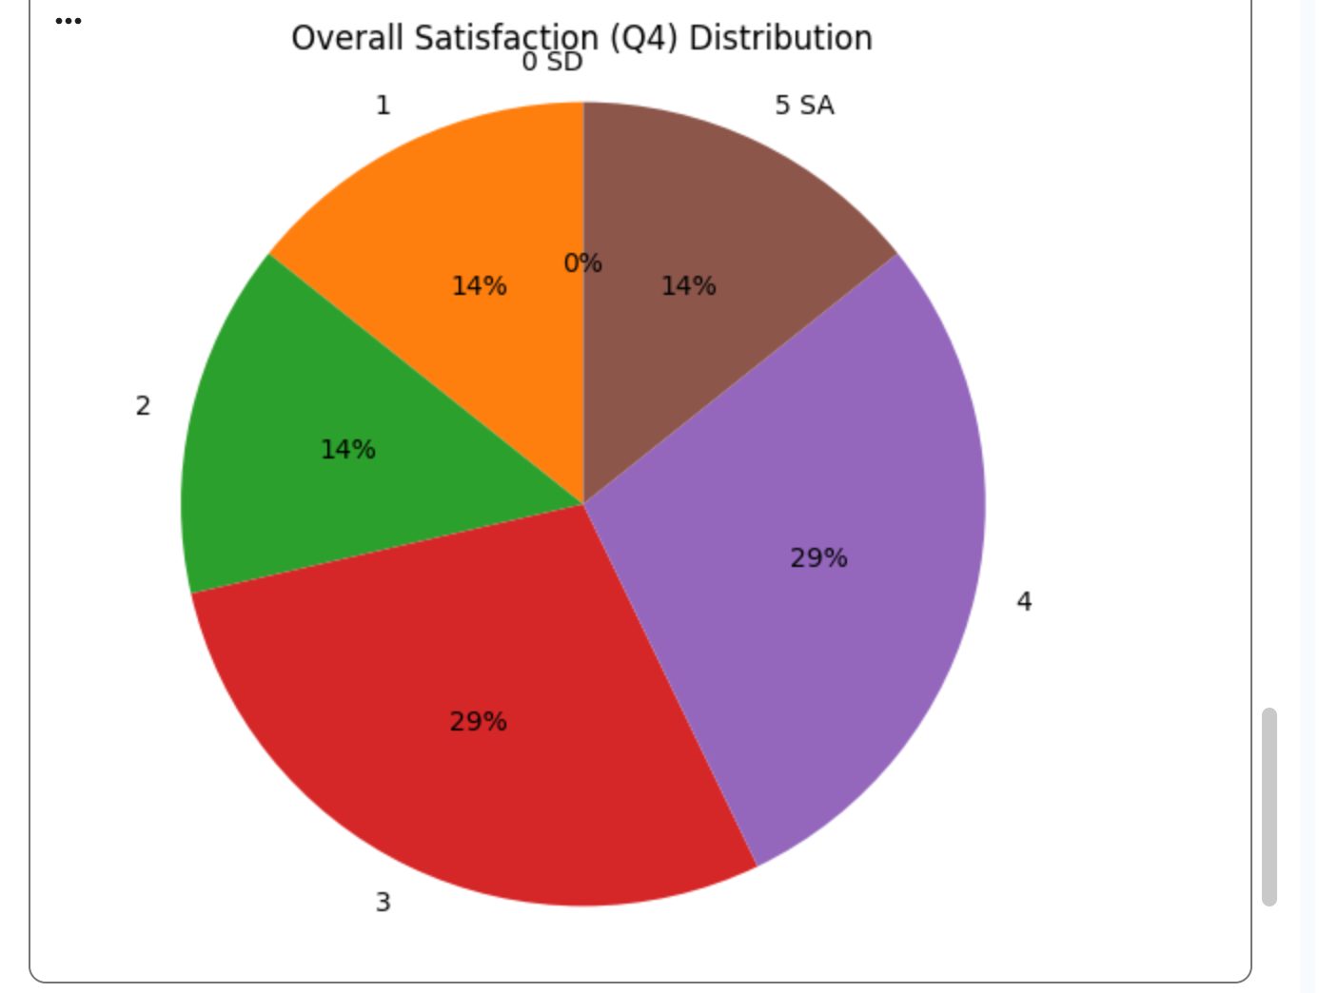
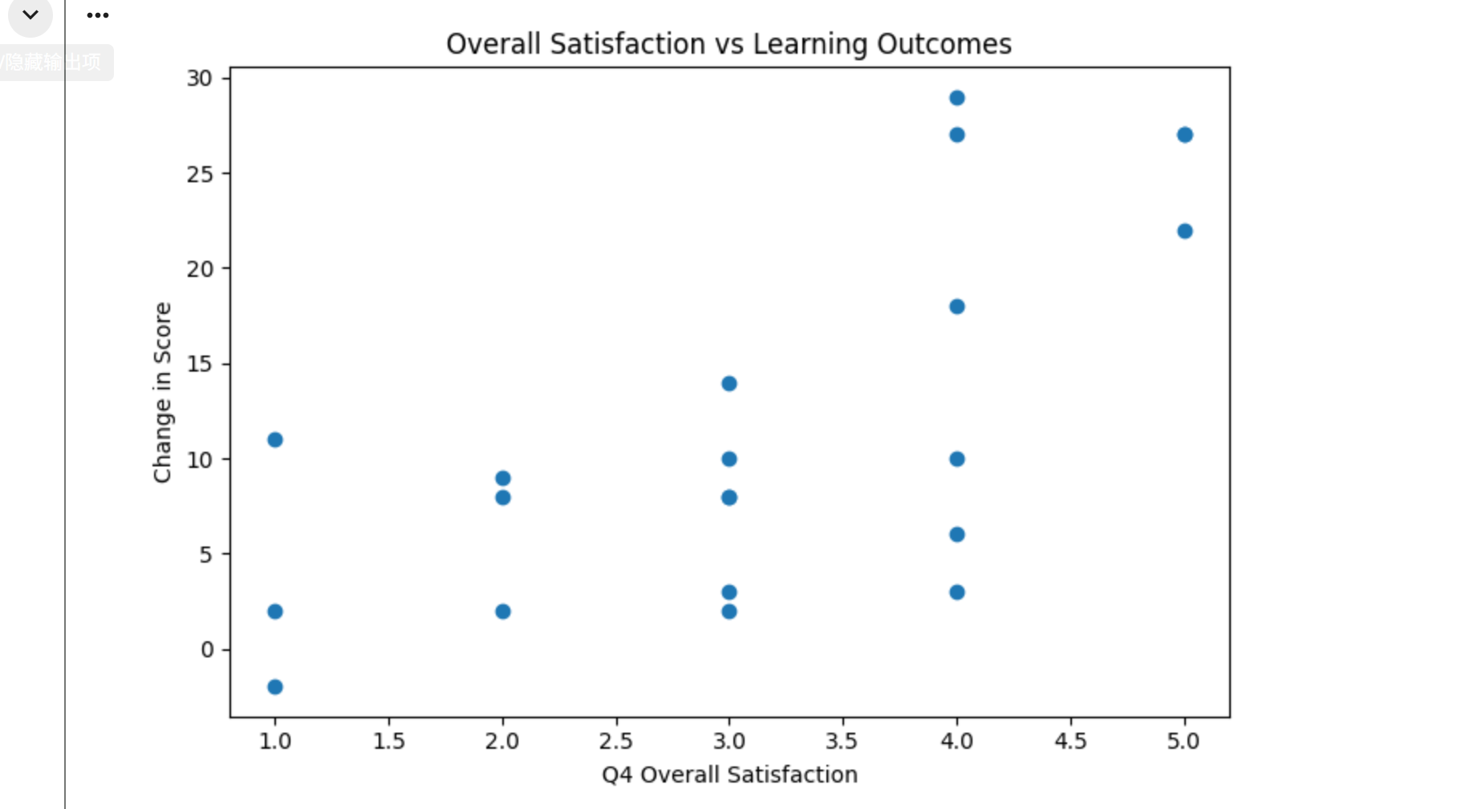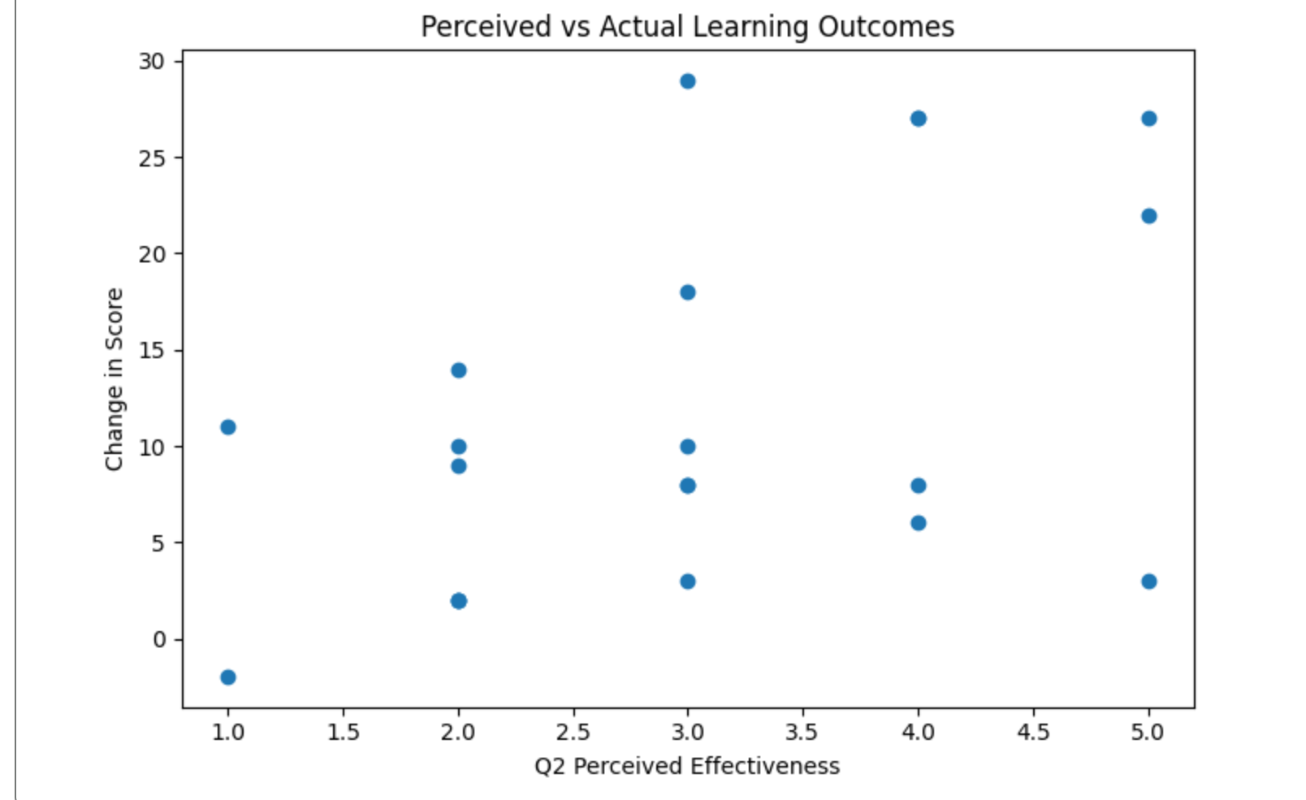
Activty3
Q5
- Usability Issues
• Complicated navigation
• User interface is not intuitive
• Some lessons are too long
- Technical Issues
• Occasional crashes during lessons
• Slow to load new lessons
• Occasional technical glitches
• Frequent crashes
- Engagement Features •
• Interactive quiz game
• Gamification elements
• Quiz game and feedback
• The lessons are engaging and fun
• Interactive games and quizzes
• Learning games
Flashcard game
- Learning Effectiveness •
Personalized learning paths
• Daily progress tracker
• Variety of exercises
• Progress tracking and learning path
• Comprehensive lessons
- AI Interaction
• AI conversations
• AI-driven practice conversations
• AI pronunciation feedback
• Grammar tips from AI
• Real-time feedback
• Real-time feedback on pronunciation
• Speech recognition needs improvement
• Inaccurate translations sometimes
• AI didn’t understand what I was saying
- Content Limitations and Diversity
Multiple language support
• Cultural insights
• Extensive vocabulary lists
• Needs more language options
• Too few examples in foreign language
• Lacks advanced content for proficient users
• Repetitive tasks
• Not enough cultural context
• A few games were a bit too easy
• Limited number of stories
• Some games can be too easy
• More examples needed in some sections
• Would have loved more flashcard variety
Q6
Learning Support
Another theme that could be developed from the data is Learning Support. This theme focuses on how the software helps users improve their language skills and includes codes such as Learning Effectiveness, AI Interaction, and some Engagement Features. Comments about personalised learning paths, real-time feedback, and AI grammar tips suggest that users value features that directly support their learning progress.
Content Quality and Variety
A second theme is Content Quality and Variety. This theme mainly relates to Content Limitations and Diversity, but also connects to Learning Effectiveness. Many participants mentioned the need for more language options, more examples, and more advanced content, indicating that the breadth and depth of learning materials strongly influence the overall usefulness of the app.
Activity5
Q7
The study design could be improved by collecting more detailed and structured data from both the software and the survey. First, the system could track more granular user behaviour, such as time spent on specific features, frequency of use, and dropout points during lessons. Second, the survey could include more specific questions, such as ratings for AI accuracy, content difficulty, and usability of navigation, rather than relying only on general satisfaction scores. In addition, increasing the sample size and recording participants’ baseline language proficiency more precisely would improve the reliability and comparability of the results. Finally, consistency checks could be added to the survey to reduce contradictory responses, such as the mismatch observed in Participant 13.
Q8
The main benefit of the mixed-method data set is that it combines quantitative patterns with qualitative explanations. The quantitative data shows measurable trends, such as the relationship between satisfaction scores and improvements in test results, while the qualitative data provides insights into why these patterns occur, such as users valuing AI interaction or complaining about technical issues. For example, the numerical scores alone cannot explain why some users reported low satisfaction, but the qualitative comments reveal issues like crashes, poor navigation, or lack of content. Therefore, the mixed-method approach allows researchers to gain a more complete and meaningful understanding of both user experience and learning effectiveness than either method alone.
Activity5
Using generative AI may produce faster and more generalised insights, such as identifying broader themes or summarising patterns in the data. However, human analysis is better at interpreting context and identifying inconsistencies, such as the contradictory responses of Participant 13. Therefore, while LLMs are useful for initial analysis, human judgment is still important for ensuring accuracy and depth.

