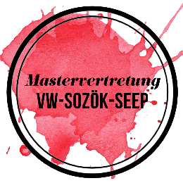

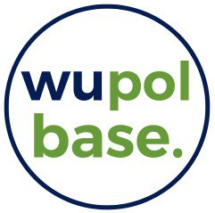
Certificate of

Participation

This is to certify that

has successfully participated in eight sessions (2h each) of R Tutorial organized by the VW-Zentrum, Wupol Base, and the Student Representation VW-SozÖk-SEEP at WU Vienna in the winter semester 2025.
The following topics were covered, allowing the student to independently perform empirical research in R, interpret results, and prepare them for applied use:
- Introduction to base R and data wrangling with tidyverse: Knowledge of R and RStudio environment, import data formats, data types, R syntax including loops and conditional statements, data manipulation and wrangling for further analysis, handling of survey datasets.
- Data visualization using ggplot2: principles of data visualization, accessibility standards, exporting figures and tables for publication.
- Handling spatial data: importing and transforming geodata, using the sf package, projections, maps, spatial autocorrelation.
- Multivariate analysis: Thorough walkthrough of multivariate estimation processes. Pre-estimation analyses (descriptives, variable selection), model specification, model building, linear regression, linear regression using surveydesign, interpretation of results, R², interpretation of interaction terms, model comparison, post-estimation techniques (residual diagnostics, robustness, multicollinearity, influence, …), (graphical) presentation of results.
- Handling complex datasets and weights: Use of complex survey datasets (Eurobarometer, EU-SILC, Austrian Time Use Survey), handling of multiple datasets and weights, linear regressions with surveydesign.
The course enables the participant to independently conduct all steps of an empirical research process, starting from exploratory data analysis but also emphasizing the importance of presenting results to a broader audience. The student is able to critically reflect and evaluate their results.

Vienna, 15.12.2025,

Clara Himmelbauer, instructor and course lead

