Asymmetric learning facilitates human inference   
of transitive relations

Simon Ciranka1,3*, Juan Linde-Domingo1*, Ivan Padezhki1, Clara Wicharz1, Charley M. Wu1,2, and Bernhard Spitzer1,3**

1Center for Adaptive Rationality, Max Planck Institute for Human Development, Berlin, Germany

2Human and Machine Cognition Lab, University of Tübingen, Tübingen, Germany

3Max Planck UCL Centre for Computational Psychiatry and Ageing Research, Berlin, Germany

*shared first-authors

**corresponding author, email: [spitzer@mpib-berlin.mpg.de](mailto:spitzer@mpib-berlin.mpg.de)

**Abstract**

**Humans and other animals are capable of inferring never-experienced relations (e.g., A>C) from other relational observations (e.g., A>B and B>C). The processes behind such transitive inference are subject to intense research. Here, we demonstrate a new aspect of relational learning, building on previous evidence that transitive inference can be accomplished through simple reinforcement learning mechanisms. We show in simulations that inference of novel relations benefits from an asymmetric learning policy, where observers update only their belief about the winner (or loser) in a pair. Across 4 experiments (n=145), we find substantial empirical support for such asymmetries in inferential learning. The learning policy favoured by our simulations and experiments gives rise to a compression of values which is routinely observed in psychophysics and behavioural economics. In other words, a seemingly biased learning strategy that yields well-known cognitive distortions can be beneficial for transitive inferential judgments.**

## 

## 

## 

## Main

Humans routinely infer relational structure from local comparisons. For instance, learning that boxer Muhammad Ali defeated George Foreman can let us infer that Ali would likely win against other boxers that Foreman had defeated. More formally, generalizing from relational observations to new, unobserved relations (e.g., knowing A>B and B>C leads to A>C) is commonly referred to as transitive inference [(Bryant & Trabasso, 1971; Burt, 1909; Jensen et al., 2015; Piaget, 1928)](https://www.zotero.org/google-docs/?UhQ6Y9). Transitive inference is not a uniquely human capacity [(see Vasconcelos, 2008 for a review)](https://www.zotero.org/google-docs/?4skNku) but can also be observed in non-human primates [(Boysen et al., 1993; Gillan, 1981; McGonigle & Chalmers, 1977)](https://www.zotero.org/google-docs/?L3JReh), rats [(Davis, 1992)](https://www.zotero.org/google-docs/?gvHw18), and birds [(Bond et al., 2003; Lazareva & Wasserman, 2012; Wynne, 1997)](https://www.zotero.org/google-docs/?bzjxLz).

In the laboratory, transitive inference can be observed after teaching subjects the relations between neighbouring elements from an ordered set of arbitrary stimuli (**Fig. 1a**). The neighbour relations are typically taught through pairwise choice feedback (**Fig. 1b**) where the relational information is deterministic (i.e., if A>B, in our sporting analogy, A would never lose a match against B). Various theories have been proposed to describe how observers accomplish transitive inferences of non-neighbour relations (e.g., A>D) in such settings. One class of models posits that subjects learn implicit value representations for each individual element (A, B, C, etc.), which then enables judgments of arbitrary pairings [(Delius & Siemann, 1998; Jensen et al., 2015; Wynne, 1995)](https://www.zotero.org/google-docs/?8ULgNR). Alternatively, transitive inference could be accomplished through more explicit, hippocampus-based memory processes [(Dusek & Eichenbaum, 1997; Garvert et al., 2017; Kumaran & McClelland, 2012; Smith & Squire, 2005)](https://www.zotero.org/google-docs/?J7oYBM), which we will return to further below.

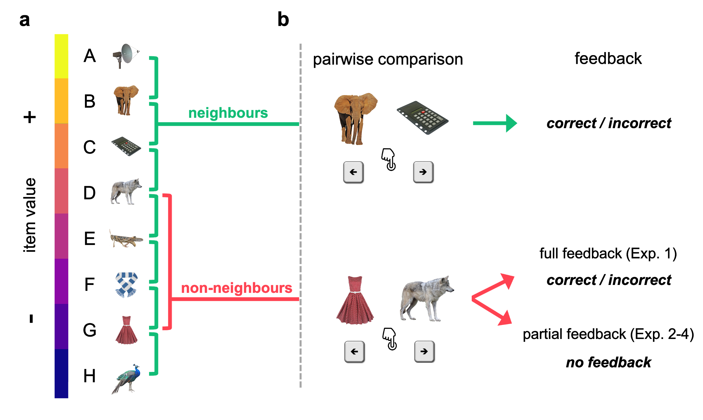

**Figure 1**. **a**, Exemplary stimulus set and hidden relational value structure. **b**, Example trials for pairwise comparisons of neighbouring (*top*) and non-neighbouring items (*bottom*). Participants are asked on each trial to select the higher-valued item. Choices on neighbour trials are always given feedback. Choices on non-neighbour trials are given feedback in the full-feedback condition, but not in the partial feedback condition (see text for details).

Before turning to transitive inference, we consider relational learning in a “full feedback” scenario (cf. Fig. 1b) where choice feedback is provided for every possible pairing of items, such that no transitive inference is required. We model implicit value learning in this setting through a simple reinforcement learning (RL) mechanism (*Q*-learning, see Methods) by which relational feedback (e.g., “correct” when selecting A over B) may increase the perceived value (*Q*) of item A and decrease that of item B (Model **Q1,** **Fig. 2a**). In this simple RL model, relational feedback *symmetrically* updates (with opposite signs) the value estimates for both items in a pair. For instance, if Muhammad Ali beat George Foreman, it seems rational to attribute this outcome to Ali’s greater skill as much as to Foreman’s deficit. We show in simulations that symmetric value updating is in fact optimal in the full feedback setting. An alternative model with *asymmetric* learning rates (α+ ≠ α-) applied to the winner and loser in a pair, respectively (Model **Q2**; “2” denotes dual learning rates), learns worse than the symmetric model (Q1) where (**Fig. 2b-c**). Implicit value learning generally gives rise to a “symbolic distance effect” [(Bryant & Trabasso, 1971; Frank et al., 2005; Hamilton & Sanford, 1978)](https://www.zotero.org/google-docs/?h5j2XJ), where nearby elements are less discriminable (due to more similar value estimates) than elements with greater ordinal distance [(von Fersen et al., 1991; Wynne, 1995)](https://www.zotero.org/google-docs/?M6Tfpa).

Next, we turn to a “partial feedback” setting, which is the typical transitive inference scenario, with feedback only being provided for pairs of items with neighbouring values (Fig. 1b). Here, the simple RL model only effectively learns about stimuli at the extremes of the ordered set (e.g., A and H, **supplementary** **Fig. S1a**), since these are statistically more likely to be winners or losers than their neighbours (under uniform sampling). No value learning occurs for intermediate items (stimuli B to G), since these are equally likely to be paired with lower and higher valued stimuli [(see also Jensen et al., 2015)](https://www.zotero.org/google-docs/?WxriRN). However, the model can easily be adapted to performing transitive inference when extending it with a simple assumption [(for similar approaches, see Kumaran et al., 2016; von Fersen et al., 1991; Wynne, 1995)](https://www.zotero.org/google-docs/?bhPkvV): value updates should scale with the difference between the estimated item values, *Q*(A)-*Q*(B). More specifically, to the extent that A is already higher valued than B, observing the expected outcome A>B should induce weaker value updates, whereas the unexpected outcome A<B should induce stronger updates. To illustrate, observing an unknown amateur boxer win against a world champion should induce stronger changes in belief than the opposite, less surprising result (champion>amateur). When incorporating this simple assumption into our model (Model **Q1\***), it learns orderly structured values, *Q*(A) > *Q*(B) > … > *Q*(H), and thus accomplishes transitive inferences for all pairs of items (**Fig. 2d**; see also **supplementary Movie M1** for illustration how our Q-learning models accomplish transitive learning). We also observe a symbolic distance effect with this type of learning under partial feedback, similar to what we observed with simple RL under full feedback (cf. Fig. 2d and 2a).

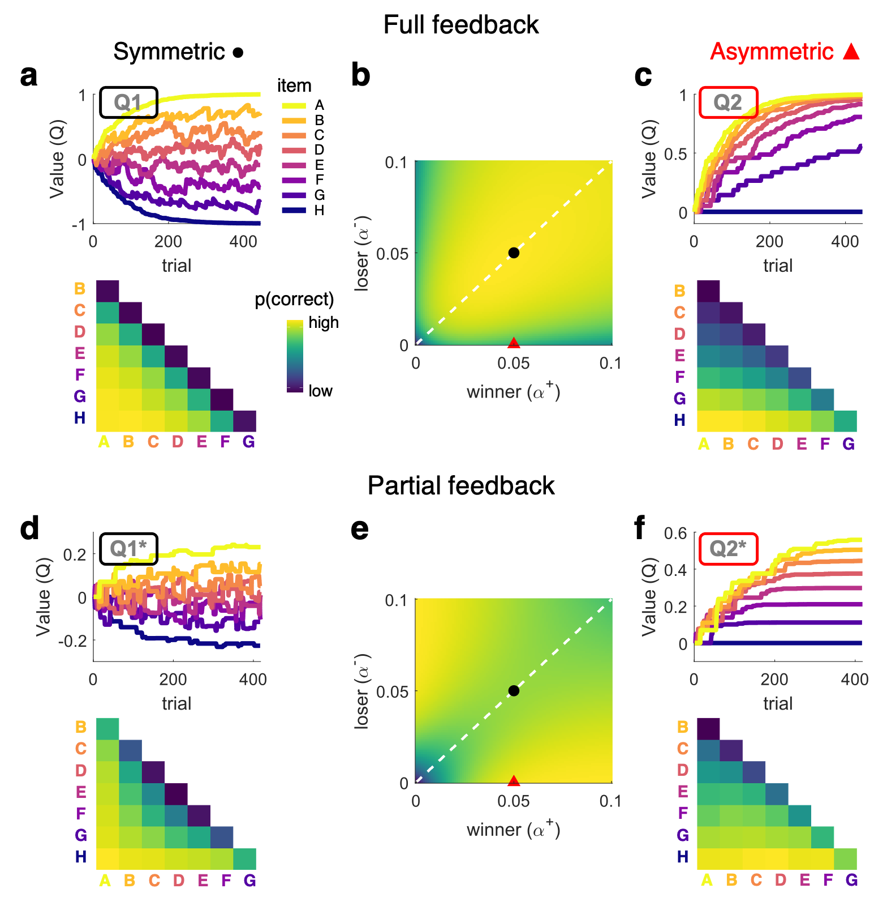

**Figure 2***.* Model simulations under full (panels a-c) and partial feedback (panels d-f); **a,** Item-level learning under full feedback (*grey* in Fig. 1, see Exp. 1) predicted by symmetric model Q1. *Upper*, exemplary evolution of item values (a.u.) over trials. *Lower*, predicted probabilities of correct choices for each item pairing. **b,** Simulated task performance (mean proportion correct choices on the second half of trials) of model Q2 across varying values of learning rates (winning items) and (losing items). For values on the diagonal (dashed white), model Q2 is equivalent to model Q1. Black dot indicates parameters used for simulation of symmetric learning in panel *a*. Red triangle indicates parameters used for asymmetric learning in panel *c*. **c,** Same as *a*, but using model Q2 with asymmetric learning rates. **d,** Same as *a*, but for model Q1* in a partial feedback scenario (see Exp. 2-4). **e and f,** Same as *b* and *c*, but using model Q2* under partial feedback. Note that asymmetric learning leads to lower performance under full feedback (*b*) but improves performance under partial feedback (*e*). Asymmetric learning results in a compressed value structure (*c* and *f*).

Notably, the effect of asymmetric learning rates (, Model **Q2\***) under partial feedback is strikingly different from what we observed with full feedback. Under partial feedback, optimal performance is achieved with a strongly asymmetric learning policy (α+>>α- or α+<<α-), where only the winner (or loser) in a pair is updated (**Fig. 2e-f**, see also supplementary Movie M1). In other words, in a setting where hidden relational structure is inferred from only local comparisons, it is surprisingly beneficial to ignore losers (or winners) in outcome attribution. Of note, the winner/loser asymmetry outlined here differs from, and is orthogonal to, previously described asymmetries in learning from positive/negative [(e.g., Frank et al., 2007; Lefebvre et al., 2017; Palminteri et al., 2015; van den Bos et al., 2012)](https://www.zotero.org/google-docs/?CnCLfe) or (dis-)confirmatory outcomes [(Lefebvre et al., 2020; Palminteri et al., 2017)](https://www.zotero.org/google-docs/?IieXul). A noteworthy aspect of our model Q2* is that the surprisingly superior, asymmetric learning policy results in a compression of the observer’s latent value structure (Fig. 2f). Selective updating therefore naturally gives rise to diminishing sensitivity towards larger values as is universally observed in Psychophysics [(Weber, 1834)](https://www.zotero.org/google-docs/?vVvFSs), numerical cognition [(Cheyette & Piantadosi, 2020; Nieder & Miller, 2003)](https://www.zotero.org/google-docs/?fAVnUR), and Behavioural Economics [(Kahneman & Tversky, 1979)](https://www.zotero.org/google-docs/?LZuh4C).

Going beyond typical studies of transitive inference with deterministic outcomes, we examined whether our simulation results generalize to scenarios where relational outcomes can be variable, as is the case in many real-world domains such as sports, stock markets, or social hierarchies. To this end, we added random variance to the comparison outcomes such that e.g., an item won over its lower-valued neighbour in approx. 80% of cases but lost in the other 20% (see *Methods* for details). Intuitively, we allowed for the possibility that competitor A may sometimes lose against B, even if A is generally stronger. We found that our simulation results held for such probabilistic environments, just as they did for deterministic scenarios (**supplementary Fig. S2)**.

Before turning to empirical data, we also consider an alternative strategy to solving transitive inferences [(Eichenbaum, 2004; McGonigle & Chalmers, 1977; O’Reilly & Rudy, 2001)](https://www.zotero.org/google-docs/?7cmHnl), which relies more directly on memories of pair relations experienced on previous trials (**supplementary** **Fig. S1b**). For instance, a sports enthusiast might remember Ali’s triumph over Foreman 1974 in Zaire[1], and also recall that Foreman had previously defeated Joe Frazier[2], to conclude that Ali would outmuscle Frazier in a fight[3] . More formally, when asked to judge the relationship between A and C, one might retrieve the “missing” (linking) neighbour relations (A-B, B-C) to infer a transitive comparison. In its simplest form, memory for pair relations can enhance performance on the neighbouring pairs proper (Model **P**, **supplementary Fig. S1b, *left***). To the extent that further pair relations can be retrieved through associative learning [(Kumaran & McClelland, 2012; Whittington & Bogacz, 2019)](https://www.zotero.org/google-docs/?TmtjcV) or spreading activation [(Anderson, 1983)](https://www.zotero.org/google-docs/?NovmqT), one may also infer non-neighbour relations through the linking of intermediate relations (Model **Pi**, **supplementary Fig. S1b, *right***). Such relational memory-based transitive inference gives rise to an *inverse* symbolic distance effect (Fig. S1b, *right*), where nearby pairs are more discriminable than more distant pairs, reflecting the high dimensionality of the underlying associative memory structure. In modelling our empirical data, we allow for both implicit value learning (models denoted by a Q), relational memory-based strategies (models denoted by a P), and a combination of both, in explaining human transitive inference.

## Results - Experiments

We report the results of four experiments (n=145) where we varied whether feedback was full or partial and whether it was probabilistic or deterministic (see *Methods*). In all experiments, participants were shown a pair of items (drawn from a set of 8) on each trial and were asked to make a relational choice (Fig. 1). Participants were given no prior knowledge about item values and could only learn through trial and error feedback.

### Full Feedback

In Experiment 1 (n=17), probabilistic choice feedback (see *Methods*) was provided after each of 448 sequential pair comparisons (“full feedback”). **Figure 3a** shows the mean proportions of correctly choosing the higher-valued item, averaged over all trials in Exp. 1. Descriptively, the choice matrix is dominated by a symbolic distance effect, as predicted by implicit value learning. Fitting our item-level learning models (Q1, Q2, Q1*, Q2*), the best fit of the data is provided by the simplest model (**Q1**) with a single learning rate for winners and losers (**Fig. 3c** and **3e**;protected exceedance probability: pxp(Q1)>0.99; mean BIC=361.79 ± 24.68 s.e.m.). In other words, participant behaviour was consistent with a symmetrical updating policy, which our simulations showed to be optimal in the full feedback setting.

### Partial Feedback

In Experiments 2-4, choice feedback was only provided on neighbour pairs (“partial feedback”) to study transitive inference. In these experiments, we increased the frequency participants were shown neighbouring pairs relative to non-neighbouring pairs to provide more learning opportunities, since the task is inherently harder. We verified that our simulation results were invariant to this modification (**supplementary Figure S3**). Otherwise, the design of Experiment 2 (n=31) was identical to Exp. 1. Experiment 3 (n=48) was an online replication of Exp. 2, where the pair items on each trial were shown side-by-side instead of sequentially. Experiment 4 (n=49) was similar to Exp. 3, but feedback was made deterministic (100% truthful) as in previous studies of transitive inference (see *Methods* for individual experiment details).

The choice data from each of the partial feedback experiments (Exp. 2-4, **Fig. 3b**) showed clear evidence for transitive inference, with above-chance performance for non-neighbouring pairs that never received feedback (mean accuracy averaged over non-neighbour trials, Exp. 2: 0.714 ± 0.028; Exp. 3: 0.698 ± 0.018; Exp 4: 0.709 ± 0.019; Wilcoxon signed-rank tests against chance level (0.5): all p<0.001, all r>0.84). Further, the grand mean choice matrices showed the following descriptive characteristics: (i) a symbolic distance effect similar to that observed with full feedback, (ii) an asymmetry with greater discriminability of lower-valued items, and (iii) relatively increased discriminability of neighbour pairs.

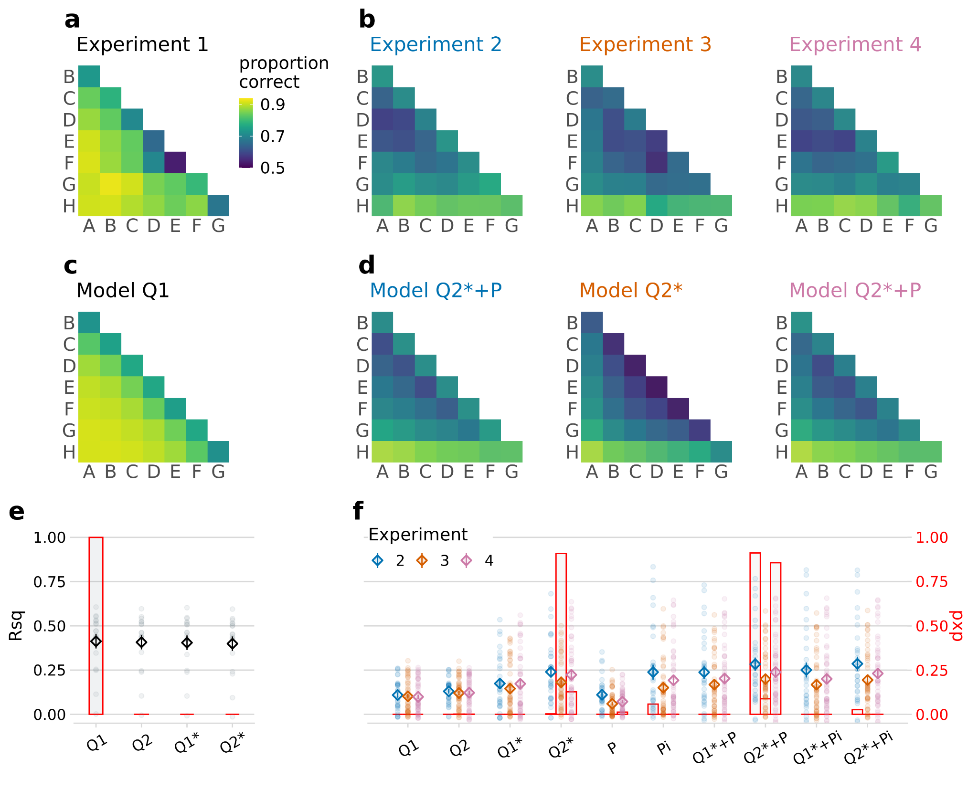

**Figure 3.** Empirical results and model fits. **a-b**, mean proportions of correct choices observed in each experiment (*a*, full feedback; *b*, partial feedback). **c-d**, mean choice probabilities predicted by the best fitting model in each experiment. **e-f**, model comparison (*e*, Exp.1; *f*, Exp. 2-4). Markers show variance explained (Rsq, Pseudo-R-squared, left y-axis; diamonds, mean; dots, individual participants. Rsq is inversely related to BIC, with larger values indicating better fit). Error indicators show s.e.m. Overlaid bar graphs indicate each model’s probability of being the winning model in terms of protected exceedance probability (pxp, right y-axis, see *Methods*). The model space is described with the nomenclature **Q:** item-level learning; **1/2:** symmetric/asymmetric; **\*:** difference-weighted updating; **P**: pair-relational learning; **i**: pair-relation-based inference.

The modelling results for the partial feedback experiments are summarized in **Fig. 3d** and **3f**. We highlight two main findings. Firstly, the partial feedback data were better described by asymmetric models with different learning rates for winners and losers. This held true at every level of model complexity, with our asymmetric models (Q2, Q2*, Q2*+P, Q2*+Pi) always performing better than their symmetric counterparts (Q1, Q1*, Q1*+P, Q1*+Pi; Wilcoxon signed-rank tests comparing BICs, Exp. 2-4 combined: all p<0.001, all r>0.35), and regardless of whether the partial feedback was probabilistic (Exp. 2 and 3; comparison of mean BIC between Q2- and Q1 models: both p<0.001, both r>0.60) or deterministic (Exp. 4; p<0.001, r=0.63). In other words, participants adopted an asymmetric learning policy which proved superior in our model simulations (cf. Fig. 2e). Secondly, behaviour in the partial feedback scenario was not fully described by item-level value learning alone. The winning model in Exp. 2 and 4 (Q2*+P; pxp=0.91 and 0.85; mean BIC=609.15 ± 12.77 and 434.27 ± 6.29) incorporated the additional assumption of memory for the pair relations (< or >) experienced on neighbour trials, in addition to the value estimates of the individual items. This pair-relational memory (+P, see *Methods*: *Models*) accounts for the relatively increased performance for neighbouring pairs in Exp. 2 and 4 (Fig. 3b, first off-diagonals, cf. supplementary Figure S1b). In Exp. 3, the model comparison was less clear, with model Q2* showing the highest pxp (0.91) but model Q2*+P providing a better average fit in terms of BIC (676.86 ± 19.40 vs. 692.09 ± 8.61, Wilcoxon signed-rank test: p<0.001, r=0.48). However, we found no evidence that pair-relational memory contributed to transitive inference in our experiments. Incorporating associative recall of “linking” neighbour pair relations (+Pi) worsened the model fits, both in terms of pxp (all pxp < 0.03) and BIC (Exp. 2-4 combined, Q2*+Pi: 570.42 ± 15.72 compared to Q2*+P: 567.60 ± 15.38; Wilcoxon signed-rank test: p<0.001, r=0.53), which is in line with the absence of an “inverse” symbolic distance effect (cf. Fig. S1b, *right*) in the empirical choice data (Fig. 3b).

We also compared our new model family against two previous models of transitive inference (see *supplementary Methods*): a classic value-transfer model [(VAT; von Fersen et al., 1991)](https://www.zotero.org/google-docs/?ETr3Fv) and a more recent model that is based on ranking algorithms used in competitive sports such as chess [(RL-ELO; Kumaran et al., 2016)](https://www.zotero.org/google-docs/?7uVU8t). When fitted to our partial feedback data (Exp. 2-4 combined), both VAT and RL-ELO were outperformed by our winning model Q2*+P (mean BIC VAT: 606.59 ± 14.04; RL-ELO: 617.96 ± 15.07; Q2*+P: 567.60 ± 15.38; Wilcoxon signed-rank tests vs. Q2*+P: both p<0.001, both r>0.65). This held true even when we modified VAT and RL-ELO to include pair-level learning (+P) and separate learning rates for winners and losers (mean BIC=572.95 ± 15.17 and 576.34 ± 15.94, respectively; both p<0.014, both r>0.21). Our new, asymmetric Q-learning process thus explained our experimental data better than these earlier models of transitive inference.

Our model simulations (Fig. 2e) indicated two aspects of asymmetric learning that are not directly evident from the group-level results shown in Fig. 3. First, performance benefits under partial feedback emerged not only for selective updating of winners, but likewise for selective updating of losers. Second, performance was highest for extreme asymmetries where the loser (or winner) in a pair was entirely ignored. We examined these aspects more closely on the individual participant level (**Fig. 4**). Half of our subjects in Exp. 2-4 (n=64) were indeed characterized by extreme asymmetry towards winners (with near zero). Interestingly, however, another subgroup (n=17) showed the opposite, an extreme asymmetry towards losers (with near zero). In other words, in the partial feedback setting, most individuals showed an extreme bias towards winners or losers, either of which proved to be optimal policies in our model simulations (Fig. 2e and Fig. S2, *right*). Under full feedback (Exp. 1), in contrast, we found no substantial asymmetries when allowing the learning rates for winners and losers to vary freely (model Q2, Fig. 4*, white bars*). Statistical analysis confirmed that the asymmetries under full feedback (Exp. 1) were significantly lower than under partial feedback (Mann–Whitney U test of absolute asymmetry indices collapsed over Exp. 2-4: p=0.006, r=0.23; see *Methods*).

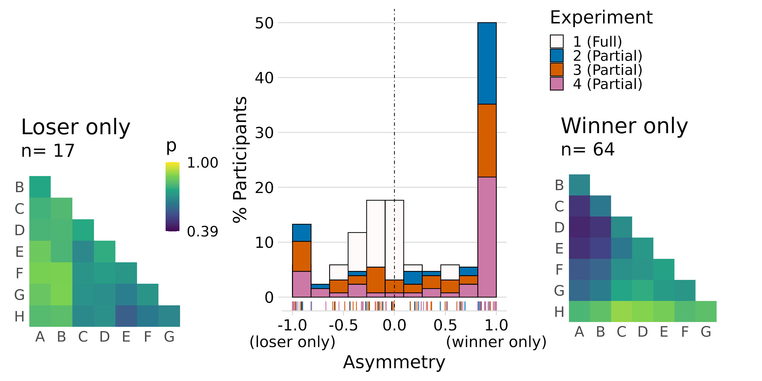

**Figure 4**. *Middle*, histogram of participants in Exp. 1 (full feedback, white) and Exp. 2-4 (partial feedback; color-coded) sorted according to normalized model-estimated asymmetry: . A majority (n=81 out of 128) of the participants in the partial feedback experiments (Exp. 2-4) showed strongly asymmetric updating either of winning or of losing items. Raster plot on bottom shows individual participant results (Exp. 1 shown in black). *Left*, mean choice behaviour of participants that were strongly biased towards losers (leftmost bar in *middle*). *Right*, same as *left,* for participants strongly biased towards winners (rightmost bar in *middle*).

A potentially surprising observation in the subgroup of participants who selectively updated winners (Fig. 4 *right*) is a tendency for *below*-chance performance for relatively high-valued non-neighbours (e.g., A-D) despite each individual performing robustly above chance overall (cf. *Methods*: *Participants*). A priori, RL-based models such as our Q-learning family could encompass below-chance performance only through the counterintuitive assumption of negative learning rates. Indeed, repeating our analysis while allowing for negative values of and/or yielded a small but significant improvement in model fit (mean BIC=562.52 ± 15.23 compared to 567.60 ± 15.07; Wilcoxon signed-rank test: p<.001, r=0.50). Upon closer inspection, in the *n*=64 participants who selectively updated winners (i.e., with a positive ; mean=0.069 ± 0.007), the estimate of indeed was weakly negative (mean=-0.009 ± 0.0016; Wilcoxon signed-rank test against zero: p<0.001, r=0.64). A potential explanation is that participants may sometimes have confused the pair items in memory at the time of feedback (cf. Fig. 1b, *right*). Under one-sided learning of only winners, such confusion would result in the losing item occasionally being updated with the incorrect sign, while no other learning about the loser would occur on the remaining trials. In our modelling, which did not consider memory confusions, this would manifest in a negative net learning rate for losers. No such result would be expected under more symmetric learning, where the effect of occasional confusions would be counteracted by correct learning (about either item) on the remaining trials. Thus, while the trend for a negative learning rate and the observation of systematically false inferences about certain item pairs (Fig. 4 *right*) seem illogical, they are consistent with a strongly asymmetric learning mechanism that is also prone to occasional memory errors.

To summarize our empirical findings, when transitive relations could only be inferred from local comparisons (Exp. 2-4), human learning was characterized by a one-sided outcome attribution, which proved to be surprisingly optimal in model simulations. In contrast, a symmetrical attribution of relational outcome to winners and losers emerged in a setting where all pair relations could be directly experienced (Exp. 1), and for which our simulations identified symmetrical updating to be the most efficient.

## Discussion

Reasoning about the relationships between arbitrary pairings of items is a key component of human intelligence. Through simulations, we showed how different learning regimes perform better in full and partial feedback contexts. Under full feedback, the best Q-learning model used *symmetric* learning to update the value estimates for the winning and losing items in opposite directions, with the same magnitude. However, under partial feedback (only for neighbouring items), the best learning model used *asymmetric* learning to only update the value representations for either the winner or the loser. Across four experiments, we find robust evidence that human learners used the best learning rule to match their feedback context. Participants used symmetric learning under full feedback (Exp. 1) and asymmetric learning under partial feedback (Exp. 2-4). While our asymmetric models allowed for a wide range of possible learning rate combinations, a majority of subjects showed one-sided learning, where value representations were only updated for either winners or losers.

An important feature found both in our model simulations and participant behaviour is a compression of the emerging implicit value structure, which results in a systematic decrease in discriminability of higher valued items (see Fig. 2f and Fig. 3b,d). This resembles the Weber-Fechner Law in psychophysics [(Weber, 1834)](https://www.zotero.org/google-docs/?AQo8dH), where sensitivity to stimulus differences diminishes with increasing magnitude [(see also Dehaene, 2003; Kahneman & Tversky, 1979)](https://www.zotero.org/google-docs/?QI47DS). While there exist alternative theoretical accounts for this ubiquitous phenomenon [(e.g., Pardo-Vazquez et al., 2019)](https://www.zotero.org/google-docs/?f0xjPI), our findings add a new perspective: compressed representations of magnitude emerge naturally from a learning policy that is optimized for inferring global relationships from only local comparisons. From this perspective, subjective compression might not only reflect an efficient adaptation to the distribution of stimuli in the environment [(e.g., Bhui & Gershman, 2018; Stewart et al., 2006; Summerfield & Li, 2018)](https://www.zotero.org/google-docs/?C3ruQS), but could also result from learning policies that enhance transfer to novel relationships.

In other contexts, previous RL studies have discovered different types of learning asymmetries, such as between positive and negative [(Lefebvre et al., 2017; Palminteri et al., 2015)](https://www.zotero.org/google-docs/?LfGbal) or confirmatory and disconfirmatory outcomes [(Palminteri et al., 2017)](https://www.zotero.org/google-docs/?P6FAXh). The one-sided learning policy highlighted here in the context of transitive inference is orthogonal to these other asymmetries but may play a similar role in leveraging a biased but advantageous learning strategy [(Lefebvre et al., 2020; see also Gigerenzer & Brighton, 2009; Wu et al., 2018)](https://www.zotero.org/google-docs/?aIqb9a). Unlike with *optimal* cognitive biases reported previously [(Juechems et al., 2021; Li et al., 2017; Luyckx et al., 2020; Spitzer et al., 2017; Tsetsos et al., 2016)](https://www.zotero.org/google-docs/?eZwFfE), we did not find the benefit of the present learning asymmetries to emerge from general limitations (noise) in decision making (**supplementary Fig. S4**). We speculate that human learners may adopt the present biases more strategically, in settings where the availability of only sparse feedback presages the requirement of future inferential judgments.

Previous theories have proposed richer and more complex cognitive mechanisms for transitive inference, often with an emphasis on the key role of the hippocampus in representing relational knowledge [(Dusek & Eichenbaum, 1997; Eichenbaum, 2000)](https://www.zotero.org/google-docs/?0YmtC4). Early research appealed to the idea that individuals used spatial representations to learn ordered value sequences [(Bryant & Trabasso, 1971; De Soto et al., 1965; McGonigle & Chalmers, 1977)](https://www.zotero.org/google-docs/?N4B24j). More recently, various models have been proposed that use associative learning mechanisms to describe how interactions between episodic memories in the hippocampus can generalize relational knowledge from local to distant comparisons [(Kumaran & McClelland, 2012; Whittington et al., 2020)](https://www.zotero.org/google-docs/?8rgYv4). In our present experiments, we found no evidence for transitive inference through such “associative linking” and failed to observe its key empirical prediction (an inverse symbolic distance effect, cf. Fig. 3b and S1b, *right*). We show instead that simpler mechanisms of value learning [(Frank et al., 2003; Van Elzakker et al., 2003; von Fersen et al., 1991)](https://www.zotero.org/google-docs/?uZVTkV) combined with clever biases (i.e., asymmetric learning rates) can be sufficient for performing TI and for accurately describing human learners.

In summary, we report evidence for pronounced asymmetries in transitive relational learning, where observers selectively update their beliefs only about the winner (or the loser) in a pair. Although asymmetric learning yields distorted value representations, it proves beneficial for generalization to new, more distant relationships. Thus, this biased learning regime appears well-adapted for navigating environments with relational structure on the basis of only sparse and local feedback.

## Methods

### Participants

Participants in Exp. 1 and 2 were recruited from a participant pool at the Max Planck Institute for Human Development. Of these, n=20 participated in Experiment 1, (13 female, mean age 27.15 ± 3.91 years) and n=35 participated in Experiment 2 (14 female, 27 ± 3.80 years). Participants in Exp. 3 and 4 were recruited online via Prolific Academic ([www.prolific.co](http://www.prolific.co)) with n=76 completing Exp. 3 (23 female, 24.73 ± 5.40 years) and n=60 completing Exp. 4 (23 female; 25.92 ± 4.54 years). Participants in Exp. 1 and 2 received a compensation of €10 per hour and a bonus of €5 depending on performance. Payment in Experiment 3 and 4 was £4.87 (£1.46 bonus) and £3.75 (£1.12 bonus), respectively. We obtained written informed consent from all participants and all experiments were approved by the ethics committee of the Max Planck Institute for Human Development.

Participants who did not reach above-chance learning levels were excluded from analysis. The threshold for inclusion was set to 60% correct judgments in the last two blocks of the experiment, which corresponds to a binomial test probability of p<0.01 compared to chance-level (50%). After exclusion, n=17 (Exp. 1), n=31 (Exp. 2), n=48 (Exp., 3) and n=49 (Exp. 4) participants remained for analysis.

### Stimuli, task, and procedure

in Exp. 1 and 2, eight pictures of everyday objects and common animals were used as stimuli (Fig. 1a). In Exp. 3 and 4, we included 12 additional pictures of objects and animals and selected for each participant a new subset of 8 images as stimuli. An additional set of 8 pictures was used for instructions and practice purposes in each experiment. All images were from the BOSS database [(Brodeur et al., 2014)](https://www.zotero.org/google-docs/?pV1Nwz), with the original white background removed.

All experiments involved learning the latent relations between the 8 stimuli (A>B>C>D>E>F>G>H) through pairwise choice feedback, where the latent value structure was pseudo-randomly assigned to the pictures for each participant. On each trial, a pair of pictures was presented and observers were asked to choose the higher-valued stimulus (two-alternative choice with time-out). All possible stimulus pairings (8 neighbours and 20 non-neighbours) were randomly intermixed across trials, with randomized ordering of the elements in a pair (e.g., A-B or B-A). Prior to all experiments, participants were given written instructions and were asked to complete two brief practice blocks to familiarize with the task.

**Experiment 1 (full Feedback, n=17).** On each trial, two items were presented one after the other at fixation (0.5 s/item) with an inter-stimulus interval of 2-3s (randomized). After the second item, Arabic digits “1” and “2” were displayed to the left and right of fixation (positions randomized across trials) and participants were asked to choose the higher-valued item by pressing the corresponding arrow key (left or right) within 2s. A written feedback message (“great” for correct responses, “incorrect” for errors) was shown after each choice (neighbouring and non-neighbouring pairs). The items’ latent values in Exp. 1 were probabilistic (with a Gaussian distribution) and designed such that feedback was truthful on approx. 80% of neighbour trials (“probabilistic feedback”). Each Participant performed 448 learning trials with all possible stimulus pairings (n=56) presented in each of 8 consecutive blocks. Experiments 1 and 2 were conducted in lab, using Psychophysics Toolbox Version 3 [(Brainard, 1997)](https://www.zotero.org/google-docs/?Wupwzw) running in MATLAB 2017a (MathWorks).

**Experiment 2 (partial feedback, n=31).** The design was nearly identical to Exp. 1, but choice feedback was only given after neighbouring pairs. After non-neighbouring pairs instead, a neutral “thank you” message was displayed. Neighbouring pairs were presented more often (2.5 times as often as non-neighbouring pairs), resulting in 616 trials (presented in 8 blocks of 77). In Exp. 2, we additionally recorded EEG and participants performed a brief picture viewing task prior to the experiment. These data were collected for the purpose of a different research question and are not reported here.

**Experiment 3 (partial feedback, n=48).** The basic design was identical to Exp. 2, except for the following changes: Both pair items were displayed simultaneously on screen for 2.5 s, one to the left and the other to the right of a centred fixation cross. Participants were instructed to quickly select the higher valued item using the left or right arrow key. After neighbouring pairs, a feedback message (“win” or ”loss”) was presented. After non-neighbouring pairs, no feedback message was shown. Experiments 3 and 4 were programmed in PsychoPy 2020.1.3 [(Peirce et al., 2019)](https://www.zotero.org/google-docs/?n7APKY) and conducted online (Pavlovia.org), with intermittent attention checks.

**Experiment 4 (partial feedback, deterministic, n=49).** The design was identical to Exp. 3, but feedback was always truthful (“deterministic feedback”). As learning expectedly proceeds faster with deterministic feedback, neighbouring pairs were presented only 2 times as often as non-neighbours and we reduced the number of trials to 420 (presented in 6 blocks of 70 trials).

### 

### Models

#### Item-level learning

To model how observers update their value estimates about the winning item and the losing item after relational feedback, we assume a simple delta rule (Rescorla & Wagner, 1972) (model **Q1**; Eq. 1a and 1b):

where is the estimated item value at time and is the learning rate.

Transitive inference is enabled by a modified updating rule [(similar to Kumaran et al., 2016; Wynne, 1995)](https://www.zotero.org/google-docs/?rNjjXa) based on the relative difference between the value estimates for the winner and the loser in a pair (Eq. 2):

where is a scaling factor. Value updating is then moderated by the extent to which feedback is consistent (or inconsistent) with (model **Q1\***; Eq. 3a and 3b):

for the winning item and the losing item , respectively. Note that Eq. 1 is a special case of Eq. 3 when .

We can also allow asymmetric updating of winners and losers by introducing separate learning rates and (models **Q2**/**Q2\***; Eq. 4a and 4b):

where the winning item is updated via and the losing item is updated via .

In order to convert the value estimates from item-level learning into pairwise choice probabilities for any two items and , we use a logistic choice function to define the probability of choosing based on the difference between the estimated item values (Eq. 5):

where is the (inverse) temperature parameter controlling the level of decision noise in choices based on item-level learning.

#### 

#### Pair-relational learning

For the partial feedback scenario, we also define an alternative learning model that tracks the learned relations between neighbouring items (rather than the individual items’ values). For each neighbouring pair (1..7), we can describe the relation between its members (e.g., A>B) probabilistically in terms of a beta distribution:

Following truthful feedback (e.g., “correct” when A>B was chosen), the upper value of the beta distribution is updated (Eq. 6a):

whereas following untruthful feedback (only in experiments with probabilistic feedback, see Exp. 2 and 3), the lower value is updated (Eq. 6b):

with acting as a learning rate. We can thus define the learned neighbour relation at time based on the expectation of the beta distribution (Eq. 7):

where reflects indifference and values of larger (or smaller) than 0.5 reflect a preference for the true (or opposite) relation. While this mechanism can learn the relation between neighbouring items under partial feedback, it fails to learn the relations between non-neighbouring items for which there is no direct feedback signal. However, transitive inference of non-neighbouring relations is possible through associative recall of those neighbour relations that “link” the two non-neighbour items in question. To allow for this possibility, we define the inferred relation between any two items and *j* via the intermediate neighbour pair relations separating and (Eq. 8):

where is the rank distance between the items’ true values, and is a free parameter reflecting failure to retrieve linking relations in the range . If , non-neighbour relation will be a lossless average of all intermediate neighbour relations (i.e., perfect memory). As grows, the preference between non-neighbours will shrink to indifference with increasing distance between and . In other words, this model performs perfect transitive inference if, and no transitive inference as . Note that for neighbour pairs (where ), Eq. 8 is equivalent to Eq. 7.

We again use a logistic choice rule to define the probability of choosing item over based on pair relation subject to decision noise (Eq. 9):

|  |  |  |
| --- | --- | --- |
|  | . |  |

From Equations 6-8, we constructed alternative models incorporating pair-relational learning (Model **P,** where is fixed at a large value) and pair-relational inference (Model **Pi**, where is a free parameter).

To combine item-level and pair-relational learning, we assume that choices are triggered by whichever of the two models provides a stronger preference on a given trial. Thus, choices are based on item-level learning () if (Eq. 10a):

and are based on pair-relational learning () if (Eq. 10b):

This effectively implements a mixture of item- and pair-level learning.

#### Model space

From Equations 1-10, we constructed a nested model space with either one or two learning rates (**1**: symmetric, **2**: asymmetric updating, cf. Eq. 4). One set of models allows for simple item-level RL only (Models **Q1** and **Q2**) or additionally for item-level transitive inference (Models **Q1\*** and **Q2\***, Eq. 1-5). Alternative models (Eq. 6-9) incorporated pair-relational learning (Model **P**) and pair-relational inference (Model **Pi**). Mixture models (Eq. 10) combined item-level and pair-relational learning, specifically (**Q1*+P**, **Q2*+P, Q1*+Pi, Q2*+Pi**)**.** Technically, all models under study were derived from the most flexible model Q2*+Pi with individual parameter restrictions (e.g., yields model Q2*; or yields symmetric updating).

#### Performance simulations

We simulated the performance of our item-level learning models (Q1, Q2, Q1*, Q2*) in tasks akin to those used in the human experiments, with full and partial feedback (Fig. 2 and Fig. S1-S2). The performance simulations were run in Matlab R2020a (MathWorks). Models were initialized with flat priors about the item values (all , i.e., the first choice was always a random guess with ). Like in the human experiments, choice feedback was provided either for all pairs (full feedback) or only for neighbour pairs (partial feedback). We simulated model performance over a range of learning rates ( and , 0 to 0.1 in increments of 0.001). Relational difference-weighting () was set to either 0 (models Q1/Q2) or 8 (models Q1*/Q2*), and decision noise () was set to 0.2 and 0.04 (full and partial feedback) which resembles the noise levels estimated in our human observers in the respective experiments. Mean choice probabilities (e.g., Fig 2a *lower*) and performance levels (e.g., Fig 2b) were simulated using the same number of trials and replications (with a new trial sequence) as in the respective human experiments. Simulation results under partial feedback (Fig. 2e and S2-4) were qualitatively identical when inspecting performance on non-neighbouring pairs only.

#### Parameter estimation and model comparison

Model parameters were estimated by minimizing the negative log-likelihood of the model given each observer’s single-trial responses across values of the model’s free parameters [within bounds (lower;upper): //(0;0.2), (0;10), (0;1), (0;1), (0;100), (0;1), with a uniform prior]. All model fitting was performed in R (R core team, 2020; [https://www.R-project.org/](http://www.r-project.org/)). Minimization was performed using a differential evolution algorithm [(Mullen et al., 2011)](https://www.zotero.org/google-docs/?FXITD1) with 200 iterations. We then computed the Bayesian Information Criterion (BIC) of each model for each participant and evaluated the models’ probability of describing the majority of participants best [(protected exceedance probability, pxp; Rigoux et al., 2014)](https://www.zotero.org/google-docs/?xIrkHJ). In Fig. 3e and 3f, we also provide a Pseudo-R-squared computed as , which quantifies goodness of fit relative to a null model of the data, with larger values indicating better fit [(similar to McFadden, 1973)](https://www.zotero.org/google-docs/?iwM5xG). Model comparisons for Exp.1 (full feedback) were restricted to item-level learning models, as the availability of direct feedback for every pairing would equate pair-level learning models (P, Pi) to homogenous learning of all pairs, obviating contributions from transitive inferences.

To quantify model-estimated asymmetry (Fig. 4), we computed an index of the normalized difference in learning rates which ranges from -1 (updating of losers only) to 1 (updating of winners only), with indicating symmetric updating. For comparison between full and partial feedback experiments, we contrasted the absolute estimated from the winning models in Exp. 2-4 (Q2*+P/Q2*, see Fig. 3) with that estimated from model Q2 in Exp. 1.

#### Model- and parameter recovery

To establish whether the individual models can be distinguished in model comparison we simulated, for each participant and model, 100 experiment runs using the individuals’ empirical parameter estimates under the respective model. We then fitted the generated data sets (binomial choice data) with each model and evaluated how often it provided the best fit (in terms of BIC). This way we estimated the conditional probability that a model fits best given the true generative model []. However, a metric more critical for evaluating our empirical results is , which is the probability that the data was generated by a specific model, given that the model was observed as providing the best fit to the generated data [(Wilson & Collins, 2019)](https://www.zotero.org/google-docs/?64zwii). We compute this probability using Bayes theorem, with a uniform prior over models []:

To mimic the level of inference in our human data fitting, we examined mean and on the experiment level, based on full simulations of all participants in Exp. 1 (full feedback) and Exp. 2 (partial feedback). Critically, under partial feedback (cf. Exp. 2-4), all our models were robustly recovered with this approach (**supplementary Fig. S5**).

Under full feedback (Exp. 1), human participant behaviour was best characterized by symmetric learning rates (), even when both learning rates were free parameters (Fig. 3e and Fig. 4). To test whether we could have detected asymmetric learning, had it occurred in Exp. 1, we enforced asymmetry in simulation by setting to values near zero (by drawing from a rectified Gaussian with and ). We likewise enforced difference-weighted updating () when simulating model Q2*, by setting to similar levels as empirically observed in the partial feedback experiments ( and ). With this, the model recovery for Exp. 1 successfully distinguished between symmetric (Q1/Q1*) and asymmetric learning models (Q2/Q2*, **supplementary Fig. S6**). However, models with difference-weighted updating (Q1*/Q2*, Eq. 2-3) were partly confused with models Q1/Q2. In other words, our empirical finding of Q1 as the winning model in Exp. 1 (Fig. 3e) does not rule out the possibility of Q1* as the generative process under full feedback.

To establish whether our inferences about model parameters (e.g., Fig. 4) are valid, we simulated choices under partial feedback (Exp. 2) using our winning model (Q2*+P). Choice data sets were simulated using each participant’s empirical parameter estimates and iteratively varying each parameter over 20 evenly spaced values within the boundaries used in *Parameter estimation* (see above). We then fit the model to the simulated data sets and examined the correlations between generative and recovered parameters (**supplementary Fig. S7 and S8**). All fitted parameters correlated most strongly with their generative counterparts (min 0.59, max 0.93) while correlations with other generative parameters were generally weaker (min -0.44, max 0.43).

### Statistical analyses

Behavioural and modelling results were analysed using nonparametric tests (two-sided) as detailed in *Results*. In case of multiple tests, the maximum p-value (uncorrected) is reported.

### Code and data availability

The data that support the findings of this study are available at:

<https://arc-git.mpib-berlin.mpg.de/ti/asymm>

The experiment- and analysis code will be made available at:

<https://arc-git.mpib-berlin.mpg.de/ti/asymm>

### Author contributions

JLD and BS designed the experiments. JLD, CW, and IP performed the experiments. BS designed the modelling approach. SC and BS performed the simulations and analyses with contributions from CMW and JLD. BS, CMW, SC, and JLD wrote the paper.

### Acknowledgements

We thank Konstantinos Tsetsos, Stephanie Nelli, and Nico Schuck for helpful feedback and discussion, and Stefan Appelhoff and Jann Wäscher for technical support.

This work was supported by a DFG (German Research Foundation) research grant to BS (DFG SP-1510/6-1). CMW is supported by the German Federal Ministry of Education and Research (BMBF): Tübingen AI Center, FKZ: 01IS18039A and funded by the Deutsche Forschungsgemeinschaft (DFG, German Research Foundation) under Germany’s Excellence Strategy – EXC 2064/1 – 390727645.

## 

## References

[Anderson, J. R. (1983). *The Architecture of Cognition*. Harvard University Press.](https://www.zotero.org/google-docs/?x8yqSB)

[Bhui, R., & Gershman, S. J. (2018). Decision by sampling implements efficient coding of psychoeconomic functions. *Psychological Review*, *125*(6), 985–1001. https://doi.org/10.1037/rev0000123](https://www.zotero.org/google-docs/?x8yqSB)

[Bond, A. B., Kamil, A. C., & Balda, R. P. (2003). Social complexity and transitive inference in corvids. *Animal Behaviour*, *65*(3), 479–487. https://doi.org/10.1006/anbe.2003.2101](https://www.zotero.org/google-docs/?x8yqSB)

[Boysen, S. T., Berntson, G. G., Shreyer, T. A., & Quigley, K. S. (1993). Processing of ordinality and transitivity by chimpanzees (Pan troglodytes). *Journal of Comparative Psychology (Washington, D.C.: 1983)*, *107*(2), 208–215. https://doi.org/10.1037/0735-7036.107.2.208](https://www.zotero.org/google-docs/?x8yqSB)

[Brainard, D. H. (1997). The Psychophysics Toolbox. *Spatial Vision*, *10*(4), 433–436. https://doi.org/10.1163/156856897X00357](https://www.zotero.org/google-docs/?x8yqSB)

[Brodeur, M. B., Guérard, K., & Bouras, M. (2014). Bank of Standardized Stimuli (BOSS) Phase II: 930 New Normative Photos. *PLOS ONE*, *9*(9), e106953. https://doi.org/10.1371/journal.pone.0106953](https://www.zotero.org/google-docs/?x8yqSB)

[Bryant, P. E., & Trabasso, T. (1971). Transitive inferences and memory in young children. *Nature*, *232*(5311), 456–458. https://doi.org/10.1038/232456a0](https://www.zotero.org/google-docs/?x8yqSB)

[Burt, C. (1909). Experimental tests of general intelligence. *British Journal of Psychology*, *3*(1), 94–177.](https://www.zotero.org/google-docs/?x8yqSB)

[Cheyette, S. J., & Piantadosi, S. T. (2020). A unified account of numerosity perception. *Nature Human Behaviour*, *4*(12), 1265–1272. https://doi.org/10.1038/s41562-020-00946-0](https://www.zotero.org/google-docs/?x8yqSB)

[Davis, H. (1992). Transitive inference in rats (Rattus norvegicus). *Journal of Comparative Psychology*, *106*(4), 342–349. https://doi.org/10.1037/0735-7036.106.4.342](https://www.zotero.org/google-docs/?x8yqSB)

[De Soto, C. B., London, M., & Handel, S. (1965). Social reasoning and spatial paralogic. *Journal of Personality and Social Psychology*, *2*(4), 513–521. https://doi.org/10.1037/h0022492](https://www.zotero.org/google-docs/?x8yqSB)

[Dehaene, S. (2003). The neural basis of the Weber–Fechner law: A logarithmic mental number line. *Trends in Cognitive Sciences*, *7*(4), 145–147. https://doi.org/10.1016/S1364-6613(03)00055-X](https://www.zotero.org/google-docs/?x8yqSB)

[Delius, J. D., & Siemann, M. (1998). Transitive responding in animals and humans: Exaptation rather than adaptation? *Behavioural Processes*, *42*(2–3), 107–137. https://doi.org/10.1016/s0376-6357(97)00072-7](https://www.zotero.org/google-docs/?x8yqSB)

[Dusek, J. A., & Eichenbaum, H. (1997). The hippocampus and memory for orderly stimulus relations. *Proceedings of the National Academy of Sciences*, *94*(13), 7109–7114. https://doi.org/10.1073/pnas.94.13.7109](https://www.zotero.org/google-docs/?x8yqSB)

[Eichenbaum, H. (2000). A cortical–hippocampal system for declarative memory. *Nature Reviews Neuroscience*, *1*(1), 41–50. https://doi.org/10.1038/35036213](https://www.zotero.org/google-docs/?x8yqSB)

[Eichenbaum, H. (2004). Hippocampus: Cognitive Processes and Neural Representations that Underlie Declarative Memory. *Neuron*, *44*(1), 109–120. https://doi.org/10.1016/j.neuron.2004.08.028](https://www.zotero.org/google-docs/?x8yqSB)

[Frank, M. J., Moustafa, A. A., Haughey, H. M., Curran, T., & Hutchison, K. E. (2007). Genetic triple dissociation reveals multiple roles for dopamine in reinforcement learning. *Proceedings of the National Academy of Sciences*, *104*(41), 16311–16316. https://doi.org/10.1073/pnas.0706111104](https://www.zotero.org/google-docs/?x8yqSB)

[Frank, M. J., Rudy, J. W., Levy, W. B., & O’Reilly, R. C. (2005). When logic fails: Implicit transitive inference in humans. *Memory & Cognition*, *33*(4), 742–750. https://doi.org/10.3758/bf03195340](https://www.zotero.org/google-docs/?x8yqSB)

[Frank, M. J., Rudy, J. W., & O’Reilly, R. C. (2003). Transitivity, flexibility, conjunctive representations, and the hippocampus. II. A computational analysis. *Hippocampus*, *13*(3), 341–354. https://doi.org/10.1002/hipo.10084](https://www.zotero.org/google-docs/?x8yqSB)

[Garvert, M. M., Dolan, R. J., & Behrens, T. E. (2017). A map of abstract relational knowledge in the human hippocampal–entorhinal cortex. *ELife*, *6*, e17086. https://doi.org/10.7554/eLife.17086](https://www.zotero.org/google-docs/?x8yqSB)

[Gigerenzer, G., & Brighton, H. (2009). Homo heuristicus: Why biased minds make better inferences. *Topics in Cognitive Science*, *1*(1), 107–143. https://doi.org/10.1111/j.1756-8765.2008.01006.x](https://www.zotero.org/google-docs/?x8yqSB)

[Gillan, D. J. (1981). Reasoning in the chimpanzee: II. Transitive inference. *Journal of Experimental Psychology: Animal Behavior Processes*, *7*(2), 150–164. https://doi.org/10.1037/0097-7403.7.2.150](https://www.zotero.org/google-docs/?x8yqSB)

[Hamilton, J. M. E., & Sanford, A. J. (1978). The symbolic distance effect for alphabetic order judgements: A subjective report and reaction time analysis. *Quarterly Journal of Experimental Psychology*, *30*(1), 33–41. https://doi.org/10.1080/14640747808400652](https://www.zotero.org/google-docs/?x8yqSB)

[Jensen, G., Muñoz, F., Alkan, Y., Ferrera, V. P., & Terrace, H. S. (2015). Implicit Value Updating Explains Transitive Inference Performance: The Betasort Model. *PLOS Computational Biology*, *11*(9), e1004523. https://doi.org/10.1371/journal.pcbi.1004523](https://www.zotero.org/google-docs/?x8yqSB)

[Juechems, K., Balaguer, J., Spitzer, B., & Summerfield, C. (2021). Optimal utility and probability functions for agents with finite computational precision. *Proceedings of the National Academy of Sciences*, *118*(2). https://doi.org/10.1073/pnas.2002232118](https://www.zotero.org/google-docs/?x8yqSB)

[Kahneman, D., & Tversky, A. (1979). Prospect Theory: An Analysis of Decision under Risk. *Econometrica*, *47*(2), 263–291. https://doi.org/10.2307/1914185](https://www.zotero.org/google-docs/?x8yqSB)

[Kumaran, D., Banino, A., Blundell, C., Hassabis, D., & Dayan, P. (2016). Computations Underlying Social Hierarchy Learning: Distinct Neural Mechanisms for Updating and Representing Self-Relevant Information. *Neuron*, *92*(5), 1135–1147. https://doi.org/10.1016/j.neuron.2016.10.052](https://www.zotero.org/google-docs/?x8yqSB)

[Kumaran, D., & McClelland, J. L. (2012). Generalization through the recurrent interaction of episodic memories: A model of the hippocampal system. *Psychological Review*, *119*(3), 573–616. https://doi.org/10.1037/a0028681](https://www.zotero.org/google-docs/?x8yqSB)

[Lazareva, O. F., & Wasserman, E. A. (2012). Transitive inference in pigeons: Measuring the associative values of Stimuli B and D. *Behavioural Processes*, *89*(3), 244–255. https://doi.org/10.1016/j.beproc.2011.12.001](https://www.zotero.org/google-docs/?x8yqSB)

[Lefebvre, G., Lebreton, M., Meyniel, F., Bourgeois-Gironde, S., & Palminteri, S. (2017). Behavioural and neural characterization of optimistic reinforcement learning. *Nature Human Behaviour*, *1*(4), 1–9. https://doi.org/10.1038/s41562-017-0067](https://www.zotero.org/google-docs/?x8yqSB)

[Lefebvre, G., Summerfield, C., & Bogacz, R. (2020). A normative account of confirmatory biases during reinforcement learning. *BioRxiv*, 2020.05.12.090134. https://doi.org/10.1101/2020.05.12.090134](https://www.zotero.org/google-docs/?x8yqSB)

[Li, V., Herce Castañón, S., Solomon, J. A., Vandormael, H., & Summerfield, C. (2017). Robust averaging protects decisions from noise in neural computations. *PLoS Computational Biology*, *13*(8), e1005723. https://doi.org/10.1371/journal.pcbi.1005723](https://www.zotero.org/google-docs/?x8yqSB)

[Luyckx, F., Spitzer, B., Blangero, A., Tsetsos, K., & Summerfield, C. (2020). Selective Integration during Sequential Sampling in Posterior Neural Signals. *Cerebral Cortex*, *30*(8), 4454–4464. https://doi.org/10.1093/cercor/bhaa039](https://www.zotero.org/google-docs/?x8yqSB)

[McFadden, D. (1973). *Conditional Logit Analysis of Qualitative Choice Behavior*. Institute of Urban and Regional Development, University of California.](https://www.zotero.org/google-docs/?x8yqSB)

[McGonigle, B. O., & Chalmers, M. (1977). Are monkeys logical? *Nature*, *267*(5613), 694–696. https://doi.org/10.1038/267694a0](https://www.zotero.org/google-docs/?x8yqSB)

[Mullen, K. M., Ardia, D., Gil, D. L., Windover, D., & Cline, J. (2011). DEoptim: An R Package for Global Optimization by Differential Evolution. *Journal of Statistical Software*, *40*(1), 1–26. https://doi.org/10.18637/jss.v040.i06](https://www.zotero.org/google-docs/?x8yqSB)

[Nieder, A., & Miller, E. K. (2003). Coding of Cognitive Magnitude: Compressed Scaling of Numerical Information in the Primate Prefrontal Cortex. *Neuron*, *37*(1), 149–157. https://doi.org/10.1016/S0896-6273(02)01144-3](https://www.zotero.org/google-docs/?x8yqSB)

[O’Reilly, R. C., & Rudy, J. W. (2001). Conjunctive representations in learning and memory: Principles of cortical and hippocampal function. *Psychological Review*, *108*(2), 311–345. https://doi.org/10.1037/0033-295x.108.2.311](https://www.zotero.org/google-docs/?x8yqSB)

[Palminteri, S., Khamassi, M., Joffily, M., & Coricelli, G. (2015). Contextual modulation of value signals in reward and punishment learning. *Nature Communications*, *6*(1), 8096. https://doi.org/10.1038/ncomms9096](https://www.zotero.org/google-docs/?x8yqSB)

[Palminteri, S., Lefebvre, G., Kilford, E. J., & Blakemore, S.-J. (2017). Confirmation bias in human reinforcement learning: Evidence from counterfactual feedback processing. *PLOS Computational Biology*, *13*(8), e1005684. https://doi.org/10.1371/journal.pcbi.1005684](https://www.zotero.org/google-docs/?x8yqSB)

[Pardo-Vazquez, J. L., Castiñeiras-de Saa, J. R., Valente, M., Damião, I., Costa, T., Vicente, M. I., Mendonça, A. G., Mainen, Z. F., & Renart, A. (2019). The mechanistic foundation of Weber’s law. *Nature Neuroscience*, *22*(9), 1493–1502. https://doi.org/10.1038/s41593-019-0439-7](https://www.zotero.org/google-docs/?x8yqSB)

[Peirce, J., Gray, J. R., Simpson, S., MacAskill, M., Höchenberger, R., Sogo, H., Kastman, E., & Lindeløv, J. K. (2019). PsychoPy2: Experiments in behavior made easy. *Behavior Research Methods*, *51*(1), 195–203. https://doi.org/10.3758/s13428-018-01193-y](https://www.zotero.org/google-docs/?x8yqSB)

[Piaget, J. (1928). *Judgment and reasoning in the child* (pp. viii, 260). Harcourt, Brace. https://doi.org/10.4324/9780203207260](https://www.zotero.org/google-docs/?x8yqSB)

[Rigoux, L., Stephan, K. E., Friston, K. J., & Daunizeau, J. (2014). Bayesian model selection for group studies—Revisited. *NeuroImage*, *84*, 971–985. https://doi.org/10.1016/j.neuroimage.2013.08.065](https://www.zotero.org/google-docs/?x8yqSB)

[Smith, C., & Squire, L. R. (2005). Declarative Memory, Awareness, and Transitive Inference. *Journal of Neuroscience*, *25*(44), 10138–10146. https://doi.org/10.1523/JNEUROSCI.2731-05.2005](https://www.zotero.org/google-docs/?x8yqSB)

[Spitzer, B., Waschke, L., & Summerfield, C. (2017). Selective overweighting of larger magnitudes during noisy numerical comparison. *Nature Human Behaviour*, *1*(8), 0145. https://doi.org/10.1038/s41562-017-0145](https://www.zotero.org/google-docs/?x8yqSB)

[Stewart, N., Chater, N., & Brown, G. D. A. (2006). Decision by sampling. *Cognitive Psychology*, *53*(1), 1–26. https://doi.org/10.1016/j.cogpsych.2005.10.003](https://www.zotero.org/google-docs/?x8yqSB)

[Summerfield, C., & Li, V. (2018). Perceptual suboptimality: Bug or feature? *Behavioral and Brain Sciences*, *41*. https://doi.org/10.1017/S0140525X18001437](https://www.zotero.org/google-docs/?x8yqSB)

[Tsetsos, K., Moran, R., Moreland, J., Chater, N., Usher, M., & Summerfield, C. (2016). Economic irrationality is optimal during noisy decision making. *Proceedings of the National Academy of Sciences of the United States of America*, *113*(11), 3102–3107. https://doi.org/10.1073/pnas.1519157113](https://www.zotero.org/google-docs/?x8yqSB)

[van den Bos, W., Cohen, M. X., Kahnt, T., & Crone, E. A. (2012). Striatum–Medial Prefrontal Cortex Connectivity Predicts Developmental Changes in Reinforcement Learning. *Cerebral Cortex*, *22*(6), 1247–1255. https://doi.org/10.1093/cercor/bhr198](https://www.zotero.org/google-docs/?x8yqSB)

[Van Elzakker, M., O’Reilly, R. C., & Rudy, J. W. (2003). Transitivity, flexibility, conjunctive representations, and the hippocampus. I. An empirical analysis. *Hippocampus*, *13*(3), 334–340. https://doi.org/10.1002/hipo.10083](https://www.zotero.org/google-docs/?x8yqSB)

[Vasconcelos, M. (2008). Transitive inference in non-human animals: An empirical and theoretical analysis. *Behavioural Processes*, *78*(3), 313–334. https://doi.org/10.1016/j.beproc.2008.02.017](https://www.zotero.org/google-docs/?x8yqSB)

[von Fersen, L., Wynne, C. D., Delius, J. D., & Staddon, J. E. (1991). Transitive inference formation in pigeons. *Journal of Experimental Psychology: Animal Behavior Processes*, *17*(3), 334–341. https://doi.org/10.1037/0097-7403.17.3.334](https://www.zotero.org/google-docs/?x8yqSB)

[Weber, E. H. (1834). *De Pulsu, resorptione, auditu et tactu: Annotationes anatomicae et physiologicae ...* C.F. Koehler.](https://www.zotero.org/google-docs/?x8yqSB)

[Whittington, J. C. R., & Bogacz, R. (2019). Theories of Error Back-Propagation in the Brain. *Trends in Cognitive Sciences*, *23*(3), 235–250. https://doi.org/10.1016/j.tics.2018.12.005](https://www.zotero.org/google-docs/?x8yqSB)

[Whittington, J. C. R., Muller, T. H., Mark, S., Chen, G., Barry, C., Burgess, N., & Behrens, T. E. J. (2020). The Tolman-Eichenbaum Machine: Unifying Space and Relational Memory through Generalization in the Hippocampal Formation. *Cell*, *183*(5), 1249-1263.e23. https://doi.org/10.1016/j.cell.2020.10.024](https://www.zotero.org/google-docs/?x8yqSB)

[Wilson, R. C., & Collins, A. G. (2019). Ten simple rules for the computational modeling of behavioral data. *ELife*, *8*, e49547. https://doi.org/10.7554/eLife.49547](https://www.zotero.org/google-docs/?x8yqSB)

[Wu, C. M., Schulz, E., Speekenbrink, M., Nelson, J. D., & Meder, B. (2018). Generalization guides human exploration in vast decision spaces. *Nature Human Behaviour*, *2*(12), 915–924. https://doi.org/10.1038/s41562-018-0467-4](https://www.zotero.org/google-docs/?x8yqSB)

[Wynne, C. D. L. (1995). Reinforcement accounts for transitive inference performance. *Animal Learning & Behavior*, *23*(2), 207–217. https://doi.org/10.3758/BF03199936](https://www.zotero.org/google-docs/?x8yqSB)

[Wynne, C. D. L. (1997). Pigeon transitive inference: Tests of simple accounts of a complex performance. *Behavioural Processes*, *39*(1), 95–112. https://doi.org/10.1016/S0376-6357(96)00048-4](https://www.zotero.org/google-docs/?x8yqSB)

1. <https://en.wikipedia.org/wiki/The_Rumble_in_the_Jungle>
2. <https://de.wikipedia.org/wiki/The_Sunshine_Showdown>
3. Muhammad Ali in fact defeated Joe Frazier in 1974 and 1975 ([https://en.wikipedia.org/wiki/Thrilla_in_Manila) An earlier bout between the two was won by](https://en.wikipedia.org/wiki/Thrilla_in_Manila) Frazier (<https://en.wikipedia.org/wiki/Fight_of_the_Century>), representing an example of non-deterministic comparison outcomes (see also Exp. 1-3). We note that in real-life examples such as competitive sports, transitivity can also be violated when outcomes are determined by multiple relevant dimensions (e.g., speed, endurance, technique).