SOM: Diagnostics of linear models

Ben Marwick

Elspeth Hayes

Chris Clarkson

Richard Fullagar

2016-09-12

This is the abstract.

## Loading required package: ggplot2

## Diagnostic plots for linear models of horizontal displacement of artefacts

## $elongation

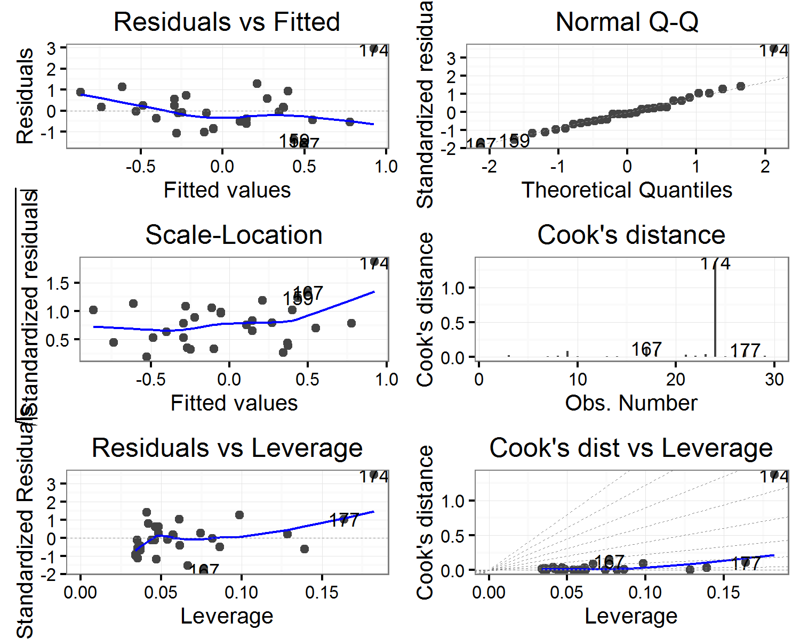

##   
## $flatness

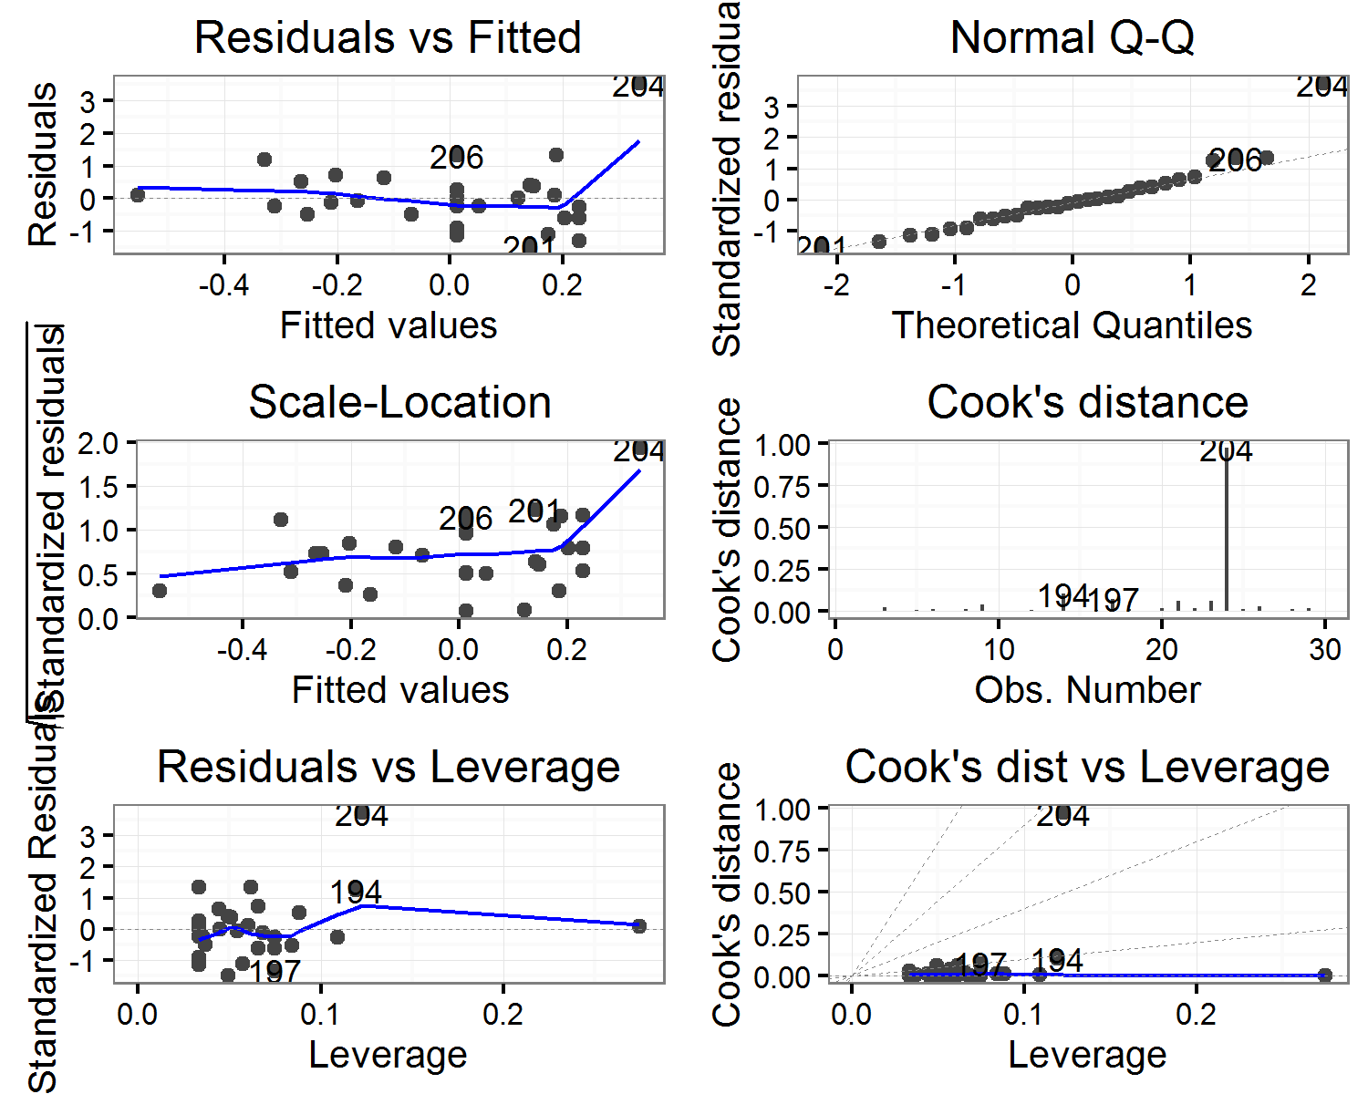

##   
## $`length(mm)`

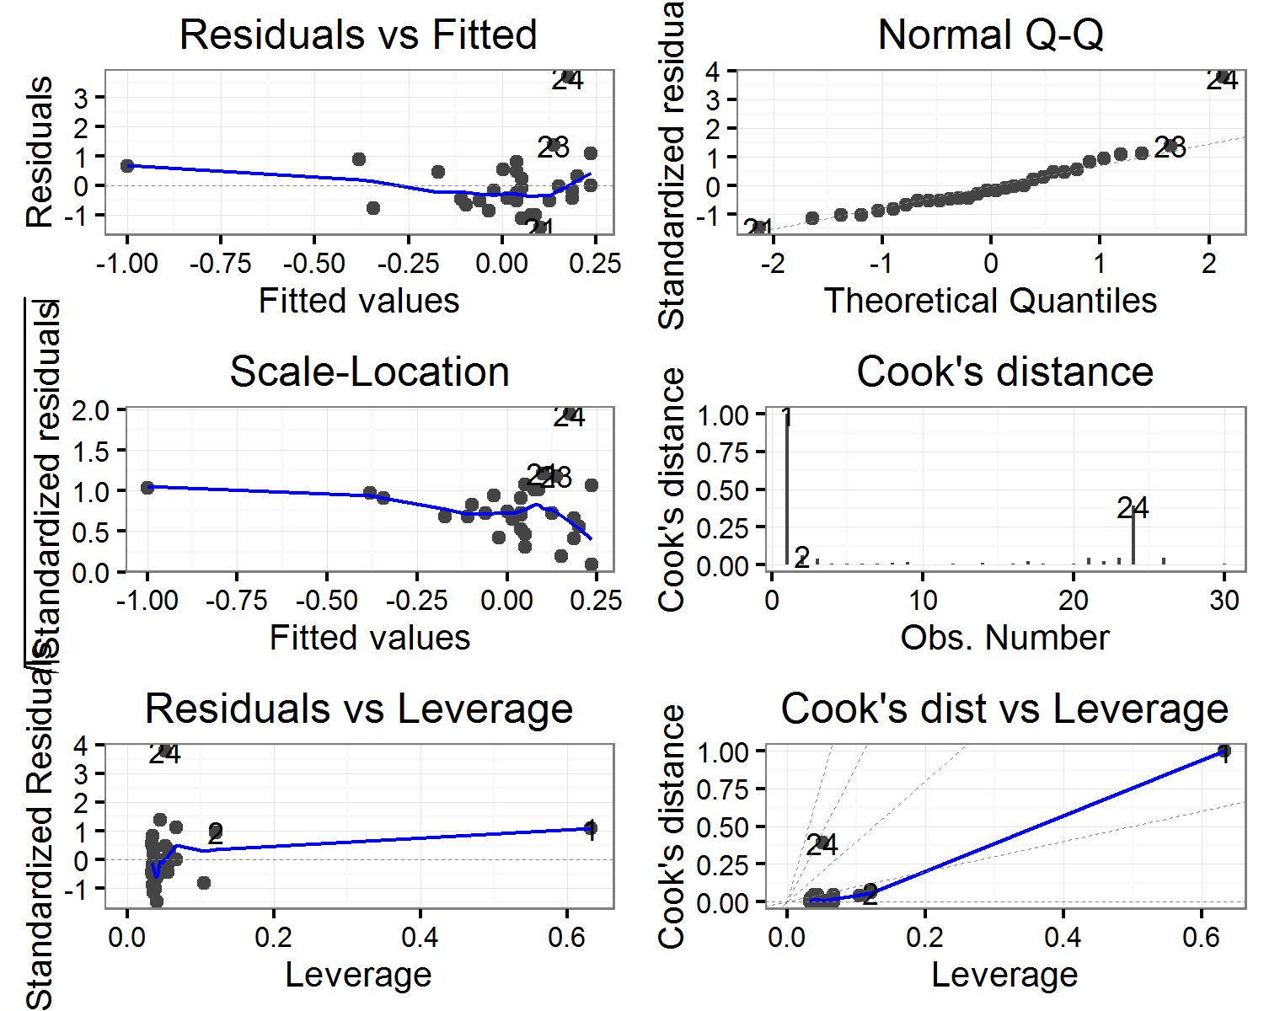

##   
## $shape

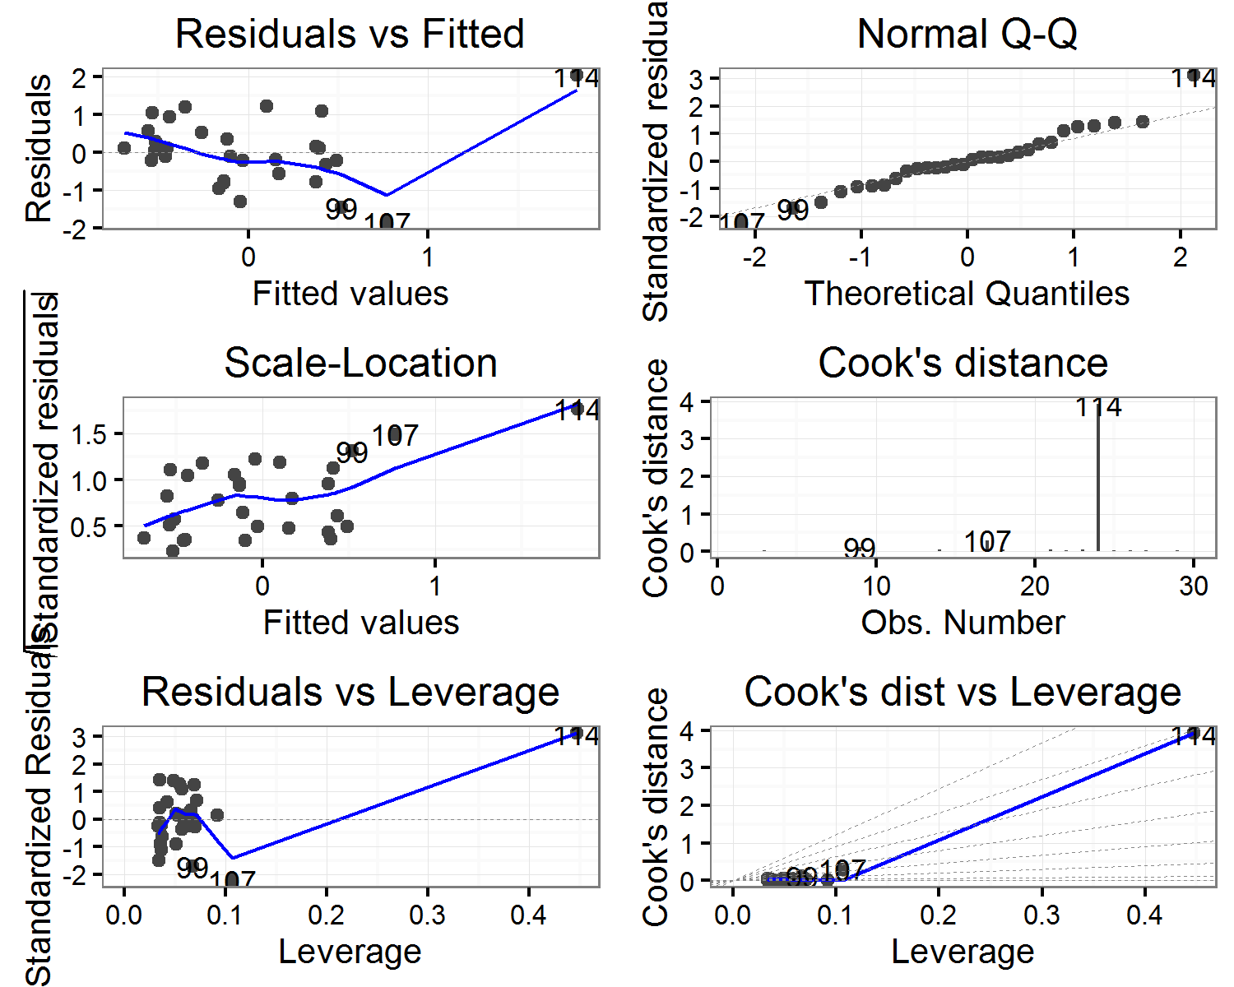

##   
## $sphericity

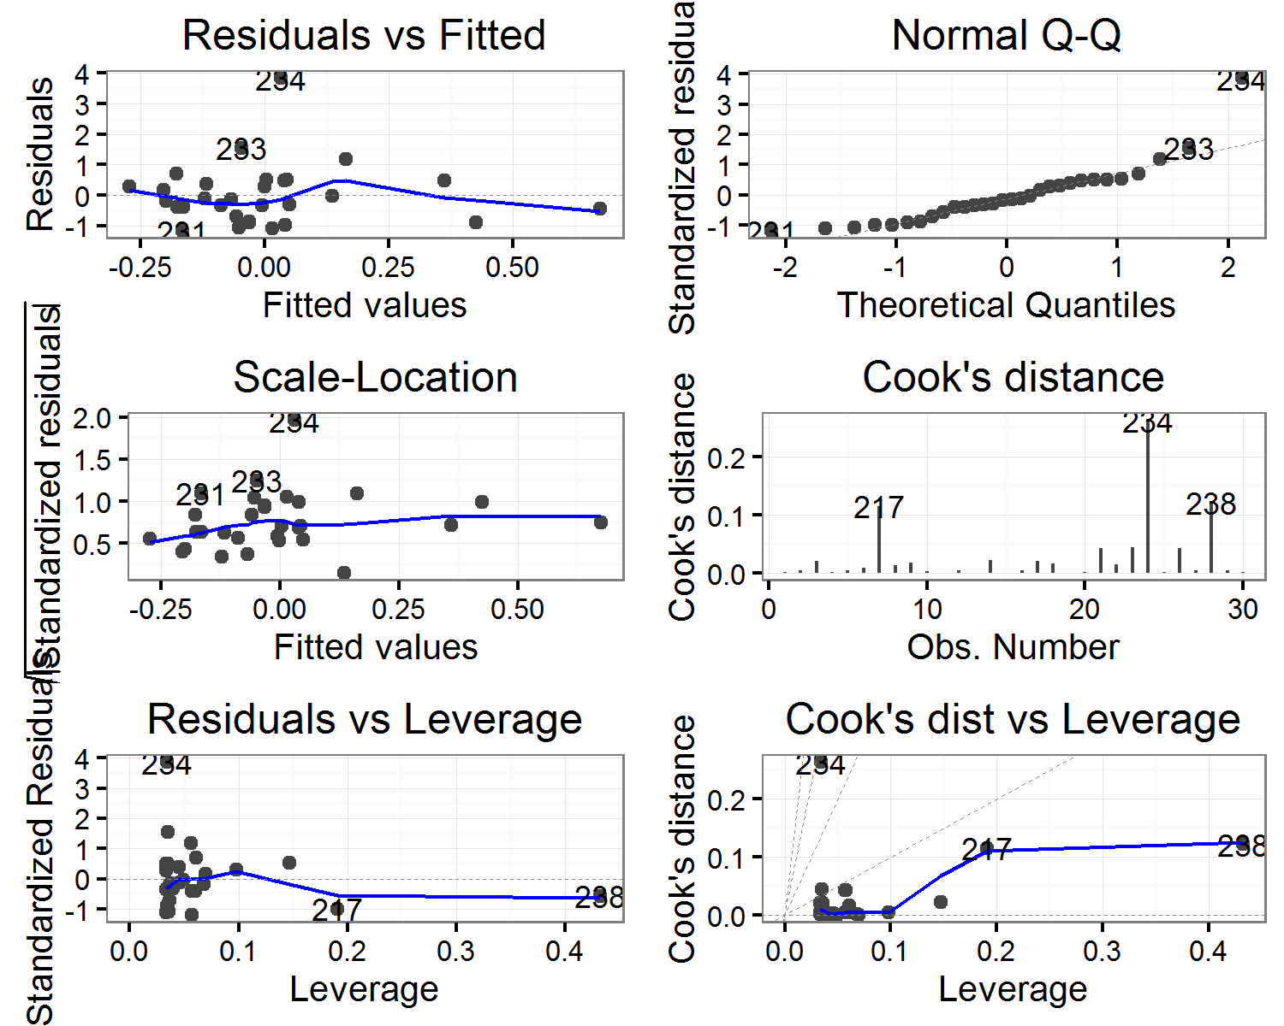

##   
## $`thickness(mm)`

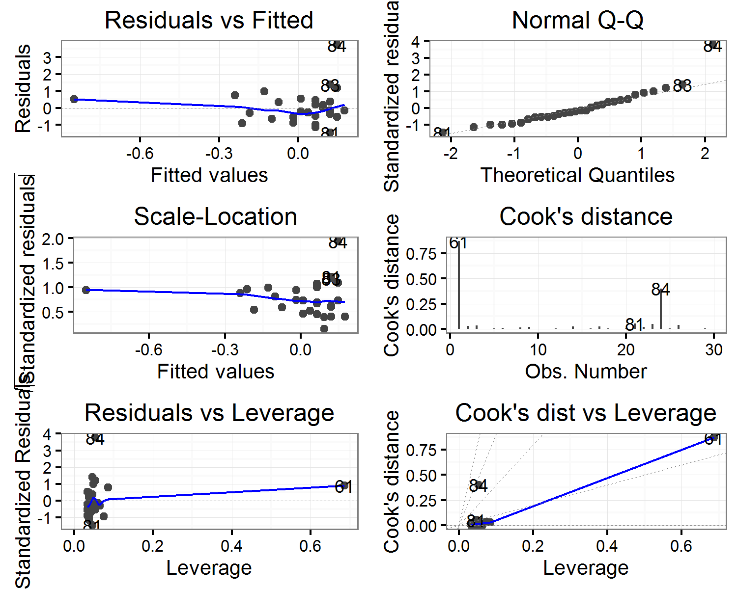

##   
## $volume

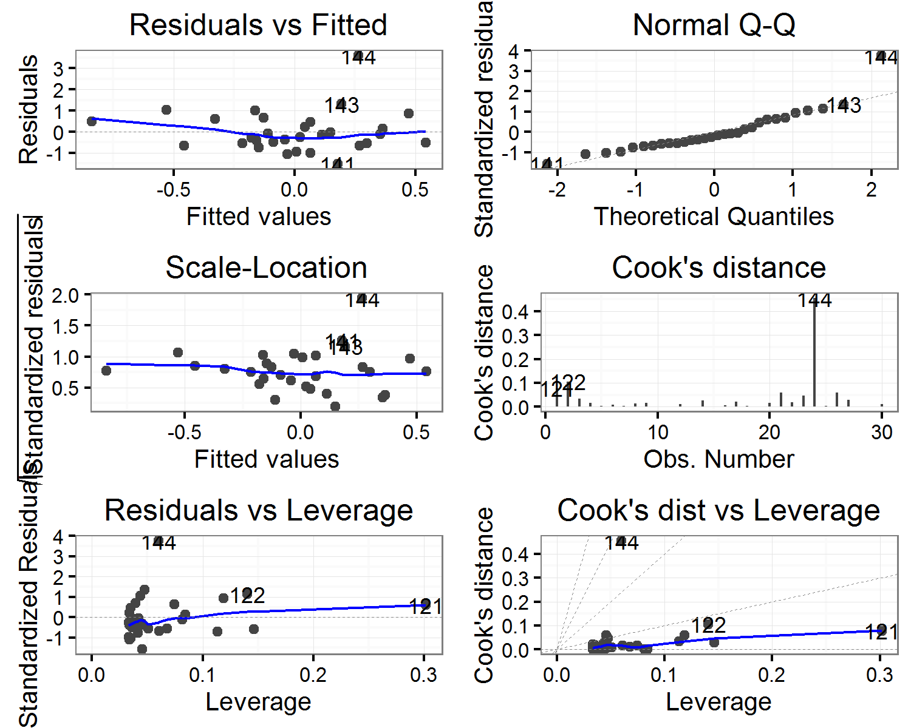

##   
## $`width(mm)`

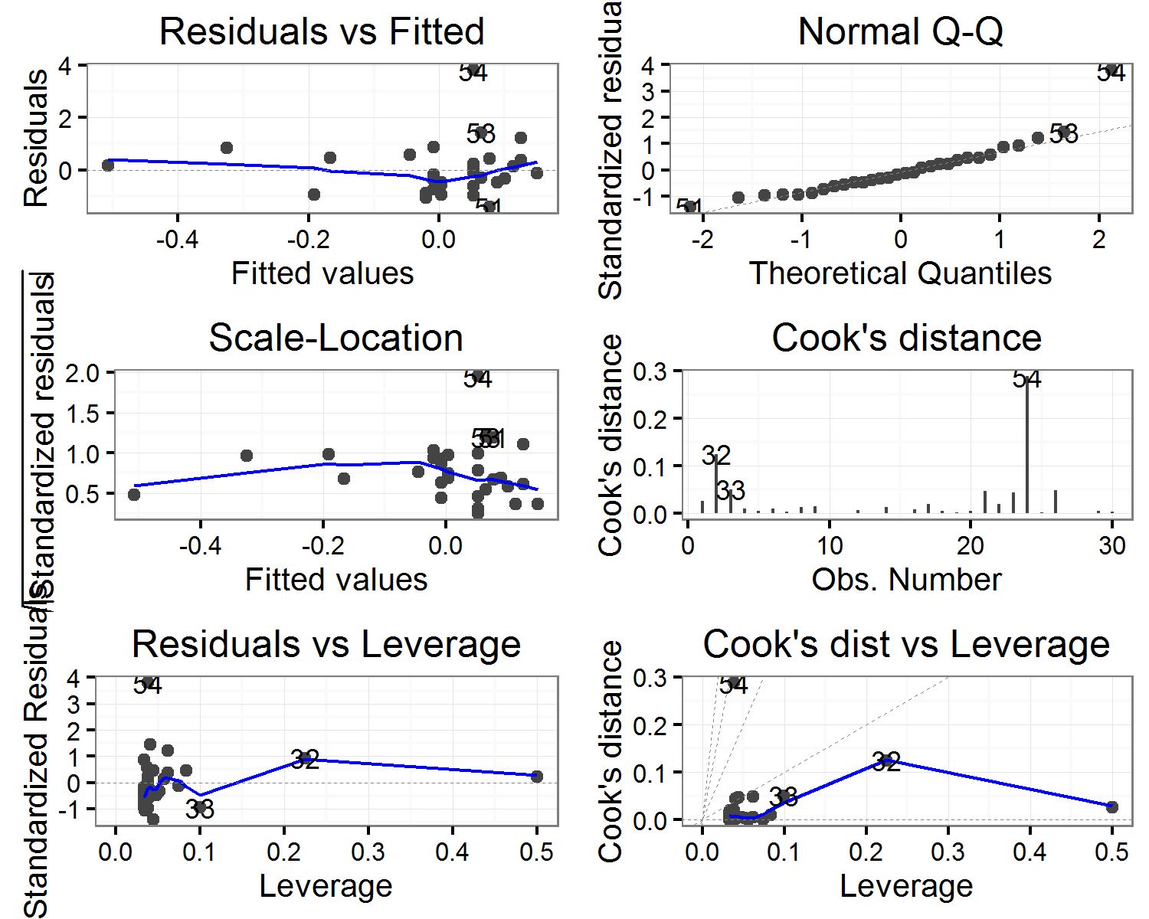

(#tab:hormodels_diagnostics)Horizontal displacement: Correlation of artefact volume with Cook's distance values for each model

|  |  |  |  |  |  |  |
| --- | --- | --- | --- | --- | --- | --- |
| estimate | statistic | p.value | parameter | conf.low | conf.high | variable |
| -0.2111567 | -1.1431108 | 0.2626726 | 28 | -0.5310288 | 0.1613900 | elongation |
| -0.1779000 | -0.9566179 | 0.3469474 | 28 | -0.5057545 | 0.1948580 | flatness |
| 0.4514844 | 2.6774481 | 0.0122668 | 28 | 0.1089339 | 0.6981890 | length(mm) |
| -0.1725105 | -0.9267336 | 0.3619846 | 28 | -0.5016049 | 0.2002013 | shape |
| -0.2392109 | -1.3036325 | 0.2029761 | 28 | -0.5519158 | 0.1324751 | sphericity |
| 0.4195870 | 2.4459722 | 0.0209879 | 28 | 0.0698814 | 0.6774500 | thickness(mm) |
| -0.0550927 | -0.2919666 | 0.7724645 | 28 | -0.4072782 | 0.3113564 | volume |
| 0.0026988 | 0.0142807 | 0.9887073 | 28 | -0.3579184 | 0.3626154 | width(mm) |

## Diagnostic plots for linear models of horizontal direction of artefacts

## $elongation

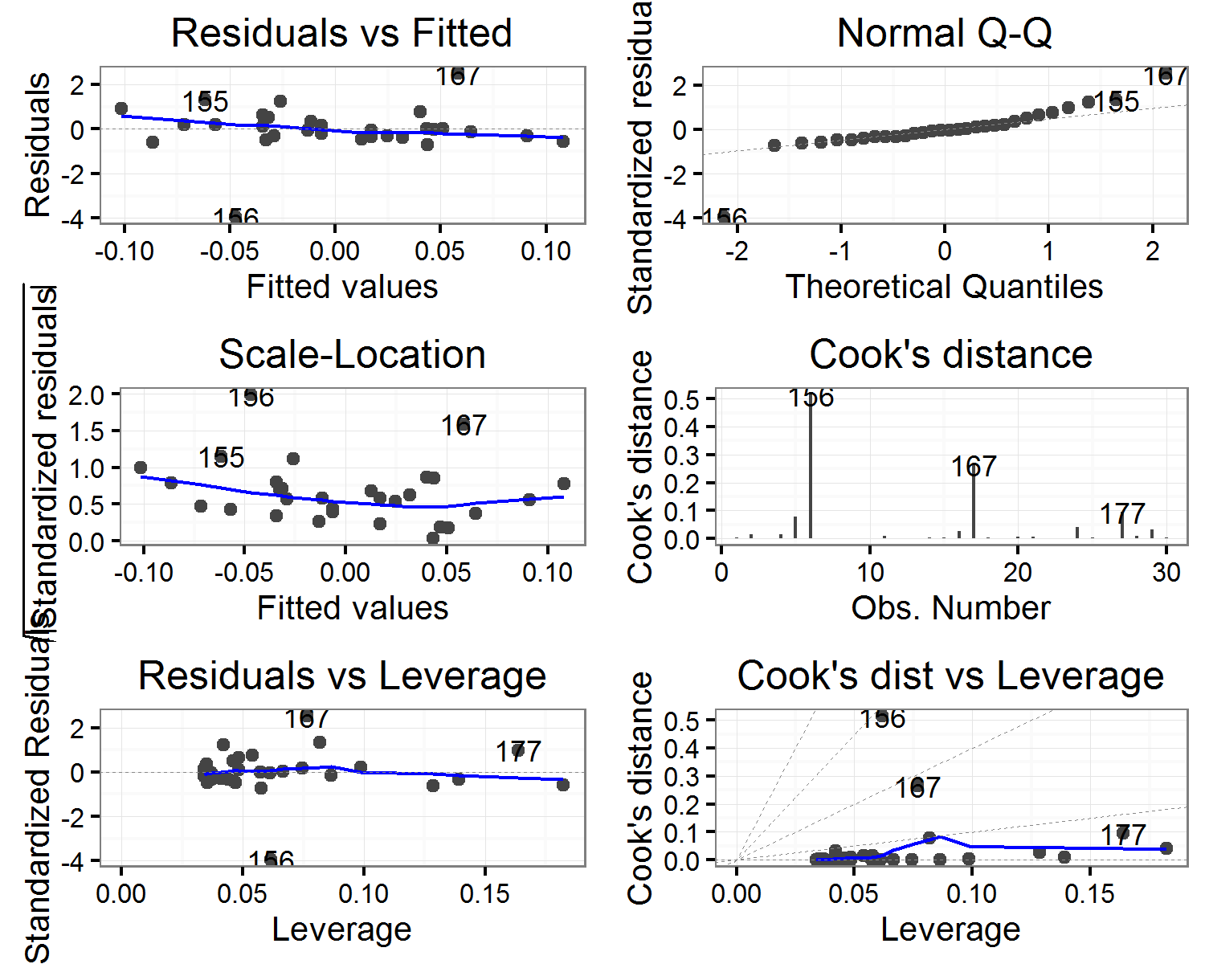

##   
## $flatness

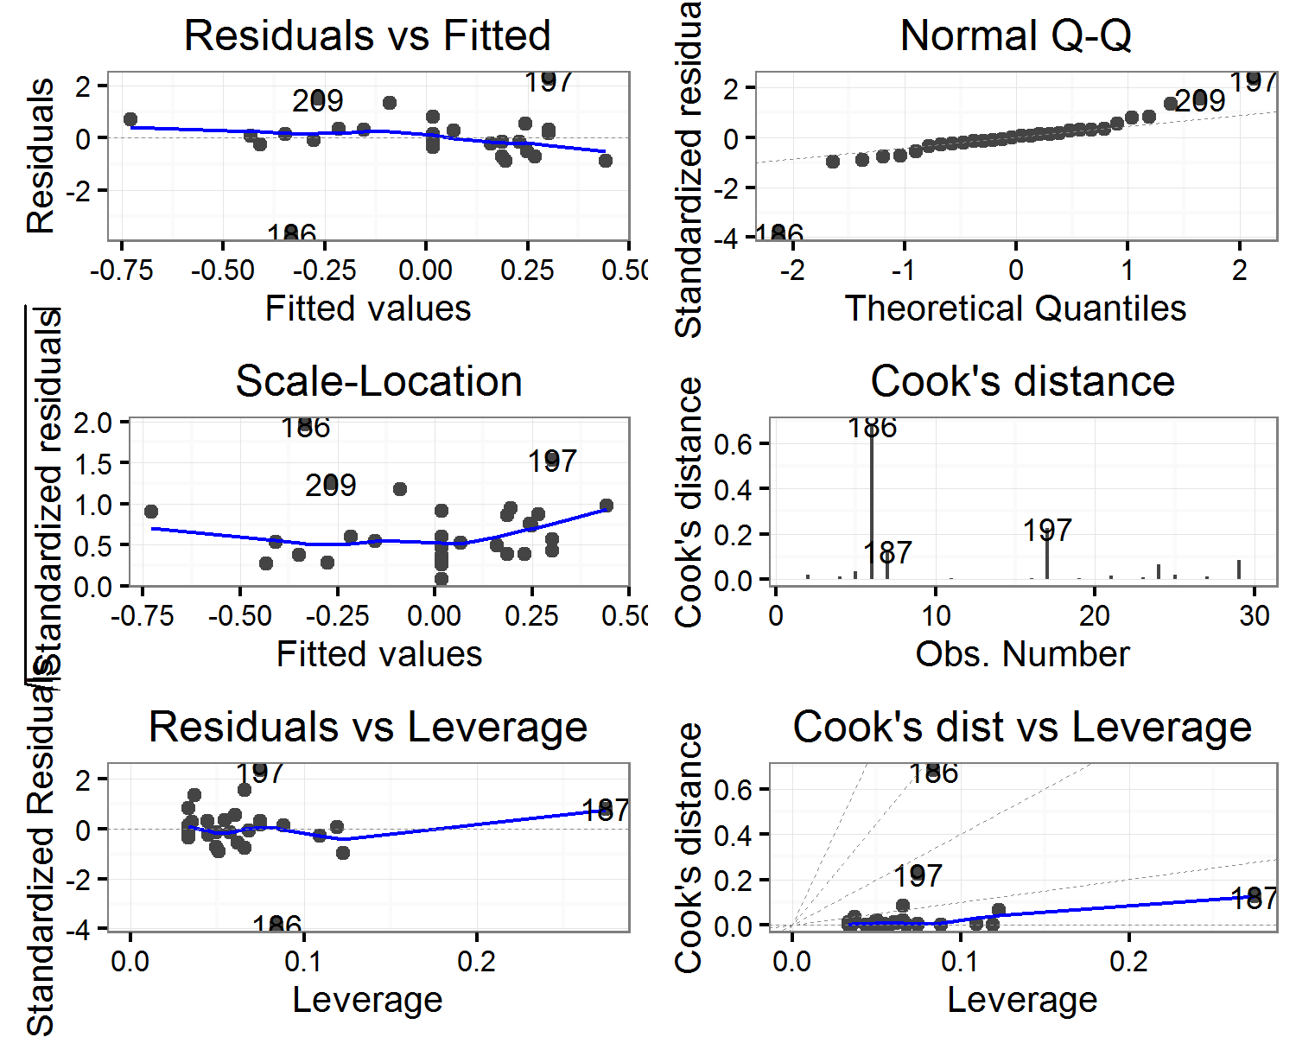

##   
## $`length(mm)`

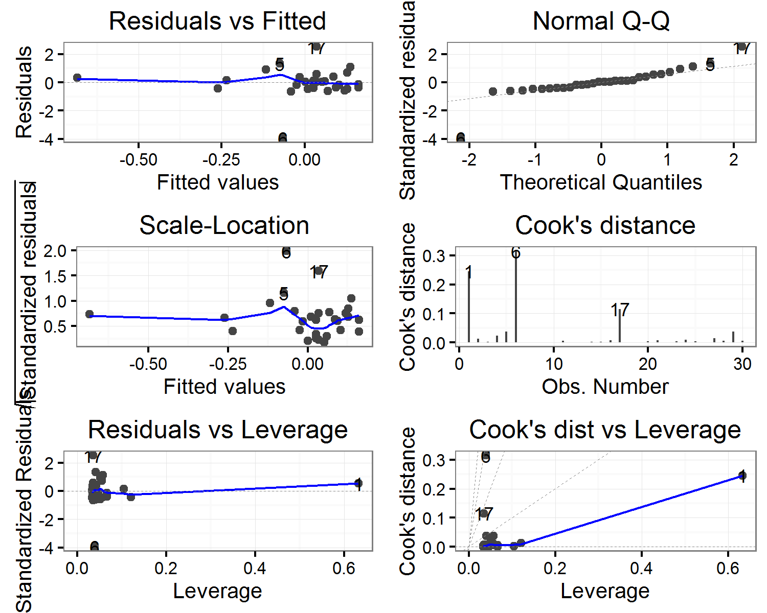

##   
## $shape

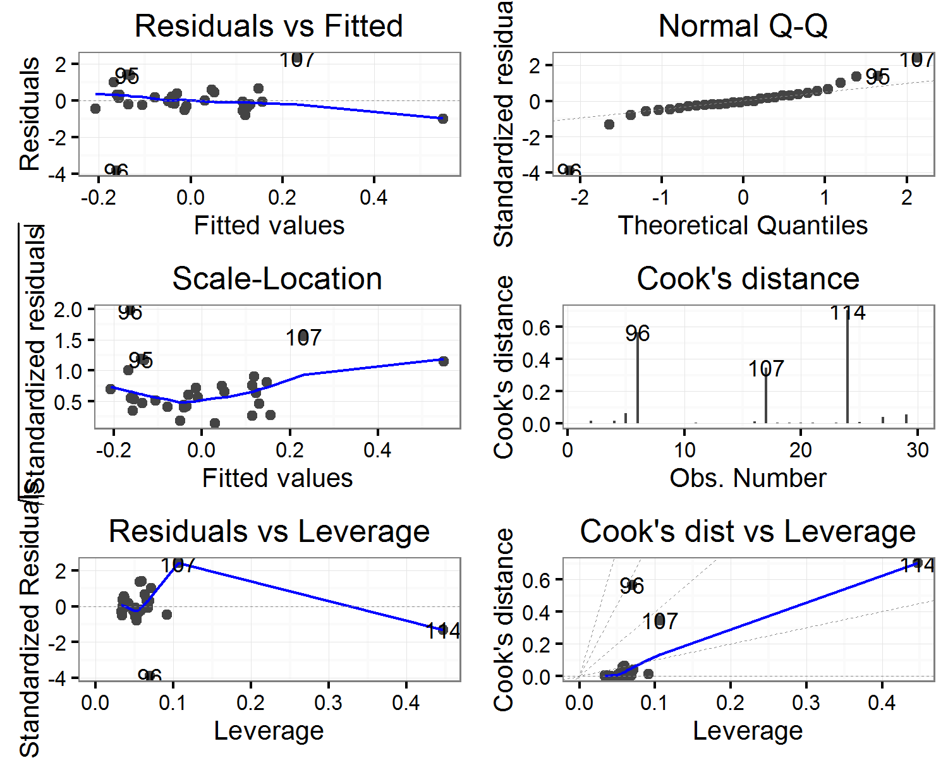

##   
## $sphericity

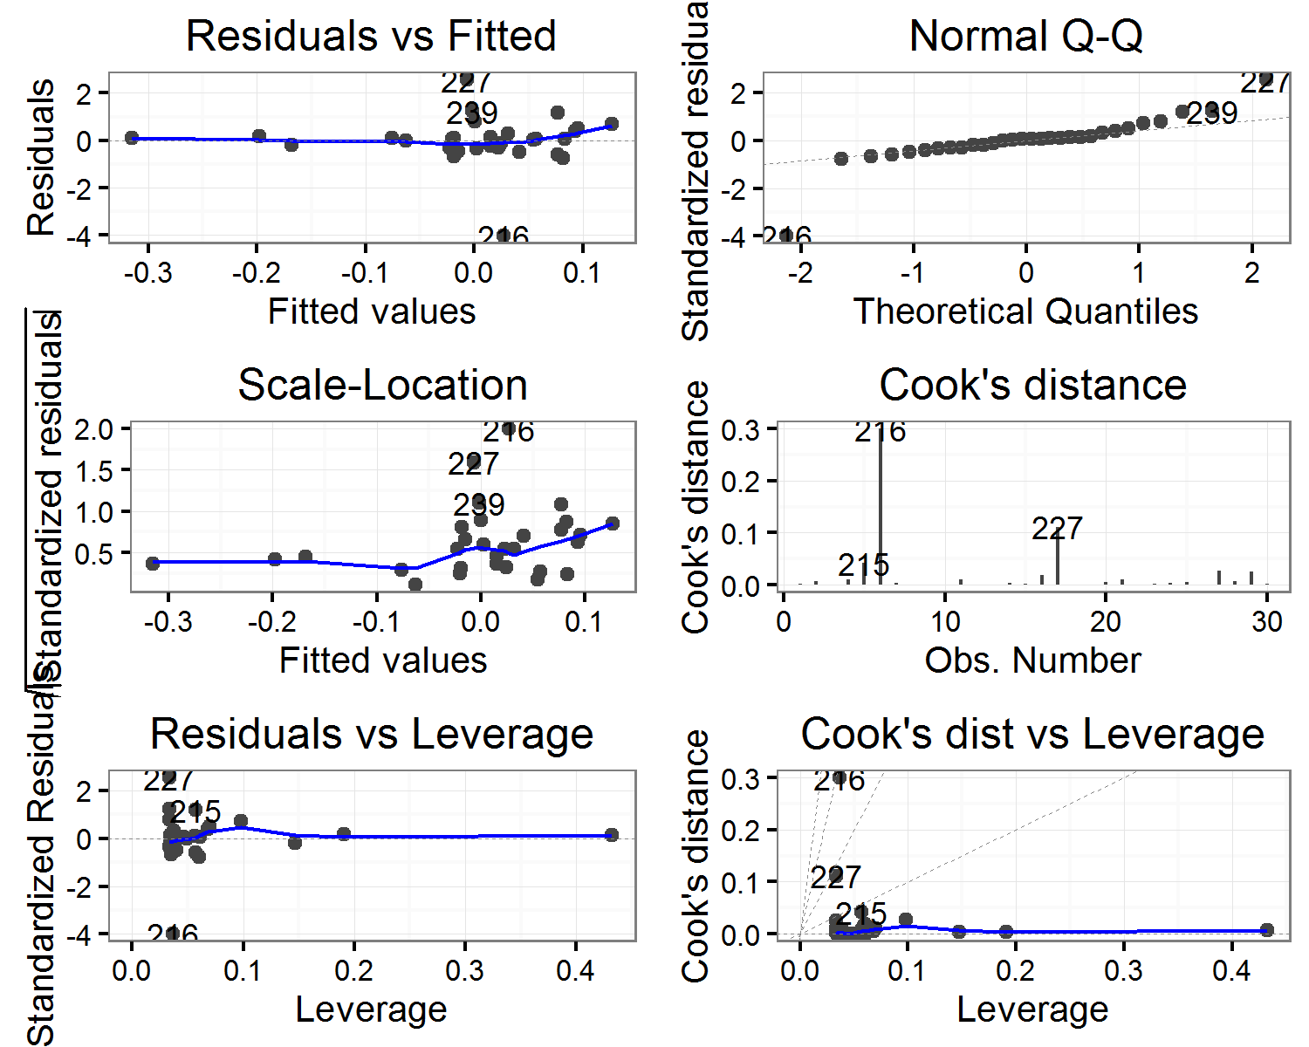

##   
## $`thickness(mm)`

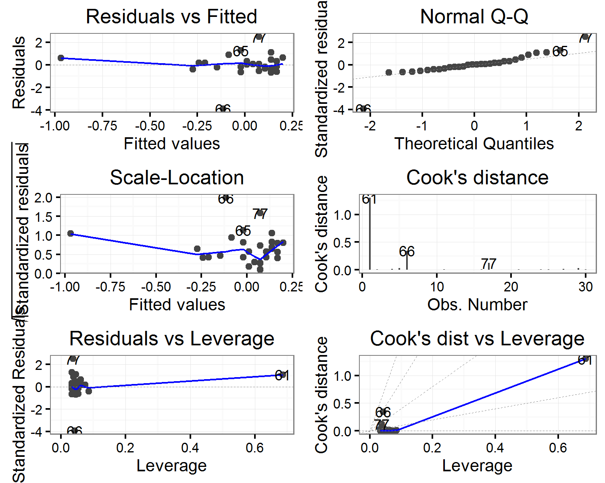

##   
## $volume

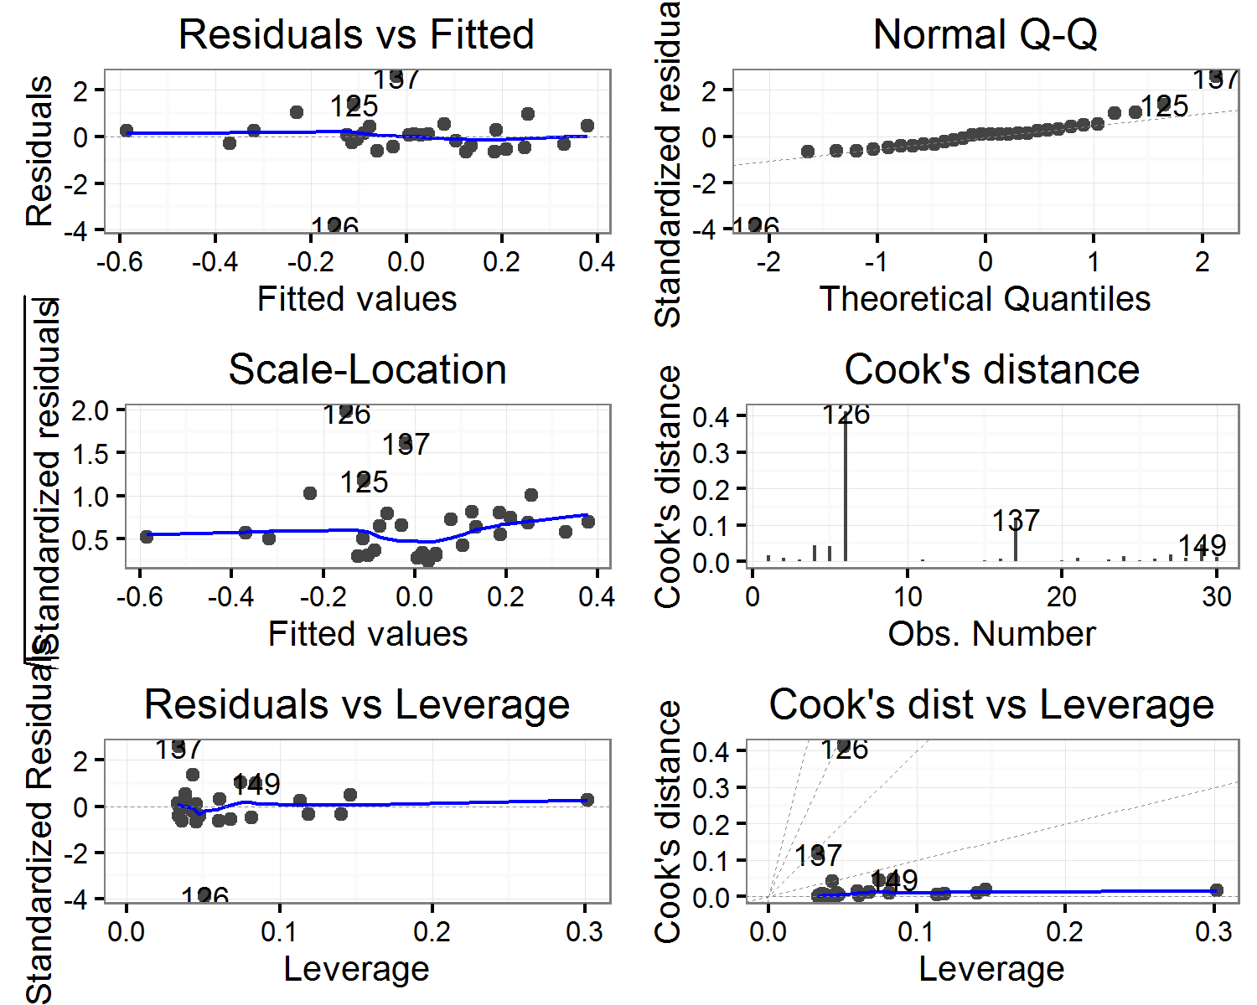

##   
## $`width(mm)`

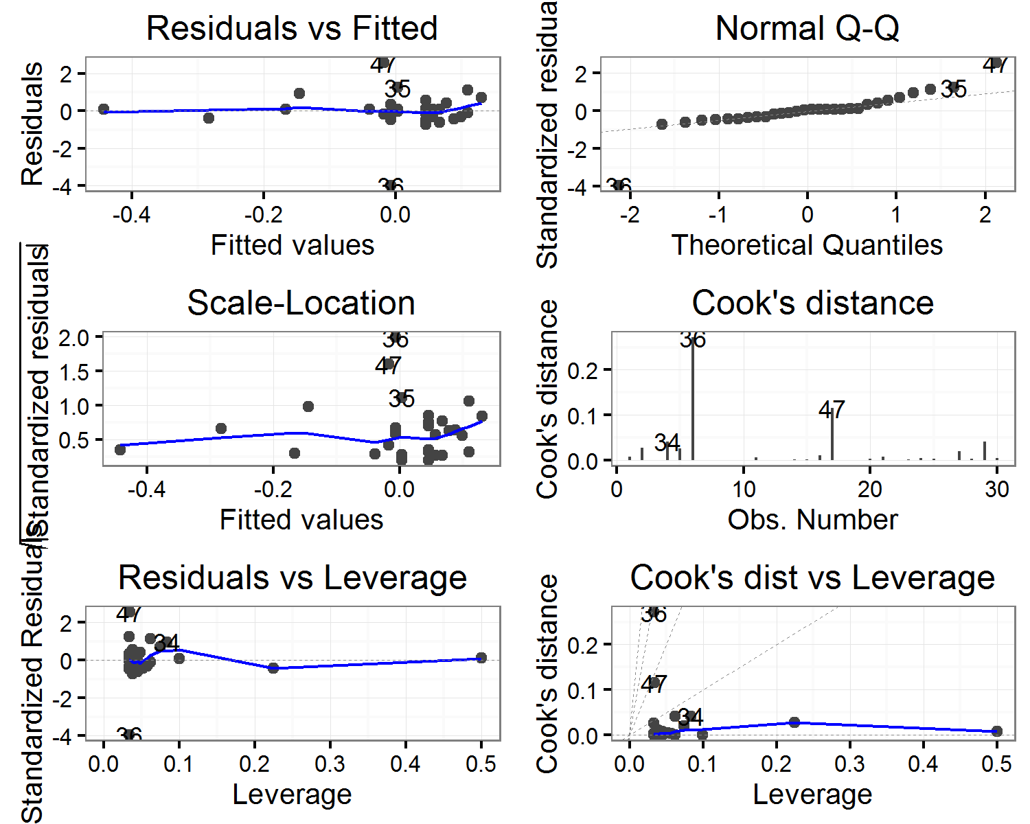

(#tab:hordirmodels_diagnostics)Horizontal direction: Correlation of artefact volume with Cook's distance values for each model

|  |  |  |  |  |  |  |
| --- | --- | --- | --- | --- | --- | --- |
| estimate | statistic | p.value | parameter | conf.low | conf.high | variable |
| 0.0753160 | 0.3996698 | 0.6924323 | 28 | -0.2929008 | 0.4240782 | elongation |
| 0.1217348 | 0.6489867 | 0.5216351 | 28 | -0.2494758 | 0.4617528 | flatness |
| 0.4254928 | 2.4879458 | 0.0190709 | 28 | 0.0770319 | 0.6813210 | length(mm) |
| -0.0493922 | -0.2616781 | 0.7954850 | 28 | -0.4024991 | 0.3165092 | shape |
| 0.1089994 | 0.5802276 | 0.5664017 | 28 | -0.2615403 | 0.4515371 | sphericity |
| 0.5473642 | 3.4608652 | 0.0017451 | 28 | 0.2330526 | 0.7581311 | thickness(mm) |
| 0.1339560 | 0.7152751 | 0.4803613 | 28 | -0.2377890 | 0.4714719 | volume |
| 0.1503118 | 0.8045156 | 0.4278778 | 28 | -0.2219782 | 0.4843520 | width(mm) |

## Diagnostic plots for linear models of vertical displacement of artefacts

## $elongation

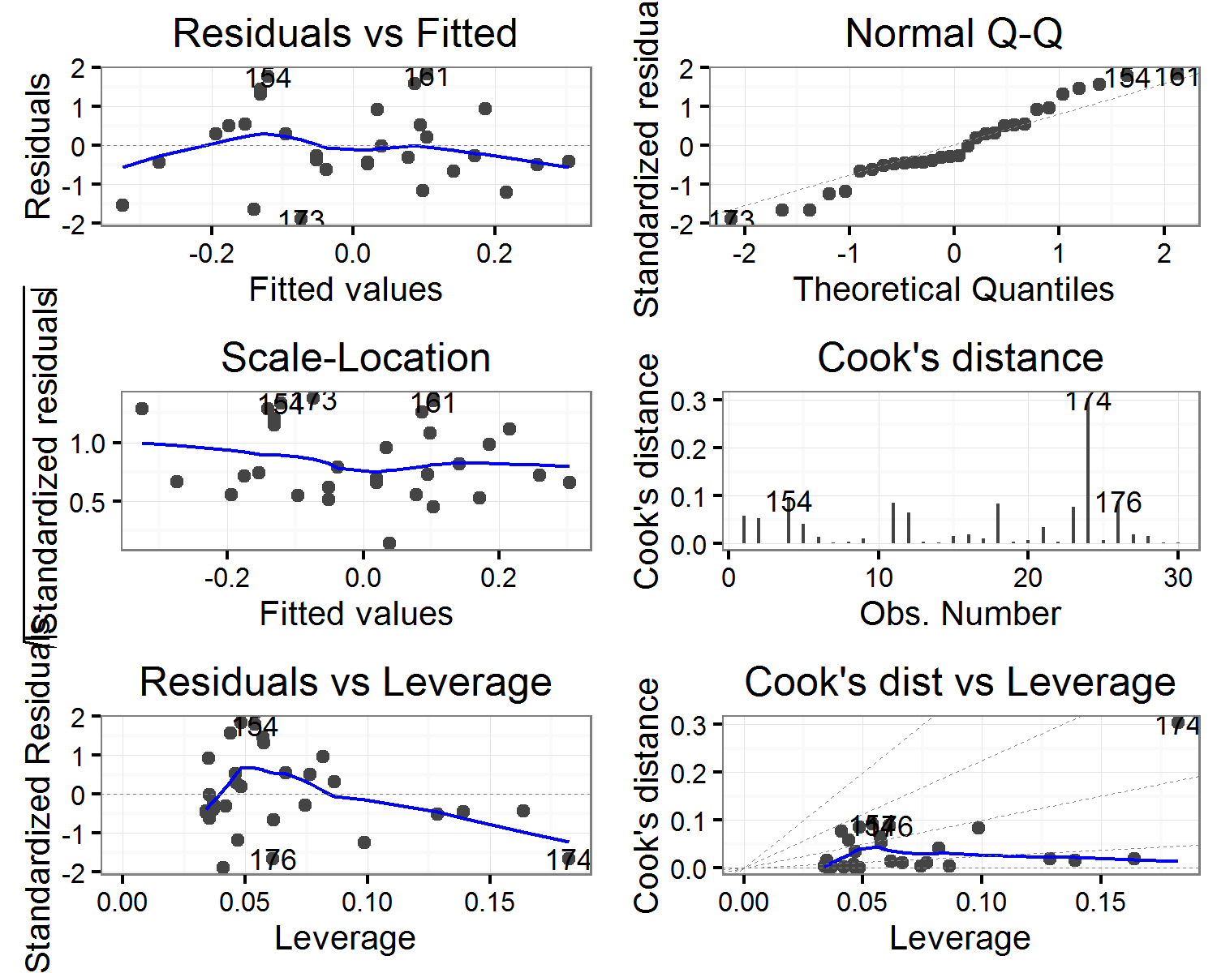

##   
## $flatness

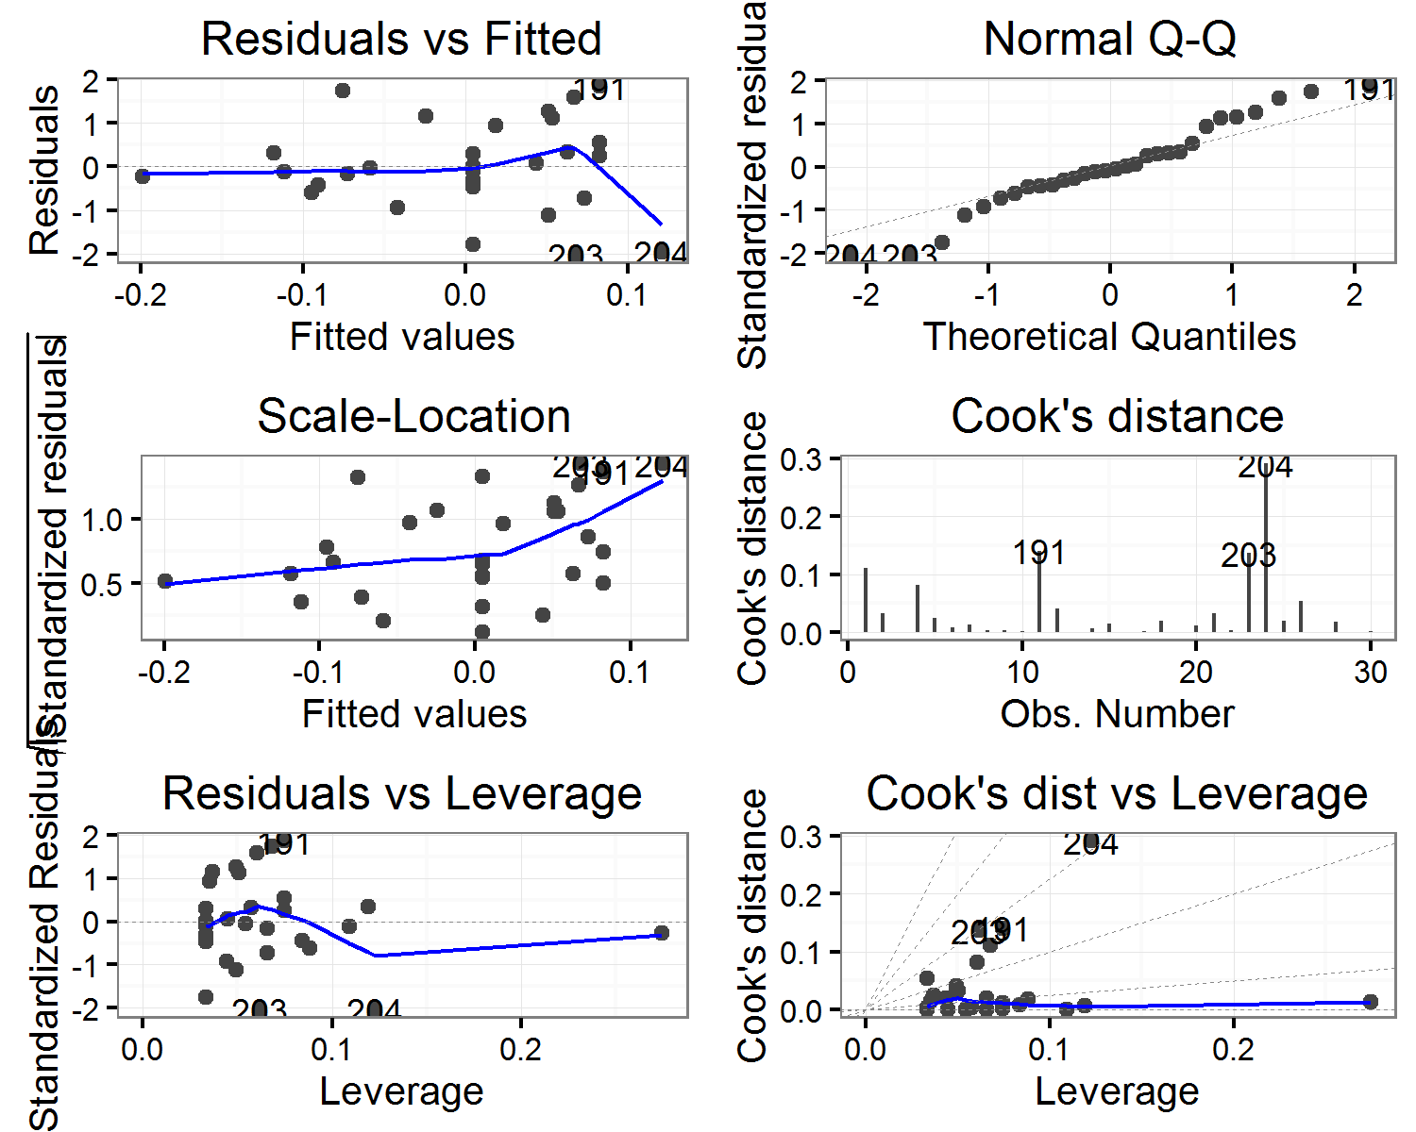

##   
## $`length(mm)`

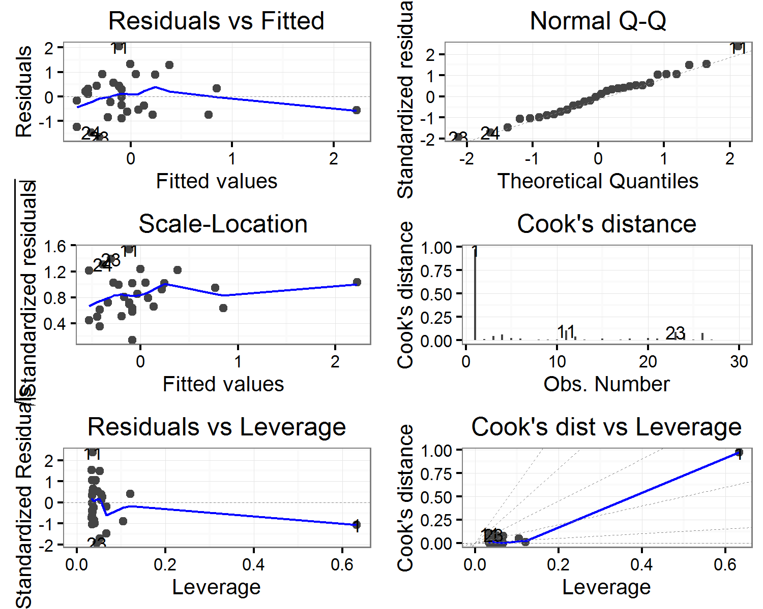

##   
## $shape

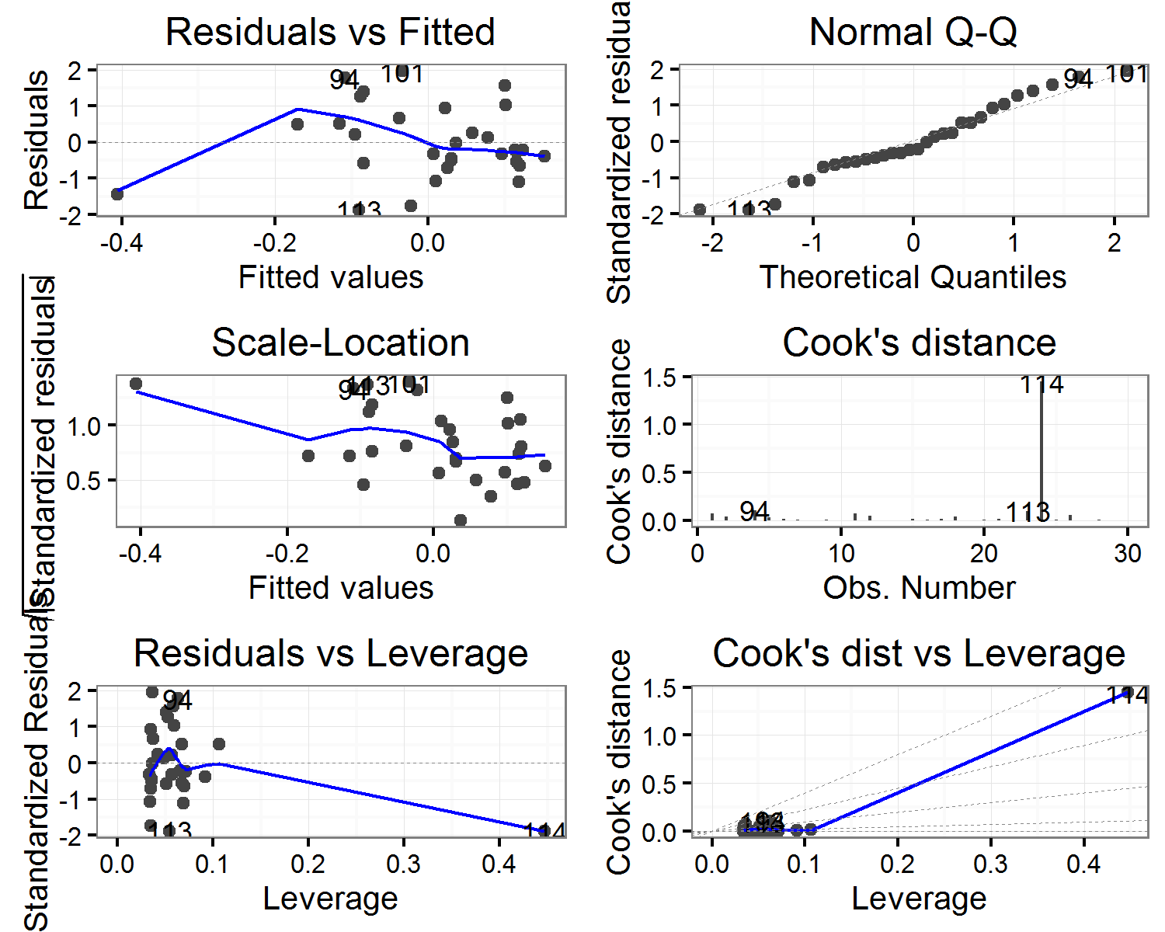

##   
## $sphericity

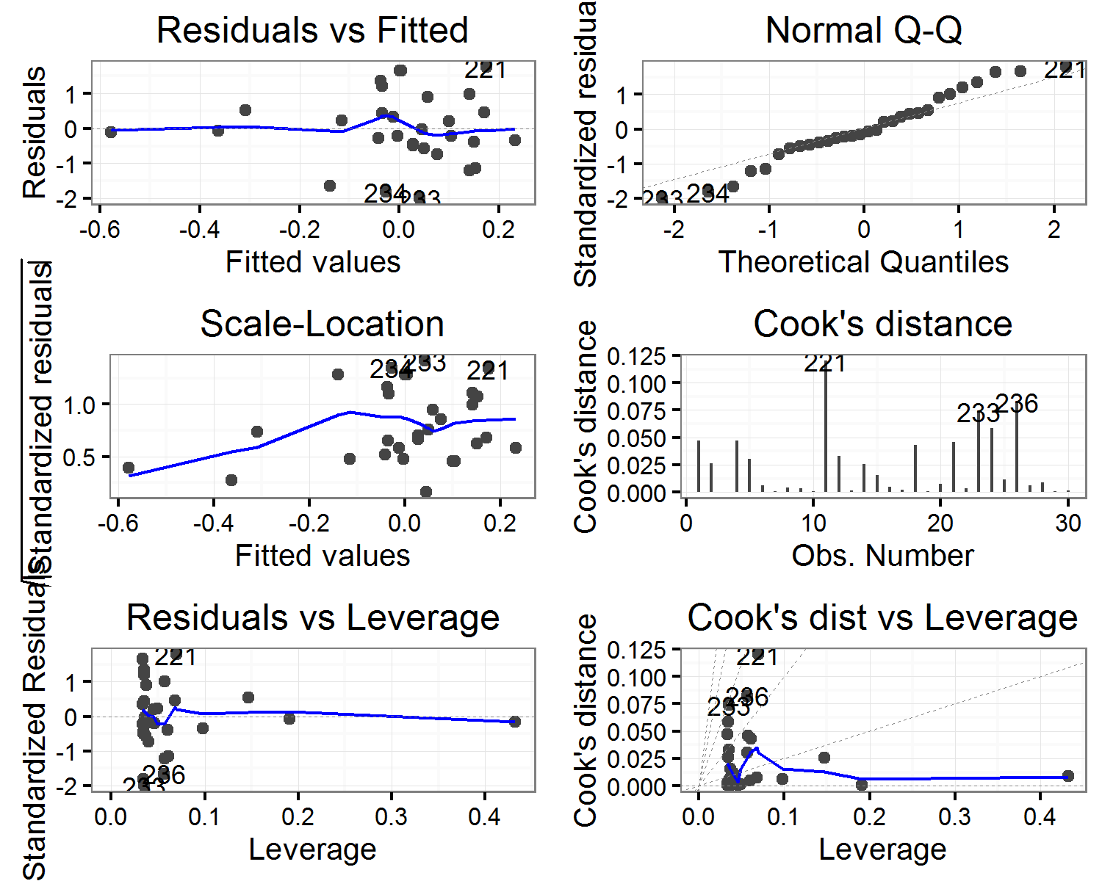

##   
## $`thickness(mm)`

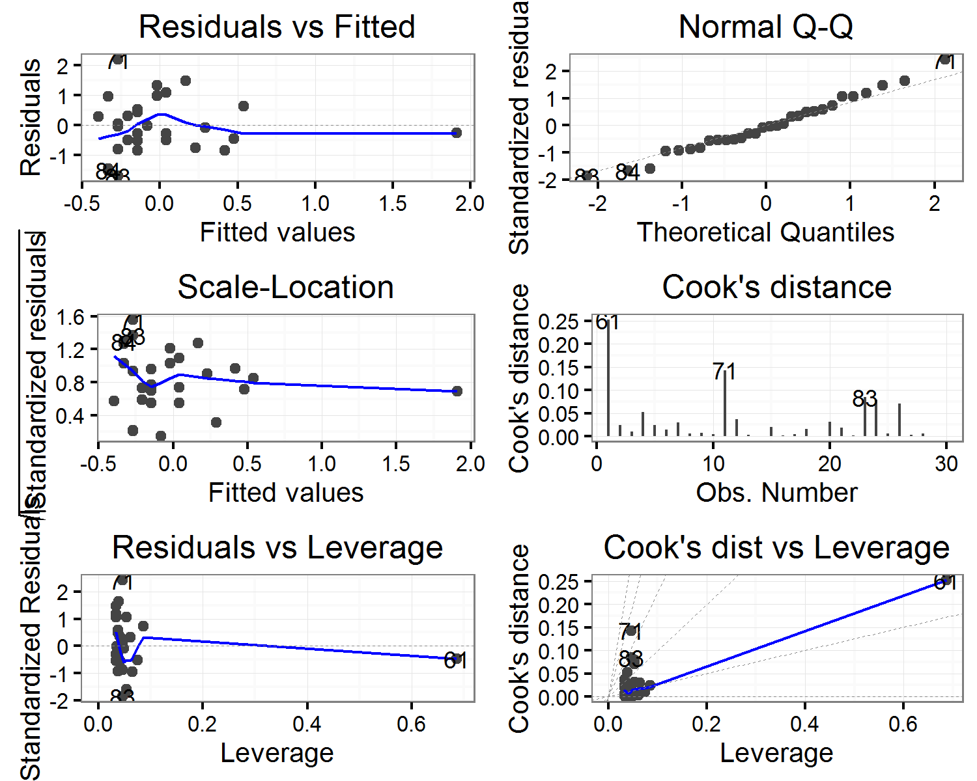

##   
## $volume

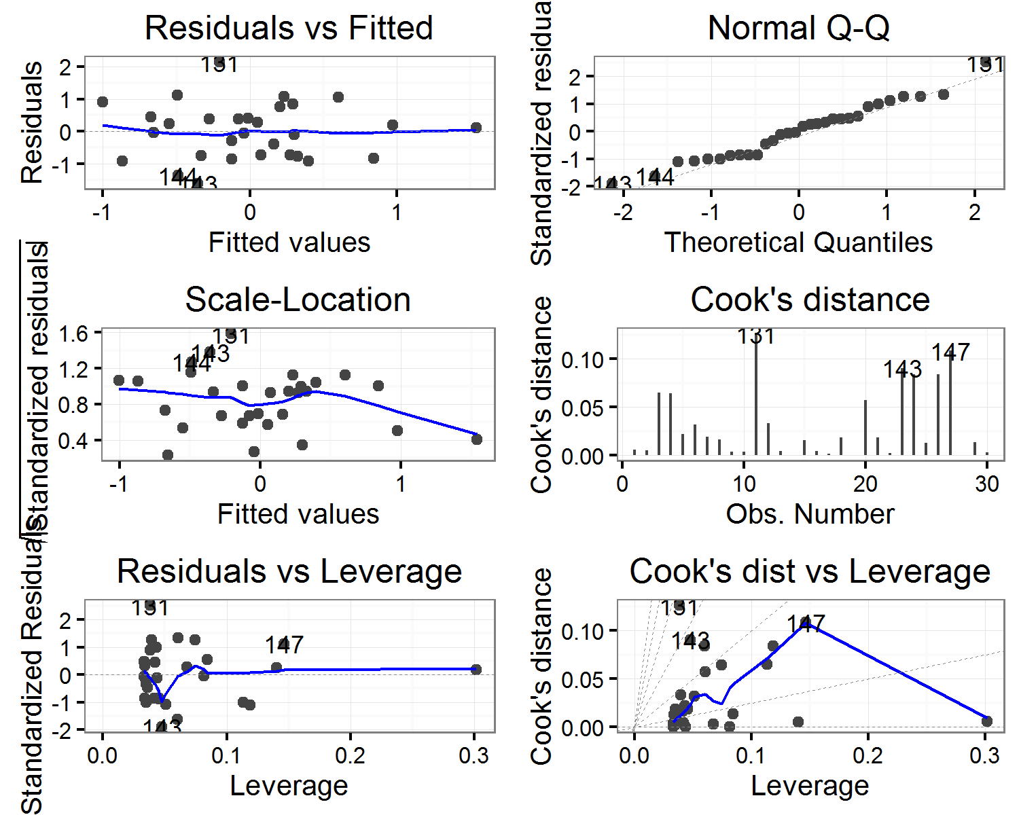

##   
## $`width(mm)`

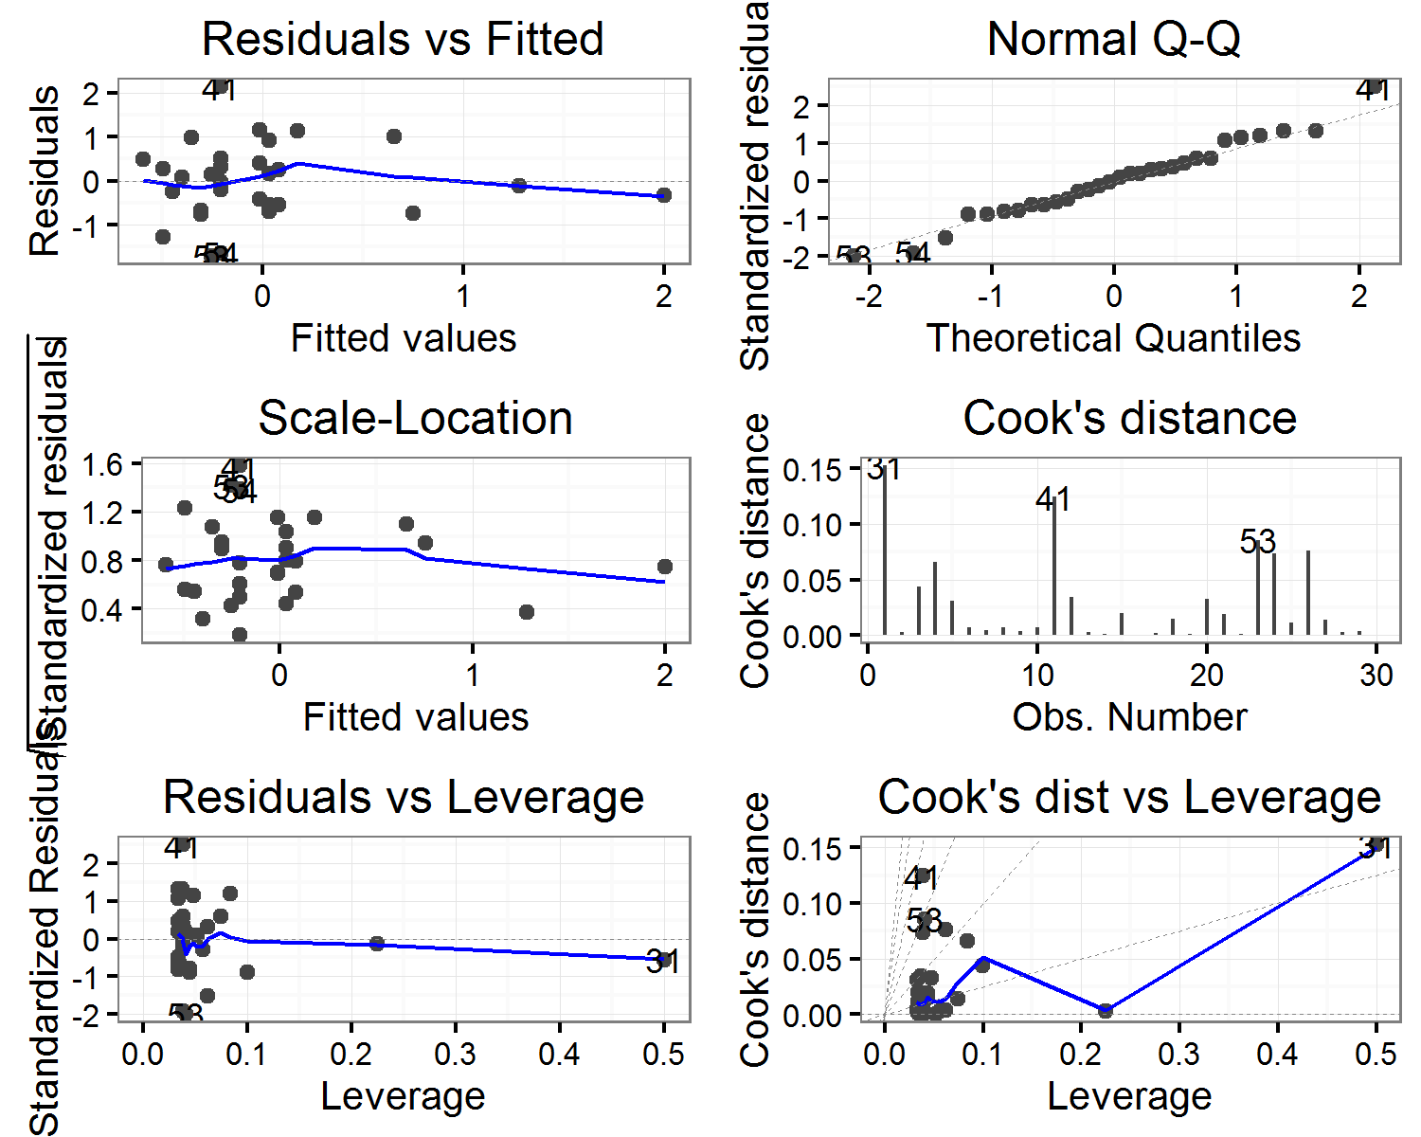

(#tab:vermodels_diagnostics)Vertical displacement: Correlation of artefact volume with Cook's distance values for each model

|  |  |  |  |  |  |  |
| --- | --- | --- | --- | --- | --- | --- |
| estimate | statistic | p.value | parameter | conf.low | conf.high | variable |
| -0.0949093 | -0.5044902 | 0.6178643 | 28 | -0.4401292 | 0.2747546 | elongation |
| -0.0128097 | -0.0677883 | 0.9464359 | 28 | -0.3713651 | 0.3490704 | flatness |
| 0.5070683 | 3.1130466 | 0.0042389 | 28 | 0.1796105 | 0.7333655 | length(mm) |
| -0.1352176 | -0.7221367 | 0.4761987 | 28 | -0.4724706 | 0.2365763 | shape |
| -0.0637791 | -0.3381759 | 0.7377533 | 28 | -0.4145236 | 0.3034630 | sphericity |
| 0.3525586 | 1.9935728 | 0.0560227 | 28 | -0.0088324 | 0.6324913 | thickness(mm) |
| -0.3094460 | -1.7219532 | 0.0961094 | 28 | -0.6025416 | 0.0572001 | volume |
| 0.2242869 | 1.2178418 | 0.2334477 | 28 | -0.1479361 | 0.5408532 | width(mm) |

## Diagnostic plots for linear models of artefact orientation

## $elongation

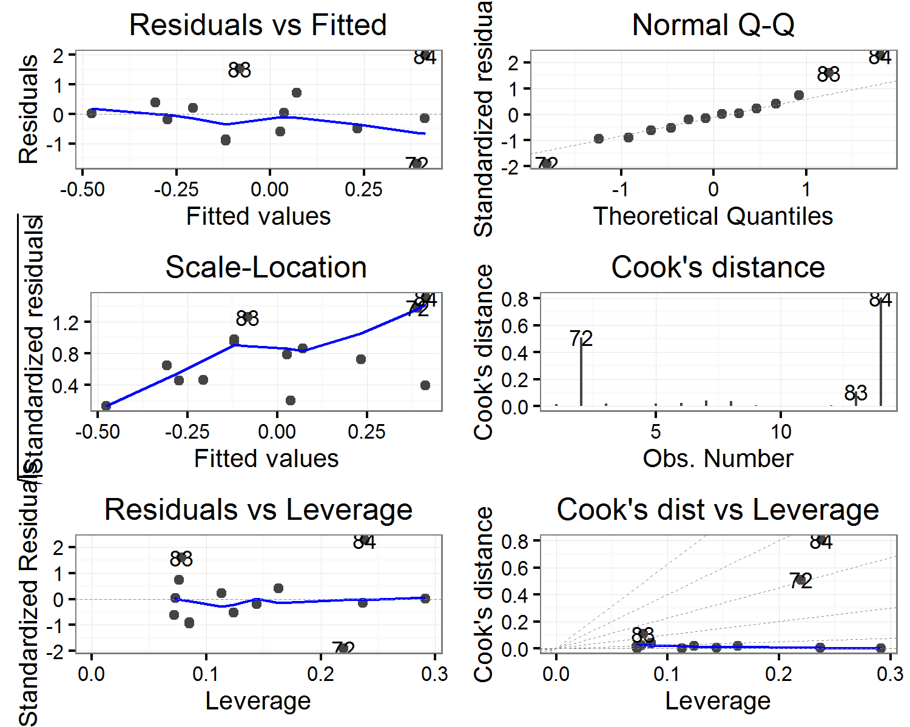

##   
## $flatness

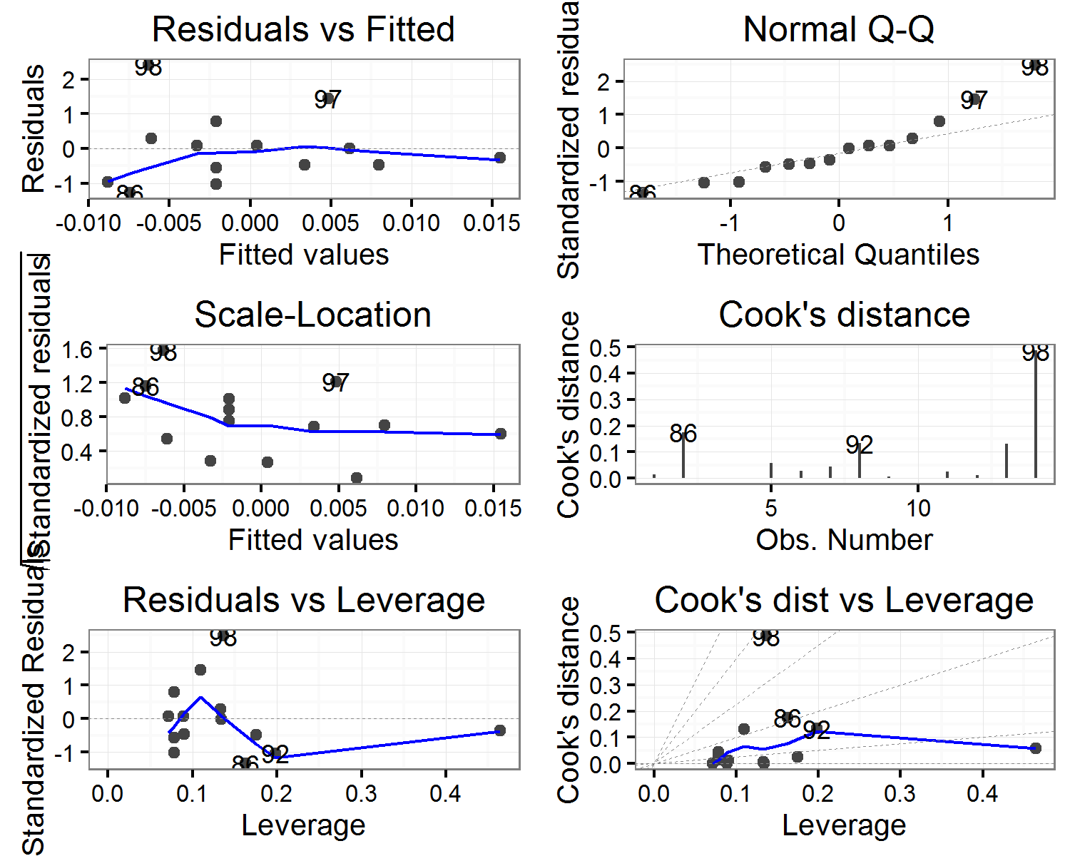

##   
## $`length(mm)`

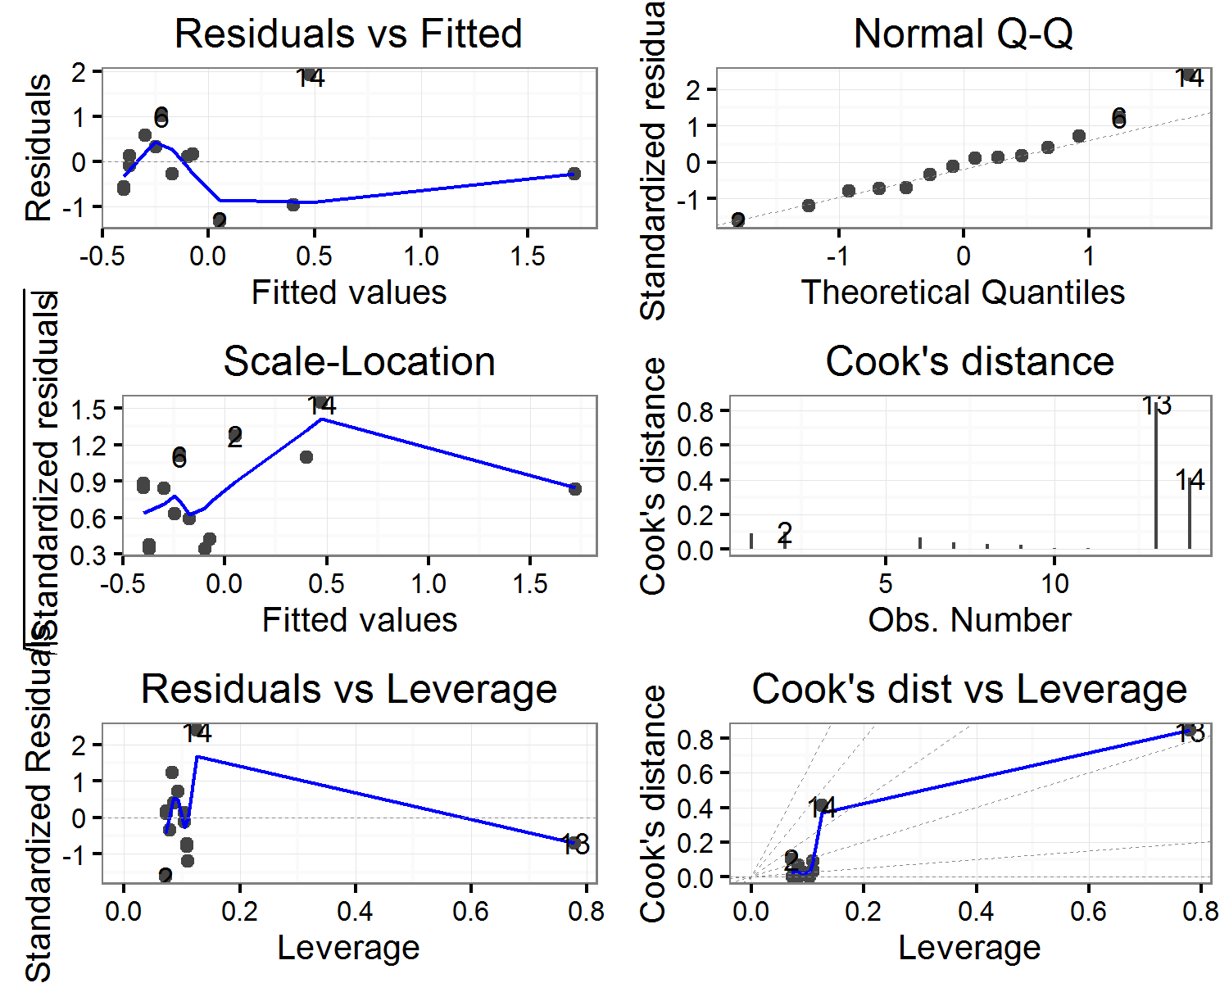

##   
## $shape

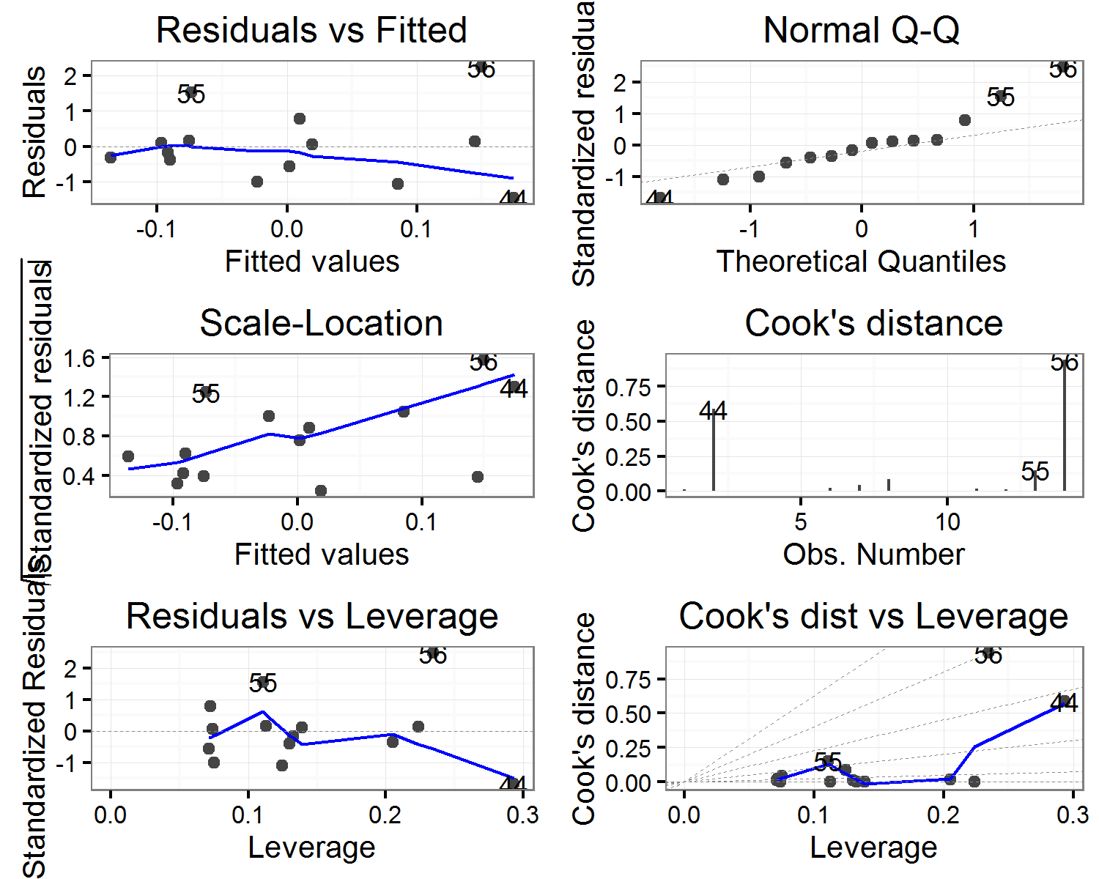

##   
## $sphericity

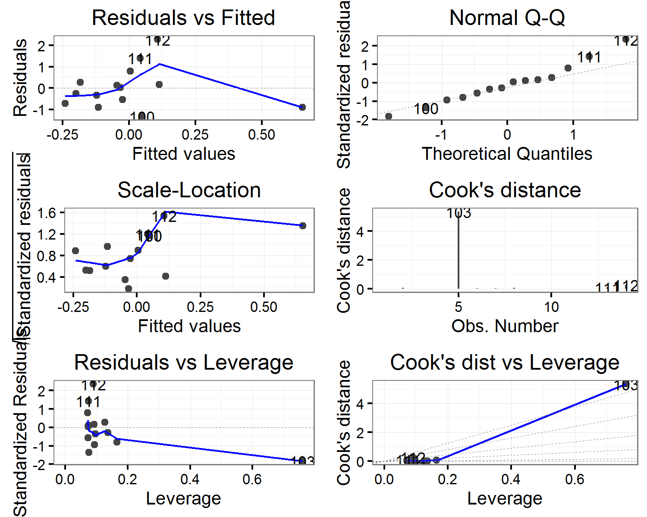

##   
## $`thickness(mm)`

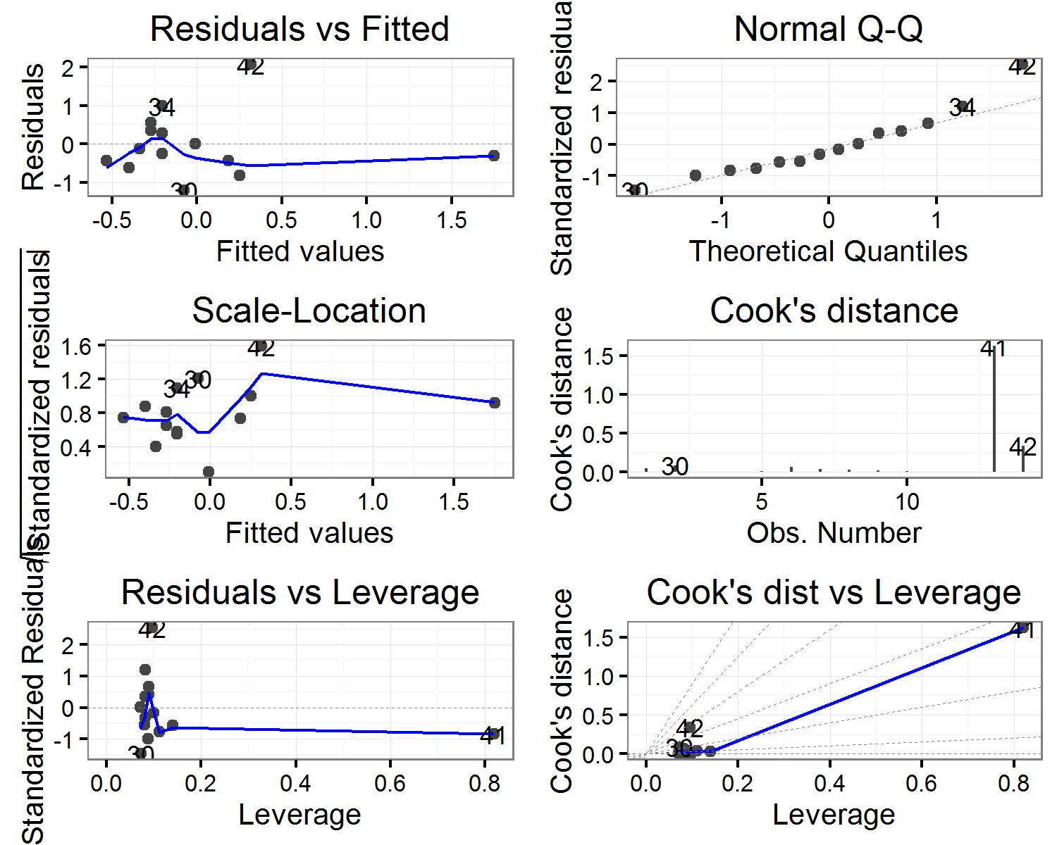

##   
## $volume

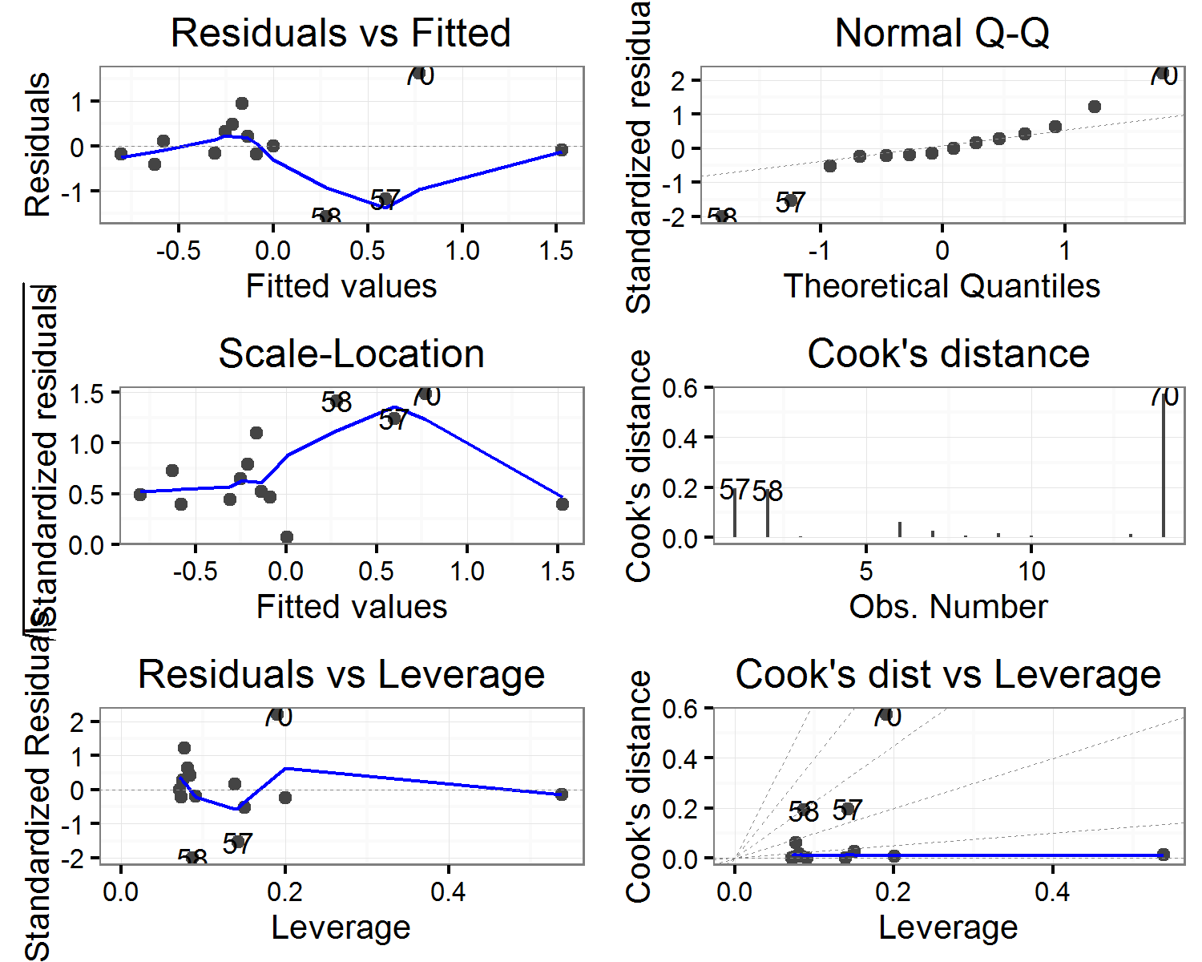

##   
## $`width(mm)`

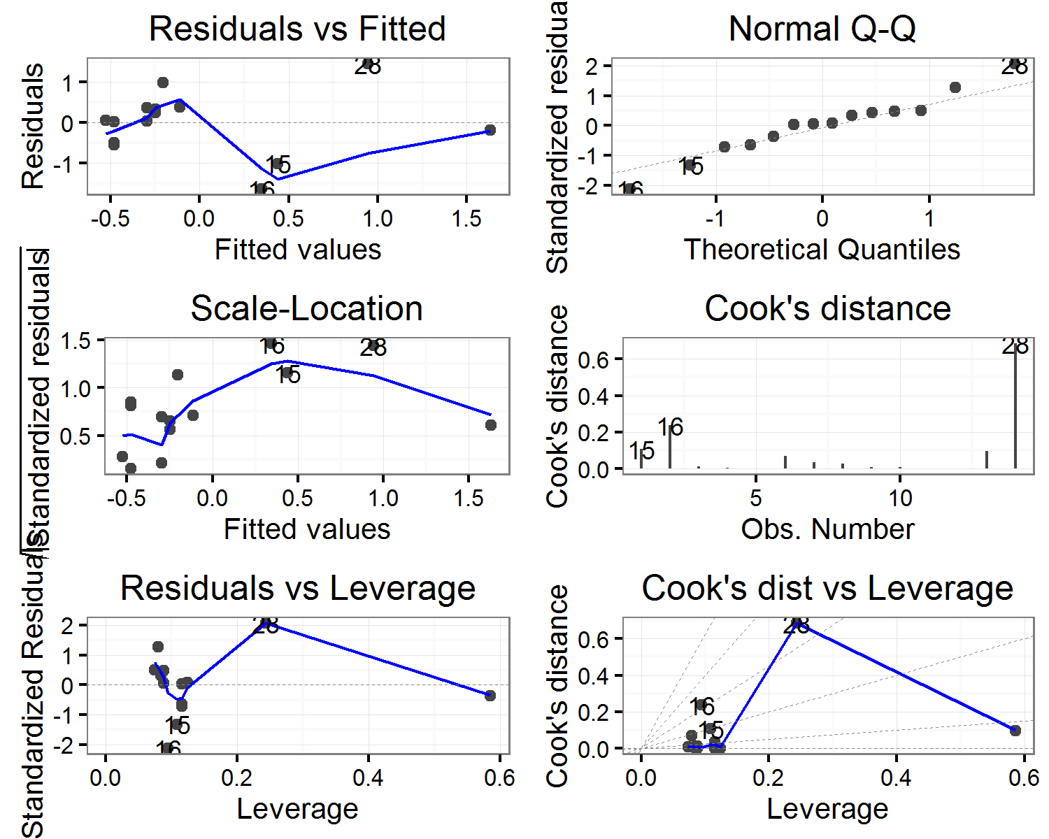

(#tab:orientmodels_diagnostics)Artefact orientation: Correlation of artefact volume with Cook's distance values for each model

|  |  |  |  |  |  |  |
| --- | --- | --- | --- | --- | --- | --- |
| estimate | statistic | p.value | parameter | conf.low | conf.high | variable |
| 0.4503559 | 1.7473039 | 0.1061013 | 12 | -0.1054116 | 0.7917476 | elongation |
| 0.4507625 | 1.7492831 | 0.1057475 | 12 | -0.1049072 | 0.7919379 | flatness |
| 0.8538854 | 5.6833176 | 0.0001018 | 12 | 0.5911112 | 0.9527965 | length(mm) |
| 0.4521234 | 1.7559192 | 0.1045686 | 12 | -0.1032164 | 0.7925743 | shape |
| -0.0177394 | -0.0614606 | 0.9520042 | 12 | -0.5432061 | 0.5177129 | sphericity |
| 0.7887669 | 4.4450997 | 0.0007997 | 12 | 0.4440052 | 0.9300974 | thickness(mm) |
| 0.4695951 | 1.8425172 | 0.0902315 | 12 | -0.0812213 | 0.8006793 | volume |
| 0.5036017 | 2.0192788 | 0.0663690 | 12 | -0.0368147 | 0.8161147 | width(mm) |

## Diagnostic plots for linear models of artefact plunge

## $elongation

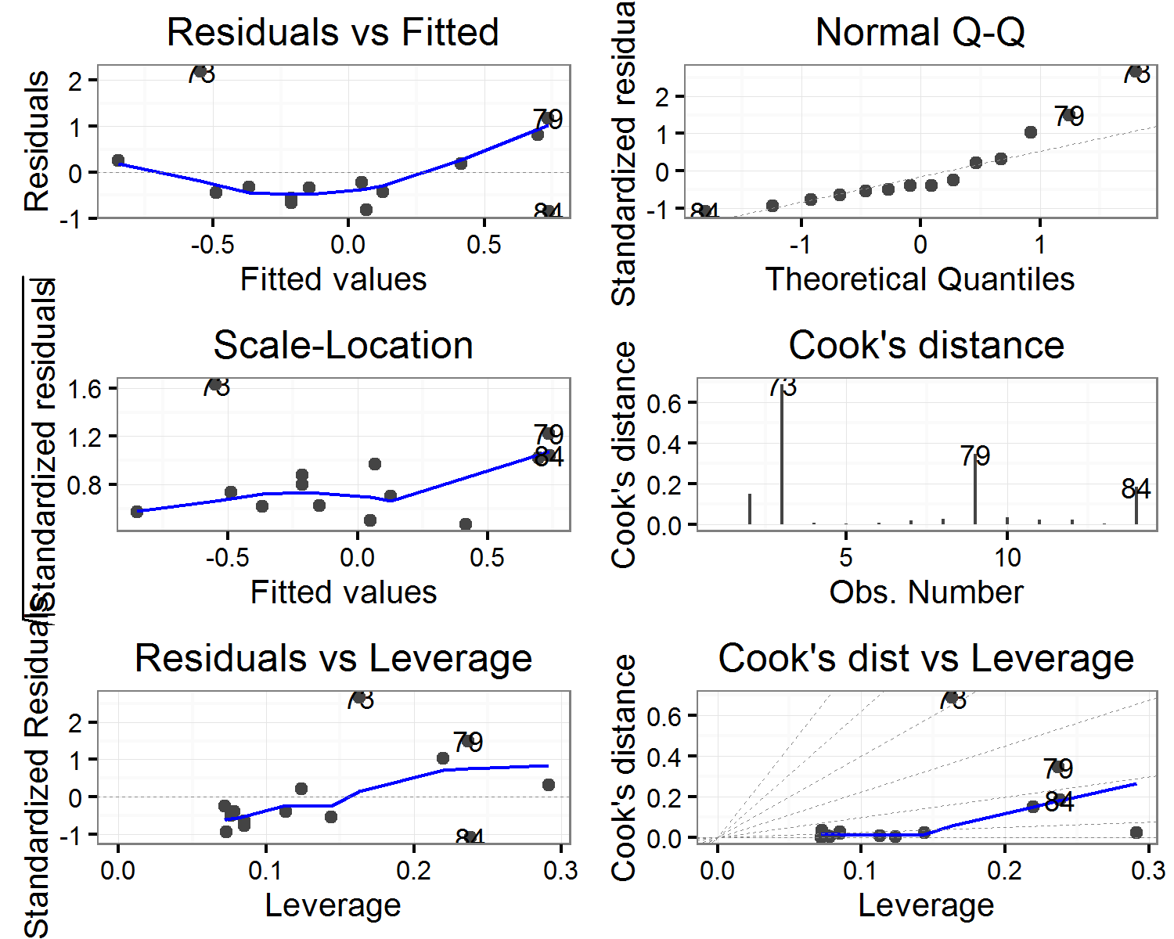

##   
## $flatness

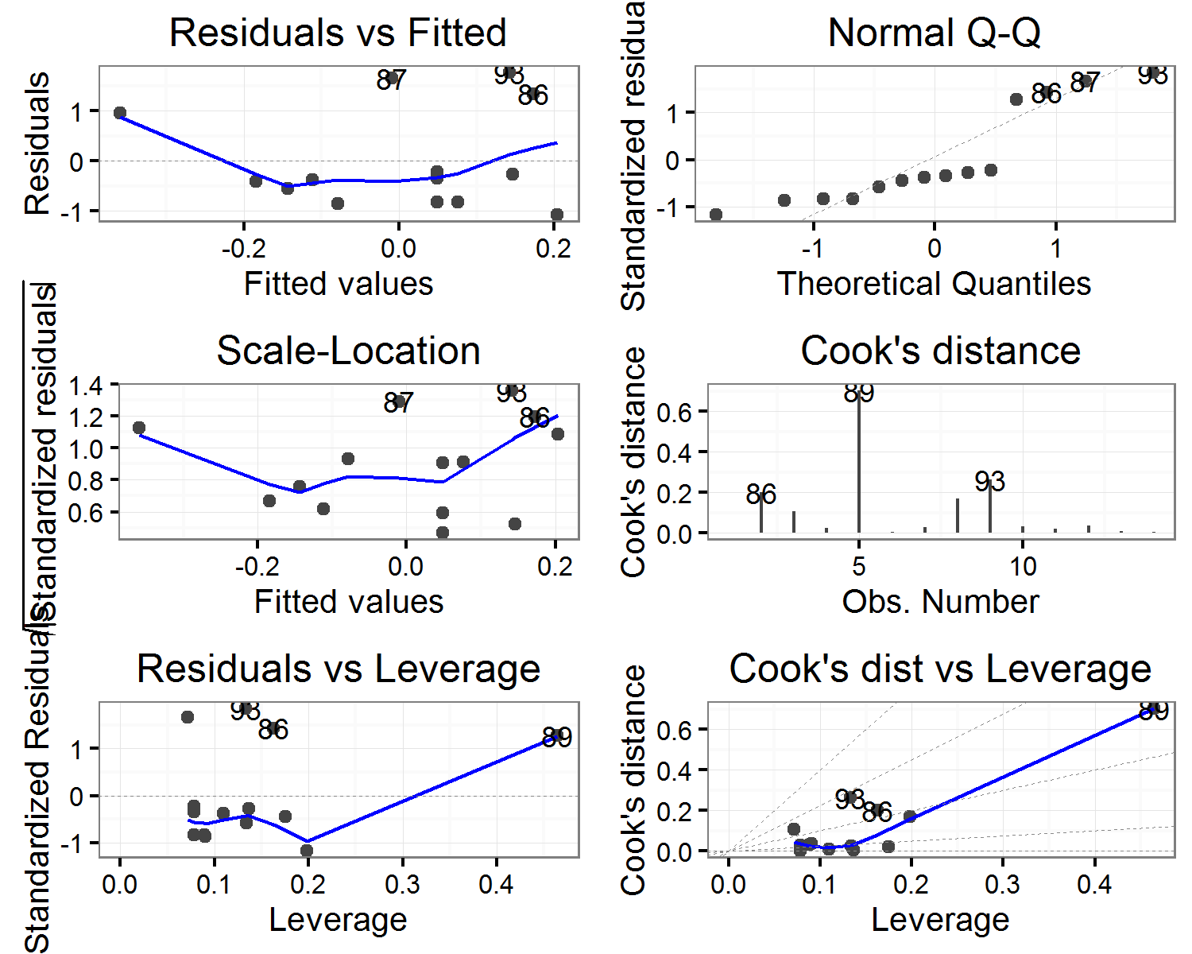

##   
## $`length(mm)`

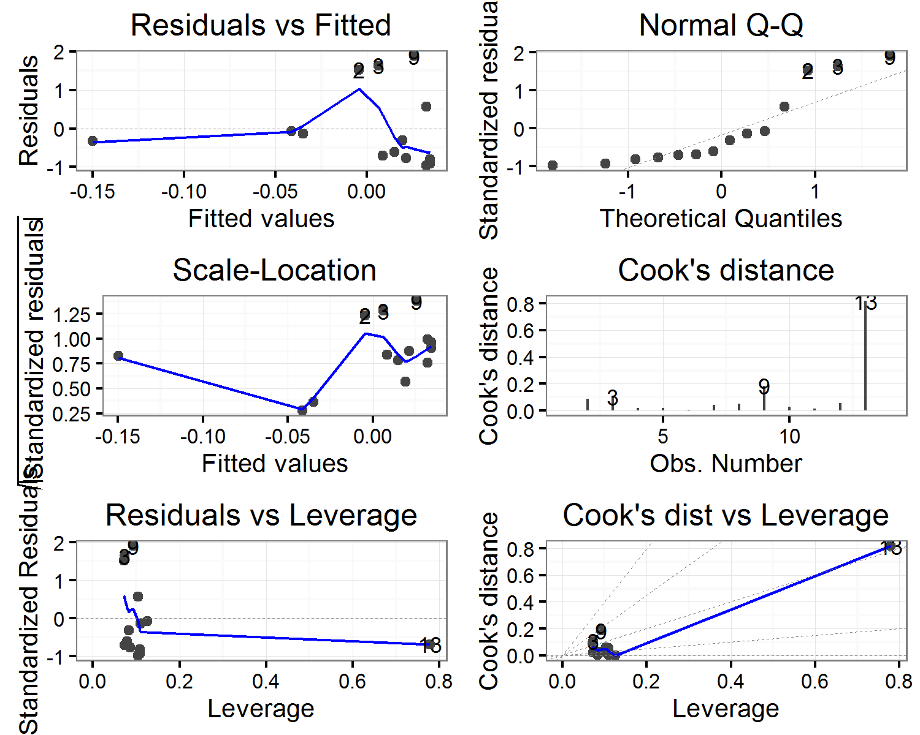

##   
## $shape

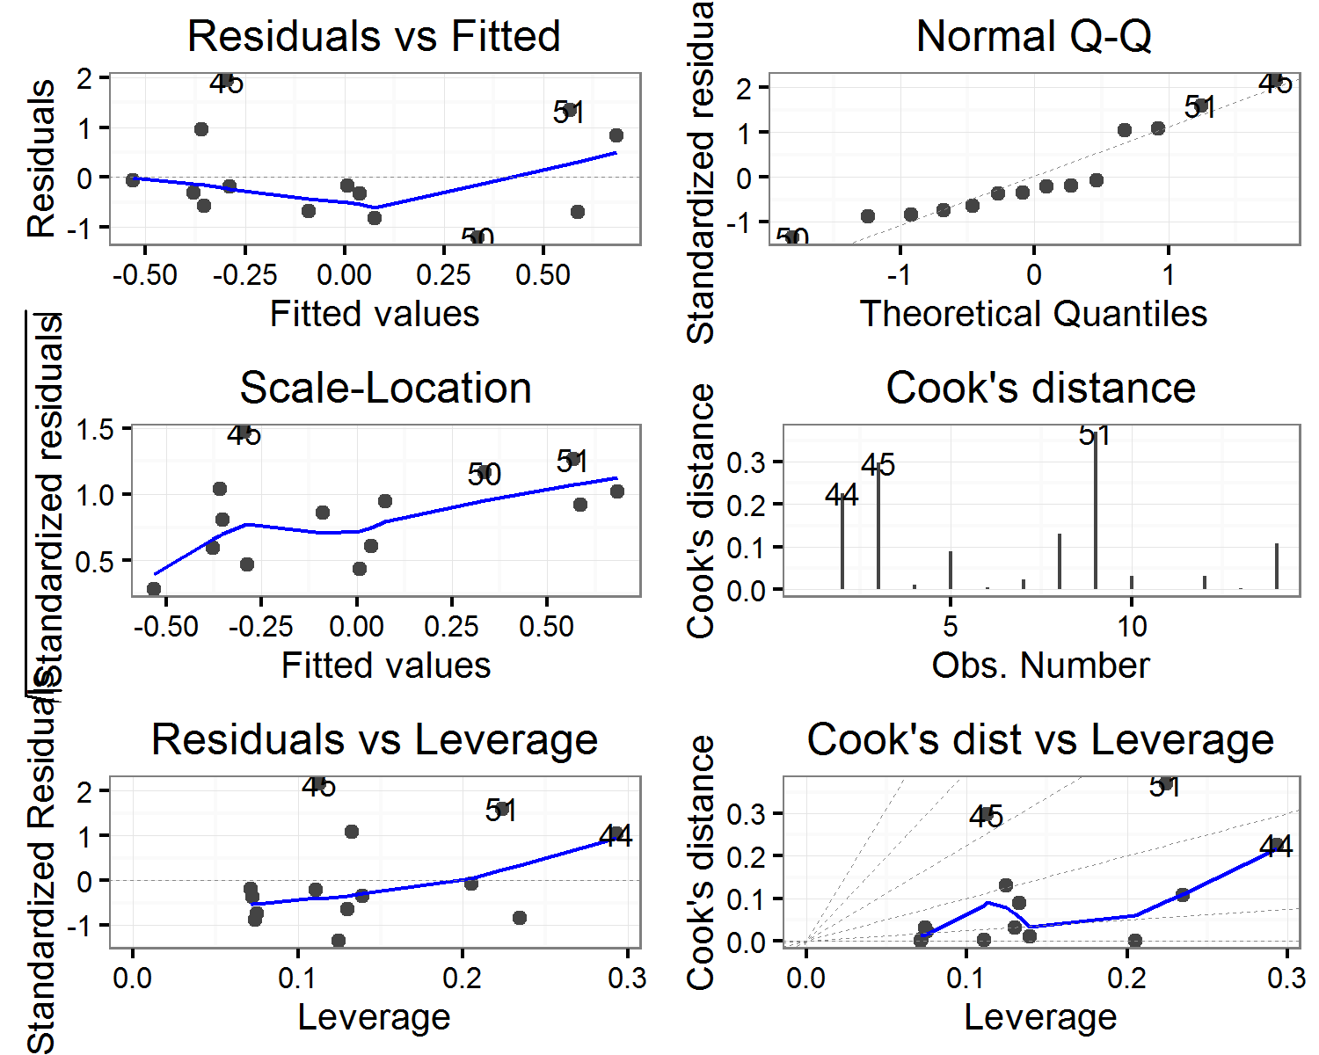

##   
## $sphericity

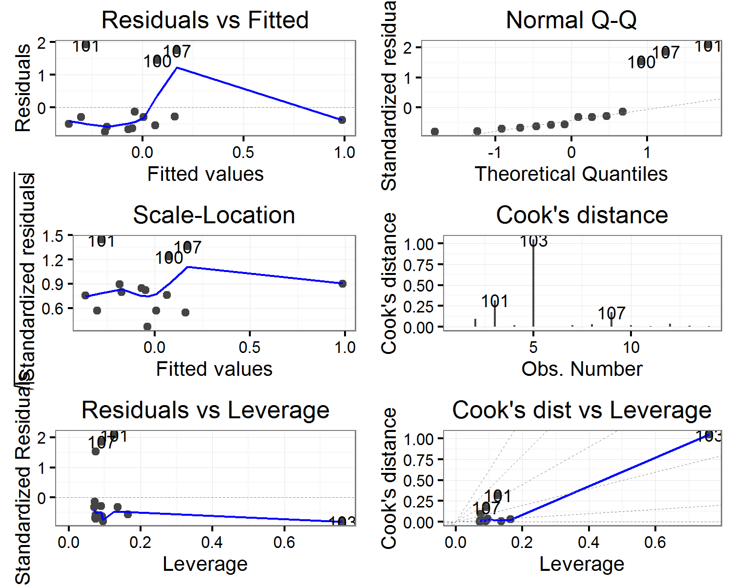

##   
## $`thickness(mm)`

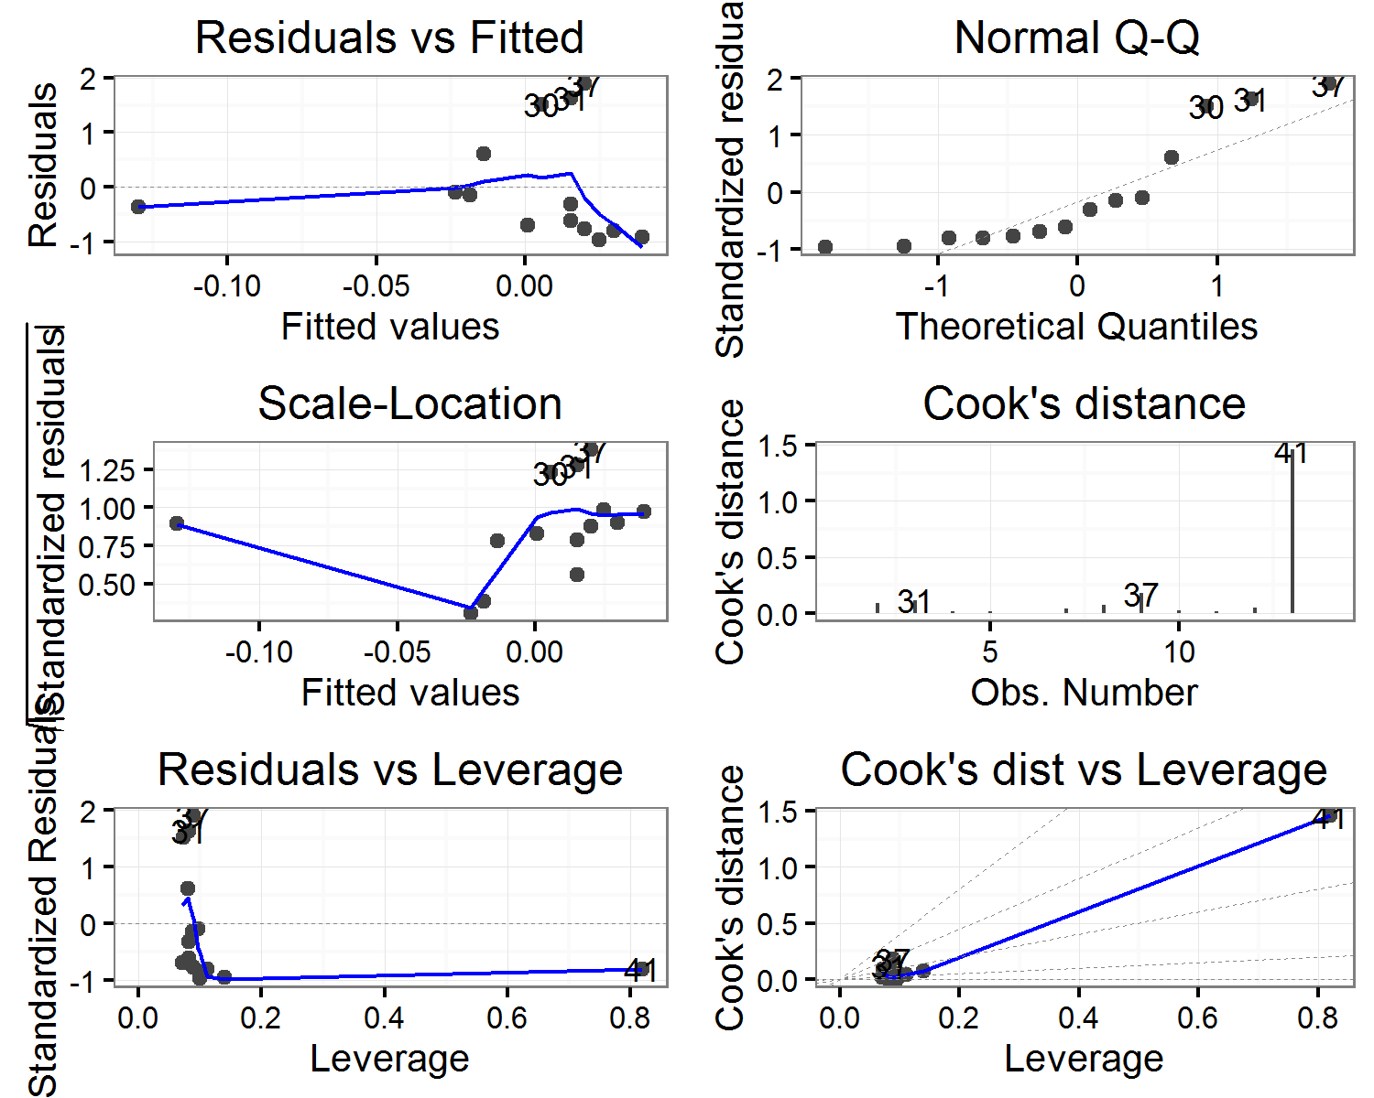

##   
## $volume

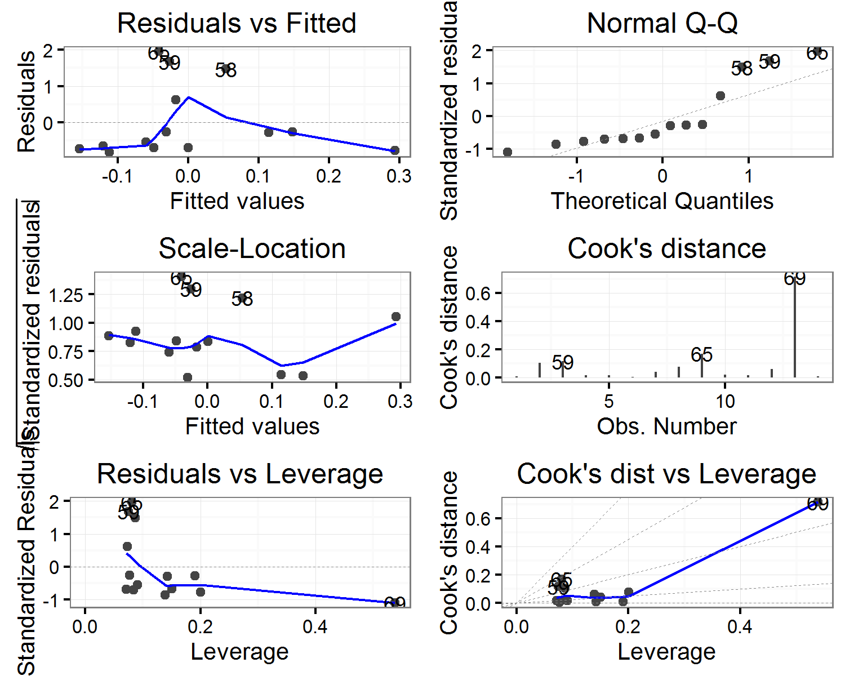

##   
## $`width(mm)`

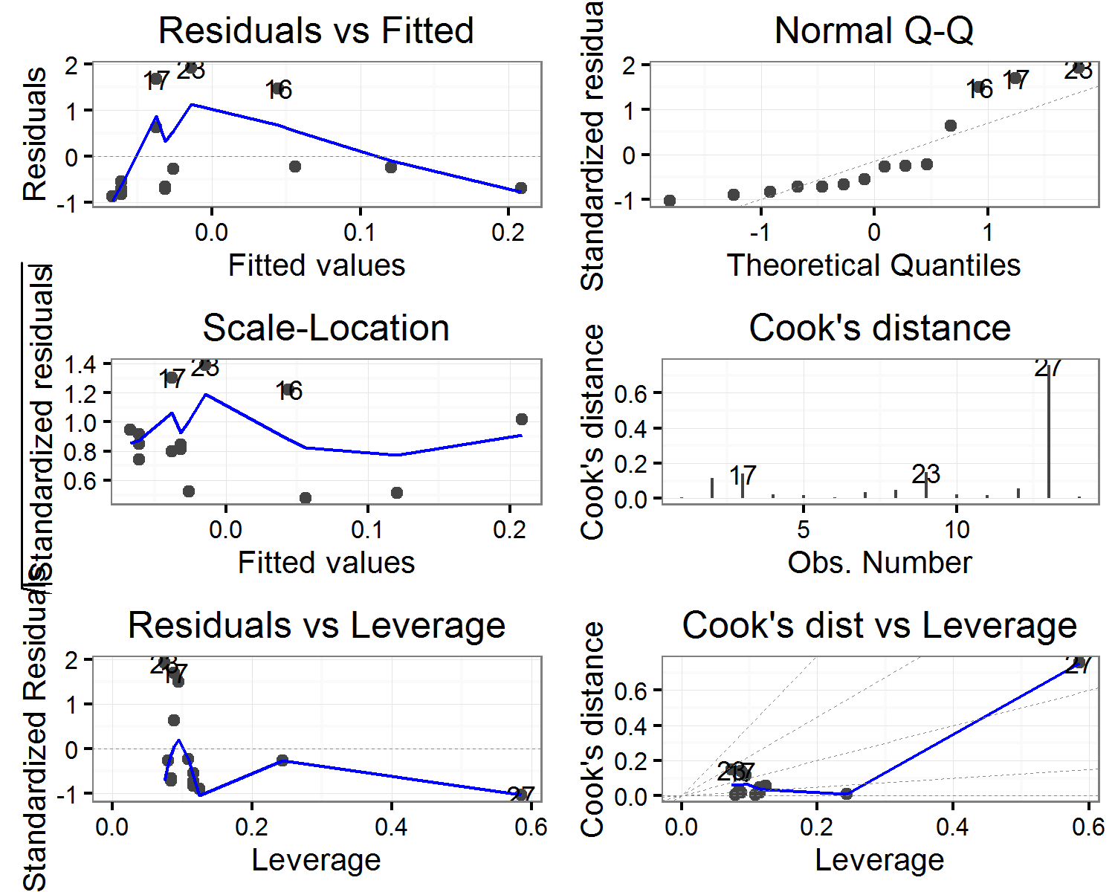

(#tab:plungemodels_diagnostics)Artefact plunge: Correlation of artefact volume with Cook's distance values for each model

|  |  |  |  |  |  |  |
| --- | --- | --- | --- | --- | --- | --- |
| estimate | statistic | p.value | parameter | conf.low | conf.high | variable |
| -0.0240870 | -0.0834639 | 0.9348588 | 12 | -0.5476673 | 0.5130493 | elongation |
| -0.1656422 | -0.5818390 | 0.5714441 | 12 | -0.6399765 | 0.4001007 | flatness |
| 0.6479169 | 2.9465902 | 0.0122214 | 12 | 0.1788058 | 0.8770066 | length(mm) |
| -0.1253496 | -0.4376757 | 0.6693952 | 12 | -0.6150250 | 0.4341011 | shape |
| -0.0845445 | -0.2939231 | 0.7738386 | 12 | -0.5887156 | 0.4669827 | sphericity |
| 0.6759241 | 3.1771524 | 0.0079632 | 12 | 0.2266164 | 0.8880286 | thickness(mm) |
| 0.6373726 | 2.8653648 | 0.0142116 | 12 | 0.1613619 | 0.8727935 | volume |
| 0.6625271 | 3.0640122 | 0.0098255 | 12 | 0.2034732 | 0.8827866 | width(mm) |