Assessment 2 – Tracking Biological Weapon Fallout
Intention of software:
A model the spread of bacteria from a given point given user defined wind direction probability, number of bacteria released, and height bacteria released from. Produce a .txt file output of the locations where the bacteria landed.
UML diagram:
Action flow diagram of the model process reflecting user interaction triggered events and parameters.
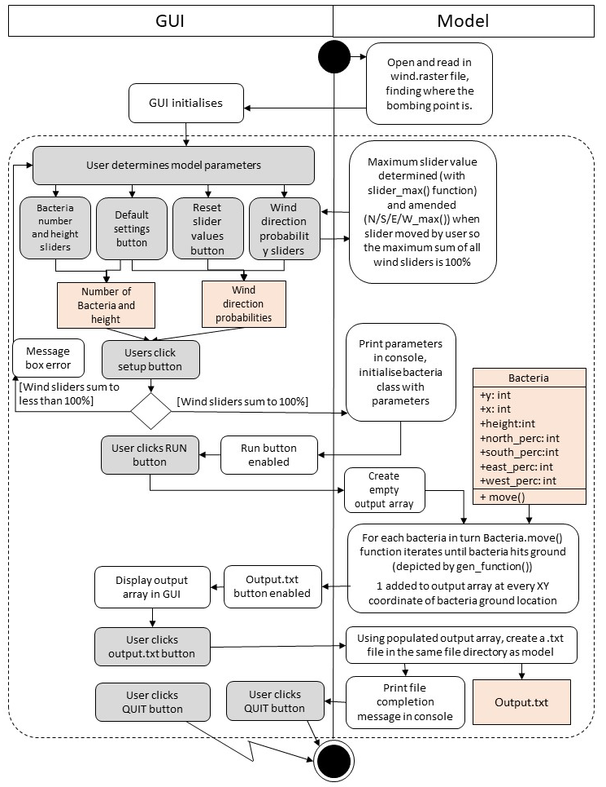
Software development process:
The overall development process taken was to break down the model into smaller sections that could be tested individually then merged/integrated together. The below details chronological order of section development and integration.
Movement Phase:
- Basic movement mechanism.
- Decided to integrate the movement mechanism into a bacteria class, allowing the movement process to be looped and within the bacteria agent framework.
- Reading in of wind.raster file and finding the coordinates of the start point, feeding in the start x and y to the bacteria class
Height and Turbulence Phase:
- Used value of wind.raster start point (255) as height of start point, fed this into bacteria class.
- Created the turbulance/falling mechanism in the bacteria class using height value.
- Created a generator function which ran the movement of bacteria until the height of the bacteria was 0 (aka it hit the ground)
Output file Phase:
- Created a blank array txt file
- Made a list in the bacteria movement loop which recorded the x and y of the bacteria when it hit the ground
- Made a loop which read the coordinates in the bacteria ground location list and added 1 to every coordinate in the output file which had bacteria landing on it.
GUI Phase:
- Used basic tkinter canvas based on assessment 1 code, adding in sliders and buttons.
- Altered the wind slider values to sum to 100% (details in ‘issues during development’ section)
- Integrated the slider values into the rest of the code
- Considered the usability of the GUI and made the run and output buttons disabled until relevant point in activity flow
- Added the output resolution slider
Making code more efficient:
- Merged the finding of the start bombing point x and y with the reading in of the wind.raster file
- Merged the bacteria movement with the documentation of the point the bacteria lands in the output file.
Issues during development:
- Wind probability sliders – The summed probabilities of the four wind directions should be 100%, so it was determined mechanisms and check should be integrated into the model to prevent more or less than 100% being run. Initially funtcion was implemented to set the sliders to 25 each on initialisation and auto-adjust the remaining thee wind sliders when one was moved so maintain a sum of 100. However, this was not usable if the user wanted to add in precise values as controlling the auto adjustment of the other sliders was not easy. Therefore, some functions were created that amend the maximum slider value when each slider is being moved, considering the values of all other wind sliders. Although this does cause some visual disparities given the scales of the slides differ, the outcome is the user can select precise inputs easily. To prevent the used from running the model with less than 100% wind probabilities, when the user presses the SETUP button the code checks the wind directions add to 100 and displays an error message box if they do not, asking the user to amend the wind directions. The RUN button remained disabled until a setup is completed where they sum to 100%.
- Output in GUI – Initially wanted to create an animation, where the GUI image updated for every additional bacteria hitting the ground, but this was not feasible as it took a long time for the animation to run (given the large number of bacteria) and processed increasingly slowly - so this was cut from the model.
- Output array – Maintaining the same 300 by 300 array size as the input wind.raster file meant that sometimes, when there was a higher windspeed for one direction for example, the bacteria fell outside of the output array, which created an error. Firstly, to amend this some code was added so bacteria was only added to the output array if they were within the array boundaries. The number of bacteria that fell outside of this boundary was counted and printed when the model had finished running. A slider was added so the used can select the output array size.
General sources used:
- Online Library Documentation
- Various forum posts on stackoverflow

