Lesson 3 - Scripting and OOP
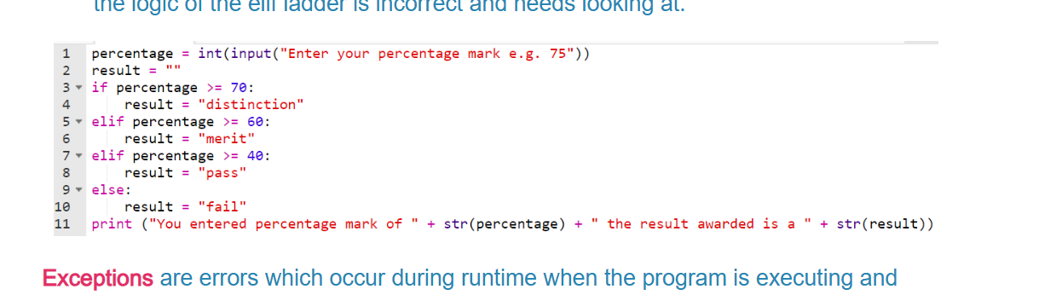
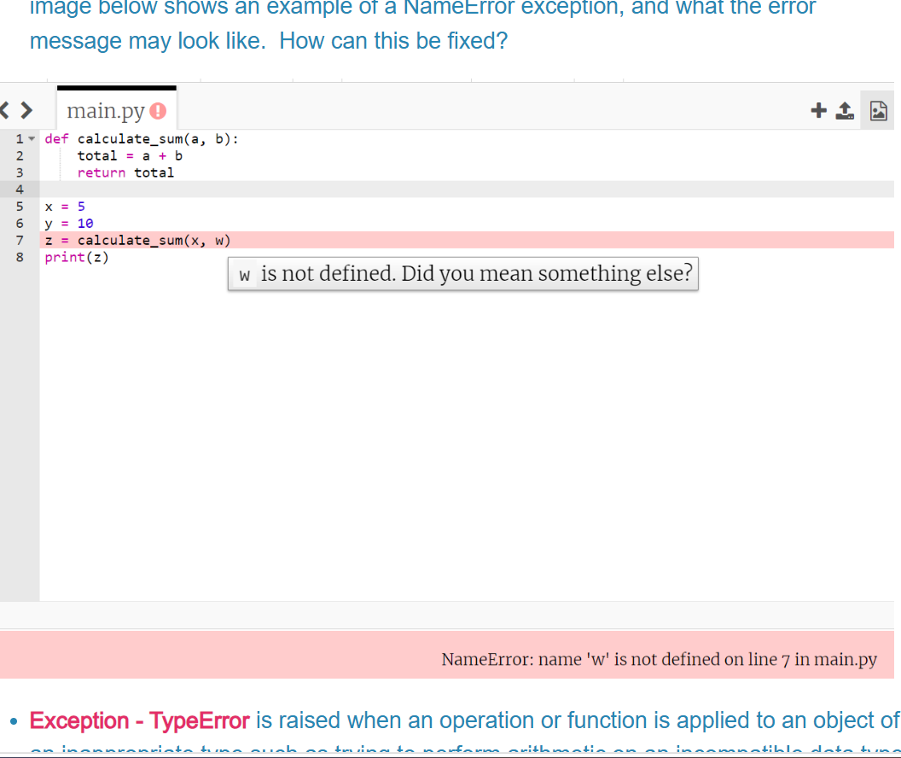
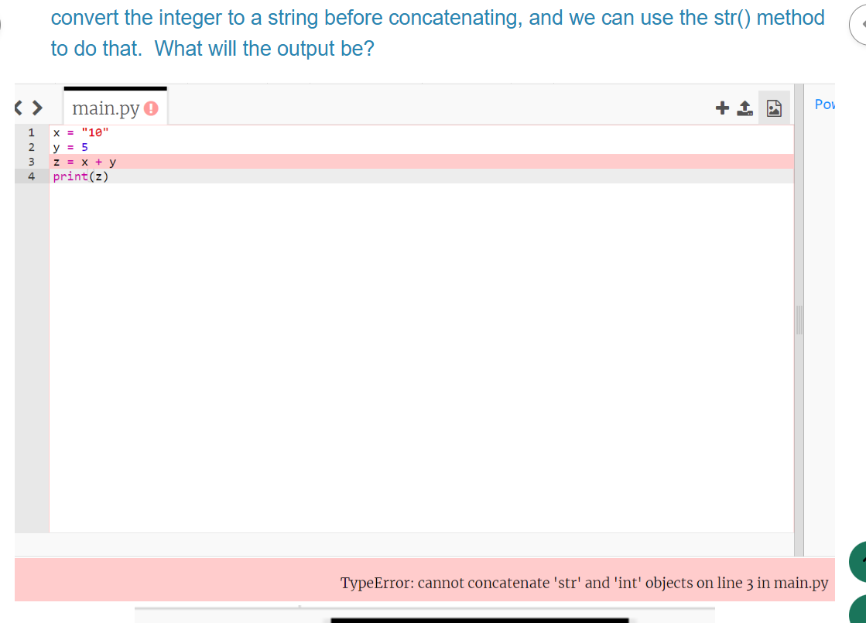
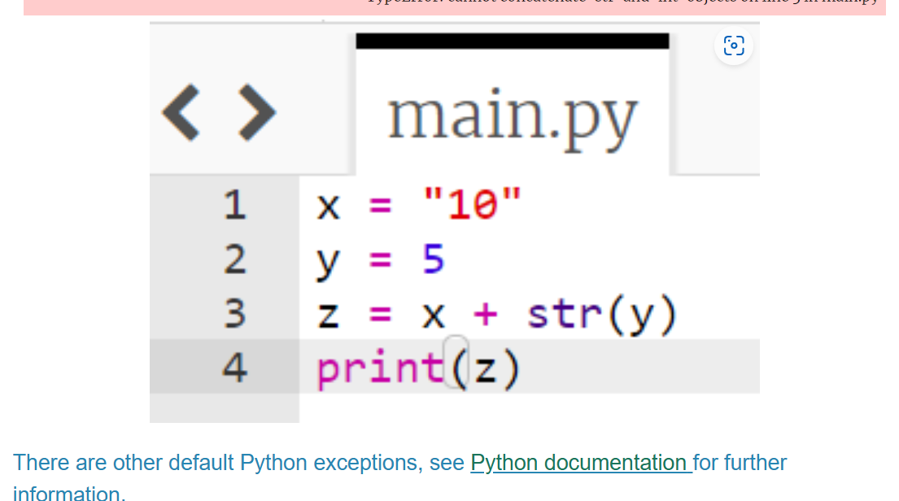
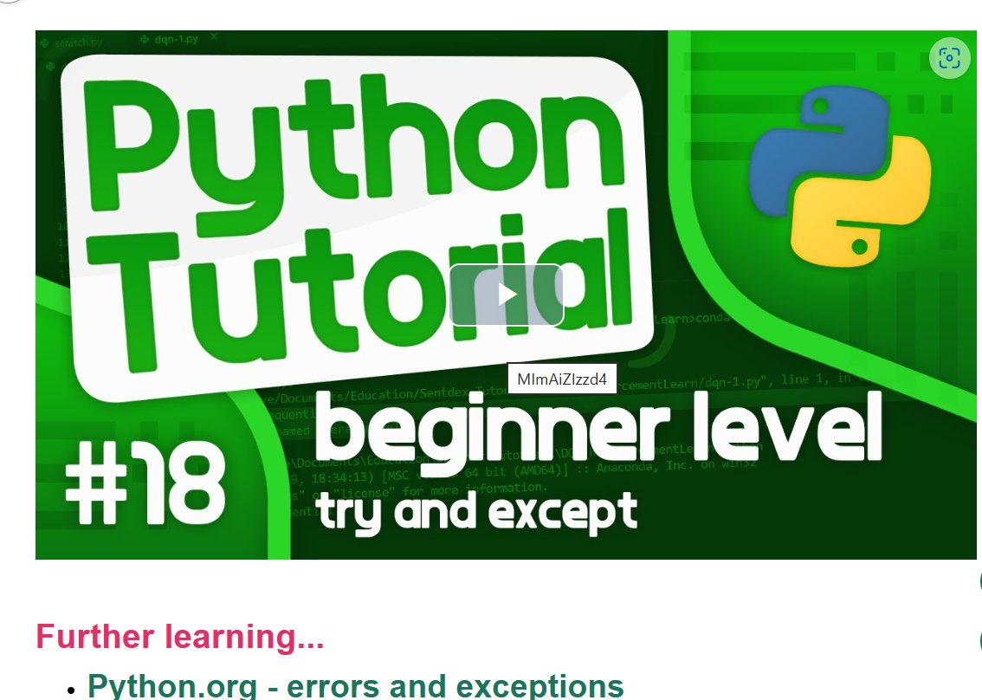
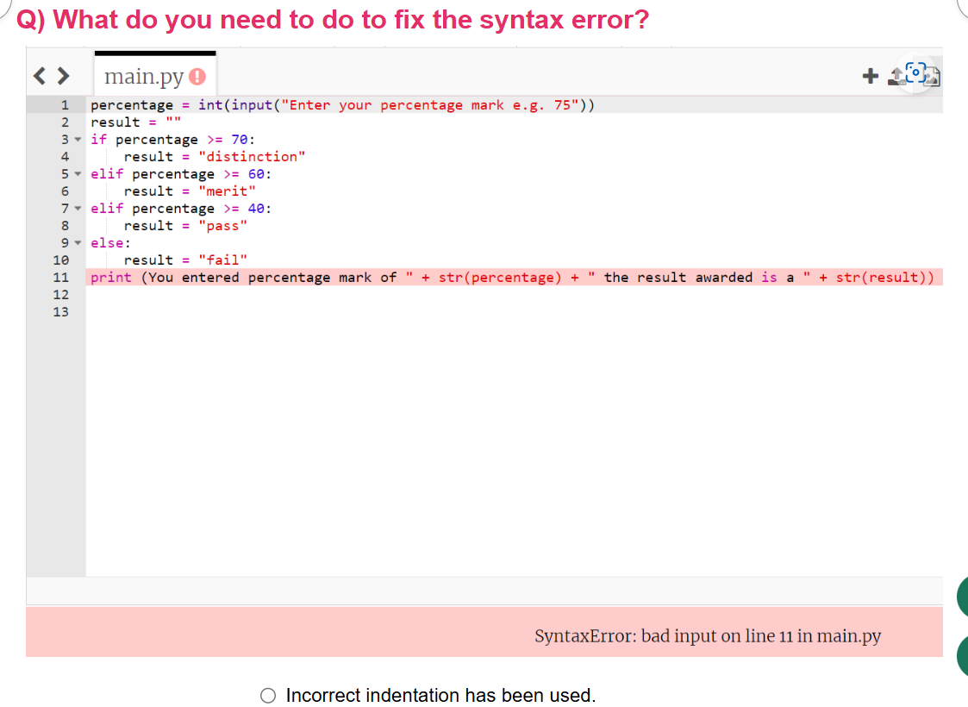
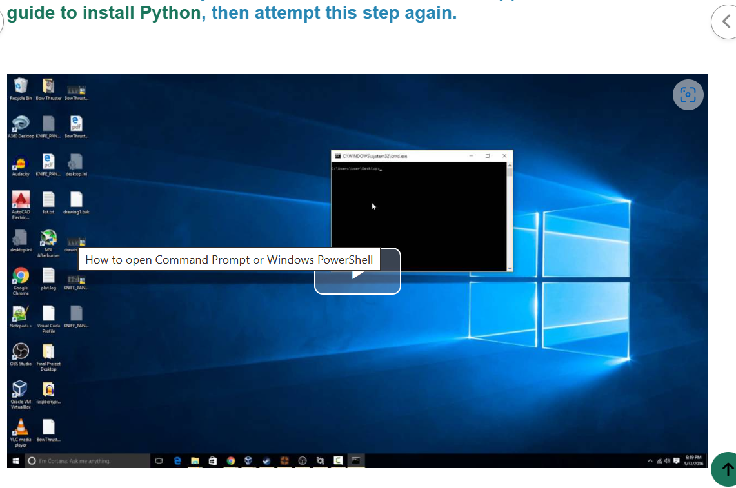

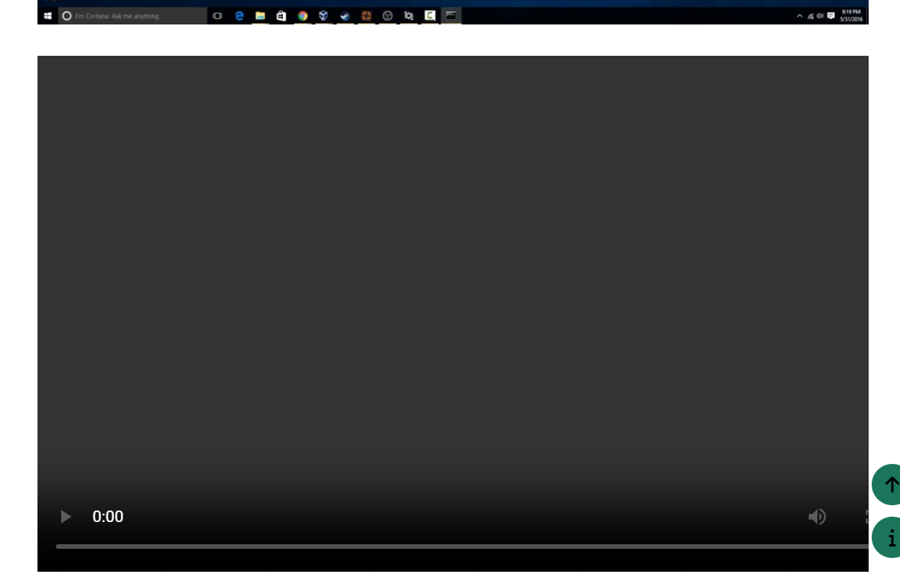


https://img.youtube.com/vi/yivyNCtVVDk/maxresdefault.jpg

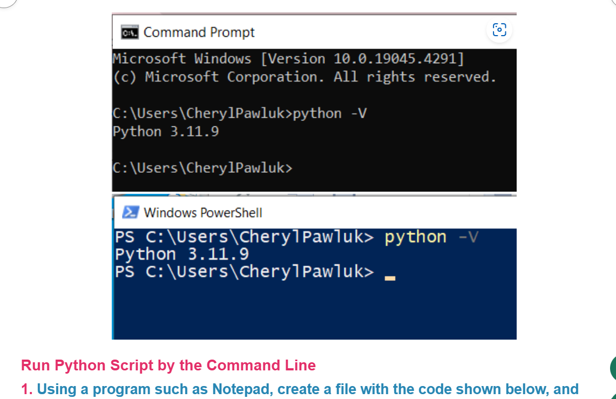

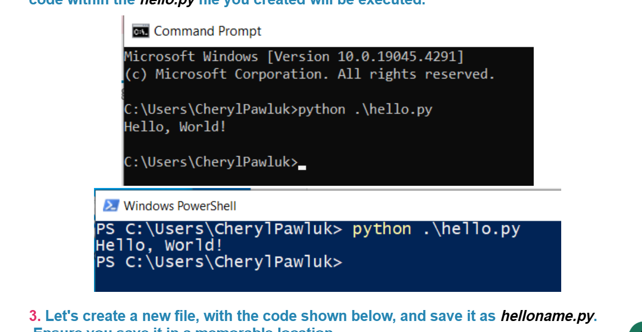

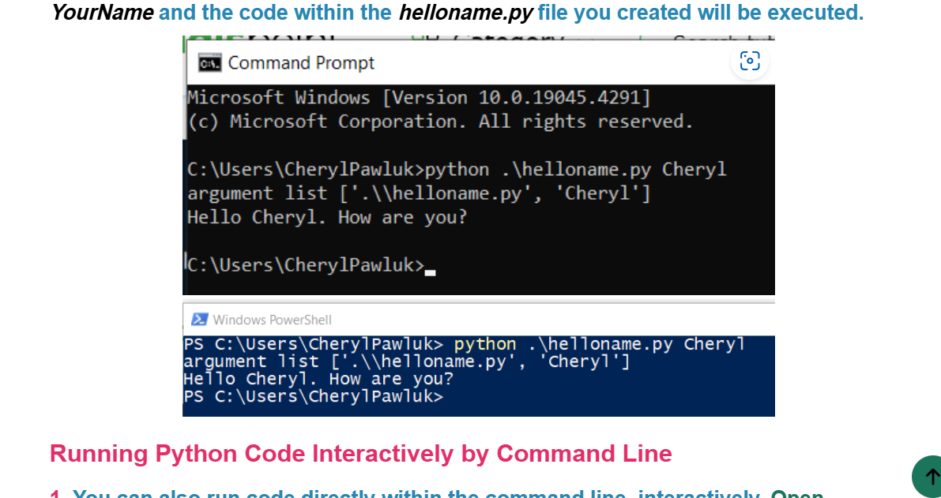
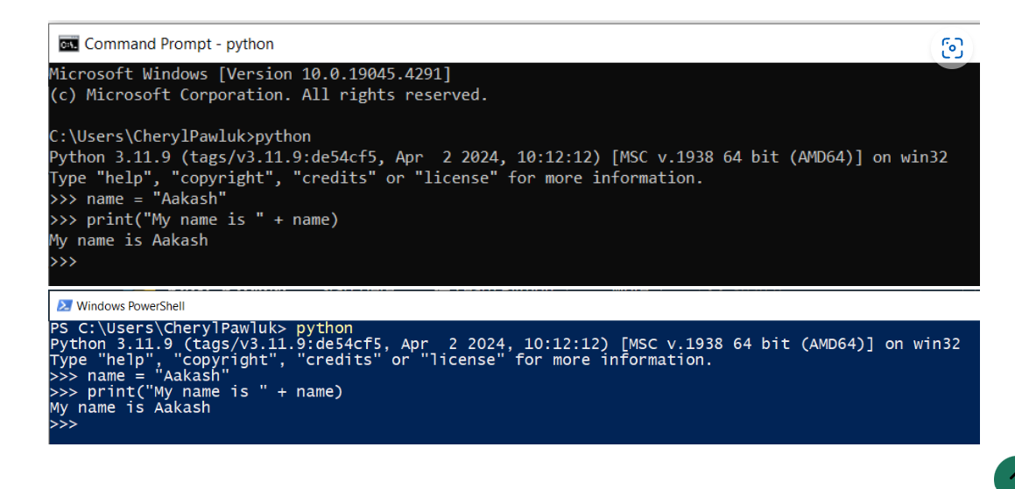
https://img.youtube.com/vi/6Ff5ls0TXHU/maxresdefault.jpg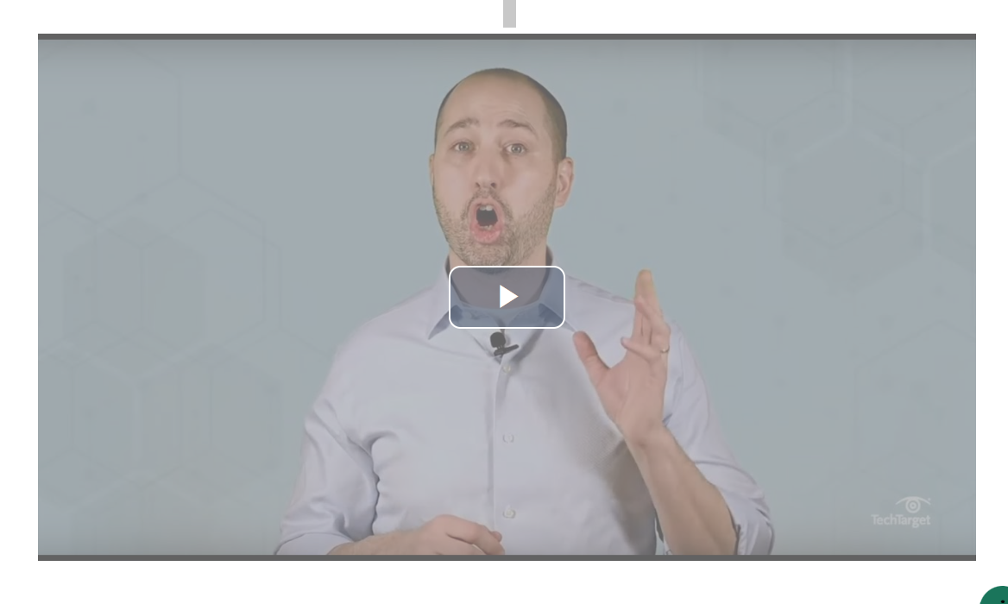
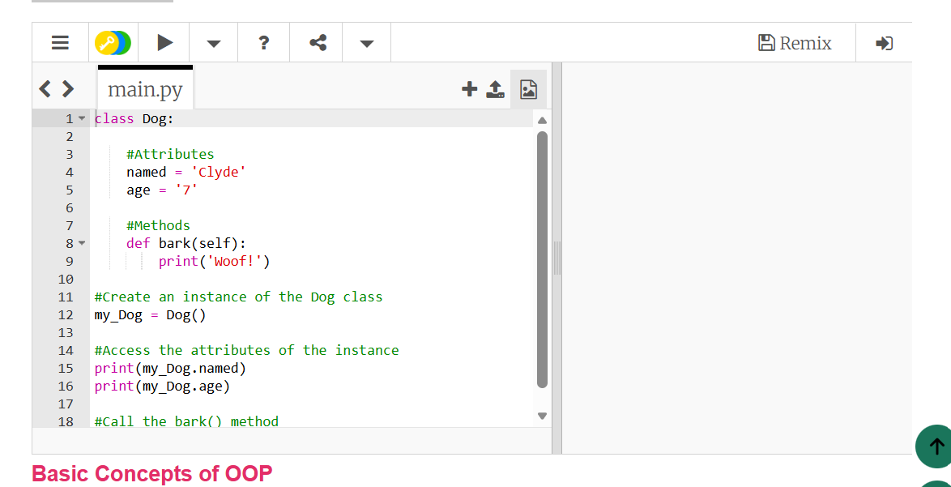

Errors and exceptions can lead your program to fail, stop it from running, unexpected behaviour to occur or an incorrect outcome. Fortunately, Python comes with a robust set of tools and functions to handle these and to improve the stability of the code.
But what's the difference between an error and an exception? An error is an issue with the program which stops the program from completing its intended purpose. An exception is a condition that interrupts the normal flow of the program. They are both in essence a type of runtime error, which means they only occur once the program is executed.
Error - Syntax errors happen when the Python interpreter ("A Python interpreter is a computer program that converts each high-level program statement into machine code. An interpreter translates the command that you write out into code that the computer can understand.") is unable to recognise the structure of the statements in code. So basically, there is something wrong with the code we have written, structure-wise - your code must follow Python’s syntax rules for it to make sense.
These are some common Python syntax errors...
Misplaced, missing, or mismatched punctuation (parentheses, brackets, braces, quotes, commas, colons, etc.)
Misspelled, misplaced, or missing Python keywords
Incorrect use of the assignment operator (=)
Illegal characters in variable names i.e. using reserved keywords
Incorrect indentation
How can you help to avoid common Python syntax errors?
Use an integrated development environment (IDE), or a code editor that highlights the reserved Python keywords and errors, as well as suggests edits as you write your code.
Frequently test your code as you write it as this helps to find syntax errors from the start and reduces the risk of repeating the same mistake throughout all of your coding.
Be consistent with your indentation. The use of an IDE will support with this as this is one of the most frequent syntax errors.
Read The Python Language Reference as it not only will deepen your knowledge and understanding but also enable you to understand the meaning of syntax error messages.
Further reading on Python syntax errors
Error - Logical errors can occur when the syntax is correct and runs without errors, but the output isn't what was expected i.e. it produces incorrect results due to flawed logic in the code. These types of errors are often caused by incorrect assumptions, an incomplete understanding of the problem, or the incorrect use of algorithms or formulas. These errors can be challenging to find and fix because no error messages are produced, it's down to the developer to locate why the expected output wasn't correct. The image below shows code for a grade generator, if the output was not as expected i.e. distinction instead of merit, then it could mean that the logic of the elif ladder is incorrect and needs looking at.
Exceptions are errors which occur during runtime when the program is executing and encounters an unexpected condition that prevents it from continuing. Even if the code is syntactically correct, it may cause an error when an attempt is made to execute it, which is known as an exception. Exceptions can be a challenge to debug because they happen during runtime and can be difficult to reproduce.
How do you fix an exception? You need to identify the cause of the error and modify the code to handle the error, or even avoid it altogether. Let's look at some specific types of exceptions to help understand how to fix them, and then see how we can use a try-except block to avoid it.
Exception - NameError is raised when the interpreter encounters the name of a variable or function that it cannot find. This can happen due to a misspelling of a variable or function name, attempting to use a variable or function before it has been defined or referencing a variable or function that is outside the current scope. The image below shows an example of a NameError exception, and what the error message may look like. How can this be fixed?
Exception - TypeError is raised when an operation or function is applied to an object of an inappropriate type such as trying to perform arithmetic on an incompatible data type such as string or when passing arguments of the wrong type to a function. The image below shows an example of a TypeError exception, and what the error message may look like. The message indicates that we cannot concatenate a string and an integer using the + operator, as they are two different data types. To fix this we need to convert the integer to a string before concatenating, and we can use the str() method to do that.

What will the output be?

