Unit Name: Unit 2 GitHub for Python
Assessment Name: Lesson 2 Repository, Commits and CLI
Tutor/Assessor Name: Mohammad Ali Afgan
Date: 15.06.26
How to use this document…
The reference column is to be used for the assessment question number/AC, or just to label your screenshots.
Paste your screenshot into the screenshot column.
Ensure each screenshot has an annotation to…
- Offer clarity - draw attention to specific elements in a screenshot i.e. what are you showing us?
- Provide emphasis – point out the important parts of the screenshot i.e. showing that you have undertaken something specific.
- Give context – for contextual information that explains the purpose or highlights specific areas.
Reference | Screenshot | Annotation
Fig 1a-c Create a GitHub repository (2.1)  Fig 1a  Fig 1b  Fig 1c | 1. In the upper-right corner of any page, select , then click New repository.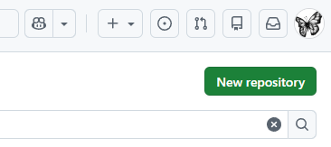  2. I then typed a short, memorable name for my repository. “My_new_repo_CS”  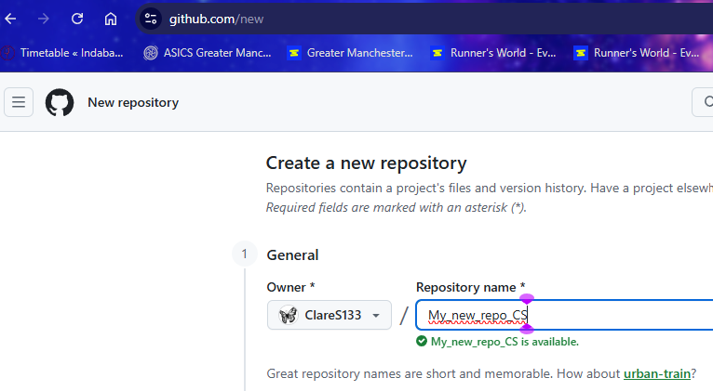  3. Optionally, I added a description of my repository. "Clare’s repo for U2."  4. I chose to set the repository visibility as “Public”. For more information, see "About repositories."  5. I selected Add README: “On”.  6. I clicked Create Repository to complete the steps. I've now created a repository with “Public visibility” and initialised it with a README file.  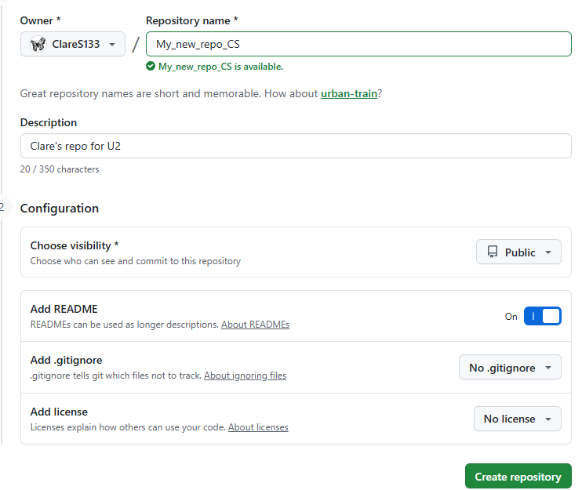
Fig 2 Create a fork GitHub repository (2.2) | Forking a repository allows you to make changes to, essentially a copy of an existing repository, without affecting the original. A fork is a personal copy of another user's repository that lives on your GitHub account. This is useful as you can use someone else's project as a starting point for your own personal idea.  Forks allow you to freely make changes to a project without affecting the original upstream repository (the primary branch on the original repository). So for example, if you have found a bug, rather than logging an issue for the bug you have found, you can fork the repository, fix the bug then submit a pull request to the project owner.  You can put in a pull request in the upstream repository and keep your fork synced with the latest changes since both repositories are still connected. The fork you are working on is then called the "downstream".  To create a fork navigate to https://github.com and sign in.  In the “Type/to search” box type "ClareS133/".  Note that the forward slash at the end of the search string is important here to result in an effective search.  Review the search results:  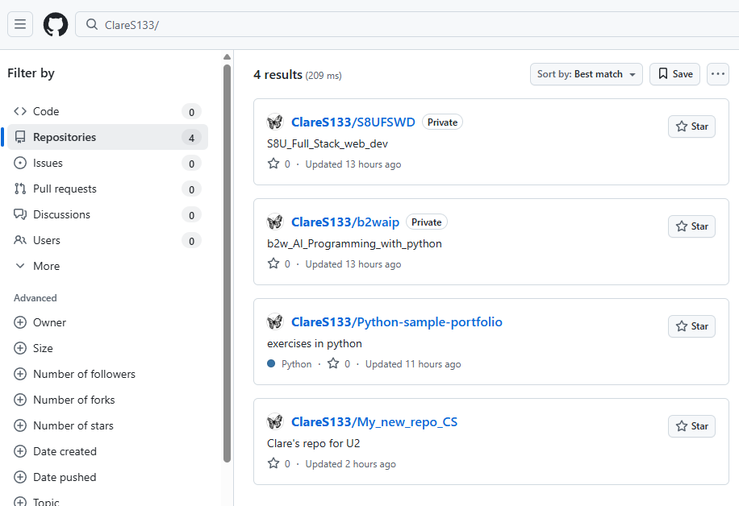  And then select the repo which you are choosing to work with by clicking on it:  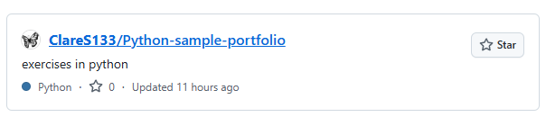  Click on the dropdown arrow in the “Fork” menu:  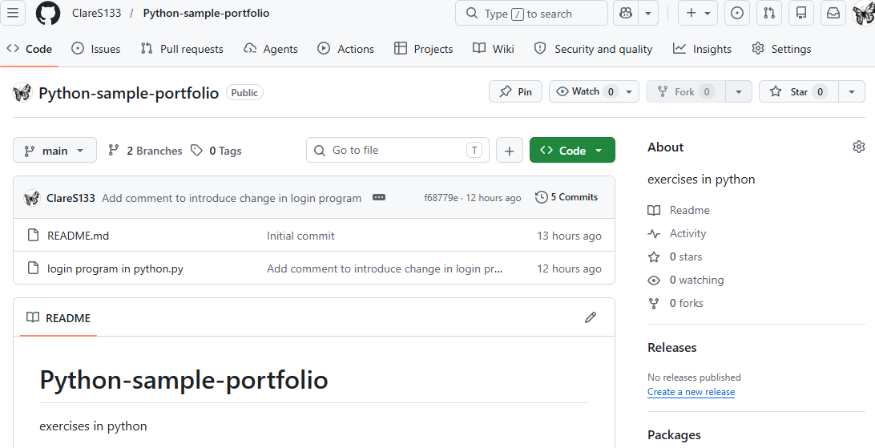  Where you should be able to “+ Create a new fork”  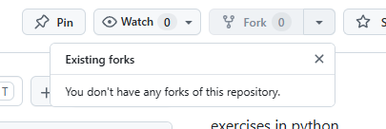  This is where I realise that I should be in the third party repo “CherylPawluk/” as per here:  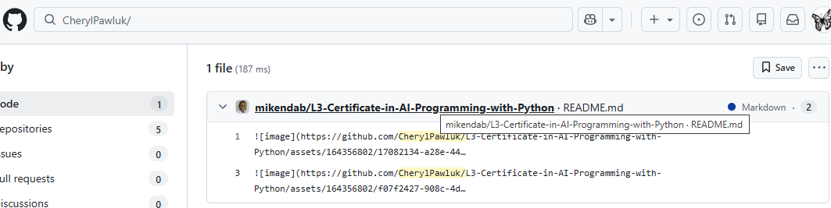  Where I am now able to create a new fork:  Step 1  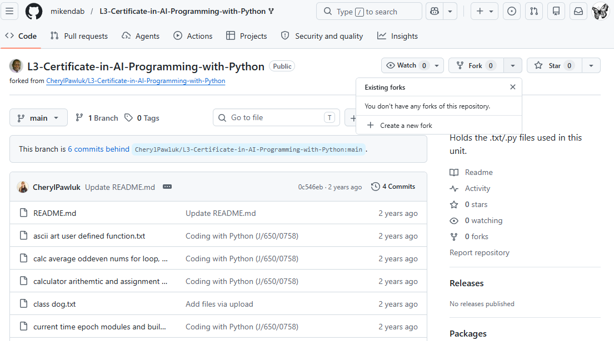  Step 2:  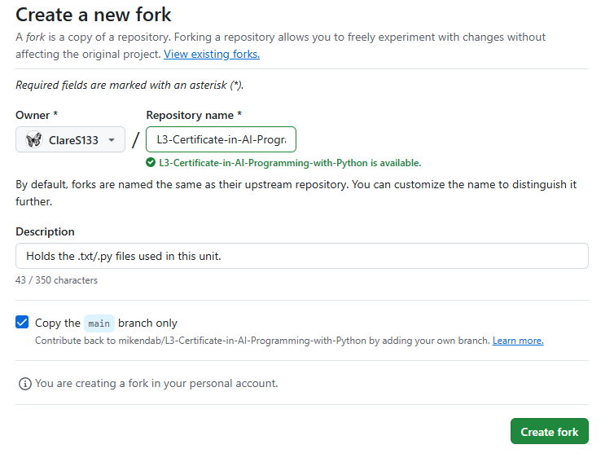  Resulting in a fork to the “.py” files which are held in the repo “CherylPawluk” in my repo giving me easy access to these files:  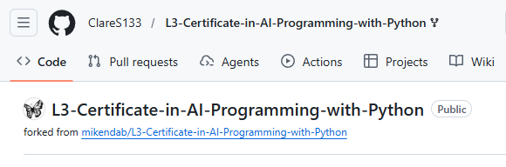  In creating the evidence for this answer I have learned the importance of the slash at the end of the search string and the importance to be in the third-party repo from where you can then create the fork. And I have now created a fork and demonstrated this in the above screenshot evidence.
Fig 3 - Demonstrate the use of commits for version control including: -  (a) Access README.md  (b) Use commit descriptive messages  (c) Use commits to refactor  (d) Push commits to a remote repository  (e) Edit and delete commits  (f) Undo or erase a commit (2.3)  3.1, 3.2, 3.3 | (a)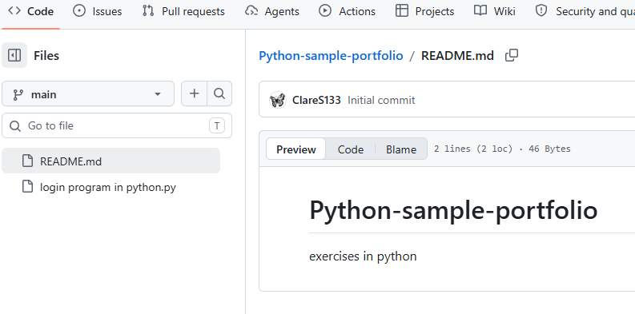  (b.i)  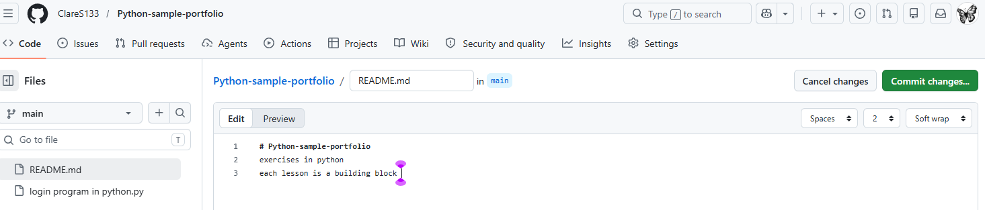  (b.ii)  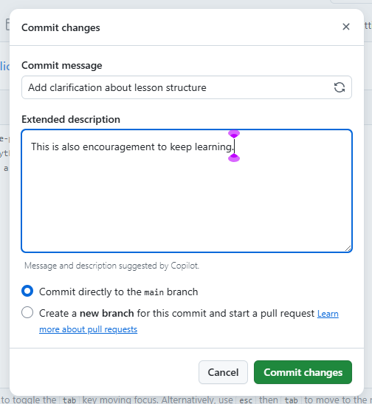  (b.iii)  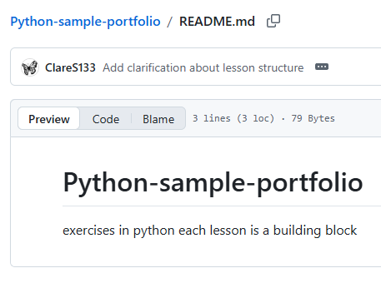  (c.i)  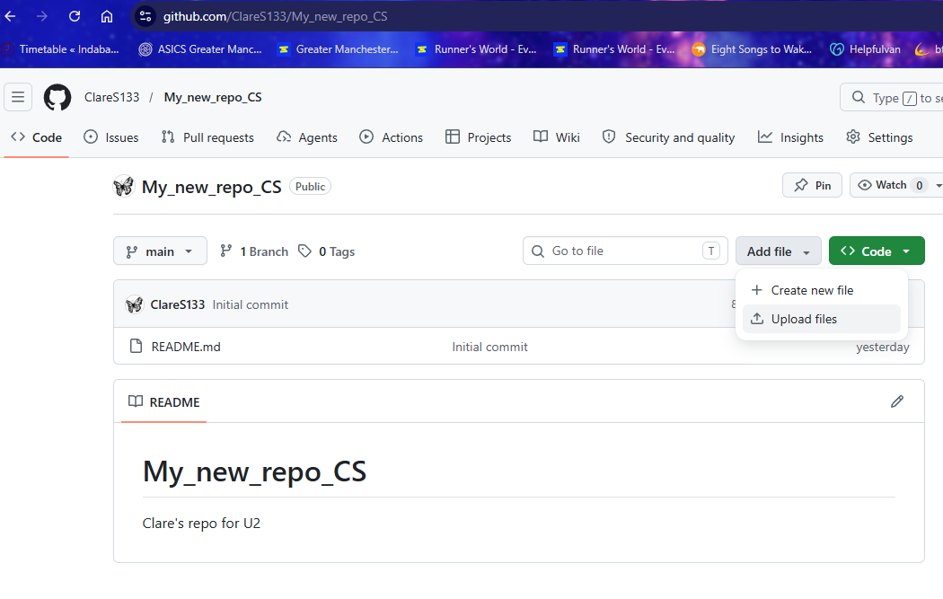  (c.ii)  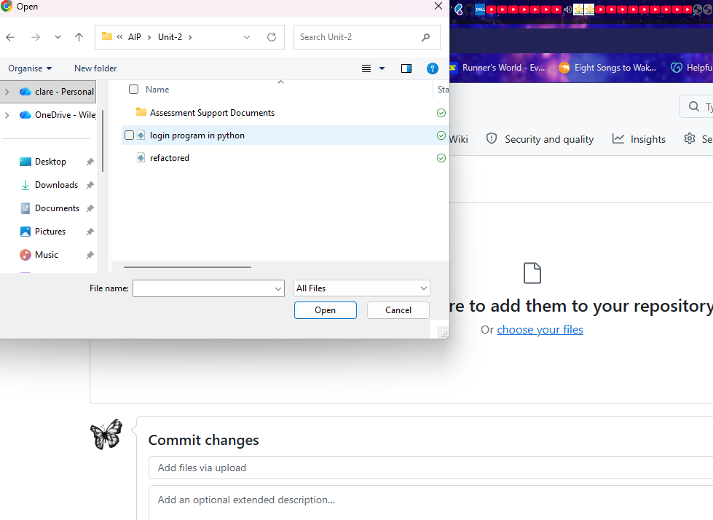  (c.iii)  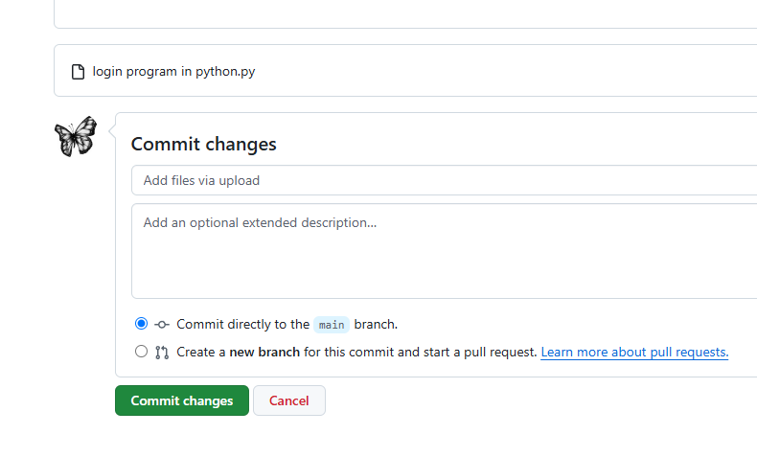  (c.iv)  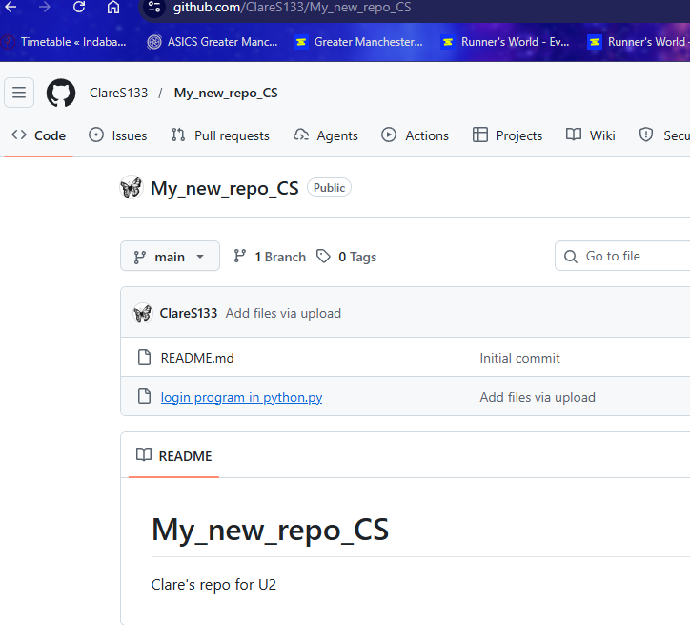  (c.v)  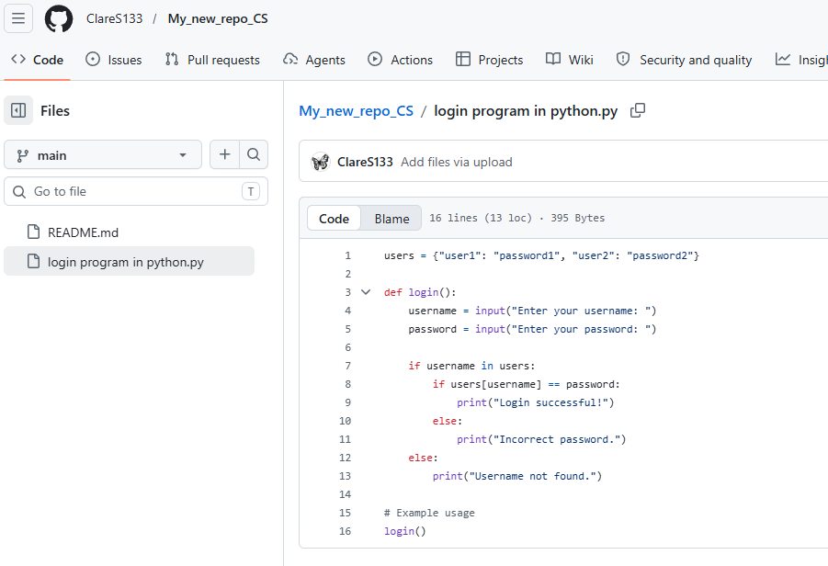  (c.v.i)  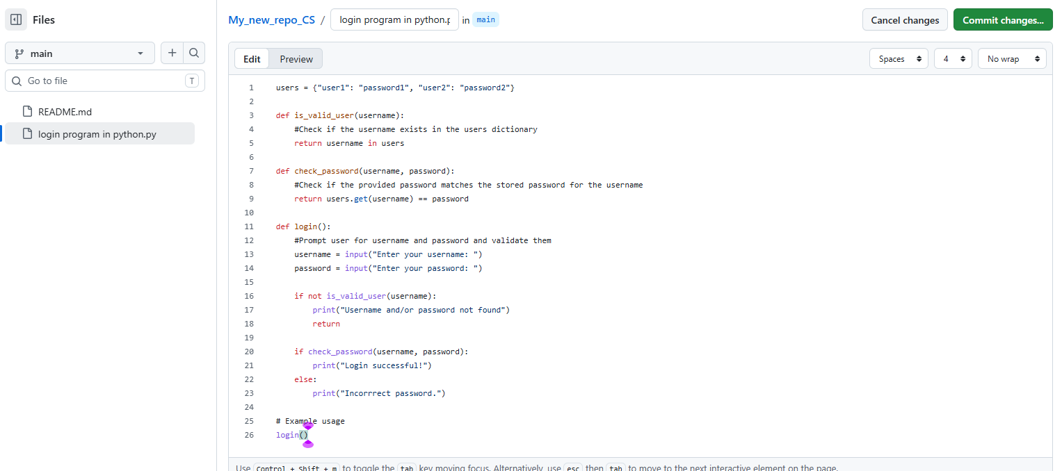  (c.v.ii)  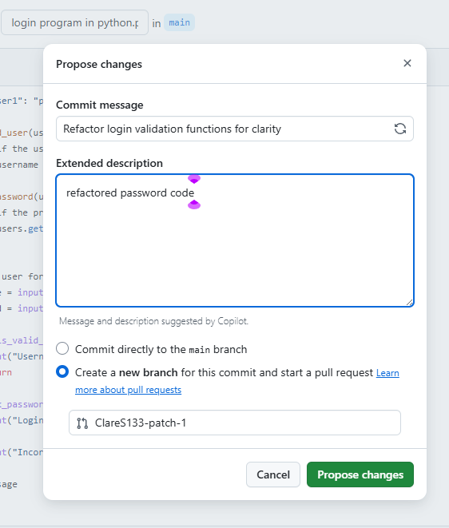  (c.v.iii)  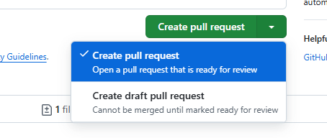  (c.v.iii.1)  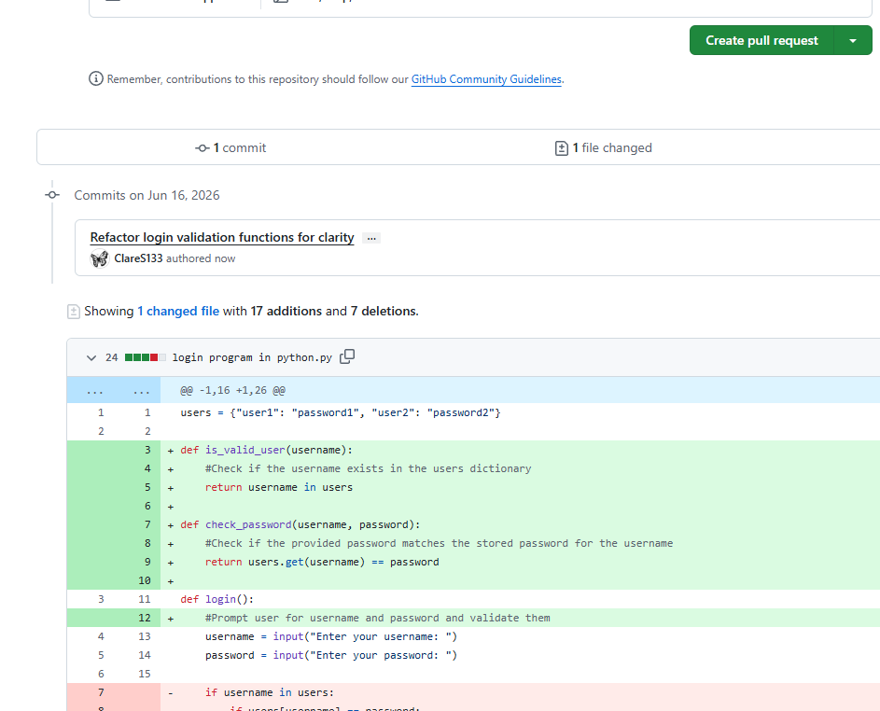  (c.v.iv)  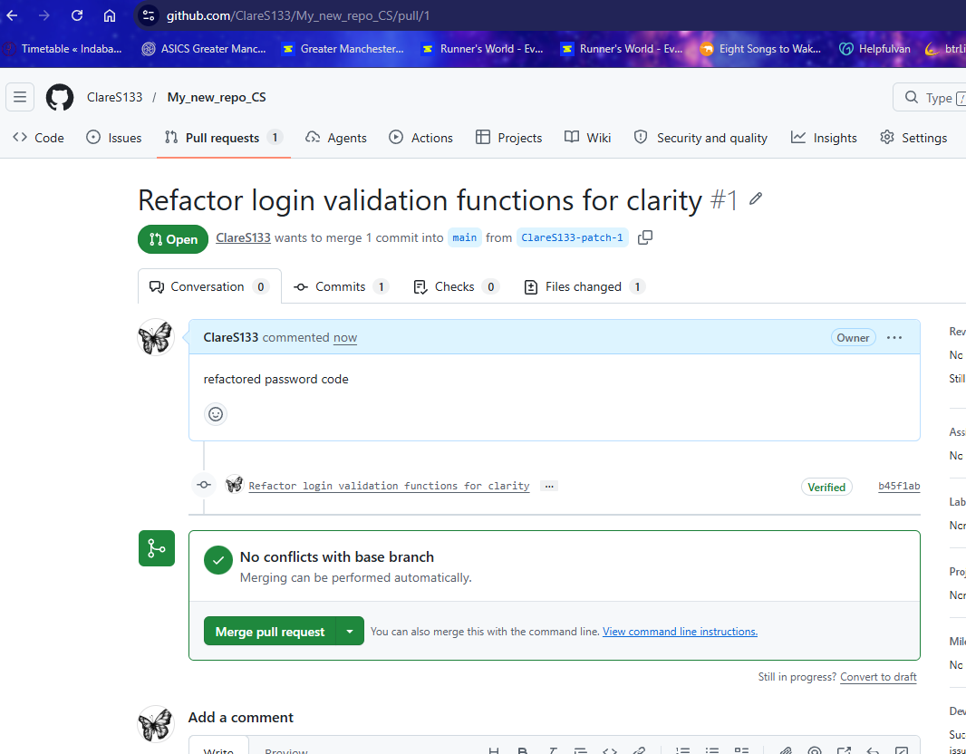  (c.v.v)  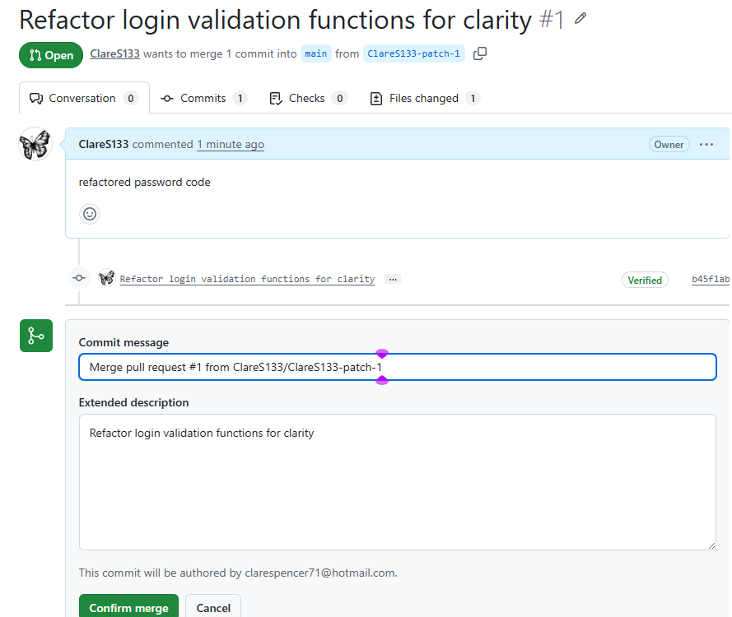  (d)  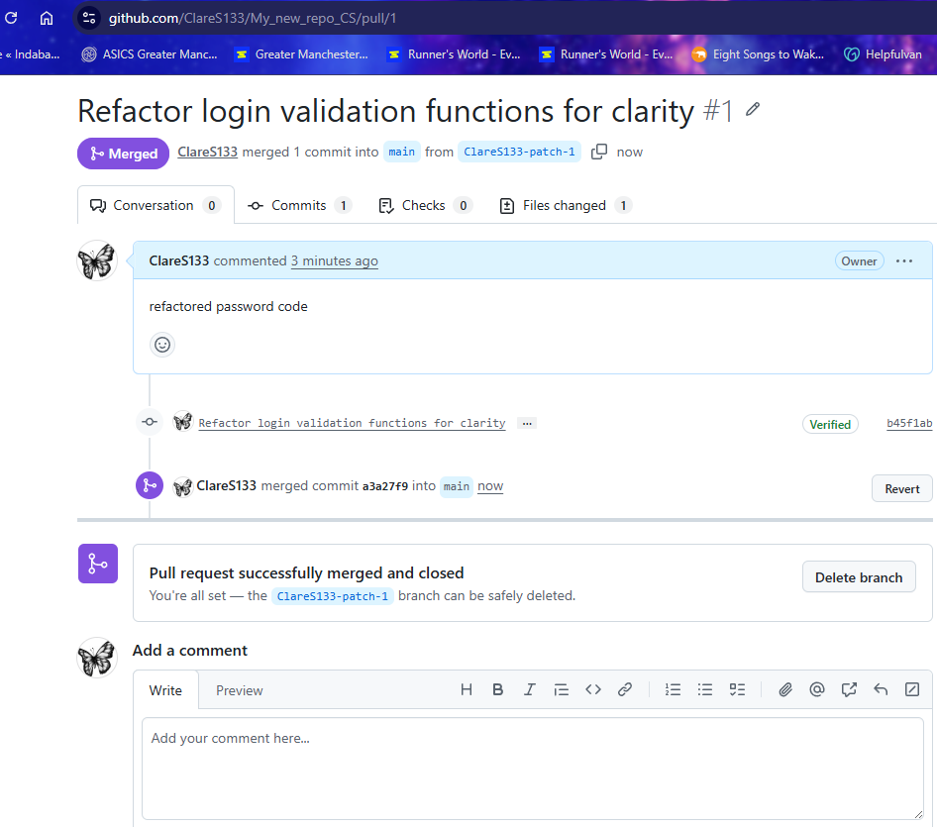  (e.i)  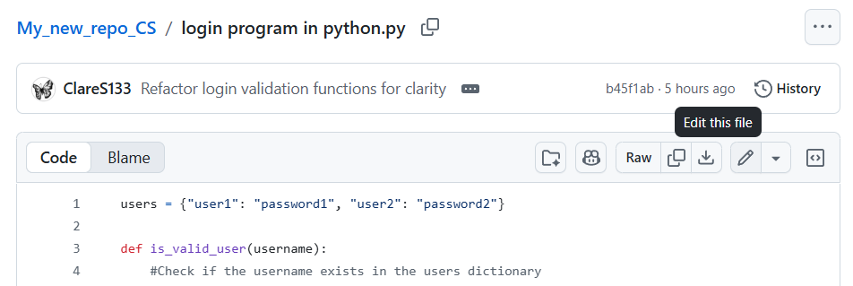  (e.ii) 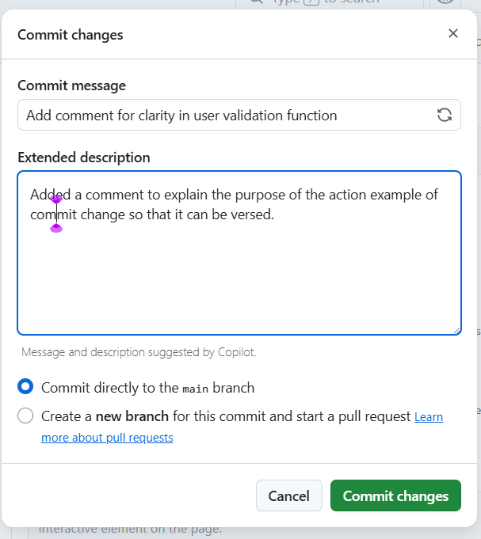  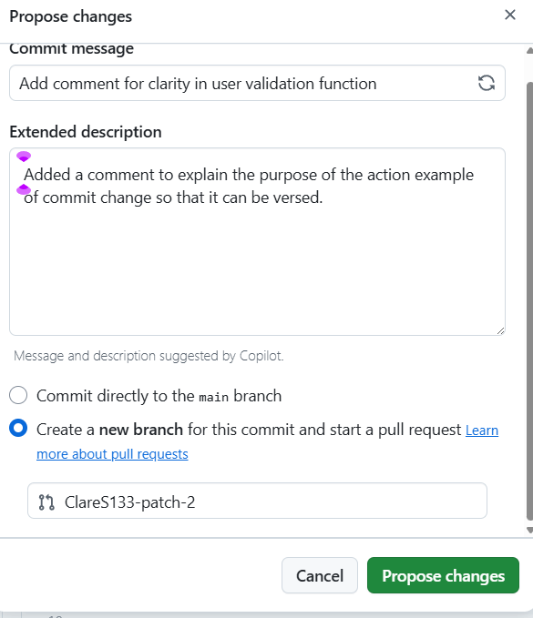  (e.iii)  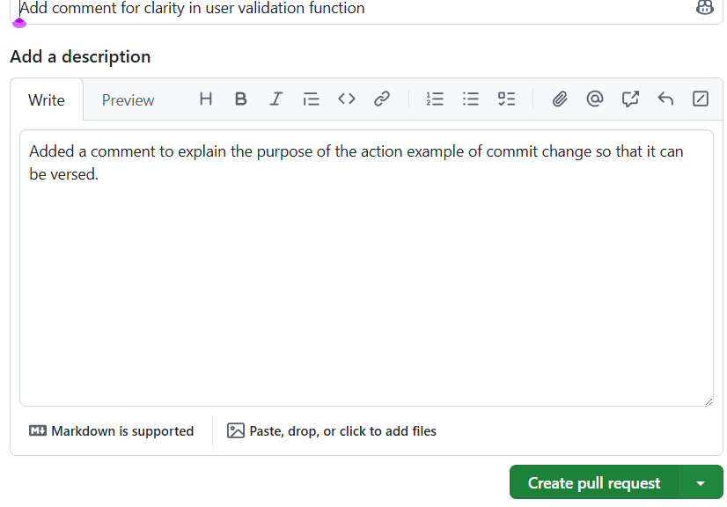  (eiv)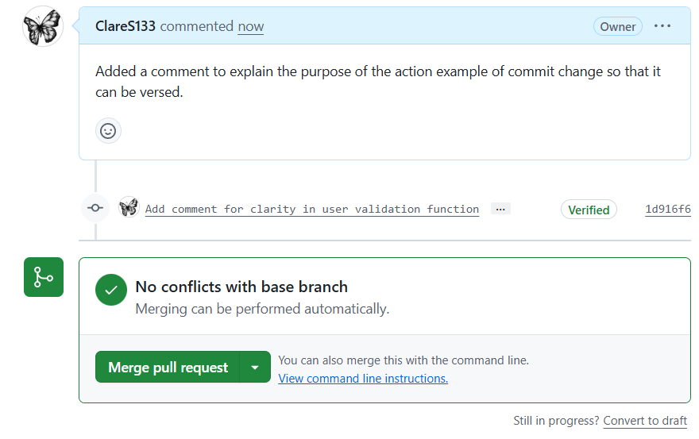  (e.v)  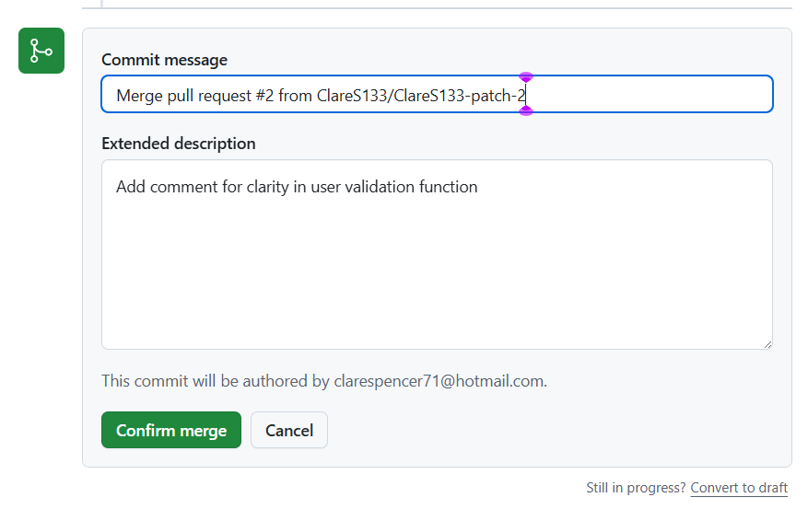  (e.vi)  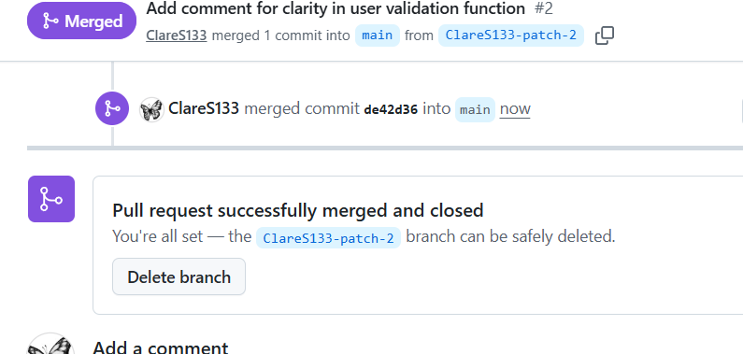  (f.i)  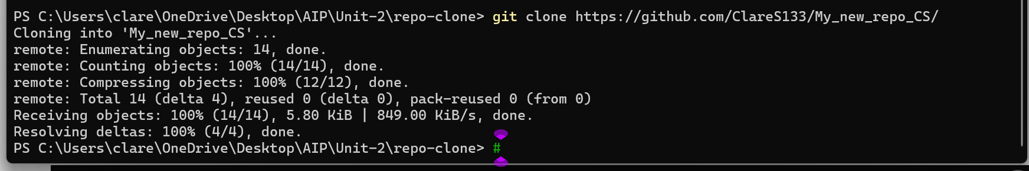  Created a local copy of the repo in the terminal  PS C:\Users\clare\OneDrive\Desktop\AIP\Unit-2\repo-clone> git clone https://github.com/ClareS133/My_new_repo_CS/  (f.ii)  Opened the folder where the clone has been copied to  PS C:\Users\clare\OneDrive\Desktop\AIP\Unit-2\repo-clone> cd My_new_repo_CS  (f.iii)  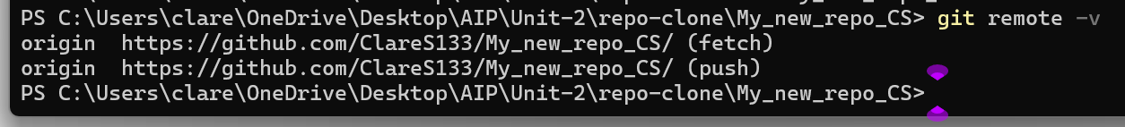  Verifying this is remote  PS C:\Users\clare\OneDrive\Desktop\AIP\Unit-2\repo-clone\My_new_repo_CS> git remote -v  (f.iv)  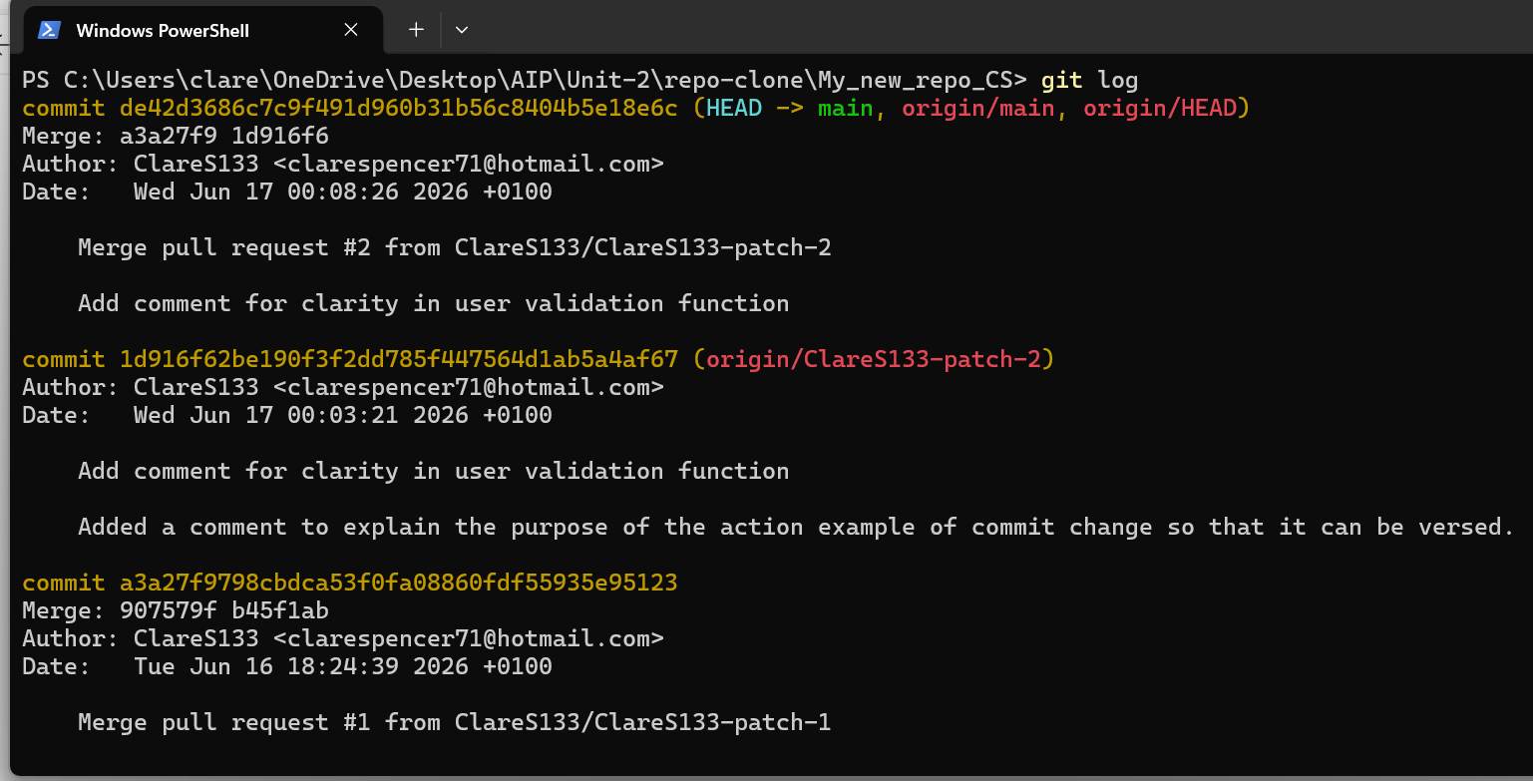  Requested a log of the commits to then seek the Merge code  PS C:\Users\clare\OneDrive\Desktop\AIP\Unit-2\repo-clone\My_new_repo_CS> git log  (f.v)  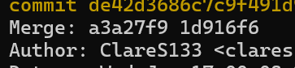  The required Merge code is the second two-part code 1d916f6 and to exit the git log type q if necessary.  (f.v.i)  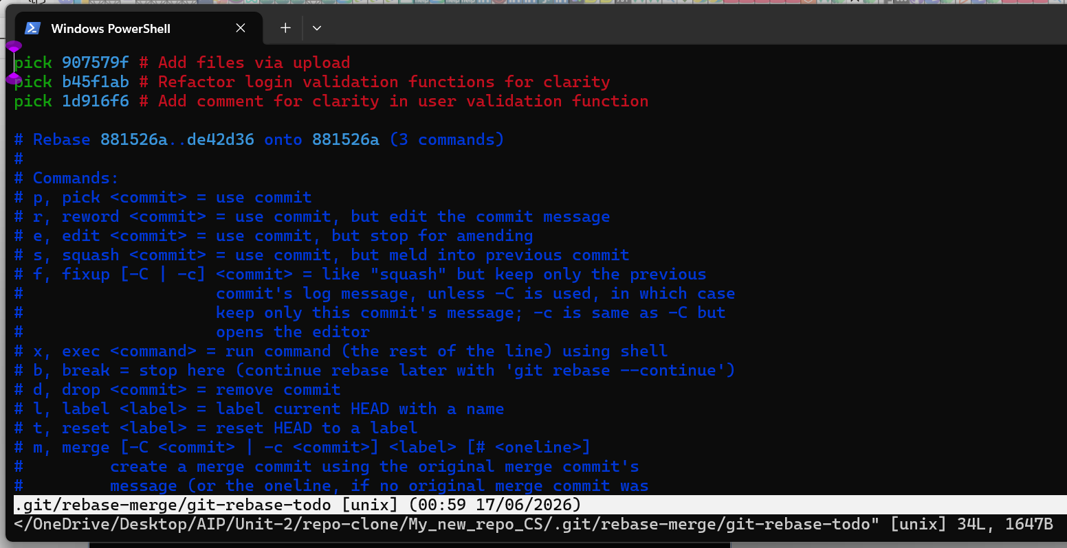  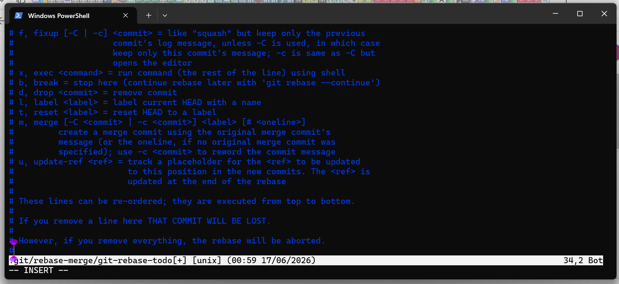  Enter ‘git rebase -i HEAD~3’ where ‘3’ represents the quantity of the commit list.  (f.v.ii)  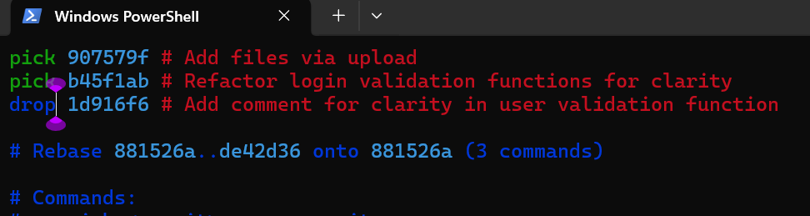  Change ‘pick’ to ‘drop’ for the Merge which needs to be cancelled.  (f.v.iii)  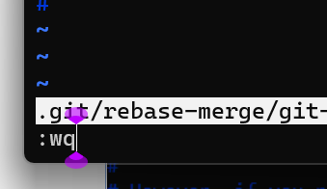  Pressed Esc to exit the Vim window and typed :wq to save changes and quit.  (f.v.iv)  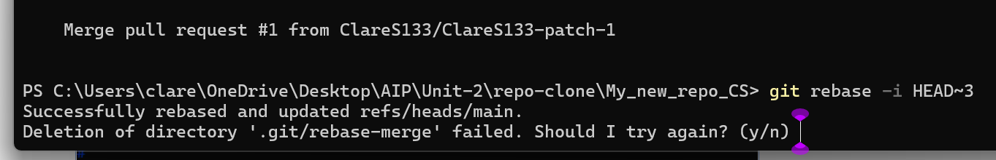  Message to confirm the request was successful.  (f.v.iv.i)  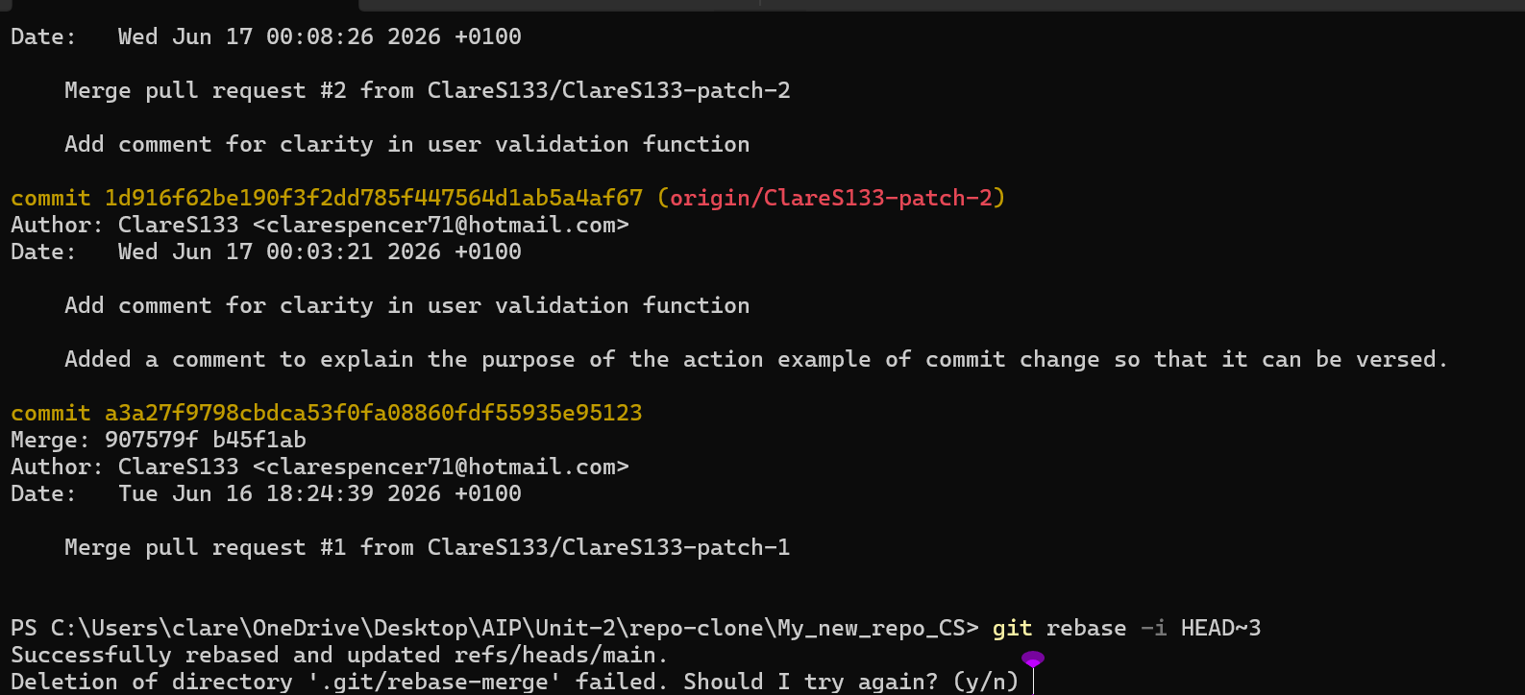  git log --oneline –graph 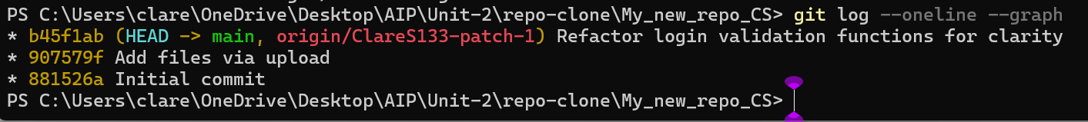  Pushing files to a remote repository using: git push origin main –force  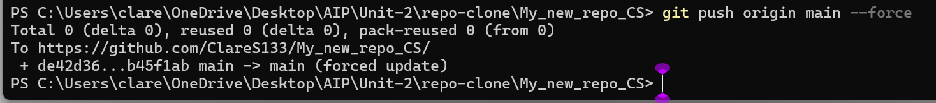  Undo a commit (and push commits to a remote repo) git reset --hard HEAD~1

