Unit 2 Lesson 1

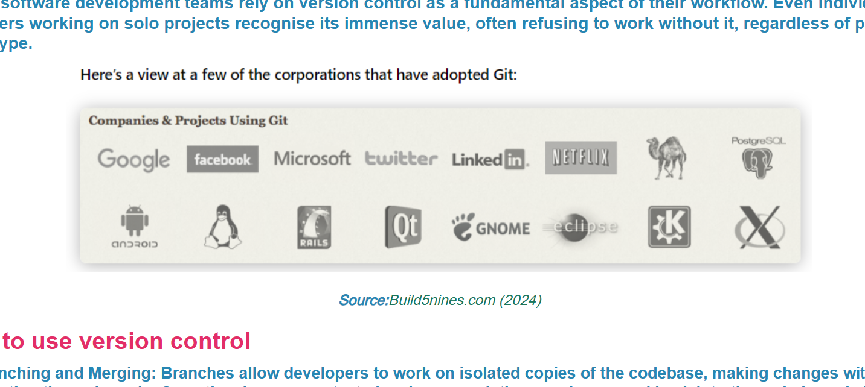

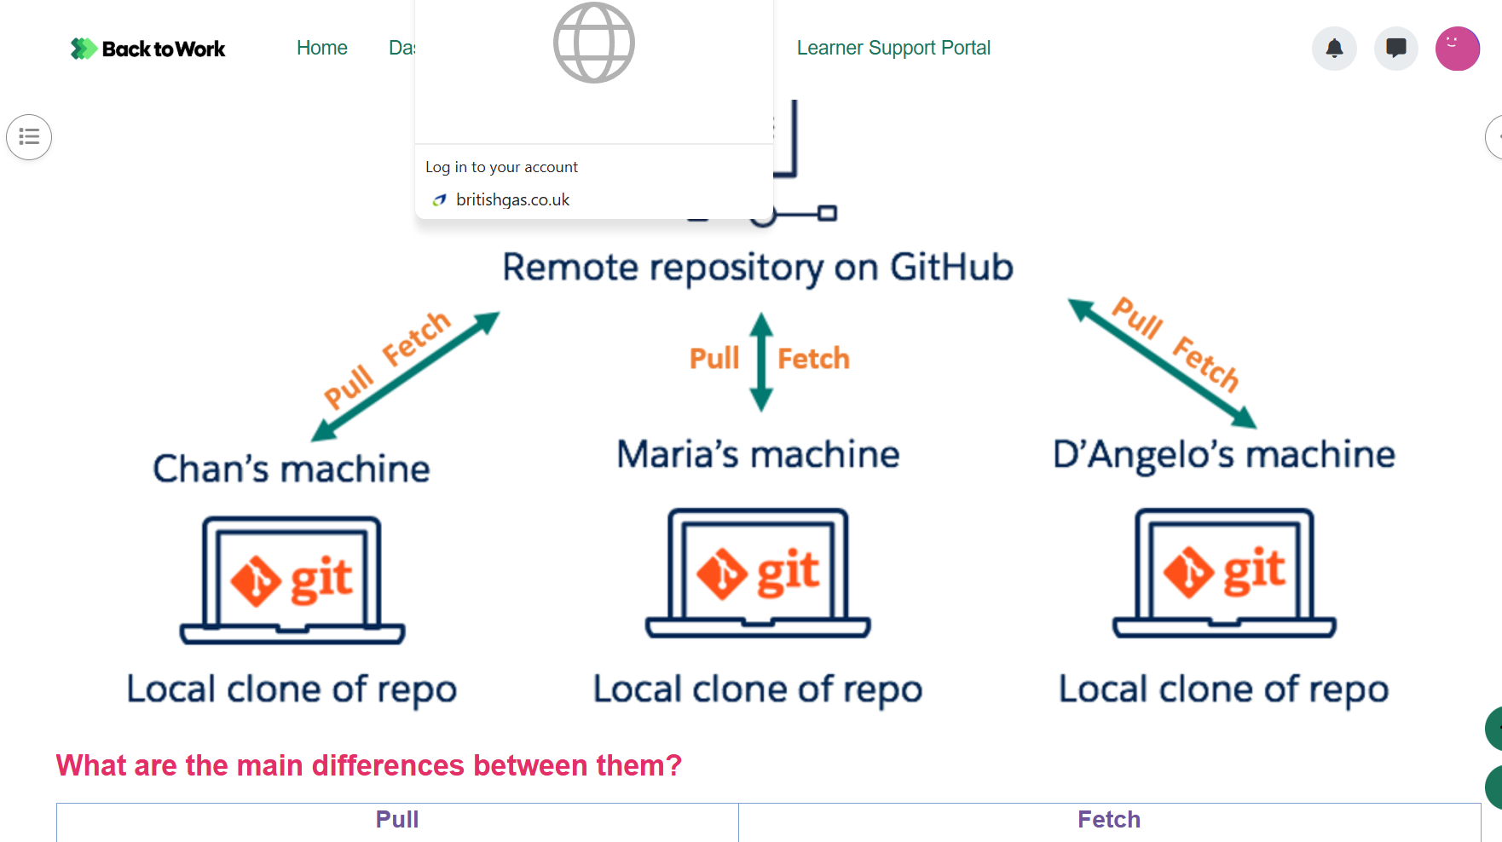

Ways to use version control
Branching and Merging: Branches allow developers to work on isolated copies of the codebase, making changes without affecting the main code. Once the changes are tested and approved, they can be merged back into the main branch. This allows for parallel development of features, bug fixes, and experiments without disrupting the main project.
Committing Changes:Developers make changes to the code locally and then commit them to the version control system. Each commit represents a snapshot of the code at a specific point in time, along with a description of the changes made. This allows for easy tracking of modifications and facilitates collaboration among team members.
Tagging Releases: Version control systems allow developers to tag specific commits as releases. This makes it easy to identify and access stable versions of the software. Tags can include version numbers or release names, providing a clear reference point for users and developers.
Pull Requests and Code Reviews: Developers can create pull requests to propose changes to the main codebase. This initiates a review process where team members can provide feedback, suggest improvements, and ensure code quality before merging the changes. Code reviews help maintain code consistency, identify potential issues, and share knowledge among team members.
Conflict Resolution: When multiple developers make changes to the same file or code block, version control systems detect and highlight conflicts. Developers can then resolve these conflicts manually or through automated tools, ensuring that changes are integrated smoothly without loss of data.
Rollbacks and Reverts:If a change introduces unexpected issues or bugs, version control systems allow developers to roll back to a previous state of the code. This provides a safety net and helps mitigate the risk of introducing errors into the software. Similarly, individual changes can be reverted if they are found to be unnecessary or problematic.
Ways to use version control in GitHub

