Lesson 2 - Repository, Commits & CLI
Completion requirements

During Lesson 2 - Repository & Commits, you will learn how to...
AC 2.1 Create a GitHub repository.
AC 2.2 Create a fork GitHub repository.
AC 2.3 Demonstrate the use of commits for version control including: -
• Use commit descriptive messages
• Use commits to refactor
• Push commits to a remote repository
• Edit and delete commits
• Undo or erase a commit
AC 3.1 Demonstrate how to verify a remote using GitHub.
AC 3.2 Demonstrate how to clone remote repositories using GitHub.
AC 3.3 Demonstrate how to push files to own remote repository using GitHub.
Signup to GitHub
1. Navigate to https://github.com/.
2. Click Sign up.
3. Follow the prompts to create your personal account.
Further support is available here, should you need it.

What is a GitHub repository?
A repository is the most basic element of GitHub. It's a place where you can store your code, your files, and each file's revision history. Repositories can have multiple collaborators and can be either public or private. You can discuss and manage your work within the repository. Before creating your first repository, you must be familiar with these terms. A remote repository is a version of your project that is hosted on a remote server, typically on a platform like GitHub - it serves as a centralised place where you and your team can push (upload) and pull (download) changes, facilitating collaboration and version control. We will only be using remote repositories created in GitHub for this unit.

Further information on repositories is here, should you need it.
Creating a remote repository in GitHub (web interface)
1. In the upper-right corner of any page, select , then click New repository.
2. Type a short, memorable name for your repository. For example, "hello-world".
3. Optionally, add a description of your repository. For example, "My first repository on GitHub."
4. Choose a repository visibility. For more information, see "About repositories."
5. Select Initialize this repository with a README.
6. Click Create Repository - Congratulations! You've successfully created your first repository and initialised it with a README file.

Commit your first change to the remote repository
A commit is basically a snapshot of all the files in your project at a particular point in time. When you make a commit to save your work, a unique ID (a.k.a. the "SHA" or "hash") is created which allows you to keep a record of the specific changes committed along with who made them and when. Commits usually contain a commit message which is a brief description of what changes were made.
When you created your first repository (named "hello-world"), you initialised it with a README file. README files are a great place to describe your project in more detail or add some documentation such as how to install or use your project. The contents of your README file are automatically shown on the front page of your repository.
Let's commit a change to the README file.
1. In your repository's list of files, select README.md or click to open the file editor.

2. In the text box, type a sentence about yourself.

3. Above the sentence you have typed, click Preview.
4. You can review the changes you made to the file if you select Show diff, you will see the new content in green.
5. Click "Commit changes". In the "Commit message" dialogue box, type a short, meaningful commit message within "Extended description" that describes the change you made to the file.

6. Below the "Extended description" field, select "Commit directly to the main branch" and click "Commit changes" - Congratulations! You've successfully made your first commit.
Further learning...
- Github.com - creating-a-new-repository
- Github.com - about-readmes
- Github.com - about-repositories
- Github.com - quickstart-for-repositories
Knowledge check!
Q) A repository is...
a place where you can store your code, your files, and each file's revision history.
the branch on an original repository that has been forked or cloned.
a parallel version of your code.

You have completed 0% of the lesson
Knowledge check!
Q) A repository is...
Your answer :
a place where you can store your code, your files, and each file's revision history.
Response:
Correct!

Lesson 2 - Repository, Commits & CLI
Completion requirements

Lesson 2 - Repository & Commits continued...
AC 2.1 Create a GitHub repository.
AC 2.2 Create a fork GitHub repository.
AC 2.3 Demonstrate the use of commits for version control including: -
• Use commit descriptive messages
• Use commits to refactor
• Push commits to a remote repository
• Edit and delete commits
• Undo or erase a commit
AC 3.1 Demonstrate how to verify a remote using GitHub.
AC 3.2 Demonstrate how to clone remote repositories using GitHub.
AC 3.3 Demonstrate how to push files to own remote repository using GitHub.
What is a fork?
Forking a repository allows you to make changes to, essentially a copy of an existing repository, without affecting the original.
A fork is a personal copy of another user's repository that lives on your GitHub account. This is useful as you can use someone else's project as a starting point for your own personal idea.
Forks allow you to freely make changes to a project without affecting the original upstream repository (the primary branch on the original repository). So for example, if you have found a bug, rather than logging an issue for the bug you have found, you can fork the repository, fix the bug then submit a pull request to the project owner.
You can put in a pull request in the upstream repository and keep your fork synced with the latest changes since both repositories are still connected. The fork you are working on is then called the "downstream".
Creating a fork
Forking a GitHub repository step-by-step | Scribe
Further learning...
- Docs.github.com - working-with-forks
- Docs.github.com - fork-a-repo
Knowledge check!
Q) A local repository is...
where you log an issue for a bug that you have found.
called a "downstream".
where you make changes to, essentially a copy of an existing repository, without affecting the original.

You have completed 25% of the lesson
25%

Lesson 2 - Repository, Commits & CLI
Completion requirements

Lesson 2 - Repository & Commits continued...
AC 2.1 Create a GitHub repository.
AC 2.2 Create a fork GitHub repository.
AC 2.3 Demonstrate the use of commits for version control including: -
• Use commit descriptive messages
• Use commits to refactor
• Push commits to a remote repository
• Edit and delete commits
• Undo or erase a commit
AC 3.1 Demonstrate how to verify a remote using GitHub.
AC 3.2 Demonstrate how to clone remote repositories using GitHub.
AC 3.3 Demonstrate how to push files to own remote repository using GitHub.

Use commit descriptive messages...
When you created your first repository (named "hello-world"), you initialised it with a README file. README files are a great place to describe your project in more detail or add some documentation such as how to install or use your project. The contents of your README file are automatically shown on the front page of your repository.
Let's commit a change to the README file, to practice our use of "descriptive messages ".
1. In your repository's list of files, select README.md or click to open the file editor.

2. In the text box, type a sentence about yourself.

3. Above the sentence you have typed, click Preview.
4. You can review the changes you made to the file if you select Show diff, you will see the new content in green.
5. Click "Commit changes". In the "Commit message" dialogue box, type a short, meaningful commit message within "Extended description" that describes the change you made to the file.

6. Below the "Extended description" field, select "Create a new branch for this commit and start a pull request" and click "Propose changes" - Congratulations! You have used commit descriptive messages!

Use commits to refactor...
Firstly, what does "refactor" mean?
It is the process of restructuring existing computer code without changing its purpose. The main goal of refactoring is to improve the code’s internal structure, making it more readable, maintainable, and extendable. Refactoring can involve various activities, such as renaming variables, breaking large functions into smaller ones, making complex conditional logic into simpler more understandable statements, adding code comments and removing duplicate code.
We are going to...1) create a new repository (you are welcome to use an existing one),
⬇️
2) upload this file to the main branch,
⬇️
3) edit the code to refactor it using this file,
⬇️
4) commit the changes to a new branch, using a descriptive message and pull request,
⬇️
5) then finally merge the changes. Let's follow the steps below to undertake this activity.
Step 1 - watch this video to get an idea of what the code is, that you are going to refactor.

Step 2 - follow the Scribe guide below.
Create GitHub repository for refactoring Python login program | Scribe
Congratulations! You have used commits to refactor!
Further learning...
- Pullrequest.com - commit-messages
- Bmc.com - code-refactoring-explained
- Refactoring.guru - refactoring
- Github.com - refactoring-examples
Knowledge check!
Q) Refactoring is making code more (select all that apply)...
interactive
maintainable
readable
safe
extendable

You have completed 50% of the lesson

Lesson 2 - Repository, Commits & CLI
Completion requirements

Lesson 2 - Repository & Commits continued...
AC 2.1 Create a GitHub repository.
AC 2.2 Create a fork GitHub repository.
AC 2.3 Demonstrate the use of commits for version control including: -
• Use commit descriptive messages
• Use commits to refactor
• Push commits to a remote repository
• Edit and delete commits
• Undo or erase a commit
AC 3.1 Demonstrate how to verify a remote using GitHub.
AC 3.2 Demonstrate how to clone remote repositories using GitHub.
AC 3.3 Demonstrate how to push files to own remote repository using GitHub.

Edit a commit...
You can edit a commit by making a new commit.
1. Go to the file you want to edit.
2. Click the pencil icon (✏️) to edit the file.

3. Make your changes and commit them with a new commit message. Ideally, you would create a new branch with the changes, and submit a pull request.

Delete a commit (and clone a remote repository, verify a remote repository and push files to a remote repository)...
Unfortunately, there are limitations when using the GitHub web interface - it does not support deleting commits directly. However, you can work around this by using Git commands locally and then pushing the changes to your remote repository.
1. If you have not installed Git, you need to download it from git-scm.com/downloads (ensure you chose the correct version for your machine) and install it.
During installation, ensure to select the option to "Use Git from the Windows Command Prompt" or "Git Bash Here", which will add Git to your system PATH automatically, and remember the file path you chose where to install it.

2. Once installed, open Command Prompt and type the code shown to open your Git directory. The file path in the example e.g. C:\Users\CherylPawluk\AppData\Local\Programs\Git\ needs to be replaced with the file path where you installed Git.
cd C:\Users\CherylPawluk\AppData\Local\Programs\Git\

3. We now need to make a clone of one of your existing repositories, to your local machine. First, you need to browse to the repository you want to clone by logging into github.com, selecting the repository and then copying the URL for that repository e.g. "https://github.com/CherylPawluk/hello-world".

4. Once you have the URL, within the Command Prompt, type the code below to clone your chosen existing repository and create a local copy, ensuring you replace"https://github.com/CherylPawluk/L3-Certificate-in-AI-Programming-with-Python" with your repositories URL.
git clone https://github.com/CherylPawluk/L3-Certificate-in-AI-Programming-with-Python

5. Now let's open up the folder where the clone has been copied to, ensuring you replace "
L3-Certificate-in-AI-Programming-with-Python" with the name of your repository.
cd L3-Certificate-in-AI-Programming-with-Python

6. Verifying a remote is one of the first steps after cloning as it ensures that you are pushing and pulling from the correct remote repository. Use code to verify the remote repository.
git remote -v

7. Now let's list all the commits for this repository to see which we'd like to delete. We use the code git log to see all the commits listed which will be similarly listed to the image shown below. We need to note the Merge code, which is the second part of the two-part code displayed i.e. for the first commit in the list shown below it is ae74467. If, for any reason, you cannot exit the git log, type q on your keyboard and this should fix the issue.

7. Now let's type git rebase -i HEAD~5 to show the rebase list for the first 5 commits. Alter the "5" if you need to. The rebase list will look similar to the image below. You need to type over the word "pick" and change it to "drop", for the commit you want to delete - you made a note of the Merge code in step 7 i.e. ae74467.

8. Once changed to "drop", type :wq to save the changes and quit. You will get a message like the one below saying it was successful.

9. Pushing files to a remote repository typically follows committing changes locally. It involves transferring commits from your local repository to the remote repository. You can then push the changes to your remote repository using the code git push origin main --force. You will get a message like the one below which means it was successful.

Undo a commit (and push commits to a remote repository)...
If you want to undo the most recent commit and discard the changes, follow steps 1 to 6 from the "Delete a commit" section (above), then use code git reset --hard HEAD~1 to undo, and then code git push origin main --force to push commit to the remote repository.

Further learning...
- Git-scm.com - downloads
- Hackernoon.com - how-to-delete-commits
- Baeldung.com - modify-commit
- Nobledesktop.com - undo-changes
Knowledge check!
Q) What is this code (git push origin main --force) used for?...
push changes to the main branch on the remote repository.
force changes to the second branch.
undo the latest commit.

You have completed 75% of the lesson
75%
push changes to the main branch on the remote repository.
Response:
Correct!
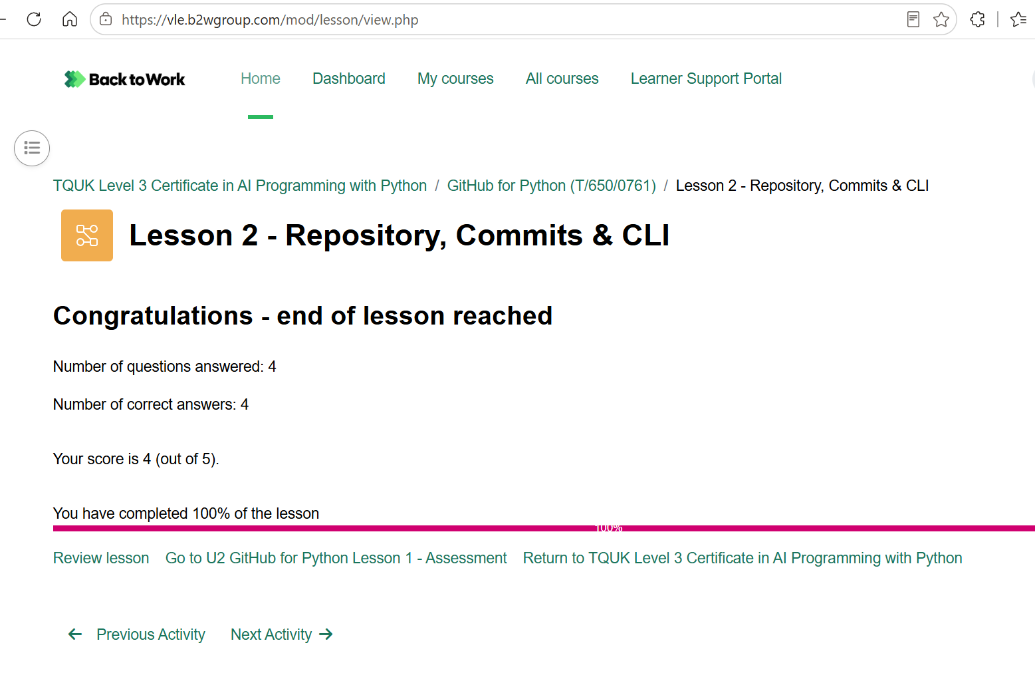

U2 GitHub for Python Lesson 2 - Project
Completion requirements
To do: Receive a grade

To do: Receive a passing grade
This assessment covers assessment criteria:-
2.1 Create a GitHub repository
2.2 Create a fork GitHub repository
2.3 Demonstrate the use of commits for version control. Learners must:
• Use commit descriptive messages
• Use commits to refactor
• Push commits to a remote repository
• Edit and delete commits
• Undo or erase a commit
3.1 Demonstrate how to verify a remote using GitHub.
3.2 Demonstrate how to clone remote repositories using GitHub.
3.3 Demonstrate how to push files to own remote repository using GitHub

Grading method: Last attempt
Grade to pass: 1 out of 1

