**Overview**

This analysis aims to help Alphabet Soup determine whether or not applicants for funding will be successful based on the data and circumstances surrounding previous investments. With a deep learned model, Alphabet Soup should be able to make an informed decision about future investors with similar criteria.

**Results**

The “IS_SUCCESSFUL” designation was considered the target for the model.

Features of the model include:

* Application Type
* Affiliation
* Classification
* Use Case
* Organization
* Status
* Income Amount
* Ask Amount

The following are neither features nor targets:

* Special Considerations
* Status

I selected 80 and 30 neurons and 2 layers initially to match the starter code output.

Target model performance was not achieved, although the model did improve from 72.3% accuracy to 72.4% accuracy.

I removed the columns deemed neither features nor targets, increased the second hidden layer to 50 neurons, and added a third layer.

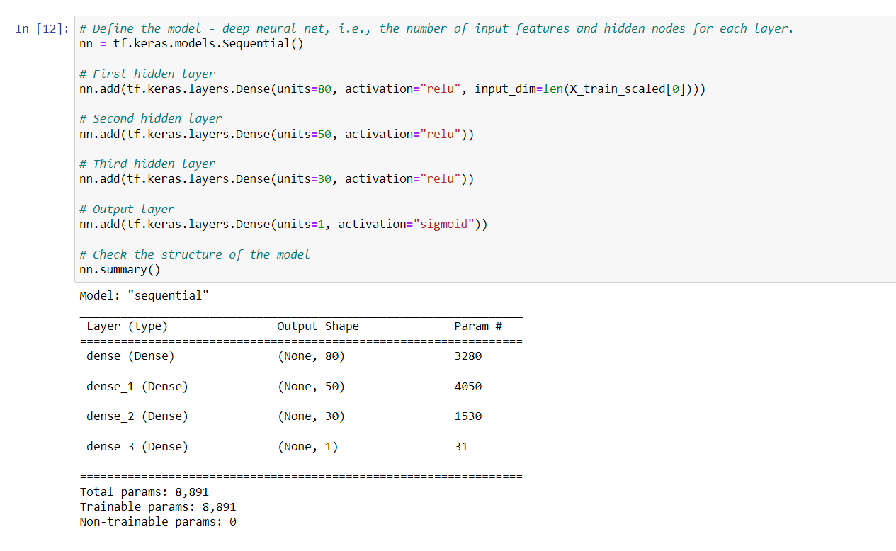

**Summary**

This model could use improvement for better accuracy but is still much better than random chance at its current accuracy and can be used with caution by Alphabet Soup. Next time I was use a random forest model to prevent overfitting.