**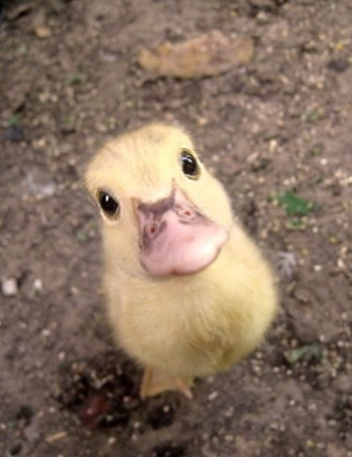Instructions**

We will build a simple categorisation experiment shown in the screen shots. The object of the experiment is to categorise images of ducks as ‘real’ or ‘fake’.

Here is the structure of the experiment:



First of all, **open up PsychoPy,** then go to **View > Open Builder** view.

Delete the example trial that it gives you - we will start from scratch.

1) BUILDING A TRIAL ROUTINE

First, we will build a trial routine, which shows an image of a duck and asks people to categorise it as real or fake.

**a) Insert a new routine** called ‘trial’ into the study flow.

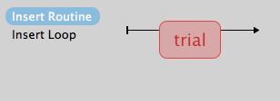

**b) Add an image component** to this routine called ‘real\_image’.

- Set image to: ‘$image’

- Tick SET EVERY REPEAT (important - otherwise the image will not change across trials!).

- Settings: Change image size to nothing (blank), and check image position is [0,0].

- Timing: Make the image start at 0.5 seconds with a duration of 1 second.

**c) Add a text component** called ‘fixation cross’.

- Set text to: ‘+’.

* Settings: change text colour to ‘black’, check letter height is 0.1, check position is [0,0].
* Timing: check text starts at 0 seconds, make the duration 0.5 seconds.

**d) Add a keyboard response component** called ‘response\_keys’.

- Set allowable responses to: ‘y’ and ‘n’ only.

- Timing: make keyboard start at 1.5 seconds with an endless duration (i.e. blank end point).

- Tick ‘Store correct’ and set to: $correctAns. This will pre-code correct and incorrect responses.

**e) Add an image component** called ‘instructions’.

* First, look at the image file called ‘instructions.png’ in your folder.
* Now, set the image to: ‘instructions.png’.
* Settings: change size of image to blank, check position is [0,0].

- Timing: make image start at 1.5 seconds with an endless duration (i.e. blank end point).

Your trial routine should look like this:



2) BUILDING A WELCOME ROUTINE

Now, we will add a routine that welcomes the participant and gives them some instructions.

**a) Insert a new routine** called ‘welcome’ to the start of the study flow.

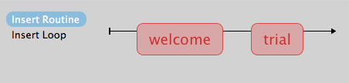

**b) Add an image component** to this routine called ‘welcome\_slide’.

* First look at the image file called ‘welcome\_slide.png’ in your folder.
* Now, set the image component to: ‘welcome\_slide.png’.
* Settings: make size blank and check position is [0,0].
* Timing: check image starts at 0, and make duration endless (i.e. blank end point).

**c)** **Add a keyboard component called** ‘welcome\_keypress’.

- Set allowable response to: ‘space’ only.

Your welcome routine should look like this:

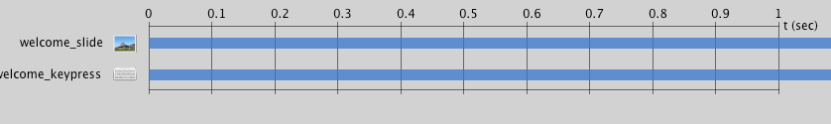

3) LOOP AROUND TRIALS

To show multiple different trials instead of the same duck over and over again, we need to create a loop that links to an excel file with the different duck images in it.

**a) Insert a loop around the trial routine** called ‘experiment\_loop’.

-Firstlook at the excel file ‘trials.xlsx’ in your folder.

* Now, set the loops to the excel file: ‘trials.xlsx’ (choose from your folder via ‘Browse’)
* Settings: change ‘reps’ to 1, check loop type is set to ‘random’.

Your experimental trial loop should look like this:



4) PRACTISE ROUTINE

To get the participants used to categorising ducks (because admittedly, it's a weird task!) we will first allow them to practice the task by creating an initial practice routine. To save time, to create the practice routine we will copy and paste the experimental trial routine (and then rename it).

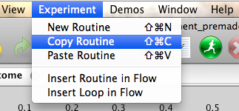

**a) Copy trial routine** (in the Experiment menu).

Note: make sure the trial routine is selected and not the welcome routine.

**b) Paste routine** (call it ‘practice\_trial’)

**c) Insert the practice\_trial** **routine** into the study flow (between the welcome and trial routines)

- Note that PsychoPy appended \_2 to everything because it’s a copy – clever!

- Rename “2” to “practice” (for clarity).

**d) In the image\_practice component,** rename $image to $practice\_image

**e) Insert a loop** around the practise trial routine, called ‘practice\_loop’

- First look at the excel file “practice\_trials.xlsx” in your folder.

* Now, set the loop to the excel file: ‘practice\_trials.xlsx’ (choose from your folder via ‘Browse’).

- Settings: change ‘reps’ to 1, make loop type is set to ‘sequential’.

Your practice loop should look like this:

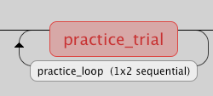

Your practice routine should look like this:

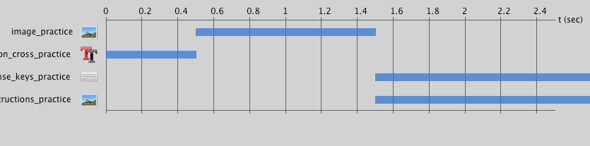

MacintoshHD:Users:Rivendell:Documents:UWA:Psychopy_workshop:Bits and pieces:experiment_settings.tiff5) EXPERIMENT SETTINGS

Now, we will make some final changes to the overall experiment.

**a) Go to Experiment Settings. Under the ‘Basic’ tab:**

- Change the experiment name to whatever makes sense to you.

- Add ‘age’ and ‘gender’ questions (don’t worry about the order).

- This will allow you to record the age and gender of the participant at start up.

**b) Under the ‘Data’ tab,** check that ‘excel’, ‘csv’, ‘log’ and ‘psydat’ files are selected as output.

**c) Under the ‘Screen’ tab,** set Color to $[1,1,1] to make the background white.

- Note: it would be $[0,0,0] for grey and $[-1,-1,-1] for black.

- Or, you can use the words ‘white’, ‘grey’ or ‘black’.

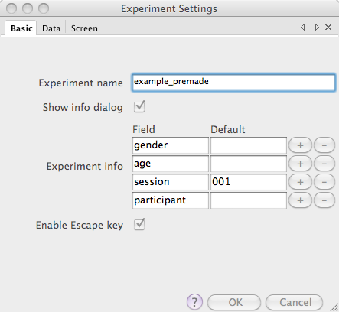

**Done!!**

Your experiment should look like this:

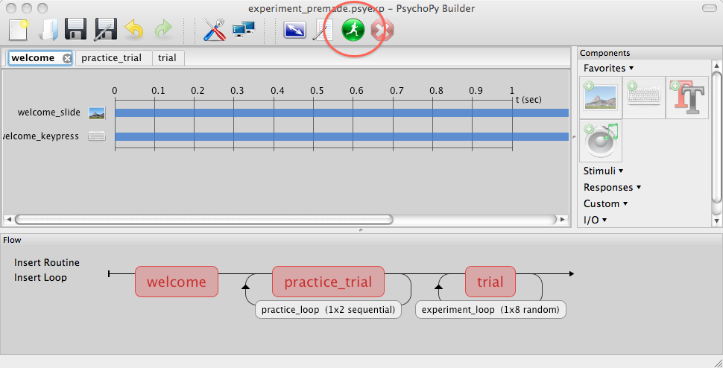

Try running your experiment by pressing the green running man icon ☺

Once you have a template experiment of your own, it’s easier to modify this rather than starting completely from scratch again.