Q1

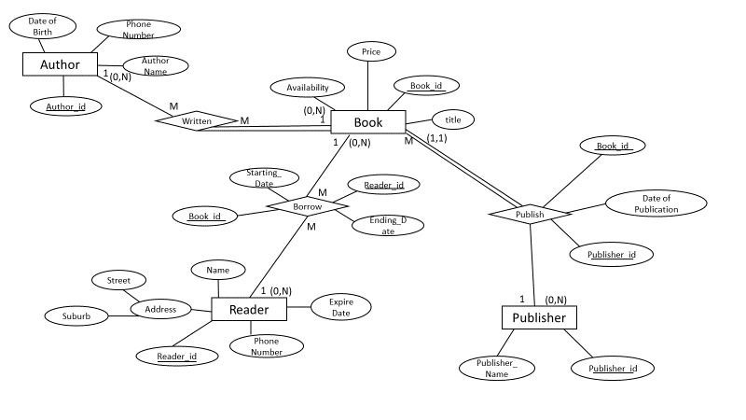

Q3

DFS:

V0 V1 V5 V2 V4 V8 V7 V9 V6 V3

Explanation: Firstly, v0 points to two nodes, which are v1 and v3 respectively.

|  |
| --- |
|  |
|  |
|  |
| V1 |
| V3 |
| V0 |

According to the rule that ‘first in last out’, in that circumstance, v1 is popped out.

Later finding the neighbour of v1, which are v5 and v6.

|  |
| --- |
|  |
|  |
| V5 |
| V6 |
| V3 |
| V0 |

Similarly, we get v5 and then v2.

|  |
| --- |
|  |
|  |
| V2 |
| V6 |
| V3 |
| V0 |

|  |
| --- |
| V4 |
| V7 |
| V9 |
| V6 |
| V3 |
| V0 |

As shown in the table above, since v1 and v3 have already been marked before, so we only add v4 inside, later it is the turn for v4 to pop out.

|  |
| --- |
| V8 |
| V7 |
| V9 |
| V6 |
| V3 |
| V0 |

|  |
| --- |
|  |
| V7 |
| V9 |
| V6 |
| V3 |
| V0 |

|  |
| --- |
|  |
|  |
| V9 |
| V6 |
| V3 |
| V0 |

|  |
| --- |
|  |
|  |
|  |
| V6 |
| V3 |
| V0 |

Lastly, since no more nodes need to be added, therefore, just popping out in turn, say v8, v7, v9, v6 and v3.

BFS

V0 V1 V3 V5 V6 V2 V4 V7 V9 V8

0 1 2 3 4 5

1:

Start from v0, it has two neighbours which are v1 and v3 respectively.

2.

BFS is like the queue, following the rule of ‘first in, first out’. In that case, v1 is popped out, checking the attachment of v1 that are v5 and v6.

3.

Later, v3 is out. However, v3 is not directly points to any other node.

4.

Therefore, we pop out v5 and similarly v6 as well.

5.

And since v5 has been pointed to v2, therefore, it is the turn for v2 popping out. And after adding v2, we join v7 and v9 into the queue. Followed by v7 and b9.

6.

And v8 is the last one, which is popped out when moving to v4 (there is a direct line points from v4 to v8)