Software Design Specification
Guthrie Document Centre (CRS)
SD Guthrie · SharePoint Online document management system

Repository sd-gatrie · SPFx 1.23 · package version 1.0.580.0
Live site https://sdguthrie.sharepoint.com/sites/CRS
Data structures captured from the live site on 2026-10-01
Document version 1.0 · 1 October 2026 · Prepared by Trinergy Digital

Document control
Version | Date | Author | Change
1.0 | 1 October 2026 | Trinergy Digital | First issue, for handover to the development team.
This specification replaces the earlier CRS Developer Guide. The data structures in chapter 4 and the security data in chapter 5 were read from the live site, not from the code, so they describe what is really deployed.

Contents
Document control 2
Contents 3
1. Introduction 6
1.1 Purpose 6
1.2 Scope 6
1.3 How to read this document 6
1.4 Definitions and abbreviations 6
1.5 References 7
2. System overview 8
2.1 What the system does 8
2.2 Users 8
2.3 System context 9
2.4 Design principles 10
3. Architecture 11
3.1 Technology stack 11
3.2 Logical architecture 11
3.3 Deployment architecture 13
3.4 Solution components 14
3.5 Pages 15
3.6 Code organisation 15
3.7 Runtime behaviour common to all web parts 16
4. Data design 17
4.1 Where data is stored 17
4.2 Logical data model 17
4.3 Libraries 19
4.4 Document columns 22
4.5 CRS lists 26
4.6 Configuration data 29
4.7 Term store 31
4.8 Folder model 32
4.9 Record lifecycles 33
4.10 Audit events 34
4.11 Volumes and limits 35
5. Security design 36
5.1 Identity and authentication 36
5.2 Authorisation model 36
5.3 Personas and roles 38
5.4 Roles, permission levels and libraries 39
5.5 Permission levels 39
5.6 Where permissions are applied (live) 40
5.7 Service account and proxy actions 41
5.8 Highly Confidential separation 41
5.9 Security rules for developers 41
6. Component design 43
6.1 Upload Form 43
6.2 Bulk Upload 44
6.3 Approval Document and the Approve or reject panel 44
6.4 My Submissions and Document-Viewer 45
6.5 Requests 45
6.6 Search 46
6.7 Folder Administration and Folder Reconciliation 46
6.8 Folder Structure and Migration 47
6.9 Group Management 48
6.10 Settings, Configuration and Access pages 48
6.11 Audit Log 49
6.12 Extensions 49
7. Process design 51
7.1 Upload and tagging 51
7.2 Approval and routing 53
7.3 Bulk import 54
7.4 Approver notifications and reminders 54
7.5 Delete request 56
7.6 Share request and expiry 58
7.7 Seven-year archive 59
7.8 Folder reconciliation 60
7.9 Adding a unit (end to end) 61
8. Integration design: Power Automate 62
8.1 Environment and connections 62
8.2 Flow inventory 62
8.3 Which flows listen to which list 63
8.4 Data contract between code and flows 63
8.5 Emails 64
8.6 List GUIDs the flows use (CRS) 65
9. Interface design 66
9.1 User interface map 66
9.2 SharePoint APIs used 66
9.3 REST conventions 67
10. Non-functional design 68
11. Design decisions 69
12. Known issues and open items 70
12.1 Ready to roll out on CRS (tested on the test site) 70
12.2 Waiting on someone 70
12.3 Known gaps (accepted for now) 70
Appendix A. Build, run and deploy 71
A.1 Software and access 71
A.2 Run locally 71
A.3 Build 72
A.4 Deploy 72
A.5 Register the extensions 73
Appendix B. Set up a test site 74
Appendix C. Troubleshooting 75
Appendix D. Flow operations 76
D.1 Rules for editing flows 76
D.2 If gdc's password changes 76
D.3 Export and back up 76
D.4 Import or update 76
D.5 Point a flow at another site 76
D.6 Make the HC copy of a flow 76
D.7 Rebuild a generated flow 77
D.8 Turn a flow off safely 77

1. Introduction

1.1 Purpose
This Software Design Specification (SDS) describes how the Guthrie Document Centre (CRS) is built: its architecture, where every piece of data is stored and how it is structured, the security model, each component, the processes that move a document through its life, the Power Automate integration, and the design decisions behind them. It is written so that a development team can maintain, extend, rebuild or audit CRS without the original developer.

1.2 Scope
- In scope: the SharePoint Framework (SPFx) solution sd-gatrie (17 web parts, 2 active extensions), the SharePoint site /sites/CRS it runs on (libraries, lists, term store, groups, pages), and the 25 Power Automate flows that run as the service account.
- Out of scope: Microsoft 365 tenant administration, Entra ID, Exchange mail-flow rules and the SD Guthrie network. These are referenced only where CRS depends on them.
- Sites: the live site is https://sdguthrie.sharepoint.com/sites/CRS. Development and testing use a separate site with the same structure (Appendix B). The two sites have different list GUIDs, term GUIDs and data.

1.3 How to read this document
If you need to… | Read
Understand the system in one sitting | Chapters 2 and 3
Know where data is stored and what each column means | Chapter 4 (data design)
Change who can see or do what | Chapter 5 (security), then 6.9 Group Management
Change a screen | Chapter 6 (that component), then chapter 9 (interfaces)
Change or debug an email, routing or deletion | Chapters 7 and 8
Build, deploy or set up a test site | Appendices A and B
Fix something broken | Appendix C, then chapter 12

1.4 Definitions and abbreviations
Table 1. Definitions
Term | Meaning
CRS | Central Repository System, the product name. Formerly DMS (Document Management System); some code and list names still say DMS.
GDC | Guthrie Document Centre: the site title and the display name of the service account gdc@sdguthrie.com.
SPFx | SharePoint Framework: client-side web parts and extensions, written in TypeScript and React.
Segment | A business segment, the top folder of the tree (Group Head Office = GHO, Minamas Head Office = MHO, NBPOL Head Office = NBPOLHO).
Tier / level | A folder level below the segment. Two are permissioned (normally Department, Unit); the rest (Sub Unit, Year, Document Type) inherit.
Unit | The second permissioned tier and the smallest confidentiality boundary.
Staging / approval library | Library holding uploads waiting for approval (ApprovalDocument, HCApprovalDocument).
Documents / approved library | Library holding approved documents (Shared Documents, HCDocuments).
HC | Highly Confidential. HC documents live in their own library pair.
PIC | Person in charge: an uploader.
HoU, HoD | Head of Unit (approver), Head of Department.
Persona | A named bundle of roles given to a SharePoint group (e.g. Head of Unit = APR + SHARE + UPL).
Role | A capability code stored in CRS Group Map (UPL, APR, SHARE, MEMBER, DEPTVIEW, SEGVIEW, GLOBAL and HC variants).
Term / term GUID | A managed-metadata term in the site term store. Its GUID is the stable key used across CRS.
Abbreviation | Short code used as a folder name for a term (e.g. Group IT → GIT).
Reconciliation | The admin process that builds folders and grants permissions from the configuration lists.
Proxy action | An action a user cannot perform with their own permissions, done for them by a flow running as gdc.
TagPayload | JSON of metadata the upload form leaves on a CRS Submissions row for the tagging flow to apply.
Moderation status | SharePoint content approval state: 0 Approved, 1 Rejected, 2 Pending (field OData__ModerationStatus).

1.5 References
Item | Where
Source code | Git repository sd-gatrie (branch main)
Power Automate exports (source of truth for flows) | PowerAutomateFlowsSDG/*.zip in the repository, exported 25 September 2026
Live schema capture used in chapters 4 and 5 | scripts/dump-site-schema.js (read-only browser-console script); captured on 2026-10-01
Flow generators | scripts/build-bundled-approver-flow.py, scripts/build-bundled-reminder-flow.py
Diagnostic scripts | scripts/check-*.js, scripts/diagnose-*.js (read-only); repair-*, purge-* (write, off by default)

2. System overview

2.1 What the system does
CRS is a document management system on SharePoint Online. Staff file documents into a structured folder tree (segment › department › unit › year › document type). Every upload waits in an approval library until the unit's Head of Unit approves it; Power Automate then moves it into the permanent library. Seven years after creation a document moves to a read-only archive. Every folder carries its own permissions, so a person only sees the units they belong to.
- Upload with metadata (single upload form, and bulk upload for historical documents).
- Approval by the unit's approver, one at a time or in bulk, with email notification and reminders.
- Automatic filing into the approved library, keeping version history when a file is replaced.
- Search across approved and archived documents, security-trimmed by SharePoint.
- Delete and share requests with approval, carried out by the service account.
- A full audit log of uploads, decisions, deletions, shares and admin changes.
- Admin tools: folder structure, folder codes, groups and members, reconciliation, file types, page access.

2.2 Users
Table 2. Personas
Persona | What they do in CRS
PIC (uploader) | Uploads into their unit; reads their unit's approved documents; tracks uploads on My Submissions; raises delete and share requests.
PIC (HC) | As PIC, and may file Highly Confidential documents.
Head of Unit (approver) | Approves or rejects uploads for their unit; decides delete and share requests; may upload (own uploads can self-approve).
Head of Unit (HC) | As Head of Unit, including the HC libraries. The only persona that approves HC documents.
Head of Department | Reads the whole department; decides share requests in the department.
SDG Employee (viewer) | Reads their unit's approved documents (the HC variant reads HC too).
C-Level (segment / global) | Reads a whole segment, or every segment, read-only, including the archives.
System administrator | Member of the site Owners group (Guthrie Document Centre Owners). Uses the admin pages.
Service account gdc@sdguthrie.com | Owner of every flow; performs proxy actions and sends every email. Must stay in Owners.

2.3 System context
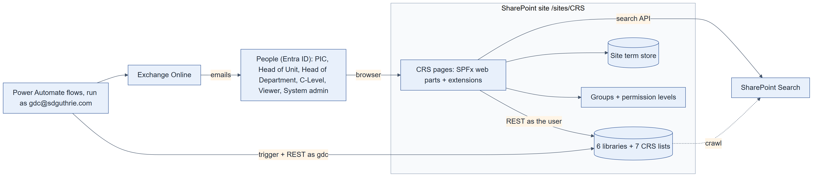
Figure 1. System context: people, the CRS site, flows and Microsoft 365 services

2.4 Design principles
- Act as the user. Web parts call SharePoint REST with the signed-in user's own permissions. There is no backend server, no Microsoft Graph and no app-only permission.
- Proxy what users must not do. Writing metadata (for uploaders), moving approved files, deleting, revoking shares and sending email are done by flows running as gdc.
- Configuration in lists, not code. Folder levels, codes, role mappings, file types and switches live in CRS lists and take effect on the next page load.
- Names are resolved at run time. The client renames lists, libraries and pages. Code resolves them from candidate titles and URL segments, never from literals.
- Terms are keyed by GUID. Labels can change (and some are corrupted on this tenant); GUIDs are the join keys everywhere.
- Empty is not unknown. A failed read is unknown, never an empty result. Form gates fail open; security and destructive decisions fail closed.
- Permissions are additive. Reconciliation only adds grants; deleting a group is the only revoke.

3. Architecture

3.1 Technology stack
Table 3. Technology stack
Layer | Technology | Version / note
UI framework | SharePoint Framework (SPFx) | 1.23.0
Language | TypeScript | ~5.8
UI library | React | 17.0.1
Components | Fluent UI React | 8.x
Build | Heft (rushstack) | npm run build; gulp is listed in package.json but unused
Runtime | Node.js | >= 22.14, < 23
Data access | SPHttpClient (SharePoint REST) | /_api, term store /_api/v2.1/termStore, Search /_api/search/query. @pnp/sp is installed but not used.
Automation | Power Automate (cloud flows) | 25 flows, owner gdc@sdguthrie.com, default environment
Connectors | SharePoint, Office 365 Outlook | Connections named GDC Proxy - SharePoint and GDC Proxy - Outlook
Hosting | SharePoint Online site collection app catalog | /sites/CRS/AppCatalog; assets packaged inside the .sppkg (no CDN)
Tests | Jest via Heft | Pure logic modules have a x.test.ts; npx heft test --clean

3.2 Logical architecture
CRS has no server of its own. The browser runs the SPFx code inside SharePoint pages and reads and writes SharePoint directly as the signed-in user. Power Automate is the only server-side component; it works on the same lists and libraries as the service account.
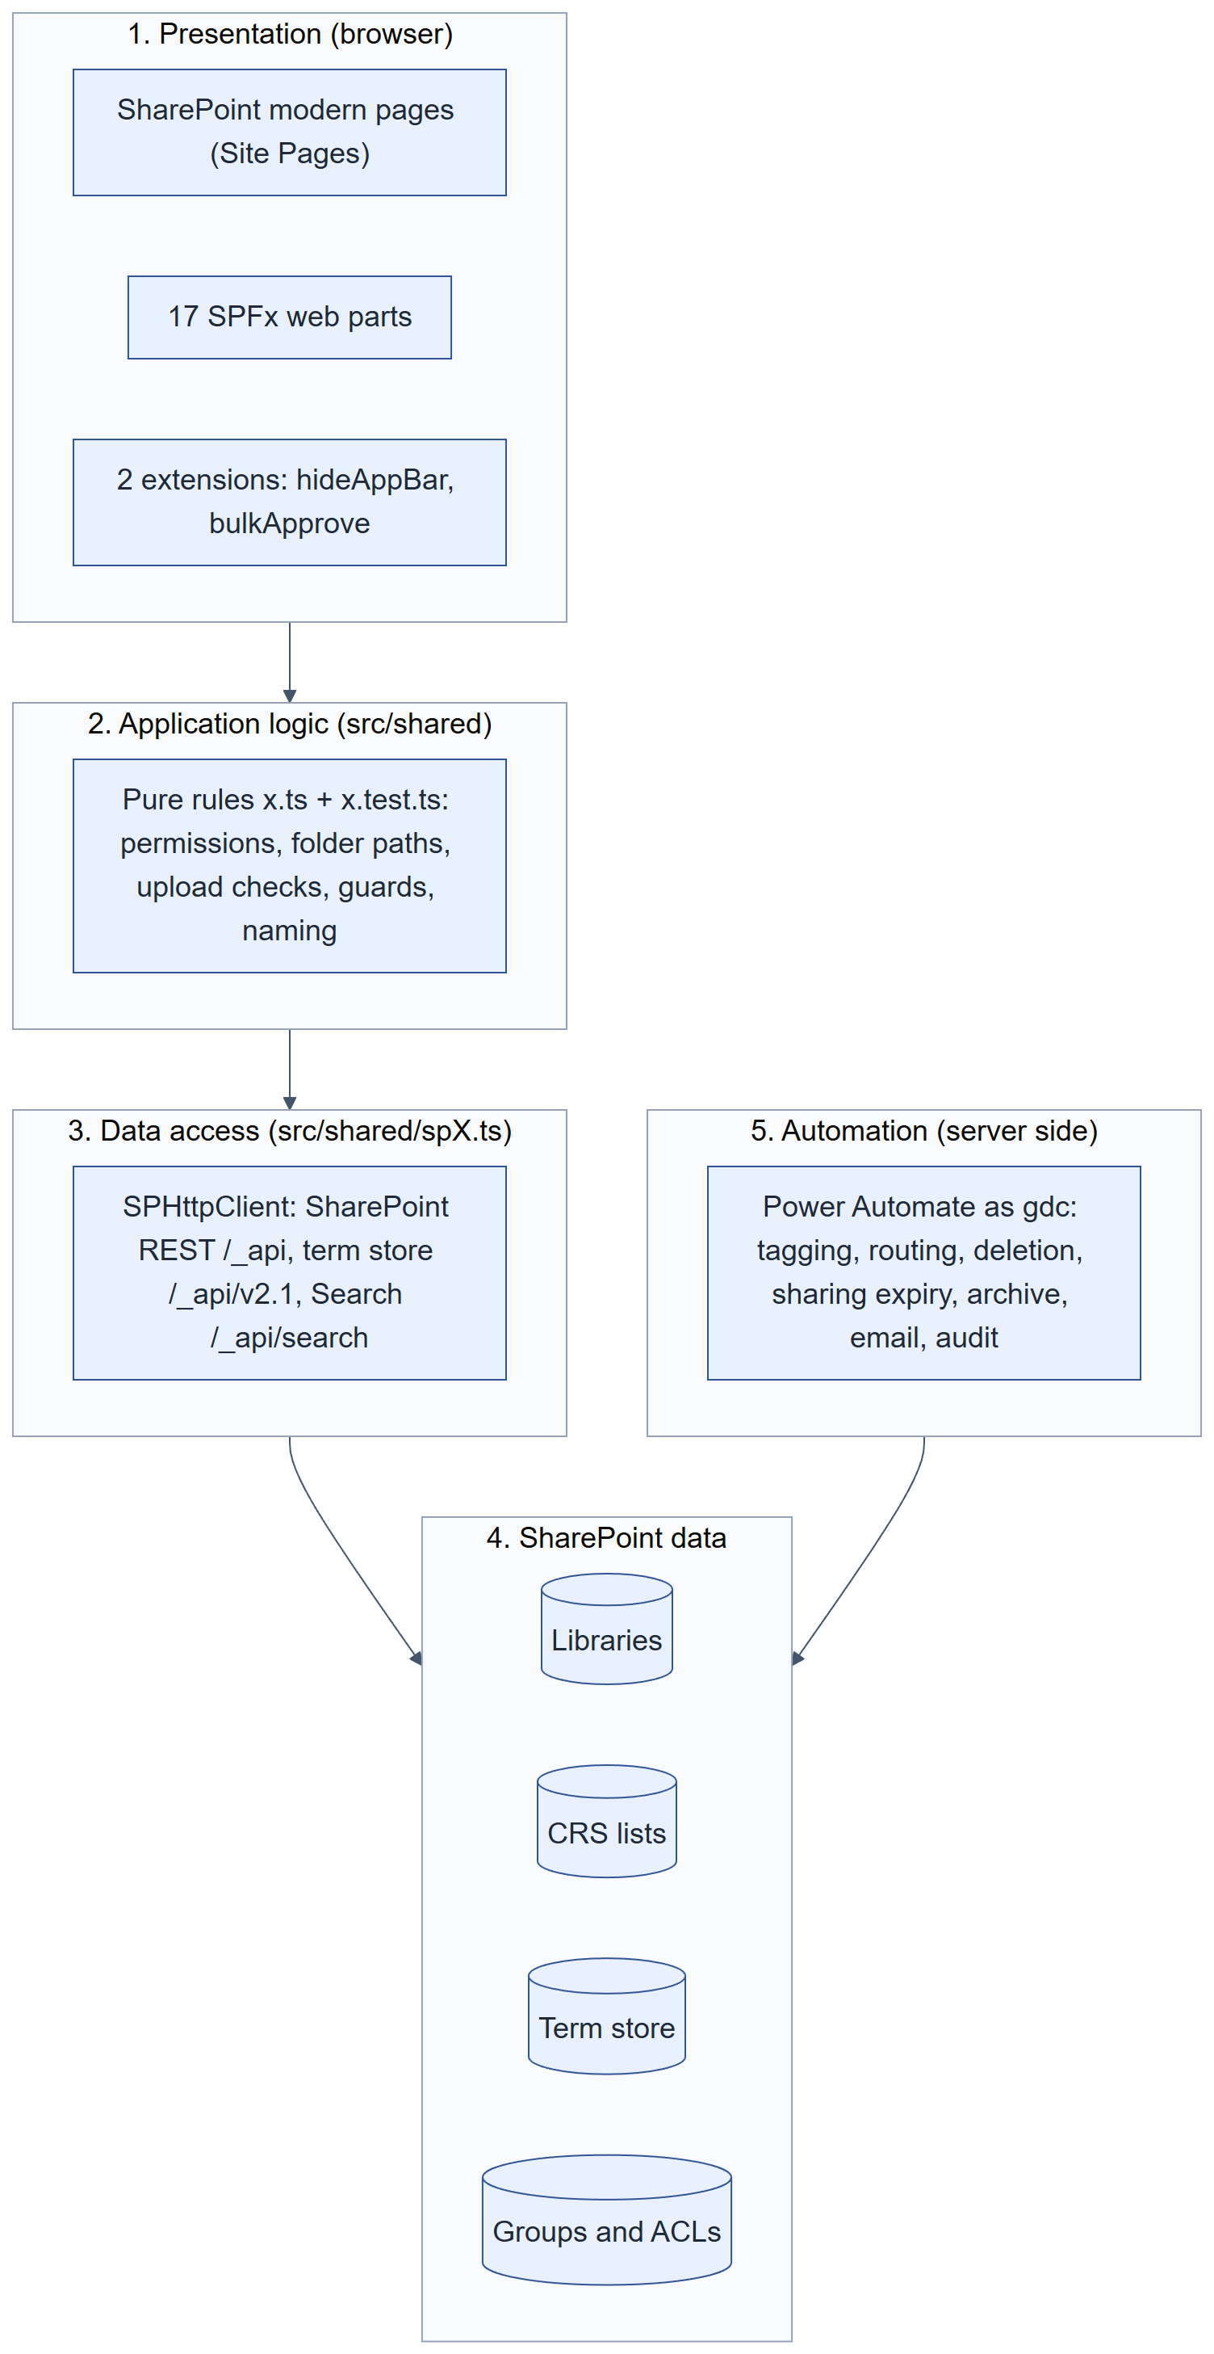
Figure 2. Logical layers
- Presentation: one web part per page; the extensions change the library command bar.
- Application logic: src/shared/*.ts. Rules are pure functions with tests (permissions, folder paths, upload checks, approval guards, request scope). Behaviour changes are made here.
- Data access: src/shared/sp*.ts and the REST calls inside components. Every read that decides an action is cache-busted; throttled calls (429/503) are retried by throttleRetry.ts.
- Data: SharePoint libraries, lists, term store and permissions (chapters 4 and 5).
- Automation: flows triggered by list changes or schedules (chapter 8).

3.3 Deployment architecture
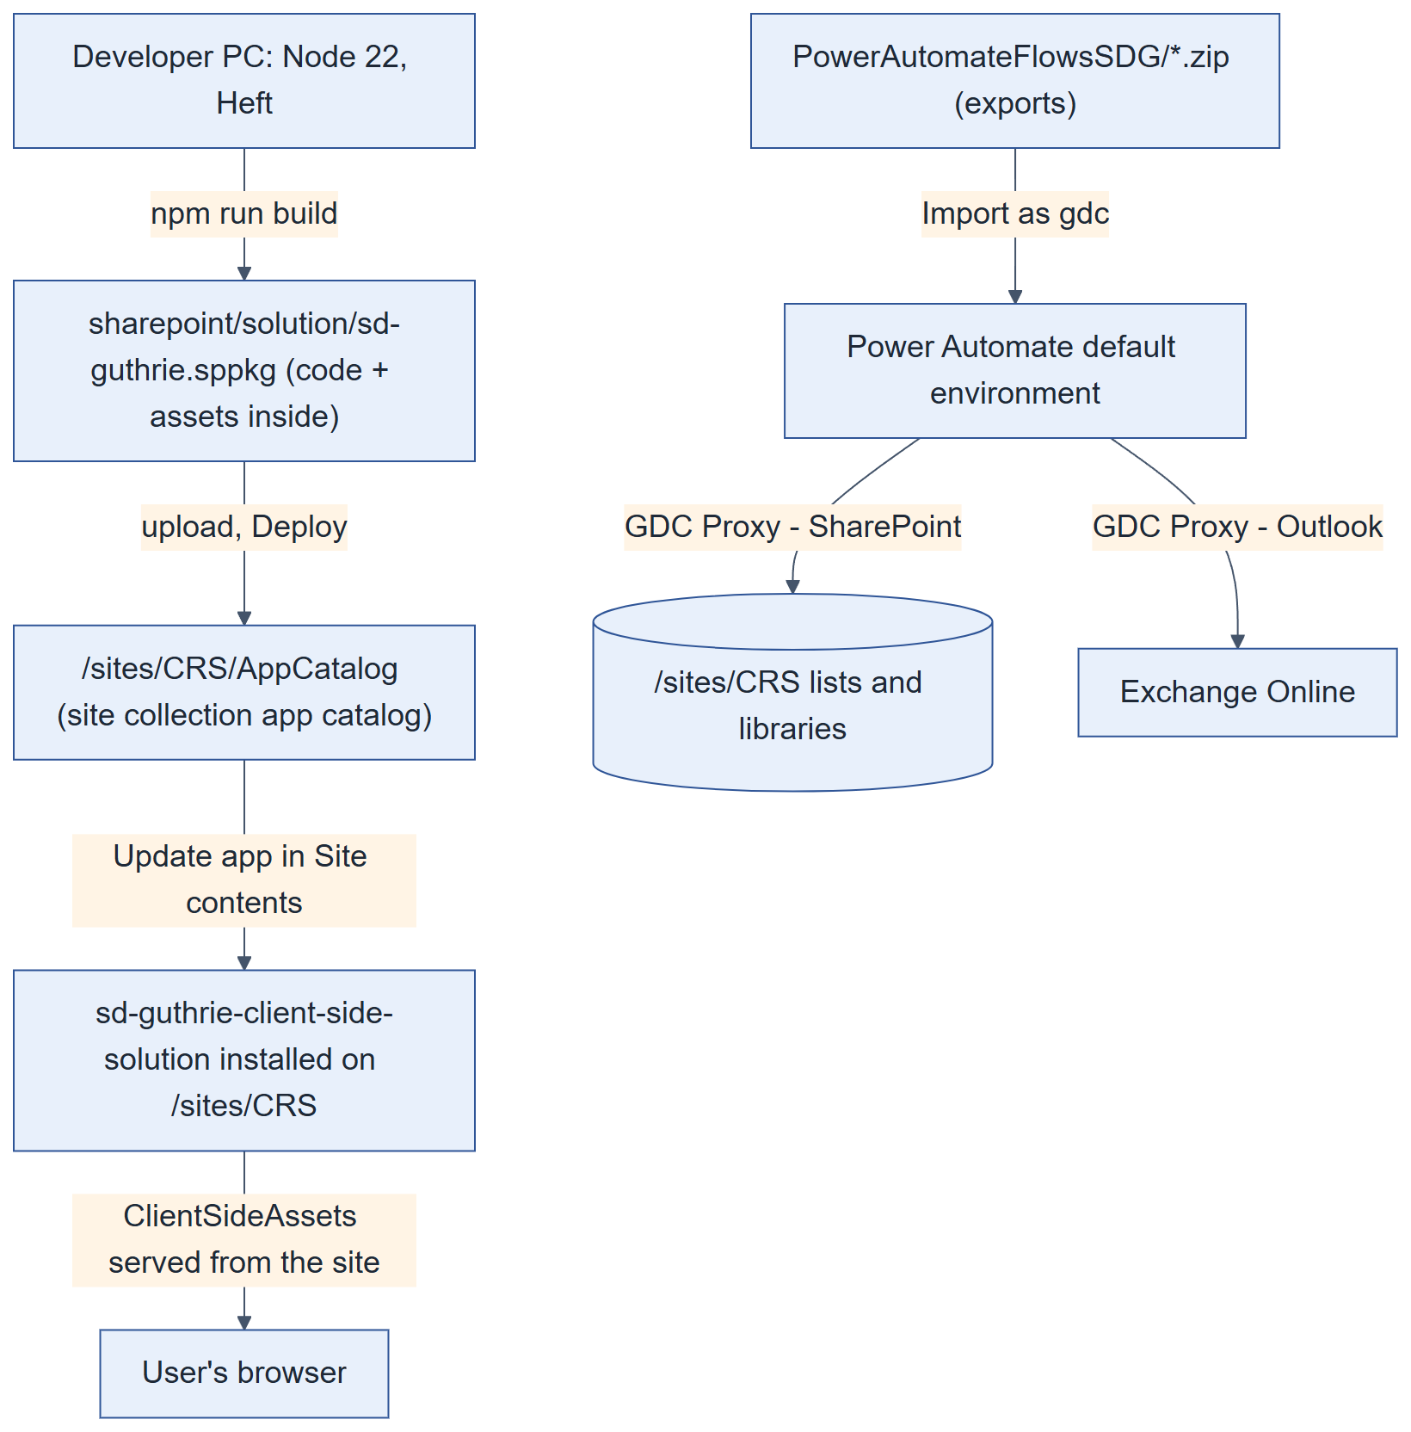
Figure 3. Deployment view
Table 4. Deployment facts
Item | Value
Solution name / id | sd-guthrie-client-side-solution / 4c93b50e-03c1-4005-a280-add0da86c86f (never change the id)
Package | sharepoint/solution/sd-guthrie.sppkg, includeClientSideAssets: true (code ships inside the package)
App catalog | Site collection app catalog /sites/CRS/AppCatalog. The tenant app catalog is not used.
API permissions | None (webApiPermissionRequests is empty): no admin consent is needed.
Feature deployment | skipFeatureDeployment: false. On this tenant the extensions did not register from the feature and were added by hand (Appendix A.5).
Flow environment | SD Guthrie default environment, signed in as gdc.

3.4 Solution components
Table 5. Components in sd-guthrie.sppkg
Component | Type | Id | Used on page
Upload Form (form) | Web part | 21b82fca-081a-4ce4-bbe6-a83f2fce63a3 | Upload-Form.aspx
Bulk Upload | Web part | 299700f0-9a8e-4367-8018-1f9d54b92705 | Bulk-Upload.aspx
Approval Document | Web part | 3a8f2e6d-1b4c-4a7f-8e9d-2c5b7f3a1e6d | Approval-Document.aspx
My Submissions | Web part | 5c9d1a83-6f24-4b07-9e51-8d3a0c7f2b46 | My-Submissions.aspx, Document-Viewer.aspx
GDC Requests | Web part | 7a4f1e93-2c58-4d07-b6a1-9e3c85f2d410 | CRS-Request.aspx
GDC Search | Web part | 8b2f4a95-7c31-4d68-9e04-1a6b3f8c25d7 | Home.aspx
Folder Administration | Web part | 02007994-7d63-4178-9a43-2b6ec96f9e44 | Folder-Administrator.aspx
Folder Structure | Web part | ba145053-3728-4b6c-8a1e-a393c520abb2 | Used inside the Folder Administration guided flows
Group Management | Web part | 3f81c6d2-45ae-4b93-8c17-0d5e2a9f6b41 | Group-Management.aspx
Page Access | Web part | 2d6d7010-8bc0-4ac2-8573-fe694db220f8 | Page-Access.aspx
Approval Library Access | Web part (signpost) | 591eb30f-4bb3-4853-a799-a41c5664d7fc | Approval-Library-Access.aspx
Site Access | Web part (signpost) | 695640a1-5bf9-4582-adbe-30a988c4945a | Site-Access.aspx
Folder Access | Web part (retired signpost) | a5955b3e-0945-4ad4-9cb1-db8006c7fa7f | Folder-Access.aspx
GDC Settings | Web part | 4d8b7e21-9c65-4a3f-b028-5e71d9c4a836 | CRS-Settings.aspx
GDC Configuration | Web part | c7a41f6b-5d92-4e08-9a37-6b1f2c8d4e05 | CRS-Configuration.aspx
GDC Audit Log | Web part | 9e2c4d17-8b3a-4f60-a5d1-7c0e6b28f394 | CRS-Audit-Log.aspx
Folder Onboarding | Web part (legacy) | 7b3e9c14-2a8d-4f61-9b0e-5d3c8a1f4e72 | Not on any page
hideAppBar | Application customizer | c1d2e3f4-a5b6-47c8-d9e0-f1a2b3c4d5e6 | Every CRS library (registered as CRS New Folder Button)
bulkApprove | List view command set | 6d1a9f47-3c82-4e15-b7a0-9f2e5c8d4136 | Document libraries (registered as CRS Bulk Approve, RegistrationId 101)
uploadCommand | Command set (legacy) | c2fd5b59-02ed-4892-87f2-2418fefb4980 | Not registered; links to an old sandbox. Ignore.

3.5 Pages
Pages are modern Site Pages, each holding one CRS web part. The client renames pages, so the settings directory finds them by file name at run time. Read from the live site:
Table 6. Site Pages with web parts
File | Page title | Web parts on the page
Home.aspx | Home | CRS Search, Document library, Document library
Approval-Document.aspx | Approval Document | Approval Document
CRS-Settings.aspx | 🛠️ GDC Settings | CRS Settings
Upload-Form.aspx | Document Upload | form
Folder-Administrator.aspx | Folder Management | Folder Administration
Group-Management.aspx | Group Management | Group Management
Folder-Access.aspx | Folder Access | Title area, Folder Access
Site-Access.aspx | Site Access | Site Access
Approval-Library-Access.aspx | Approval Document Access | Approval Library Access
Page-Access.aspx | Page Access | Page Access
CRS-Configuration.aspx | CRS Configuration | CRS Configuration
CRS-Audit-Log.aspx | CRS Audit Log | CRS Audit Log
Bulk-Upload.aspx | Bulk Upload | Bulk Upload
My-Submissions.aspx | 📨 My Submission | My Submissions
CRS-Request.aspx | File Permission | CRS Requests
Page.aspx |  | Title area
Document-Viewer.aspx | Document-Viewer | My Submissions
User-Guides.aspx | User Guides | Image, Image, Image, Image
User-Guideline-Viewer.aspx | User Guideline Viewer | Quick links, File and media
User-Guide-Uploader-Approver.aspx | User Guideline Uploader Approver | Quick links, File and media
User-Guide-Viewer.aspx | User Guide Viewer | Quick links, File and media
User-Guide(1).aspx | User Guide | Quick links, File and media
User-Guide.aspx | User Guide | Quick links, File and media

3.6 Code organisation
Table 7. Repository layout
Folder | Contents
src/webparts/<name>/ | One folder per web part: <Name>WebPart.ts (entry, property pane, render) and components/<Name>.tsx (React UI).
src/extensions/ | hideAppBar (adds + New Folder; hides native Upload, Approve/Reject and Share), bulkApprove (Approve or reject panel), uploadCommand (legacy).
src/shared/ | All shared logic. Pure rules in x.ts with x.test.ts; SharePoint calls in spX.ts. About 120 modules.
config/ | package-solution.json (version, component ids), serve.json (local debug pages).
scripts/ | Browser-console diagnostics and repairs; Python flow generators.
PowerAutomateFlowsSDG/ | Exported flow packages. Re-export and commit after every flow change.
sharepoint/assets/elements.xml | Feature definition for the extensions (did not provision on this tenant).

Table 8. Shared module catalogue
Area | Shared modules
Names of lists, libraries, groups | naming.ts, spNaming.ts
Folder structure | folderChain.ts, folderAbbreviation.ts, abbreviationDraft.ts, spAbbreviationTree.ts, folderFullName.ts, termChains.ts, tierColumnGuard.ts
Folder Map and permission probes | dmsFolderMap.ts, folderMapDuplicates.ts, segmentReadiness.ts
Guided admin flows | folderFlows.ts
Segments and migration | newSegment.ts, segmentDeletion.ts, segmentRecode.ts, spSegmentRecode.ts, reconScope.ts, subtreeMigration.ts, uploadPause.ts
Groups and roles | groupMapModel.ts (PERSONAS), bulkGroups.ts, groupMappings.ts, spGroups.ts, spGroupsFilter.ts, siteEntryGroup.ts, userAccess.ts, groupExportCsv.ts
Page access | pageAccessPolicy.ts, pageGrants.ts, adminPages.ts, grantSkip.ts
Upload | formModel.ts, uploadBatches.ts, allowedFileTypes.ts, fileTypeSettings.ts, inputSanitize.ts, optionalColumns.ts, spColumns.ts, legalPrivilege.ts, confidentialityOrder.ts, clashProxyDeletion.ts
Highly Confidential | hcRouting.ts, hcClearance.ts
Approval | approvalGuards.ts, approvalDestination.ts, approvalQueue.ts, selfApprove.ts
Submissions | mySubmissions.ts, submissionGroups.ts, submissionRecords.ts, spSubmissionRecords.ts
Requests | requests.ts, directFileActions.ts, deletionGuard.ts, liveRefresh.ts
Search | documentSearch.ts
Audit | auditLog.ts, spAuditLog.ts, displayName.ts
Network | throttleRetry.ts, networkErrors.ts, pathEncoding.ts
UI helpers | toast.tsx, pagination.tsx, filterSelect.tsx, datePicker.tsx, responsive.ts, fileDetailPanel.tsx, filePreview.ts and others

3.7 Runtime behaviour common to all web parts
- Name priming. On load, primeNames (in naming.ts) asks SharePoint which lists exist and resolves each logical list (LIST_SUFFIX: Config, Group Map, Folder Map, Term Abbreviation, Submissions, Requests, Audit Log) to CRS <suffix>, falling back to the old DMS <suffix>. Libraries resolve from candidate title arrays (LIBRARY_CANDIDATES, DOCUMENTS_CANDIDATES, HC_APPROVAL_CANDIDATES …) and URL segments.
- Config load. CRS Config is read once per page load (settings rows and mode rows).
- Permission probes. Before offering an action, the code asks SharePoint for the user's effective permissions on the exact folder or item (EffectiveBasePermissions). Group Map membership is a second source for display; writes are always checked by SharePoint itself.
- Cache-busting. Reads that decide an action add Cache-Control: no-cache and a unique query parameter.
- Optional columns. A $select naming an unknown column fails the whole read, so reads of optional columns use a fallback ladder (one rung per optional column).
- Throttling. HTTP 429/503 are retried with back-off (throttleRetry.ts).
- No browser storage. CRS keeps no state in localStorage or sessionStorage; all state lives in SharePoint.
- Mobile. Layouts are phone-first and widen with min-width media queries.

4. Data design
CRS has no database of its own. All data lives in SharePoint Online on the CRS site: document libraries hold the files and their metadata, custom lists hold configuration and records, the site term store holds the classification, and SharePoint groups and permissions hold security. This chapter was produced from a read-only capture of the live site on 2026-10-01.

4.1 Where data is stored
Table 9. Data stores
Store | What it holds | Written by | Retention
Approval libraries (2) | Uploaded files waiting for approval, rejected files, and their metadata | Upload Form, Bulk Upload, tagging flow, approvers | Until routed (approved) or deleted; rejected files stay
Approved libraries (2) | Approved documents with version history | Auto-route flows only | 7 years from creation, then archived
Archive libraries (2) | Documents older than 7 years, read-only | Archive flows only | Indefinite
CRS Config | Settings and per-segment folder structure | Admin pages | Configuration
CRS Term Abbreviation | Term → folder code | Folder Administration | Configuration
CRS Group Map | Which group holds which role at which term | Group Management | Configuration
CRS Folder Map | Term → folder id and URL | Folder Reconciliation | Rebuilt by reconciliation
CRS Submissions | One record per uploaded file; survives deletion; carries TagPayload | Upload Form, Bulk Upload, flows | Indefinite (history)
CRS Requests | Delete and share requests and decisions | My Submissions, Requests page, flows | Indefinite
CRS Audit Log | Append-only event log | Web parts (writeAudit) and flows | Indefinite
Site term store | Segments, departments, units, Year, Document Type, Confidentiality Level | Admins in the term store tool | Configuration
SharePoint groups and ACLs | Who can open which library, folder and page | Group Management, Reconciliation, Requests page | Configuration
Site Pages | The CRS pages and their web part instances | Admins | Configuration
SharePoint Search index | Crawled copy of approved and archive libraries for Search | SharePoint crawler (re-crawl nudged every 6 h) | Follows the libraries
Power Automate | Flow definitions, connections, 28-day run history | gdc | Run history 28 days

4.2 Logical data model
The term GUID is the main key: it ties the term store to folder codes, folders and role grants. On the document side, SubmissionFileId ties a document to its submission record through every move (a file's UniqueId changes when Auto-route copies it), and ItemUniqueId ties requests and audit rows to a file.

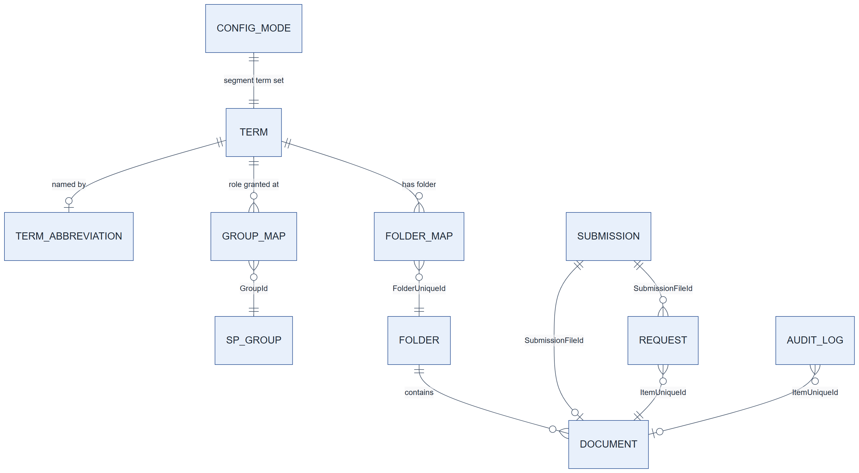
Figure 4. Logical data model (keys only)

Table 10. Keys and joins
Key | Format | Links
Term GUID | GUID from the term store | Term Abbreviation.TermGuid, Folder Map.TermGuid, Group Map.UnitTermGuid, document *Tid columns, Requests.UnitTermGuid; Config mode row TermSetGuid (set level)
Group id | SharePoint group Id (integer, stored as text) | Group Map.GroupId → site group
Folder UniqueId | GUID | Folder Map.FolderUniqueId → folder in the approval library
SubmissionRef / SubmissionId | SUB-yyyymmdd-xxxx | One upload (all its sets). Record.SubmissionRef = document.SubmissionId
BatchRef / BatchId | BAT-yyyymmdd-xxxx | One set (one destination folder)
SubmissionFileId | Generated per file by the form | Record ↔ document (approval and approved copies) ↔ Requests.SubmissionFileId
ItemUniqueId | File UniqueId | Requests and Audit Log → the file at the time of the event

4.3 Libraries
Table 11. Document libraries (live settings)
Library (title / URL) | Key in code | Role | List GUID | Content approval | Versioning | Items* | Unique perms
Approval for Document  /ApprovalDocument | Staging | Pending and rejected uploads (normal) | eeb1bb19-ec53-4c41-8dc9-ecf255979c9b | Yes (Author + approvers) | Major, keep 500 | 175 | Yes
Restricted & Confidential Document  /Shared Documents | Documents | Approved documents (normal) | fbc062dd-fcd0-4458-9161-2bfc19c917fa | No | Major, keep 500 | 175 | Yes
Approval for Highly Confidential Document  /HCApprovalDocument | StagingHC | Pending and rejected uploads (Highly Confidential) | d935aa6d-dc48-4832-ba7e-eca485ecdff3 | Yes (Author + approvers) | Major, keep 500 | 175 | Yes
Highly Confidential Document  /HCDocuments | DocumentsHC | Approved Highly Confidential documents | 122a4aa9-65fb-479a-90a7-3866d19f51b4 | No | Major, keep 500 | 175 | Yes
Archive Restricted & Confidential Document  /Archive | Archive | Approved documents older than 7 years (read-only) | 647fd644-ab00-4358-9b3f-49031083fcf0 | No | Major, keep 500 | 175 | Yes
Archive Highly Confidential Document  /HCArchive | ArchiveHC | Highly Confidential documents older than 7 years (read-only) | fc301054-abf5-4e53-957a-6f8c58a410b8 | No | Major, keep 500 | 175 | Yes

*Item counts include folders. At capture the libraries held only the folder tree (the launch purge emptied them on 30 September 2026).
The client renames library titles; the URL segment never changes. Code must resolve titles at run time (naming.ts), and the hideAppBar extension keeps its own title list (CRS_LIBRARIES). Add a renamed title to both, build and deploy.
Table 12. Content types per library
Library | Content types
Approval for Document | Document, Folder, CRS Folder
Restricted & Confidential Document | Document, Folder, CRS Folder
Approval for Highly Confidential Document | Document, Folder, CRS Folder
Highly Confidential Document | Document, Folder, CRS Folder
Archive Restricted & Confidential Document | Document, Folder, CRS Folder
Archive Highly Confidential Document | Document, Folder, CRS Folder

CRS Folder is the folder content type that carries the Full Name column.
Table 13. Library views (non-hidden)
Library | View | Columns | Filter / sort
Approval for Document | All Documents | DocIcon, LinkFilename, Author, Created, _ModerationStatus, Confidentiality_x0020_Level, LegallyPrivileged, Business_x0020_Segment, Department, Unit, SubUnit, Year, Document_x0020_Type, Full_x0020_Name, ProjectName, Vendor_x002f_CustomerName, DocumentDate, SubmissionId, Editor, FileSizeDisplay | FileLeafRef
Approval for Document | Pending Files (default) | DocIcon, LinkFilename, Author, Created, _ModerationStatus, Confidentiality_x0020_Level, LegallyPrivileged, Business_x0020_Segment, Department, Unit, SubUnit, Year, Document_x0020_Type, Full_x0020_Name, ProjectName, Vendor_x002f_CustomerName, DocumentDate, SubmissionId, Editor, FileSizeDisplay, Keyword, NextReminderAt | Eq _ModerationStatus = Pending
Approval for Document | Rejected Files | DocIcon, LinkFilename, Author, Created, _ModerationStatus, Confidentiality_x0020_Level, LegallyPrivileged, Business_x0020_Segment, Department, Unit, SubUnit, Year, Document_x0020_Type, Full_x0020_Name, ProjectName, Vendor_x002f_CustomerName, DocumentDate, SubmissionId, Editor, FileSizeDisplay | Eq _ModerationStatus = Rejected
Restricted & Confidential Document | All Documents (default) | DocIcon, LinkFilename, Author, Created, Confidentiality_x0020_Level, LegallyPrivileged, Business_x0020_Segment, Department, Unit, SubUnit, Year, Document_x0020_Type, ProjectName, Vendor_x002f_CustomerName, DocumentDate, SubmissionId, Editor, FileSizeDisplay | FileLeafRef
Restricted & Confidential Document | Show All Files | DocIcon, LinkFilename, Author, Created, Confidentiality_x0020_Level, LegallyPrivileged, Business_x0020_Segment, Department, Unit, SubUnit, Year, Document_x0020_Type, ProjectName, Vendor_x002f_CustomerName, DocumentDate, SubmissionId, Editor, FileSizeDisplay, Keyword | —
Approval for Highly Confidential Document | All Documents | DocIcon, LinkFilename, Editor, Full_x0020_Name, _ModerationStatus, Business_x0020_Segment, Department, Unit, SubUnit, DocumentDate, Vendor_x002f_CustomerName, ProjectName, LegallyPrivileged, Remark, Document_x0020_Type, Year, Confidentiality_x0020_Level, Created, FileSizeDisplay | FileLeafRef
Approval for Highly Confidential Document | Pending Files (default) | DocIcon, LinkFilename, Editor, Full_x0020_Name, _ModerationStatus, Business_x0020_Segment, Department, Unit, SubUnit, DocumentDate, Vendor_x002f_CustomerName, ProjectName, LegallyPrivileged, Document_x0020_Type, Year, Confidentiality_x0020_Level, Created, FileSizeDisplay, Remark, Author, NextReminderAt | Eq _ModerationStatus = Pending
Approval for Highly Confidential Document | Rejected Files | DocIcon, LinkFilename, Editor, Full_x0020_Name, _ModerationStatus, Business_x0020_Segment, Department, Unit, SubUnit, DocumentDate, Vendor_x002f_CustomerName, ProjectName, LegallyPrivileged, Document_x0020_Type, Year, Confidentiality_x0020_Level, Created, FileSizeDisplay, Remark | Eq _ModerationStatus = Rejected
Highly Confidential Document | All Documents (default) | DocIcon, LinkFilename, Author, Created, Confidentiality_x0020_Level, LegallyPrivileged, Business_x0020_Segment, Department, Unit, SubUnit, Year, Document_x0020_Type, ProjectName, Vendor_x002f_CustomerName, DocumentDate, SubmissionId, Editor, FileSizeDisplay | FileLeafRef
Highly Confidential Document | Show All Files | DocIcon, LinkFilename, Author, Created, Confidentiality_x0020_Level, LegallyPrivileged, Business_x0020_Segment, Department, Unit, SubUnit, Year, Document_x0020_Type, ProjectName, Vendor_x002f_CustomerName, DocumentDate, SubmissionId, Editor, FileSizeDisplay | —
Archive Restricted & Confidential Document | All Documents (default) | DocIcon, LinkFilename, Archived, Author, Created, Confidentiality_x0020_Level, LegallyPrivileged, Business_x0020_Segment, Department, Unit, SubUnit, Year, Document_x0020_Type, FullName, ProjectName, Vendor_x002f_CustomerName, DocumentDate, SubmissionId, Editor, FileSizeDisplay | FileLeafRef
Archive Restricted & Confidential Document | View All Files | DocIcon, LinkFilename, Archived, Author, Created, Confidentiality_x0020_Level, LegallyPrivileged, Business_x0020_Segment, Department, Unit, SubUnit, Year, Document_x0020_Type, Full_x0020_Name, ProjectName, Vendor_x002f_CustomerName, DocumentDate, SubmissionId, Editor, FileSizeDisplay | —
Archive Highly Confidential Document | All Documents (default) | DocIcon, LinkFilename, Archived, Author, Created, Confidentiality_x0020_Level, LegallyPrivileged, Business_x0020_Segment, Department, Unit, SubUnit, Year, Document_x0020_Type, FullName, ProjectName, Vendor_x002f_CustomerName, DocumentDate, SubmissionId, Editor, FileSizeDisplay | FileLeafRef
Archive Highly Confidential Document | View All Files | DocIcon, LinkFilename, Archived, Author, Created, Confidentiality_x0020_Level, LegallyPrivileged, Business_x0020_Segment, Department, Unit, SubUnit, Year, Document_x0020_Type, FullName, ProjectName, Vendor_x002f_CustomerName, DocumentDate, SubmissionId, Editor, FileSizeDisplay | —

The bundled approver emails link to the Pending Files view of each approval library. Do not rename or delete those views.

4.4 Document columns
All six libraries share one set of document columns, so a file keeps its metadata when it is routed and archived. The table lists every visible custom column found on the live libraries that CRS uses.
Table 14. Document columns
Display name | Internal name | Type | Libraries | Meaning | Written by
Title | Title | Text | All 6 | SharePoint's built-in title. Not used by the logic. | —
Description | _ExtendedDescription | Multi-line text | All 6 | Built-in document Description. Shown in the details panel when filled. | Users (optional)
Business Segment | Business_x0020_Segment | Text | All 6 | Business segment label (e.g. Group Head Office). | Apply pending tags (from TagPayload); copied by Auto-route
BusinessSegmentTid | BusinessSegmentTid | Text | All 6 | Business segment term GUID. Logic compares GUIDs, never labels. | Apply pending tags; copied by Auto-route
Department | Department | Text | All 6 | Permissioned tier 1 label. | Apply pending tags
DepartmentTid | DepartmentTid | Text | All 6 | Tier 1 term GUID. | Apply pending tags
Unit | Unit | Text | All 6 | Permissioned tier 2 label (the confidentiality boundary). | Apply pending tags
UnitTid | UnitTid | Text | All 6 | Unit term GUID. Flows use it to find the unit's approver group in CRS Group Map. | Apply pending tags
SubUnit | SubUnit | Text | All 6 | Optional per-unit level label. | Apply pending tags
SubUnitTid | SubUnitTid | Text | All 6 | Sub Unit term GUID. | Apply pending tags
Document Date | DocumentDate | Date and time | All 6 | Document date. Part of the file name. | Apply pending tags (from the upload form)
Vendor/CustomerName | Vendor_x002f_CustomerName | Text | All 6 | Vendor or customer. Optional part of the file name. | Apply pending tags
ProjectName | ProjectName | Text | All 6 | Project. Optional part of the file name. | Apply pending tags
Remark | Remark | Text | All 6 | Remark for the approver. Removed from the upload form on 21 Sep 2026 (client); kept for older files. | Older uploads only
LegallyPrivileged | LegallyPrivileged | Yes/No | All 6 | Legally privileged flag. Asked only for the levels in the legallyPrivilegedFor config row. | Apply pending tags
Full Name | Full_x0020_Name | Text | All 6 | On folders (CRS Folder content type): the full label behind the abbreviated folder name. | Folder Reconciliation
Document Type | Document_x0020_Type | Managed metadata (Document Type) | All 6 | Managed metadata, Document Type term set. | Apply pending tags; copied explicitly by Auto-route
Year | Year | Managed metadata (Year) | All 6 | Managed metadata, Year term set. | Apply pending tags; copied explicitly by Auto-route
Confidentiality Level | Confidentiality_x0020_Level | Managed metadata (Confidentiality Level) | All 6 | Managed metadata, Confidentiality Level term set. hcConfidentialityLevel names the HC value. | Apply pending tags; copied explicitly by Auto-route
Submission Id | SubmissionId | Text | All 6 | Upload id (SUB-yyyymmdd-xxxx), same as SubmissionRef on the record. | Apply pending tags; copied by Auto-route
Batch Id | BatchId | Text | All 6 | Batch (set) id (BAT-yyyymmdd-xxxx). | Apply pending tags; copied by Auto-route
Bulk Import | BulkImport | Yes/No | All 6 | True for Bulk Upload files. Triggers auto-approval and suppresses the approved email. Must stay visible. | Bulk Upload
Archived | Archived | Yes/No | All 6 | Set by the seven-year archive mover. Used for badges in My Submissions and Search; the library, not this flag, decides access. | Archive flows
Submission File Id | SubmissionFileId | Text | All 6 | Per-file id. The join key to CRS Submissions; survives routing (UniqueId does not). | Apply pending tags; copied by Auto-route
Approved By | ApprovedBy | Text | All 6 | Approver's email, written in its own MERGE before the status change (SharePoint keeps no approved-by field). | Approval Document page, Approve or reject panel, self-approve
Keyword | Keyword | Text | All 6 | Free-text keywords for search. | Apply pending tags
Image Tags | MediaServiceImageTags | Managed metadata (Image Tags) | Approval, Documents, HC approval, HC documents | SharePoint's automatic image tags. Not used by CRS. | SharePoint
Approval Comment | ApprovalComment | Multi-line text | All 6 | Comment typed when approving. The rejection reason is the built-in moderation comment. | Approval Document page, panel
NextReminderAt | NextReminderAt | Date and time | Approval, HC approval | When the next approver reminder is due. Approval libraries only. | Reminder flows
Full Name | FullName | Text | Archive, HC archive | Second Full Name column that exists only on the two archive libraries. | Archive flows

Built-in columns the system relies on
Table 15. Built-in columns used
Column (REST name) | Use in CRS
OData__ModerationStatus (CAML _ModerationStatus) | Approval state: 0 Approved, 1 Rejected, 2 Pending. Never MERGE it together with another field (HTTP 500).
OData__ModerationComments | Rejection reason, emailed to the uploader.
Author (Created By) | The uploader. My Submissions filters on AuthorId. Auto-route re-stamps it on the approved copy. Never use Editor as the uploader.
Editor (Modified By) | Re-stamped to gdc by Auto-route; not reliable for who approved.
Created | Upload date; the archive flows use it for the 7-year cut-off.
UniqueId, FileRef, FileLeafRef | File identity and path. UniqueId changes when Auto-route copies a file.
FileSystemObjectType / CAML FSObjType | 0 file, 1 folder. Queues and flows exclude folders.
TaxCatchAll and the hidden note fields | SharePoint's storage for managed metadata values.

Folder-level columns created by Folder Structure
When an admin adds a below-Unit folder level, Folder Structure creates a label column and a …Tid (term GUID) column on all six libraries. The live libraries carry the pairs below from client testing. At capture no CRS Config mode row referenced them (all three segments use Department › Unit › Year › Document Type), so they hold no live meaning. Remove one only after confirming that no mode row's Levels or PendingLevels names it and no document holds a value.
Table 16. Unused tier columns at capture
Display name | Internal name | Libraries
Mini | Mini | All 6
Mini ID | MiniTid | All 6
Showroom Branch | ShowroomBranch | All 6
Showroom Branch ID | ShowroomBranchTid | All 6
European Brand | EuropeanBrand | All 6
European Brand ID | EuropeanBrandTid | All 6
Japanese Brand | JapaneseBrand | All 6
Japanese Brand ID | JapaneseBrandTid | All 6
European Brand Test | EuropeanBrandTest | All 6
European Brand Test ID | EuropeanBrandTestTid | All 6
Japenese Brand Test | JapeneseBrandTest | All 6
Japenese Brand Test ID | JapeneseBrandTestTid | All 6
Test | Test | All 6
Test ID | TestTid | All 6
te | te | All 6
te ID | teTid | All 6
New Folder level testing | NewFolderleveltesting | All 6
New Folder level testing ID | NewFolderleveltestingTid | All 6
Volvo | Volvo | All 6
Volvo ID | VolvoTid | All 6
volvo | volvo0 | All 6
volvo ID | volvoTid0 | All 6
Branch Test | BranchTest | All 6
Branch Test ID | BranchTestTid | All 6
Deparment | Deparment | All 6
Deparment ID | DeparmentTid | All 6
Tset again | Tsetagain | All 6
Tset again ID | TsetagainTid | All 6
test again1 | testagain1 | All 6
test again1 ID | testagain1Tid | All 6
Do | Do | All 6
Do ID | DoTid | All 6
t | t | All 6
t ID | tTid | All 6
d | d | All 6
d ID | dTid | All 6
y | y | All 6
y ID | yTid | All 6
sa | sa | All 6
sa ID | saTid | All 6
asad | asad | All 6
asad ID | asadTid | All 6
sad | sad | All 6
sad ID | sadTid | All 6

4.5 CRS lists
Table 17. CRS lists (live)
List | URL | List GUID | Rows | Unique perms
CRS Audit Log | /sites/CRS/Lists/CRS Audit Log | 4ac219e5-b855-46a3-be4b-4e96bba546c5 | 298 | No
CRS Config | /sites/CRS/Lists/CRS Config | 22e4f613-1693-407c-9f94-318088c51775 | 16 | No
CRS Folder Map | /sites/CRS/Lists/CRS Folder Map | 8a0c644d-638a-4282-83bd-6c73a9e36618 | 172 | No
CRS Group Map | /sites/CRS/Lists/CRS Group Map | 5acf3f3e-d955-4a82-8a49-24db3a353514 | 1708 | No
CRS Requests | /sites/CRS/Lists/CRS Requests | 1bcb1aa1-fbf1-4d1b-a6d2-88436824c297 | 0 | Yes
CRS Submissions | /sites/CRS/Lists/CRS Submissions | dd1bc5bd-daa7-491a-9dc7-b81212c391ab | 0 | Yes
CRS Term Abbreviation | /sites/CRS/Lists/CRS Term Abbreviation | b1c3d460-18da-466f-a19c-5f597d113cfa | 172 | No

The lists are found by suffix with a CRS or DMS prefix, never by a literal title. CRS Requests, CRS Audit Log and CRS Submissions create themselves and their columns when their web part first opens, and the Requests page has an add-missing-columns repair. Never hand-create a column on them: SharePoint fixes a column's internal name at creation.
Table 18. CRS Config columns (16 rows at capture)
Internal name | Type | Indexed | Meaning
ConfigType | Text |  | setting or mode.
SettingValue | Text |  | Value of a setting row (text; yes/no settings use yes/no).
ModeLabel | Text |  | Mode row: the segment's display name.
Category | Text |  | Mode row: BusinessSegment.
TermSetGuid | Text |  | Mode row: the segment's term set (departments, units).
StagingFolder | Text |  | Mode row: the segment's top folder code (GHO, MHO, NBPOLHO).
SortOrder | Number |  | Mode row: order in the segment picker.
Levels | Multi-line text |  | Mode row: JSON array of folder levels (see 4.6).
PendingLevels | Multi-line text |  | Mode row: a staged structure change waiting for migration.
AllowedFileTypes | Choice (multi) |  | Multi-choice of extensions on the allowedExtensions row.

Table 19. CRS Term Abbreviation columns (172 rows at capture)
Internal name | Type | Indexed | Meaning
TermGuid | Text |  | Term GUID (the key).
Abbreviation | Text |  | Short folder code, unique among siblings (e.g. GIT).
Level | Text |  | Department or Unit (or a below-Unit level name).

Table 20. CRS Folder Map columns (172 rows at capture)
Internal name | Type | Indexed | Meaning
TermGuid | Text |  | Unit (or department) term GUID.
FolderUniqueId | Text |  | UniqueId of the folder in the approval library.
FolderUrl | Multi-line text |  | Server-relative URL of that folder.
Section | Text |  | Segment code (GHO, MHO, NBPOLHO).
Library | Text |  | Library the row points at (blank = approval library).

Table 21. CRS Group Map columns (1708 rows at capture)
Internal name | Type | Indexed | Meaning
GroupId | Text |  | SharePoint group id (text).
GroupName | Text |  | Group title at the time of writing.
Segment | Text |  | Segment term set GUID the row belongs to.
UnitTermGuid | Text |  | Term the role applies at (unit, department or segment term).
Role | Text |  | One role code (UPL, APR, SHARE, MEMBER …). A group has one row per role.
Scope | Text |  | Folder for every row at handover.
Target | Text |  | Reserved; empty at handover.

Table 22. CRS Submissions columns (0 rows at capture)
Internal name | Type | Indexed | Meaning
SubmissionRef | Text |  | Upload id SUB-yyyymmdd-xxxx.
BatchRef | Text |  | Set id BAT-yyyymmdd-xxxx.
SubmissionFileId | Text |  | Per-file id stamped on the document. Join key.
ItemUniqueId | Text |  | UniqueId of the file in the approval library (changes when routed).
FileName | Text |  | File name at upload.
ItemPath | Multi-line text |  | Server-relative path at upload.
LibraryTitle | Text |  | Library title at upload.
UploadedBy | Text |  | Uploader's email.
UploadedAt | Date and time |  | Upload time (UTC).
MetadataSnapshot | Multi-line text |  | JSON of the metadata LABELS at upload, for history.
Source | Text |  | Which screen wrote it (upload form or bulk upload).
ReplacedAt | Date and time |  | Set by Auto-route when a newer upload replaced this file.
ReplacedBy | Text |  | Who replaced it.
ArchivedAt | Date and time |  | Set by the archive flows.
WithdrawnAt | Date and time |  | Set when the uploader cancelled (direct staging delete).
WithdrawnBy | Text |  | Who withdrew it.
TagPayload | Multi-line text |  | JSON of the field values the tagging flow must write (internal names).
TagStatus | Text |  | Blank = waiting, Tagged, or Failed.
TagError | Multi-line text |  | Error text when tagging failed.

ApproverNotifiedAt (Date and Time, include time) is not yet on the live CRS Submissions list. It must be added before the bundled approver email is turned on (chapter 12).
Table 23. CRS Requests columns (0 rows at capture)
Internal name | Type | Indexed | Meaning
RequestType | Text |  | Deletion or Share.
Stage | Text |  | pending or approved (stage of the target file).
Status | Text |  | Pending, Approved, Rejected, Failed, Cancelled, Revoked.
ItemUniqueId | Text |  | UniqueId of the target file.
ItemName | Text |  | File name.
ItemUrl | Text |  | Server-relative URL of the file.
Segment | Text |  | Segment of the file.
Unit | Text |  | Unit label.
UnitTermGuid | Text |  | Unit term GUID; decides which approvers see the request.
RequestedBy | Text |  | Requester's email.
RequestedAt | Date and time |  | When raised.
Reason | Multi-line text |  | Requester's reason.
ShareWith | Text |  | Share: recipient email(s).
SharePermission | Text |  | Share: View or Edit.
ExpiresAt | Date and time |  | Share: expiry. Blank = permanent.
DecidedBy | Text |  | Approver's email.
DecidedAt | Date and time |  | Decision time.
DecisionNote | Multi-line text |  | Approver's reason, plus notes appended by flows.
SubmissionFileId | Text |  | Join key to CRS Submissions (replaced-file guard).
RevokedBy | Text |  | Who revoked a share (gdc for expiry).
TargetETag | Text |  | File ETag when the delete was decided; the delete flow refuses if it changed.

Table 24. CRS Audit Log columns (298 rows at capture)
Internal name | Type | Indexed | Meaning
EventTime | Date and time | Yes | When it happened (UTC).
EventType | Text | Yes | Event code (Text, never Choice). See 4.10.
Outcome | Text |  | Success or failure text.
ActorName | Text |  | Who did it (display name).
ActorEmail | Text | Yes | Who did it (email).
Source | Text |  | Screen or flow that wrote the row.
LibraryName | Text |  | Library involved.
ItemUniqueId | Text | Yes | File or folder UniqueId.
ItemName | Text |  | File or folder name.
ItemPath | Multi-line text |  | Path.
Segment | Text |  | Segment.
UnitPath | Text |  | Segment / department / unit codes.
Details | Multi-line text |  | JSON or text with event details.

4.6 Configuration data
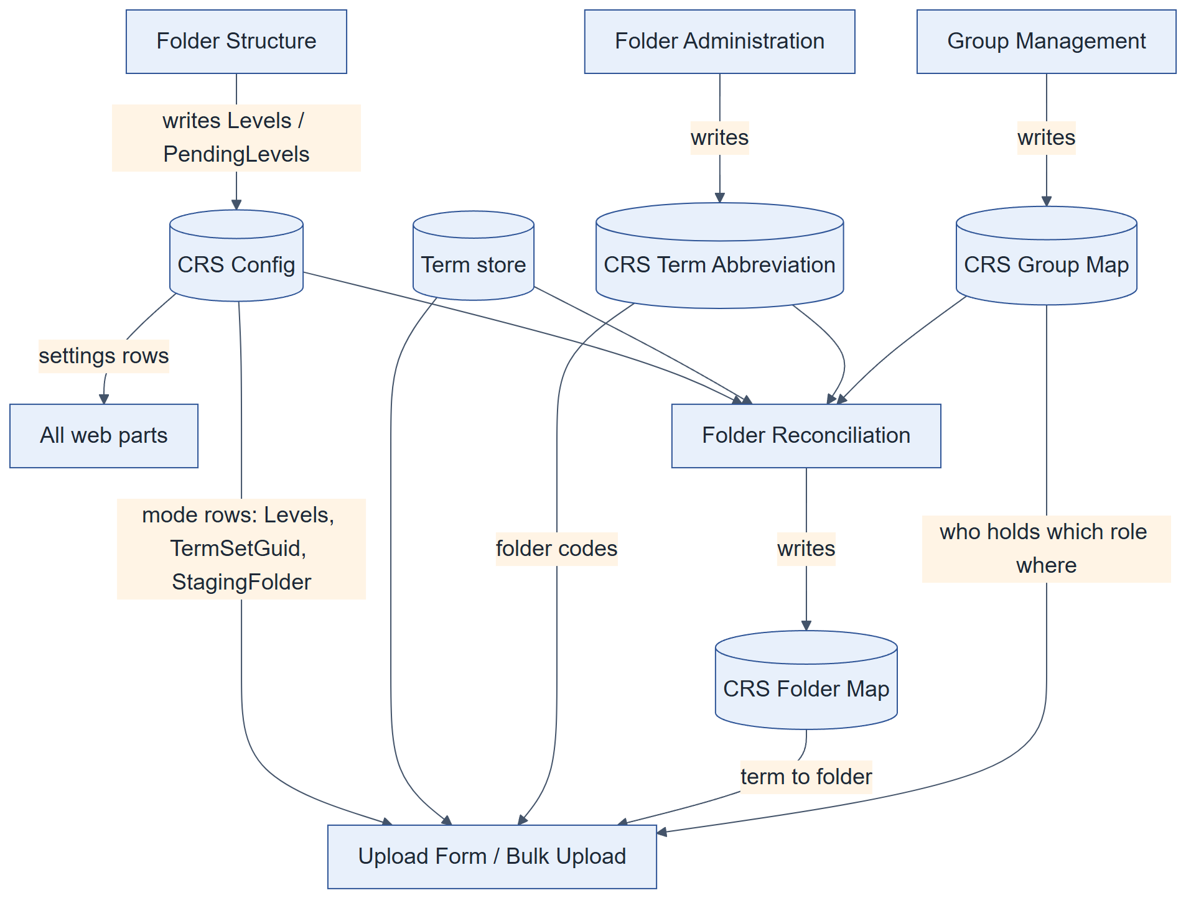
Figure 5. How the configuration lists drive the system

Settings rows (live values)
Table 25. CRS Config settings
Row (Title) | Value | Effect
termSet_documentType | fd973a45-3c34-483a-bfae-2a5b9dc5a556 | Term set for the Document Type picker.
termSet_yearPeriod | 3a262838-fbfe-4219-84e6-f3d1d6710163 | Term set for the Year picker.
termSet_confidentiality | 7901b1dd-a04b-4102-b1ce-dfe169e6248d | Term set for the Confidentiality Level picker.
hcConfidentialityLevel | Highly Confidential | Which confidentiality label means Highly Confidential. Without it every uploader sees the HC option.
legallyPrivilegedFor | Confidential;Highly Confidential | Confidentiality levels for which the form asks Legally Privileged (semicolon list).
tenantDomains | sdguthrie.com | Domains that count as internal for share requests. (Two identical rows exist; harmless, keep one.)
allowExternalSharing | no | Whether a share request may name an outside address.
uploadsPaused | no | yes pauses all uploads (set during a folder migration).
allowedExtensions | .xls .xlsx .jpg .pdf .jpeg .png | Allowed upload file types (AllowedFileTypes). Nothing ticked blocks every upload, on purpose.
tenantDomains | sdguthrie.com | Domains that count as internal for share requests. (Two identical rows exist; harmless, keep one.)
autoApproveOwnUpload | yes | A Head of Unit's own upload approves itself after a live ApproveItems probe.
noApprovalEmailFor | crs@sdguthrie.com | Not read by the code or by any exported flow at handover (legacy row).
bulkUploadRestricted | no | Not read by the code or by any exported flow at handover (legacy row).

recon_departmentFanOut has no row on the live site; absent means on, which it must stay (department-level grants reach every unit folder below).

Mode rows: one per business segment
Table 26. CRS Config mode rows
Row | Segment | Top folder | Term set | Levels (* = permissioned)
mode_group_head_office | Group Head Office | GHO | 271fa0cd-a1a8-4b13-9622-27b24038aa76 | Department * › Unit * › Year › Document Type
mode_minamas_head_office | Minamas Head Office | MHO | d16dfefb-c542-48ae-906f-89c4f1982b9b | Department * › Unit * › Year › Document Type
mode_nbpol_head_office | NBPOL Head Office | NBPOLHO | 21ee6b63-8601-4b0b-a470-0d68d35f112a | Department * › Unit * › Year › Document Type

Levels is a JSON array, one object per folder level below the segment, in order:
[{"label":"Department","column":"Department","labelCol":"Department","tidCol":"DepartmentTid","permissioned":true},
{"label":"Unit","column":"Unit","labelCol":"Unit","tidCol":"UnitTid","permissioned":true},
{"label":"Year","column":"Year","labelCol":"Year","termSet":"<Year term set>","permissioned":false},
{"label":"Document Type","column":"DocumentType","labelCol":"Document_x0020_Type",
"termSet":"<Document Type term set>","permissioned":false}]

- Exactly two levels are permissioned. Year and Document Type are fixed and come from their own term sets.
- labelCol / tidCol are the document columns that receive the label and term GUID.
- A missing permissioned key on the first two levels means permissioned (the MHO and NBPOLHO rows).
- A structure change on a segment that already holds documents is written to PendingLevels and applied by the migration (6.8).

4.7 Term store
Terms live in the site collection's own term group, managed at /sites/CRS/_layouts/15/termstoremanager.aspx (not the tenant admin centre). The code reads them through /_api/v2.1/termStore/sets/{id}/children.
Table 27. Term sets (live)
Term set | GUID | Terms | By depth | Used for
Document Type | fd973a45-3c34-483a-bfae-2a5b9dc5a556 | 23 | L1: 23 | Document Type column and folder level
Year | 3a262838-fbfe-4219-84e6-f3d1d6710163 | 2 | L1: 2 | Year column and folder level
Confidentiality Level | 7901b1dd-a04b-4102-b1ce-dfe169e6248d | 3 | L1: 3 | Confidentiality column; decides HC routing
Group Head Office | 271fa0cd-a1a8-4b13-9622-27b24038aa76 | 71 | L1: 8, L2: 63 | Segment folder tree: level 1 = departments, level 2 = units
Minamas Head Office | d16dfefb-c542-48ae-906f-89c4f1982b9b | 69 | L1: 20, L2: 49 | Segment folder tree: level 1 = departments, level 2 = units
NBPOL Head Office | 21ee6b63-8601-4b0b-a470-0d68d35f112a | 33 | L1: 12, L2: 20, L3: 1 | Segment folder tree: level 1 = departments, level 2 = units

- Segment term sets: level 1 = departments (40 across the three segments), level 2 = units (132). One NBPOL term sits at level 3.
- Folder names come from CRS Term Abbreviation, keyed by term GUID, not from labels.
- Rename terms; never delete and re-create them. A new term gets a new GUID and orphans its Term Abbreviation, Folder Map and Group Map rows, and every document tagged with it.
- Some stored labels on this tenant are corrupted (show a number). Always compare by GUID.
- The tenant's Image Tags term set (1871 terms) belongs to SharePoint's image tagging and is not used by CRS.

4.8 Folder model
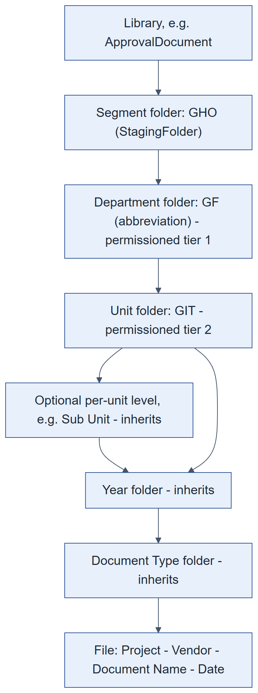
Figure 6. Folder tree and where permissions break
- Path: <Library>/<Segment>/<Department>/<Unit>/[Sub Unit]/<Year>/<Document Type>/<file>.
- Segment folder name = the mode row's StagingFolder. Department and unit folder names = abbreviations.
- Permissions are broken at the permissioned folders (segment, department, unit). Everything below inherits from the unit.
- The same tree exists in all six libraries. CRS Folder Map records the approval-library folders (172 rows at capture: GHO 71, MHO 69, NBPOLHO 32).
- File name = [Project] - [Vendor] - [Document Name] - [Date]; blank optional parts are dropped.
- Below-Unit folders are created on demand by the upload form and by Auto-route.

4.9 Record lifecycles

Document
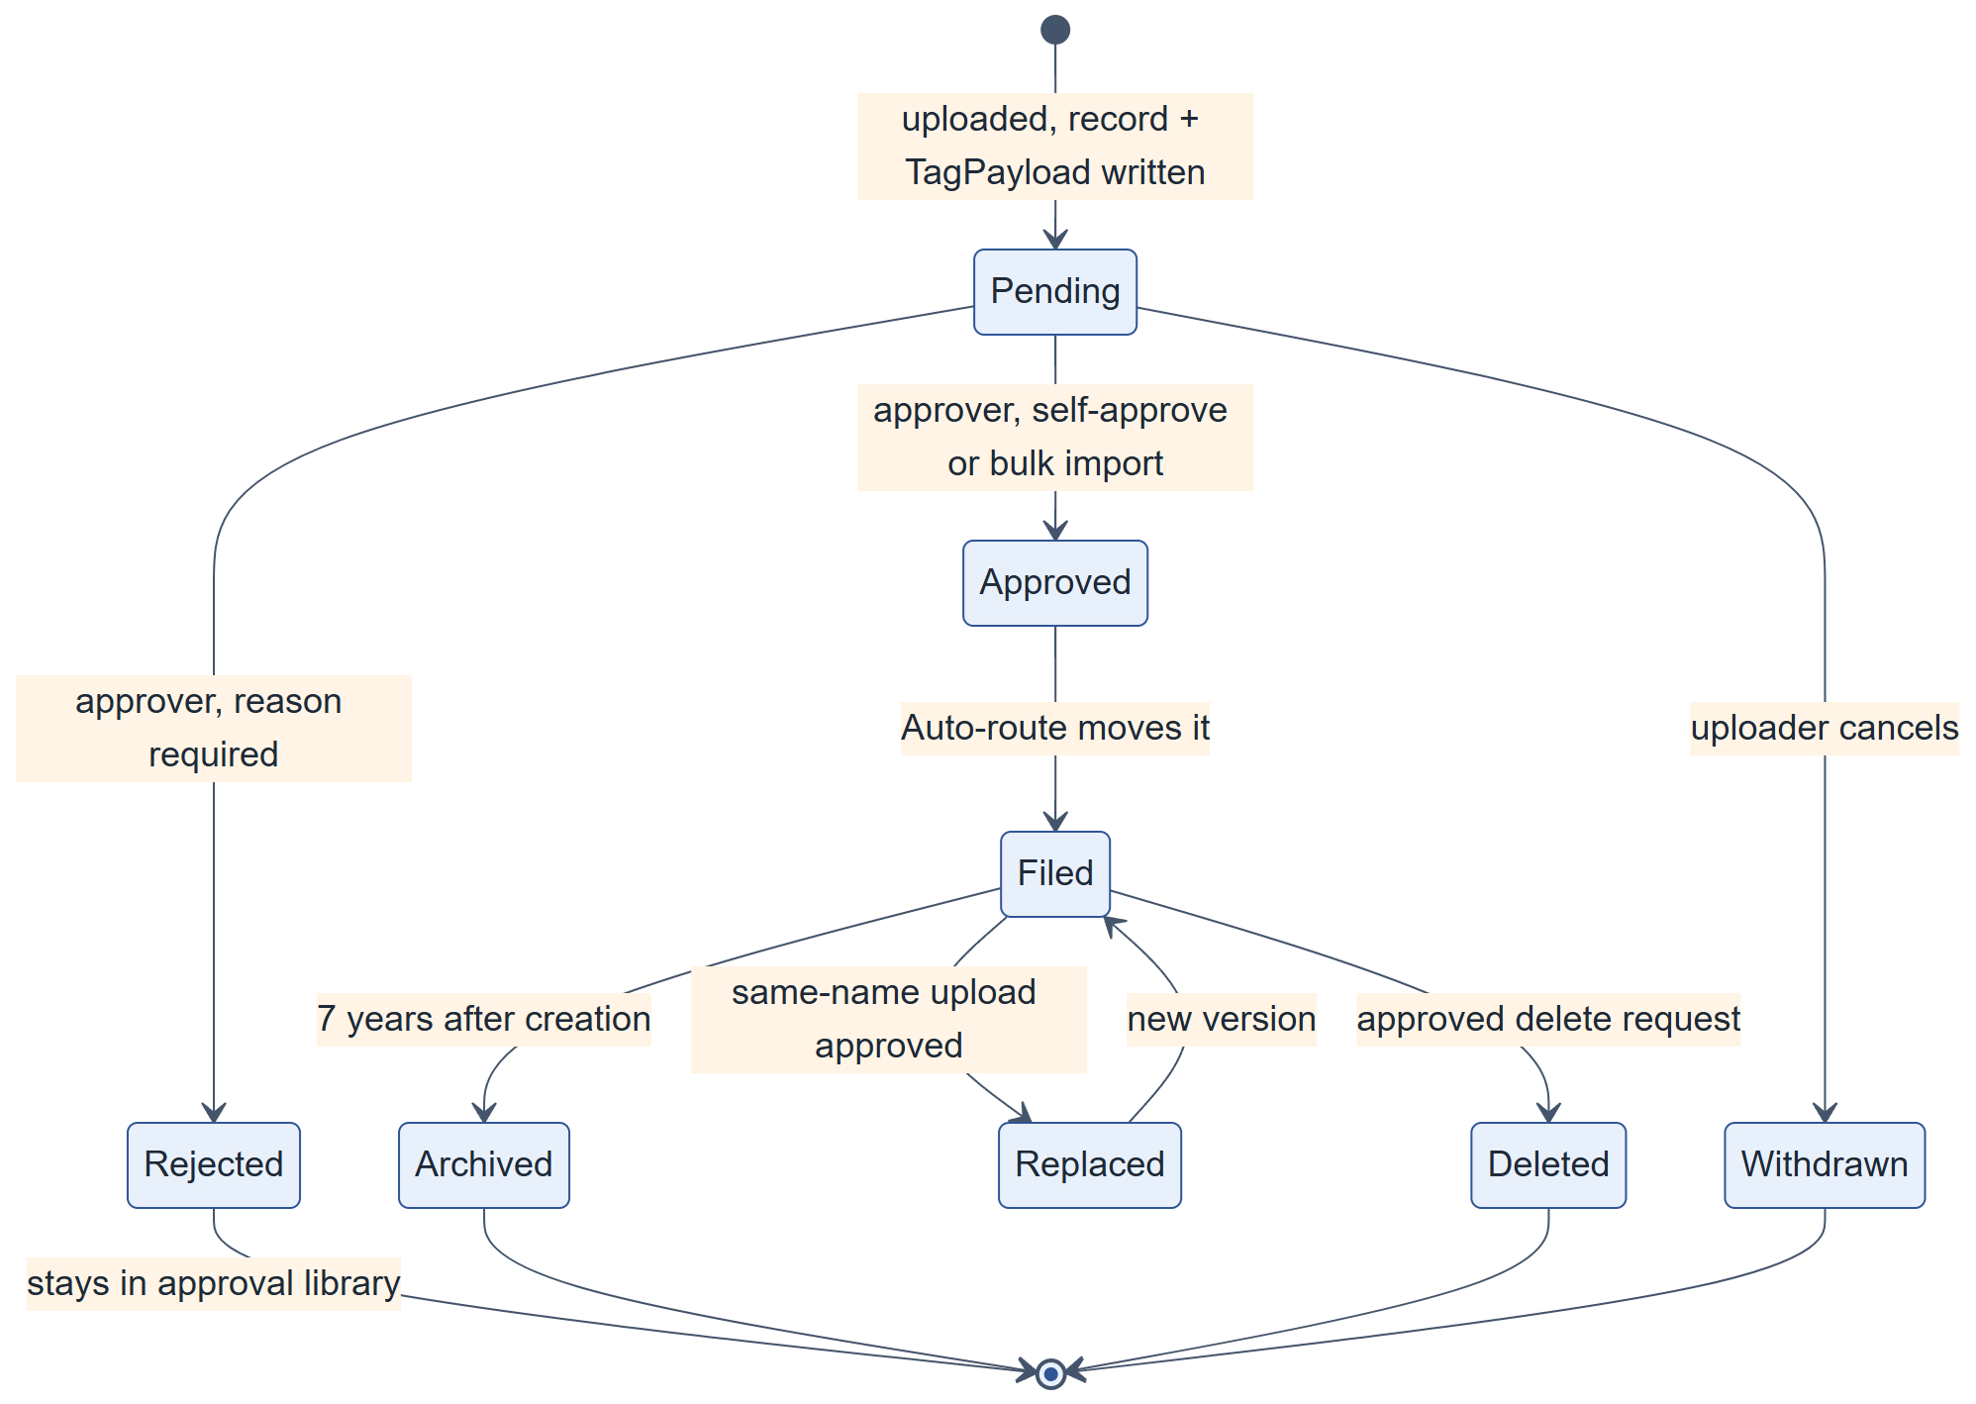
Figure 7. Document lifecycle

Tagging (CRS Submissions.TagStatus)
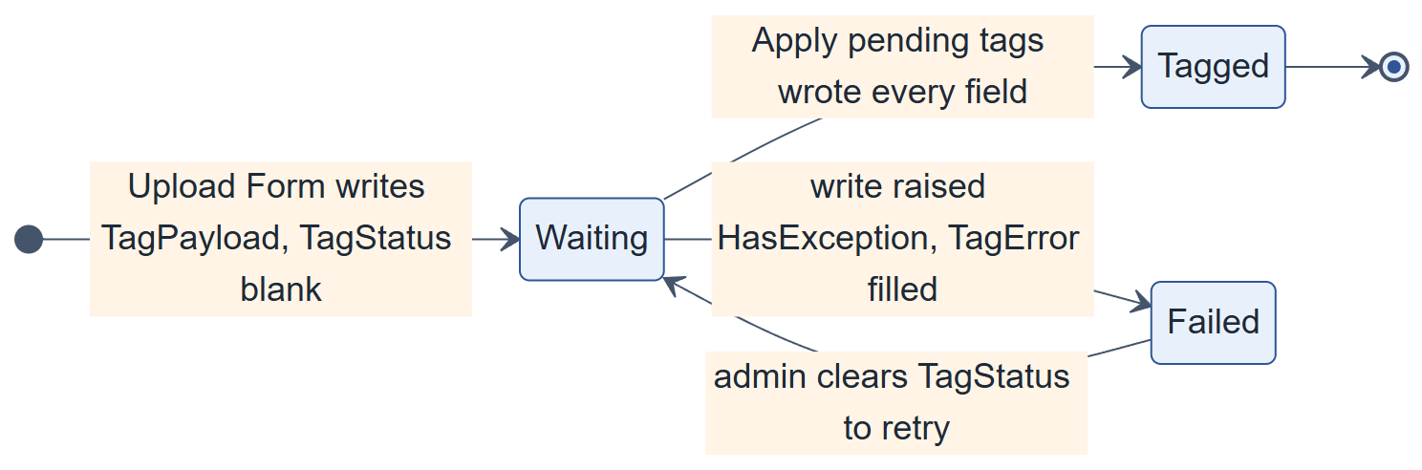
Figure 8. Tagging status

Request (CRS Requests.Status)
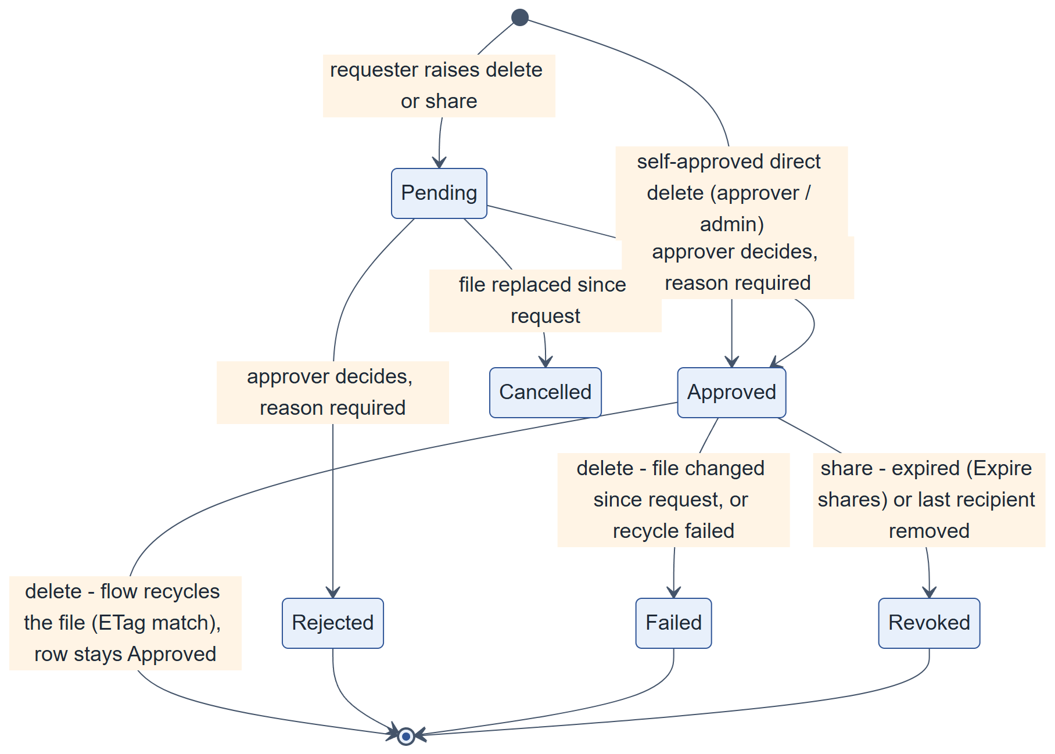
Figure 9. Request lifecycle

Submission record state shown on My Submissions
Table 28. Record states (precedence: live > withdrawn > cancelled > archived > deleted/unknown)
State | Meaning | Shown as
live | The file was found in a library (status read live). | Pending / Approved / Rejected
withdrawn | WithdrawnAt set: the uploader cancelled a pending file. | Cancelled
cancelled | ReplacedAt set: a newer upload replaced it. | Replaced
archived | ArchivedAt set, or found in an archive library. | Archived
deleted | Not found, and the library read was complete. | Deleted
settling | Just uploaded; the join is not expected yet. | Pending
unknown | A library read failed; nothing is concluded. | Unknown

4.10 Audit events
CRS Audit Log.EventType is free text, but every value must be one of the codes below (EVENT in src/shared/auditLog.ts). A new code must also be added to EVENT_LABEL and ALL_EVENT_TYPES, or the viewer cannot filter it.
Table 29. Audit event codes
Group | Event codes
Document | Uploaded, Approved, Rejected, Cancelled, Routed, Deleted, Archived, Replaced, UploadRefused
Sharing and access | ShareRevoked, AccessGranted, AccessRevoked
Requests | DeletionRequested, ShareRequested, RequestApproved, RequestRejected
Administration | ReconciliationRun, StructureChanged, MigrationRun, SegmentCreated, SegmentDeleted, SegmentRecoded, AbbreviationChanged, PolicyChanged, GroupMapChanged, GroupCreated, GroupDeleted, MembersChanged

- writeAudit() never throws and never blocks the action it records.
- Uploaded and Rejected rows come from the Audit approval activity flows; Approved and Routed from Auto-route; Deleted from the deletion flows; request events from Audit request activity. The Requests page writes no audit row on decide, to avoid duplicates.
- The viewer counts rows by walking ids; ItemCount is cached and wrong.

4.11 Volumes and limits
Table 30. Volumes and limits
Item | At capture | Limit or note
SharePoint groups | 840 | Site collection limit 10,000. About 6 groups per unit, 1 per department, 1 per segment.
CRS Group Map rows | 1708 | One row per group per role. Read with paging.
Units / departments / segments | 132 / 40 / 3 | From CRS Term Abbreviation and the mode rows
Role assignments on the web | 845 | Mostly Limited Access created by folder grants
Files per upload set | 20 | MAX_FILES_PER_BATCH; Bulk Upload allows 50
List view threshold | 5,000 | Filter on indexed columns. The Audit Log is the list that will reach it.
$top reads | — | A capped read cannot prove absence. Filter server-side or page with nextLink / Id gt last.
/sitegroups | — | Returns no nextLink: page by Id gt <last>.

5. Security design

5.1 Identity and authentication
- Everyone signs in with their SD Guthrie Entra ID account. CRS has no login of its own.
- SPFx web parts call SharePoint with the signed-in user's token through SPHttpClient. The package requests no API permissions and uses no app-only identity, so the code can never do more than the user could do in SharePoint itself.
- Power Automate flows run under the connections of the service account gdc@sdguthrie.com (GDC Proxy - SharePoint, GDC Proxy - Outlook). When gdc's password changes the connections must be re-authenticated (Appendix D.2).
- A new group member must sign out and in again before an open session sees the new access.

5.2 Authorisation model
Access is plain SharePoint permissions. CRS decides which SharePoint group gets which permission level on which folder; SharePoint enforces it everywhere (libraries, search, direct links, the REST API). The code adds no second security layer; it only hides actions the user cannot perform.
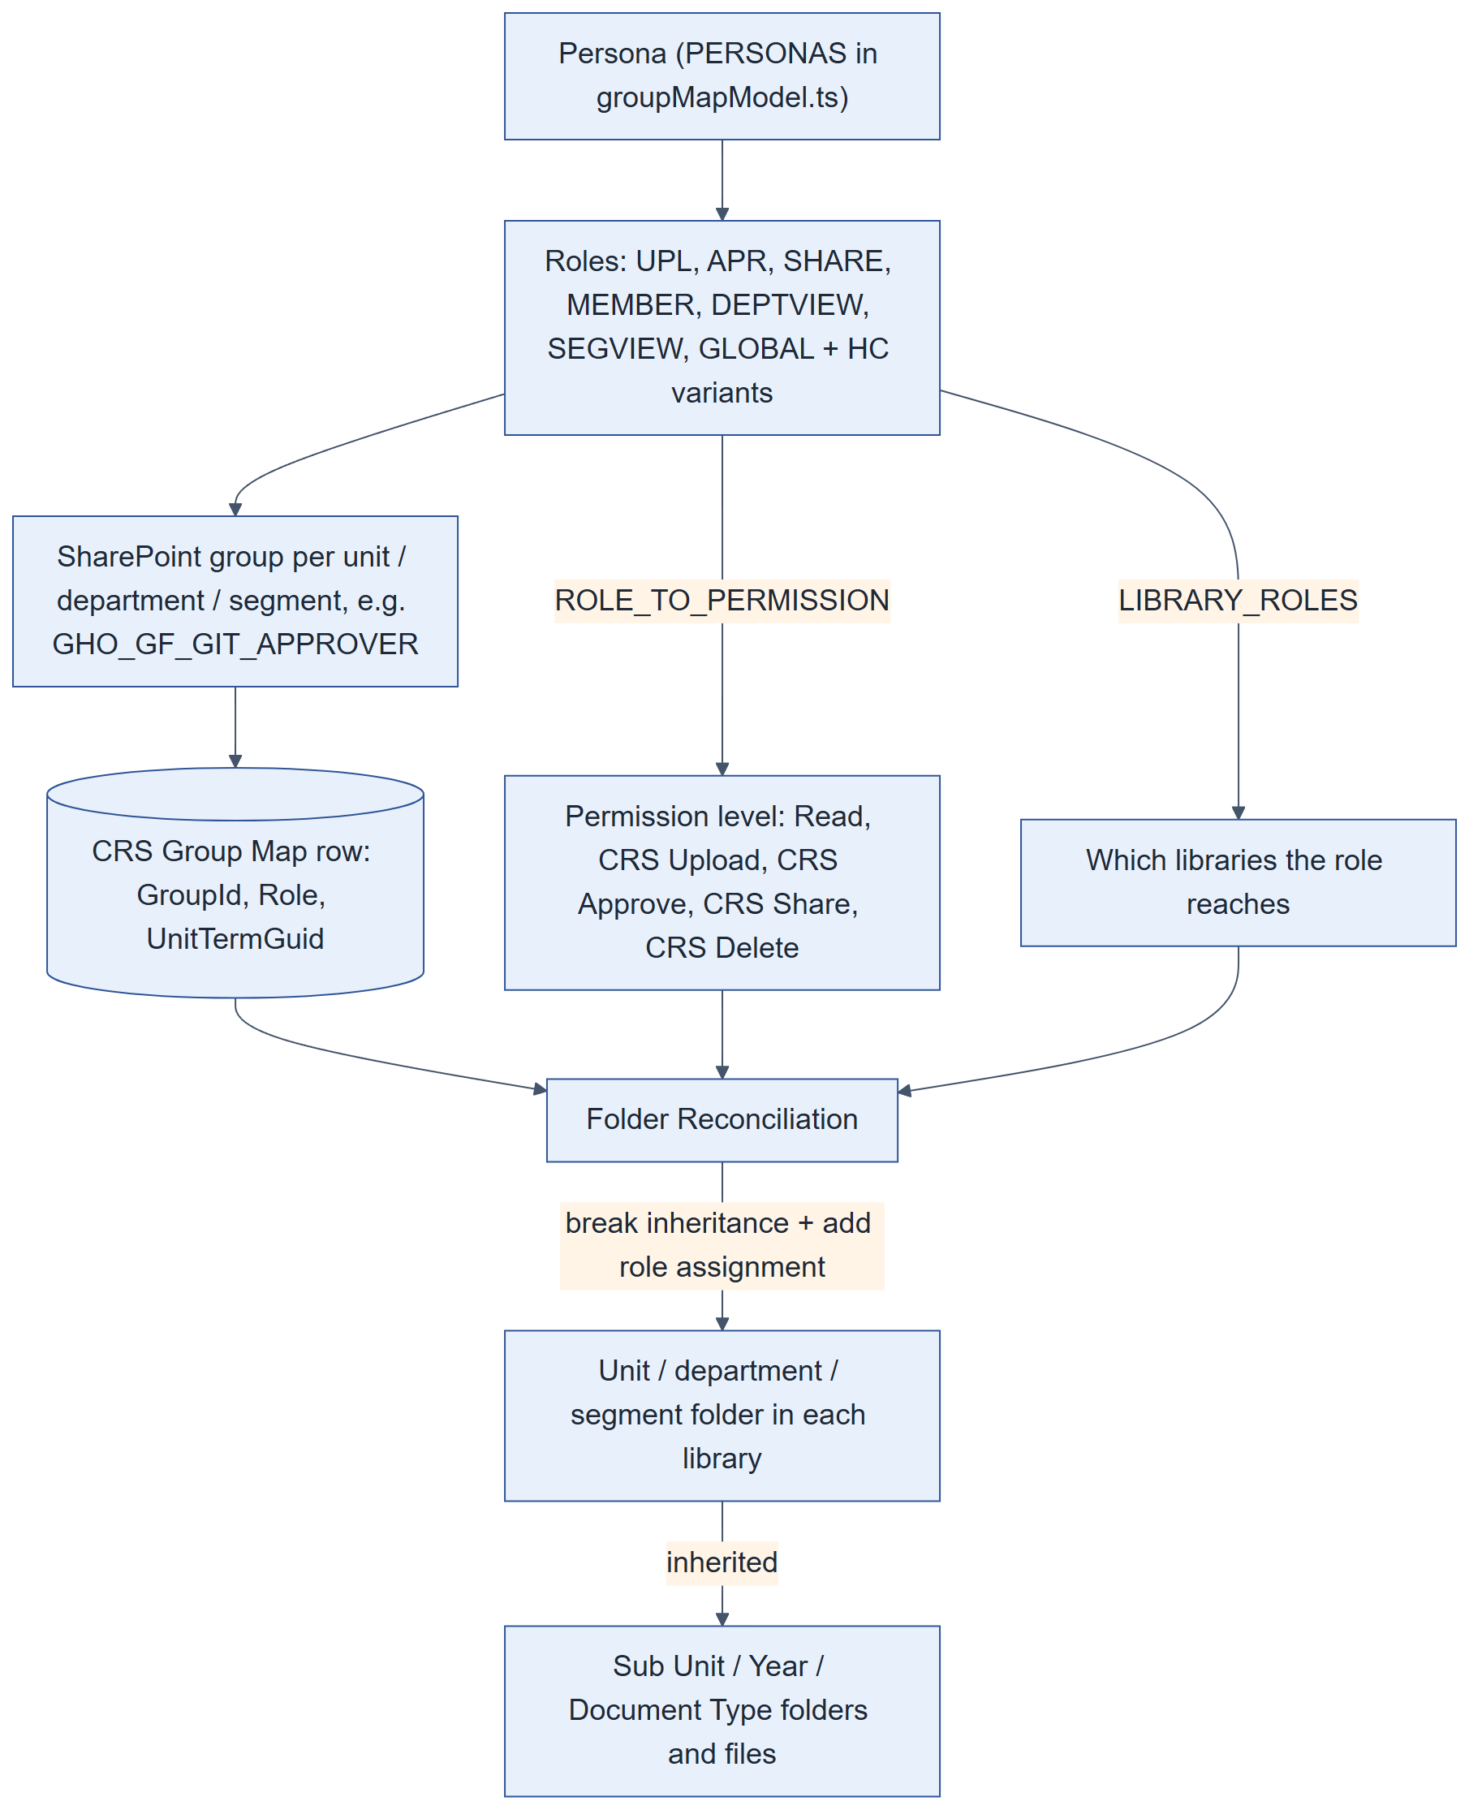
Figure 10. From persona to folder permission
- An admin creates groups with Group Management. Each group is created for one persona at one term (unit, department or segment) and gets one CRS Group Map row per role in the persona.
- Folder Reconciliation reads the Group Map and, for each row, grants the group the permission level for that role (ROLE_TO_PERMISSION) on the term's folder in each library the role reaches (LIBRARY_ROLES).
- Permissions are broken at the segment, department and unit folders. Everything below a unit inherits from it.
- SharePoint adds Limited Access on the parents automatically, which is why the web and library roots carry hundreds of Limited Access entries.

5.3 Personas and roles
PERSONAS in src/shared/groupMapModel.ts is the only list of personas. A persona is matched by its exact role set.
Table 31. Personas (PERSONAS)
Persona (key) | Scope | Roles | Group name suffix
PIC (pic) | Unit | UPL | _UPLOADER
PIC HC (pic_hc) | Unit | UPLHC | _UPLOADER_HIGHLY_CONFIDENTIAL
Head of Unit (hou) | Unit | APR, SHARE, UPL | _APPROVER
Head of Unit HC (hou_hc) | Unit | APRHC, SHARE, UPLHC, SHAREHC | _APPROVER_HIGHLY_CONFIDENTIAL
SDG Employee (employee) | Unit | MEMBER | _VIEWER
SDG Employee HC (employee_hc) | Unit | MEMBER, MEMBERHC | _VIEWER_HIGHLY_CONFIDENTIAL
Head of Department (hod) | Department | DEPTVIEW, SHARE, SHAREHC | _HOD
C-Level segment (clevel_segment) | Segment | SEGVIEW | _C_LEVEL
C-Level global (clevel_global) | All segments | GLOBAL | C_LEVEL_GLOBAL

Group names are built from the folder codes, e.g. GHO_GCA_EG_APPROVER = segment GHO, department GCA, unit EG, Head of Unit. Live counts at capture:
Table 32. SharePoint groups by pattern (840 in total)
Group pattern | Count
Site default groups (Owners, Members, Visitors) | 3
_SITE_MEMBERS | 1
C_LEVEL_GLOBAL | 1
_C_LEVEL | 3
_HOD | 40
_APPROVER | 132
_APPROVER_HIGHLY_CONFIDENTIAL | 132
_UPLOADER | 132
_UPLOADER_HIGHLY_CONFIDENTIAL | 132
_VIEWER_HIGHLY_CONFIDENTIAL | 132
_VIEWER | 132

Table 33. CRS Group Map rows by role
Role | Group Map rows
GLOBAL | 1
SEGVIEW | 3
DEPTVIEW | 40
SHARE | 304
SHAREHC | 172
APR | 132
UPL | 264
APRHC | 132
UPLHC | 264
MEMBER | 264
MEMBERHC | 132

5.4 Roles, permission levels and libraries
The level each role gets in each library (permissionForRole in FolderManager.tsx). On the approved libraries the upload and approve roles are reduced to Read; on the archives every role is Read.
Table 34. Role × library permission matrix
Role | Approval | Documents | HC approval | HC documents | Archive | HC archive
UPL | CRS Upload | Read | — | — | — | —
APR | CRS Approve | Read | — | — | — | —
UPLHC | CRS Upload | Read | CRS Upload | Read | — | —
APRHC | CRS Approve | Read | CRS Approve | Read | — | —
SHARE | — | CRS Share | — | — | — | —
SHAREHC | — | — | — | CRS Share | — | —
MEMBER | — | Read | — | — | — | —
MEMBERHC | — | — | — | Read | — | —
DEPTVIEW | — | Read | — | Read | — | —
SEGVIEW | — | Read | — | Read | Read | Read
GLOBAL | — | Read | — | Read | Read | Read

- The grant is placed on the folder of the Group Map row's term: a unit folder for unit personas, the department folder for Head of Department (with recon_departmentFanOut it also reaches every unit below), the segment folder for SEGVIEW, and every segment for GLOBAL.
- System administrators need no row: Guthrie Document Centre Owners holds Full Control on the web and on every library.
- The delete roles (DEL, DELS, DELHC, DELSHC → CRS Delete) are no longer in any persona. Every delete is done by the service account (5.7).
- Pending and rejected drafts in the approval libraries are visible only to their author and approvers (Draft Item Security = author + approvers).

5.5 Permission levels
Table 35. Permission levels on the site (live)
Level | Kind | Purpose
Full Control | Built-in | Has full control.
Design | Built-in | Can view, add, update, delete, approve, and customize.
Edit | Built-in | Can add, edit and delete lists; can view, add, update and delete list items and documents.
Contribute | Built-in | Can view, add, update, and delete list items and documents.
Read | Built-in | Can view pages and list items and download documents.
CRS Upload | Custom | Uploaders. View and add items and folders; no Edit Items and no Delete Items (metadata is written by gdc).
CRS Approve | Custom | Approvers. View, Edit Items and Approve Items, without Add Items. Approve Items needs Edit Items in SharePoint.
CRS Delete | Custom | Read plus Delete Items. No persona holds a delete role since 17 Sep 2026; kept for history.
CRS Share | Custom | Sharers. Read plus Manage Permissions on their unit folder, used by the Requests page to grant access.
CRS Request | Custom | Granted on CRS Requests and CRS Submissions to every role group, so users can raise and track requests and records.

The exact base permissions of the custom levels are set on the site (Site settings › Site permissions › Permission levels). Check them there before changing a role mapping; the descriptions above give their design intent.

5.6 Where permissions are applied (live)
Table 36. Library roots
Library | Role assignments | Explicit grants other than Limited Access
Approval for Document | 531 | Guthrie Document Centre Owners (Full Control)
Restricted & Confidential Document | 842 | Guthrie Document Centre Owners (Full Control)
Approval for Highly Confidential Document | 267 | Guthrie Document Centre Owners (Full Control)
Highly Confidential Document | 443 | Guthrie Document Centre Owners (Full Control)
Archive Restricted & Confidential Document | 8 | Guthrie Document Centre Owners (Full Control)
Archive Highly Confidential Document | 7 | Guthrie Document Centre Owners (Full Control)

Table 37. Lists with unique permissions
List | Role assignments | Levels granted
CRS Requests | 571 | Full Control × 1, Read × 1, Edit × 1, CRS Request × 568
CRS Submissions | 571 | Full Control × 1, Read × 1, Edit × 1, CRS Request × 568
Site Pages | 841 | Full Control × 1, Limited Access × 839, Read × 2, Edit × 1
Site Assets | 5 | Full Control × 1, Limited Access × 3, Read × 2, Edit × 1

Table 38. Site-level group grants other than Limited Access
Group on the web | Levels
Guthrie Document Centre Owners | Full Control, Limited Access, Web-Only Limited Access
Guthrie Document Centre Visitors | Read
Guthrie Document Centre Members | Edit
GDC_SITE_MEMBERS | Read, Limited Access

- GDC_SITE_MEMBERS is the site-entry group: Read on Site Pages and Site Assets so every CRS user can open the pages. Folder grants alone only reach a folder by direct link; the site root would still deny.
- Guthrie Document Centre Members holds Edit on the web and on the request lists, and Visitors holds Read. Keep their membership to administrators: anyone added there bypasses the folder model.
- Admin pages (file names matching folder|group.?manag|config|setting|mapping|admin|access|audit) are locked to Owners by reconciliation. Uploader pages (Upload Form, Bulk Upload, My Submissions) are granted to the UPL, UPLHC, APR and APRHC groups (pageAccessPolicy.ts, pageGrants.ts).

5.7 Service account and proxy actions
Table 39. Proxy actions
Action | Why the user cannot do it | Who does it
Write metadata on an upload | Uploaders hold CRS Upload, which has no Edit Items | CRS — Apply pending tags, from TagPayload
Move an approved file to Documents | Users have Read on the approved library | Auto-route flows
Delete a file | Nobody holds Delete Items | CRS — Execute approved deletion, from an Approved request row
Approve a bulk import | Historical files need no human approval | CRS — Auto-approve bulk imports
Approve new folders | A pending folder is invisible to other uploaders | CRS — Approve new folders
Revoke an expired share | Time-based | CRS — Expire shares
Archive after 7 years | Users have no rights on the archives | Archive flows
Send every email | One sender identity | All email flows, as gdc

gdc must stay in the Owners group. Removing it on 23 Sep 2026 stopped tagging, notifications and routing at once. Group Management hides gdc from the administrators list so it cannot be removed by accident. crs@sdguthrie.com is an ordinary account.

5.8 Highly Confidential separation
- HC documents live in their own approval, approved and archive libraries. Ordinary uploaders hold no permission there.
- The upload form offers the HC confidentiality level only if a live write probe on the HC unit folder succeeds (useHcClearance); group membership alone is not enough. The HC unit folder is resolved, never created by the form.
- Without the hcConfidentialityLevel config row every uploader would see the HC option.
- HC writes fail closed: they never fall back to the normal library.
- Only Head of Unit HC (APRHC) approves HC documents. Plain approvers receive only normal-library notifications.
- Every HC flow is a copy of the normal one pointed at the HC libraries (8.4). A missed library reference acts on the wrong file, because item ids are per list.

5.9 Security rules for developers
- Never add role checks in Search: SharePoint security trimming is the control.
- A failed permission read is unknown, never "no access" and never "access". Destructive and security decisions fail closed; form conveniences fail open.
- Reconciliation only adds grants, and fails closed if it cannot read the permission levels or the Owners group id.
- Deleting a CRS Group Map row revokes nothing. To take a role away: export members, delete the group, re-create it, re-add members, reconcile.
- SharePoint's native Approve/Reject and Share skip every CRS guard and are hidden by the hideAppBar extension. Keep it registered.
- Never hardcode a list or library title; a wrong title fails silently.

6. Component design
One section per component: what it does, what it reads and writes, how it works, and the rules that are deliberate and must not change without review. The large files are best searched by function name rather than read whole.

6.1 Upload Form
Item | Detail
Purpose | Main way documents enter CRS. The uploader picks a destination, fills one batch (set) of up to 20 files, and presses Upload.
Page / entry | Upload-Form.aspx (web part form)
Users | UPL, UPLHC, APR, APRHC groups; admins
Reads | CRS Config (mode rows, settings), term store, CRS Term Abbreviation, CRS Folder Map, CRS Group Map, approval and approved libraries (name clash)
Writes | Approval library (folders, files), CRS Submissions (record + TagPayload), CRS Requests (proxy delete when replacing a pending draft), CRS Audit Log
Main files | src/webparts/form/components/Form.tsx (6.7k lines), formModel.ts, uploadBatches.ts, dmsFolderMap.ts, spSubmissionRecords.ts, clashProxyDeletion.ts, hcClearance.ts

Processing
- Segment › tiers › Year › Document Type come from the mode row's Levels and the term store. A path is offered only if the leaf has a Folder Map row and an AddListItems probe on it succeeds (admins see every path, labelled when not fully set up).
- Each file gets Project, Vendor, Document Name, Date, Confidentiality, Legally Privileged (when required) and Keyword. File name = [Project] - [Vendor] - [Document Name] - [Date] (composeUploadBase).
- On Upload: re-check the chain (stale tab) and uploadsPaused; create missing below-Unit folders; upload each file; write a CRS Submissions row with TagPayload. The tagging flow writes the metadata as gdc (7.1).
- Name clash: a Yes/No dialog. Yes replaces: a pending draft is recycled by proxy (self-approved request row); an approved file is replaced by Auto-route only once the new one is approved.
- Self-approve (autoApproveOwnUpload = yes): for a Head of Unit, after TagStatus = Tagged, writes ApprovedBy in its own MERGE, then sets the moderation status, provided a live ApproveItems probe passes.
- A successful batch is removed; a failed one stays, so pressing Upload again is a safe retry.

Rules that must not change without review
- Only one batch is editable at a time; its destination is snapshotted at save (leaf term id), never read live at upload.
- Max 20 files per batch (MAX_FILES_PER_BATCH).
- A choice with a single option is greyed out for non-admins (segment and permissioned levels, isLevelLocked).
- The form never calls validateUpdateListItem itself; tagging is by proxy.
- HC is offered only with clearance; the HC unit folder is never created by the form.
- Styles are a CSS template literal: a backtick inside a CSS comment ends it.

6.2 Bulk Upload
Item | Detail
Purpose | Upload of historical, already-approved documents. One destination, up to 50 files.
Page / entry | Bulk-Upload.aspx
Users | Uploaders and approvers
Reads | CRS Config, term store, CRS Group Map, approval and approved libraries (duplicates)
Writes | Approval library with BulkImport = true, CRS Submissions
Main files | src/webparts/bulkUpload/components/BulkUpload.tsx (4.8k lines), uploadBatches.ts

Processing
- Writes files into the approval library with BulkImport = true and the level values (buildLevelFormValues).
- CRS — Auto-approve bulk imports approves them; Auto-route files them. No approved email is sent.
- Duplicates are checked against both the approval and the approved library; the clash dialog is the same as the Upload Form's.

Rules that must not change without review
- BulkImport must stay visible on both approval libraries; a hidden column is missing from the flow trigger.
- Files are matched by the File object, never by index or name.
- HC writes go through writeSideSegment() and fail closed.
- My Submissions shows these as Approved By Guthrie Document Centre, on purpose.

6.3 Approval Document and the Approve or reject panel
Item | Detail
Purpose | The approver reviews one pending file (page) or many (command-bar panel) and approves or rejects.
Page / entry | Approval-Document.aspx ?itemId=N (&lib=hc for HC; &decision=approve|reject pre-ticks only). Panel: bulkApprove command set in the approval libraries.
Users | APR, APRHC groups; admins
Reads | Approval libraries, approved libraries (clash), CRS Config, permission probes
Writes | Approval library: ApprovedBy, ApprovalComment, moderation status and comment
Main files | src/webparts/approvalDocument/components/ApprovalDocument.tsx, src/shared/approvalGuards.ts, approvalDestination.ts, src/extensions/bulkApprove/components/BulkApprovePanel.tsx

Processing
- The approval panel shows only if the ApproveItems probe on the file says granted.
- Shared guards (approvalGuards.ts) check the decision is allowed: the destination unit is found by counting permissioned tiers from the top; documentsFileClash fails closed.
- Approve: MERGE ApprovedBy and ApprovalComment in one request, then set the moderation status in a second request. Reject: a reason is required.
- Prev / Next walk the pending queue (FSObjType eq 0, no folders). Auto-route does the rest (7.2).
- The panel handles a mixed selection per file and names each skipped file with its reason.

Rules that must not change without review
- Never set OData__ModerationStatus in the same MERGE as another field (HTTP 500).
- The panel and the page use the same guards; never copy them inline.
- The HC library's Name column formatting must carry &lib=hc (item ids are per list).
- React hooks stay above the early returns (the file returns early three times).

6.4 My Submissions and Document-Viewer
Item | Detail
Purpose | An uploader's own files across all six libraries, with history from CRS Submissions, and the place to raise delete and share requests.
Page / entry | My-Submissions.aspx; Document-Viewer.aspx ?file=<UniqueId> (same web part, viewer-only mode)
Users | Uploaders, approvers, admins
Reads | Six libraries (AuthorId eq me), CRS Submissions, CRS Requests, CRS Group Map, CRS Config, item permissions
Writes | CRS Requests (delete and share requests, self-approved direct deletes), CRS Submissions (withdrawn)
Main files | src/webparts/mySubmissions/components/MySubmissions.tsx (5.8k lines), mySubmissions.ts, submissionRecords.ts, requests.ts

Processing
- Tabs: All · Permission · Submissions · Pending · Approved · Rejected · Archive (a dropdown under 768 px, buttons from 768 px).
- Records are joined on the stamped SubmissionFileId, never UniqueId. Status is always read live from the libraries; the record adds history (record state precedence in 4.9).
- Rights for an action = the item's live permissions (probeFileRights) or the Group Map; either can say yes.
- A direct delete is a self-approved CRS Requests row; the deletion flow recycles the file.

Rules that must not change without review
- A row is shown as deleted only if the library read was complete.
- On Document-Viewer, direct Delete is shown to system admins only, and an approved file shows no Approved badge or Approved-by box (client decision, 28 Sep 2026).
- Reads use $select fallback ladders; every read is cache-busted.
- The deep link must keep ?file= in the URL (a refresh would go blank).

6.5 Requests
Item | Detail
Purpose | Approvers decide delete and share requests; the page also lists documents with shared access.
Page / entry | CRS-Request.aspx (?request=<Id> opens one request; ?file=<UniqueId> gives direct actions from a library row)
Users | Approvers (their units), Heads of Department (department shares), admins (all), requesters (their own)
Reads | CRS Requests, CRS Submissions, CRS Config, CRS Group Map, file ACLs
Writes | CRS Requests (decision), file permissions (SP.Web.ShareObject), the list and its columns if missing
Main files | src/webparts/requests/components/Requests.tsx (4.4k lines), requests.ts, directFileActions.ts, deletionGuard.ts

Processing
- Three accordions: Delete Requests · Share Requests · Documents with Shared Access. Closed on landing, one open at a time, pending count in each header.
- decide() re-reads the row and refuses if it is no longer Pending. A reason is required to approve and to reject.
- Delete: writes Approved and the resolved ItemUniqueId; the deletion flow recycles the file if its ETag still matches TargetETag.
- Share: SP.Web.ShareObject with sendEmail: false; the flow sends the custom invite.
- If the request's submission record has ReplacedAt, the request cancels instead of executing.

Rules that must not change without review
- Who sees what is inScope() in requests.ts and nowhere else.
- No audit row is written on decide (the flow writes it).
- Statuses are parsed through STATUS_SET.
- Shared-access state is read live (live / revoked / unknown); Limited Access does not count as access.

6.6 Search
Item | Detail
Purpose | Home-page search: free text plus filters (Document Type, Year, Confidentiality, Segment, tiers).
Page / entry | Home.aspx (GDC Search web part)
Users | Everyone
Reads | SharePoint Search (approved and archive libraries), a 24-hour REST top-up of those libraries, term store, CRS Config, CRS Group Map
Writes | Nothing
Main files | src/webparts/documentSearch/components/DocumentSearch.tsx, documentSearch.ts, throttleRetry.ts

Processing
- KQL query over Documents, HC Documents, Archive and HC Archive through /_api/search/query.
- A direct REST read of the last 24 hours adds files not yet crawled (deduplicated on UniqueId).
- Document Type, Year and Confidentiality are narrowed client-side by term GUID.

Rules that must not change without review
- Approval libraries are not searched (client decision).
- Security is SharePoint's trimming; never add role checks here.
- Search calls send odata-version: "" or they fail with 500.
- Stale results: re-index the library, and check the reindex flow.

6.7 Folder Administration and Folder Reconciliation
Item | Detail
Purpose | Guided admin flows (add segment, add department/unit, change structure, rename/re-code, retire, run reconciliation) and the reconciliation engine.
Page / entry | Folder-Administrator.aspx (admins only)
Users | System administrators
Reads | CRS Config, term store, CRS Term Abbreviation, CRS Group Map, CRS Folder Map, permission levels, groups, folders
Writes | Folders in all six libraries, folder permissions, CRS Folder Map, CRS Term Abbreviation, page and request-list permissions, CRS Audit Log
Main files | FolderAdmin.tsx, FolderManager.tsx (9k lines; runReconciliation, ROLE_TO_PERMISSION, LIBRARY_ROLES, permissionForRole), AbbreviationManager.tsx, src/shared/folderFlows.ts

Processing
- Next is gated only by blocksNext in folderFlows.ts; the step rail is forward-locked.
- Reconciliation (7.8) builds folders, writes Folder Map rows, breaks inheritance on permissioned folders, grants from the Group Map, locks admin pages and grants the request lists.
- Abbreviations are unique among siblings and checked while typing. Saving writes rows only; reconciliation renames the folders.

Rules that must not change without review
- Reconciliation only adds permissions, and fails closed if it cannot read the permission levels or the Owners group.
- A scoped run skips the orphan and prune passes.
- Values read inside runReconciliation must be resolved inside the run (stale closures).
- FolderManager.tsx is the most site-tested code: change it narrowly.

6.8 Folder Structure and Migration
Item | Detail
Purpose | Changes a segment's folder levels, migrates existing files, and creates, retires or re-codes segments.
Page / entry | Inside the Folder Administration guided flows
Users | System administrators
Reads | CRS Config mode rows, term store, libraries
Writes | CRS Config Levels / PendingLevels and uploadsPaused, library columns (new levels), folders and files (migration), mode and Group Map rows (segments)
Main files | src/webparts/userAccess/components/StructureManager.tsx, SubtreeMigrator.tsx, SegmentCreator.tsx, src/shared/folderChain.ts, subtreeMigration.ts

Processing
- Saving on a segment in use stages PendingLevels; saving an unchanged chain clears it.
- Migration needs uploads paused (re-read, fails closed). A value is chosen per library per unit; files move, folders are created, clashes get a rename.
- The new chain goes live only after a fresh scan finds nothing left to move.
- Retire removes the mode row, Group Map rows and abbreviation rows, and the folders if ticked. Re-code works on empty segments only.

Rules that must not change without review
- Exactly two permissioned levels per segment; Year and Document Type are fixed.
- A per-unit level sits only directly under Unit, one per segment; a nested term set is refused for a shared level.
- The migrator walks leaf folders only; a file on a non-leaf folder is invisible to it.

6.9 Group Management
Item | Detail
Purpose | Creates the per-unit groups and their Group Map rows in bulk, manages members, answers "what can this person reach", and shows the system administrators.
Page / entry | Group-Management.aspx
Users | System administrators
Reads | Site groups and members, CRS Group Map, CRS Term Abbreviation, CRS Folder Map, term store
Writes | Site groups (create, delete, members), CRS Group Map, Owners membership (and Site Collection Admin)
Main files | GroupManager.tsx, BulkGroupProvisioner.tsx, GroupMembersEditor.tsx, src/shared/groupMapModel.ts, bulkGroups.ts, spGroups.ts

Processing
- Bulk provisioning builds every group a segment needs (one per persona per unit, _HOD per department, _C_LEVEL per segment) and loops until a pass writes nothing (max 10 passes).
- Groups are matched by term GUID after the name, so a renamed abbreviation does not create duplicates.
- Members are read with keyset paging (Id gt last).
- Reconciliation must run afterwards: creating a group grants nothing by itself.

Rules that must not change without review
- PERSONAS is the only role list; a persona is matched by its exact role set.
- Deleting a group removes its access at once; deleting a Group Map row does not.
- A persona change affects new groups only; existing groups must be deleted and re-created.
- gdc is hidden from the administrators card. Removing an admin never demotes yourself or the last admin.

6.10 Settings, Configuration and Access pages
Item | Detail
Purpose | GDC Settings is a directory of admin pages; GDC Configuration edits allowed file types; Page Access shows page grants; Approval Library Access, Site Access and Folder Access are signposts kept for old links.
Page / entry | CRS-Settings.aspx, CRS-Configuration.aspx, Page-Access.aspx, Approval-Library-Access.aspx, Site-Access.aspx, Folder-Access.aspx
Users | System administrators
Reads | Site Pages, CRS Config, page permissions
Writes | CRS Config allowedExtensions row and the AllowedFileTypes choices (Configuration only)
Main files | CrsSettings.tsx, adminPages.ts, backToSettings.tsx, FileTypeSettings.tsx, allowedFileTypes.ts, PageAccess.tsx, pageAccessPolicy.ts, pageGrants.ts

Processing
- Settings links are resolved from Site Pages at run time: resolved, ambiguous (shortest name wins) or missing (row disabled, names the page to create).
- Removing a file type unticks it first, then removes the choice. A Choices MERGE needs odata-version: "".
- Page Access writes nothing; reconciliation sets every page grant.

Rules that must not change without review
- Nothing ticked in AllowedFileTypes blocks every upload, on purpose. A missing column falls back to a default list with an admin warning.
- The Back to CRS Settings band is added in each web part's render(), never inside a shared component.

6.11 Audit Log
Item | Detail
Purpose | Filters, reads and exports CRS Audit Log.
Page / entry | CRS-Audit-Log.aspx
Users | System administrators
Reads | CRS Audit Log
Writes | Creates the list if missing
Main files | src/webparts/auditLog/components/AuditLog.tsx, src/shared/auditLog.ts, spAuditLog.ts, displayName.ts

Processing
- Filters: date, action, person, keyword. The Who column shows the person, or Guthrie Document Centre for automated steps (resolveActorDisplay).
- Totals are counted by walking ids. The CSV export keeps the stored actor.

Rules that must not change without review
- EventType is Text, never Choice; every event a flow writes must be in EVENT, EVENT_LABEL and ALL_EVENT_TYPES.
- writeAudit never throws and never blocks.

6.12 Extensions
Item | Detail
Purpose | hideAppBar: adds + New Folder and hides SharePoint's native Upload, Approve/Reject and Share in CRS libraries. bulkApprove: the Approve or reject panel.
Page / entry | Every CRS library
Users | Everyone (hideAppBar); approvers (bulkApprove, shown only when the permission probe says granted)
Reads | Library permissions, CRS Config
Writes | Folders (+ New Folder); moderation fields (panel, as 6.3)
Main files | src/extensions/hideAppBar/HideAppBarApplicationCustomizer.ts, src/extensions/bulkApprove/BulkApproveCommandSet.ts, components/BulkApprovePanel.tsx, sharepoint/assets/elements.xml

Processing
- hideAppBar works only on libraries whose title is in CRS_LIBRARIES; elsewhere it switches itself off.
- bulkApprove sets cmd.visible inside the probe's promise, so one click is enough.

Rules that must not change without review
- Both were registered by hand in /_api/web/usercustomactions on this tenant (Appendix A.5). Two registrations load an extension twice.
- Add a renamed library title to CRS_LIBRARIES.
- uploadCommand is legacy and not registered.

7. Process design

7.1 Upload and tagging
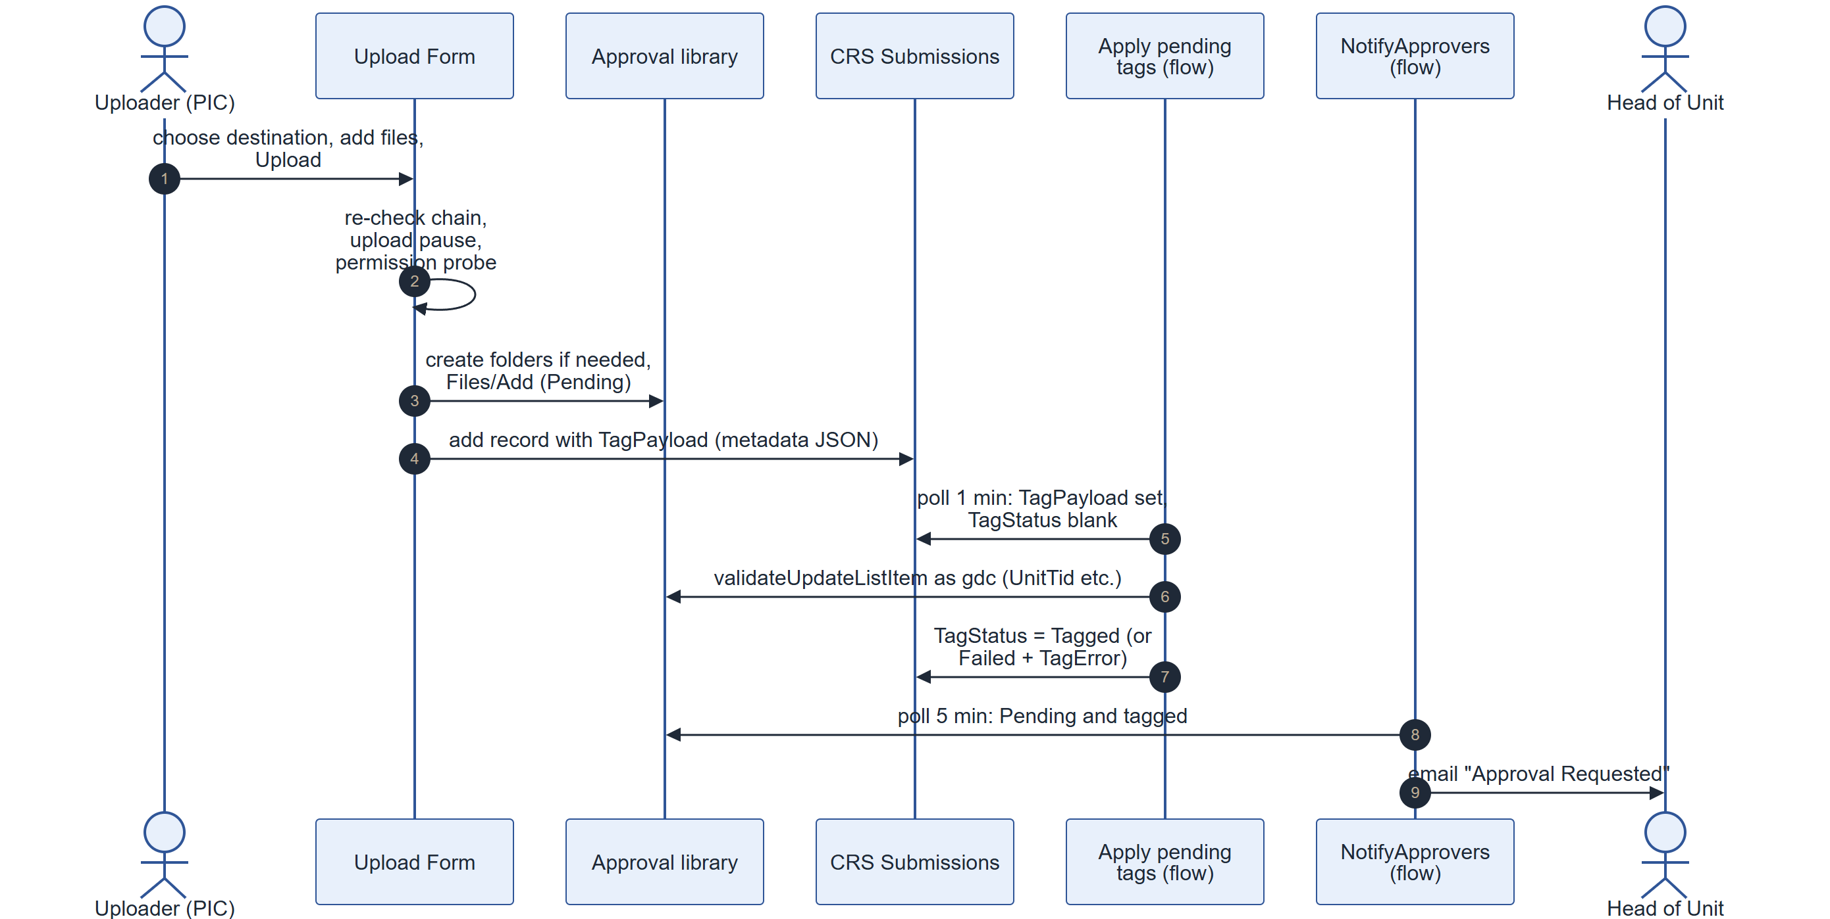
Figure 11. Upload, tagging and approver notification

- The file lands Pending in the approval library as the uploader; its metadata arrives up to a minute later when the tagging flow runs.
- If tagging fails, TagStatus = Failed and TagError says why. NotifyApprovers waits for UnitTid, so no approver email is sent until tagging succeeds.
- Self-approval waits for TagStatus = Tagged, then approves (6.1).

7.2 Approval and routing
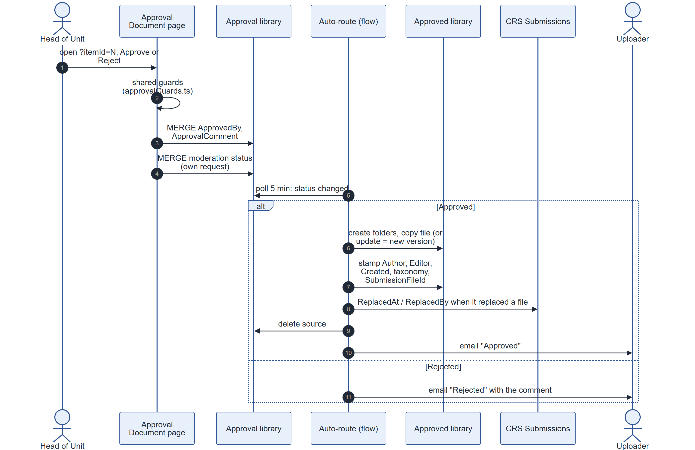
Figure 12. Approval and Auto-route

- Auto-route polls every 5 minutes, so an approved file appears in the approved library within about 5 minutes.
- If a same-named approved file exists, Auto-route updates it (a real new version) and stamps ReplacedAt / ReplacedBy on the old record.
- SharePoint's copy drops managed metadata, so Auto-route copies Document Type, Year and Confidentiality explicitly.
- The approved email is skipped for bulk imports, self-approvals and uploaders who are site owners.
- A rejected file stays in the approval library so the uploader can read the comment.

7.3 Bulk import
- Bulk Upload writes files to the approval library with BulkImport = true and the level values.
- CRS — Auto-approve bulk imports (polls every 5 min) sets the moderation status to Approved.
- Auto-route files them as in 7.2, without the approved email.

7.4 Approver notifications and reminders
Live on CRS at capture: NotifyApprovers (+ HC) sends one email per file, and the reminder flows email each approver per due file every 3 days. Built and tested on the test site, ready for CRS: the bundled approver email and the bundled reminder.
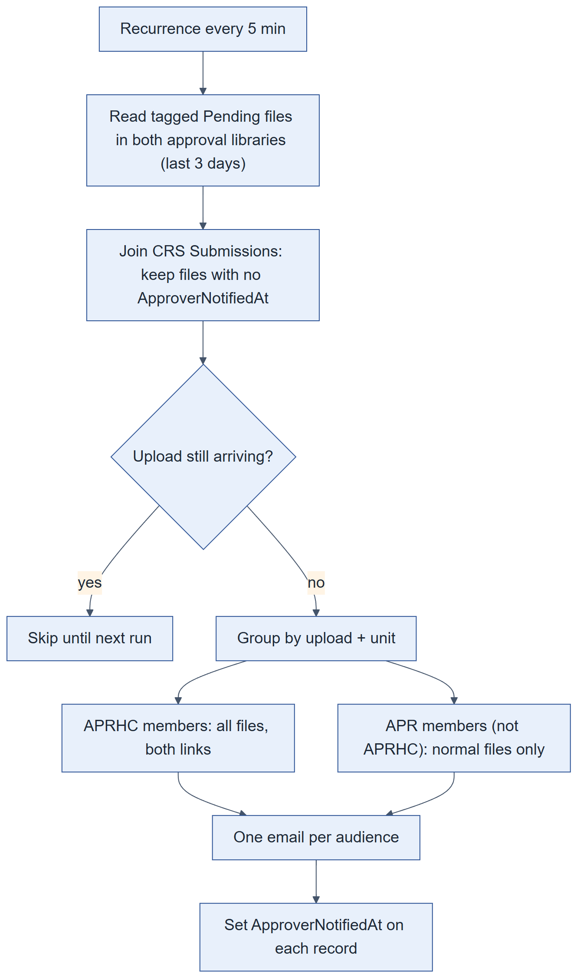
Figure 13. Bundled approver email (replaces the per-file email)
- Due rule for reminders: Pending, not a folder, not a bulk import, and NextReminderAt has passed (or is empty and the file is over 3 days old). After sending, NextReminderAt moves 3 days on.
- The bundled reminder reminds about every pending file of an upload once any of them is due, and resets all of them, so an upload never splits across reminders.
- Audiences: APRHC members get every file and both library links; plain APR members get only normal files. Reminders leave out the uploader, gdc and site admins; the first approval email includes site admins.

7.5 Delete request
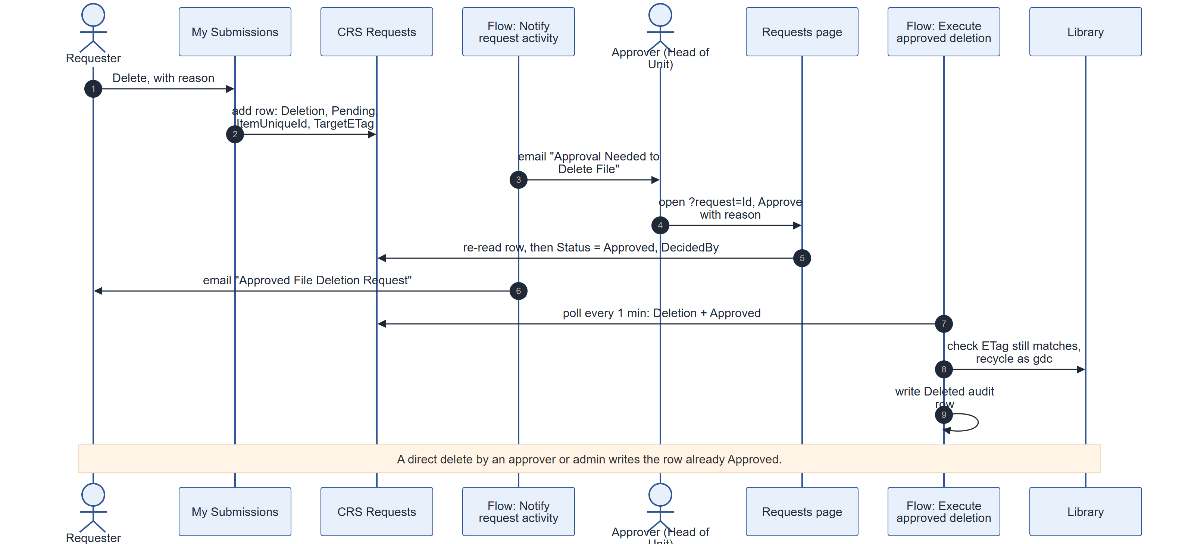
Figure 14. Delete request and proxy deletion

- TargetETag is stamped when the delete is decided. If the file changed since, the flow refuses and marks the request Failed with a note.
- When an uploader deletes their own pending draft (cancel), WithdrawnAt is set on the record and My Submissions shows Cancelled.

7.6 Share request and expiry
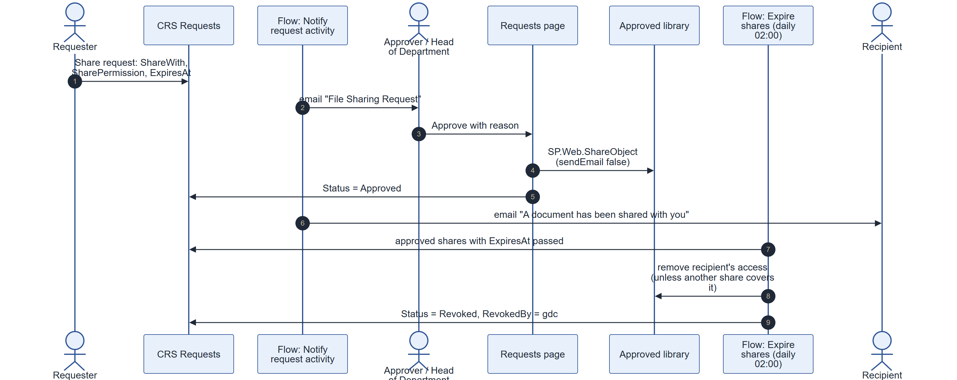
Figure 15. Share request, grant and expiry

- A blank ExpiresAt means the share is permanent and is never revoked by the flow.
- Revoked is written only when the last recipient's access goes; a partial revoke appends to DecisionNote.
- Outside addresses are allowed only when allowExternalSharing = yes; domains in tenantDomains count as internal. The tenant's mail-flow rule blocks email to outside addresses unless SD Guthrie IT adds an exception.

7.7 Seven-year archive
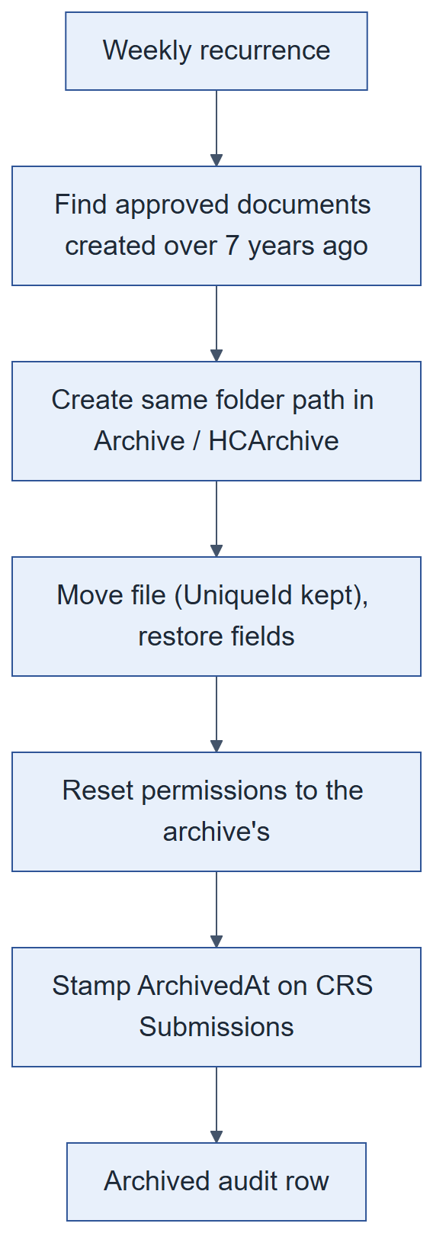
Figure 16. Archive after seven years (weekly, normal and HC flows)

7.8 Folder reconciliation
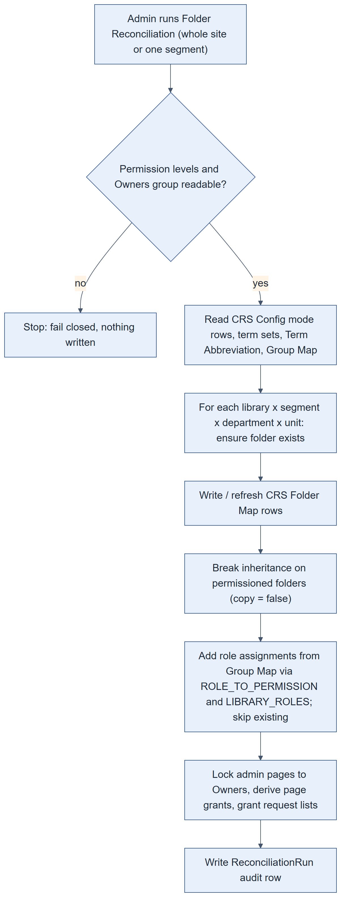
Figure 17. Folder Reconciliation
- Writes are paced (200 ms between writes, a cooldown every 300 writes) to avoid throttling. A full run can take tens of minutes on the live site.
- Grants that already exist are skipped, so a re-run is safe.

7.9 Adding a unit (end to end)
- Add the department and unit terms in the site term store (rename existing terms; never re-create them).
- Folder Administration › Add department/unit: set the abbreviations.
- Group Management › Bulk Provisioning for the segment: creates the unit's groups and Group Map rows.
- Add members to the groups.
- Folder Administration › Run reconciliation (scoped to the segment): creates the folders in all six libraries and grants the groups.
- Test with a non-admin uploader and approver.

8. Integration design: Power Automate
About half of CRS's behaviour lives in Power Automate, not in the code. The exports in PowerAutomateFlowsSDG/ (25 September 2026) are the source of truth: unzip one and read definition.json.

8.1 Environment and connections
Table 40. Power Automate environment
Item | Detail
Owner | gdc@sdguthrie.com ("Guthrie Document Centre"). Every flow runs as it.
Environment | SD Guthrie default environment, https://make.powerautomate.com. Sign in as gdc to see them under My flows.
Connections | GDC Proxy - SharePoint (every list and file step) and GDC Proxy - Outlook (every email). Both signed in with gdc's password.
Site | Every flow names https://sdguthrie.sharepoint.com/sites/CRS and CRS list GUIDs (8.6).
Run history | 28 days per flow; each step's inputs and outputs are visible (Show raw outputs).
Trigger latency | SharePoint triggers poll: 1 minute (tagging, deletion) or 5 minutes (others). A recurrence flow catches up on its next run; a trigger flow that is off misses changes made while it was off.

8.2 Flow inventory
Table 41. Flows (25 live, 2 ready to deploy)
Flow | Trigger | Purpose
Auto-route approved Pending files to Documents Library (+ HC Auto-route) | Approval library item created/modified, polls 5 min, files only | On approve: create folders, copy or update the file, stamp metadata and ids, mark replaced records, delete the source, audit, email the uploader. On reject: email the uploader with the comment.
CRS — Apply pending tags | CRS Submissions created/modified, polls 1 min; TagPayload set and TagStatus empty | Find the file by ItemUniqueId, write TagPayload with validateUpdateListItem as gdc, set TagStatus / TagError.
CRS — Auto-approve bulk imports (+ HC auto-approve) | Approval library item modified, polls 5 min; BulkImport and Pending | Set the moderation status to Approved.
CRS — Approve new folders (+ HC folder approval) | Approval library item created, polls 5 min; folders only | Approve the folder so other uploaders can see and navigate it.
NotifyApprovers (+ HCNotifyApprovers) | Approval library item created/modified, polls 5 min; Pending, not bulk | When UnitTid is set and NextReminderAt empty: find the unit's APR / APRHC group in CRS Group Map, email its members except the uploader. Bcc gdc.
CRS — Reminding Approver to Approve (+ CRS — HC approval reminder) | Recurrence, 30 min | Email each approver of each due file (max 10), then move NextReminderAt 3 days on.
CRS — Notify request activity | CRS Requests created/modified, polls 5 min | New request: email the approver group. Decision: email the requester. Approved share: email the recipient.
CRS — Execute approved deletion | CRS Requests modified, polls 1 min; Deletion + Approved | Check the file's ETag against TargetETag, recycle it as gdc, write a Deleted audit row; mark Failed with a note if it cannot.
CRS — Expire shares | Recurrence, daily 02:00 (Singapore time) | Remove expired recipients' access (unless another approved share covers them), set Revoked.
CRS — Archive after seven years (+ HC) | Recurrence, weekly | Move approved documents older than 7 years to the archive, restore fields, reset permissions, stamp ArchivedAt, audit.
CRS — Nightly library reindex | Recurrence, every 6 hours | Toggle NoCrawl on the approved and archive libraries so search re-crawls them.
Audit — approval activity (+ HC) | Approval library item created/modified, polls 5 min | Write Uploaded and Rejected audit rows, once per file and event.
Audit — approval deletions, Documents deletions (+ HC: four flows) | Item deleted, polls 5 min | Read the recycle bin for who and when; write a Deleted row (skips files Auto-route just moved).
CRS — Audit request activity | CRS Requests modified, polls 5 min | Write request events to the audit log, once each.
CRS — Audit replacements | CRS Submissions modified, polls 5 min; ReplacedAt set | Write Replaced events.
CRS — Notify approvers (bundled) · test site only | Recurrence, 5 min | One email per upload per unit per audience; sets ApproverNotifiedAt. Replaces NotifyApprovers. Built by scripts/build-bundled-approver-flow.py.
CRS — Remind approvers (bundled) · test site only | Recurrence, 30 min, one run at a time | Bundled reminders; replaces both reminder flows. Built by scripts/build-bundled-reminder-flow.py.

8.3 Which flows listen to which list
Writing a field re-triggers every "created or modified" flow on that list. Check this table before adding a write.
Table 42. Flow triggers by list
List or library | Event | Flows
Approval for Document / HC | Created or modified | Auto-route, Auto-approve bulk imports, NotifyApprovers, Audit approval activity (and their HC twins)
Approval for Document / HC | Created (folders) | Approve new folders (+ HC)
Approval for Document / HC | Deleted | Audit approval deletions (+ HC)
Documents / HC Documents | Deleted | Audit Documents deletions (+ HC)
CRS Submissions | Created or modified | Apply pending tags, Audit replacements
CRS Requests | Created or modified | Notify request activity, Execute approved deletion, Audit request activity
(schedule) | Recurrence | Reminders (30 min), Expire shares (daily), Archive (weekly), Reindex (6 h), bundled flows (5 / 30 min)

8.4 Data contract between code and flows
Renaming, deleting or hiding one of these columns breaks a flow silently.
Table 43. Columns the flows depend on
Where | Column | Used by (R = reads, W = writes)
Approval libraries | BulkImport | R: NotifyApprovers, Auto-approve bulk imports (trigger), reminders, Auto-route (email skip). Must stay visible.
Approval libraries | UnitTid | R: NotifyApprovers, reminders, bundled flows (approver group lookup).
Approval libraries | NextReminderAt | W: reminder flows. R: NotifyApprovers, bundled approver email, bundled reminder.
Approval libraries | ApprovedBy | R: Auto-route (approver name, self-approval check), Audit approval activity. Written by the app.
Approval libraries | OData__ModerationStatus, OData__ModerationComments | W: Auto-approve, Approve new folders. R: Auto-route (decision, rejection comment), NotifyApprovers.
Approval libraries | SubmissionId, BatchId, SubmissionFileId | R: Auto-route (copied to the approved file), bundled flows.
Approval libraries | Document_x0020_Type, Year, Confidentiality_x0020_Level | R: Auto-route (copied explicitly), emails.
Approved libraries | SubmissionFileId, Created | R: archive flows (7-year cut-off, ArchivedAt stamp), Auto-route (replacement).
CRS Submissions | TagPayload, TagStatus, TagError, ItemUniqueId | R/W: Apply pending tags.
CRS Submissions | ReplacedAt, ReplacedBy | W: Auto-route. R: Audit replacements.
CRS Submissions | ArchivedAt | W: archive flows.
CRS Submissions | ApproverNotifiedAt, SubmissionRef, UploadedAt | R/W: bundled approver email (column to be added on CRS).
CRS Requests | RequestType, Status, ItemUniqueId, RequestedBy, DecidedBy, ShareWith, ExpiresAt, TargetETag, UnitTermGuid, DecisionNote, RevokedBy | Notify request activity, Execute approved deletion, Expire shares, Audit request activity.
CRS Group Map | Role, UnitTermGuid, GroupId | R: NotifyApprovers, reminders, Notify request activity, bundled flows.
CRS Audit Log | Title, EventTime, EventType, Outcome, ActorName, ActorEmail, Source, LibraryName, ItemUniqueId, ItemName, ItemPath, Details, Segment, UnitPath | W: every audit flow, Auto-route, archive flows, Execute approved deletion.

8.5 Emails
All emails are sent as gdc through GDC Proxy - Outlook. Email to addresses outside SD Guthrie is blocked by the tenant's mail-flow rule; the bounce lands in gdc's inbox.
Table 44. Emails
Subject | Sent by | To | Bcc
Approval Requested: <file> | NotifyApprovers (+ HC) | Unit approvers (site admins included), not the uploader | gdc
REMINDER: Approval Required for <file> | Reminder flows | Each approver separately (max 10); not the uploader, site admins or gdc | —
Approved: <file> has been approved | Auto-route (+ HC) | Uploader (not for bulk imports, self-approvals or owner uploaders) | —
Rejected: <file> has been rejected | Auto-route (+ HC) | Uploader | —
Approval Needed to Delete File: <name> | Notify request activity | Unit approvers | gdc
File Sharing Request: <name> | Notify request activity | Unit approvers | gdc
Approved / Rejected File Deletion Request | Notify request activity | Requester (not if they decided it themselves) | —
Approved / Rejected File Sharing Request | Notify request activity | Requester (not if they decided it themselves) | —
A document has been shared with you: <name> | Notify request activity | The share recipients | —
Approval Requested: <file> / N documents | Bundled approver email (test site) | APRHC / APR audiences | gdc (client deciding)
REMINDER: Approval Required: <file> / N documents | Bundled reminder (test site) | Same audiences, minus site admins | As above

8.6 List GUIDs the flows use (CRS)
Table 45. CRS list GUIDs
List | GUID
Approval for Document | eeb1bb19-ec53-4c41-8dc9-ecf255979c9b
Approval for Highly Confidential Document | d935aa6d-dc48-4832-ba7e-eca485ecdff3
Restricted & Confidential Document | fbc062dd-fcd0-4458-9161-2bfc19c917fa
Highly Confidential Document | 122a4aa9-65fb-479a-90a7-3866d19f51b4
Archive Restricted & Confidential Document | 647fd644-ab00-4358-9b3f-49031083fcf0
Archive Highly Confidential Document | fc301054-abf5-4e53-957a-6f8c58a410b8
CRS Submissions | dd1bc5bd-daa7-491a-9dc7-b81212c391ab
CRS Requests | 1bcb1aa1-fbf1-4d1b-a6d2-88436824c297
CRS Audit Log | 4ac219e5-b855-46a3-be4b-4e96bba546c5
CRS Group Map | 5acf3f3e-d955-4a82-8a49-24db3a353514
CRS Config | 22e4f613-1693-407c-9f94-318088c51775

Some flow actions name lists by title instead (e.g. getbytitle('CRS Group Map')); those keep working on another site with the same titles. Item ids are per list.

9. Interface design

9.1 User interface map
Table 46. Pages and deep links
Page | Who | Deep-link parameters
Home.aspx (Search) | Everyone | —
Upload-Form.aspx | UPL, UPLHC, APR, APRHC | —
Bulk-Upload.aspx | UPL, UPLHC, APR, APRHC | —
My-Submissions.aspx | UPL, UPLHC, APR, APRHC | —
Document-Viewer.aspx | Anyone with access to the file | ?file=<UniqueId>
Approval-Document.aspx | Approvers | ?itemId=<id>, &lib=hc for HC, &decision=approve|reject (pre-tick only)
CRS-Request.aspx | Approvers, HoD, requesters, admins | ?request=<Id>, ?file=<UniqueId> (strip braces)
CRS-Settings.aspx and admin pages | Owners only | —
Library views | By permission | Name column formatting links to Approval-Document / Document-Viewer

- Debug a page against local code: ?debug=true&noredir=true&debugManifestsFile=https://localhost:4321/temp/build/manifests.js.
- Every admin page shows a Back to CRS Settings band.
- Layouts are phone-first; status tabs become a dropdown under 768 px.

9.2 SharePoint APIs used
Table 47. REST calls per component
Component | Lists | Main REST calls
Upload Form | Config, Group Map, Folder Map, Term Abbreviation, Submissions, Audit Log | /_api/v2.1/termStore/sets/{id}/children; GetFolderByServerRelativeUrl, folders/AddUsingPath; Files/Add; /items; EffectiveBasePermissions; approve()
Bulk Upload | Config, Group Map | Term store v2.1; Files/Add; validateUpdateListItem; currentuser
Approval Document | Approval libraries, Config | /items; approve(); MERGE OData__ModerationStatus; file lookups
Approve or reject panel | Approval libraries, Config | MERGE ApprovedBy, then MERGE OData__ModerationStatus (two requests)
My Submissions / Document-Viewer | Six libraries, Submissions, Requests, Group Map, Config | /items with $select ladders; currentuser
Requests | Requests, Config, Group Map, Audit Log | /items; list and column creation (/_api/web/lists, CreateFieldAsXml); role assignments; SP.Web.ShareObject
Search | Approved and archive libraries, Config, Group Map | /_api/search/query; term store v2.1; TaxonomyHiddenList
Folder Administration | Config, Group Map, Folder Map, Term Abbreviation, Submissions, Requests | Term store v2.1; folders/AddUsingPath; breakroleinheritance, roleassignments/addroleassignment; sitegroups; list and column creation
Group Management, access pages | Config, Group Map, Term Abbreviation, Folder Map | sitegroups (create, members, delete); ensureuser; role assignments; term store v2.1
GDC Settings / Configuration | Site Pages, Config | /items; field Choices MERGE
Audit Log | Audit Log | /items; list creation if missing

9.3 REST conventions
- One unknown column in $select, or one unknown field in a write, fails the whole call. Optional columns are read in fallback steps.
- validateUpdateListItem returns HTTP 200 even when a field fails: check HasException. Dates go as M/D/YYYY there, ISO in /items and $filter.
- Taxonomy values are Label|GUID. Compare terms by GUID.
- Yes/No in $filter is 1/0, not true/false.
- Deep paths use the alias form GetFolderByServerRelativeUrl(@f)?@f='…'.
- CAML needs internal names (FSObjType, _ModerationStatus); REST uses FileSystemObjectType, OData__ModerationStatus.
- FieldValuesAsText double-encodes underscores in keys (e.g. Department_x005f_x0020_x005f_Type).
- Search and Choices MERGE calls need the header odata-version: "".
- A read capped with $top cannot prove something is missing. Reads that decide an action are cache-busted.

10. Non-functional design
Table 48. Quality attributes
Quality | Design
Performance | Reads are filtered server-side on indexed columns; queues exclude folders; search uses the index plus a 24-hour top-up. Large admin runs are paced to avoid throttling.
Latency | Tagging up to 1 min; routing, approver email and audit up to 5 min; reminders every 30 min; archive weekly; search re-crawl every 6 h.
Scalability | About 6 groups per unit; 840 groups for 132 units, against a 10,000 limit. The 5,000-item list view threshold is handled by indexed filters and paging; the Audit Log is the list that will grow largest.
Reliability | Upload retries are safe (success removes, failure stays). Audit-writing flows are idempotent (once per file and event). The delete flow checks the ETag before acting.
Error handling | A failed read is unknown, never empty. Form gates fail open; destructive and security decisions fail closed. validateUpdateListItem results are checked for HasException. 429/503 are retried.
Auditability | Every upload, decision, routing, deletion, share, archive and admin change writes a CRS Audit Log row. Writing an audit row never blocks the action.
Security | Chapter 5: SharePoint permissions only, user-context REST, proxy actions as gdc, HC isolation.
Maintainability | Rules in pure tested modules (src/shared/x.ts + x.test.ts); configuration in lists; names resolved at run time; flows exported to Git.
Testability | npx heft test --clean runs the unit tests; npm run build runs every test before packaging. Live checks via scripts/check-*.js.
Usability | Phone-first layouts; one destination per batch; locked choices when there is only one option; clear refusal messages.
Backup and recovery | SharePoint versioning (major, 500 versions) and the recycle bin (93 days) cover files; flow exports in Git cover flows; config lists can be exported with PnP (Appendix B).
Localisation | English UI. Schedules use Singapore time. Dates are stored in UTC.

11. Design decisions
Table 49. Design decisions
Decision | Reason | Consequence
SharePoint REST, no Microsoft Graph | The client would not grant tenant-wide admin consent. | No Graph features (e.g. Entra group search); everything works with user permissions.
Site collection app catalog | The team has read-only access to the tenant app catalog. | Deploy to /sites/CRS/AppCatalog; extensions registered by hand.
One site, not several | Multi-site was retired on 26 Jul 2026: same tenant storage quota, no gain. | All libraries on /sites/CRS.
Tagging by proxy (18 Sep 2026) | Uploaders must not hold Edit Items. | Metadata arrives up to a minute after upload; the tagging flow must stay on.
No delete permission for anyone (17 Sep 2026) | Every deletion must be approved and audited. | Deletes are request rows executed by gdc.
Approvers keep Edit Items | SharePoint's Approve Items depends on Edit Items; removing it hid pending files. | An approver-side proxy was built and parked (pendingDecisions.ts).
Content approval with Draft Item Security on the approval libraries | Per-uploader isolation: drafts visible to author and approvers only. | Not possible in Documents (Approve cannot be split from Edit); folders must be approved by a flow.
Separate HC library pair | HC must be invisible to ordinary staff. | Every flow has an HC twin.
Site-collection term store | The client wants terms managed inside the site. | Term GUIDs are site-specific; test sites share the term group or import it.
Terms compared by GUID | Labels are corrupted on this tenant and renamed by the client. | Every term reference stores a GUID.
Additive reconciliation | Folder roots carry automatic Limited Access; a full assertion would strip it. | Revoking means deleting the group.
Approval libraries not searched | Client decision. | Search covers approved and archive libraries only.
Search with a 24-hour REST top-up | The crawler lags behind uploads. | New files appear in search immediately.
Bundled approver email and reminder | Client template; fewer emails for large uploads. | New flows replace NotifyApprovers and the reminder flows on CRS (chapter 12).
Reminders skip site admins (30 Sep 2026) | Client decision. | The first approval email still includes them.
Archive moves after 7 years | Retention requirement; a move keeps the UniqueId. | Archives are read-only; only C-Level roles have access.
Configuration in lists | Admins change behaviour without a deploy. | Lists must be backed up with the site; code must tolerate missing rows.

12. Known issues and open items

12.1 Ready to roll out on CRS (tested on the test site)
- Deploy package 1.0.580.0 (CRS runs 1.0.575.0). It is the first build named sd-guthrie.sppkg: see the note in Appendix A.4.
- Bundled approver email: add ApproverNotifiedAt (Date and Time, include time) to CRS Submissions; build the flow with python scripts/build-bundled-approver-flow.py crs; import it as gdc; turn it on; add the switch-over condition @empty(coalesce(triggerOutputs()?['body/SubmissionFileId'], '')) to NotifyApprovers and HCNotifyApprovers.
- Bundled reminder: python scripts/build-bundled-reminder-flow.py crs; import it as gdc; turn off the two old reminder flows; turn the new one on.
- Re-export the changed flows into PowerAutomateFlowsSDG/ and commit them.

12.2 Waiting on someone
- Client: keep or drop gdc as Bcc on the bundled emails (bcc in TARGETS["crs"]).
- SD Guthrie IT: a mail-flow exception so flow emails can reach addresses outside SD Guthrie.

12.3 Known gaps (accepted for now)
Table 50. Known gaps
Gap | Effect | Fix if needed
Reject does not record who rejected | The rejection email says "Rejected By: not recorded"; Audit Rejected rows name the uploader. | Write ApprovedBy in its own MERGE before the reject, in ApprovalDocument.tsx and BulkApprovePanel.tsx.
Reminders skip site admins who are approvers | Kept as is (30 Sep 2026). | —
Notify request activity fires on every edit | Editing an Approved request row by hand re-sends its emails. | Add a guard column or condition.
Old reminder email link | Points to ApprovalDocument.aspx; the page is Approval-Document.aspx. | Goes away with the bundled reminder.
Corrupted taxonomy labels | Some stored labels show a number. | Code compares by GUID.
Unused tier columns on all six libraries | Clutter from client testing (4.4). | Remove after checking Levels, PendingLevels and values.
Duplicate and legacy config rows | Two tenantDomains rows; noApprovalEmailFor and bulkUploadRestricted are not read. | Delete the extra rows when convenient.
Site Members group holds Edit | Anyone added bypasses the folder model. | Keep membership to administrators.
Extensions registered by hand | A new site needs the two custom actions added (Appendix A.5). | —
Very large components | FolderManager.tsx (9k lines), Form.tsx (6.7k), MySubmissions.tsx (5.8k). | Change narrowly; extract logic into tested shared modules.

Appendix A. Build, run and deploy

A.1 Software and access
- Node.js 22 (22.14 or later, below 23) through nvm (nvm-windows on Windows); Git; VS Code; Python 3 only to rebuild the generated flows.
- Owner on https://sdguthrie.sharepoint.com/sites/CRS (admin pages, deploying).
- The site app catalog /sites/CRS/AppCatalog (a site Owner can upload and deploy).
- The service account gdc@sdguthrie.com for Power Automate.
- The term store at /sites/CRS/_layouts/15/termstoremanager.aspx.
- A test site set up like CRS (Appendix B).
nvm install 22
nvm use 22
npm ci
npx heft trust-dev-cert (once per machine)

A.2 Run locally
- In config/serve.json, set initialPage and serveConfigurations.default.pageUrl to your test site's workbench (https://<tenant>.sharepoint.com/sites/<test-site>/_layouts/15/workbench.aspx). At handover they point at the live site: never debug against CRS.
- npm run start (Heft dev server on https://localhost:4321).
- Add a web part from the toolbox, or open a real page with the debug query string (9.1).
- The hideAppBar extension has its own serve entry: point its pageUrl at a library on the test site.
- Type check npx tsc --noEmit; tests npx heft test --clean. Use Heft only (gulp is unused).

A.3 Build
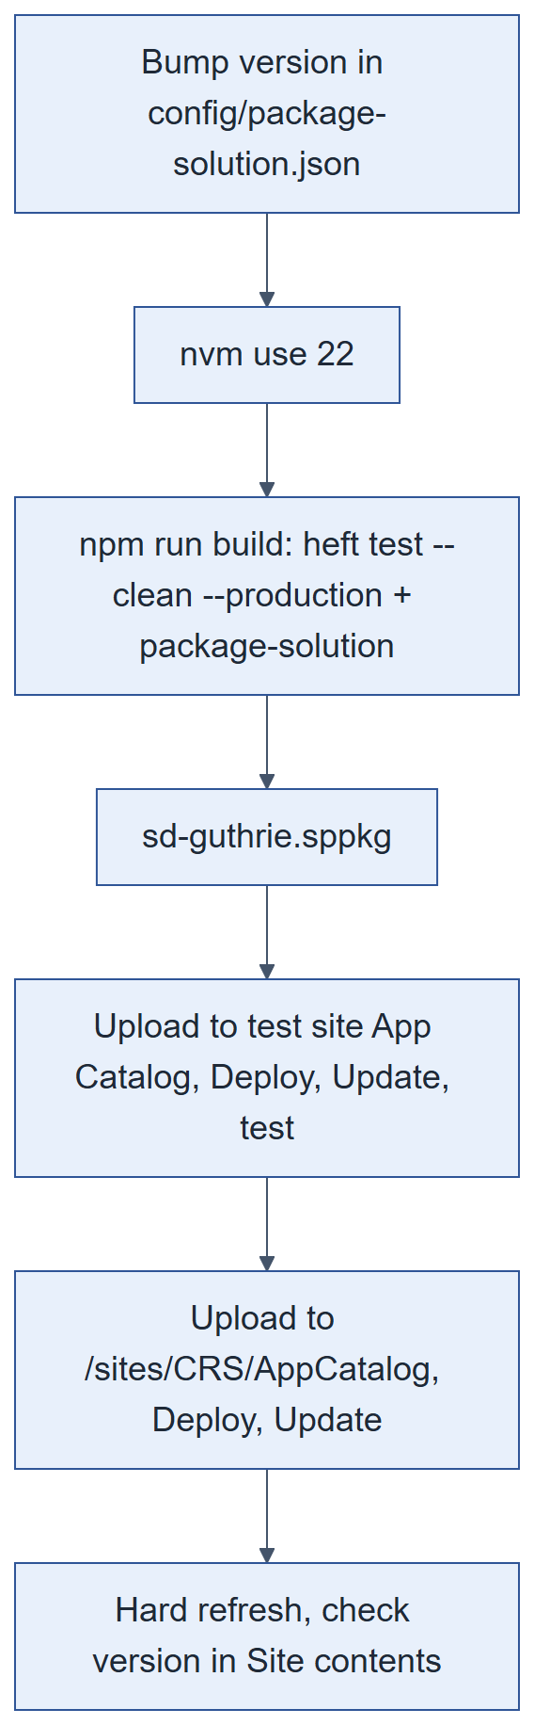
Figure 18. Build and deploy pipeline
- Add 1 to the last number of version in config/package-solution.json (e.g. 1.0.578.0 → 1.0.579.0). Uploading the same version looks like nothing changed.
- nvm use 22, then npm run build (runs every test, then packages). Output: sharepoint/solution/sd-guthrie.sppkg.
- Optional checks (Git Bash): unzip -p sharepoint/solution/sd-guthrie.sppkg AppManifest.xml | grep -o 'Version="[^"]*"' and unzip -p sharepoint/solution/sd-guthrie.sppkg "ClientSideAssets/<bundle>_*.js" | grep -c "<text you added>".
Always use npm run build. heft package-solution alone packages the JavaScript of the previous build. A new web part needs its id in componentIds in package-solution.json (a test fails the build if it is missing). Never change the solution id.

A.4 Deploy
- Deploy to the test site first.
- Open https://sdguthrie.sharepoint.com/sites/CRS/AppCatalog, upload sd-guthrie.sppkg replacing the existing file, click Deploy.
- Site contents › sd-guthrie-client-side-solution › Update, if offered.
- Hard refresh (Ctrl+F5) or open a new tab; check the version in Site contents matches the build.
- A brand-new component can take several minutes to appear with no Update prompt.
First upload after the rename (1.0.580.0): the package used to be called sd-gatrie.sppkg. In the App Catalog, rename the existing sd-gatrie.sppkg to sd-guthrie.sppkg first, then upload, so the upload replaces it. Never delete the old entry: the app's code is served from it. Try it on the test site first.

A.5 Register the extensions
On this tenant the feature did not register the extensions. On a new site, after the first deploy, check <site>/_api/web/usercustomactions?$select=Title,Location,ClientSideComponentId. If one is missing, add it once with a POST to <site>/_api/web/usercustomactions (two rows load it twice):
Table 51. Custom actions (both present on CRS at capture)
Extension | Title | Location | ClientSideComponentId | Also set
+ New Folder, hides native buttons | CRS New Folder Button | ClientSideExtension.ApplicationCustomizer | c1d2e3f4-a5b6-47c8-d9e0-f1a2b3c4d5e6 | —
Approve or reject panel | CRS Bulk Approve | ClientSideExtension.ListViewCommandSet.CommandBar | 6d1a9f47-3c82-4e15-b7a0-9f2e5c8d4136 | RegistrationId "101", RegistrationType 1

Appendix B. Set up a test site
Copy the structure of CRS (lists, libraries, columns, views, pages, config rows) with PnP PowerShell, then deploy the app, create the groups and import the flows. No documents are copied. Plan about a day; these steps have not yet been run end to end on a fresh site, so check each one.
- Create a Team site (e.g. /sites/CRS-Test); add the service account to its Owners; ask a SharePoint admin for a site app catalog: Add-SPOSiteCollectionAppCatalog -Site <test site URL>.
- Terms. Same tenant: in CRS's term store, open the site collection term group and add the test site under Site Collection Access, so it uses the same term sets and GUIDs. Another tenant: Export-PnPTermGroupToXml / Import-PnPTermGroupFromXml (keeps term ids).
- Deploy the app (Appendix A.4), add it to the site, register the extensions if missing (A.5).
- Copy the structure (needs an Entra app registration once per tenant, Register-PnPEntraIDAppForInteractiveLogin). Leave Group Map and Folder Map empty (the app refills them); do not copy site security.
- Check the settings: content approval on for both approval libraries (drafts: approvers + author) and off for both approved libraries; BulkImport visible; NextReminderAt on both approval libraries; ApproverNotifiedAt on CRS Submissions; every page published and named as on CRS.
- In the app, as Owner: Group Management › Bulk Provisioning; add test users (an uploader and an approver who are not site admins); Folder Administration › Folder Reconciliation.
- Import the flows pointed at the test site (D.5). Minimum set: Apply pending tags, Approve new folders (+ HC), NotifyApprovers, Auto-route (+ HC), Auto-approve bulk imports (+ HC).
- Smoke test: upload as the uploader (metadata fills in, approver gets an email), approve (the file moves within about 5 minutes), check My Submissions.
Connect-PnPOnline -Url https://sdguthrie.sharepoint.com/sites/CRS -Interactive -ClientId <app id>
Get-PnPSiteTemplate -Out crs.pnp -Handlers Fields,ContentTypes,Lists,Pages,Navigation -IncludeAllClientSidePages
Add-PnPDataRowsToSiteTemplate -Path crs.pnp -List "CRS Config"
Add-PnPDataRowsToSiteTemplate -Path crs.pnp -List "CRS Term Abbreviation"
Connect-PnPOnline -Url <test site URL> -Interactive -ClientId <app id>
Invoke-PnPSiteTemplate -Path crs.pnp

Appendix C. Troubleshooting
Most problems turned out to be a stale browser tab, the wrong site, or a flow. Check in this order:
- Which site? Live and test sites have different list GUIDs, term GUIDs and data.
- Which build? Hard refresh; compare the app version in Site contents with package-solution.json.
- The real error: browser F12 Console, and the Network tab's status and response body.
- Is it a flow? Open its run history as gdc; check the gdc connections (D.2).
- Live data: run a scripts/check-* or diagnose-* script in the F12 console.
Table 52. Symptoms and causes
Symptom | Usual cause
Web part blank, no error | A React hook placed below an early return (React error #310).
A library "disappeared" after a rename | New title missing from src/shared/naming.ts (and CRS_LIBRARIES).
Uploaded file has no metadata | Apply pending tags failed or is off; check the record's TagStatus / TagError.
No approval or reminder email | Flow off or failed; gdc connection broken; the person is the uploader or (reminders) a site admin; or an outside address blocked by the tenant.
Uploaders cannot see each other's folders | Folder still pending: Approve new folders must be on.
New member has no access | They must sign out and in; or reconciliation has not run for their group.
Items or groups missing from a screen | A $top-capped read; filter server-side or page it.
Write returned 200 but nothing changed | validateUpdateListItem reported a field error inside the 200 (HasException).
Search results stale | Re-index the library; check the reindex flow.
Everything automated stopped at once | gdc removed from Owners, or its connections need re-authentication.

Appendix D. Flow operations

D.1 Rules for editing flows
- Build, import and edit flows signed in as gdc, and export to PowerAutomateFlowsSDG/ after any change.
- HTTP header names have no colon (Accept, not Accept:); with a colon the header silently does nothing.
- Always send Accept: application/json;odata=nometadata, or ?['value'] comes back empty, except the two deliberate owner/admin lookups in NotifyApprovers (adding the header would switch that exclusion on).
- Writing a field re-triggers every other created-or-modified flow on that list (8.3).
- The connector's Update item rewrites every column; for one field use an HTTP MERGE.
- Never MERGE OData__ModerationStatus together with another field.
- Type expressions in the fx box and never press Enter in it; a 0 typed into a Condition is text.
- A green run does not prove the logic is right; re-export to confirm an edit landed.
- gdc must stay in the site's Owners group.

D.2 If gdc's password changes
- Sign in to https://make.powerautomate.com as gdc@sdguthrie.com.
- Open Connections. Any showing Reconnect or Fix connection is broken; the two that matter are GDC Proxy - Outlook and GDC Proxy - SharePoint.
- Reconnect and sign in as gdc with the new password, never as yourself (the flows would then act and send email as you).
- Open one email flow's latest run to confirm it is green. Resubmit failed runs from the run history if the missed actions matter.

D.3 Export and back up
- Open the flow as gdc › Export › Package (.zip).
- Save it into PowerAutomateFlowsSDG/ replacing the old one, and commit it.

D.4 Import or update
- My flows › Import › Import Package (Legacy) › choose the zip.
- For each resource pick Create as new (first time) or Update.
- Under Related resources pick the gdc connections.
- Import, open the flow, save, turn it on.

D.5 Point a flow at another site
Each export names CRS's site URL and list GUIDs (8.6). Change every SharePoint action's Site Address and List Name in the designer, or replace the URL and each GUID in definition.json before importing. Get the other site's GUIDs from <site>/_api/web/lists?$select=Title,Id&$filter=Hidden eq false.

D.6 Make the HC copy of a flow
- Open the normal flow › Save As, name it with HC.
- Change every library reference to its HC twin: triggers, Get items, HTTP URIs (getbytitle(...) and lists(guid'...')), and links in emails. Role APR becomes APRHC.
- Re-export and search definition.json for the normal library names and GUIDs: every HC copy so far has kept at least one.

D.7 Rebuild a generated flow
- Edit TARGETS in scripts/build-bundled-approver-flow.py (site URL, list GUIDs, bcc, base export path and output path). The reminder script reuses it.
- Run python scripts/build-bundled-approver-flow.py crs or python scripts/build-bundled-reminder-flow.py crs.
- Import the zip as gdc (Create as new the first time, Update afterwards), pick the connections, save, turn on.

D.8 Turn a flow off safely
- A recurrence flow that is off catches up on its next run. A trigger flow that is off does not see changes made while it was off.
- Never turn off Apply pending tags, Auto-route or Approve new folders on the live site except for a short, announced window.

