CRS Developer Guide
Guthrie Document Centre (CRS) for SD Guthrie
How the system is built, how to install, run, build and deploy it, which SharePoint APIs each part uses, how the configuration lists drive the code, and how the Power Automate flows work. Written for SharePoint Framework (SPFx) developers taking over the project.
Repository sd-gatrie · SPFx 1.23 · package version at handover 1.0.578.0 · 1 October 2026

Contents
1. Architecture 4
Technology 4
Upload to approval, end to end 5
Libraries 5
Folder tree and permissions 6
Code layout 6
2. What to install, and the access you need 7
Software 7
Access (ask SD Guthrie IT) 7
3. Run it locally 8
4. Build 9
5. Deploy 10
Extensions: check they are registered 10
6. Configuration lists and how the code uses them 11
How the code finds lists 11
The lists 11
CRS Config settings rows 12
7. Components 13
Upload Form 13
Bulk Upload 14
Approval Document and the Approve or reject panel 15
My Submissions and Document-Viewer 16
Requests 17
Search 18
Folder Administration and Folder Reconciliation 18
Folder Structure and Migration 19
Group Management 20
Settings, Configuration and Access pages 21
Audit Log 21
Extensions 22
APIs used by each component 22
8. Power Automate 24
8.1 Where the flows live 24
8.2 If gdc's password changes: reconnect 24
8.3 Flow reference 24
8.4 Columns the flows depend on 29
8.5 Emails the system sends 30
8.6 How-tos 30
8.7 Rules for editing flows 32
9. Set up a test site 33
10. Troubleshooting 34
11. Open items at handover 35
Ready to roll out on CRS (tested on the test site) 35
Waiting on someone 35
Known gaps (accepted for now) 35

1. Architecture
People use SPFx web parts that talk to SharePoint as the signed-in user. Anything a user is not allowed to do themselves (write metadata, move approved files, delete, send email) is done by Power Automate flows running as the service account gdc@sdguthrie.com.
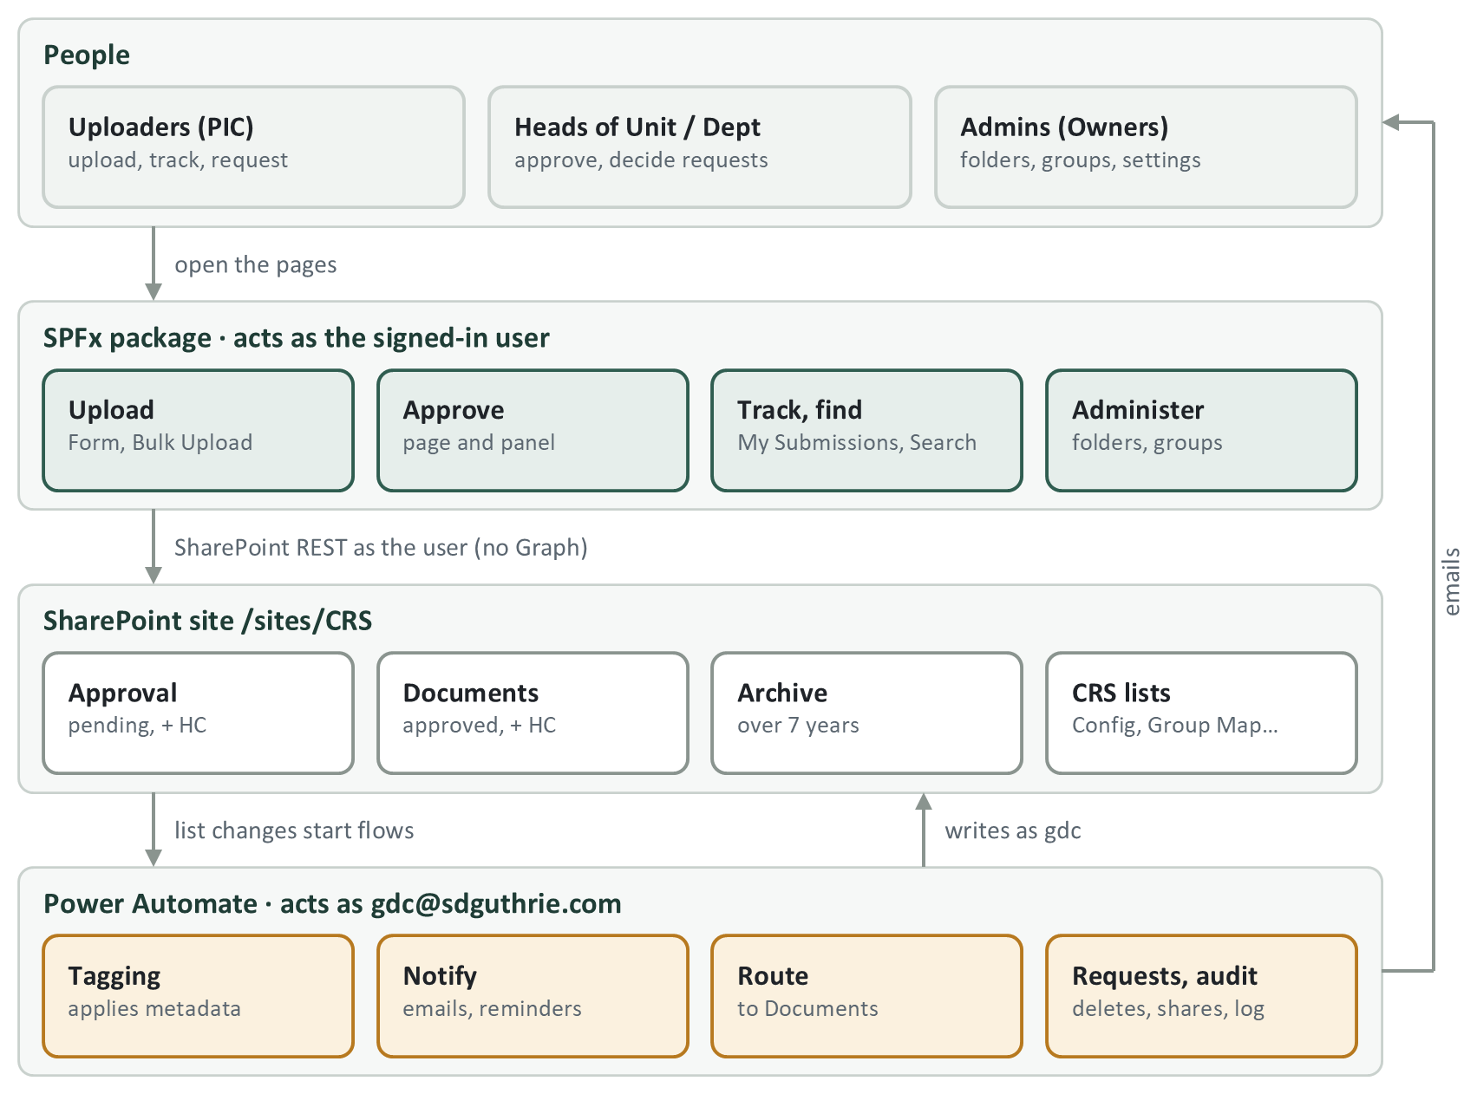
Figure 1. The four layers of CRS

Technology
- SPFx 1.23, React 17, TypeScript 5.8, Fluent UI 8. Built with Heft (not Gulp).
- All data access is SharePoint REST through SPFx's SPHttpClient. No Microsoft Graph and no admin consent. (@pnp/sp is installed but not used.)
- One solution, sd-gatrie.sppkg: 17 web parts and 2 active extensions, deployed to the CRS site's own App Catalog.
- About 25 Power Automate flows, all running as gdc@sdguthrie.com (chapter 8).

Upload to approval, end to end
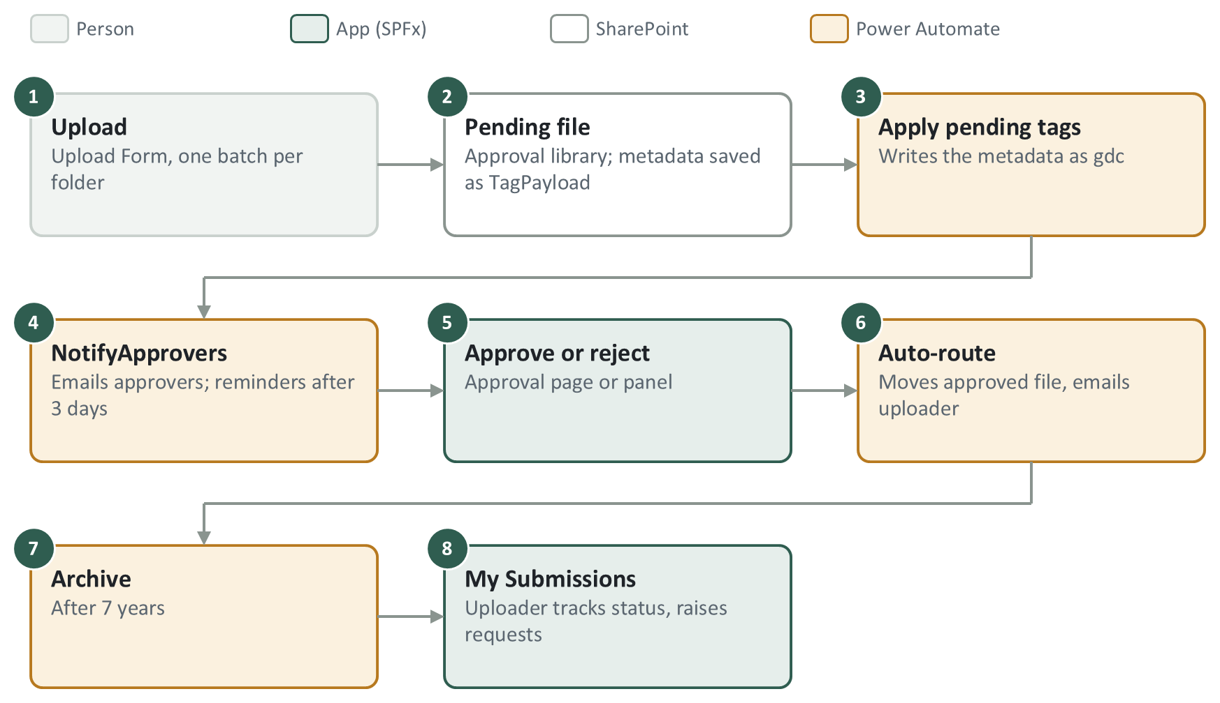
Figure 2. The path every document takes
- Uploaders cannot edit items, so the metadata goes through CRS Submissions (TagPayload) and the flow CRS — Apply pending tags.
- Rejected files stay in the approval library so the uploader can see the comment.
- Bulk Upload (historical files) skips approval: a flow approves them straight away.

Libraries
Six libraries in three pairs (normal and Highly Confidential, "HC"). The client renames library titles; the URL never changes.
Role | Title at handover | URL | Content approval
Pending and rejected uploads | Approval for Document | ApprovalDocument | On (approvers + author see drafts)
Approved documents | Restricted & Confidential Document | Shared Documents | Off
Pending HC uploads | Approval for Highly Confidential Document | HCApprovalDocument | On
Approved HC documents | Highly Confidential Document | HCDocuments | Off
Older than 7 years | Archive Restricted & Confidential Document | Archive | Off, read-only
HC older than 7 years | Archive Highly Confidential Document | HCArchive | Off, read-only

Folder tree and permissions
<Library> / <Segment> / <Department> / <Unit> / [Sub Unit] / <Year> / <Document Type> / file
|-- permissioned ---| |- inherit the unit's permissions --|
- Folders come from the site's term store; folder names are short codes from CRS Term Abbreviation (e.g. GHO/GF/GIT).
- Each unit has about five SharePoint groups (uploader, approver, viewer and HC versions), e.g. GHO_GF_GIT_APPROVER. The list of roles is PERSONAS in src/shared/groupMapModel.ts.
- Folder Reconciliation (Folder Administration page) creates the folders and grants each group its folders from CRS Group Map. It only adds permissions, never removes them.
- Nobody holds a delete permission. A delete is a request row that a flow carries out as gdc.
- System admins are the site's Owners group.

Code layout
Folder | What is in it
src/webparts/ | One folder per web part (chapter 7).
src/extensions/ | hideAppBar (+ New Folder button; hides SharePoint's own Upload, Approve/Reject and Share) and bulkApprove (the "Approve or reject" panel). uploadCommand is legacy: it links to an old sandbox site and is not registered. Ignore it.
src/shared/ | The app's logic (permissions, folder paths, upload checks, list names). Pure logic in x.ts with a x.test.ts; SharePoint calls in spX.ts. Change behaviour here and run its test.
config/ | package-solution.json (version, component list), serve.json (local run pages).
scripts/ | Browser-console scripts for checking live data (check-*, diagnose-* read only; repair-*, purge-* write, off by default) and two Python flow generators.
PowerAutomateFlowsSDG/ | Exports of the live flows (25 September 2026). The source of truth for any flow question.

2. What to install, and the access you need

Software
- Node.js 22 (22.14 or later, below 23). Use nvm (nvm-windows on Windows) to switch versions.
- Git and an editor (VS Code).
- Python 3, only if you rebuild the two generated flows (chapter 8).
nvm install 22
nvm use 22
npm ci
npx heft trust-dev-cert (once per machine: trusts the local HTTPS certificate)

Access (ask SD Guthrie IT)
What | Where | Why
Owner on the live site | https://sdguthrie.sharepoint.com/sites/CRS | Admin pages, settings, deploying.
The site's App Catalog | /sites/CRS/AppCatalog | Where the package is uploaded. A site Owner can upload and deploy here. The tenant App Catalog is not used.
Service account gdc@sdguthrie.com | Power Automate (SD Guthrie tenant) | Every flow runs as this account. Needed to edit, import or fix flows.
Term store | /sites/CRS/_layouts/15/termstoremanager.aspx | Business Segment, Department, Unit, Year, Document Type, Confidentiality terms.
A test site set up like CRS | Your own SharePoint site | The code reads and writes real lists (chapter 9).

3. Run it locally
SPFx runs your local code inside a real SharePoint page (the hosted workbench). There is no offline mode, so always point it at a test site, never at live CRS.
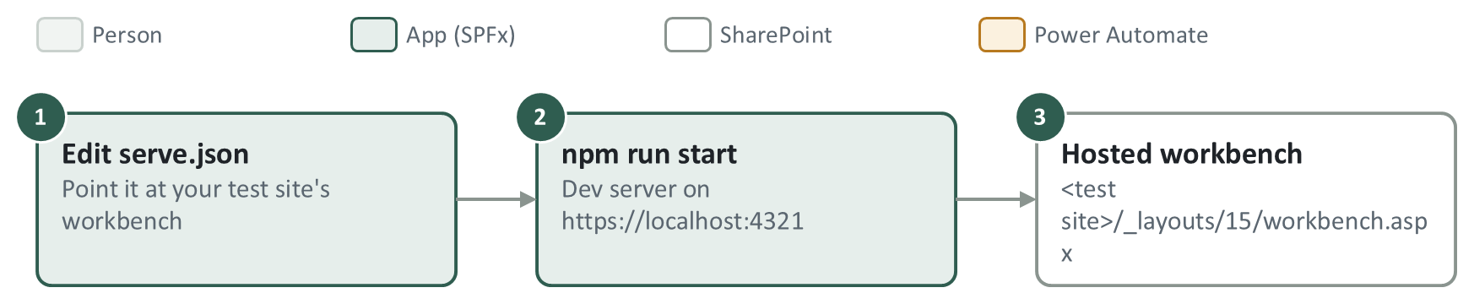
Figure 3. Running locally
- Open config/serve.json. Change initialPage and serveConfigurations.default.pageUrl to your test site's workbench: https://<tenant>.sharepoint.com/sites/<test-site>/_layouts/15/workbench.aspx. At handover they point at the live CRS site.
- Run npm run start. The dev server starts on https://localhost:4321 and opens the workbench.
- Add a web part from the toolbox.
- To test on a real page, open it with ?debug=true&noredir=true&debugManifestsFile=https://localhost:4321/temp/build/manifests.js.
- The hideAppBar extension has its own entry in serve.json: set its pageUrl to a library on your test site.
- Type check: npx tsc --noEmit. Tests: npx heft test --clean.
Use Heft only. gulp is still listed in package.json, but the build does not use it.

4. Build
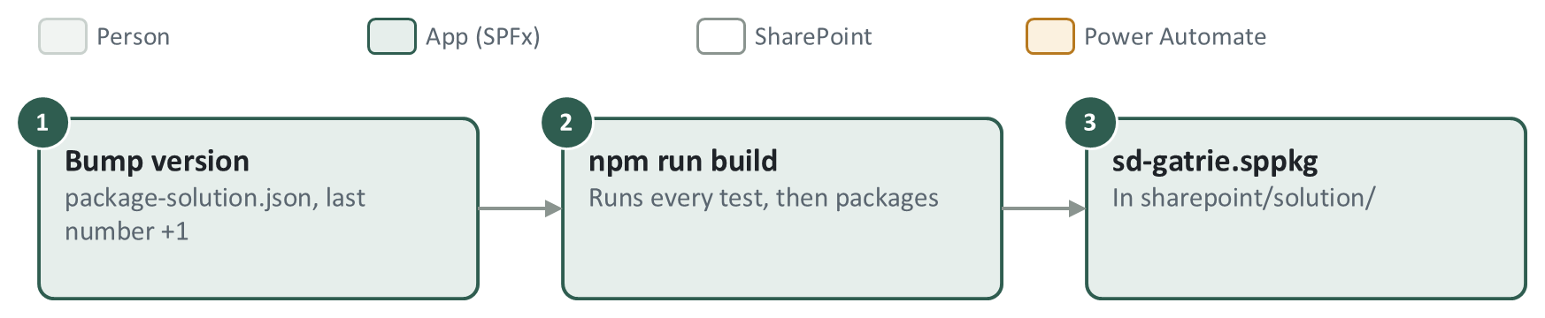
Figure 4. Building the package
- In config/package-solution.json, add 1 to the last number of version (e.g. 1.0.578.0 → 1.0.579.0). Uploading the same version again makes it look like nothing changed.
- Run nvm use 22 then npm run build. This runs every test, then packages. Output: sharepoint/solution/sd-gatrie.sppkg.
- Optional checks (Git Bash): the version inside the package, and that your change is really in it.
unzip -p sharepoint/solution/sd-gatrie.sppkg AppManifest.xml | grep -o 'Version="[^"]*"'
unzip -p sharepoint/solution/sd-gatrie.sppkg "ClientSideAssets/<bundle>_*.js" | grep -c "<text you added>"
Always use `npm run build`. Never run heft package-solution on its own: it packages the old JavaScript from the previous build.
- A new web part needs its ID in componentIds in config/package-solution.json, or it will not appear in the toolbox. A test fails the build if it is missing.
- Never change the solution id 4c93b50e-03c1-4005-a280-add0da86c86f, or SharePoint treats it as a different app.

5. Deploy
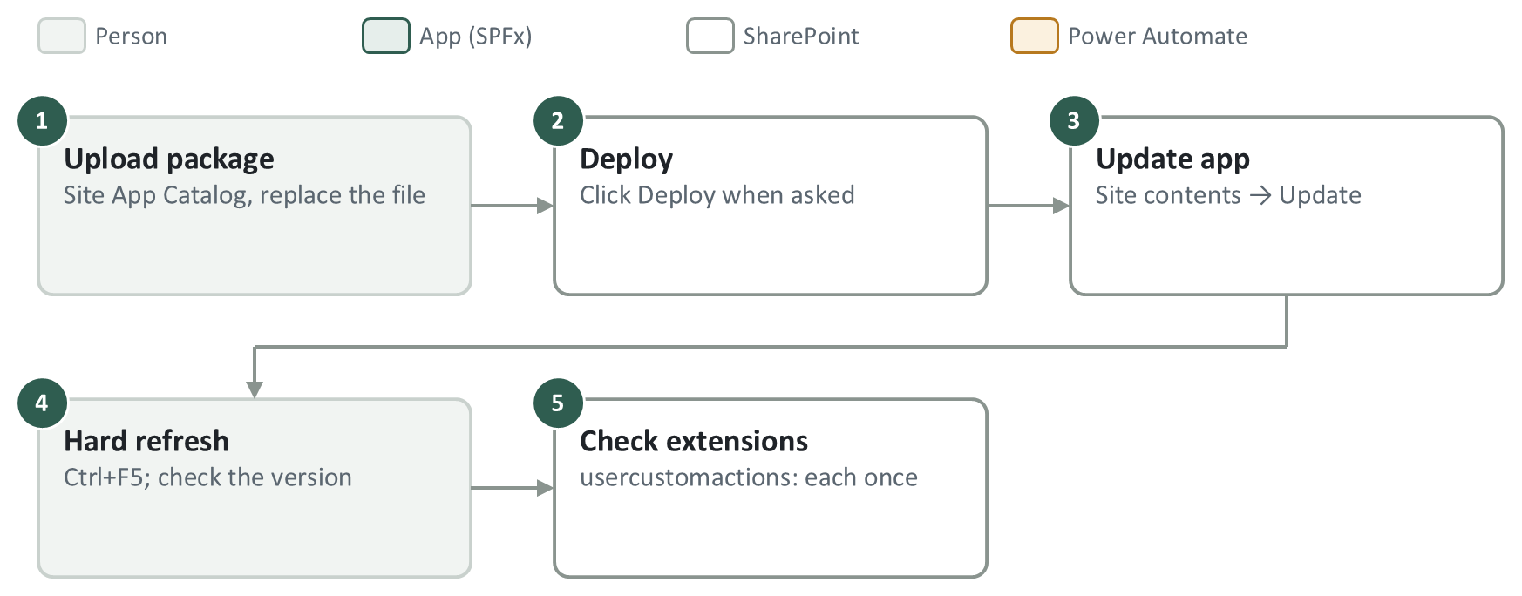
Figure 5. Deploying to the site
- Open https://sdguthrie.sharepoint.com/sites/CRS/AppCatalog (the site's own catalog; the client does not allow the tenant catalog).
- Upload sd-gatrie.sppkg, replacing the existing file. Click Deploy.
- Go to Site contents, find sd-gatrie-client-side-solution, click Update if offered.
- Hard refresh (Ctrl+F5) or open a new tab. Check the version in Site contents matches the one you built.
Always deploy to your test site first. The package needs no CDN (includeClientSideAssets: true).

Extensions: check they are registered
On the SD Guthrie tenant the package's feature did not register the two extensions, so they were added by hand. On a new site, after the first deploy, open <site>/_api/web/usercustomactions?$select=Title,Location,ClientSideComponentId. If one is missing, add it once (two rows load the extension twice) with a POST to <site>/_api/web/usercustomactions:
Extension | Title | Location | ClientSideComponentId | Also set
+ New Folder, hides native buttons | CRS New Folder Button | ClientSideExtension.ApplicationCustomizer | c1d2e3f4-a5b6-47c8-d9e0-f1a2b3c4d5e6 | —
Approve or reject panel | CRS Bulk Approve | ClientSideExtension.ListViewCommandSet.CommandBar | 6d1a9f47-3c82-4e15-b7a0-9f2e5c8d4136 | RegistrationId: "101", RegistrationType: 1

A brand-new component can take several minutes to reach the site after a deploy, with no Update prompt. If the Network tab shows no request for its bundle, wait and refresh.

6. Configuration lists and how the code uses them
Almost all configuration lives in SharePoint lists on the site, not in code. Change a setting in the list and the app picks it up on the next page load (no deploy).
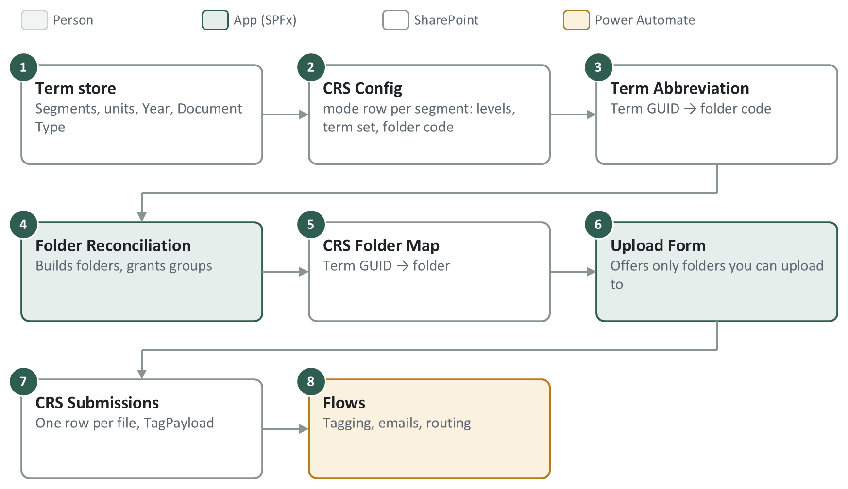
Figure 6. How the configuration connects

How the code finds lists
- src/shared/naming.ts: each list has a fixed suffix (LIST_SUFFIX: Config, Group Map, Folder Map, Term Abbreviation, Submissions, Requests, Audit Log). The code tries the prefix CRS, then the old DMS, and uses the first list that exists.
- Libraries are found from candidate title arrays (LIBRARY_CANDIDATES, DOCUMENTS_CANDIDATES, HC_APPROVAL_CANDIDATES, …). A title not in these arrays fails silently. After the client renames a library, add the new title, build and deploy.
- The hideAppBar extension has its own title list (CRS_LIBRARIES). Add a renamed library there too.
- Use libraryTitle(), documentsLibraryTitle(), libApiTitle() and cachedListTitle(LIST_SUFFIX.x); never a literal title.

The lists
List | What it holds | Code that uses it | Flows that use it
CRS Config | Settings rows, and one mode row per business segment: Levels (JSON of folder tiers), PendingLevels, TermSetGuid, StagingFolder | Nearly every web part. The mode rows drive the Upload Form's choices and folder paths, and Folder Reconciliation. | —
CRS Term Abbreviation | Term GUID → short folder code (e.g. Group IT → GIT) | folderAbbreviation.ts, dmsFolderMap.ts; edited on Folder Administration | —
CRS Group Map | Group ID and name, role (UPL, APR, APRHC, MEMBER…), and the term it applies to | Written by Group Management; read by reconciliation, Upload Form, Search, My Submissions, Requests | NotifyApprovers, reminders, request emails find the approver group here
CRS Folder Map | Term GUID → folder UniqueId and URL | Written by reconciliation; read by dmsFolderMap.ts | —
CRS Submissions | One row per uploaded file (SubmissionFileId, TagPayload, TagStatus, ApproverNotifiedAt…). Survives deletion. | Written by the Upload Form (spSubmissionRecords.ts); read by My Submissions | Apply pending tags, Auto-route, Audit replacements, archive flows, bundled email
CRS Requests | Delete and share requests and their decisions | requests.ts; Requests page, My Submissions | Notify request activity, Execute approved deletion, Expire shares, Audit request activity
CRS Audit Log | Append-only event log | spAuditLog.ts; Audit Log page | Audit flows, Auto-route, archive, deletion

CRS Config settings rows
Title | Effect
allowedExtensions | Allowed upload file types (AllowedFileTypes column). Nothing ticked blocks every upload, on purpose. Edited on GDC Configuration.
hcConfidentialityLevel | Which confidentiality term means Highly Confidential. Without it every uploader sees the HC option.
autoApproveOwnUpload | A Head of Unit's own upload approves itself, after a live permission check.
uploadsPaused | Pauses uploads during a folder migration.
allowExternalSharing, tenantDomains | Share requests: whether outside addresses are allowed, and which domains count as internal.
recon_departmentFanOut | Department-level groups reach every unit folder below. On by default; must stay on.

Terms: rename terms, never delete and re-add them. A re-created term gets a new GUID and breaks the rows in Term Abbreviation, Group Map and Folder Map that point at it.

7. Components
One section per web part or extension: a flow diagram, a short explanation, and the files to open first. The numbers in each diagram give the order; the colour says who does the step.

Upload Form
src/webparts/form
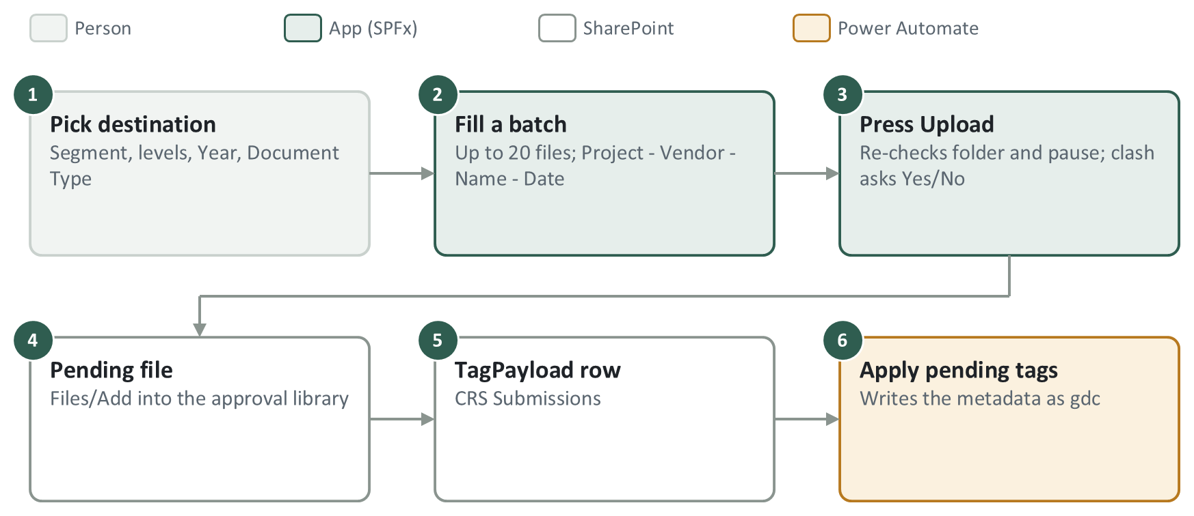
Upload Form
The main way documents enter CRS. The uploader picks a destination, fills one batch (one folder, up to 20 files) and presses Upload. Each file lands in the approval library as Pending, and its metadata is written by a flow, because uploaders cannot edit items.
- A folder is offered only if it has a Folder Map row and a permission probe says the user can add items there.
- The destination is fixed when a batch is saved; only one batch is editable at a time. File name = Project - Vendor - Document Name - Date.
- HC is offered only with clearance; the form never creates an HC unit folder.
- A Head of Unit's upload can approve itself (autoApproveOwnUpload) once the tags land.
- A successful batch disappears, a failed one stays: pressing Upload again is a safe retry.
Start reading
- src/webparts/form/components/Form.tsx
- src/shared/formModel.ts
- src/shared/uploadBatches.ts
- src/shared/dmsFolderMap.ts
- src/shared/spSubmissionRecords.ts
- src/shared/clashProxyDeletion.ts

Bulk Upload
src/webparts/bulkUpload
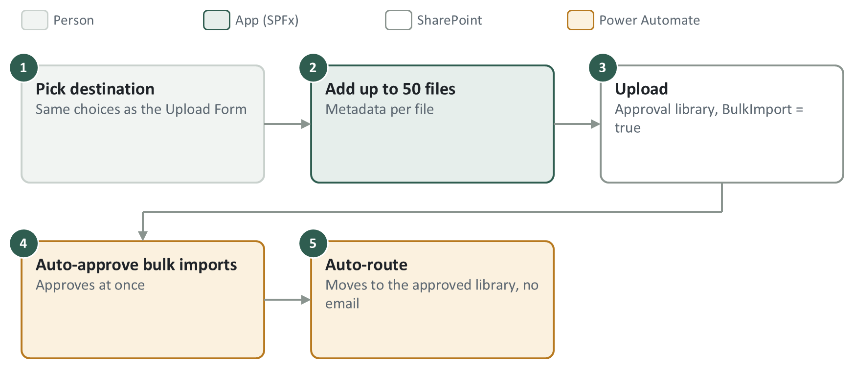
Bulk Upload
For historical documents that were already approved. Files go into the approval library with BulkImport = true, a flow approves them straight away, and Auto-route files them.
- BulkImport must stay visible on both approval libraries, or the flow never sees it.
- Duplicates are checked in both the approval and the approved library.
- HC writes fail closed: they never fall back to the normal library.
- My Submissions shows these as Approved By Guthrie Document Centre, on purpose. No "approved" email is sent.
Start reading
- src/webparts/bulkUpload/components/BulkUpload.tsx
- src/shared/uploadBatches.ts

Approval Document and the Approve or reject panel
src/webparts/approvalDocument · src/extensions/bulkApprove
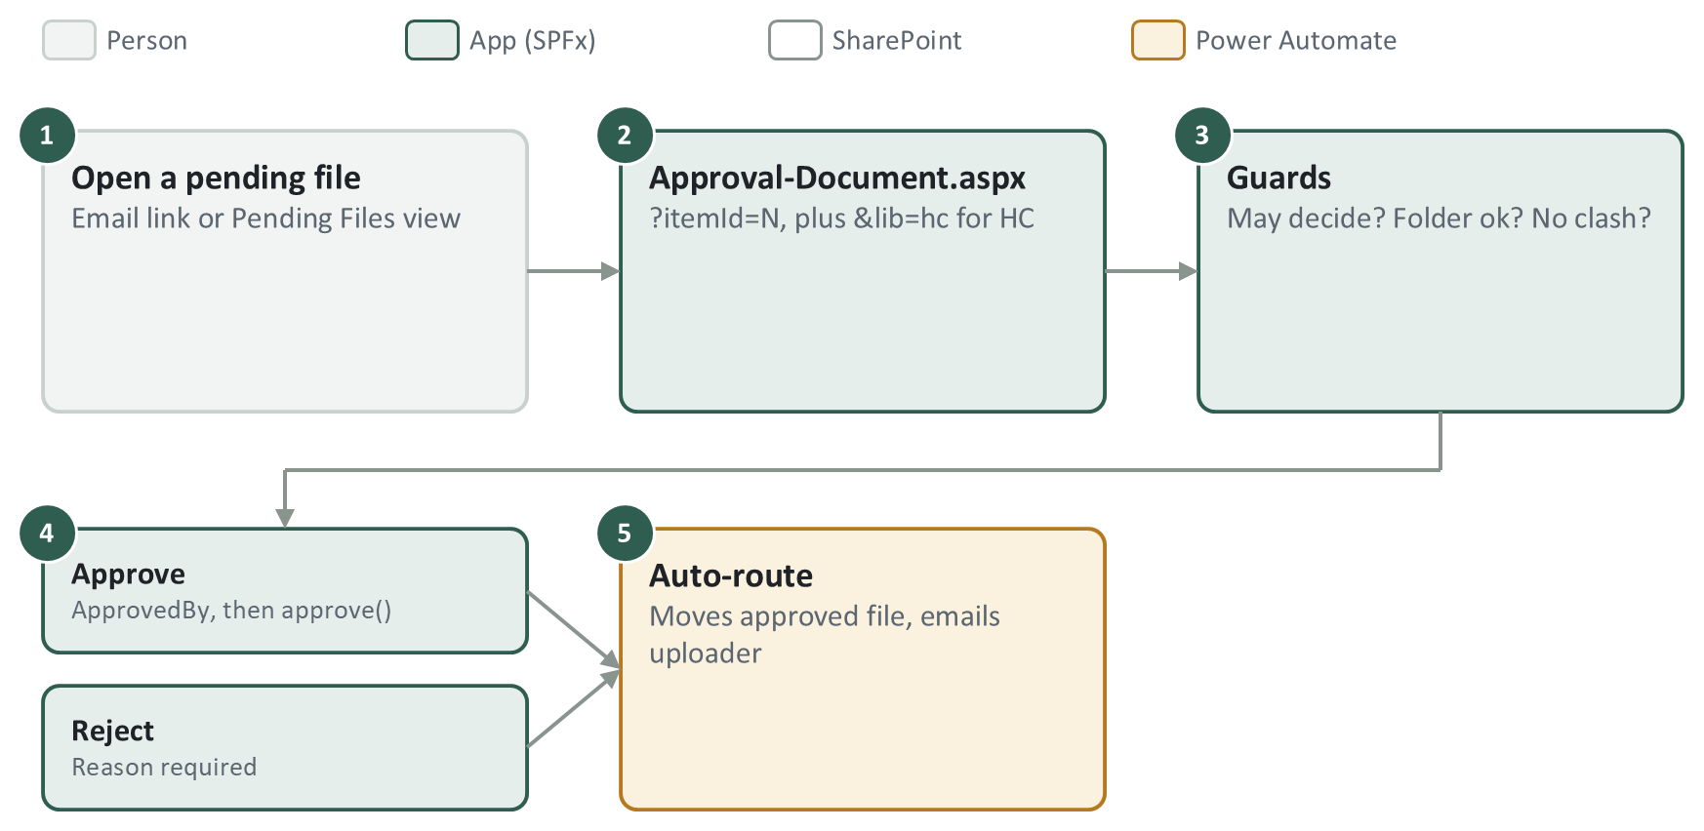
Approval Document and the Approve or reject panel
An approver opens one pending file on Approval-Document.aspx (or selects many in the library and uses the panel). Shared guards check the decision is allowed, then the page writes the decision and Auto-route does the rest.
- Never set OData__ModerationStatus in the same MERGE as another field: SharePoint returns 500. ApprovedBy is written first, then the status.
- The panel uses the same guards as the page (approvalGuards.ts); never copy them inline.
- SharePoint's own Approve/Reject is hidden by hideAppBar because it skips every guard.
- ?decision=approve|reject only pre-ticks the choice; it never submits.
Start reading
- src/webparts/approvalDocument/components/ApprovalDocument.tsx
- src/shared/approvalGuards.ts
- src/shared/approvalDestination.ts
- src/extensions/bulkApprove/components/BulkApprovePanel.tsx

My Submissions and Document-Viewer
src/webparts/mySubmissions
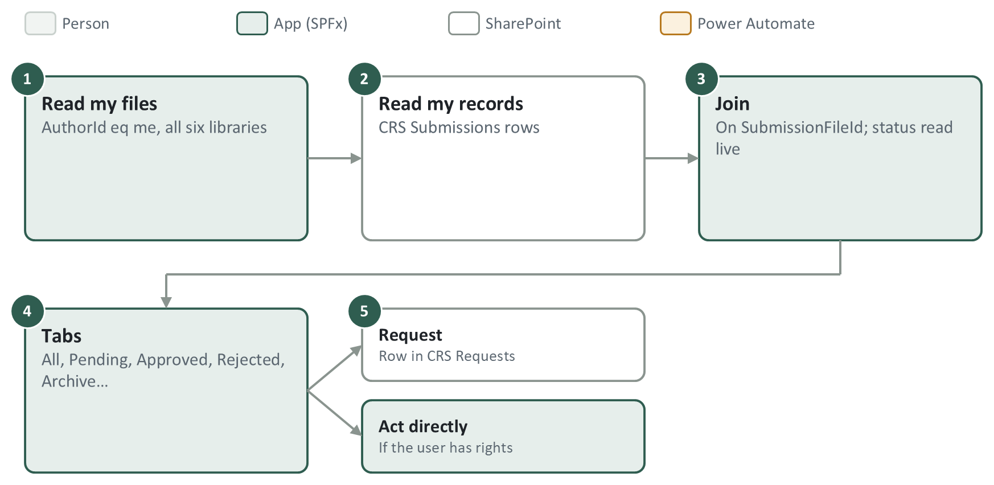
My Submissions and Document-Viewer
An uploader's own files across all six libraries, joined to their CRS Submissions records so a file stays visible after it is deleted, replaced or archived. From here the user raises delete and share requests, or acts directly if they have the rights.
- Status is always read live from the libraries; the record only adds history.
- Document-Viewer.aspx is the same web part in viewer-only mode: ?file=<UniqueId>.
- Reads use $select fallback steps: one missing column would fail the whole read.
- The file is over 5,000 lines: search for a function by name.
Start reading
- src/webparts/mySubmissions/components/MySubmissions.tsx
- src/shared/mySubmissions.ts
- src/shared/submissionRecords.ts
- src/shared/requests.ts

Requests
src/webparts/requests (page CRS-Request.aspx)
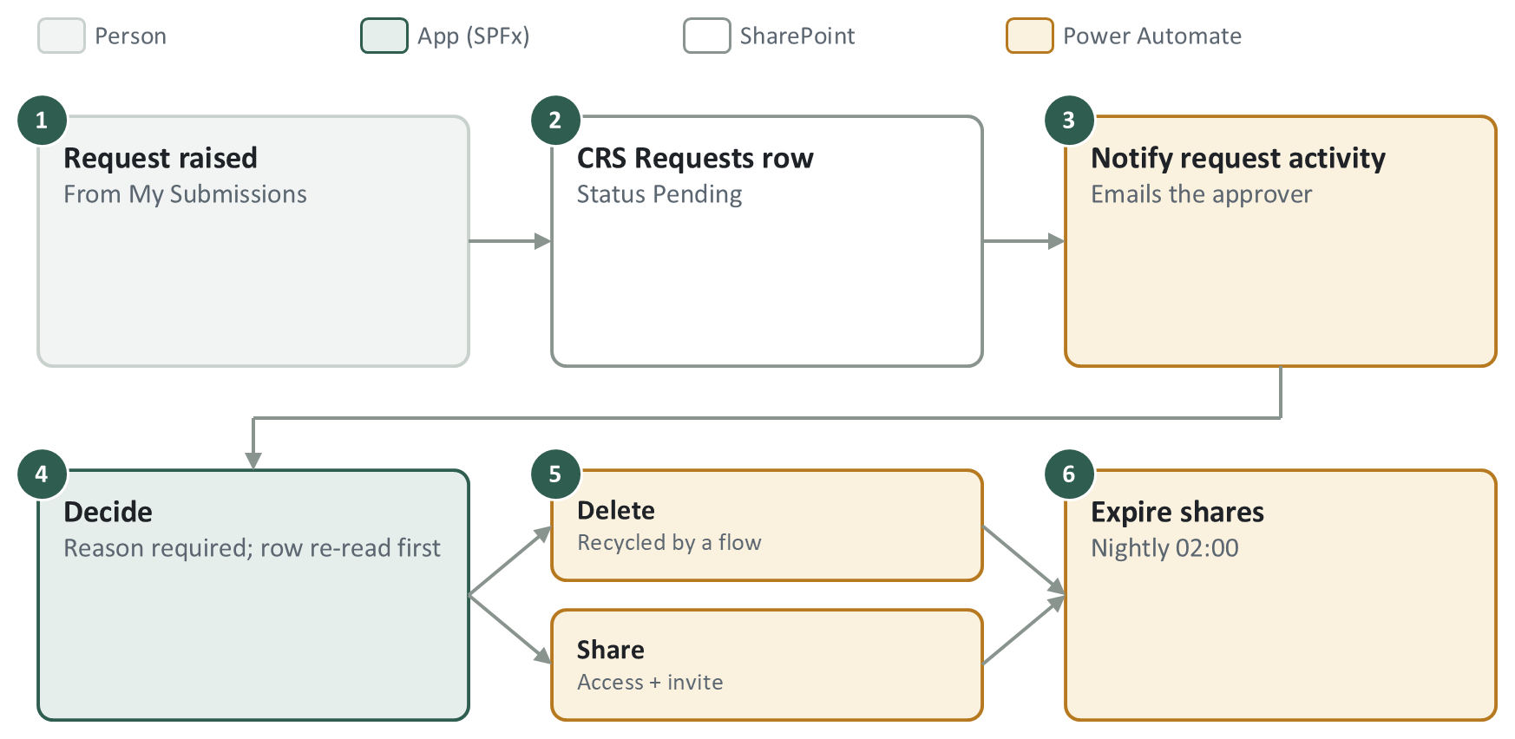
Requests
Delete and share requests are rows in CRS Requests. A flow emails the approver, the approver decides on the Requests page, and flows carry out the decision as gdc.
- Who sees which request is inScope() in requests.ts (approvers: their units; Head of Department: shares).
- If the file was replaced since the request, the request cancels instead of executing.
- The page writes no audit row on decide: the flow does, to avoid duplicates.
- ?request=<Id> opens one request; ?file=<UniqueId> gives direct actions from the library.
Start reading
- src/webparts/requests/components/Requests.tsx
- src/shared/requests.ts
- src/shared/directFileActions.ts
- src/shared/deletionGuard.ts

Search
src/webparts/documentSearch (home page)
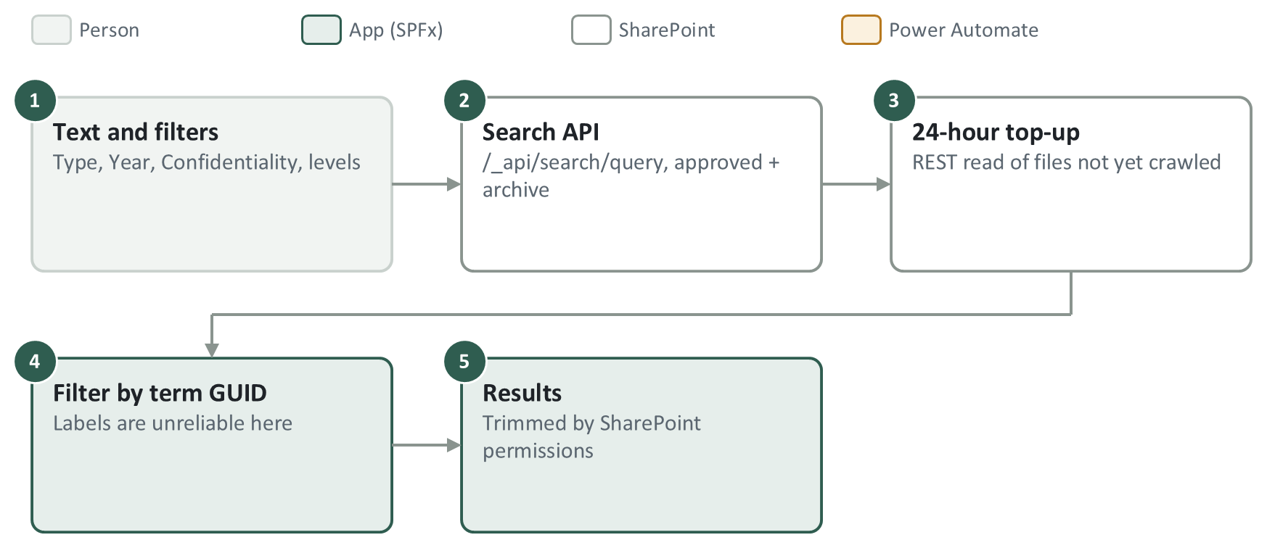
Search
Free text plus filters over the approved and archive libraries, through the SharePoint Search API, topped up with a direct read of the last 24 hours (not yet crawled).
- Approval libraries are not searched (client decision).
- Security comes from SharePoint's permission trimming: never add role checks here.
- Search calls need the header odata-version: "" or they fail with 500.
- Stale results: re-index the library (Library settings → Advanced), or check the reindex flow.
Start reading
- src/webparts/documentSearch/components/DocumentSearch.tsx
- src/shared/documentSearch.ts
- src/shared/throttleRetry.ts

Folder Administration and Folder Reconciliation
src/webparts/folderManager (admins only)
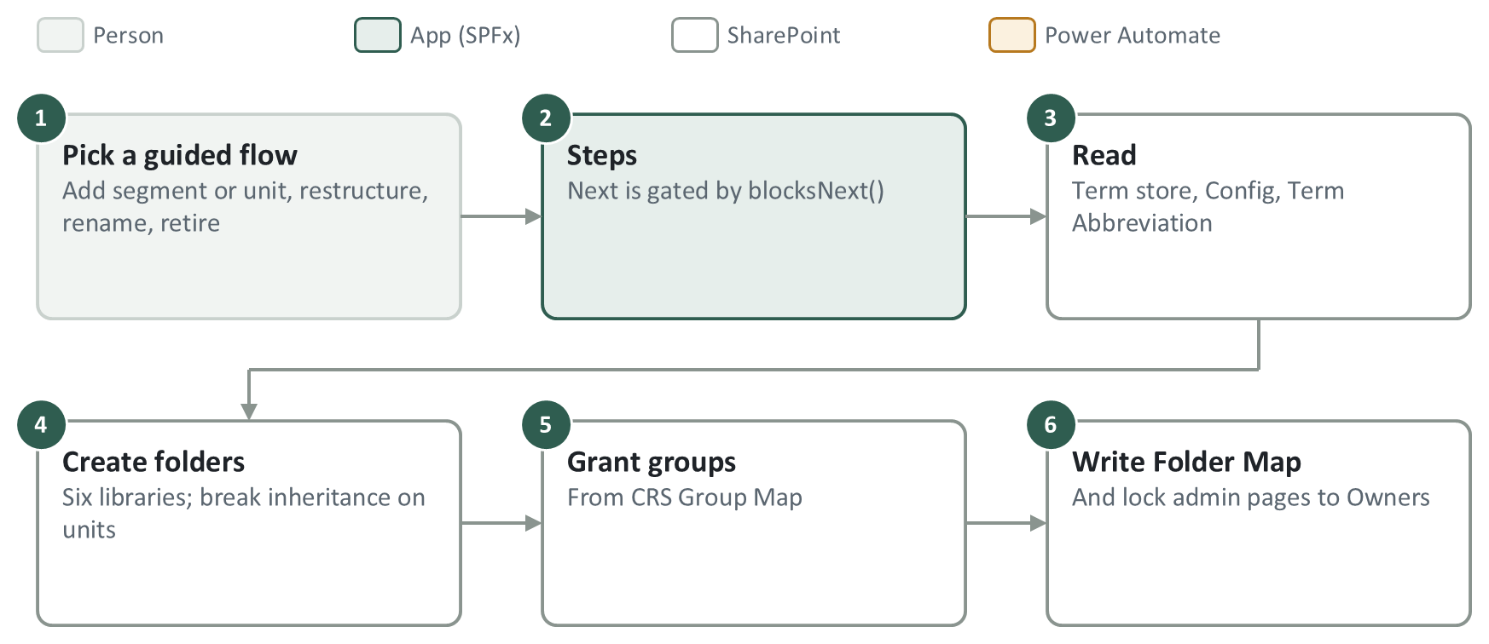
Folder Administration and Folder Reconciliation
Guided flows for adding segments and units, changing structure, renaming and retiring. Folder Reconciliation builds the folder tree in all six libraries from the term store and grants each group its folders.
- Reconciliation only adds permissions; it never removes them. It fails closed if it cannot read the permission levels.
- Saving abbreviations only writes rows; reconciliation renames the folders.
- FolderManager.tsx is about 9,000 lines and the most site-tested code: change it narrowly.
- A full run can take tens of minutes on the live site.
Start reading
- src/webparts/folderManager/components/FolderAdmin.tsx
- src/webparts/folderManager/components/FolderManager.tsx (runReconciliation)
- src/webparts/folderManager/components/AbbreviationManager.tsx
- src/shared/folderFlows.ts

Folder Structure and Migration
src/webparts/userAccess
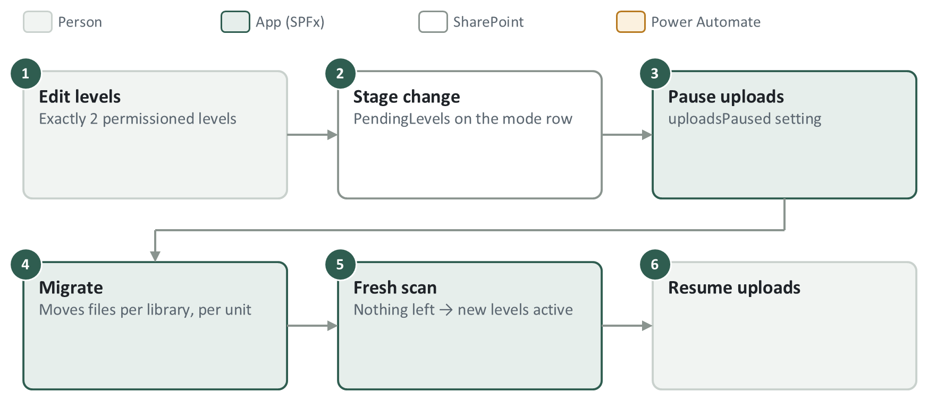
Folder Structure and Migration
Changes a segment's folder levels. On a segment that already holds documents the change is staged, uploads are paused, files are migrated, and the new levels go live only after a clean scan.
- Exactly two permissioned levels per segment. Year and Document Type are fixed.
- The migrator only walks leaf folders: a file on a non-leaf folder is invisible to it.
- Segments are created, retired and re-coded on the same page (SegmentCreator).
Start reading
- src/webparts/userAccess/components/StructureManager.tsx
- src/webparts/userAccess/components/SubtreeMigrator.tsx
- src/webparts/userAccess/components/SegmentCreator.tsx
- src/shared/subtreeMigration.ts

Group Management
src/webparts/userAccess
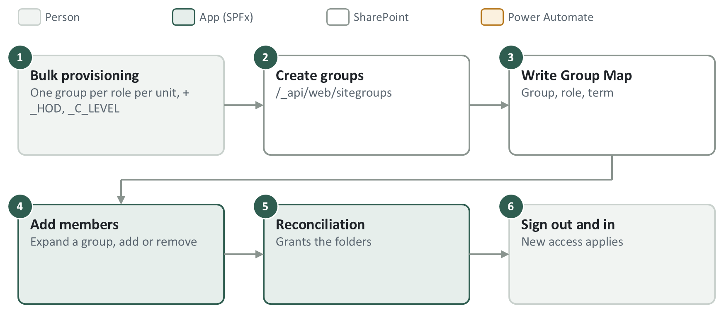
Group Management
Creates the per-unit groups in bulk and their Group Map rows, manages members, and shows the system administrators. Reconciliation then grants the folders.
- PERSONAS in groupMapModel.ts is the only list of roles.
- Deleting a Group Map row revokes nothing. To remove a role: export members, delete the group, re-create, re-add, reconcile.
- The service account gdc is hidden from the administrators list so nobody removes it.
- Members are read with keyset paging (Id gt last): /sitegroups has no next link.
Start reading
- src/webparts/userAccess/components/GroupManager.tsx
- src/webparts/userAccess/components/BulkGroupProvisioner.tsx
- src/shared/groupMapModel.ts
- src/shared/spGroups.ts

Settings, Configuration and Access pages
src/webparts/crsSettings · src/webparts/crsConfiguration · src/webparts/userAccess
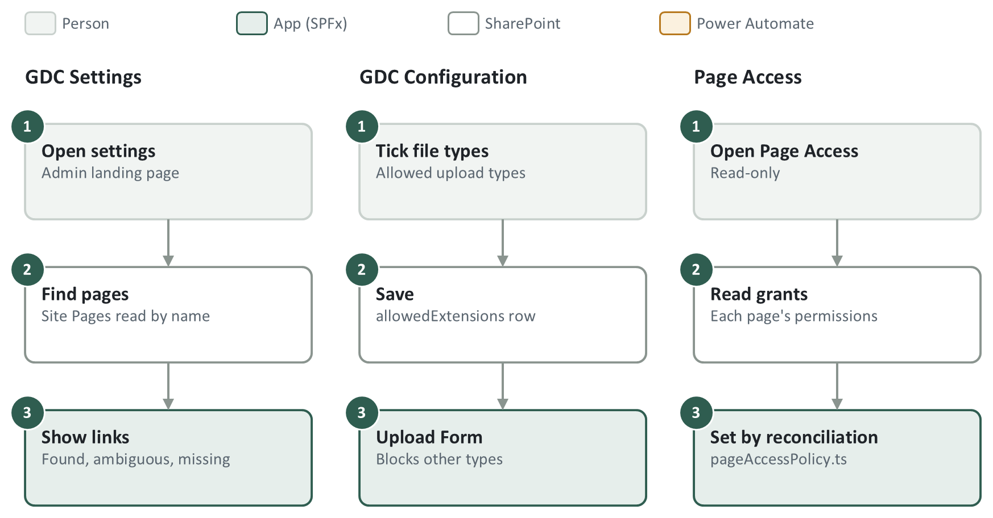
Settings, Configuration and Access pages
- GDC Settings is a directory of admin pages, found by file name at run time because the client renames pages.
- GDC Configuration edits the allowedExtensions row. Nothing ticked blocks every upload, on purpose.
- Page Access writes nothing: reconciliation sets every page grant from pageAccessPolicy.ts.

Audit Log
src/webparts/auditLog
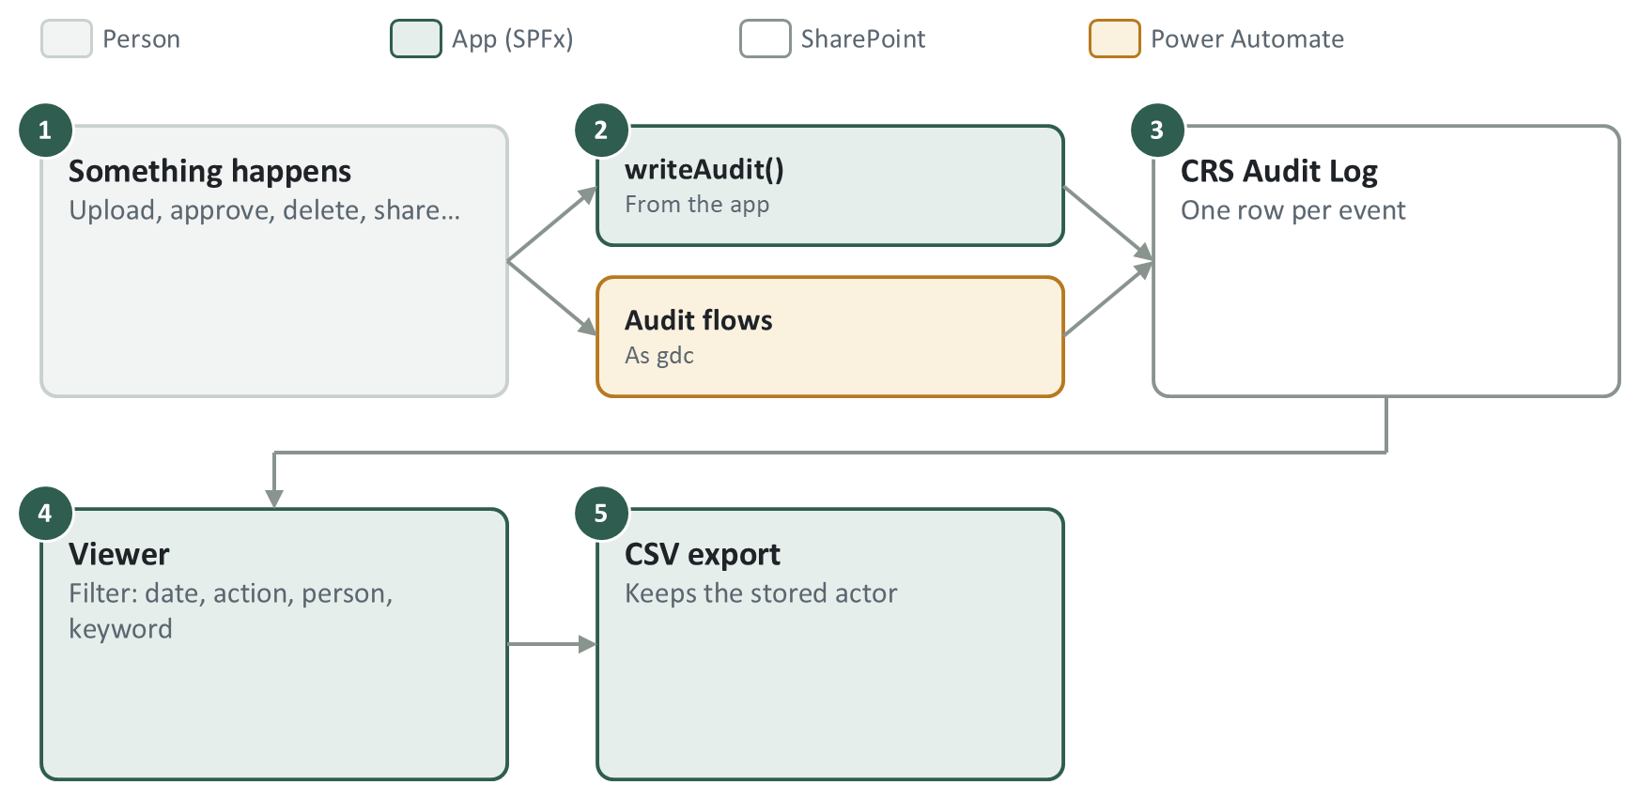
Audit Log
Every important action writes a row to CRS Audit Log, from the app (writeAudit()) or from a flow. The Audit Log page filters and exports them.
- A new event type must be added to EVENT, EVENT_LABEL and ALL_EVENT_TYPES, or it cannot be filtered.
- writeAudit() never throws and never blocks the action it records.
- EventType is a Text column, never Choice. The total is counted by walking ids (ItemCount is cached and wrong).
Start reading
- src/webparts/auditLog/components/AuditLog.tsx
- src/shared/auditLog.ts
- src/shared/spAuditLog.ts
- src/shared/displayName.ts

Extensions
src/extensions
hideAppBar (application customizer)
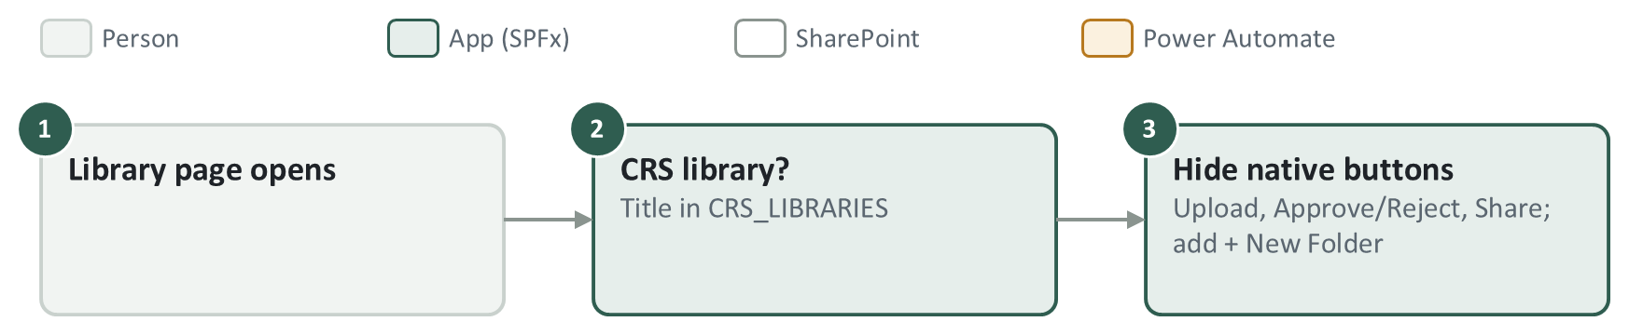
hideAppBar
bulkApprove (command set)
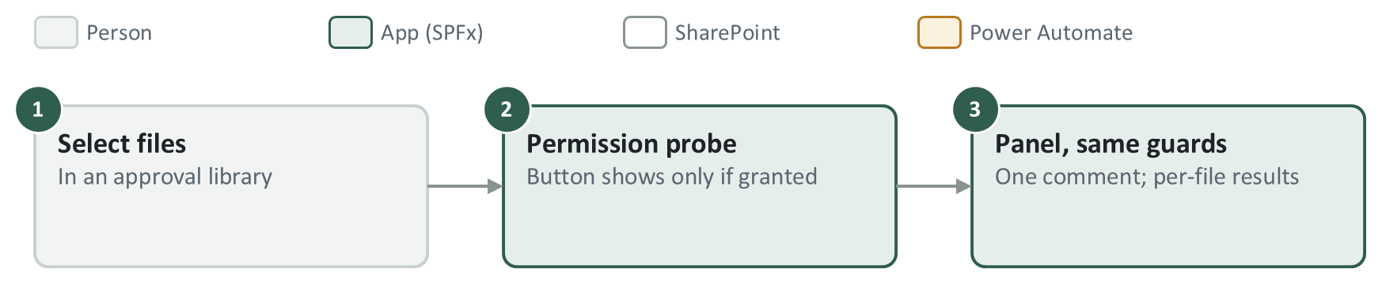
bulkApprove
- On this tenant both had to be registered by hand in /_api/web/usercustomactions (chapter 5). Two registrations load the extension twice.
- A renamed library must be added to CRS_LIBRARIES, or hideAppBar switches itself off there.
- uploadCommand is legacy: it links to an old sandbox site and is not registered. Ignore it.
Start reading
- src/extensions/hideAppBar/
- src/extensions/bulkApprove/components/BulkApprovePanel.tsx
- sharepoint/assets/elements.xml

APIs used by each component
Everything uses SharePoint REST (/_api/...) through SPHttpClient, as the signed-in user. No Microsoft Graph. Shared calls live in src/shared/sp*.ts. For how to write such a call, see docs/sharepoint-api-guide.md.
Component | Lists | Main SharePoint REST calls
Upload Form | Config, Group Map, Folder Map, Term Abbreviation, Submissions, Audit Log | /_api/v2.1/termStore/sets/{id}/children; GetFolderByServerRelativeUrl, folders/AddUsingPath; Files/Add; /items, validateUpdateListItem; EffectiveBasePermissions; approve()
Bulk Upload | Config, Group Map | Term store v2.1; Files/Add; validateUpdateListItem; currentuser
Approval Document | Approval libraries, Config | /items; approve(); MERGE OData__ModerationStatus; file lookups
Approve or reject panel | Approval libraries, Config | MERGE ApprovedBy, then MERGE OData__ModerationStatus (two requests)
My Submissions / Document-Viewer | Six libraries, Submissions, Requests, Group Map, Config | /items with $select fallback steps; validateUpdateListItem; currentuser
Requests | Requests, Config, Group Map, Audit Log | /items; creates list and columns if missing (/_api/web/lists, CreateFieldAsXml); role assignments; ShareObject
Search | Approved and archive libraries, Config, Group Map | /_api/search/query; term store v2.1; TaxonomyHiddenList
Folder Administration | Config, Group Map, Folder Map, Term Abbreviation, Submissions, Requests | Term store v2.1; folders/AddUsingPath; breakroleinheritance, roleassignments/addroleassignment; sitegroups; creates lists and columns
Group Management, access pages | Config, Group Map, Term Abbreviation, Folder Map | sitegroups (create, members, delete); ensureuser; role assignments; term store v2.1
GDC Settings / Configuration | Site Pages; Config | /items; field choices MERGE
Audit Log | Audit Log | /items; creates the list if missing

REST rules that apply everywhere
- One unknown column in $select, or one unknown field in a write, fails the whole call. Optional columns are read in fallback steps.
- validateUpdateListItem returns HTTP 200 even when a field fails: check HasException. Dates go as M/D/YYYY there, ISO in /items and $filter.
- Taxonomy values are Label|GUID. Compare terms by GUID: some labels are corrupted on the SD Guthrie tenant.
- Yes/No in $filter: 1/0, not true/false. Deep paths use GetFolderByServerRelativeUrl(@f)?@f='…'.
- A read capped with $top cannot prove something is missing: filter server-side or page it. Reads that decide an action are cache-busted.

8. Power Automate
About 25 flows do the work users are not allowed to do themselves. They are not in the code. Everything in this chapter was taken from the exports in PowerAutomateFlowsSDG/ (25 September 2026), which are the source of truth: unzip one and read definition.json.

8.1 Where the flows live
What | Detail
Owner | gdc@sdguthrie.com ("Guthrie Document Centre"), the service account. Every flow runs as it.
Environment | SD Guthrie (default) at https://make.powerautomate.com. Sign in as gdc to see them under My flows.
Connections | GDC Proxy - SharePoint (every list and file step) and GDC Proxy - Outlook (every email). Both are signed in with gdc's password.
Exports | PowerAutomateFlowsSDG/*.zip, one per flow. Re-export after every change and commit it.
Run history | Open the flow → 28-day run history. Click a run to see each step's inputs and outputs (Show raw outputs).
Site | Every flow points at https://sdguthrie.sharepoint.com/sites/CRS and at CRS list GUIDs (section 8.6).

8.2 If gdc's password changes: reconnect
When gdc's password changes, its connections break and every flow using them fails (no emails, no tagging, no routing) until they are fixed.
- Sign in to https://make.powerautomate.com as gdc@sdguthrie.com.
- Open Connections (left menu, under Data or More).
- Any connection showing Reconnect or Fix connection is broken. The two that matter are GDC Proxy - Outlook and GDC Proxy - SharePoint. Click a connection's name to see which flows use it; one no flow uses can be ignored.
- Click Reconnect and sign in as gdc with the new password. Never as yourself: the flows would then act and send email as you.
- Every flow using that connection is fixed; no flow needs editing. Open one email flow's latest run to confirm it is green.
- Runs that failed while it was broken do not re-run by themselves. Resubmit them from the run history if the missed emails or actions matter.

8.3 Flow reference
One card per flow (HC twins share a card: they are the same flow pointed at the HC libraries). "Polls" means the SharePoint trigger checks for changes on a timer, so the flow reacts up to that many minutes later.

Routing and tagging
Auto-route approved Pending files to Documents Library (+ HC Auto-route)
Trigger | An item is created or modified in Approval for Document (HC: Approval for Highly Confidential Document). Polls every 5 min. Condition: not a folder.
When approved | Creates the destination folders; if a same-named file is already approved, updates it (new version), otherwise copies the file. Stamps author, editor and dates, copies Document Type, Year, Confidentiality explicitly (a copy drops managed metadata), stamps SubmissionId, BatchId, SubmissionFileId on the copy, marks the old record ReplacedAt/ReplacedBy if it replaced a file, deletes the source, writes Approved and Routed audit rows.
When rejected | Emails the uploader with the approver's comment (OData__ModerationComments).
Emails | "Approved: <file> has been approved" to the uploader (skipped for bulk imports, self-approvals, and uploaders who are site owners). "Rejected: <file> has been rejected" to the uploader.
Watch out | The rejection email says "Rejected By: not recorded" because reject does not write ApprovedBy (known gap, chapter 11). The HC copy must point at HC libraries everywhere.

CRS — Apply pending tags
Trigger | An item is created or modified in CRS Submissions. Polls every 1 min. Condition: TagPayload is set and TagStatus is empty.
What it does | Finds the uploaded file by ItemUniqueId, writes the metadata in TagPayload to it with validateUpdateListItem (as gdc), then sets TagStatus (and TagError on failure) on the record.
Why | Uploaders do not have Edit Items, so they cannot write metadata themselves.
Watch out | If this flow is off, uploads land with no metadata and no approver email (NotifyApprovers waits for the unit tag).

CRS — Auto-approve bulk imports (+ HC auto-approve)
Trigger | Item modified in an approval library. Polls every 5 min. Conditions: not a folder, BulkImport = true, status Pending.
What it does | Sets OData__ModerationStatus to Approved. Auto-route then files it.
Watch out | BulkImport must stay visible on the library; a hidden column is missing from the trigger.

CRS — Approve new folders in Approval Document (+ HC folder approval)
Trigger | New item in an approval library. Polls every 5 min. Condition: it is a folder.
What it does | Approves the folder, so other uploaders can see and navigate it (a pending folder is invisible to them).
Watch out | Must stay on.

Approver emails and reminders
NotifyApprovers (+ HCNotifyApprovers)
Trigger | Item created or modified in an approval library. Polls every 5 min. Conditions: not a folder, not BulkImport, status Pending.
What it does | Reads the file; continues only if UnitTid is set (tagging done) and NextReminderAt is empty. Finds the unit's approver group in CRS Group Map (Role eq 'APR', HC: 'APRHC', matched on UnitTermGuid), reads its members, leaves out the uploader, and sends one email.
Emails | "Approval Requested: <file>" to the unit's approvers. Bcc gdc (the saved copy admins use if someone says they never got it).
Watch out | Site owners and admins who are approvers do get this email (client decision). The flow still contains owner/admin exclusion lookups that do nothing only because their HTTP calls lack an Accept: application/json;odata=nometadata header. Do not add that header to those two lookups: it would switch the exclusion on.

CRS — Reminding Approver to Approve (+ CRS — HC approval reminder)
Trigger | Recurrence, every 30 min.
What it does | Finds Pending files (not folders, not bulk imports) that are due: NextReminderAt has passed, or it is empty and the file is over 3 days old. For each file, finds the approver group (APR / APRHC by UnitTid), leaves out the uploader, gdc and site admins, and emails each approver separately (up to 10). Then moves NextReminderAt 3 days on, even if nobody was emailed.
Emails | "REMINDER: Approval Required for <file>" to each approver.
Watch out | Site admins do not get reminders (kept as is, 30 Sep 2026). The email's link points to ApprovalDocument.aspx; the CRS page is Approval-Document.aspx.

CRS — Notify approvers (bundled) · generated, live on the test site only
Trigger | Recurrence, every 5 min.
What it does | Reads tagged Pending files from both approval libraries (last 3 days) whose CRS Submissions record has no ApproverNotifiedAt. Waits while an upload is still arriving. Groups by upload and unit. HC approvers (APRHC) get all files and both library links; plain approvers (APR) get only the normal files and one link. Then sets ApproverNotifiedAt on each record.
Emails | "Approval Requested: <file>" or "Approval Requested: N documents", in the client's template. Bcc gdc on CRS is still a client decision.
Replaces | NotifyApprovers and HCNotifyApprovers. Switch-over: add the trigger condition @empty(coalesce(triggerOutputs()?['body/SubmissionFileId'], '')) to both, so they only handle old files without a record.
Built by | scripts/build-bundled-approver-flow.py (section 8.6). Needs the column ApproverNotifiedAt on CRS Submissions.

CRS — Remind approvers (bundled) · generated, tested on the test site
Trigger | Recurrence, every 30 min, one run at a time.
What it does | Same due rule as the old reminder. When any file of an upload is due, reminds about all that upload's pending files in one email per audience, and resets NextReminderAt to now + 3 days on all of them (so an upload never splits into two reminders).
Emails | "REMINDER: Approval Required: <file>" or "… N documents", same template and audiences as the bundled approver email. Leaves out uploader, gdc, site admins.
Replaces | The two old reminder flows: turn them off when this one goes on. They share NextReminderAt, so there is no gap or double reminder.
Built by | scripts/build-bundled-reminder-flow.py. Testing helper: scripts/make-reminder-due.js.

Requests (delete and share)
CRS — Notify request activity
Trigger | Item created or modified in CRS Requests. Polls every 5 min.
What it does | Works out the event (new delete or share request, approved, rejected). New request: finds the approver group from CRS Group Map and emails it. Decision: emails the requester (skipped when the requester decided it themselves). Approved share: emails the person it was shared with.
Emails | "Approval Needed to Delete File: <name>" and "File Sharing Request: <name>" to approvers (Bcc gdc). "Approved / Rejected File Deletion Request" and "Approved / Rejected File Sharing Request" to the requester. "A document has been shared with you: <name>" to the recipient.
Watch out | It fires on every edit of a row, so editing an Approved row by hand re-sends its emails. Status Revoked sends nothing.

CRS — Execute approved deletion
Trigger | Item modified in CRS Requests. Polls every 1 min. Acts only when RequestType is Deletion and Status is Approved.
What it does | Checks the file's ETag still matches the request's TargetETag (it was not changed since), recycles the file as gdc, writes a Deleted audit row (once), and updates the request's Status / DecisionNote when it cannot.
Why | Nobody holds a delete permission; every delete goes through this flow.

CRS — Expire shares
Trigger | Recurrence, daily at 02:00 (Singapore time).
What it does | Finds approved Share requests whose ExpiresAt has passed, removes each recipient's access to the file (unless another approved share still covers them), then sets the request to Revoked (RevokedBy = gdc).
Watch out | A blank ExpiresAt means permanent: never touched.

Archive and search
CRS — Archive after seven years (+ CRS — HC Archive after seven years)
Trigger | Recurrence, weekly (Singapore time).
What it does | Finds approved documents created more than 7 years ago, creates the same folder path in the Archive library, moves each file (a move keeps its UniqueId), restores its fields, resets its permissions to the archive's, stamps ArchivedAt on its CRS Submissions record, and writes an audit row.

CRS — Nightly library reindex
Trigger | Recurrence, every 6 hours (despite the name).
What it does | Changes and restores the NoCrawl setting on the four approved and archive libraries, which makes SharePoint search re-crawl them, so Search results stay current.

Audit
Audit — approval activity (+ HC)
Trigger | Item created or modified in an approval library. Polls every 5 min. Not a folder.
What it does | Writes an Uploaded or Rejected audit row (approvals are written by Auto-route), once per file and event. The actor is the uploader for Uploaded, ApprovedBy (or the editor) for Rejected.

Audit — approval deletions, Documents deletions (+ HC versions: four flows)
Trigger | Item deleted from an approval or approved library. Polls every 5 min. Not a folder.
What it does | Reads the recycle bin for who deleted it and when, and writes a Deleted audit row. The approval-library versions skip files Auto-route just moved (a Routed row in the last 5 min).

CRS — Audit request activity · CRS — Audit replacements
Trigger | Audit request activity: CRS Requests modified, polls every 5 min. Audit replacements: CRS Submissions modified, polls every 5 min, only when ReplacedAt is set.
What it does | Writes request events, and Replaced events, to CRS Audit Log, once each.

8.4 Columns the flows depend on
Renaming, deleting or hiding one of these columns breaks a flow silently. Check this table before changing a list.
Where | Column | Used by (R = reads, W = writes)
Approval libraries | BulkImport | R: NotifyApprovers (trigger), Auto-approve bulk imports (trigger), reminders, Auto-route (email skip). Must stay visible.
Approval libraries | UnitTid | R: NotifyApprovers, reminders, bundled flows (approver group lookup).
Approval libraries | NextReminderAt | W: reminder flows. R: NotifyApprovers, bundled approver email, bundled reminder.
Approval libraries | ApprovedBy | R: Auto-route (approver name, self-approval check), Audit approval activity. Written by the app.
Approval libraries | OData__ModerationStatus, OData__ModerationComments | W: Auto-approve, Approve new folders. R: Auto-route (decision, rejection comment), NotifyApprovers.
Approval libraries | SubmissionId, BatchId, SubmissionFileId | R: Auto-route (copied to the approved file), bundled flows.
Approval libraries | Document_x0020_Type, Year, Confidentiality_x0020_Level | R: Auto-route (copied explicitly), emails.
Approved libraries | SubmissionFileId, Created | R: Archive flows (7-year cutoff, ArchivedAt stamp), Auto-route (replacement).
CRS Submissions | TagPayload, TagStatus, TagError, ItemUniqueId | R/W: Apply pending tags.
CRS Submissions | ReplacedAt, ReplacedBy | W: Auto-route. R: Audit replacements.
CRS Submissions | ArchivedAt | W: Archive flows.
CRS Submissions | ApproverNotifiedAt, SubmissionRef, UploadedAt | R/W: bundled approver email.
CRS Requests | RequestType, Status, ItemUniqueId, RequestedBy, DecidedBy, ShareWith, ExpiresAt, TargetETag, UnitTermGuid, DecisionNote, RevokedBy | Notify request activity, Execute approved deletion, Expire shares, Audit request activity.
CRS Group Map | Role, UnitTermGuid, GroupId | R: NotifyApprovers, reminders, Notify request activity, bundled flows.
CRS Audit Log | Title, EventTime, EventType, Outcome, ActorName, ActorEmail, Source, LibraryName, ItemUniqueId, ItemName, ItemPath, Details, Segment, UnitPath | W: every audit flow, Auto-route, archive flows, Execute approved deletion.

8.5 Emails the system sends
All are sent as gdc through GDC Proxy - Outlook. Emails to addresses outside SD Guthrie are blocked by the tenant's mail-flow rule; the bounce lands in gdc's inbox (SD Guthrie IT must add an exception).
Subject | Sent by | To | Bcc
Approval Requested: <file> | NotifyApprovers (+ HC) | Unit approvers (site admins included), not the uploader | gdc
REMINDER: Approval Required for <file> | Reminder flows | Each approver separately (max 10); not uploader, site admins, gdc | —
Approved: <file> has been approved | Auto-route (+ HC) | Uploader (not for bulk imports, self-approvals, owner uploaders) | —
Rejected: <file> has been rejected | Auto-route (+ HC) | Uploader | —
Approval Needed to Delete File: <name> | Notify request activity | Unit approvers | gdc
File Sharing Request: <name> | Notify request activity | Unit approvers | gdc
Approved / Rejected File Deletion Request | Notify request activity | Requester (not if they decided it themselves) | —
Approved / Rejected File Sharing Request | Notify request activity | Requester (not if they decided it themselves) | —
A document has been shared with you: <name> | Notify request activity | The share recipient(s) | —
Approval Requested: <file> / N documents | Bundled approver email (test site) | APRHC / APR audiences | gdc (client deciding)
REMINDER: Approval Required: <file> / N documents | Bundled reminder (test site) | Same audiences, minus site admins | As above

8.6 How-tos

Export and back up a flow
- Open the flow as gdc → Export → Package (.zip).
- Give it a name, click Export, and save the zip into PowerAutomateFlowsSDG/ (replace the old one).
- Commit it. Do this after every change: the export is the only record of what the flow does.

Import or update a flow
- My flows → Import → Import Package (Legacy) → choose the zip.
- For each resource, pick Create as new (first time) or Update (to overwrite the existing flow).
- Under Related resources, pick the gdc connections (GDC Proxy - SharePoint / Outlook).
- Import, open the flow, save, and turn it on.

Point a flow at another site
Each export names CRS's site URL and CRS list GUIDs. Either change every SharePoint action's Site Address and List Name in the designer, or replace the URL and each GUID in definition.json before importing. Get the other site's GUIDs from <site>/_api/web/lists?$select=Title,Id&$filter=Hidden eq false. The CRS GUIDs are:
List | CRS list GUID
Approval for Document | eeb1bb19-ec53-4c41-8dc9-ecf255979c9b
Approval for Highly Confidential Document | d935aa6d-dc48-4832-ba7e-eca485ecdff3
Restricted & Confidential Document | fbc062dd-fcd0-4458-9161-2bfc19c917fa
Highly Confidential Document | 122a4aa9-65fb-479a-90a7-3866d19f51b4
Archive Restricted & Confidential Document | 647fd644-ab00-4358-9b3f-49031083fcf0
Archive Highly Confidential Document | fc301054-abf5-4e53-957a-6f8c58a410b8
CRS Submissions | dd1bc5bd-daa7-491a-9dc7-b81212c391ab
CRS Requests | 1bcb1aa1-fbf1-4d1b-a6d2-88436824c297
CRS Audit Log | 4ac219e5-b855-46a3-be4b-4e96bba546c5

Some actions name lists by title instead (e.g. getbytitle('CRS Group Map')); those keep working if the other site uses the same titles.

Make the HC copy of a flow
- Open the normal flow → Save As, name it with HC.
- Change every library reference to its HC twin: triggers, Get items, HTTP URIs (getbytitle(...) and lists(guid'...')), and links in emails. Role APR becomes APRHC.
- Re-export and search definition.json for the normal library names and GUIDs: every HC copy so far has kept at least one. Item IDs are per list, so a missed reference acts on the wrong file.

Read run history and resubmit
- Open the flow → 28-day run history. Red = failed.
- Open a run; the failed step is red. Expand it and use Show raw inputs / outputs to see the exact request and response.
- To re-run with the same trigger data, use Resubmit on the run.

Rebuild a generated flow
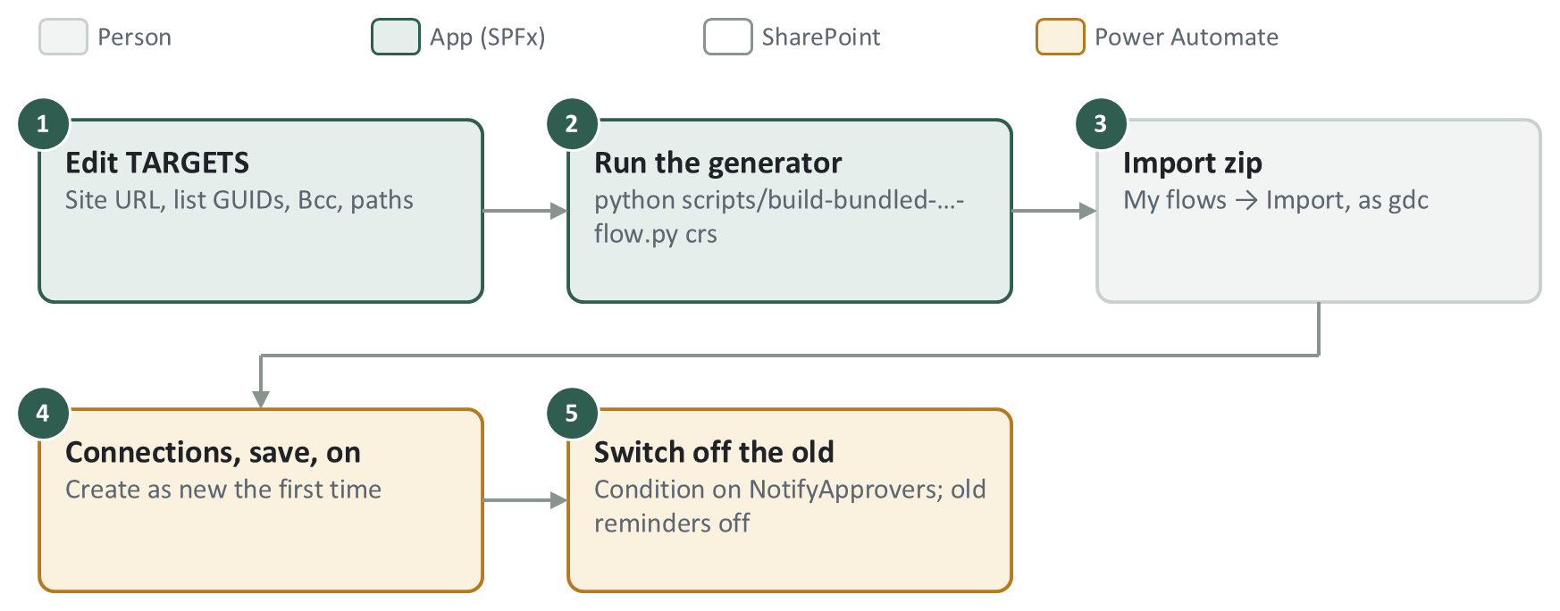
Rebuilding the bundled approver email or reminder
- Edit TARGETS in scripts/build-bundled-approver-flow.py (site URL, list GUIDs, bcc, base export path and output path). The reminder script reuses it and adds its own OUT paths.
- Run python scripts/build-bundled-approver-flow.py crs or python scripts/build-bundled-reminder-flow.py crs.
- Import the zip as gdc (Create as new the first time, Update afterwards), pick the connections, save, turn on.
- For the approver email: add ApproverNotifiedAt (Date and Time, include time) to CRS Submissions first, and the switch-over condition to NotifyApprovers and HCNotifyApprovers after. For the reminder: turn off the two old reminder flows.

Turn a flow off safely
- A Recurrence flow that is off catches up on its next run. A trigger flow that is off does not see changes made while it was off.
- Never turn off Apply pending tags, Auto-route or Approve new folders on the live site except for a short, announced window.

8.7 Rules for editing flows
- Build, import and edit flows signed in as gdc, and export to PowerAutomateFlowsSDG/ after any change.
- HTTP header names have no colon (Accept, not Accept:). With a colon the header silently does nothing.
- Always send Accept: application/json;odata=nometadata, or ?['value'] quietly comes back empty (except the two deliberate NotifyApprovers lookups, 8.3).
- Writing a field re-triggers every other "created or modified" flow on that list. Check what else listens first (8.4).
- The connector's Update item action rewrites every column. For one field use an HTTP MERGE.
- Never MERGE OData__ModerationStatus together with another field (SharePoint returns 500).
- Type expressions in the fx box and never press Enter in it: a pasted line break breaks the expression. A 0 typed into a Condition is text; enter numbers through fx.
- A green run does not prove the logic is right. Re-export the flow to confirm an edit landed.
- gdc must stay in the site's Owners group. Removing it breaks tagging, notifications and routing at once.

9. Set up a test site
Copy the structure of CRS (lists, libraries, columns, views, pages, config rows) with PnP PowerShell, then deploy the app, create the groups and import the flows. No documents are copied. Plan about a day. These steps have not yet been run end to end on a fresh site, so tick each check as you go.
- Create the site and get access. Create a Team site (e.g. /sites/CRS-Test). Add the service account to its Owners. Ask a SharePoint admin for a site App Catalog: Add-SPOSiteCollectionAppCatalog -Site <test site URL>.
- Terms. Same tenant: in CRS's term store, open the CRS site collection term group and add the test site under Site Collection Access, so it uses the same term sets and GUIDs. Another tenant: Export-PnPTermGroupToXml / Import-PnPTermGroupFromXml (keeps term IDs).
- Deploy the app first (chapter 5), then Site contents → New → App → sd-gatrie-client-side-solution. The copied pages contain its web parts. Then register the extensions if missing (chapter 5).
- Copy the structure. PnP PowerShell needs an Entra app registration once per tenant (Register-PnPEntraIDAppForInteractiveLogin). Then run the commands below. Leave Group Map and Folder Map empty (the app refills them); do not copy site security.
Connect-PnPOnline -Url https://sdguthrie.sharepoint.com/sites/CRS -Interactive -ClientId <app id>
Get-PnPSiteTemplate -Out crs.pnp -Handlers Fields,ContentTypes,Lists,Pages,Navigation -IncludeAllClientSidePages
Add-PnPDataRowsToSiteTemplate -Path crs.pnp -List "CRS Config"
Add-PnPDataRowsToSiteTemplate -Path crs.pnp -List "CRS Term Abbreviation"

Connect-PnPOnline -Url <test site URL> -Interactive -ClientId <app id>
Invoke-PnPSiteTemplate -Path crs.pnp
- Check the settings: content approval On for both approval libraries (drafts visible only to approvers and the author) and Off for both approved libraries; BulkImport visible; NextReminderAt on both approval libraries and ApproverNotifiedAt on CRS Submissions (Date and Time, include time); every page published and named as on CRS.
- Groups and folders (in the app, as Owner): Group Management → Bulk Provisioning; add test users (an uploader and an approver who are not site admins); then Folder Administration → Folder Reconciliation.
- Flows: import them pointed at the test site (8.6). Minimum set: Apply pending tags, Approve new folders (+ HC), NotifyApprovers, Auto-route (+ HC), Auto-approve bulk imports (+ HC).
- Smoke test: upload a file as the uploader (metadata fills in, approver gets an email), approve it (it moves to the approved library within about 5 minutes), check My Submissions.

10. Troubleshooting
Most problems on this project turned out to be a stale browser tab, the wrong site, or a flow. Check in this order:
- Which site? Live and test sites have different list GUIDs, term GUIDs and data.
- Which build? Hard refresh; compare the app version in Site contents with package-solution.json.
- Real error. Browser F12: Console, and the Network tab's status and response body.
- Is it a flow? Open the flow's run history as gdc; check the gdc connections (8.2).
- Live data. Run a scripts/check-* or diagnose-* script in the F12 console.
Symptom | Usual cause
Web part blank, no error | A React hook placed below an early return (React error #310).
A library "disappeared" after a rename | New title missing from src/shared/naming.ts (and CRS_LIBRARIES).
Uploaded file has no metadata | Apply pending tags failed or is off; check the record's TagStatus / TagError.
No approval or reminder email | Flow off or failed; gdc connection broken; the person is the uploader or (reminders) a site admin; or an external address blocked by the tenant.
Uploaders cannot see each other's folders | Folder still pending: Approve new folders must be on.
New member has no access | They must sign out and in; or reconciliation has not run for their group.
Items or groups missing from a screen | A $top-capped read; filter server-side or page it.
Write returned 200 but nothing changed | validateUpdateListItem reported a field error inside the 200 (HasException).

11. Open items at handover

Ready to roll out on CRS (tested on the test site)
- Deploy package 1.0.578.0 (CRS runs 1.0.575.0).
- Bundled approver email: add ApproverNotifiedAt to CRS Submissions; build and import it; then add the switch-over condition to NotifyApprovers and HCNotifyApprovers.
- Bundled reminder: build and import it; turn off the two old reminder flows; turn the new one on.

Waiting on someone
- Client: keep or drop gdc as Bcc on the bundled emails (bcc in TARGETS["crs"]).
- SD Guthrie IT: a mail-flow exception so flow emails can reach addresses outside SD Guthrie.

Known gaps (accepted for now)
Gap | Effect
Reject does not record who rejected | The rejection email says "Rejected By: not recorded". Fix: write ApprovedBy in its own MERGE before the reject, in ApprovalDocument.tsx and BulkApprovePanel.tsx.
Reminders skip site admins who are approvers | Kept as is (decided 30 Sep 2026). The first approval email does include them.
Notify request activity fires on every edit | Editing an Approved request row by hand re-sends its emails.
Old reminder email's link | Points to ApprovalDocument.aspx; the CRS page is Approval-Document.aspx. The bundled reminder fixes this.
Taxonomy labels corrupted on the tenant | Some stored labels show a number. The code compares by GUID.

