1. Table should not be expanded when page loads -> Completed
2. Submit button to be disabled and Grayed out🡪 Completed

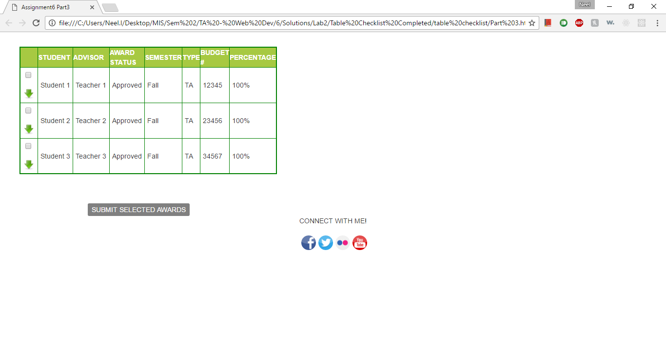

1. On selecting any of the check-boxes, background color to be changed for the particular row and Submit button to turn Orange. -> Completed
2. Deselecting the check box will make the row white again. Also, if none of the rows are selected, the Submit button should be Grayed out again(disabled). (i.e., if 1 or more of the check-boxes are selected, the Submit button will be enabled and background color will be orange. If none are selected, it will be disabled and background set to Gray) -> Completed

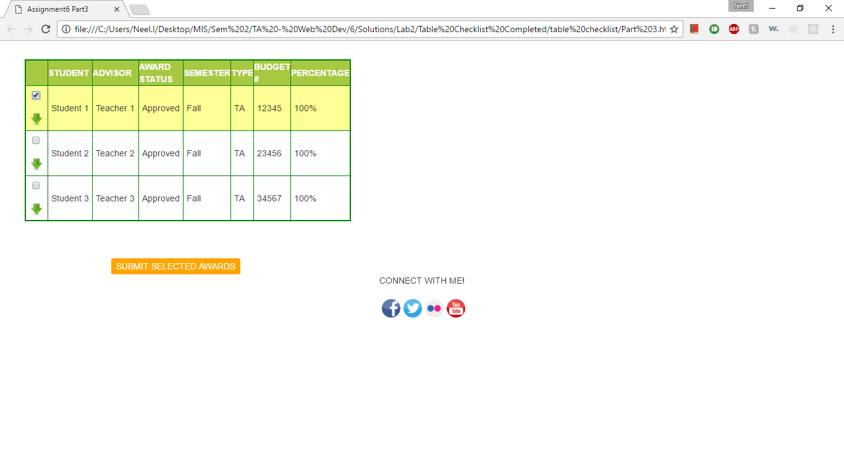

1. Clicking on any of the green arrows will expand the particular row. Clicking it again will collapse it (i.e., toggle view on click) -> Completed

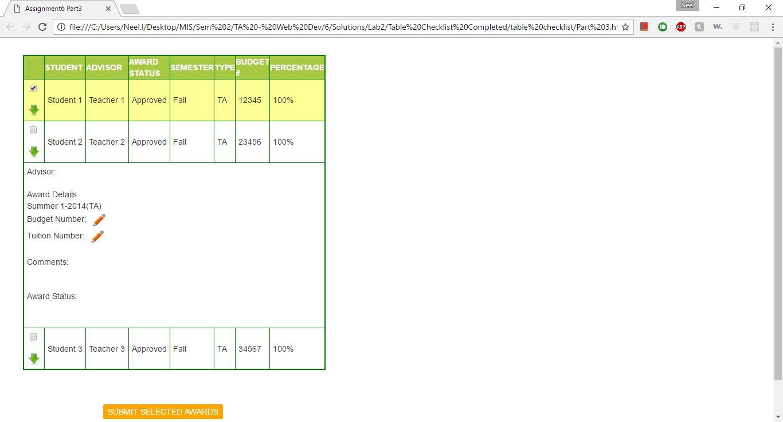

1. Create a social-media footer using prototype. Skeleton provided in html and js files

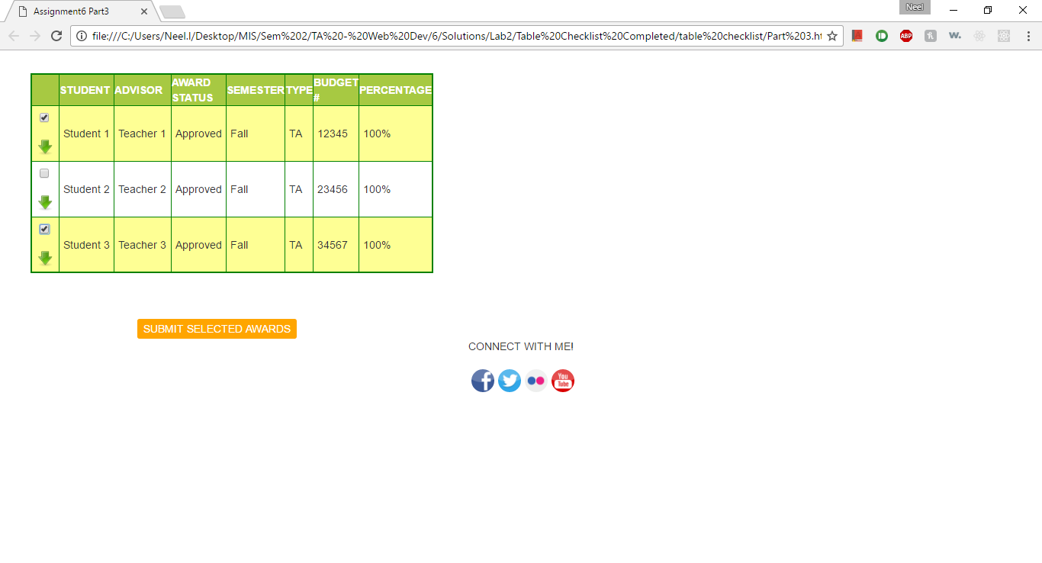

1. Read up on chapter 9 from Javascript book