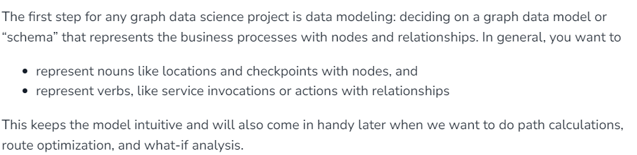

<https://neo4j.com/developer-blog/supply-chain-neo4j-gds-bloom/>

* Bookmarks
* Reading / read & write sessions
* transactions.