# Overview

* Neo4j act as a database.
* Apollo server is specifically designed to work with GraphQL APIs.
* GraphQL define the types, queries and mutations that make up the API.
* Node.js runs an HTTP server that handles incoming request from clients including GraphQL queries.
* Apollo clients sends GraphQL queries to the Node.js server.
* Apollo server receives the request and execute queries against the Neo4j database.
* Response will be returned to the clients.

# Prerequisites

* **How to install Neo4j?**
  + <https://neo4j.com/docs/operations-manual/current/installation/>
* **How to install Nodejs?**
  + <https://nodejs.dev/en/learn/how-to-install-nodejs/>

# Setup Neo4j Database

* + Step 1C: Create Project.

* + Step 2C: Create Local DBMS and fill in credentials.

* + Step 3C: Import *“load-movies.cypher”* to files.
  + Step 4C: Open file and run.

* + Step 5C: Generate schema of database using neo4j/Graphql-toolbox.
    - <https://neo4j.com/docs/graphql-manual/current/toolbox/>

# Setup Apollo Server

* + Required Packages:
    - [*@neo4j/graphql*](https://www.npmjs.com/package/@neo4j/graphql) *== 3.17.0*
    - [*Graphql-request*](https://www.npmjs.com/package/graphql-request) *== 5.2.0*
    - [*Apollo-server*](https://www.npmjs.com/package/@apollo/server) *== 3.11.1*
    - [*Neo4j-driver*](https://www.npmjs.com/package/neo4j-driver) *== 5.6.0*
  + Step 1D: Import packages.

* + Step 2D: Create driver for neo4j including URL *(localhost or other severs’ IP)*, username, and password.

* + Step 3D: Copy neo4j schema that was obtained from the toolbox and store as a constant.

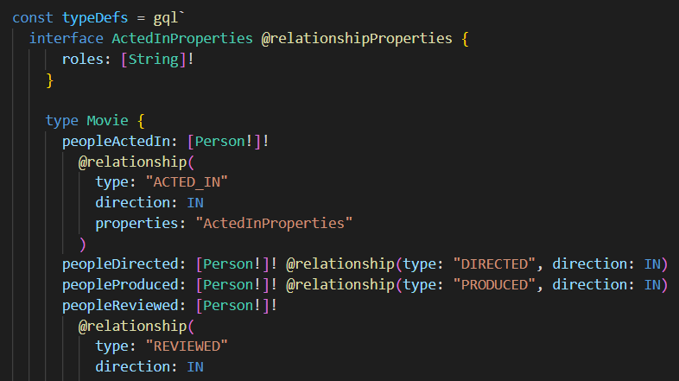

* + Step 4D: Combine schema and driver.



* + Step 5D: Run server.

# Setup Apollo Client

* + Step 1E: Import packages.



* + Step 2E: Define Graphql Query.
    - *Query can be replaced by self-defined query using the apollo client as shown in the below section* [*“More Information”*](#_(D)_More_Information:)

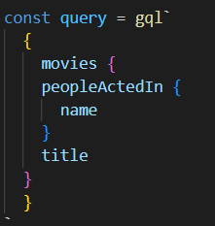

* + Step 3E: Connect to Apollo Server.



* + Step 4E: Obtain result.

# More Information:

* **To create custom GraphQL Query**
  + Step 1F: Point to Apollo Server as stated in Node.js console.



* + Step 2F: Create custom query from the provided fields.

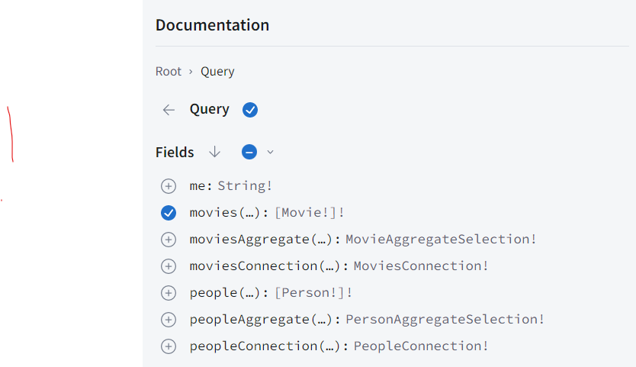

* + Step 3F: Verify auto produced query on side screen (ensure no red curly lines in query).

* + Step 4F: Run the query to obtain results in JSON format (or CSV format).

* + Step 5F: Include the GQL query to client code or store as *‘*.gql’*.

# Summary

*Steps 1E – 4E*

*Steps 1F - 5F*

*Steps 1D – 5D*

*Steps 1C - 5C*