1. **Introduction.**

Attendance is an important factor in an organization or event in achieving goals [1]. Attendance will affect the discipline of participants in order to gathering information about quality of human resources [2]. The traditional method for attendance is by using paper and signatures [1]. But this method has its own challenges, such as taking more time queue the participant to look for their name on the paper to sign it and vulnerable to fake attendance [3].

In the accordance to regarding matters, an attendance management system is required to assist an organization or event on monitoring, tracking, and managing attendance of participant. There are several methods like face recognition [2], fingerprint recognition [4], DNA Matching [5] used to manage participants’ attendance, but they have their own pros and cons [6]. For instance, face recognition-based student attendance system used in [2] can be very effective in managing attendance, but not every organization or event able to afford the installation and the price of this method [1].

Addressing the corresponding matters, a QR code-based system is introduced. A simpler method offered by Farhana in [3], expected to have a secure, systematic, accurate, and effective event management application using One Time Password and QR Code. The model incorporates a web-based system and a smartphone app for monitoring student participation at events in a comprehensive, precise, and reliable manner. It used the One-Time Password (OTP) and Quick Response Code (QR Code) security elements and algorithms. One-Time Password is used for registration. The machine uses QR codes to keep track of attendance. Other similar solution in [7] enhance the model in [3], by implementing Time-based One Time Password and QR Code. A stationary hardware token, a smartphone app, and a verification server are the three key components of the proposed framework in [7]. The stationary hardware token is a stand-alone device. The mobile app will be mounted on the service providers' employees' smartphones and will be used to mark their attendance, by scanning the latest OTP in QR code format derived from the hardware token. The TOTP (Time-based One-time Password Algorithm) algorithm is used in the authentication process, therefore the model in [7] is expected to have a better level of security.

1. **Description.**

We created an Attendance Management System to help Event Organizer to record and summarize participant attendance on Offline Events where attendance is important. As a result, we proposed Attndr. Attndr is a web-based framework as well as a mobile application to record participants attendance at events. The mobile application is to be installed on the participants’ smartphones and will be used to record their attendance, by scanning the OTP in a form of QR Code displayed on the website managed by the event administrator. So, there will be two types of user in our application, consist of Administrator or Event Organizer which will be managing the web-based Attndr, and Participant which will be using the mobile application Attndr to record their attendance.

The Unique Value Proposition of our product / application is that we focus on developing an Attendance Management System which is cost-efficient but also robust. We utilize Event OTP Concept in the form of QR Code as a tool to record participant attendance. Event OTP means, the participant need to enter their credential such as mobile phone number, to generate the QR Code. Since it is implementing OTP concept, the QR Code generated is guaranteed to be unique and only valid for one login session only. It is known that both QR Code and OTP are cheap technology and easy to use. In addition, when they are combined in our system, it could sustain a basic participant attendance monitoring device that can be used to take attendance that is both fast, affordable, efficient, and accurate as opposed to other methods.

1. **Feature.**

Feature in Web-based Attndr:

1. Register for Event Administrator
2. Login for Event Administrator: Remember me, Forgot password
3. Add New Events : List of participants could be added using .xlsx or excel file
4. View Upcoming Events (in table) : Search Events, Sort Events.
5. View Upcoming Event Details : Event details including list of participants in table.
6. Delete Upcoming Event
7. View Done Events (in table) : Search Events, Sort Events, Pagination
8. View Done Event Details : Event details, Event summary, list of attendees in table with each participant login and logout timestamp.
9. Start Event : Generate QR Code for participants
10. Server Time display
11. Profile and Logout

Feature in Mobile App Attndr:

1. Join Event: Scan QR Code from web attndr.
2. Show Event detail: Show event detail after succesfully scan QR Code
3. Log Out: Logout time would be stamped
4. Edit Name: Edit display name in application
5. **Use Case Diagram**

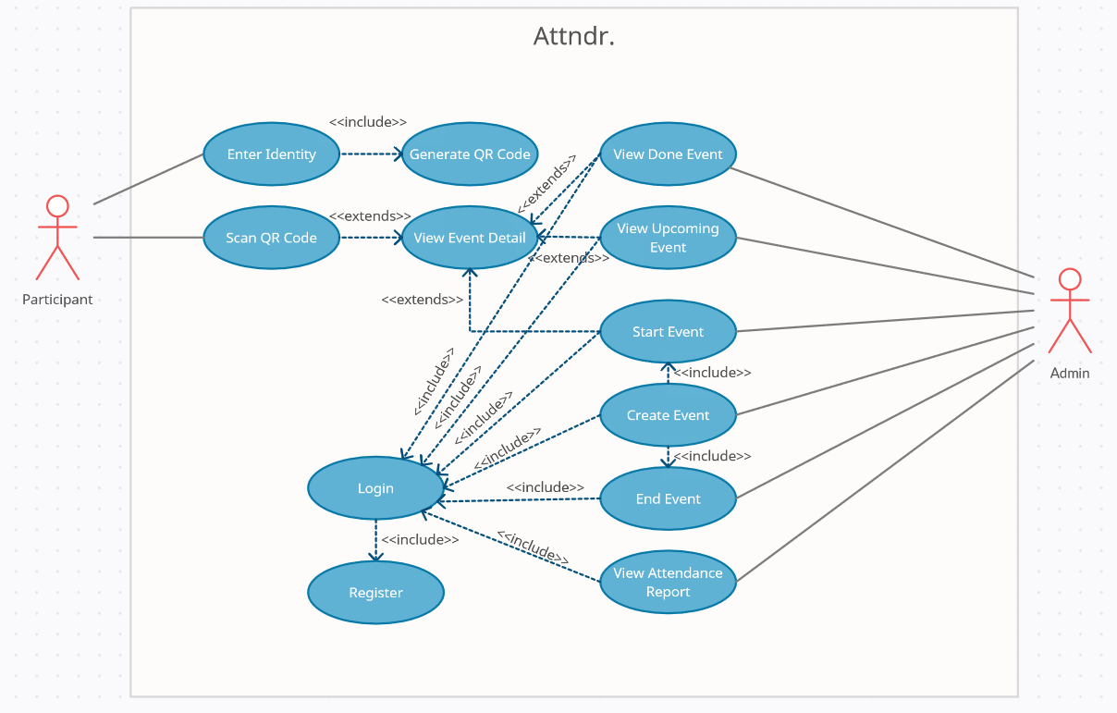

1. **Complexity**

Flow Chart Web-based Attndr:

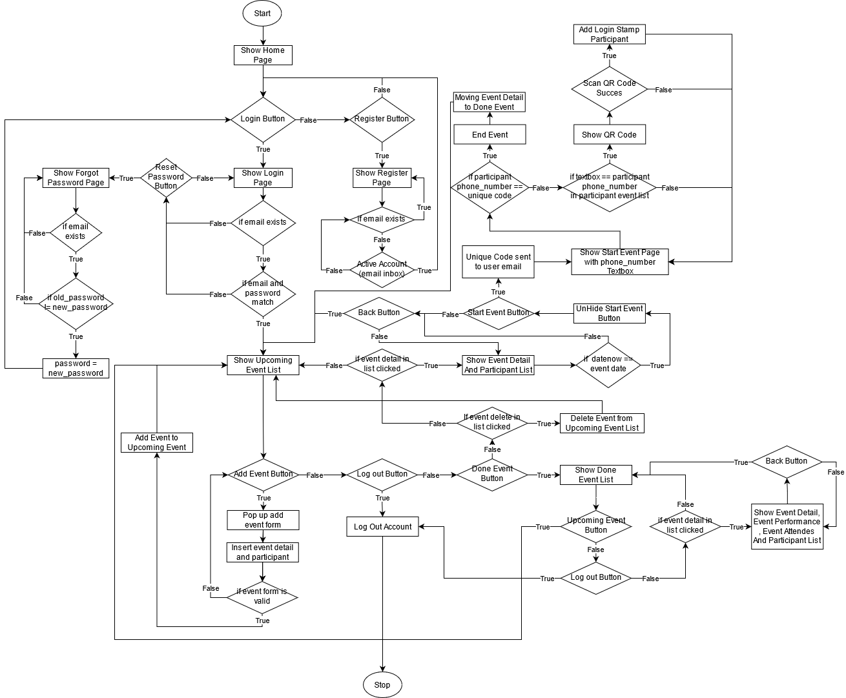

Flow Diagram Web-based Attndr for calculating complexity using cyclomatic complexity

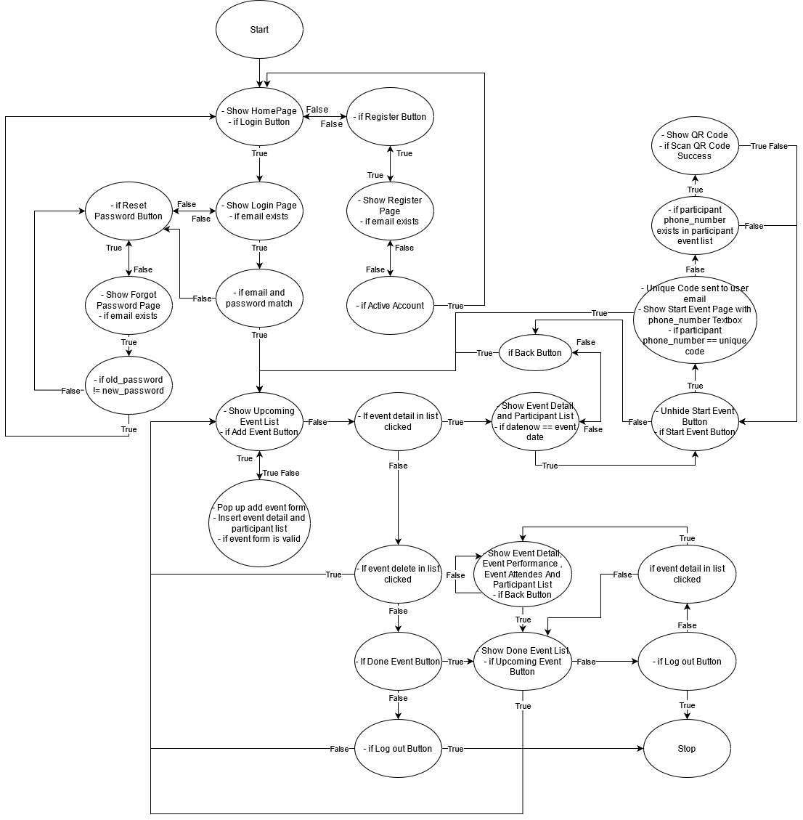

The complexity of Web-based Attndr (**M**) is defines as

Where,

So, complexity of Web-based Attndr is

Flow Chart Mobile Application Attndr:

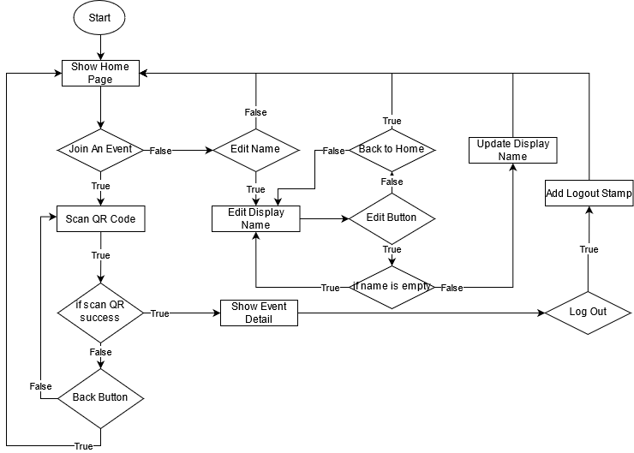

Flow Diagram Mobile Application Attndr for calculating complexity using cyclomatic complexity

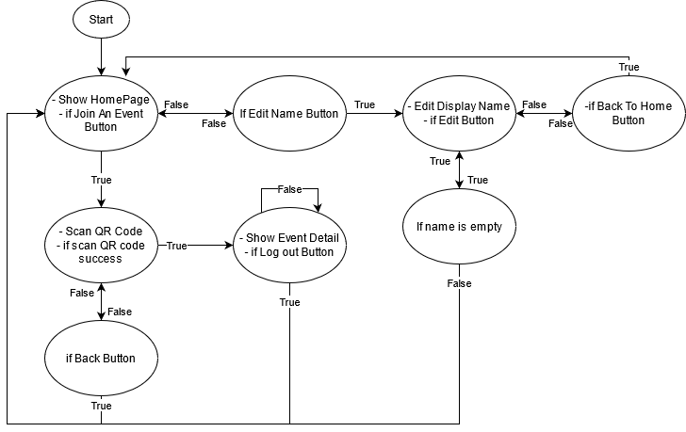

The complexity of Web-based Attndr (**M**) is defines as

Where,

So, complexity of Web-based Attndr is

1. **Effort Estimation (FP Analysis)**

Function point analysis (FPA) is one method for determining a system's overall complexity. It quantifies the functions contained within software in terms that are meaningful to the software users. The main objective of FPA is to measure and provide the functional size of a software program to a client, customer, or stakeholder upon request. Function Point (FP) itself is a unit of measurement used to describe the amount of business functionality provided to a user by an information system (as a product). At this stage Attndr is assessed using FPA for complexity, to calculate the effort estimation.

The attendance management system database is a relational database of MariaDB version 10.4.11 (or lower). The tables are defined with primary keys, foreign keys, unique index, and auto-increment. No triggers or stored procedures are implemented in the system database. Next, the web-tier of the system is a web-based application created using a Python and Node.js framework, namely Django version 3.2.4 (Backend) and Vue.js version 3.0.11 (Frontend) respectively. The architecture implemented is Model View Template (MVT). On the other hand, the mobile application of the attendance management system is an android based application version 7.0 Nougat, which is developed using Android SDK Tools version 26.1.1 (Android Software Development Kit). The architecture used on developing the android application is Model View ViewModel (MVVM).

As mentioned before, the system will be evaluated using Function point analysis (FPA). Initially, the five Information Domain Value will be determined. They consist of, internal logic files (ILF), external interface files (EIF), external Input (EI), external output (EO) and external inquiry (EQ).

**Internal logical files (ILF):** Entity count in the relational database schema.

**External interface files (EIF):** a

**External input (EI):** a

**External inquiry (EQ):** a

**External output (EO):**

1. **Screen shots of your running application**

**Web-based Attndr**

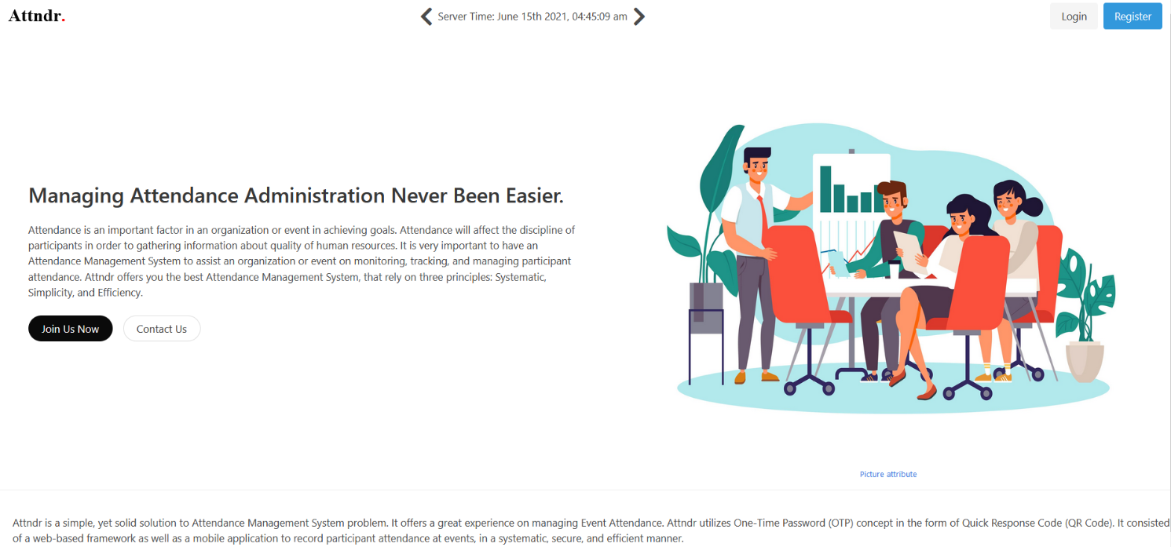

Figure 1. Home Page For Guest

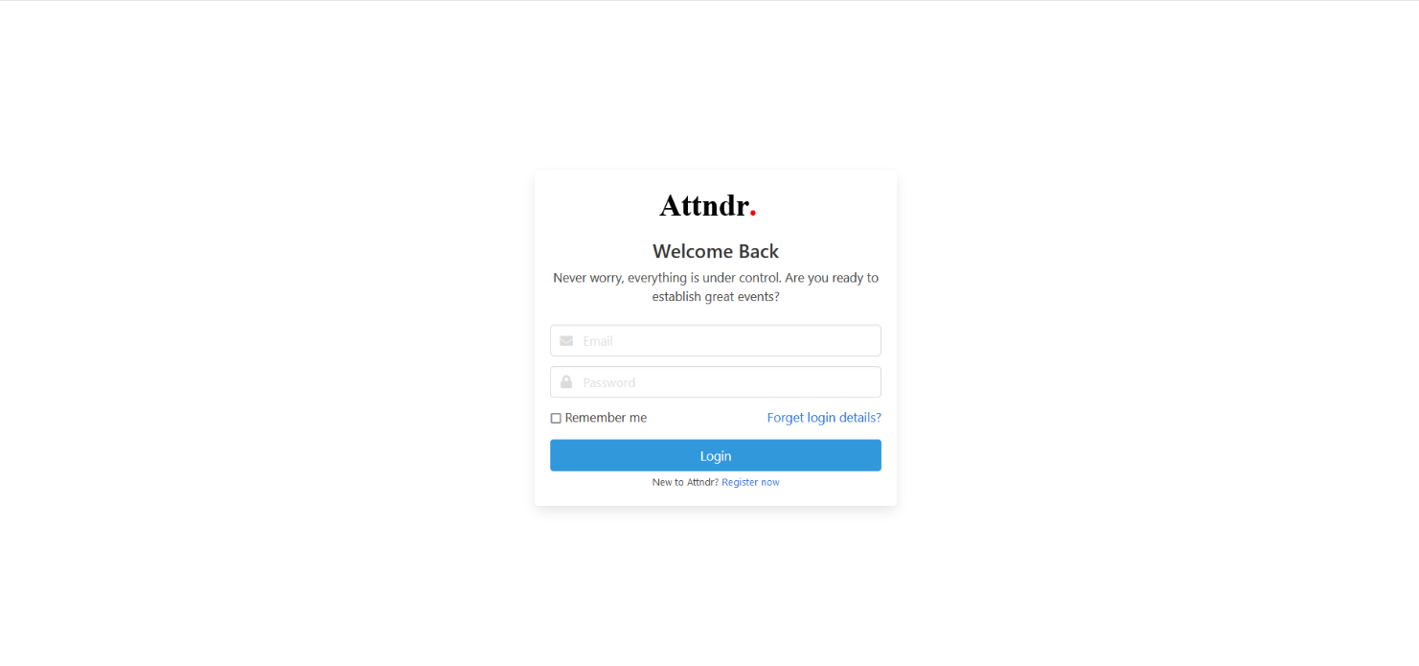

Figure 2. Login Page For Guest

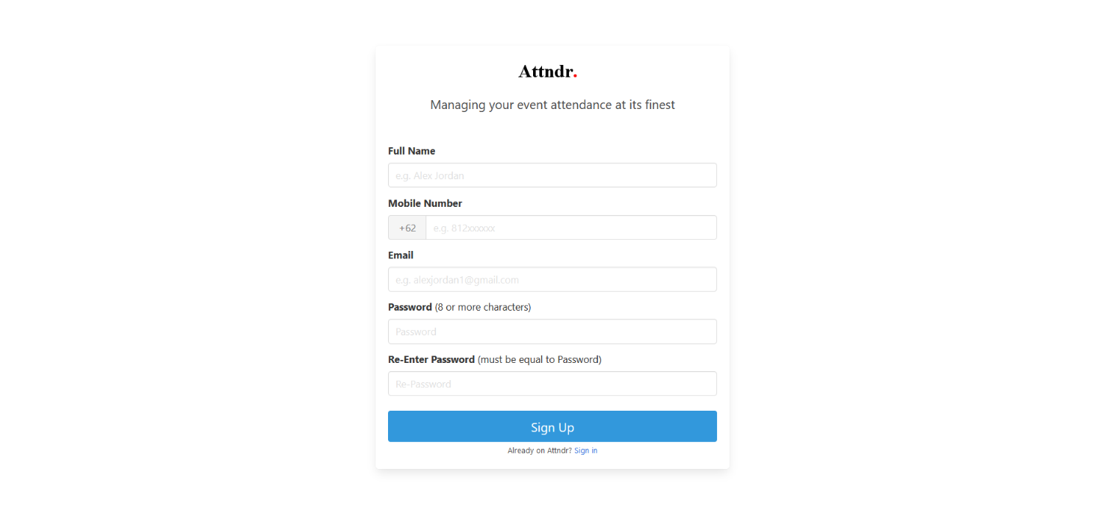

Figure 3. Register Page For Guest

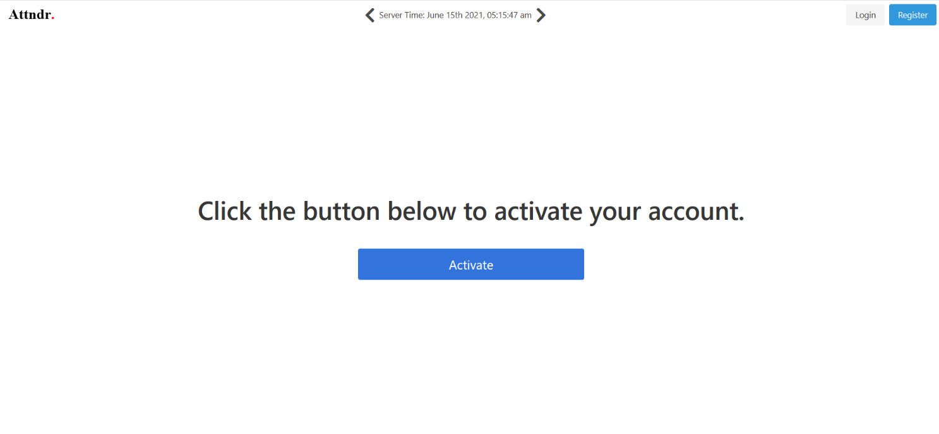

Figure 4. Active Account Page For New Registered user (Can be obtained in inbox email)

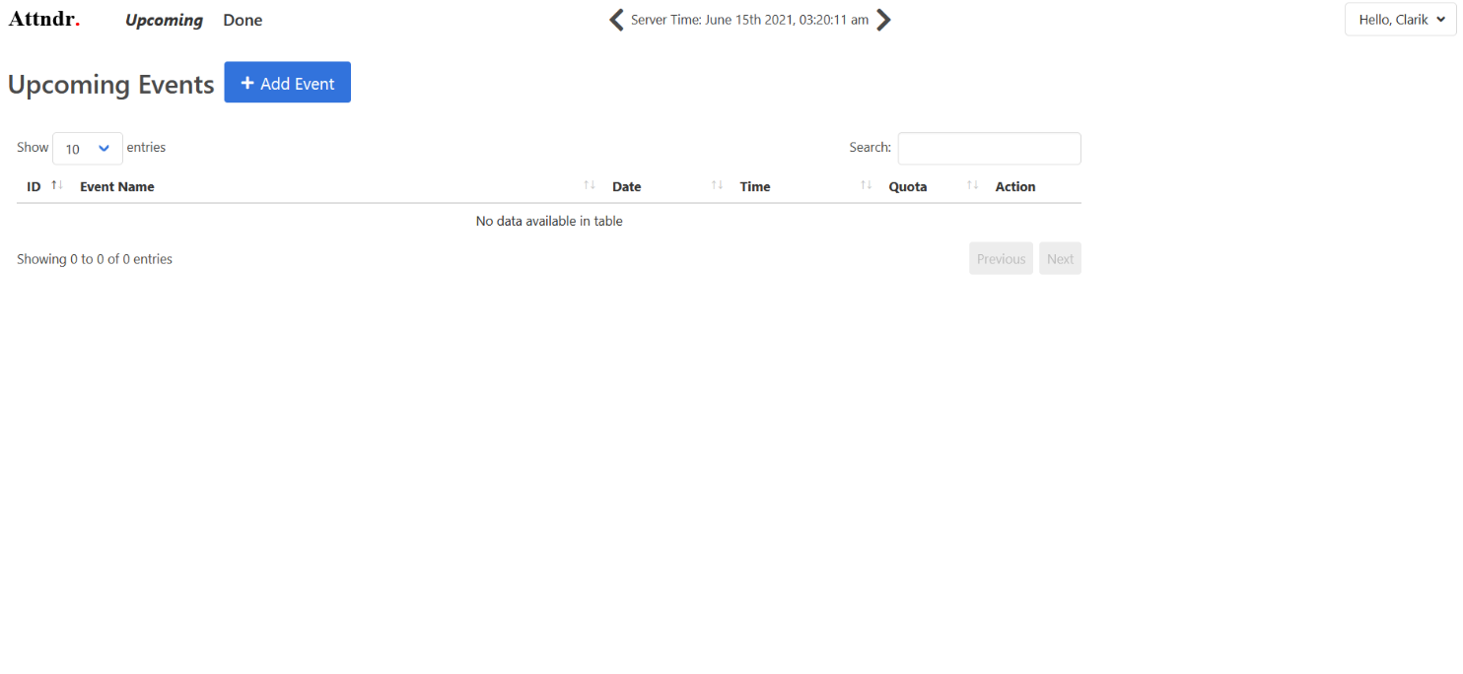

Figure 5. Home Page for logged in user (Upcoming Event)

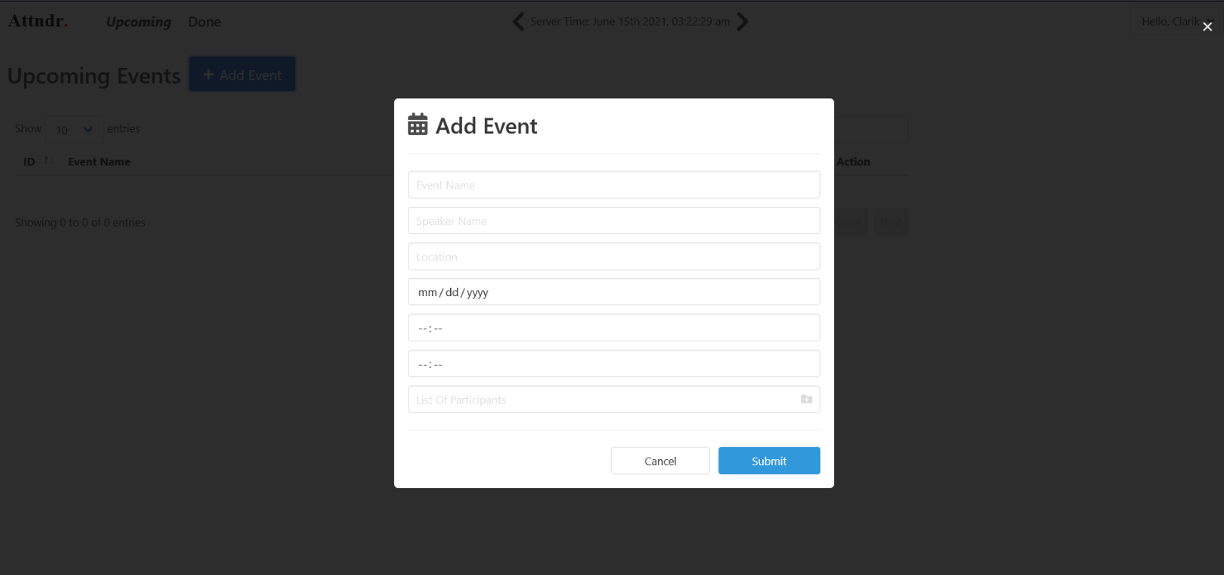

Figure 6. Pop-up Form Add Event (Pop up will appear after add event button in Upcoming Event Page is clicked)

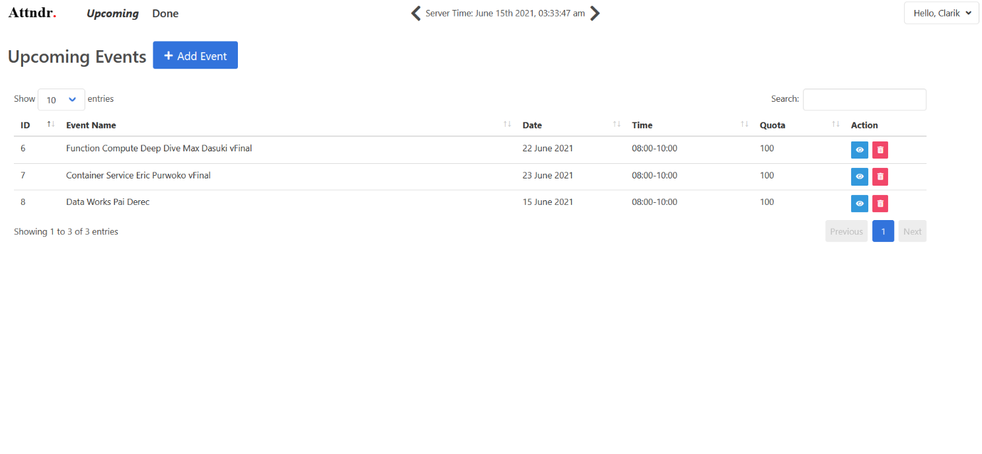

Figure 7. Upcoming Event List (User added events)

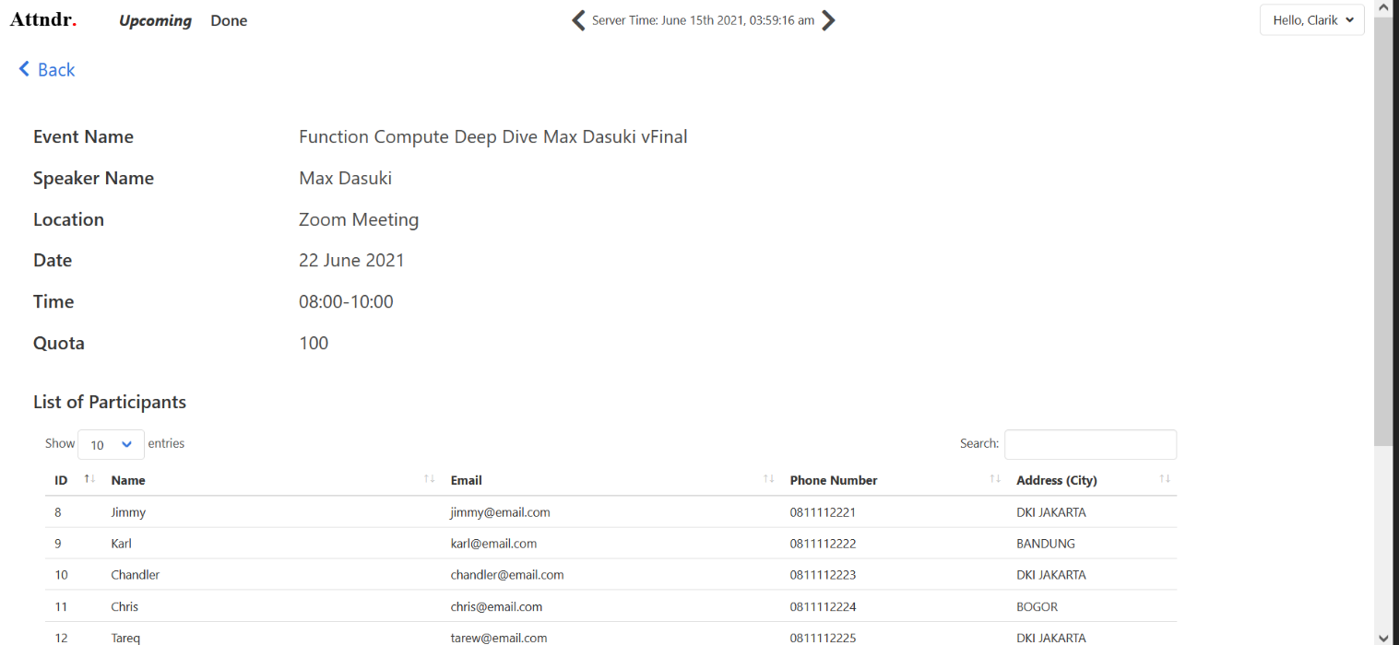

Figure 8. Upcoming Event Detail with the list of participant (Start Button will appear if the date now is same as event start date)

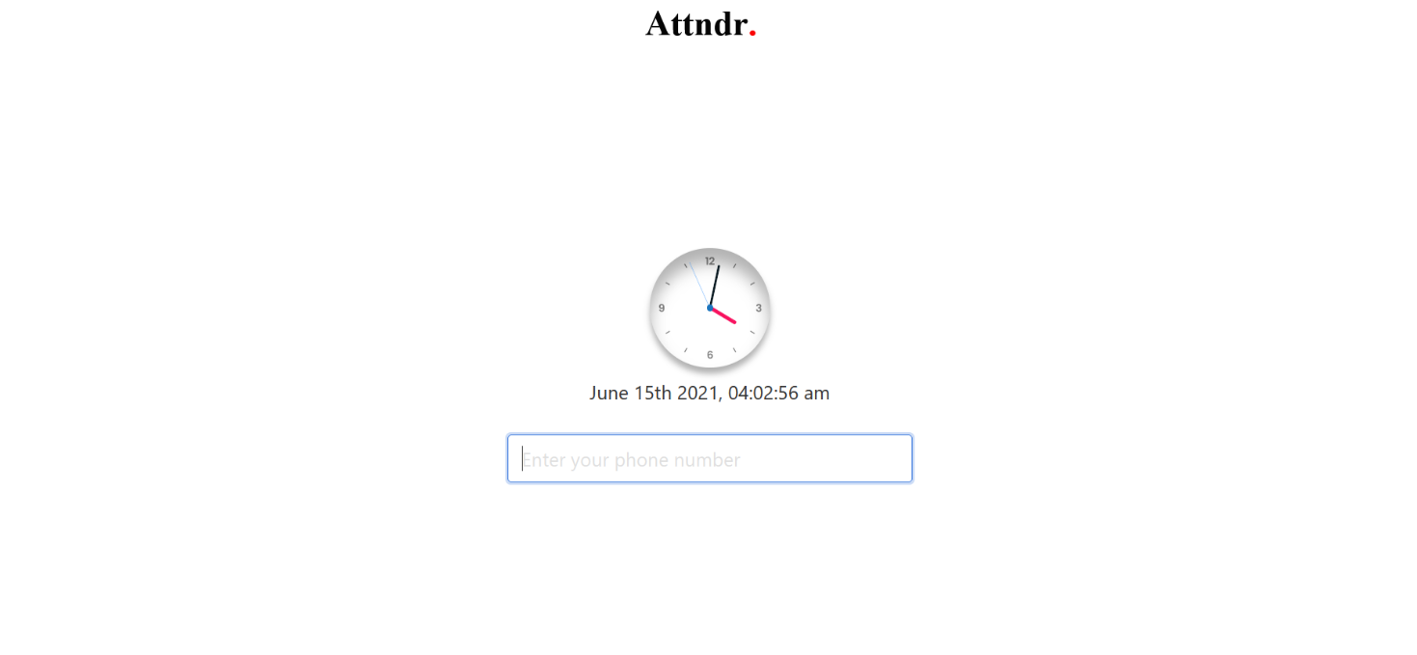

Figure 9. Event Start Page (After start event button has been clicked, event organizer will got unique code on their email for end attendance event, Participant must enter their phone number to get their attendance QR Code, if event organizer enter their unique code into the textbox, attendance event will end automaticly)

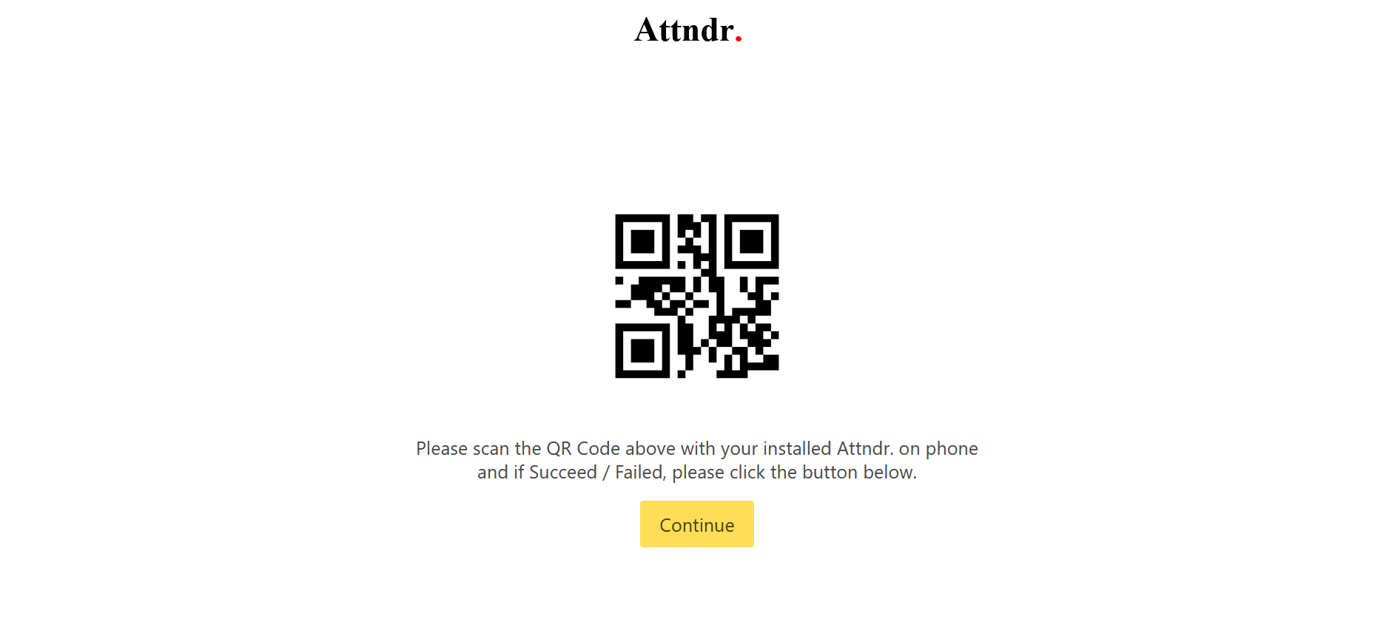

Figure 10. QR Code Show For Event (Participant must scan the QR Code with Attndr Mobile Application)

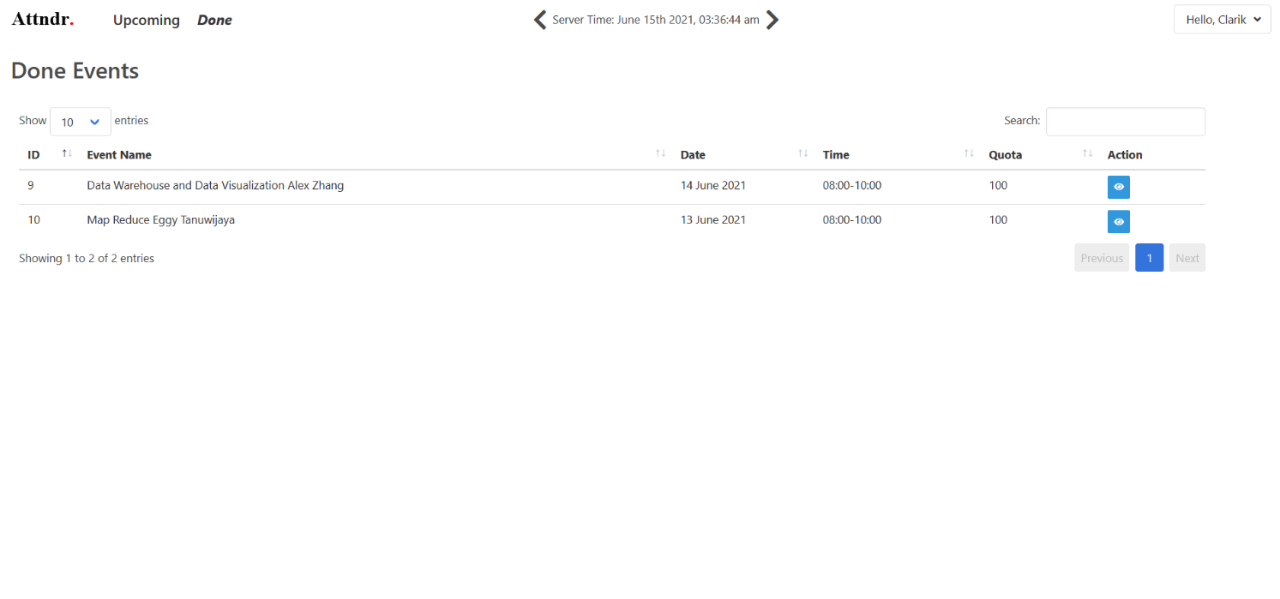

Figure 11. Done Event List (Completed event)

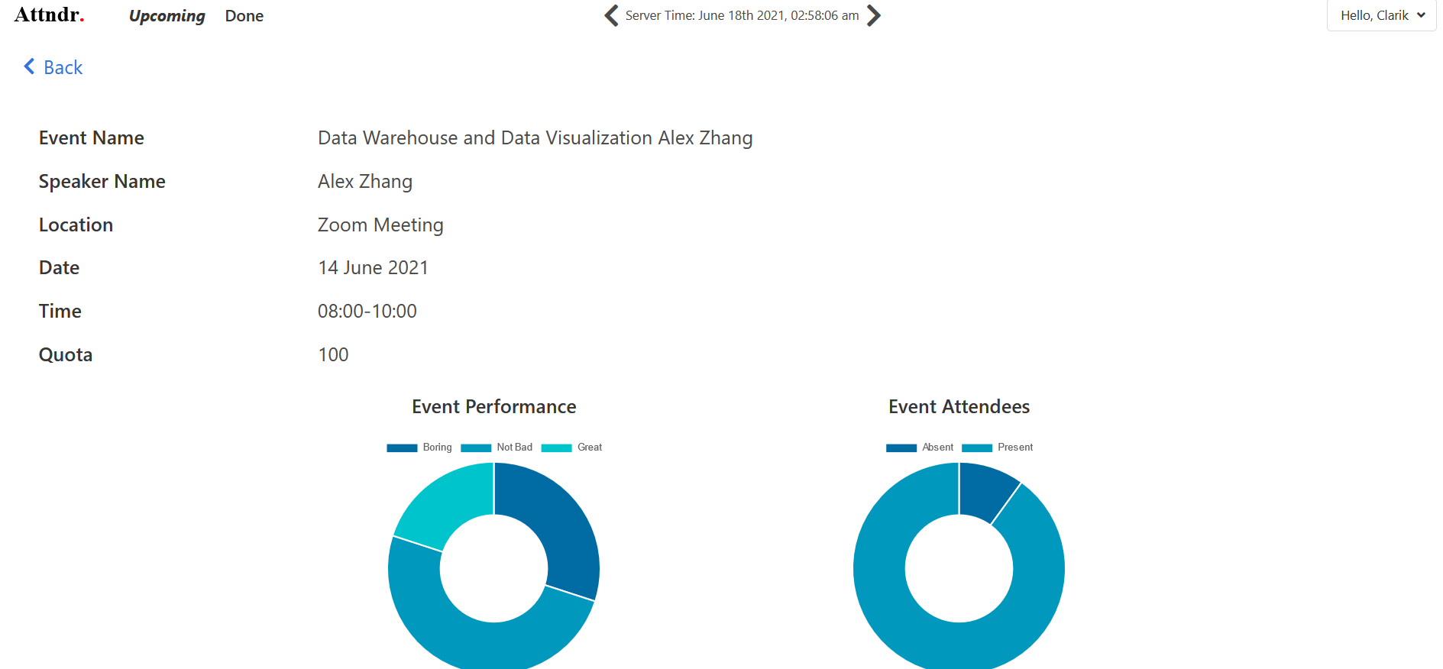

Figure 13. Done Event Detail

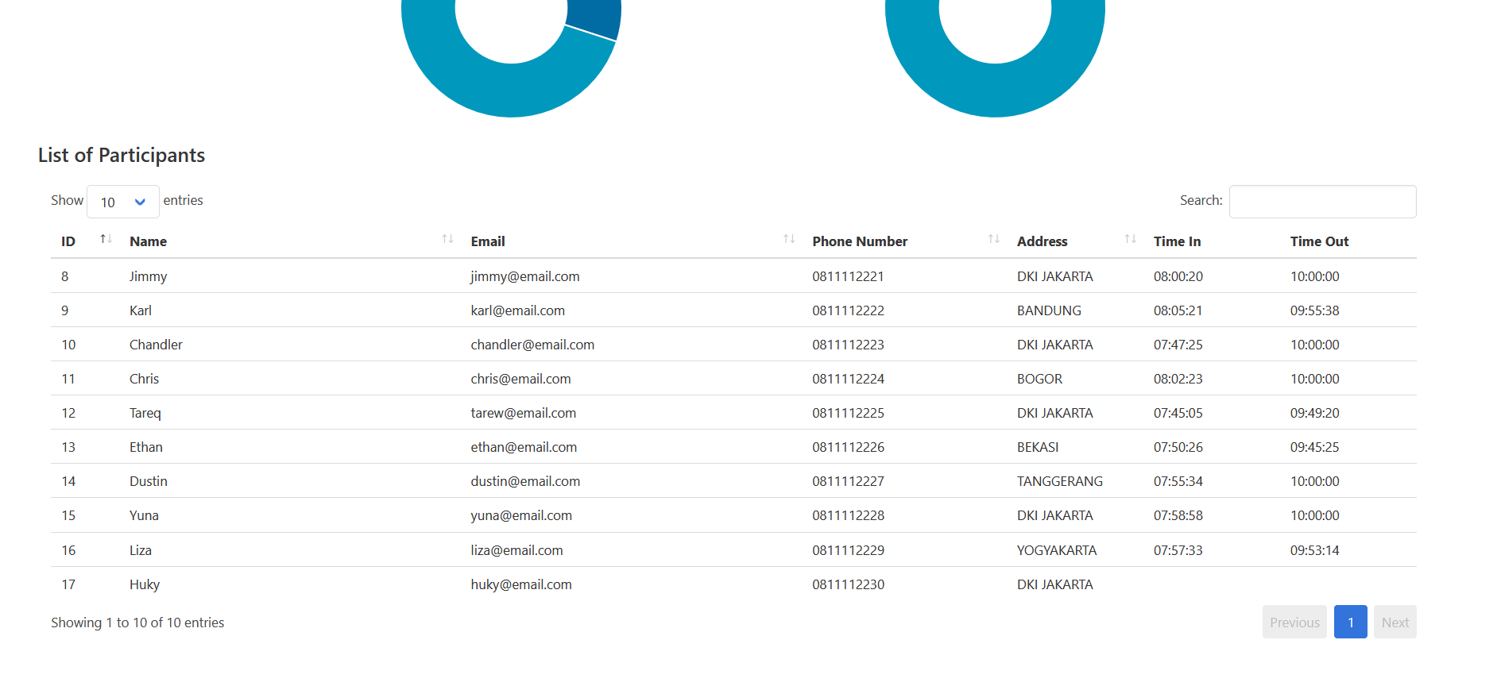

Figure 14. Done Event Detail Participant List

**Mobile Application Attndr**

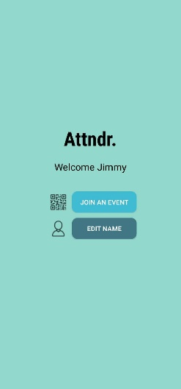

Figure 15. Home Page of Attndr Mobile Application

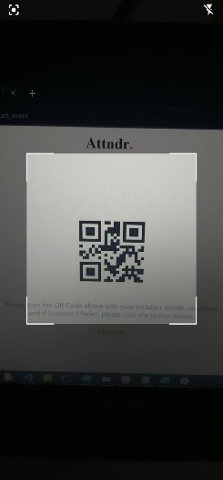

Figure 16. Scan QR Code With Mobile Camera (Camera will be opened after join an event button in homepage is clicked)

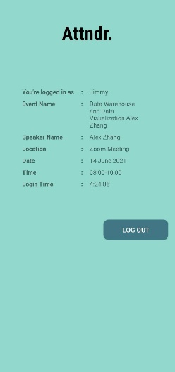

Figure 17. Scan QR Code With Mobile Camera

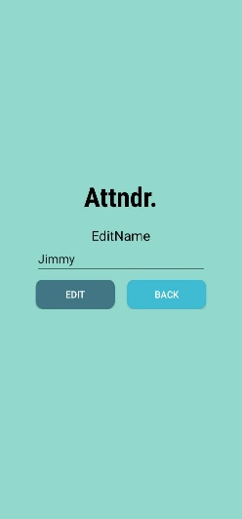

Figure 18. Edit Display Name Page

1. **Conclusion**