

Customers, reports and deposits
You do not move containers. You look after the relationship: who has what, what is late, what is owed, and the report that shows a customer what their year looked like.
Who this is for | Sales and account managers
Reading time | Ten minutes
What you need | A laptop or a phone, and your work email address
The golden rule | Every number you quote comes from the record, so you never have to hedge

What you actually do in here
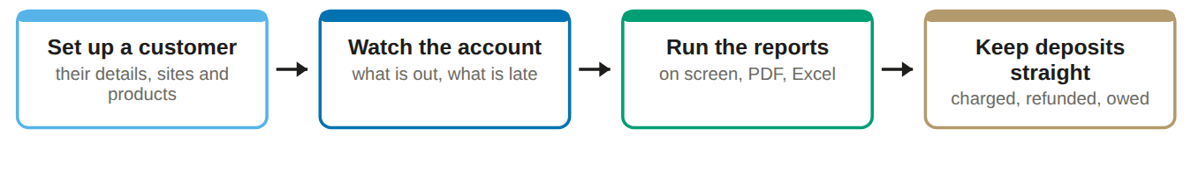
The report is the sales tool. A customer who receives a clear monthly report stops treating containers as somebody else's problem, and your overdue list gets shorter without a single phone call.

Your home screen
Reports first, because that is what you are here for.
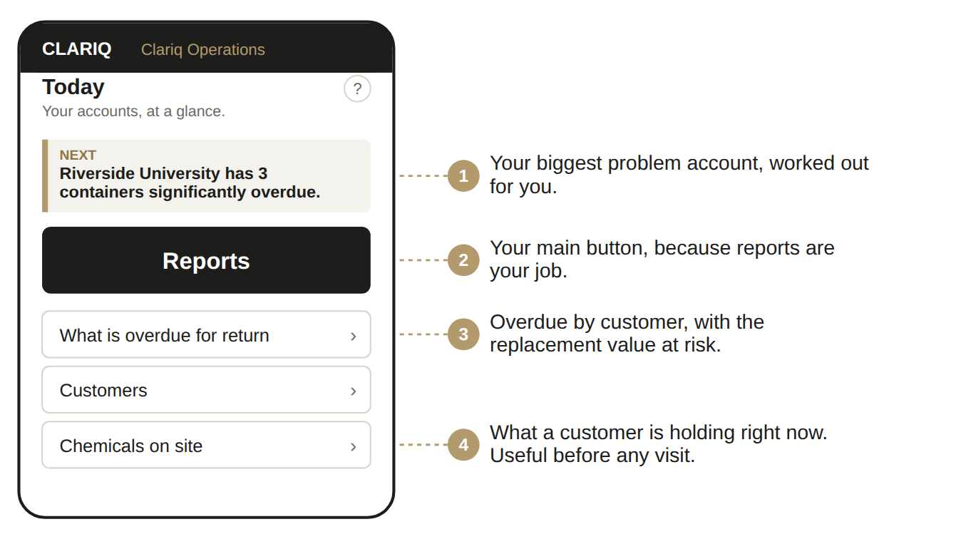

Signing in, once
1. Open clariq-hub.netlify.app in your phone browser
Type clariq-hub.netlify.app into Safari or Chrome. There is nothing to install.
2. Type your work email address, tap Send me a link
There is no password to remember. Clariq emails you a link that signs you in.
No email after a minute? Look in junk mail. The sender is Clariq.

3. Add Clariq to your home screen
iPhone: share button, then Add to Home Screen. Android: three dots, then Install app. After that it is one tap, and you stay signed in for 30 days.

Setting up and looking after a customer
1. Menu, then Customers and their sites
Add the customer: legal name, trading name, contact, email, phone. Clariq gives them a number such as CUS-0004.
2. Add their sites
One per delivery address, with the delivery and collection instructions that actually matter to a driver.
Note: if the customer runs Clariq themselves, their sites belong to them and you will see them rather than create them.

3. Add the products they buy
With the safety data sheet link. That link is what their staff see when they scan a container.
4. Agree the return arrangement and the deposit
Per container, on account, or none. It drives the deposits ledger and what appears on their report.
5. Consider inviting them as an organisation
That gives them their own Clariq, their own register and their own people. It is the difference between a customer who returns containers and one who runs a process. Ask an Admin if you cannot see the option.
The overdue conversation, made easy
Open What is overdue for return, filter to your customer, and you have the number of containers, the days outstanding and the replacement value at risk. That is a factual conversation rather than an awkward one.

The reports, and what each is for
Report | What it shows | Use it for
Report for a customer | Their containers, cycles, returns, what is still out, by site where they have more than one | Monthly account contact, contract review
Chemicals on site | What they are holding right now and where | Before a visit, and for their safety people
Reuse results | Reuse and recovery figures for the period | Their sustainability reporting, and your proposals
Deposits | Charged, refunded, forfeited and the balance | Billing queries

How to talk about the reuse figures
They are labelled prepared with reference to the measurement framework of ISO 59020:2024. Say exactly that. It means the figures follow the structure of the international standard for measuring circularity, and it does not claim anybody has certified them.
If a customer asks whether Clariq is certified, the answer is no, and the next sentence is the strong one: nobody in this market is, and anyone who says they are should be asked who assessed them and when.

✓ You can
• Add and edit customers, sites and products
• Run and export every report
• See the deposits ledger
• See every container and where it is

✗ You cannot
• Fill, dispatch, wash or inspect anything
• Change roles, people or settings
• Edit a recorded event
• See inside a customer organisation's own records

Chemicals we do not supply
Menu, Reports, Chemicals we do not supply. This is the opportunity list: what each customer holds in another supplier’s packaging, by site and by kind of chemistry.
You see product groups, never product names, container numbers or who supplies them. That is the level the customer agreed to, and saying so is usually the fastest way to get a customer to raise it.
The choice is theirs and it is self service. Each customer picks in their own Settings whether we see nothing, a summary, or their whole register, and they can change it at any time. We cannot set it for them and support cannot switch it on, so never tell a customer the report looks broken: it is working exactly as they configured it.
The page also says how many customers are not sharing. A customer showing you nothing is not a customer holding nothing, so treat a blank as a conversation to have rather than an account with no upside.
Chemicals on site now opens grouped by chemical, then site, then container size, which is the view to take into a visit.

Quick reference
If you want to | Go to
See everything one customer has | Customers, then open them
Prepare for a visit | Chemicals on site, filtered to them
Chase what is late | What is overdue for return
Send a monthly report | Report for a customer, choose the period, download the PDF
Answer a billing question | Deposits, filtered to the customer
Give them their own login | Their customer page, Invite as an organisation

If something goes wrong
What you see | What it means, and what to do
Can't reach Clariq | No phone signal where you are standing. Nothing was recorded and nothing was lost. Move to where you have signal and tap again.
The sign in link does not work | It has expired or has been used. Ask for another. Links are single use on purpose.
The button I want is not there | That step does not make sense for this container yet. The buttons you see are always the ones that are allowed right now.

The ? on every screen
Top right of the title. It opens the help for that exact screen, not a search box.

Ask Clariq
Type a question the way you would say it: "how do I print labels". You get the steps and a button that takes you there.

Dates are written day first throughout, for example 12-09-2026, and every export to Excel carries real dates so they sort properly.

