

Running Clariq
Everything the person who owns Clariq needs to know: what the app does, what it does not do, how to set up a customer, and how to get their people using it in the first month.
Who this is for | The Clariq principal and anyone else with the Admin role at Clariq
Reading time | About 25 minutes. You do not need to read it in one sitting
What you need | A phone or a laptop, and the email address Clariq knows you by
The app lives at | clariq-hub.netlify.app (real work) and clariq-demo.netlify.app (practice)

What is in here
2 to 4 | What Clariq is, what it does not do, who is who
5 to 6 | Your home screen, and signing in
7 to 10 | Setting up a customer, and the words that get an invitation opened
11 to 12 | The journey you take them on, and getting their people to use it
13 to 14 | Your week, fixing mistakes, and where the help is
15 to 16 | Before the first paying customer, and a quick reference

One thing to know before anything else. Clariq never deletes. Every scan, every delivery, every inspection is written once and kept. If something is recorded wrongly an Admin records a correction, and the correction is kept too. That is the whole point of the product: the record holds up when somebody asks.

What Clariq is
A container goes out full, comes back empty, and goes out again. Clariq gives each container one number for life and records every step. The supplier sees its fleet. The customer sees what is on their site. Both are looking at the same record.
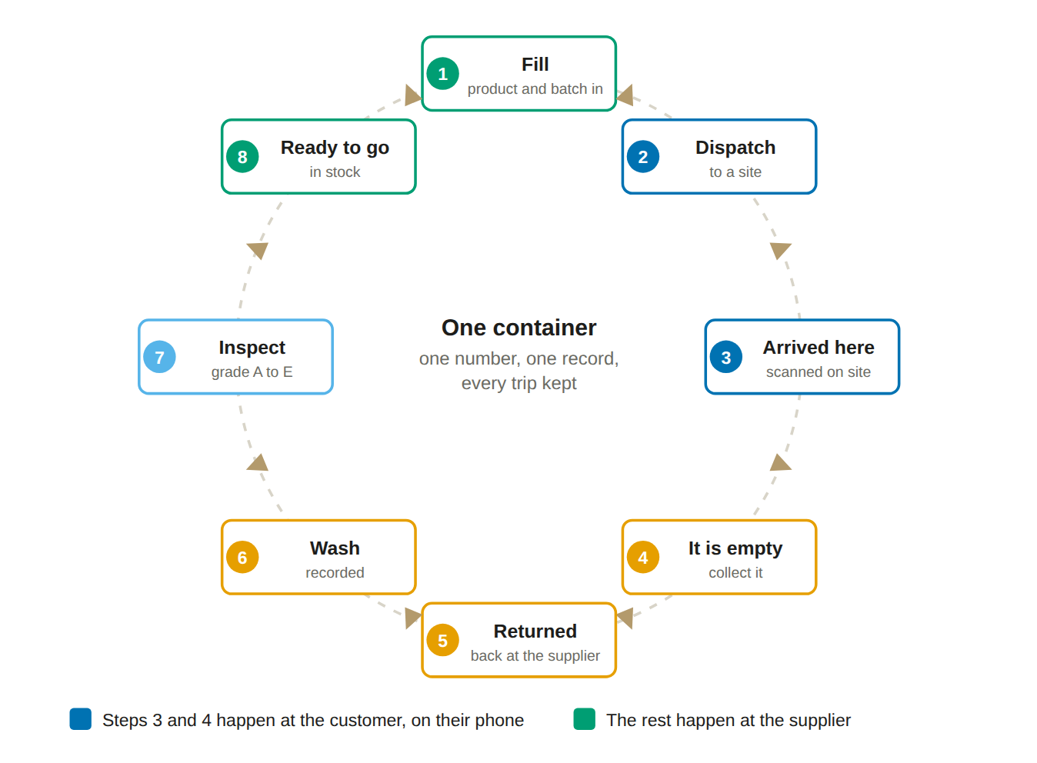
For the supplier
Where every container is, what is in it, how many trips it has done and which ones are late. One number for life, so the fleet stops being a guess.

For the customer
What is on their site and in which room, with the safety data sheet reachable from the label, kept current by the people who take the deliveries in.

For both
One record rather than two. Nobody reconciles anything, and neither side has to take the other's word for what happened.

What it does, and what it does not do
Say this plainly to customers. It is the fastest way to build trust, and everything in the right hand column has a sensible answer.
It does this today | It does not do this
Gives every container a permanent number and a QR label, and shows its whole history. | It does not read a supplier's own barcode as an identity. Clariq's number is the identity.
Records fill, dispatch, receipt, emptying, collection, wash, inspection, quarantine, retirement and recycling. | It does not control your washing plant or weigh anything for you. A person records what happened.
Keeps a register of what chemicals are on which site and in which room, with the receipt state shown honestly as confirmed, assumed or unconfirmed. | It does not guess. If nobody scanned the delivery and three days have passed, the register says assumed, not confirmed.
Builds an AICIS record for organisations that import chemicals, with the annual declaration prep pack and the evidence pack. | It does not lodge anything with AICIS and never says an introduction is authorised. Declaring is the introducer's own act.
Produces reuse figures prepared with reference to the measurement framework of ISO 59020:2024. | It never says certified, compliant or conforms to. Nobody has assessed Clariq against a standard, so the app will not print the word.
Works on any phone through the web browser. No app store, no installation required. | It does not work without a signal. With no signal you see "Can't reach Clariq" and you try again in a moment. Nothing is lost, but nothing queues up either.
Invites colleagues and customer organisations by email address. | It does not send the invitation email. You send that yourself. Page 9 gives you the words.
Exports every report to PDF and to Excel. | It does not yet talk to Xero or to a finance system. Deposits reconcile from a report.

The honest line to use in a sales meeting. "Clariq holds the record and shows you what is missing. Clariq does not tell you that you are compliant, because that is not ours to say." People trust that answer far more than a claim.

Who is who in the system
Clariq holds organisations, not just customers. Every organisation is described by three simple questions, and the answers decide what its people see when they sign in.
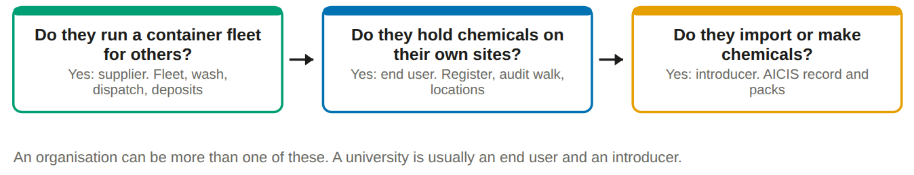

The roles, and who you would give them to
Role | Give it to | What they get
Admin | You, and one other person at Clariq | Everything, including people, settings, master data and corrections
Warehouse | The person filling and dispatching | Create containers and labels, fill, dispatch, return, wash, inspect, recycling
Driver | Whoever is on the road | Log a delivery, log a collection, see what is overdue
Inspector | Whoever grades containers | Return and inspect, and the audit walk
Sales | Account managers | Reports, customers, products, deposits. No container actions
Member | Customer site staff, for example a lab technician | Scan, mark arrived, mark empty, ask for collection, audit walk

The one extra switch. Releasing a container from quarantine, or retiring it, needs the "can authorise" flag. Admin always has it. You can give it to one trusted warehouse operator or inspector so that work does not stop when you are away.

The rule worth remembering
A role never hides information from someone who needs it. It removes buttons that person should not press. A driver is not offered Fill, so a driver cannot get it wrong.

Your home screen
One screen, four things. You will not need to hunt for anything: if the app wants you to do something, it says so at the top.
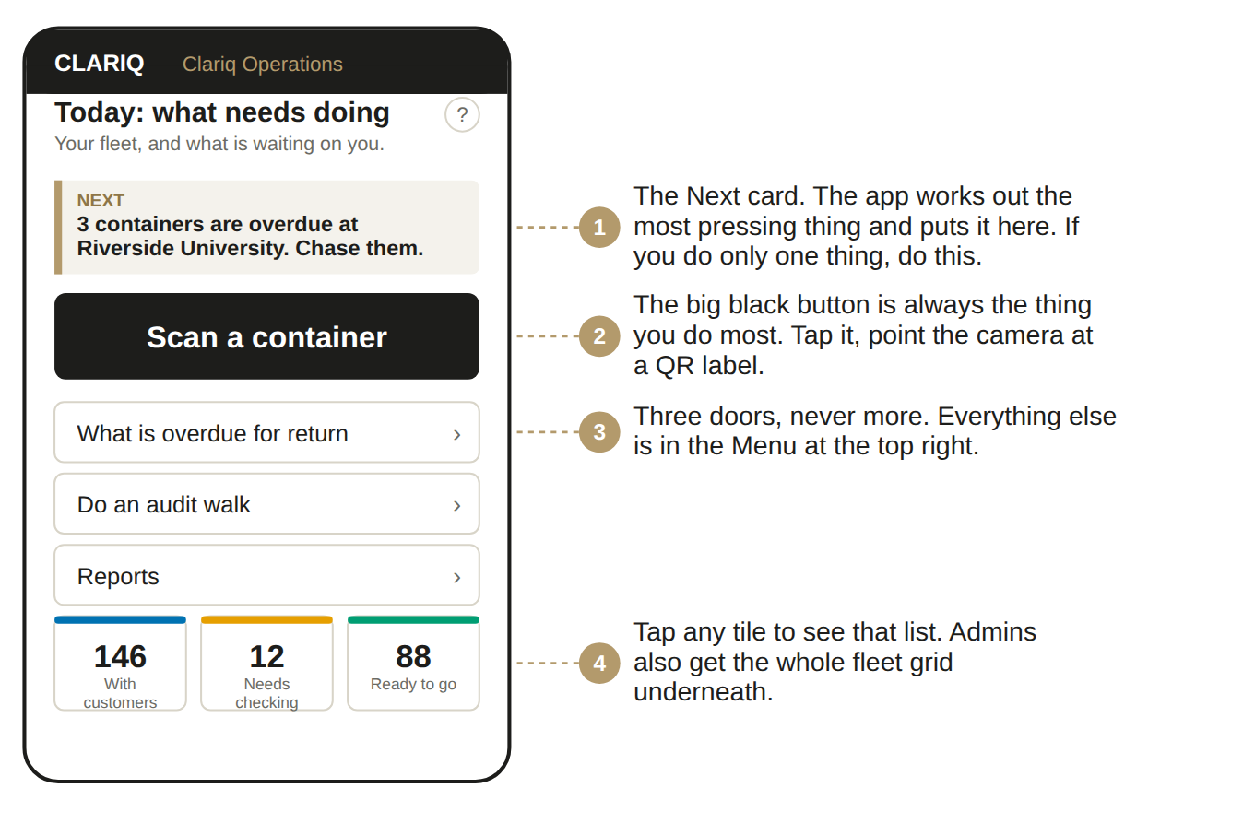

What is behind the Menu
Top right. Only Every day is open. The other groups are folded up with a count beside them, so nineteen items look like four.
Every day
Scan a container, Check a container, What is overdue for return, Do an audit walk.

Reports
Report for a customer, Chemicals on site, Chemicals we do not supply, Reuse results, Deposits. Every one opens on screen first and downloads as PDF or Excel.

Set up
Customers and their sites, Products, People, Print new labels, Settings. Week-one work, and then rarely.

Help and progress
Show me how, Ask Clariq, Words we use, Show me around, and Bringing Clariq into use for each customer's rollout.

Signing in, and putting Clariq on your phone
There is no password to remember or lose. You type your email address and the app emails you a link that signs you in. The link works once, and only for a few minutes.
1. Open the address in your phone browser
Type clariq-hub.netlify.app into Safari or Chrome. Practice site: clariq-demo.netlify.app.
2. Type your email address and tap Send me a link
Use the address Clariq knows you by. Anything else will not be recognised.
You will see: Check your email. We have sent you a link.

3. Open the email and tap the link
If it is not there in a minute, look in junk mail. The sender is Clariq.
4. You are in, and you stay in for 30 days
On your own phone you will not be asked again for a month. Do not sign in on a shared phone: every action is recorded against the person signed in.
5. Add Clariq to your home screen
On an iPhone tap the share button, then Add to Home Screen. On Android tap the three dots, then Install app. It then opens like any other app, full screen.
Worth doing. Staff who add it to the home screen use it two or three times as often as staff who have to type the address.

When a new version is ready a bar appears at the top offering Update or Later. Tap Update. It takes a second and puts you back where you were. The number in the footer, for example v0.7.36, is the version you are on. Quote it if you report a problem.

Setting up a new customer
This is the sequence for a customer who will use Clariq themselves, which is what you want for a customer organisation. It takes about fifteen minutes of your time. The rest is theirs.
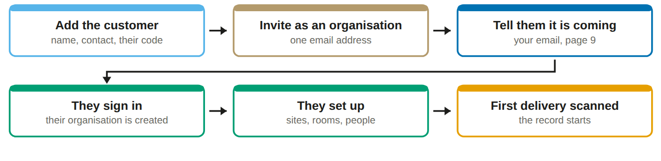
1. Menu, then Customers and their sites, then Add a customer
Legal name, trading name, one contact person, email and phone. Clariq gives them a number such as CUS-0004. You do not type it.
2. Open the customer you just made and tap Invite as an organisation
Type the email address of the one person who will own Clariq inside that organisation. Choose the person who will still be there in a year, not the most enthusiastic person in the room.
You will see: the customer's status changes to Invited. It becomes Linked the moment they sign in.

3. Send them the email yourself
The app does not send it. That is deliberate: an invitation that arrives from a person is opened, an invitation that arrives from a system is not. The words are on page 9.

Setting up a new customer, continued
4. They sign in with that address and become the Admin of their own organisation
Their organisation is created at that moment. Their sites, their rooms, their people and their chemical records belong to them, not to you.
5. Walk them through their first fifteen minutes on a call
Screen shared or side by side. They add one site, name two or three rooms, and invite one colleague. Do not do it for them. A person who has added their own site will add the next one.
6. Dispatch the first containers to them and let them scan the delivery
The moment somebody at their end taps Arrived here, their register has a line in it, and the thing stops being an idea.
What you can and cannot do for them. You can see the containers you sent them and the sites you dispatch to. You cannot add rooms, invite their people, or see chemicals they bought from somebody else unless they choose to show you, which the next section explains. That separation is what makes a customer organisation comfortable, so explain it early rather than apologising for it later.

What a customer holds, and what you can see
A customer who runs Clariq themselves holds chemicals you did not supply. Those are their record, not yours, and how much of them you can see is their decision.
Chemicals on site opens grouped by chemical, then site, then container size, rather than as a list of every container. The switch at the top turns it around to site first, and you tap through to reach an individual container.
Menu, Reports, Chemicals we do not supply. What your customers hold in someone else’s packaging, by site and kind of chemistry, where that customer has chosen to show you. Product group only: no container numbers, no product names, no competitor names. The page says how many customers are sharing and how many are not, because a customer showing you nothing is not a customer holding nothing.
A customer’s own containers are their record, held in their own organisation. You cannot sight them on a walk and they sit outside your fleet figures. Each customer decides in their own Settings whether you see nothing, a summary, or their whole register.

Inviting people, and the words that work
An invitation in Clariq is a record, not an email. You are giving an address permission. Whether a human being acts on it is down to what you write.
Three rules for every invitation you send
• Say what it replaces, not what it adds. Nobody wants a new system. Everybody wants the spreadsheet gone.
• Give one action and one minute. "Sign in and add your first site" beats "have a look around".
• Say there is no password. Half of all first-time confusion is somebody hunting for one.

To the person who will own Clariq at a new customer
Subject: Clariq is ready for you, two minutes to start Hi [name], Your Clariq account is open. There is no password to set up. 1. Go to clariq-hub.netlify.app on your phone or laptop 2. Type this address: [their email] 3. We email you a link, you tap it, you are in The first thing it will ask you to do is add one site and name a few rooms. That takes about two minutes and everything else follows from it. The app shows you the next step at the top of every screen, so there is nothing to learn in advance. Ring me on [number] while you do it if you would rather not do it alone. [your name]

Inviting people, continued

To their site staff, once their Admin is set up
Subject: Scanning deliveries from Monday Hi all, From Monday, when a container of [chemical] arrives, scan the label on the side with your phone camera and tap "Arrived here", then pick the room. It takes about ten seconds. That one tap is what keeps our chemical register right, so nobody has to walk the building with a clipboard before an audit. Go to clariq-hub.netlify.app, type your work email, and tap the link we email you. No password. [name]

Why this wording. It names the moment (a container arrives), the action (scan, tap, pick the room), the time it costs (ten seconds) and the thing it saves them (the clipboard walk). People adopt a habit when they can see the trade.

The journey you take a new customer on
The app carries this itself. Every customer Admin has a screen called Bringing Clariq into use with these four phases, target dates counted from the day they joined, and a progress bar. Tasks the app can see tick themselves.
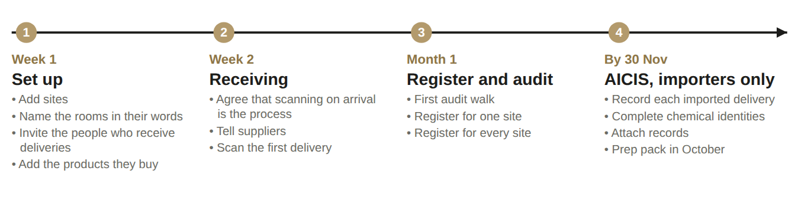

What you do at each phase
Phase | Your job | The trap
Set up | One shared call. Watch them add the first site, then stop talking. | Doing it for them. They will not come back to a system somebody else built.
Receiving | Get their leader to send the "from Monday" email. Be there the day the first delivery lands. | Letting it start on a busy week. Pick a quiet one.
Register and audit | Do the first audit walk with them, on their site, on their phone. | Sending a document instead of walking the building. The walk is the moment they get it.
AICIS | Only for importers. Show them the prep pack in October, not in November. | Talking about AICIS in week one. It frightens people before they have seen anything work.

The three month mark. If a customer is scanning most deliveries, has done one audit walk, and has opened a report without being asked, it has landed. If not, it is almost always one of three things: nobody told the staff it was the process, the rooms are named in system words instead of theirs, or their Admin never got past the first screen.

Getting people to use it
Adoption is not a training problem. People use a thing when it is shorter than what they did before, and when somebody they report to has said it is now the way things are done.
1. Get one sentence from their manager
"From Monday, scanning on arrival is how we record deliveries." Without that sentence you are asking for a favour. With it, you are describing the job.
2. Name the rooms in their words
Not Store 4. Basement chemical store. Level 2 prep room. People scan accurately when the choices sound like the building they are standing in.
3. Be there for the first delivery
Ten minutes on site beats an hour of training. The first scan done in front of a colleague is worth more than any document, including this one.
4. Show them their own register in week two
Open it on their phone: every container, every room, who received it. That is the moment the tapping stops feeling like data entry.
5. Let the app nag, not you
The Next card and the setup progress bar do the chasing. Your job is to check the progress bar once a week and ring only if it has not moved.
Signs it is working
• The receipt state on the register reads confirmed, not assumed
• Somebody asks you for a role change without being prompted
• They run a report you did not mention

Signs it is not
• Everything reads assumed after three weeks
• Only the Admin has ever signed in
• The setup progress bar is still showing

When somebody resists, the line that works is: "You are already doing this on paper. This is the same job on your phone, and at the end of it you can answer an auditor in a minute."

Your week
Clariq does not need daily attention. This is enough.
When | What you do | Where
Every morning | Read the overdue digest email. It lists what is late, by customer, with the value at risk. Act on anything significantly overdue. | Your inbox, 7am
When you open the app | Read the Next card. Do what it says or dismiss it. | Today
Weekly | Look at What is overdue for return and ring the two worst. | Today, second door
Weekly, per new customer | Check their setup progress. If it has not moved in a week, ring their Admin. | Customers
Monthly | Open Reuse results and one customer report. These are your sales material and your proof that the data is being kept. | Reports
Quarterly | Check people and roles. Remove anybody who has left. | Menu, People

Fixing a mistake
Nothing is ever deleted, so a mistake is corrected by recording a correction. Only an Admin can do it, a reason is required, and both the original entry and the correction stay in the history.
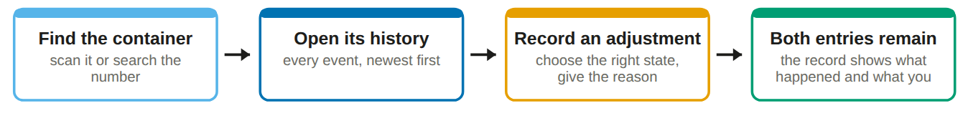
Why you should be glad about this. A system that lets people quietly edit history is worth nothing to an auditor. The awkwardness of recording a correction is exactly the property you are selling.

Where to get help, inside the app
You do not need this guide open to use Clariq. Four kinds of help are built in.
1. The ? on every screen
Top right of every page title. It opens the part of the written guide that explains that exact screen. Not a search box, the right page.

2. Ask Clariq
Type a question in plain words. "How do I print labels?" is answered with the steps and a Take me there link. Questions about the rules are answered from the legislation Clariq holds.

3. Show me around
Menu, then Show me around. Replays the three cards a new person sees on their first visit.

4. Words we use
A short glossary. Plain English on the left, the word a regulator or a standard uses on the right.

When something is actually wrong
What you see | What it means and what to do
Can't reach Clariq | No signal where you are standing. Nothing was recorded and nothing was lost. Move somewhere with a bar of signal and do it again.
The camera will not open | The app names the reason: no permission, no camera, camera busy in another app, or not a secure address. Fix that and tap retry.
That action is not available | The container is not in a state where that step makes sense, for example inspecting something that has not been washed. The list of buttons shown is always the list of things that are allowed.
The sign in link does not work | It has expired or has been used. Ask for another. Links are single use on purpose.
Something is broken | Note the version in the footer, the container number and what you tapped. Those three things solve most reports in minutes.

Before the first paying customer
Most of it is done. What remains is listed honestly, so nothing is a surprise the day real containers carry real chemicals.
Item | State | Where it stands
Production database on the paid plan | Done | Supabase Pro. The project no longer pauses when it is quiet, and daily backups are running.
Second Admin | Done | Greg. Two people can always get in, on both the production and the demo projects.
Sign in emails from the Clariq domain | Done | Magic links now go out through Resend on clariq.nz rather than a Gmail account.
The rest of the email | To do | The daily overdue digest is sent by a scheduled function calling Resend directly, not by the sign in mailer, so it needs its own key, a from address and a schedule. Magic link and invitation wording is still the plain default.
Labels printed and weather tested | To do | Avery L7060 waterproof polyester. Scan one after a week outside and after a wash.
A restore you have actually tried | To do | Backups only count once somebody has restored one. Restore into a spare project, check a few containers and their history survived, note how long it took. An hour, once, on a calm day.

One more, which is a decision rather than a task: a pilot customer will ring somebody. Agree whether that is you or Greg, and put it in writing to the customer.

Known gaps at version 0.7.43
Say these out loud to a customer before they find them. Vagueness is what loses a technical buyer.
- No offline queue. With no signal an action fails cleanly and is retried, it does not wait in a queue.
- The report menu is not yet driven from the report registry, so some reports are reached from their own screens.
- The dispatch site picker does not yet read a linked organisation's own sites.
- Customers do not see photos attached to events.
- No finance system integration. Deposits reconcile from an export.

The three sentences to have ready
What is it. Every container has one number for life, and every step is recorded against that number by the people doing the work, in about ten seconds each.
What do I get. A live register of what you hold and where, and a record you can put in front of an auditor without a fortnight of preparation.
What is the catch. Somebody has to scan the container when it arrives. If nobody does, the register says so rather than pretending.

Quick reference
Addresses
Real work: clariq-hub.netlify.app
Practice: clariq-demo.netlify.app
Both look identical. The practice site carries a banner across the top at all times.

Signing in
Email address, tap the link, no password. You stay signed in for 30 days on your own device.

Where everything lives
If you want to | Go to
See what needs doing | Today, the first screen
Look up a container | Scan a container, or type its number
See what is late | Today, What is overdue for return
Add a customer or a site | Menu, Customers and their sites
Invite a colleague or change a role | Menu, People
Print labels for new containers | Menu, Print new labels
Check chemicals on a customer site | Menu, Chemicals on site
Run a customer report, or see reuse figures | Menu, Report for a customer, Reuse results
Change overdue thresholds, or see a customer's rollout progress | Menu, Settings and Bringing Clariq into use

