

Your first month with Clariq
You are the person who owns Clariq inside your organisation. This is everything you need, in the order you will need it, and the app tells you what is next every time you open it.
Who this is for | The person responsible for chemicals, safety or facilities who will run Clariq here
Reading time | About 20 minutes, or follow it a page at a time as you go
What you need | A phone with a camera, and your work email address
Where it lives | clariq-hub.netlify.app. There is nothing to install and no password

What is in here
2 to 3 | What Clariq does for you, and what it will not do
4 to 5 | Signing in, and your home screen
6 to 8 | Week one: your sites, your rooms, your people
9 to 10 | Week two: scanning deliveries as they arrive
11 to 12 | Month one: your register and your first audit walk
13 to 16 | Reports, imported chemicals, problems, and a quick reference

The one habit that makes all of this work. When a container arrives, somebody scans it and picks the room. Ten seconds. Everything else is built from that moment.

What Clariq does for you
Today, knowing what chemicals are in your buildings means walking around with a clipboard, or trusting a spreadsheet that was right last year. Clariq keeps that answer up to date by itself, because the people who receive the deliveries are the people who record them.
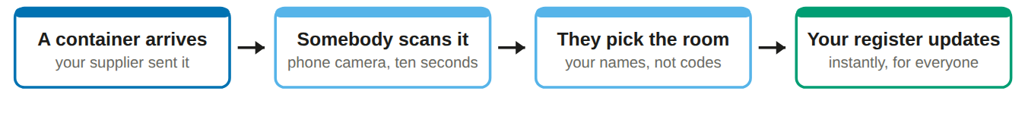
A live register
Every container on your sites, in which room, what is in it and roughly how much. It is right because the person who took the delivery in is the person who recorded it.

An audit walk
Walk a room with your phone and tap what you can see. It replaces the clipboard stocktake before an audit, and the walk itself is kept as a record with your name and the date.

A record that holds
Nothing is deleted. Every entry carries a name, a time and a place, and a correction sits beside the original rather than replacing it.

Where it fits with what you already have
You already have | What Clariq adds
Safety data sheets | Links the sheet to the container that is actually in the room, so staff find it from the label rather than from a folder.
A chemical register in a spreadsheet | Keeps it current without anybody maintaining it, and shows honestly where it is uncertain.
A supplier who delivers in drums | The same record, shared. They see the container is with you, you see what is in it and when it is due back.

What Clariq will not do
Worth knowing now rather than later. None of this is a surprise waiting for you.
It will not | What that means for you
Tell you that you are compliant | Clariq shows you what is held and what is missing. The declaration, the sign off, and the judgement remain yours. No screen in the app will ever use the words certified or compliant.
Know about a delivery nobody scanned | After three days an unscanned delivery is shown as assumed received rather than confirmed. The register never pretends.
Work with no phone signal | In a basement store you may see "Can't reach Clariq". Nothing is lost. Walk to where you have signal and tap again.
Send your staff their invitations | You add them in the app, then you email them. Page 8 gives you the words to send.
Replace your safety data sheets | Clariq stores and links them. It does not write them.
Let your supplier see inside your organisation | They see the containers they sent you and nothing else. Not your other suppliers, not your rooms, not your people.

Who can see what
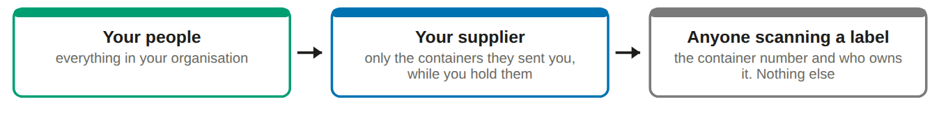
Why that matters. When a container moves on, the window closes. A supplier cannot look back at what you did with it afterwards, and cannot see anything that came from somebody else.

Signing in
There is no password. You type your email address and Clariq emails you a link that signs you in.
1. Open the address in your phone browser
Type clariq-hub.netlify.app into Safari or Chrome.
2. Type your work email address and tap Send me a link
It must be the address your Clariq account was set up with.
You will see: Check your email. We have sent you a link.

3. Open the email, tap the link
Not there after a minute? Look in junk mail. The sender is Clariq. Each link works once and lasts a few minutes, so if it has gone stale simply ask for another.
4. Add Clariq to your home screen
iPhone: tap the share button, then Add to Home Screen. Android: tap the three dots, then Install app. It will then open full screen like any other app.
Do this, and ask your staff to do it. People use it far more when it is an icon rather than an address to type.

5. You stay signed in for 30 days
On your own phone or laptop. Use your own device: everything you record is recorded as you.
If a bar appears offering Update. Tap Update. A new version is ready, it takes a second, and it puts you back where you were.

Your home screen
Everything you do regularly is on this one screen. Everything else is folded into the Menu at the top right.
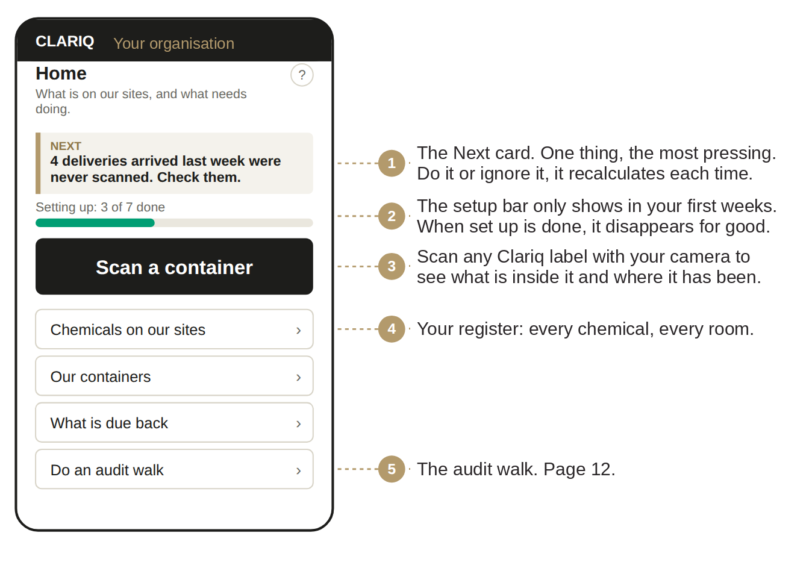
Two words you will see everywhere
Site is a site or a building, for example the Chemistry building. Location is a room or a store inside it, for example Level 2 prep room. You name both, in your own words.

Week one: setting up
Four short jobs. The app carries them as a checklist with a progress bar, and each one opens a small form with one or two fields rather than an admin page.
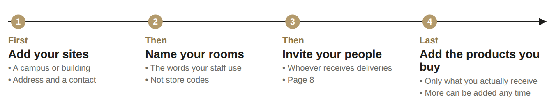
1. Add your first site
Home, then the setup checklist, then Add your first site. Name, address, a contact. That is all.
Tip: one site per building, depot or plant. If in doubt, fewer sites and more rooms is easier to live with.

2. Name the rooms inside it
Add locations in the same checklist. Use the words people say out loud: Basement chemical store, Level 2 prep room, Loading dock. Codes such as B-104 make people guess, and guessing puts chemicals in the wrong room.
You will see: your rooms appear as choices whenever anybody scans a delivery.

3. Add the products you buy
Menu, then Products we buy. You do not have to do this first: when somebody records a delivery for a product that is not there yet, they can type the name and it is created.
Do this on a laptop if you prefer. Everything in Clariq works on a computer as well as a phone. The screens are the same, just wider.

Your people, and what each can do
Two roles cover an organisation. Give most people Member, and keep Admin to yourself and one deputy.
Role | Who | What they can do
Admin | You, and a deputy | Everything: sites, rooms, people, products, deliveries, reports, and the chemical records
Member | Site staff, store staff, anyone who receives a delivery | Scan, mark arrived, mark empty, ask for collection, do an audit walk, read reports

✓ You can
• Add and remove your own people, sites and rooms
• See every container you hold, and record deliveries
• Run and export every report, and ask for collections

✗ You cannot
• See another customer's containers or chemicals
• Change anything in your supplier's fleet
• Delete a record. Corrections are recorded, never erased

1. Menu, then People, then Invite a colleague
Type their work email address and choose the role. That is the whole invitation.
You will see: they appear in the list as Invited until the first time they sign in.

2. Email them yourself
Clariq does not send the email, and that is deliberate: an invitation from a colleague gets opened, one from a system does not. Words to use are on the next page.
3. Somebody leaves
People, find them, Deactivate. Everything they recorded stays in the record with their name on it. That is what makes the history worth having.

The email to send your staff
Short, names the moment, says how long it takes and what it saves them. Change the words in brackets and send it.
Subject: From Monday, scan chemical deliveries when they arrive Hi all, We are moving our chemical register to Clariq. From Monday, when a container of anything arrives, please scan it in. Here is the whole job: 1. Point your phone camera at the label on the container 2. Tap "Arrived here" 3. Pick the room it is going into That is about ten seconds, and it means our register is always right. It replaces the stocktake walk we do before every audit. To set yourself up, once: go to clariq-hub.netlify.app, type your work email, and tap the link we send you. There is no password. On your phone, add it to your home screen so it is one tap next time. Any trouble, ring me on [number]. [your name]

Why these words, and not a training invitation
• It names the trigger. People remember "when a container arrives", not "when convenient".
• It gives three steps and a time. Ten seconds is a fact they can test on Monday.
• It offers a trade. The stocktake walk goes away, and it says there is no password. Those two lines prevent most of the first week's questions.

Send it from a manager, not from Clariq. If your head of department or facilities manager sends these same words, almost everybody acts on them.

Week two: scanning deliveries
This is the habit the whole thing rests on. It is three taps and it happens where the container is.
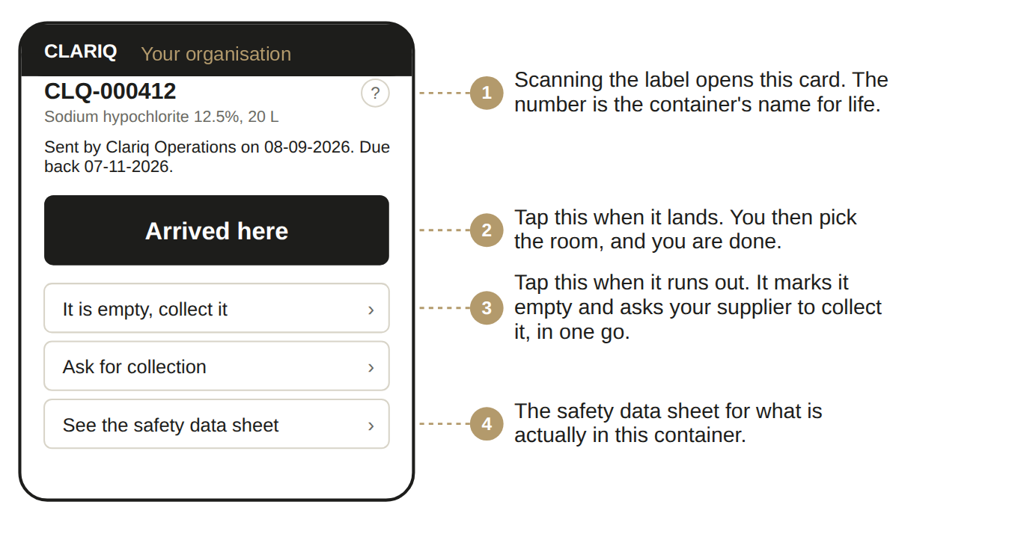
No signal in the store? Scan it in the corridor or the loading dock instead and pick the room from the list. The room you choose is what the register shows, not where you were standing.

Confirmed, assumed, unconfirmed
Your register shows one of three words against every container. Clariq will not turn a guess into a fact, and that honesty is the reason the register is worth showing to anybody.
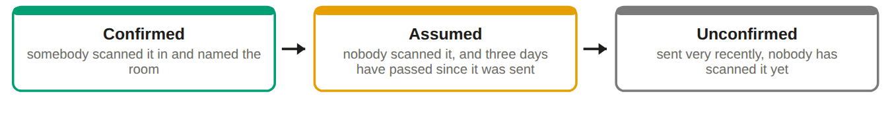

What to do about each
If it says | Do this
Confirmed | Nothing. The room and the date came from a person standing next to it.
Assumed | Ask who took the delivery. If it is on site, scan it now and the register corrects itself. If it never arrived, tell your supplier.
Unconfirmed | Wait a day, or ask the loading dock. It is probably in transit or sitting unopened.
Not supplied | Nothing. This is your own container, or another supplier’s. Nobody dispatched it to you, so there is no receipt to confirm. It reads as recorded, or audited once you have walked it.

A reasonable target. In the first month, aim for most of your register reading confirmed. If a lot of it still says assumed after three weeks, the cause is nearly always that the people receiving goods were never told this is now the process. One email from their manager fixes it.

The setting behind it
Three days is the default. An Admin can change it in Settings if your deliveries typically sit on a dock longer than that.

Month one: your register
Menu, then Chemicals on our sites. It opens grouped by chemical, then site, then container size, so you see how much of what before you see any single container; the switch at the top turns it around to site first. This is the thing you would otherwise be maintaining by hand, and the thing an inspector asks for first.
What is on it
• Every container you hold, by site and by room
• What is in it and roughly how much
• When it arrived, and who received it
• Whether that is confirmed, assumed or unconfirmed
• The safety data sheet for each product

Deciding what your supplier can see
Chemicals you hold that your supplier did not supply are your record, not theirs. They appear on your register on their own line, outside your supplier’s figures, and you decide how much of that your supplier can see.
Menu, Settings, What your supplier can see. Three choices. Nothing, which is where every link starts and means they see only the containers they supplied you. A summary, which is how much of each kind of chemistry sits at each site, with no container numbers, no product names and no supplier names. Or the register, which is everything you see.
Only your own administrators can change this, and you can change it back at any time. Your supplier cannot raise it, by any route. Deciding it is a task in your first week, and the app will ask you.

What you can do with it
• Filter to one site, or show every site at once
• Download it as a PDF to send or print
• Download it as Excel to work on
• Show it on a phone to somebody standing in the room

The three questions it answers in seconds
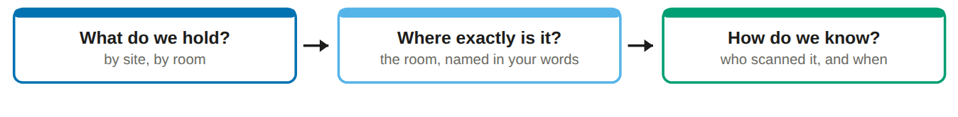
Dates are written day first throughout Clariq, for example 12-09-2026. Exports to Excel carry real dates, so sorting and filtering behave properly.

Your first audit walk
An audit walk is what it sounds like: you walk the building with your phone and tap what you can see. It takes the place of a clipboard stocktake, and the register updates as you go.
1. Menu, then Do an audit walk
Your site is chosen for you if you only have one.
2. Pick the room you are standing in
Clariq shows you what it believes is in that room.
3. Scan, or tap, each container you can see
Scanning is faster and safer. Tapping from the list is fine when a label is hidden behind a drum.
You will see: each one turns green as it is confirmed, with the time you saw it.

4. Anything you cannot find, leave alone
Do not guess. At the end, the walk shows you what was expected and not seen, which is the useful part.
5. Finish the walk
The register now reflects what is actually in the building, and the walk itself is kept as a record with your name and the date on it.
Worth knowing: a closed walk is evidence. It shows a regulator that your register is checked, not just maintained.

How often
Once a quarter for each site suits most organisations, and always before an inspection. A store that changes every week is worth walking monthly.

Who should do it
Whoever works in the room, not a manager visiting it. They know where things actually get put, and it takes them a fraction of the time.

Your reports
Three reports, all of them on screen first, all of them downloadable as PDF or Excel. Nothing needs to be requested from anybody.
Report | What it is for | When you would run it
Chemicals on our sites | The register: what you hold, where, and how you know | Before an audit, after a walk, or when somebody asks what is in a building
My report | Your activity with a supplier over a period: what came in, what went back, what is still out | Monthly, or at contract review
Reuse results | Containers reused rather than thrown away, and the packaging that avoided | For your sustainability reporting

The wording on the reuse figures, and why it is careful
Reuse figures are labelled prepared with reference to the measurement framework of ISO 59020:2024. That sentence is exact and deliberate. It says the figures follow the structure of the international standard for measuring circularity. It does not say anybody has certified them, because nobody has.
If you put these numbers in a public report, use the same wording. It is defensible, and it is the difference between a claim that survives scrutiny and one that does not.

Estimated figures carry a badge. Anything Clariq worked out rather than measured says Estimated on screen and in the export, with a link to how it was worked out.

If your organisation imports chemicals
Skip this page if everything you use is bought from an Australian supplier. If you import chemicals yourself, you have obligations under the industrial chemicals scheme, and Clariq keeps the record.
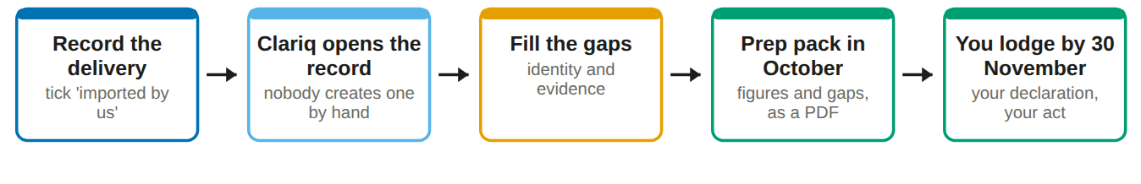
1. Record deliveries as they come in
Menu, then Record a delivery. Tick the box marked as imported by us and Clariq creates the chemical record behind the scenes.
You will see: a warning as volumes approach 10 kg, 100 kg and 250 kg, because those numbers change what is required.

2. Work down the list, one chemical at a time
Menu, then AICIS record. Each chemical has a ring showing how complete it is and one next thing to do. Where Clariq already holds what is needed, it does not ask again.
3. Attach a document once, or ask for what is missing
One upload satisfies every requirement that accepts that kind of document. Where a supplier holds the information instead of you, record that with their name. Clariq drafts the request email and records that you asked, which is itself the proof of a reasonable effort.
4. Print the prep pack in October, not in November
Menu, then AICIS prep pack: volumes for the year, the category breakdown, and what is outstanding.
What Clariq will never say. It will not tell you an introduction is authorised, or that you are compliant. It shows what is held and what is missing. Lodging is your act.

When something goes wrong
What you see | What it means, and what to do
Can't reach Clariq | No signal. Nothing was recorded and nothing was lost. Move to where you have a bar of signal and tap again.
The camera will not open | The app names the reason: permission not given, no camera, camera busy in another app, or an insecure address. Fix that one thing and tap retry.
The sign in link does not work | It has expired or been used already. Ask for another. They are single use on purpose.
"Arrived here" is not offered | The container has already been marked as arrived, or it has been marked for collection. The buttons shown are always the ones that make sense right now.
Somebody scanned the wrong room | Scan it again in the right room. The correction is recorded, and both entries stay in the history.
A container is not in the list | It was probably never dispatched to you, or it has already been collected. Scan the label and the card will tell you where it is.

Help inside the app
The ? on every screen
Top right of the title. It opens the page of the written guide that explains that exact screen.

Ask Clariq
Type a question in plain words, for example "how do I add a room". You get the steps and a button that takes you there.

Show me around
Menu. Replays the short introduction cards you saw on your first visit. Useful when training somebody.

Words we use
A short glossary. Plain English on the left, the word a regulator or a standard uses on the right.

Quick reference
The whole thing in five lines
• Sign in at clariq-hub.netlify.app with your email. No password.
• Add your sites and name your rooms in your own words.
• Invite the people who receive deliveries, then email them.
• Everybody scans containers when they arrive and picks the room.
• Run the register whenever anybody asks what you hold.

Where things live
If you want to | Go to
See what needs doing | Home, the Next card
Look up one container | Scan a container, or type the number
See what you hold, and where | Chemicals on our sites
Check a room against reality | Do an audit walk
See what is due back to a supplier | What is due back
Add a site or name rooms | Menu, Our sites and locations
Add or remove a colleague | Menu, People
Record an imported delivery | Menu, Record a delivery
See where your rollout is up to | Menu, Bringing Clariq into use

If you only remember one thing. Scan on arrival, and pick the room. Everything else in Clariq is built from that.

