

Filling, sending and receiving containers
You are the person who puts product into a container, sends it out, takes it back, washes it and gets it ready to go again. Clariq records each of those in about ten seconds on your phone.
Who this is for | Warehouse operators
Reading time | About ten minutes, and you will not need it again
What you need | A phone with a camera, and your work email address
The golden rule | Scan first. The container tells the app which one it is

Your part of the loop
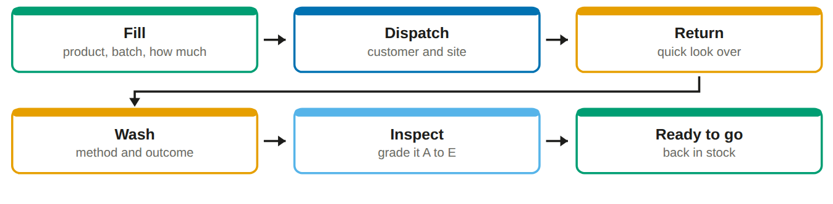
You cannot get the order wrong. Clariq only ever offers you the steps that make sense for the container in your hand. If a button is not there, that step is not due yet.

Your home screen
Everything you need is on this screen. Everything else is folded into the Menu at the top right.
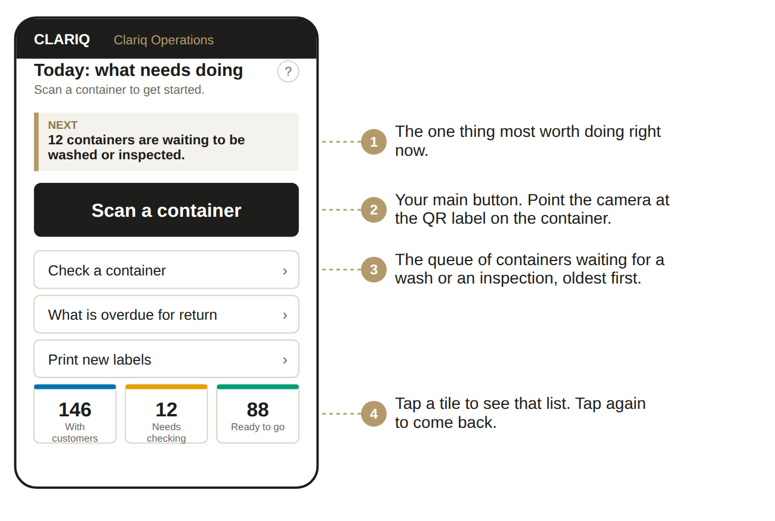

Signing in, once
1. Open clariq-hub.netlify.app in your phone browser
Type clariq-hub.netlify.app into Safari or Chrome. There is nothing to install.
2. Type your work email address, tap Send me a link
There is no password to remember. Clariq emails you a link that signs you in.
No email after a minute? Look in junk mail. The sender is Clariq.

3. Add Clariq to your home screen
iPhone: share button, then Add to Home Screen. Android: three dots, then Install app. After that it is one tap, and you stay signed in for 30 days.

Filling and sending out
1. Scan the container
Tap Scan a container and point the camera at the label. The card opens with the container number at the top.
2. Tap Fill
Choose the product and the batch. If there is only one batch open, it is chosen for you. The amount is already filled in with the container's own size, so change it only if you put in less.
You will see: a warning, not a block, if the last product in this container was a different type. You decide.

3. Tap Dispatch it now on the Done screen
Right after a fill, Clariq offers the next step. Choose the customer and the site. The last customer you used is remembered, and the date it is due back is already set to 60 days.
4. Give it to the driver
The container is now With customer. It shows on the overdue list if it has not come back by the due date.
Printing labels for new containers
Menu, then Print new labels. Say how many containers and what type, and Clariq gives you a PDF laid out for the label sheets. Each label carries its own number and QR code. Stick them on, then scan each one and do the first inspection.
A spoiled label is not a problem. Scan it, tap Void, give the reason. The number is retired, never reused, and the record says why.

Taking a container back
Three steps, always in this order. Clariq will not let you skip one, which is the point.
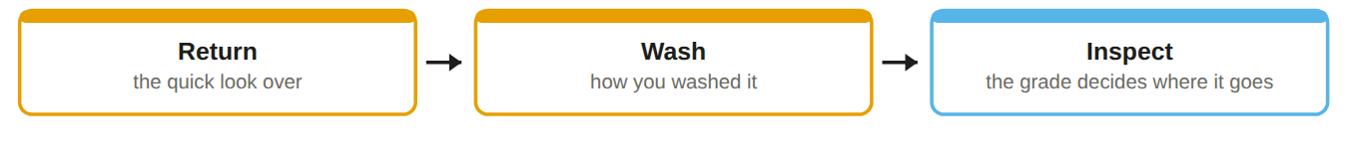
1. Scan it and tap Return
Four quick questions about what you can see: is the cap on, is there residue, any sign of contamination, any visible damage.
What happens: all clear sends it to Awaiting wash. Anything concerning sends it to Quarantined, where it waits for somebody who can authorise a decision.

2. Wash it, then record the wash
Scan, tap Wash, choose the method and the outcome. It moves to Awaiting inspection.
3. Inspect it and give it a grade
A to E. The grade is the decision, so there is no second step to remember.
Grade | Means | Where it goes
A | Excellent | Back in stock, ready to fill
B | Good | Back in stock
C | Serviceable | Back in stock, flagged to watch
D | Not fit to use | Quarantined. Give the reason
E | End of its life | Retired. Give the reason and the weight

Photos help. Any damage, take a photo while you are looking at it. It is attached to that inspection for good, and it settles arguments later.

What you can and cannot do
✓ You can
• Create containers and print labels
• Fill, dispatch, return, wash and inspect
• Record recycling when a container reaches the end
• See every container and every report
• Add a photo or a note to anything

✗ You cannot
• Add or change customers, sites or products
• Release a container from quarantine, unless you have been given that permission
• Change anybody's role, or the settings
• Edit or delete anything already recorded

If something goes wrong
What you see | What it means, and what to do
Can't reach Clariq | No phone signal where you are standing. Nothing was recorded and nothing was lost. Move to where you have signal and tap again.
The camera will not open | The app names the reason: permission not given, no camera, camera busy in another app, or an insecure address. Fix that one thing, tap retry.
The button I want is not there | That step does not make sense for this container yet. The buttons you see are always the ones that are allowed right now.
I recorded the wrong thing | Tell an Admin. Nothing is ever deleted, so they record a correction and both entries stay in the history. Do not try to hide it.

The ? on every screen
Top right of the title. It opens the help for that exact screen, not a search box.

Ask Clariq
Type a question the way you would say it: "how do I print labels". You get the steps and a button that takes you there.

Containers that are not ours
On an audit walk you will meet containers that are not ours: the customer’s own bottles, and other suppliers’ drums. They belong on that organisation’s register and are theirs to record, so the app will not let you sight them. That is deliberate, not a fault.

Keep this by the bench
Every job starts the same way
Scan the container, then pick the action.

The container is | You tap
Empty, clean, inspected | Fill
Full, waiting to go | Dispatch
Just back from a customer | Return, then the four questions
Returned and waiting | Wash
Washed | Inspect, then the grade
Damaged, and you are not sure | Quarantine, and say why
Finished for good | Retire, then recycling when it is collected

If you are not sure
Quarantine it and say why. Nothing is lost by holding a container for a day, and somebody with authority makes the call.

If the app says no
The step is not due yet. Scan the container and read the buttons you are offered: that list is always the list of things allowed right now.

