

Deliveries and collections
Two jobs, two buttons. Scan the container, say it was delivered, or say it was collected. It takes a few seconds at the tailgate and it means nobody has to ring around later asking where anything is.
Who this is for | Drivers
Reading time | Five minutes
What you need | A phone with a camera, and your work email address
The golden rule | Scan at the vehicle, not back at the depot

Your two jobs
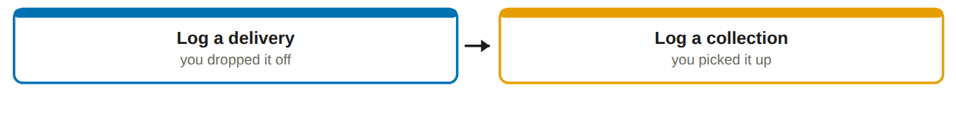
Why it matters that you do it there and then. The customer's chemical register and the supplier's overdue list both come off your tap. Recorded at the tailgate, it is right. Recorded from memory at five o'clock, it is a guess.

Your home screen
Four things, and two of them are your whole job.
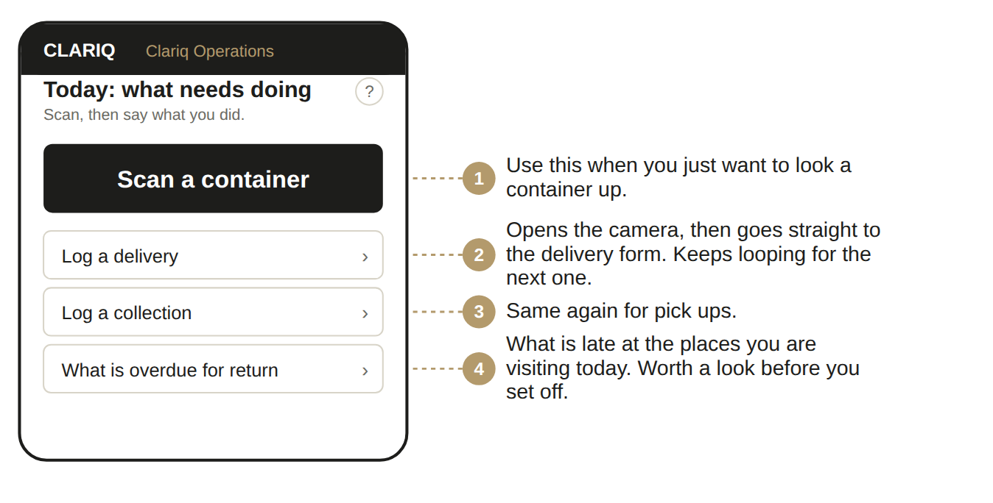

Signing in, once
1. Open clariq-hub.netlify.app in your phone browser
Type clariq-hub.netlify.app into Safari or Chrome. There is nothing to install.
2. Type your work email address, tap Send me a link
There is no password to remember. Clariq emails you a link that signs you in.
No email after a minute? Look in junk mail. The sender is Clariq.

3. Add Clariq to your home screen
iPhone: share button, then Add to Home Screen. Android: three dots, then Install app. After that it is one tap, and you stay signed in for 30 days.

Dropping off
1. Tap Log a delivery
The camera opens straight away.
2. Scan the label on the container
Hold the phone about a hand's width away. It reads the code by itself, you do not press anything.
3. Add who took it, if anybody signed for it
This is optional. A name is useful when somebody asks later.
4. Tap Record delivery
Done. The app goes back to the camera for the next one.
You will see: the container number and a green tick, then the camera again.

Picking up
1. Tap Log a collection
Camera opens.
2. Scan each container you are loading
One after another. Each one takes a couple of seconds.
3. Tap Record collection
They are now marked as on their way back, and they come off the customer's site.
If the label will not scan
Dirty, torn or wet labels happen. Tap Enter the number and type the number printed underneath the code, for example CLQ-000412. Then tell the warehouse the label needs replacing.

What you can and cannot do
✓ You can
• Log deliveries and collections
• Look up any container and see where it should be
• See what is overdue at the sites you visit
• Add a note or a photo, for example a damaged drum

✗ You cannot
• Fill or dispatch a container
• Wash or inspect
• Change customers, sites or products
• Edit anything already recorded

If something goes wrong
What you see | What it means, and what to do
Can't reach Clariq | No phone signal where you are standing. Nothing was recorded and nothing was lost. Move to where you have signal and tap again.
The camera will not open | The app names the reason: permission not given, no camera, camera busy in another app, or an insecure address. Fix that one thing, tap retry.
The sign in link does not work | It has expired or has been used. Ask for another. Links are single use on purpose.
I recorded the wrong thing | Tell an Admin. Nothing is ever deleted, so they record a correction and both entries stay in the history. Do not try to hide it.

No signal at a rural site? Nothing is lost and nothing queues up. Scan the containers again when you are back in range, or ring the warehouse and tell them what you moved. Do not leave it to the next day.

One tip worth knowing
Bringing containers back to the yard yourself? Record Return when you unload rather than Collect. Return is offered straight from with-customer, so it is one event instead of two and the container goes into the wash queue immediately.

Keep this in the cab
Dropped it off? Log a delivery, scan, done.
Picked it up? Log a collection, scan, done.

Situation | What to do
Customer is not there, you left it at the dock | Log the delivery anyway. Leave the name blank.
Container is damaged when you pick it up | Log the collection, then add a note with a photo.
You picked up a container that is not on your list | Scan it and log the collection. The app sorts out where it belongs.
The label is unreadable | Type the number instead, and report the label.
You scanned the wrong one | Ring the warehouse. An Admin records the correction, and both entries stay in the history.

The ? on every screen
Top right of the title. It opens the help for that exact screen, not a search box.

Ask Clariq
Type a question the way you would say it: "how do I print labels". You get the steps and a button that takes you there.

