

Grading containers, and audit walks
You decide whether a container goes back into service, gets held, or comes out of the fleet. Clariq turns that decision into one screen, and keeps your grade, your reasons and your photographs for the life of the container.
Who this is for | Inspectors
Reading time | Ten minutes
What you need | A phone with a camera, and your work email address
The golden rule | The grade is the decision. There is no second step

Where you sit in the loop
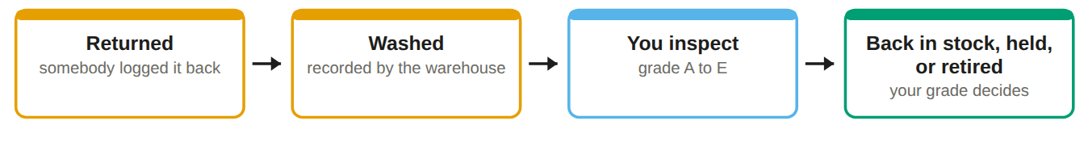
Nothing you record can be erased. If you grade something wrongly, an Admin records a correction and both entries remain. That is what makes your inspection worth something to an auditor two years from now.

Your home screen
The queue is the screen you will live in. It is always in date order, oldest first, so you never have to decide what to pick up next.
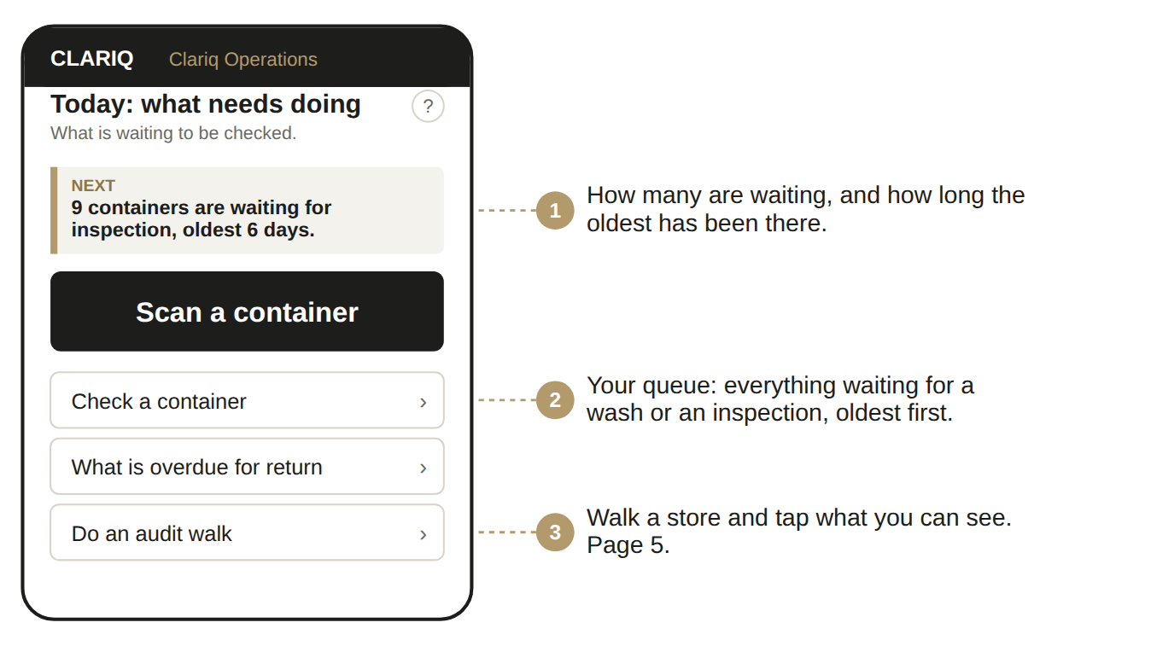

Signing in, once
1. Open clariq-hub.netlify.app in your phone browser
Type clariq-hub.netlify.app into Safari or Chrome. There is nothing to install.
2. Type your work email address, tap Send me a link
There is no password to remember. Clariq emails you a link that signs you in.
No email after a minute? Look in junk mail. The sender is Clariq.

3. Add Clariq to your home screen
iPhone: share button, then Add to Home Screen. Android: three dots, then Install app. After that it is one tap, and you stay signed in for 30 days.

Inspecting
1. Open the queue, or scan the container in your hand
Check a container lists everything waiting. Scanning is quicker when you are already holding it.
2. Work through the sub conditions
The form asks about the body, the closure, the threads, the label and whether the QR still reads. Answer what you see.
3. Take a photograph of anything you are marking down
It attaches to this inspection for good. A photograph is worth more than a sentence of description.
4. Give the grade
The grade is the outcome, so choose it carefully and the app does the rest.
Grade | Means | What happens next
A | Excellent | Straight back into stock
B | Good | Back into stock
C | Serviceable | Back into stock, flagged to watch at the next return
D | Not fit to use | Quarantined. A reason is required, and somebody with authority decides
E | End of life | Retired. A reason and an estimated weight are required

If you have been given authority
Some inspectors are given the extra permission to release a container from quarantine or to retire one. If you have it, you will see Release and Retire with a note to write. If you do not, grade it D and it waits for somebody who has.

Audit walks
An audit walk is a stocktake on your phone. You walk a store, tap what you can see, and the record reconciles itself as you go.
1. Menu, then Do an audit walk
Choose the site and the room you are standing in. If there is only one, it is chosen for you.
2. Scan or tap each container you can see
Each one turns green with the time you saw it.
3. Leave anything you cannot find
Never tick something you did not see. The gap between expected and seen is the whole value of the walk.
4. Finish the walk
It is kept as a record with your name and the date, and the list of anything missing goes to whoever needs to chase it.
✓ You can
• Record returns, inspections and grades
• Quarantine anything you are unsure about
• Run audit walks and see every report
• Attach photographs and notes

✗ You cannot
• Fill or dispatch containers
• Release from quarantine or retire, unless you have been given that permission
• Change customers, sites, products or settings
• Edit or delete a recorded inspection

Containers that are not ours
On an audit walk you will meet containers that are not ours: the customer’s own bottles, and other suppliers’ drums. They belong on that organisation’s register and are theirs to record, so the app will not let you sight them. That is deliberate, not a fault.

Keep this by the inspection bench
If you would not send it to a customer yourself, it is not an A, B or C.

If something goes wrong
What you see | What it means, and what to do
Can't reach Clariq | No phone signal where you are standing. Nothing was recorded and nothing was lost. Move to where you have signal and tap again.
The camera will not open | The app names the reason: permission not given, no camera, camera busy in another app, or an insecure address. Fix that one thing, tap retry.
The button I want is not there | That step does not make sense for this container yet. The buttons you see are always the ones that are allowed right now.
I recorded the wrong thing | Tell an Admin. Nothing is ever deleted, so they record a correction and both entries stay in the history. Do not try to hide it.
The QR code will not read any more | Mark it on the inspection. The container keeps its number: a new label is printed with the same number and stuck over the old one.

The ? on every screen
Top right of the title. It opens the help for that exact screen, not a search box.

Ask Clariq
Type a question the way you would say it: "how do I print labels". You get the steps and a button that takes you there.

When in doubt
Grade it D and write the reason. A container held for a day costs almost nothing. One that fails on a customer's site costs the account.

Write reasons a stranger could read
Your note is read by somebody who was not there, possibly two years later. "Hairline crack at the base of the neck, see photo" beats "damaged".

