

Scanning chemicals in and out
Three things to know, and each of them takes about ten seconds. When a container arrives, scan it. When it is empty, say so. Once in a while, walk the store and tap what you see.
Who this is for | Anyone who receives or uses chemicals: site staff, store staff, workshop and facilities staff
Reading time | Five minutes, and you will not need it again
What you need | Your work phone or your own phone, and your work email address
Why bother | It replaces the stocktake walk before every audit

Your three jobs
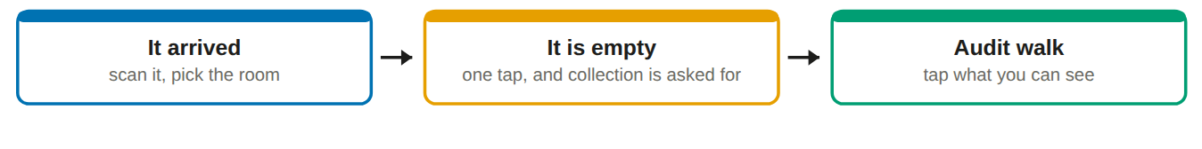
You cannot break anything. Every button you are shown is one you are allowed to press, and if you record something wrongly, somebody corrects it. Nothing is lost, and nobody gets into trouble for scanning.

Getting set up, once

Signing in, once
1. Open clariq-hub.netlify.app in your phone browser
Type clariq-hub.netlify.app into Safari or Chrome. There is nothing to install.
2. Type your work email address, tap Send me a link
There is no password to remember. Clariq emails you a link that signs you in.
No email after a minute? Look in junk mail. The sender is Clariq.

3. Add Clariq to your home screen
iPhone: share button, then Add to Home Screen. Android: three dots, then Install app. After that it is one tap, and you stay signed in for 30 days.
Use your own phone, not a shared one. Whatever you record is recorded as you, which is how the record is worth having. Signing in on somebody else's phone puts your name on their work.

Where to find help without asking anybody
Every screen has a ? at the top right that explains that screen. Ask Clariq answers questions typed the way you would say them, for example "how do I mark something empty".

When a container arrives
Do it at the trolley or the bench, not later from memory.
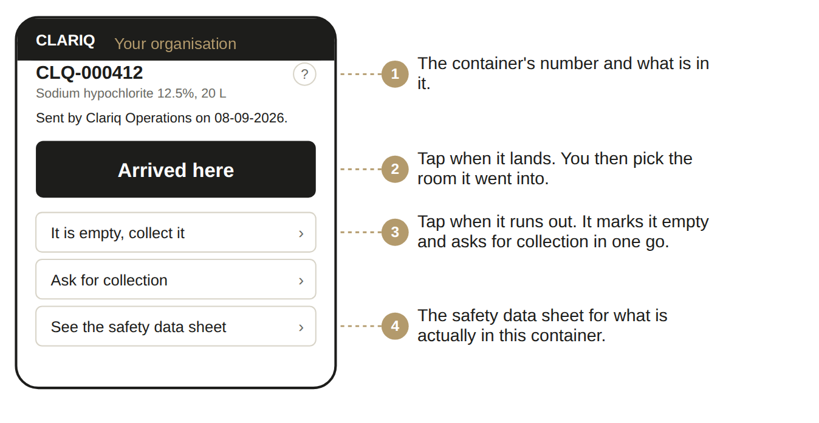
1. Open Clariq and tap Scan a container
Point the camera at the square code on the label, about a hand's width away.
2. Tap Arrived here, then pick the room
The room names are the ones your own people chose, so pick the one you are walking it into.
You will see: a green tick, and the container appears on your register in that room.

When it is empty, and when you want it gone
1. Scan it and tap It is empty, collect it
That one tap does two things: it records that the container is empty, and it asks your supplier to collect it. You do not need to email anybody.
2. Or tap Ask for collection
Use this when it is not empty but you want it gone anyway, for example the wrong product or a job that finished.

Once in a while: the audit walk
1. Menu, then Do an audit walk
Choose the room you are standing in. Clariq shows what it thinks is in there.
2. Scan or tap each container you can actually see
Each one turns green.
3. Leave anything you cannot find
Do not guess. The things that are missing are the useful part of the walk.
4. Tap Finish
That is the stocktake done, and it is recorded with your name and the date.
This is the bit that saves the most time. A walk that takes fifteen minutes with a phone used to be a morning with a clipboard and an afternoon typing it up.

Record everything you find, not just theirs
On a walk, record every container of chemicals you find, whoever supplied it. Your supplier’s containers, your own bottles and another supplier’s drums all belong on your register.
Recording how much is left is the point. A measured figure replaces what the register assumed, and the register then says audited, with the date. Anything you did not reach still reads as recorded, so the gap is visible rather than hidden.

Keep this on the store room wall
It arrived? Scan it. Tap Arrived here. Pick the room.
It is empty? Scan it. Tap It is empty, collect it.

If something goes wrong
What you see | What it means, and what to do
Can't reach Clariq | No phone signal where you are standing. Nothing was recorded and nothing was lost. Move to where you have signal and tap again.
The camera will not open | The app names the reason: permission not given, no camera, camera busy in another app, or an insecure address. Fix that one thing, tap retry.
The sign in link does not work | It has expired or has been used. Ask for another. Links are single use on purpose.
The button I want is not there | That step does not make sense for this container yet. The buttons you see are always the ones that are allowed right now.
I scanned the wrong room | Scan it again and pick the right one. The correction is recorded and nothing is lost.

✓ You can
• Scan any container and see what is in it
• Mark things arrived and empty, and ask for collection
• Do audit walks
• Open the safety data sheet from the container itself
• Read the register for your sites

✗ You cannot
• Change what is in a container
• Add sites, rooms or people. Ask your administrator
• See containers at another organisation
• Delete anything. Corrections are recorded instead

