

Looking at your containers
Your supplier tracks the containers they send you, and this is your window into that record. You can see what you are holding, what is due back, and what it adds up to over a year. You do not have to maintain anything.
Who this is for | Customers with a view only login from their supplier
Reading time | Five minutes
What you need | A phone or a laptop, and the email address your supplier used
What it costs you | Nothing to keep up to date. It is read only

What you can see
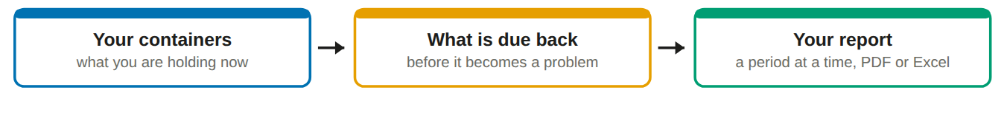
You see your own line and nothing else. Not other customers, not your supplier's other work, and not the container's life before or after it was with you.

Your home screen
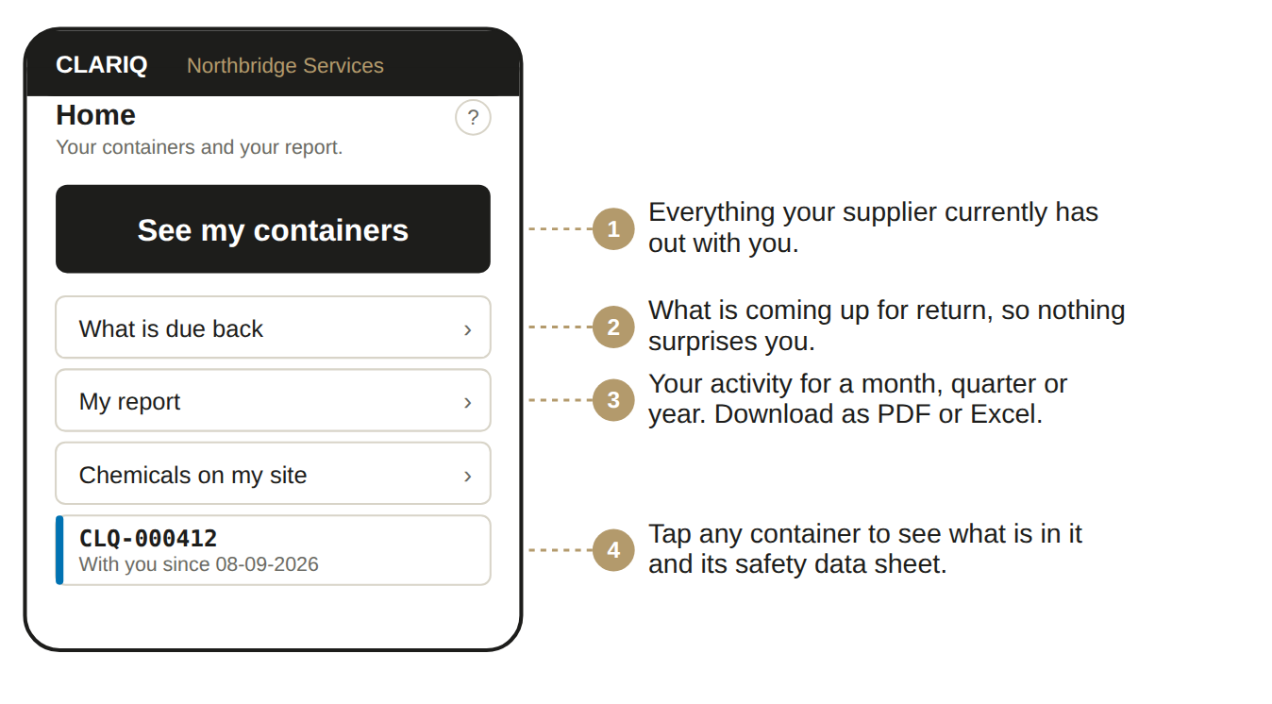

Signing in, once
1. Open clariq-hub.netlify.app in your phone browser
Type clariq-hub.netlify.app into Safari or Chrome. There is nothing to install.
2. Type your work email address, tap Send me a link
There is no password to remember. Clariq emails you a link that signs you in.
No email after a minute? Look in junk mail. The sender is Clariq.

3. Add Clariq to your home screen
iPhone: share button, then Add to Home Screen. Android: three dots, then Install app. After that it is one tap, and you stay signed in for 30 days.

What you can do, and what you cannot
✓ You can
• See every container your supplier has out with you
• See what is in each one, and open its safety data sheet
• See what is due back and when
• Run your report for any period and download it as PDF or Excel

✗ You cannot
• Record that something arrived or is empty. That needs the fuller account, which your supplier can set up for you
• See any other customer's containers
• See the container's history before or after it was with you
• Change anything. This login is read only

Worth asking your supplier about
If your people would rather scan containers in as they arrive, keep their own chemical register by room, and run audit walks, ask your supplier to set your organisation up properly in Clariq. It is the same app, it costs you no new software, and your register then maintains itself.

If something goes wrong
What you see | What it means, and what to do
Can't reach Clariq | No phone signal where you are standing. Nothing was recorded and nothing was lost. Move to where you have signal and tap again.
The sign in link does not work | It has expired or has been used. Ask for another. Links are single use on purpose.

The ? on every screen
Top right of the title. It opens the help for that exact screen, not a search box.

Ask Clariq
Type a question the way you would say it: "how do I print labels". You get the steps and a button that takes you there.

Where your chemicals are listed
Chemicals on my site opens grouped by chemical, then site, then container size, so you see how much of what before you see any single container. Tap through to reach one.
Each figure says where it came from: audited with a date, as dispatched, or as recorded. Quantities are what is on hand, so an empty container counts as nothing and is listed on its own line.

Scanning a container, even without signing in
Anybody can point a phone camera at a Clariq label. What they see depends on who they are.
Who is looking | What the screen shows
Anybody, not signed in | The container number, who owns it, and how to return it. Nothing about the contents, the price or you.
You, signed in | What is in it, the safety data sheet, how long you have had it, and when it is due back.
Your supplier | The full record for the container.

Why the public view is so bare. Containers sit on loading docks and in yards where anyone can walk past. The label needs to say "please return me" without telling a stranger what is inside.

Quick reference
If you want to | Go to
Check what you are holding | See my containers
Find out what is in one | Scan it, or tap it in the list
Find a safety data sheet | Open the container, then the sheet
See what is due back | What is due back
Get a report for the quarter | My report, choose the period, download

