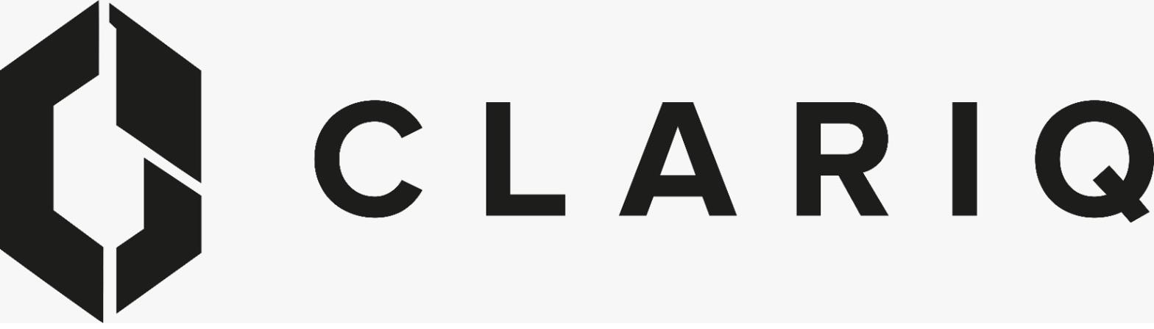 | Clariq: the hub app and the demo app  A guide for Jay. Prepared 10 September 2026. Keep this with your phone.
There is one Clariq product and it now runs in two places. They look identical, share every feature, and are updated together. The difference is what is behind them: the hub holds real containers and real customers; the demo holds a made-up fleet you can play with in front of anyone.
 | THE HUB (live) | THE DEMO
Address | clariq-hub.netlify.app | clariq-demo.netlify.app
What it is for | Running the business. Every scan, fill, dispatch and return you record here is a permanent record. | Showing people. Sales walks, training, trying things out. Nothing here matters and it can be reset to the same starting fleet at any time.
What is in it | Real customers only. It starts empty: the first container you create is CLQ-000001. | 144 containers across six fictional customers (Waikato Dairy, Southern Orchards, Harbour Marine, Canterbury Agri, Bay Water, Clarq), with months of history.
Labels | Printed from here only. The address above is printed on every label, permanently. | Never print labels from the demo. Its scan links point at the demo, not the hub.
Golden rule | If it is real, it goes in the hub. | If you are showing or learning, use the demo.
How you sign in (same on both, phone or laptop)
- Open the address in your browser. On a phone, use Safari or Chrome; the camera scanner works in either.
- Enter your email and tap Send me a link. There is no password to remember. Two addresses are set up for you as Administrator, jnf1306@gmail.com and info@clariq.nz. Use whichever inbox is handier, or both; they are separate accounts and the app shows them as Jay Ferguson and Jay Ferguson (info).
- Open your inbox. The email comes from Clariq. Tap the link inside it. You are signed in as an Administrator, which means every screen and every action is available to you.
- Do this once per device and you stay signed in for 30 days. On a phone, use Add to Home Screen so Clariq opens like an app.
- The first time, three short welcome cards explain the layout. You can replay them any time from the Menu.
The hub and the demo are separate sign-ins. Signing in to one does not sign you in to the other, and that is deliberate.
Showing someone what a staff member or a customer sees (demo only)
Your own login is Admin, so for a prospect you may want the simpler views. Two standing demo accounts exist for that. Their sign-in links arrive in the clariqnz@gmail.com inbox, so you need Greg to share that mailbox password with you (it is the only reason you would need that inbox).
Demo Staff | clariqnz+staff@gmail.com | Warehouse operator: scan, fill, dispatch, return, wash, inspect
Demo Customer | clariqnz+customer@gmail.com | Waikato Dairy Services' own view: their containers, their report, nothing else
Type those addresses exactly, plus sign included. If a walk-through leaves the demo in a mess, ask Greg to reset it; it goes back to the identical starting fleet in about ten seconds.
About the labels
Each container gets a printed QR label (Avery L7060, 63.5 x 38.1 mm) carrying its ID and the web address clariq-hub.netlify.app/c/CLQ-000001. Anyone who scans it sees "Property of Clariq, please return"; signed-in staff see the full container card and its allowed actions. Because the address is printed, it can never change, which is why the hub site is named once and never renamed. Any test labels printed before 10 September carry an old address and should be thrown away. New labels are created in the hub: Menu, then Print new labels.
Three things to remember
- The hub is real. There is no undo; corrections are recorded as new entries, never by deleting. Take a moment before you confirm an action.
- If either site shows an error or says the project is paused, do nothing and tell Greg. It is usually a two-minute fix on his side.
- New features appear on both sites at the same time, so anything you learn in the demo works the same way in the hub.
Questions: Greg. Reference: docs/Architecture.md section 20 in the clariq-app repository.

