Claire Spain

Production Studio

Prof Twigg

27 Aug 2020

Production Studio Proposal and Outline

My Goal: Create two strong portfolios. One for Storyboarding for TV Animation and the other for Character design. Ideally I would separate the two on different pages, but be within the same page. My hope is that I will be appealing enough to get an internship. I felt that--although these would be separate portfolios and I will treat them as such-- they would coincide with each other in some way. There’s going to be a lot to learn, but I’m excited!

Where I plan to keep my project back-up and updated:

<https://github.com/ClarissaSpain/Production-Studio/blob/master/README.md>

My sad portfolio currently:

<https://clairespainart.carbonmade.com/>

For storyboarding the programs, I will mainly be using is Storyboard Pro since it seems to be the industry standard currently and Adobe audition for some rough sound design if I decide to put them together as a video.

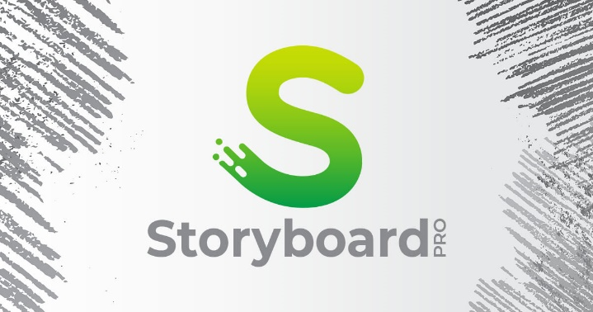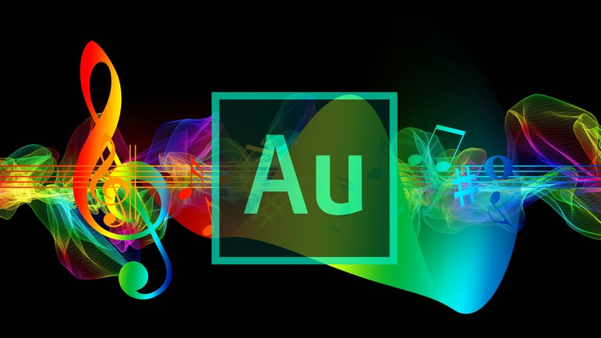

For character design I will probably stick with my usual programs: Clip Studio Paint and Procreate.

For this semester I want to shoot for three short Storyboard Ideas (I only have two at the moment):

This was a commission that I did for someone but they were so kind and let me keep the rights to these characters. What are these cat astronauts doing? Are they spreading the cat empire forces across the galaxy? And who are these misfits?

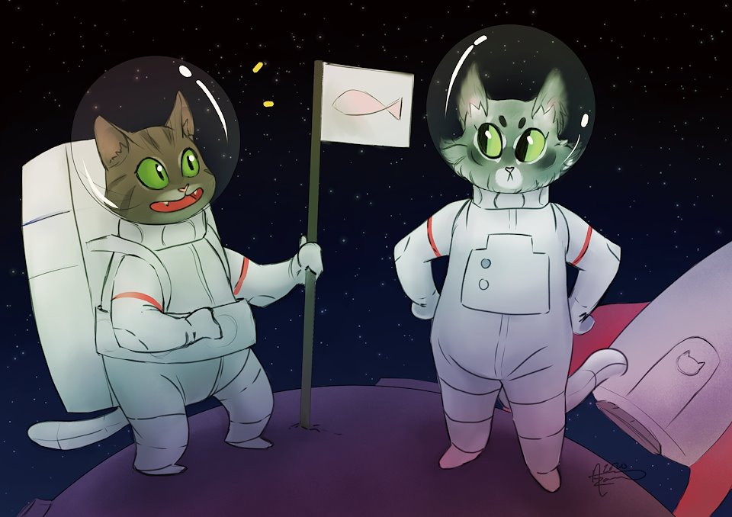

Atlas and his son, Johnny. Atlas is a missionary who travels the world and shares the good gospel of the Ancient Dragons (they’re definitely real even though no one has seen them.) Johnny enjoys being a con artist and sells his home-made newspaper to people for 200% the market price.

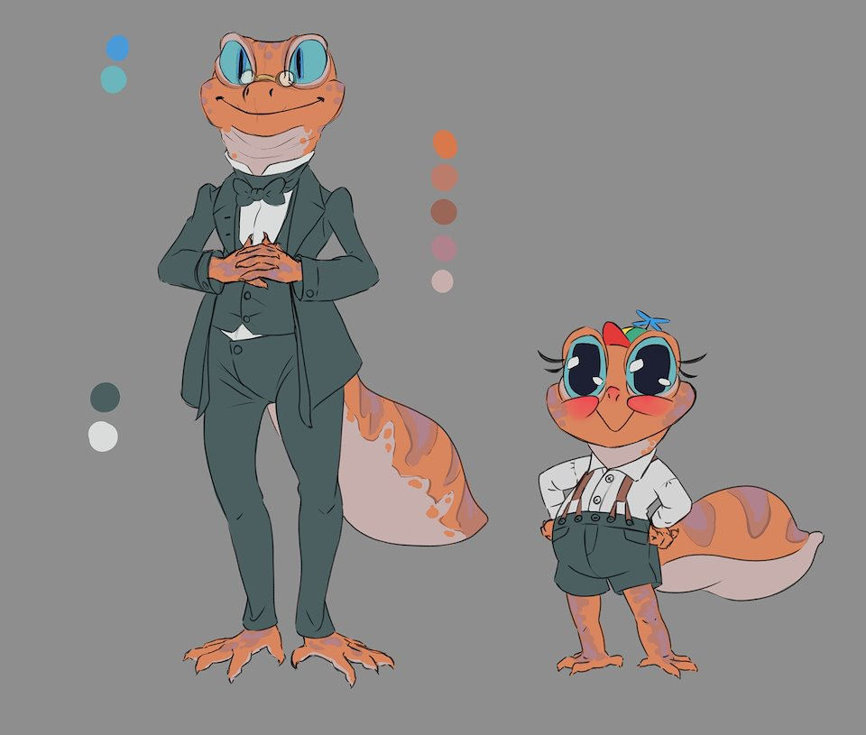

Outline

*Semester 1 Focus: Storyboarding*

Project 1: 8/31 – 9/28

Mid Project Update:9/14

Project 2: 9/28 - 10/26

Mid Project Update: 10/12

Project 3: 10/26 – 11/23

Mid Project Update: 11/9

*Winter Break: Bigger Storyboard Project ~Roughly 2 months*

Longer Storyboard-> Length of an Episode?

Story?

Thumbnails

Rough Pass

Clean up

Audio

Compositing

*Semester 2 Focus: Character Design (No definitive timeline yet)*

Sketches

Variations

Turnarounds => + Details

Expressions, poses, and movement

Single Render

Archetype Line-Ups

Splash

