# Compute Lyon 3DTiles

This document explains how to create 3DTiles models of buildings, relief, roads, bridges and water bodies from Lyon’s open data with [py3dtilers](https://github.com/VCityTeam/py3dtilers).

To be able to use the Tilers from py3dtilers, follow the [installation notes](https://github.com/VCityTeam/py3dtilers" \l "installation-from-sources).

## Geojson Tiler

### **Roads**

Download the [BD Topo](https://geoservices.ign.fr/ressource/161992) data from [IGN](https://geoservices.ign.fr/telechargement)

In [QGIS](https://www.qgis.org/en/site/), open the *BDTOPO/1_DONNEES_LIVRAISON/TRANSPORT/****TRONCON_DE_ROUTE.shp*** file.

You can filter roads, for example by keeping those starting or ending in Lyon 1er:

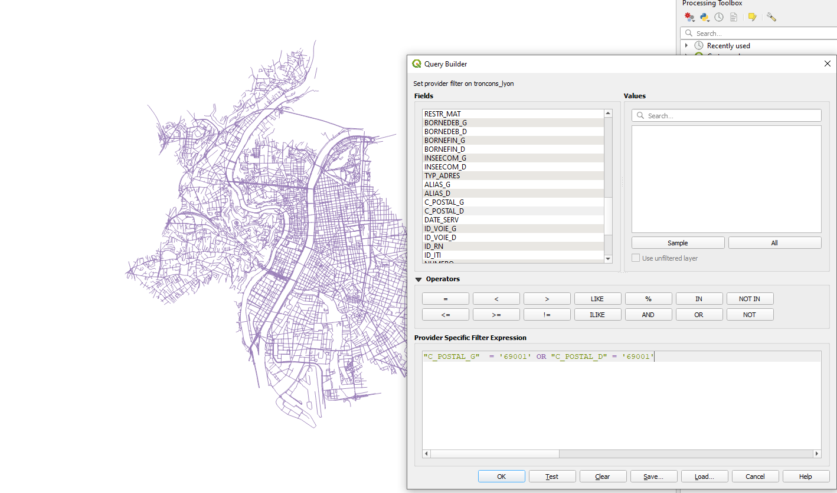

qgis_filter_road

Then, save the roads layer as a GeoJson file:

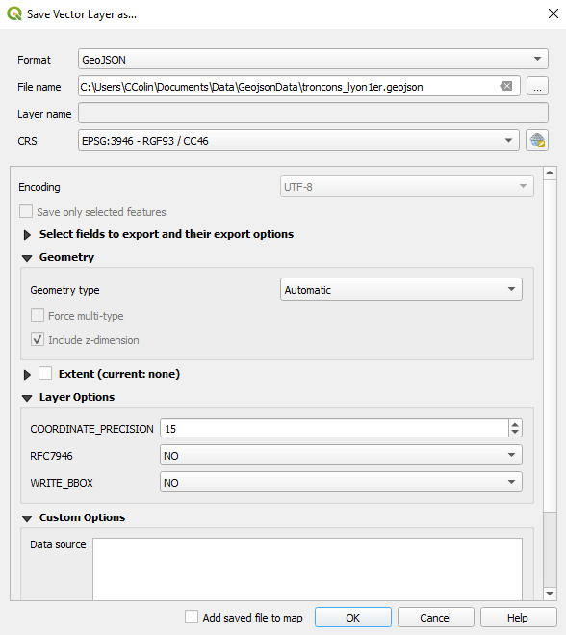

qgis_save_layer

To create roads 3DTiles with the [GeoJsonTiler](https://github.com/VCityTeam/py3dtilers/tree/master/py3dtilers/GeojsonTiler), run:

geojson-tiler --path path/to/troncons_lyon1er.geojson --height 0.5

The height argument set how thick are your roads (in meters). You can set it to an arbitrary value.  
You can also set the width of your roads with --width <float>. By default, the GeoJsonTiler targets the property LARGEUR in geojson features to find the width; the property to target can be changed with --width OTHER_PROP_NAME.

See the [GeojsonTiler README](https://github.com/VCityTeam/py3dtilers/blob/master/py3dtilers/GeojsonTiler/README.md) for more information on usage.

### **Water bodies**

Download the [BD Topo](https://geoservices.ign.fr/ressource/161992) data from [IGN](https://geoservices.ign.fr/telechargement)

In [QGIS](https://www.qgis.org/en/site/), open the *BDTOPO/1_DONNEES_LIVRAISON/HYDROGRAPHIE/****SURFACE_HYDROGRAPHIQUE.shp*** file.

You can select only the parts you need:

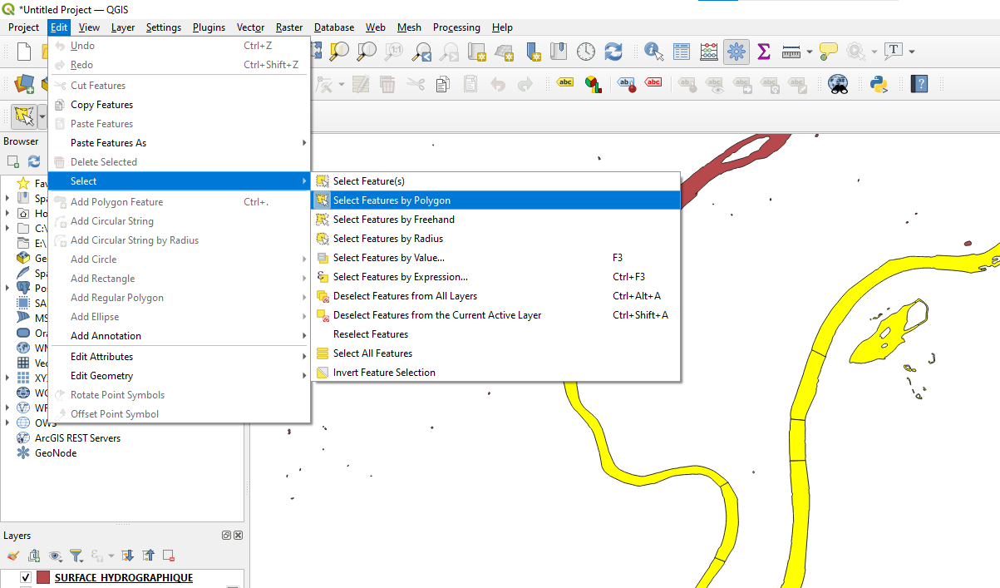

select_hydro_surface

Then, save the roads layer as a GeoJson file:

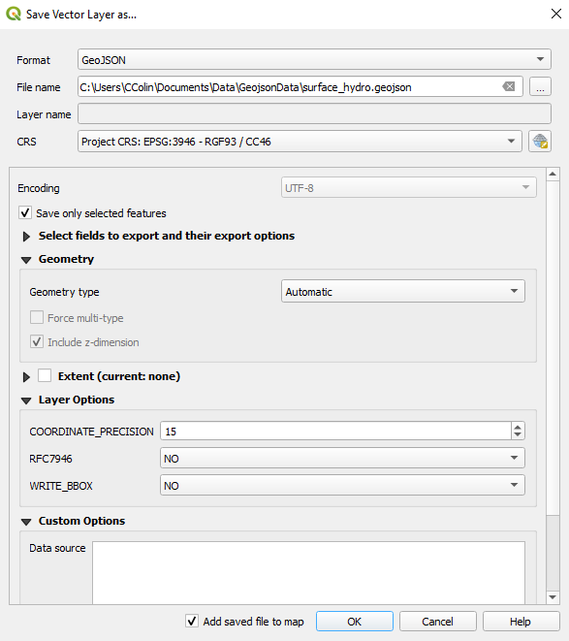

qgis_save_hydro

To create 3DTiles with the [GeoJsonTiler](https://github.com/VCityTeam/py3dtilers/tree/master/py3dtilers/GeojsonTiler), run:

geojson-tiler --path path/to/surface_hydro.geojson --height 0.5

The height argument set how thick are your water bodies (in meters). You can set it to an arbitrary value.

See the [GeojsonTiler README](https://github.com/VCityTeam/py3dtilers/blob/master/py3dtilers/GeojsonTiler/README.md) for more information on usage.

## CityGML Tiler

Creating 3DTiles with the [CityGML Tiler](https://github.com/VCityTeam/py3dtilers/tree/master/py3dtilers/CityTiler) require [Postgres/PostGIS](https://www.enterprisedb.com/downloads/postgres-postgresql-downloads) and [3DCityDB](https://www.3dcitydb.org/3dcitydb/downloads/). The cityGML data must be hosted in a 3DCityDB database to be used by the CityGML Tiler.  
To host cityGML in database, you can follow [**this tutorial**](https://github.com/VCityTeam/UD-SV/blob/master/ImplementationKnowHow/PostgreSQL_for_cityGML.md) (recommended) or use the [docker](https://github.com/VCityTeam/UD-SV/blob/master/Install/Install3DCityDB.md" \l "1a-installing-a-3dcitydbpostgis-server-the-docker-deployment-case) (may be outdated).

You should also copy the [configuration file](https://github.com/VCityTeam/py3dtilers/blob/master/py3dtilers/CityTiler/CityTilerDBConfigReference.yml) (for example py3dtilers/CityTiler/CityTilerDBConfig.yml) and add the details of your database in this new file.

### **Buildings**

Download the cityGML data from [Data Grand Lyon](https://data.grandlyon.com/jeux-de-donnees/maquettes-3d-texturees-2018-communes-metropole-lyon/info) (you can choose which districts of Lyon you want to download). Then, import the buildings into a 3DCityDB database:

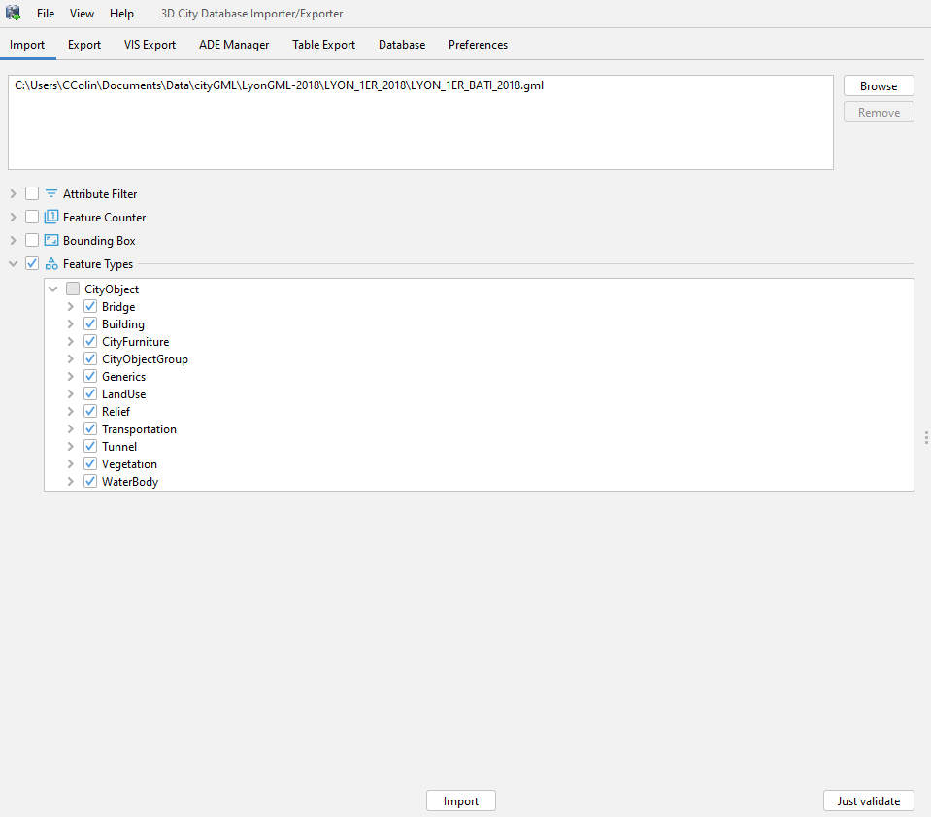

import_buildings

To use the Tiler, target your database config file and choose the type building (see the [CityTiler usage](https://github.com/VCityTeam/py3dtilers/blob/master/py3dtilers/CityTiler/README.md) for more details):

citygml-tiler --db_config_path <path_to_file>/Config.yml --type building

To create [LOA](https://github.com/VCityTeam/py3dtilers/blob/master/py3dtilers/CityTiler/README.md" \l "loa), you can for example use *BDTOPO/1_DONNEES_LIVRAISON/ADMINISTRATIF/****ARRONDISSEMENT.shp*** from [BD Topo](https://geoservices.ign.fr/ressource/161992) ([IGN](https://geoservices.ign.fr/telechargement)). To be able to use it, export the .shp as GeoJson with QGIS (the projection must be the same as buildings, i.e EPSG:3946 most of the time for Lyon’s data).

To create the 3DTiles with levels of detail, run:

citygml-tiler --db_config_path <path_to_file>/Config.yml --lod1 --loa polygons.geojson

### **Relief**

Download the cityGML data from [Data Grand Lyon](https://data.grandlyon.com/jeux-de-donnees/maquettes-3d-texturees-2018-communes-metropole-lyon/info) (you can choose which districts of Lyon you want to download). Then, import the relief into a 3DCityDB database:

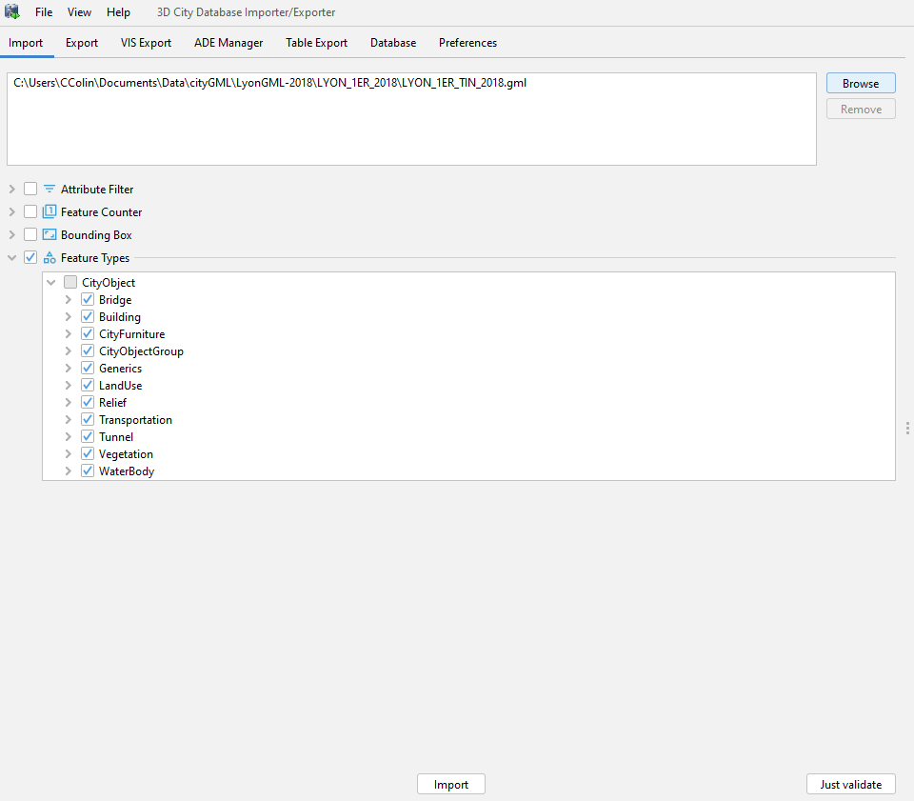

import_relief

To use the Tiler, target your database config file and choose the type relief (see the [CityTiler usage](https://github.com/VCityTeam/py3dtilers/blob/master/py3dtilers/CityTiler/README.md) for more details):

To create the relief as 3DTiles, run:

citygml-tiler --db_config_path <path_to_file>/Config.yml --type relief

### **Bridges**

Download the cityGML data from [Data Grand Lyon](https://data.grandlyon.com/jeux-de-donnees/maquettes-3d-texturees-2018-communes-metropole-lyon/info) (you can choose which districts of Lyon you want to download). Then, import the bridges into a 3DCityDB database:

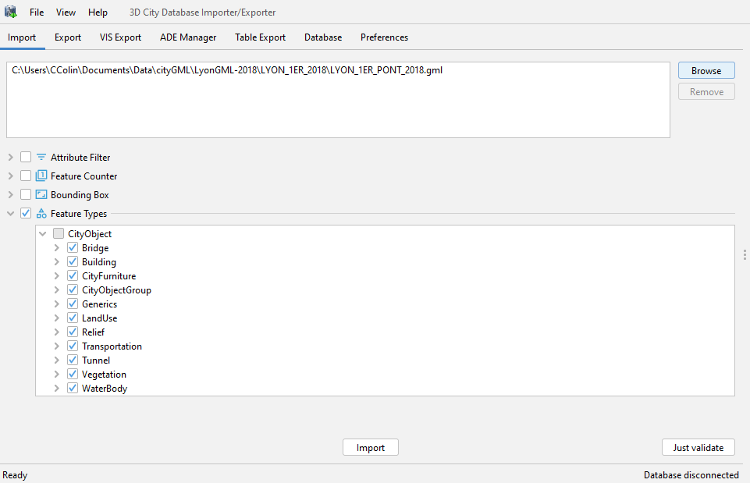

import_bridges

To use the Tiler, target your database config file and choose the type bridge (see the [CityTiler usage](https://github.com/VCityTeam/py3dtilers/blob/master/py3dtilers/CityTiler/README.md) for more details):

To create the bridges as 3DTiles, run:

citygml-tiler --db_config_path <path_to_file>/Config.yml --type bridge