**Pro-QEXAFS User Manual**

Contents

Installation with Python 2

Output Data and File Tree 3

Basic User Operation 4

Opening the Software 4

Loading a Dataset 5

Selecting a Datafile 7

Analysis of the Monochromator Oscillation: Analyse Encoder 7

Calibration of Monochromator Angle to Energy 8

Normalisation of the XAS spectrum 10

Interpolation of the XAS Spectrum 12

Butterworth Noise Filtering 13

Data Exporting 14

# Installation with Python

The required python scripts for the Quick EXAFS processing software can be found at:  
https://github.com/ClarkAH/ProXAS-GUI/

The easiest method for using the Pro-QEXAFS software is through installation of anaconda with python 3. Anaconda is a free distribution of python that comes with a large array of very useful packages and a large repository of additional python packages.

The windows 64 bit installer can be found here:

https://repo.anaconda.com/archive/Anaconda3-2018.12-Windows-x86_64.exe

In addition to this some additional packages are required to be installed. Most of which can be installed directly from the anaconda repository.

From command prompt the following commands will install or update some of the packages*:

conda update pandas

conda update scipy

conda install –c GSECARS xraylarch

conda install –c conda-forge numpy-indexed

In addition this software makes use of an external xray database which includes useful information such as X-ray absorption edge energies and core-hole lifetimes. This can be found at:

https://github.com/scikit-beam/XrayDB

To install there is a setup script located in the python folder and from command prompt run:

Python setup.py install

*the directory with anaconda python must be added to the system environment variables this can be done during installation of anaconda by ticking the box asking so

# Output Data and File Tree

The output files from processing are found in the same directory as the program itself. When processing a datafile new folders are automatically created relating the datafile being processed. The format of the folder name is as follows:

ouput_<sample absorption edge>_<data file name>

Within the output folder numerous files are created, some have use internally and are stored in the top level of the output folder:

normalisation.dat (containing information relating to the normisation)

calibration.dat (contains information relating to the angle to energy calibration)

roots.dat (contains indices of datapoints relating to the turning points of the monochromator and maximum and minimum angles)

xnew.dat (contains a grid of energy points used during interpolation)

Exported processed data is saved within the subfolder ‘Export’. Within the export folder matrix files are saved relating to the sample and reference is the following form:

<filename>_ref_matrix_<monochromator direction>.dat

<filename>_sam_matrix_<monochromator direction>.dat

parameters.txt (A small readable text file containing the parameters used during processing)

Within the export folder a further subfolder, ’individual_<monochromator direction>‘, is created which stores the individual with columns relating to the energy, sample and reference in either mu(E) or normalised mu(E) form.

Further files are created during post processing where for example averaging is conducted and saved as:

<filename>_sam_matrix_<monochromator direction>_<number of spectra averaged>.dat

# Data Extraction and Processing

## Opening the Software

The QEXAFS processing software consists of a suite of three python scripts.

The main script: ProXAS-GUI-v2.XX.py

The remaining two subroutine scripts are used for parallel processing

All three scripts are required to be places within the same folder for the program to function.

To open the software the best option is to use command prompt and navigate the folder containing the scripts and run the following command:

python ProXAS-GUI-v2.XX.py

This will bring up the main user interface shown below.

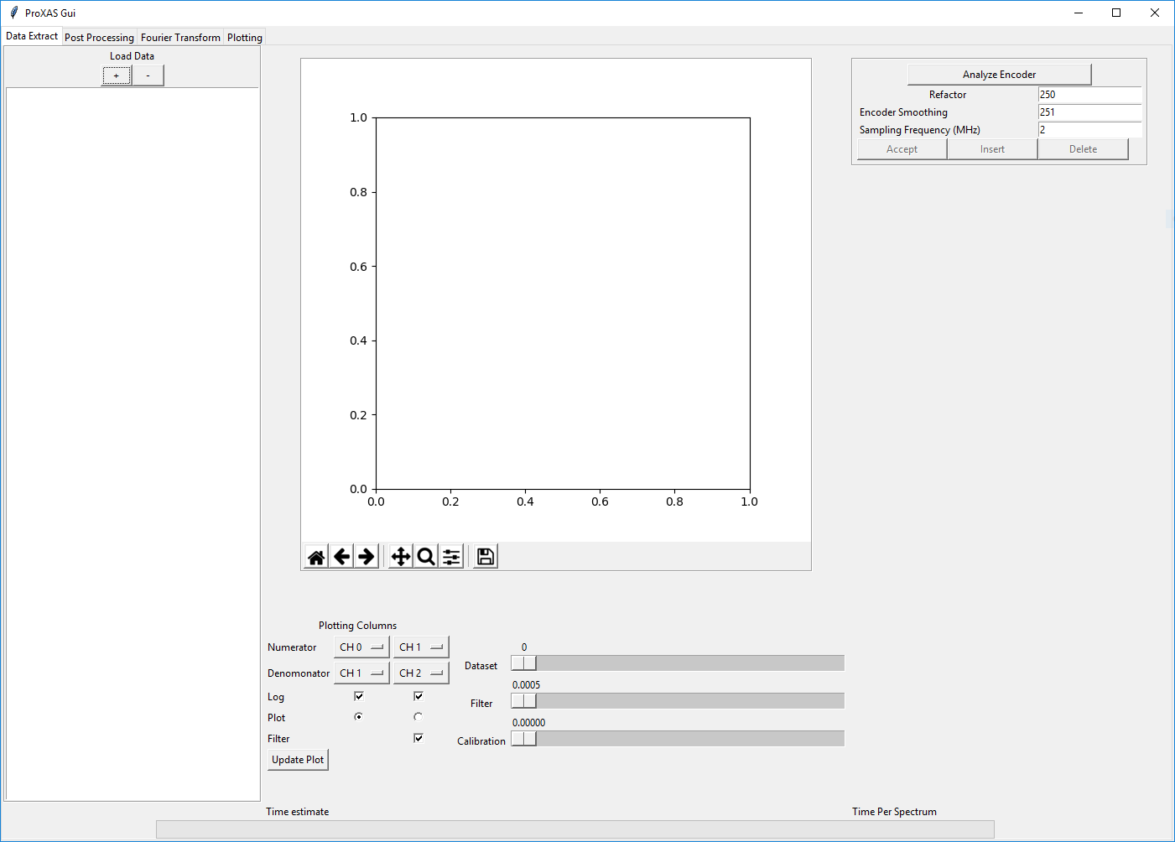

The software consists of 4 main tabs. These named: Data Extract, Post Processing, Fourier Transform and Plotting. Each has a different main functionality and are used typically in order.

## Loading a Dataset

The first task load a dataset into the software to extract the raw spectra from the binary stream data. The left panel of the software is used to list all the currently loaded datafiles and to select which item to work on. To load a file press the + button which will bring up a standard navigation window allowing you to search for a datafile, select and open. At present there are two supported file formats: the older ‘.bin’ and a new ‘.qex’ format. Switching between the two formats can be done by changing the file type from ‘.bin’ to ‘.qex’ in the dropdown box in the far bottom right.

With the older ‘.bin’ format there are two files for each measurement. The <filename>.bin and <filename>_Encoder.bin. The first contains this acquisition signals recorded, typically Ion Chambers and PIPS Fluorescence detector. The second contains the information regarding the oscillation of the QEXAFS monochromator. Select <filename>.bin

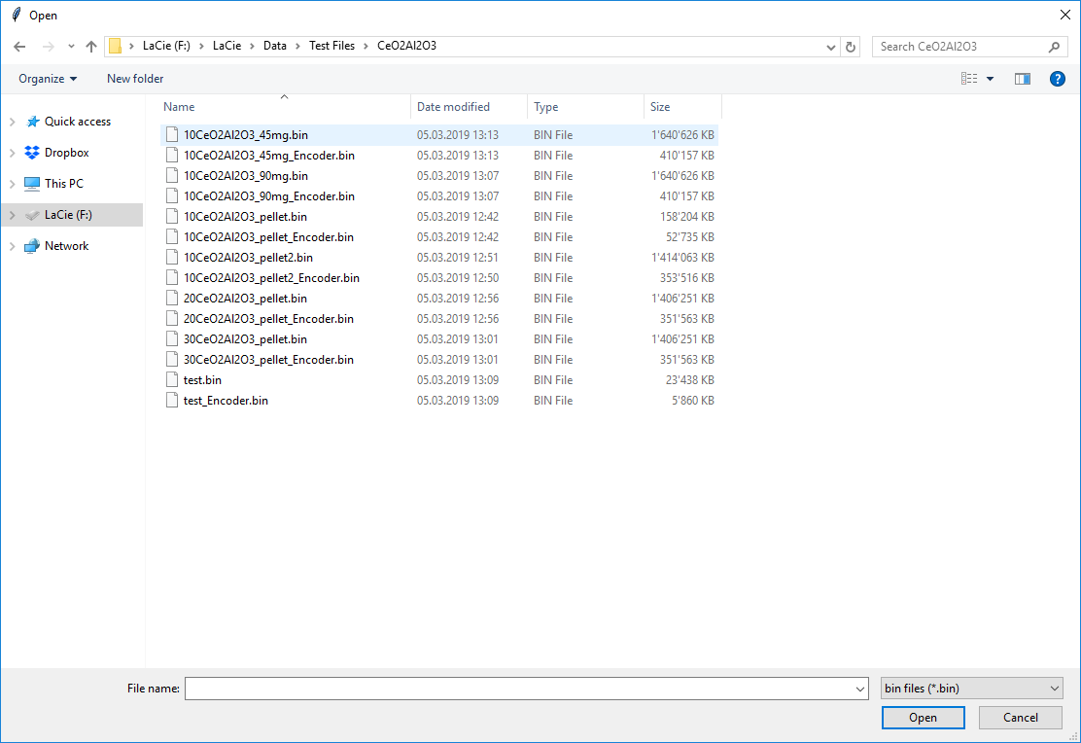

Upon selecting a file for loading into the software a small pop-up window will appear, shown below. This is used to enter some basic information regarding the edge of the element that was probed using XAS. In this example Ce L3 edge. Under most circumstances the element being probed is the same as the reference sample which is used to calibrate the energy axis.

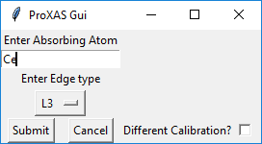

In this case the reference foil used was a V foil and as such additional information is entered upon ticking the ‘Difference Calibration?’ box. In this way it is possible to easily process a datafile containing multiple edges of interest. Pressing the submit button will complete the loading process.

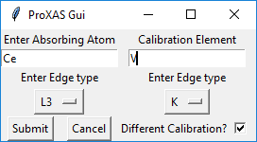

Now visible in the list panel in the left part of the tab is the name of the data file which was loaded into the program. This is a self-extending list and as such numerous data files can be loaded into the program.

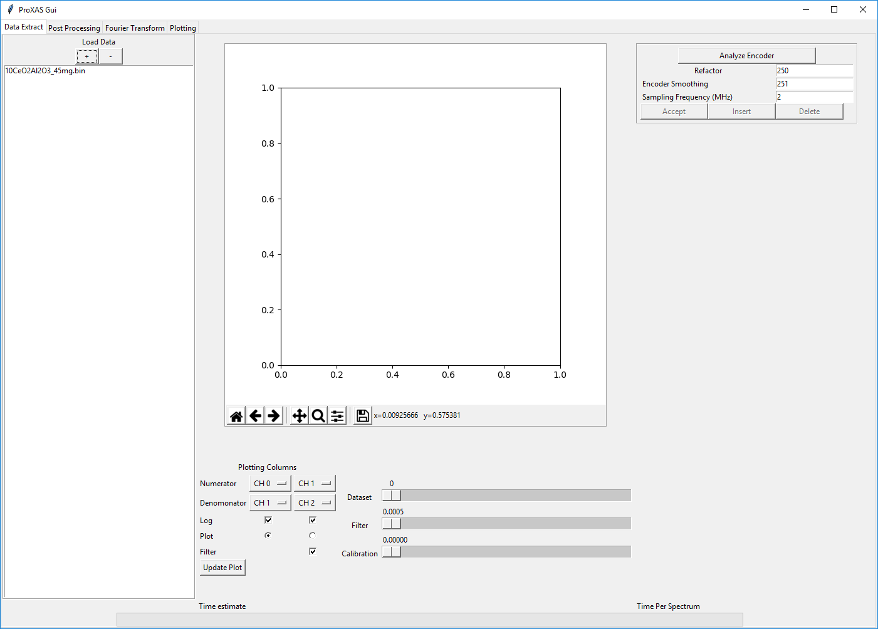

## Selecting a Datafile

Once a file is loaded into the program it must be selected by clicking on it prior to any data processing being able to be performed. On selecting a datafile which has not previously been processed or partially processed no update of the graphical interface will occur. This is due to the fact the program does not, to this point, know how the monochromator was oscillating and as such which bytes of data form individual spectra.

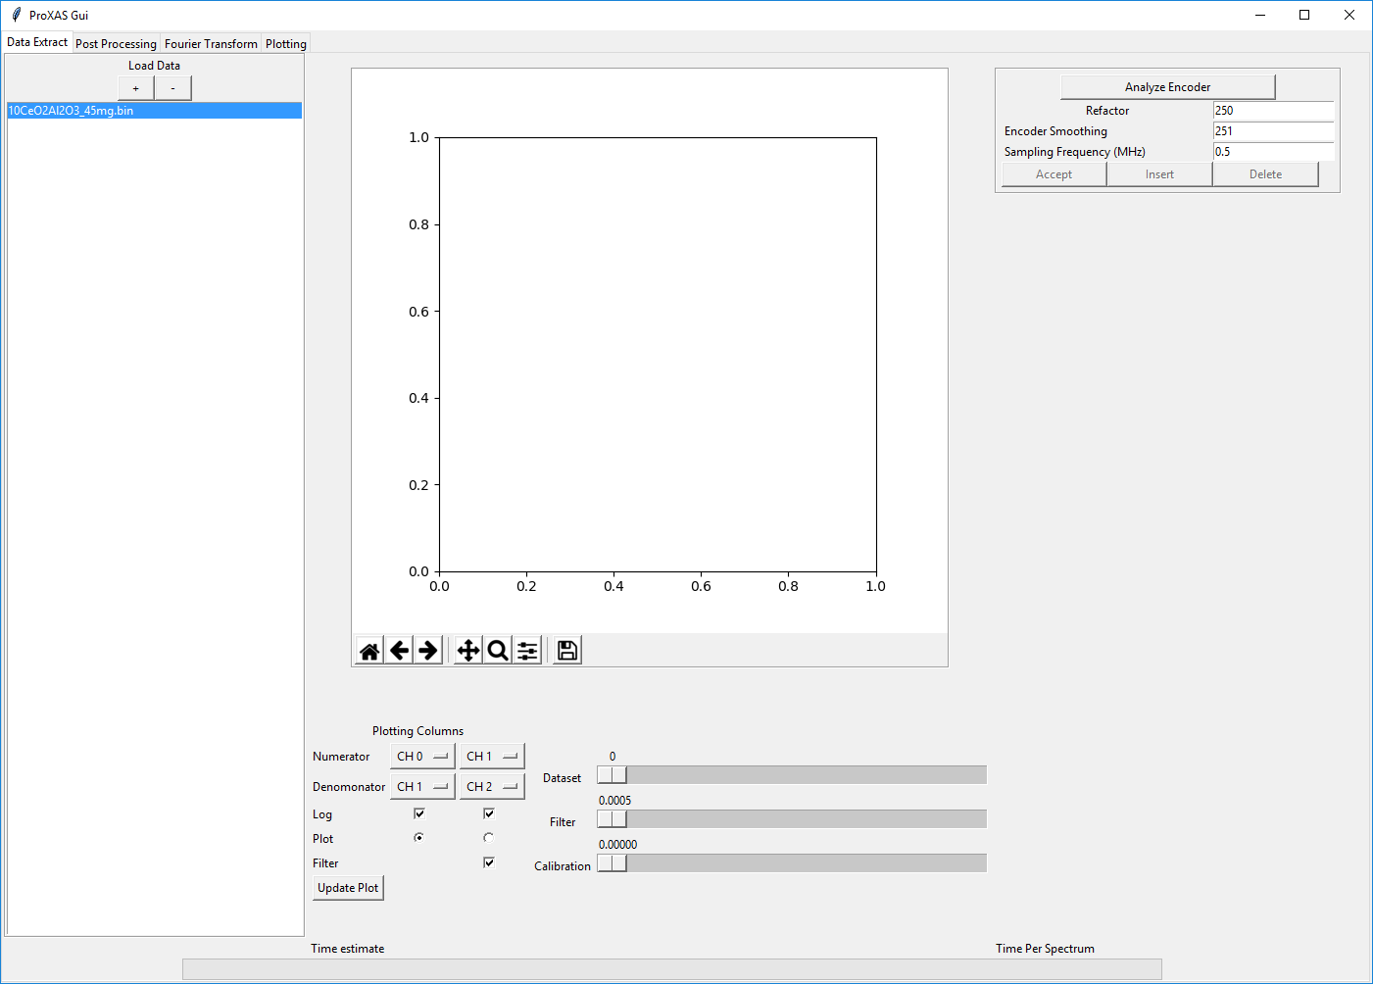

## Analysis of the Monochromator Oscillation: Analyse Encoder

To analyse the oscillation of the monochromator there is a panel in the top right part of the graphical interface. There are two main parameters to consider for splitting the monochromator oscillation: Refactor and Encoder Smoothing. These values should be initialised with sensible starting parameters that in most cases work. Pressing the ‘Analyse Encoder’ button will launch the batch-split subroutine. Upon completion the following plot will be shown.

This plot gives the number of data points per spectrum as a function of the spectrum number within the file. In a correct splitting the plot should resemble a flat line.

When using the older ‘.bin’ format In an ideal case this should be half the sampling frequency multiples by the monochromator oscillation frequency. For example for data collected with a sampling frequency of 500 kHz and a monochromator oscillation frequency of 1 Hz should yield 250,000 data points per spectrum.

This does not hold for the new ‘.qex’ format which will instead return the number of unique encoder values per half oscillation of the monochromator (on the order of 1000 for high energy experiments and 25000 for low energy experiments).

There are cases where the monochromator splitting is unsuccessful (points above and or below the correct number). And then adjustment typically of either the refactor or encoder smoothing is required. Points around 0 can often be removed by Increasing the refactor value, points above can often be removed by decreasing the refactor value. Similarly changing the encoder smoothing can often help with this process.

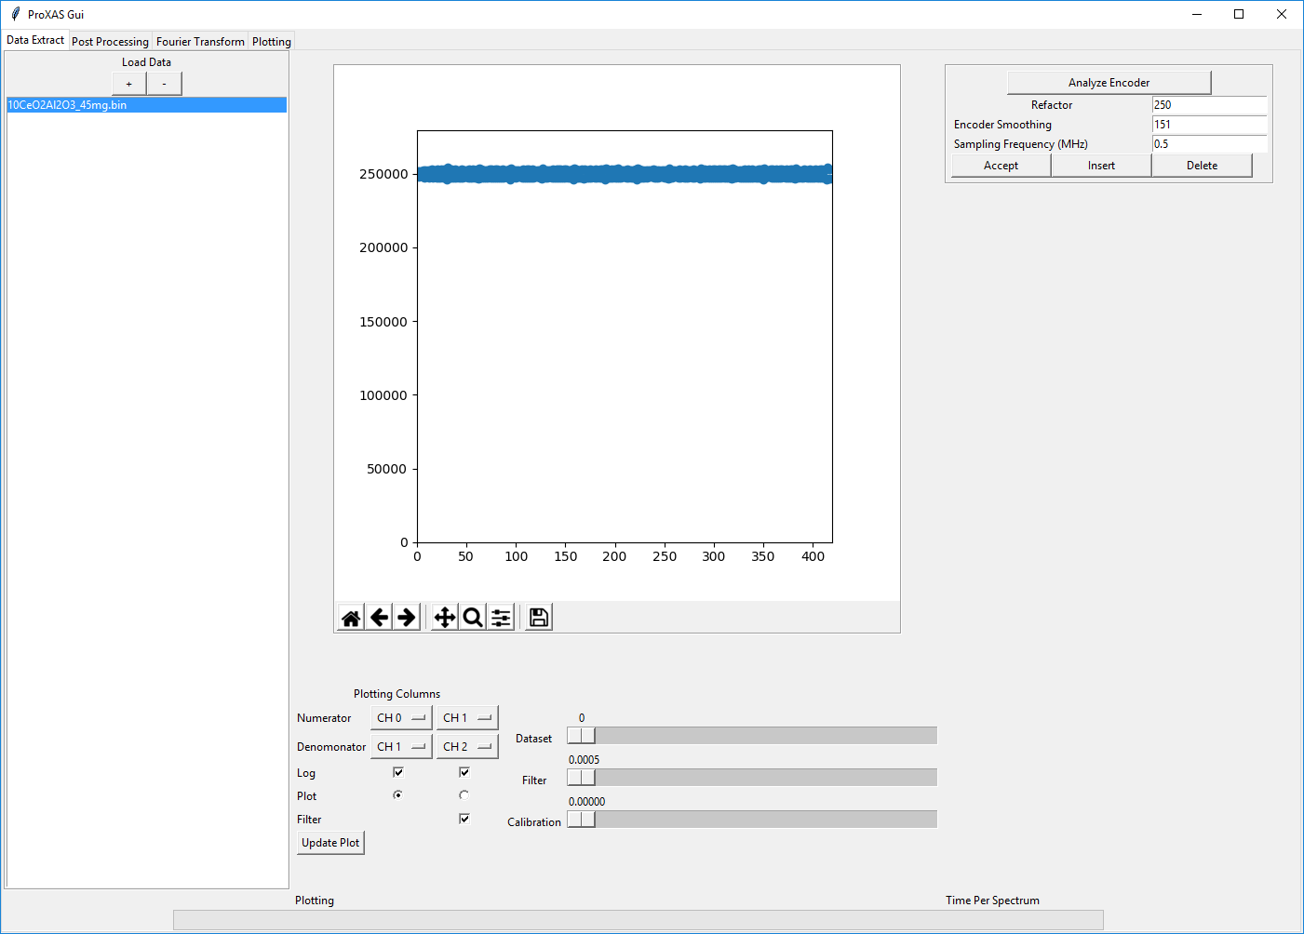

Once a splitting as shown above is achieved the accept button should be pressed. Once a set of parameters are found often they will work for most datasets collected during a beamtime.

## Calibration of Monochromator Angle to Energy

Upon accepting a monochromator encoder analysis the graphical interface will update to show a plot of the first spectrum within the datafile as a function of the monochromator angle. The plotting columns entered into the lower middle define which channels are used to represent either then sample or the reference. The left column denotes the sample, the right column the reference. In a typical QEXAFS measurement performed in transmission geometry the columns are initialized for CH0 over CH1 and CH1 over CH2 to represent the I0, I1 and I2 ion chambers. In transmission geometry the natural logarithm is also used. Typically in a fluorescence measurement the channels to select are CH3 over CH0 and without the nature logarithm selected. There is also a radio button that allows for switching between plotting the sample or the reference.

For calibration of the energy axis a reference sample is required with an edge at a known energy. Typically the reference sample consists of a metal foil. In the calibration panel shown below the encoder analysis panel the crystal of the monochromator should be selected to reflect that which was used for the experiment. The energy and edge boxes are initialized for a metal foil reference material on the edge indicated when loading the datafile. In this case a V foil was used.

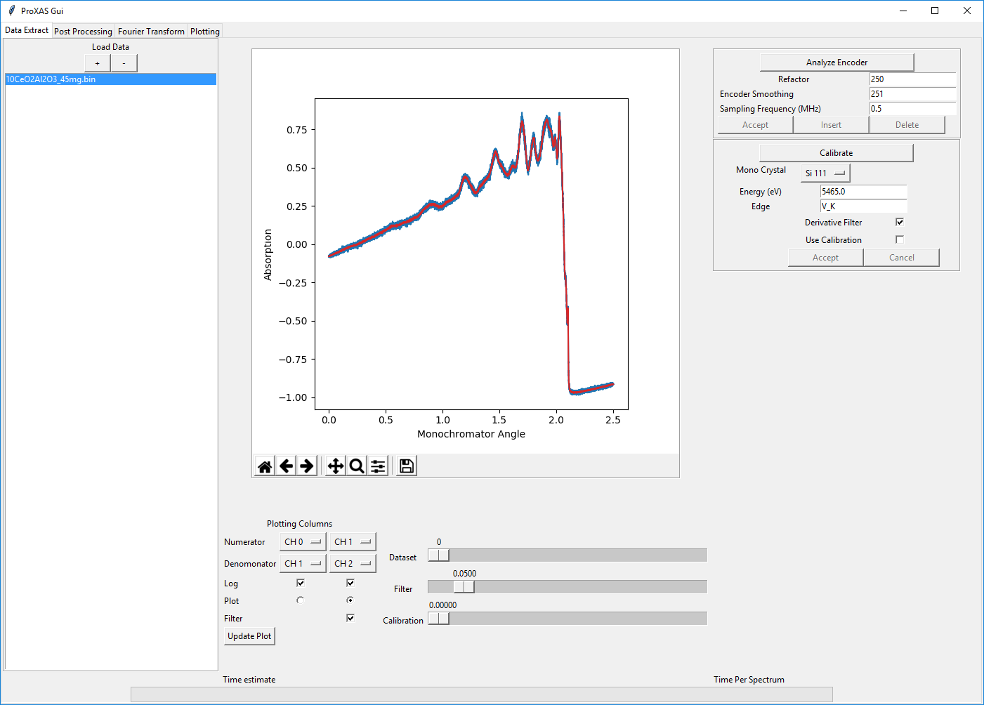

To calibrate first check the auto-filled energy that will be used for calibration (grabbed from a database dependent on the element and edge submitted during loading of the data). On pressing calibrate the graph should update to instead show the derivative of the XAS spectrum relating to either the sample or the reference channels (depending on the position of the Plot radio button). On the figure a dashed orange line is used to depict the position of the maximum of the derivate data. In the case that the maximum of the derivative is not correctly identified, or in the case where a different calibration point is desired to be used, one should use the ‘Calibration’ scroll bar located in the lower middle of the graphical interface. An example figure is shown below for the energy calibration.

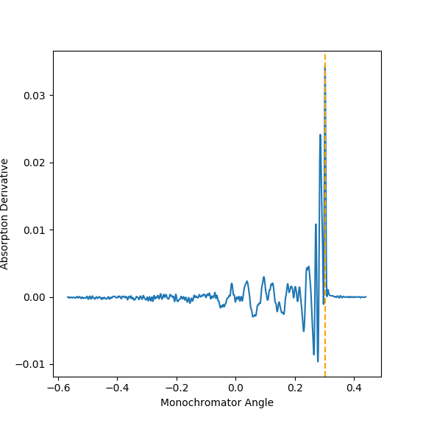

Accepting a calibration is done by pressing the ‘Accept’ button in the calibration panel of the graphical interface. Upon accepting a calibration the graph will update to show the XAS spectrum as a function of energy instead of monochromator angle, shown below.

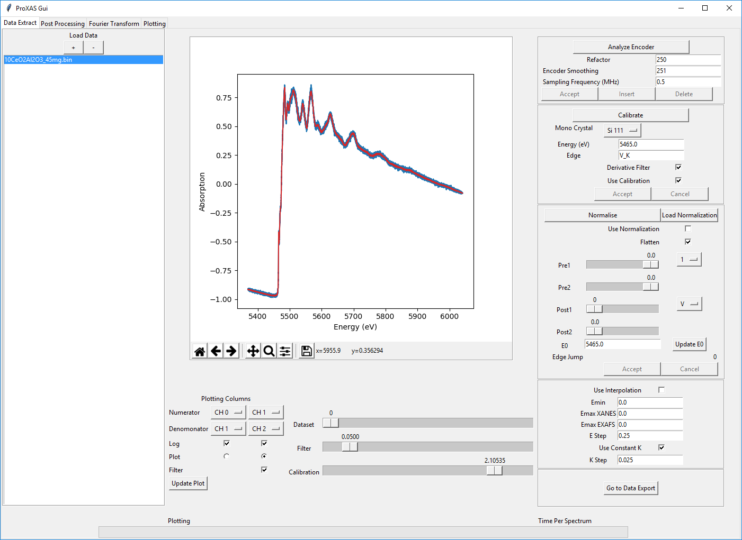

## Normalisation of the XAS spectrum

After accepting a calibration the graphical interface will now display panels for normalisation and interpolation of the spectra. Normalisation is an optional step in the processing of QEXAFS spectra and is not required to be performed in this software. Normalisation if required for quantitative analysis of XANES or for EXAFS analysis. In some cases it is beneficial not to carry out normalisation prior to data averaging due to propagation of errors in noisy data. Some functionality of this software is dependent on at which stage normalisation is performed such as an automatic dataset alignment routine.

Normalisation of the XAS spectrum is performed by considering edge step normalisation. Tpyically a polynomial function is fitted the pre-edge and post-edge regions independently and then difference between the two functions at the edge is normalised to 1. To initialize the normalisation press the ‘Normalise’ button which will first initialize the 4 sliders (two for the pre-edge, two for the post-edge) and updates the graph to show the polynomial fitting to these regions.

Two drop down boxes are used to change the order of the polynomial functions in the pre-edge and post-edge regions. The current supported options are:

0: A 1: A + Bx

2: A + Bx + Cx2 3: A + Bx + Cx2 + Dx3

4: A + Bx + Cx2 + Dx3 + Ex4 V: (AF3)/x3 - (BF4)/x4 + C (F = 1.23986x104)

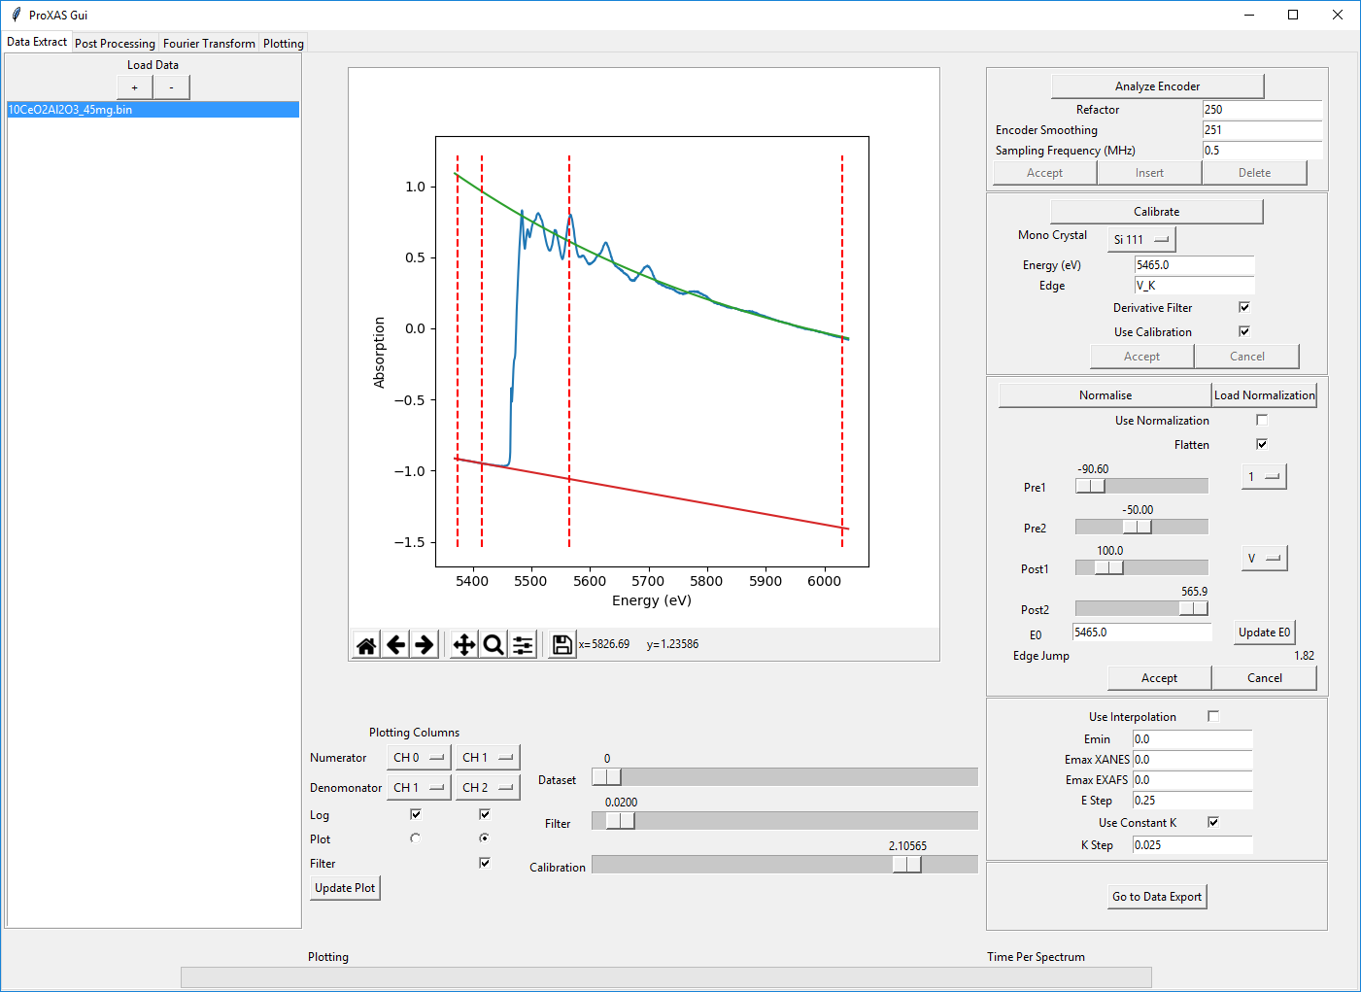

The four sliders are used to adjust the region limits of the pre-edge and post-edge regions and as such to adjust the normalisation parameters to obtain the desired normalisation of the XAS spectrum. Throughout the batch processing of the QEXAFS data the same normalisation parameters are used for all spectra for the purpose of consistency in data processing. Similar to previous steps in the data processing to accept the normalisation press the ‘Accept’ button in the normalisation panel of the graphical interface. On doing so the graph will update to show a normalised (and flattened) XAS spectrum. Flattening is used as default to show the post-edge region oscillating around 1. This is achieved by adding the difference between the post-edge polynomial function and 1 to the spectra and does result in artifacts in the data or changes to the EXAFS.

Alternatively, if a dataset is to be normalised but a previous dataset has already been processed it is possible to load a normalisation file from another set of processed data. On pressing the ‘Load Normalisation’ button a window will pop-up allowing for navigation to a file containing the normalisation parameters. The relevant file ‘normalisation.dat’ can be found in any output folder as shown below.

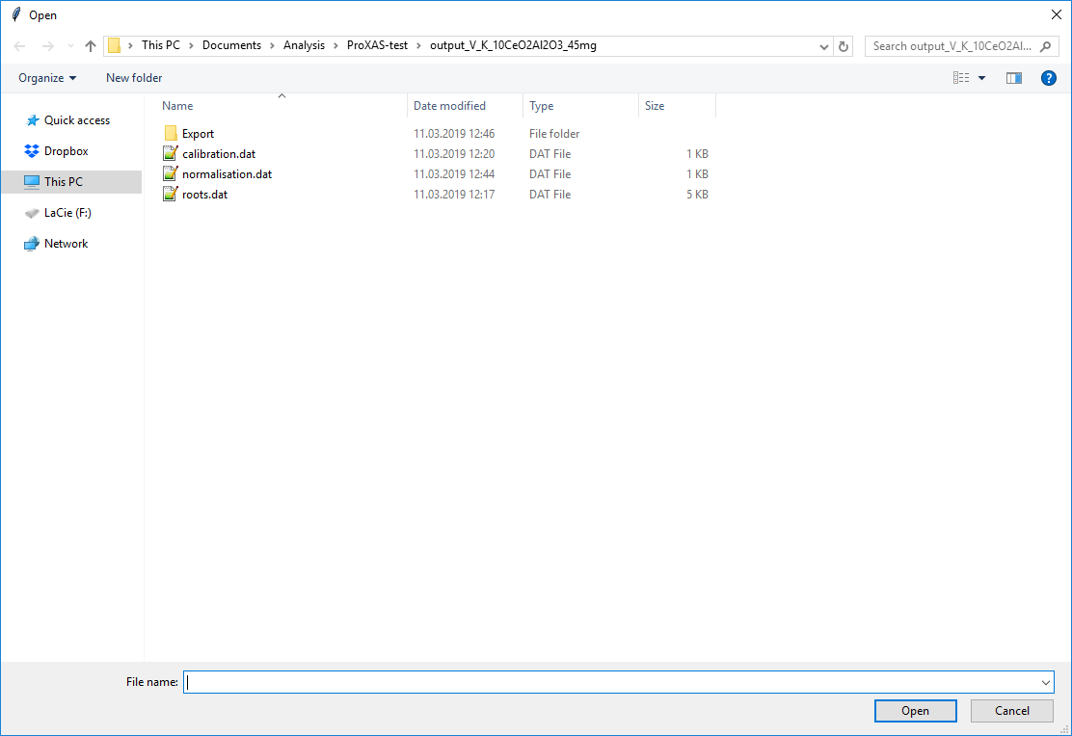

Loading a ‘normalisation.dat’ file from a previously processed experiment allows for the exact same parameters to be used across numerous experiments. This allows for different experiments to be reliably compared and is highly advisable to use this functionality.

## Interpolation of the XAS Spectrum

To reduce the density of data points XAS spectrum fast localized radial basis function interpolation has been developed. This functionality is intended to result in a meaningful, and user defined, data point density to allow for fitting in external software packages. From the raw data collection with angular resolution of 0.0005o the number of unique energy points per spectrum is typically on the order of 1000-25000 resulting in a very high oversampling of the XAS spectrum.

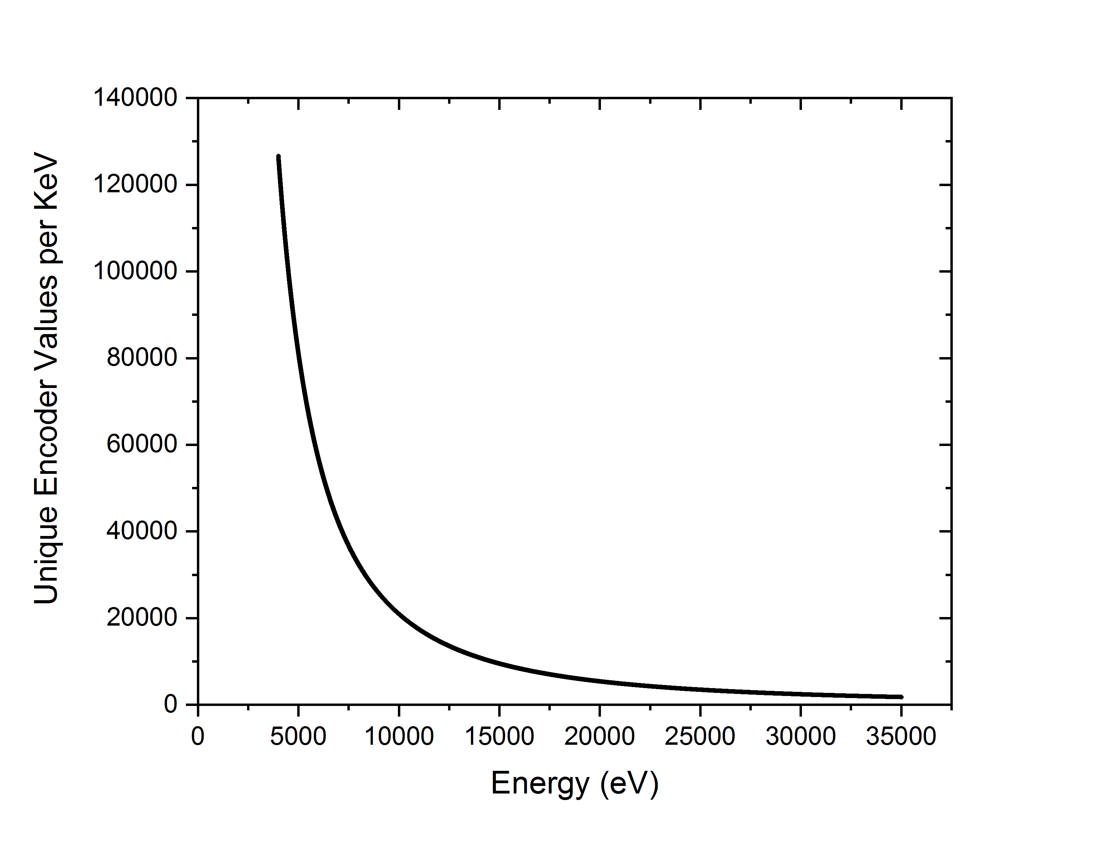

Interpolation is conducted on a user defined energy grid which is given by 5 main parameters:

Emin (the minimum energy)

Emax XANES (the maximum energy for the XANES region)

Emax EXAFS (the maximum energy of the EXAFS region)

Energy step (the energy step to apply between Emin and Emax XANES)

k step (the constant k step to apply between Emax XANES and Emax EXAFS)

These parameters are found in the low left portion of the user interface. With interpolation comes an additional feature, by defining energy regions it is possible to cut out only certain regions of the spectrum acquired. This is particularly useful in the case of multiple-edge data.

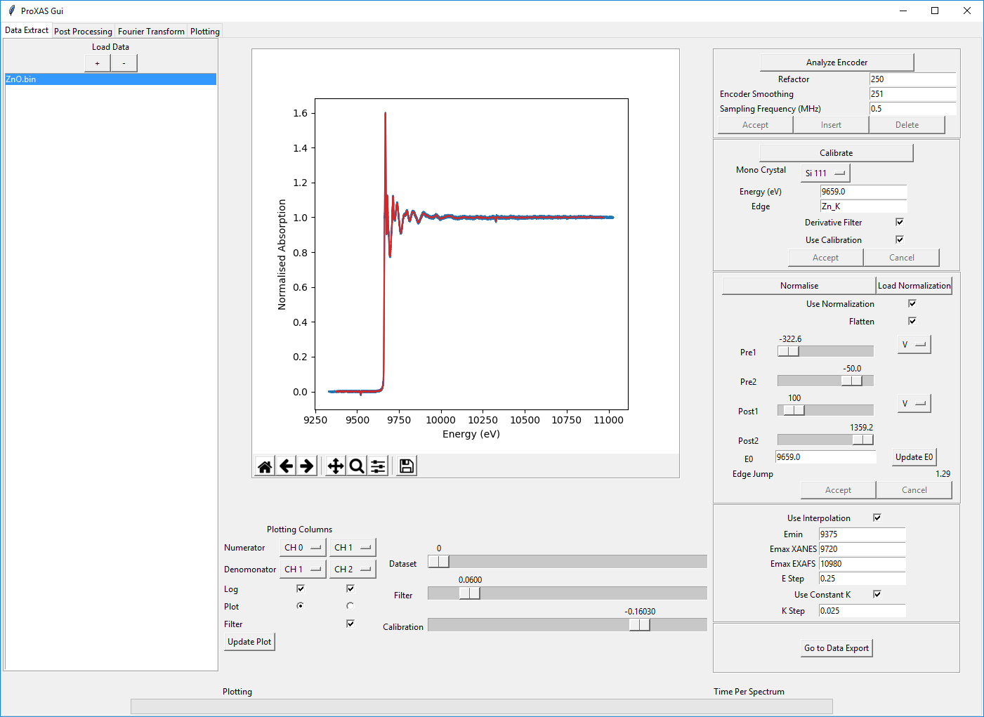

## Butterworth Noise Filtering

Throughout the processing shown above Butterworth noise filtering has been used. This is as standard selected. Butterworth noise filtering takes advantage of the large oversampling of the XAS spectrum to remove high frequency noise which originates from the data acquisition system. The software automatically initializes with a guessed value for the cut-off frequency in the region of 20 kHz, far in excess of the highest frequency component in the XANES region. The effect of Butterworth filtering is shown below for a sample of noise data without x-ray beam. The blue shows the raw data and the green the filtered data in the upper panel. The lower panel gives the raw and filtered data as a function of frequency components with a scaled gain factor curve shown in red of the applied filter. The filter strength can be adjusted by moving the filter slider. To disable the filter unselect the ‘Filter’ checkbox.

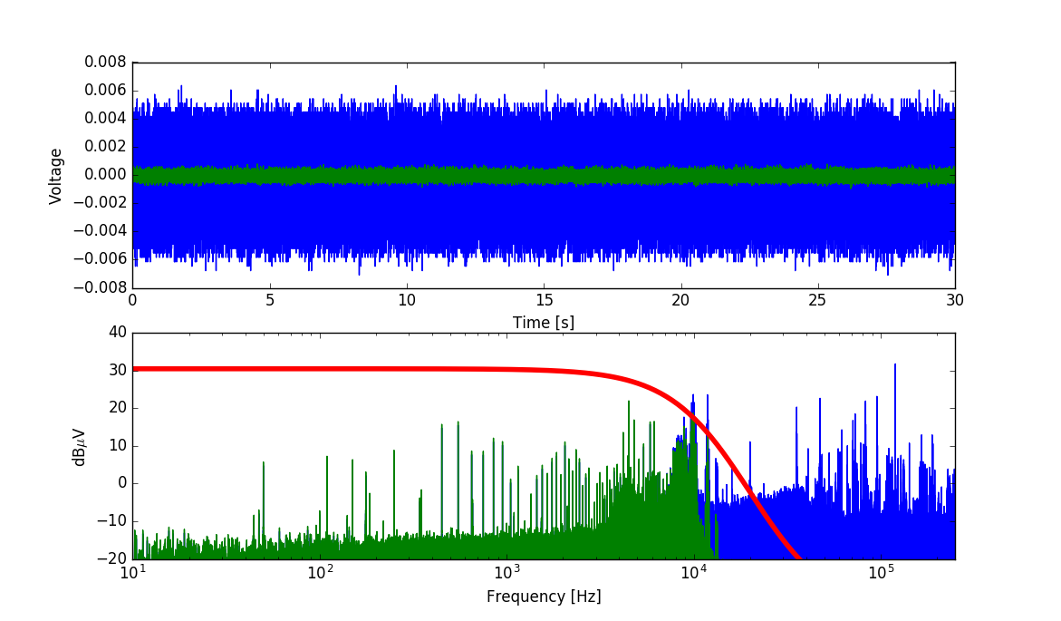



## Data Exporting

Once the initialization of all the pre-processing steps has been completed: Encoder Analysis, Energy Calibration, Normalisation (optional) and Interpolation (optional), to begin the data export process press the ‘Go to Data Export’ button located in the lower right panel. The graphical interface will update giving a few further options for data processing.

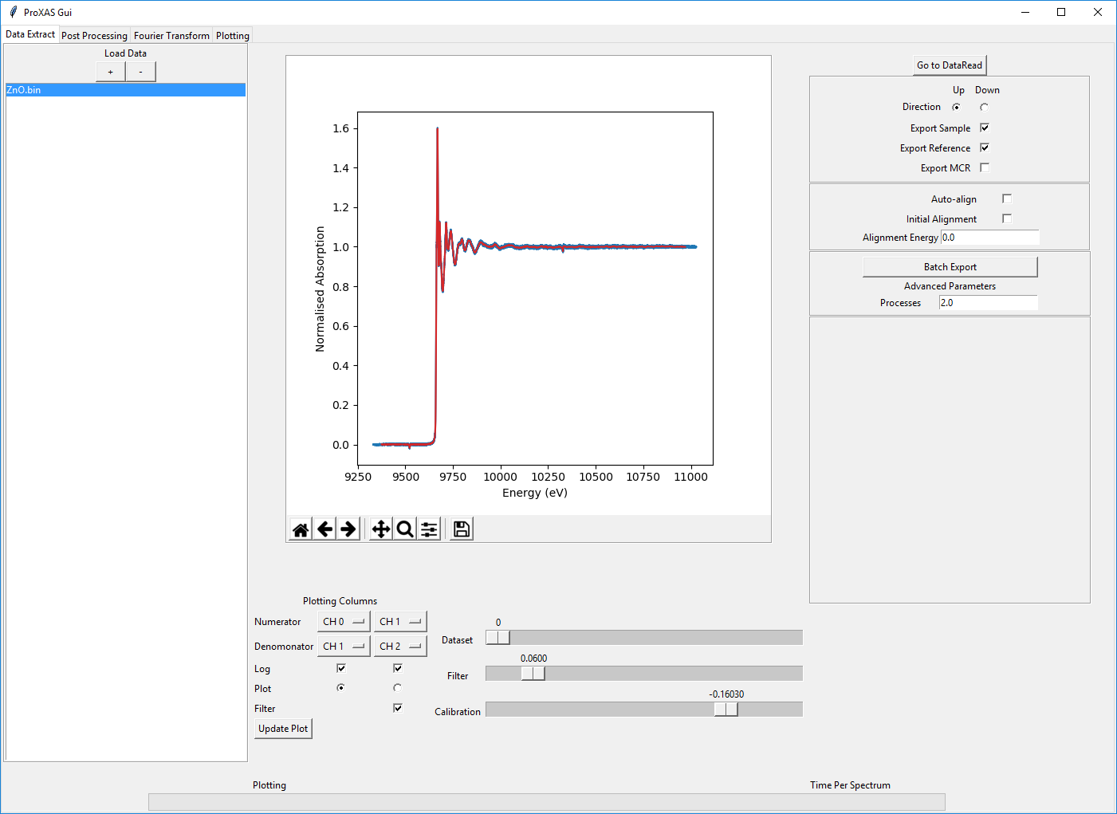

The main options in the upper panel are used to determine which direction of the monochromator should be taken for processing. Then options are given for exporting the sample data, exporting the reference data and exporting a file compatible for multivariate curve resolution analysis. By default the ‘Export MCR’ option takes only the XANES region defined in the interpolation parameters and requires that interpolation is performed. This is to allow for the direct grouping of datasets onto exactly the same energy grids which is required in multivariate analysis.

A further utility is provided that attempts to automatically align different datasets, however this functionality should be used with caution. Automatic alignment is carried out by fitting an edge-step function to the reference channel and aligning the center of the edge step to a defined alignment energy. The difference in the calibrated energy and the alignment energy is then applied to shift the spectra by the required value.

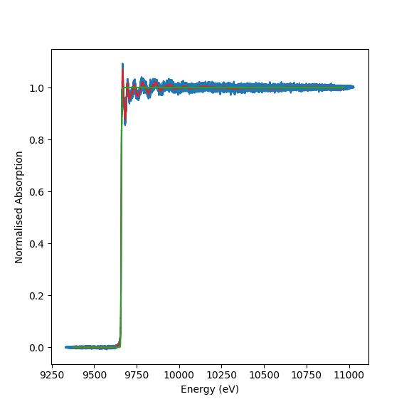

Advanced parameters are used to define the number of processing cores that should be used for the parallel processing. As default the number of logical processing cores available is used. This can be decreased if desired.

Once these parameters have been decided the batch export button should be pressed. Upon pressing the batch export a subprocess script will be launched that handles the parallel processing routines and updates the graphical interface to indicate the overall progress. An estimate of the total time remaining and the amount of time required per spectrum is given in the lower portion of the interface.

Export files are created to give in matrix form the spectra for the sample and reference channel when the batch processing is completed.

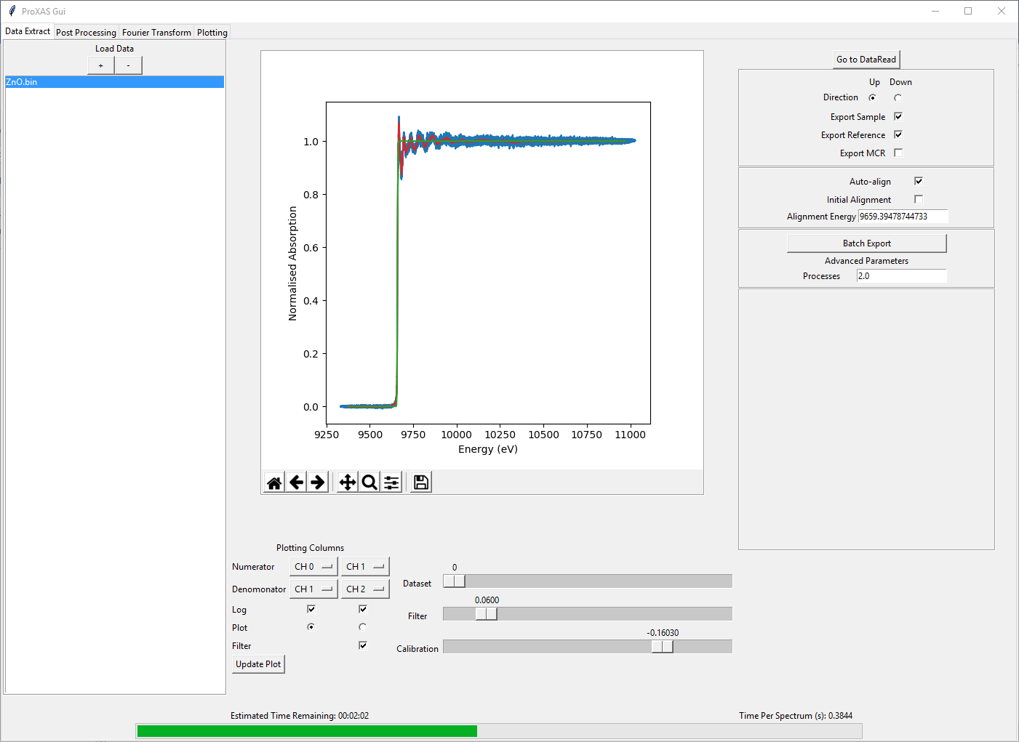

# Post Processing Routines