**GRACE Matlab Toolbox (GRAMAT)**

FENG Wei, 12 July 2016

[fengwei@whigg.ac.cn](mailto:fengwei@whigg.ac.cn)

Website: [http://sggc.whigg.ac.cn/fengwei](http://sggc.whigg.ac.cn/web/english/fengwei)

State Key Laboratory of Geodesy and Earth's Dynamics

Institute of Geodesy and Geophysics, Chinese Academy of Sciences (IGG/CAS)

GRACE Matlab Toolbox (GRAMAT) contains a set of open-source functions to process GRACE level-2 spherical harmonic coefficient products. Data processing functions in the GRAMAT contain: (1) destriping of SH coefficients to remove “north-to-south” stripes and Gaussian smoothing, (2) spherical harmonic analysis and synthesis, (3) analyzing and reducing leakage effect in GRACE-derived mass variations, (4) analyzing regional mass variations in spatial and temporal domains. Matlab GUIs are presented to facilitate the use of functions in the GRAMAT.

Firstly, please set the search path of Matlab: click "add path", click "Add with subfolders...", and select the folder "GRACE_functions" and “other_functions”.

Folder “GRACE_functions” contain all functions developed to process GRACE level-2 data.

Folder “GRACE_data” contain GRACE and other data used in the GRAMAT.

Please install “m_map” and “export_fig” toolboxs in advance. Some functions in them are used to plot the global and regional map and output different format figures.

Run “GRACE_Matlab_Toolbox.m” to open main GUI, select the menu “GRACE Processing” and click “GSM/GAD Data Processing” to show a new GUI. This new GUI can also be shown by running “GRACE_Matlab_Toolbox_preprocessing.m” directly. In this GUI, most GRACE level-2 date processing procedure can be done. For instance, destriping of GRACE original Stokes coefficients to remove “north-to-south” stripes, Gaussian smoothing, replacing degree-1 and degree-2 coefficients, removing GIA effect, and output the filtered coefficients or filtered grid.

For example, in STEP3/STEP1, click Open and find the control file “**GMT_Control_File_swenson.txt**”, then click STEP4/STEP2: Calculate, a popup window with a progress bar will be shown. After that, the results will be saved in the specified directory. Note that the path and parameters in the control file need to be modified correctly before run it. In this example, the output file “**cs_gsm_csr_swenson_2002_2014_fltr300km.mat**” will be saved in the specified directory.

I would recommend the other method in the command line mode. Type GRACE_Matlab_Toolbox_preprocessing_core('GMT_Control_File_swenson.txt') in Matlab command line mode, a popup window with a progress bar will be shown and the calculation will be finished. Note that, the control file should be prepared in advance.

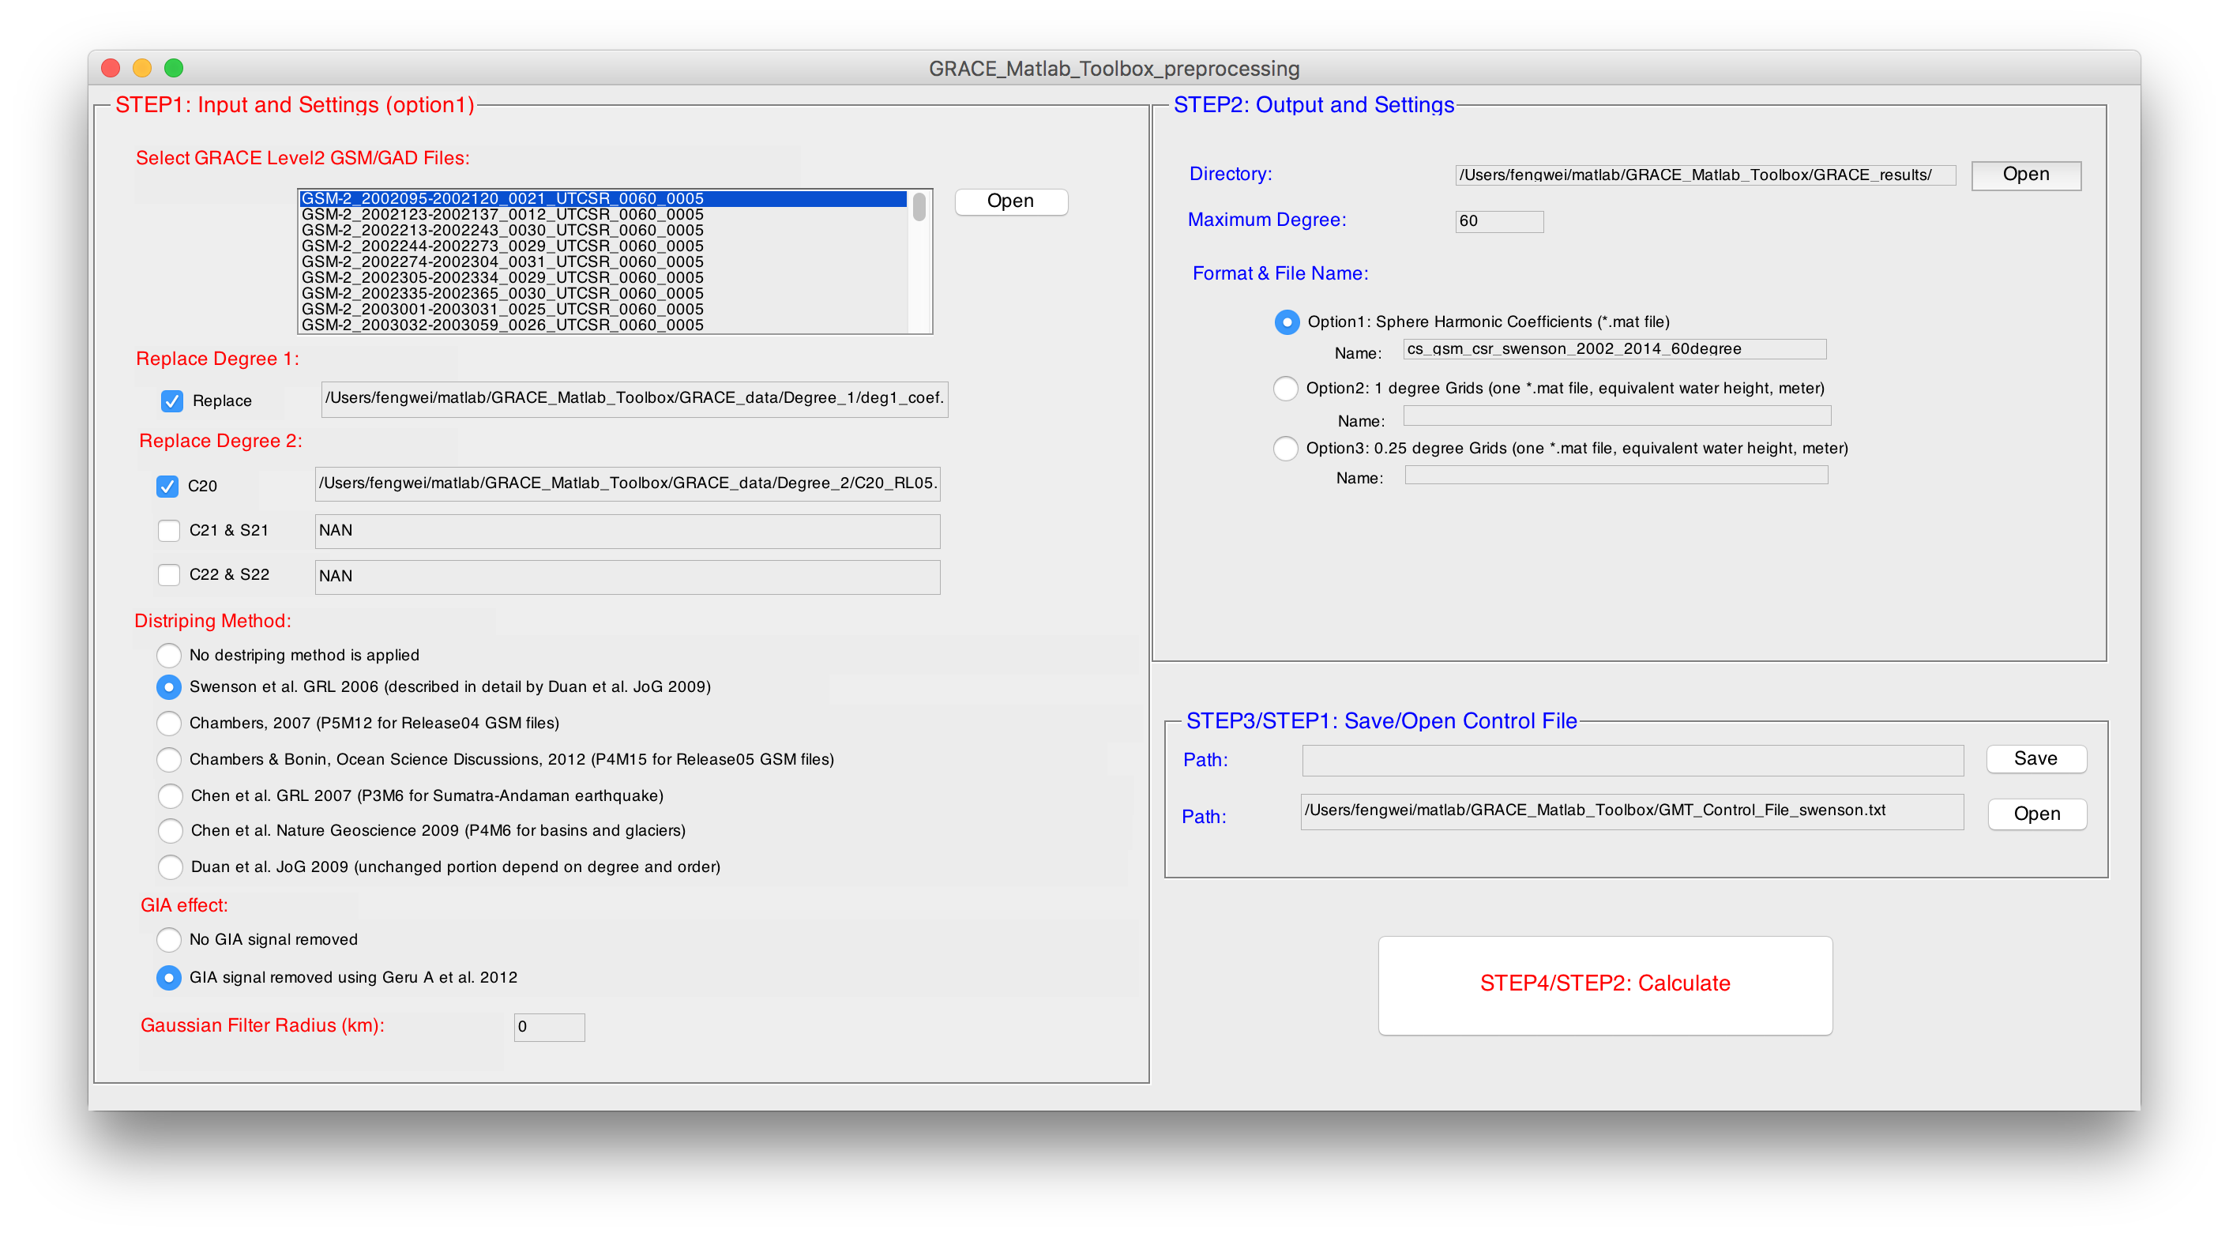

*GSM/GAD date processing GUI*

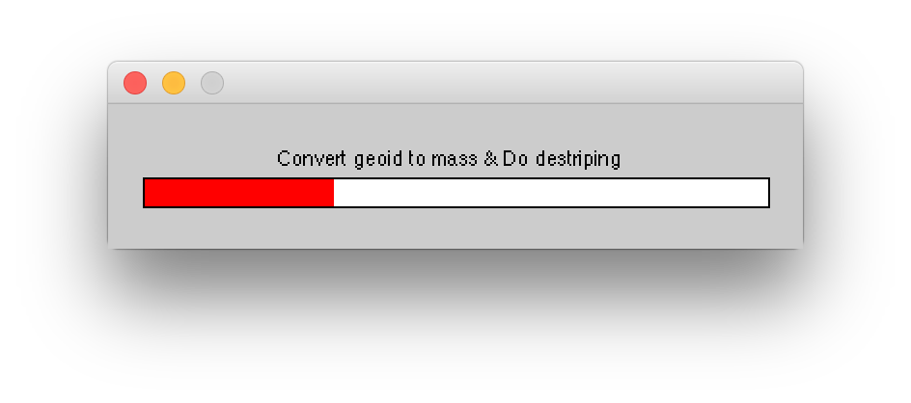

*popup window with a progress bar*

Run “GRACE_Matlab_Toolbox.m” to open main GUI, select the menu “GRACE Processing” and click “Leakage Reduction in Spatial Domain” to show a new GUI. This new GUI can also be shown by running “GRACE_Matlab_Toolbox_LeakageReductionSpatial.m” directly. In this GUI, the leakage from land in the coastal seas will be removed in the spectral domain, based on the function gmt_cs2leakagefreecs.m

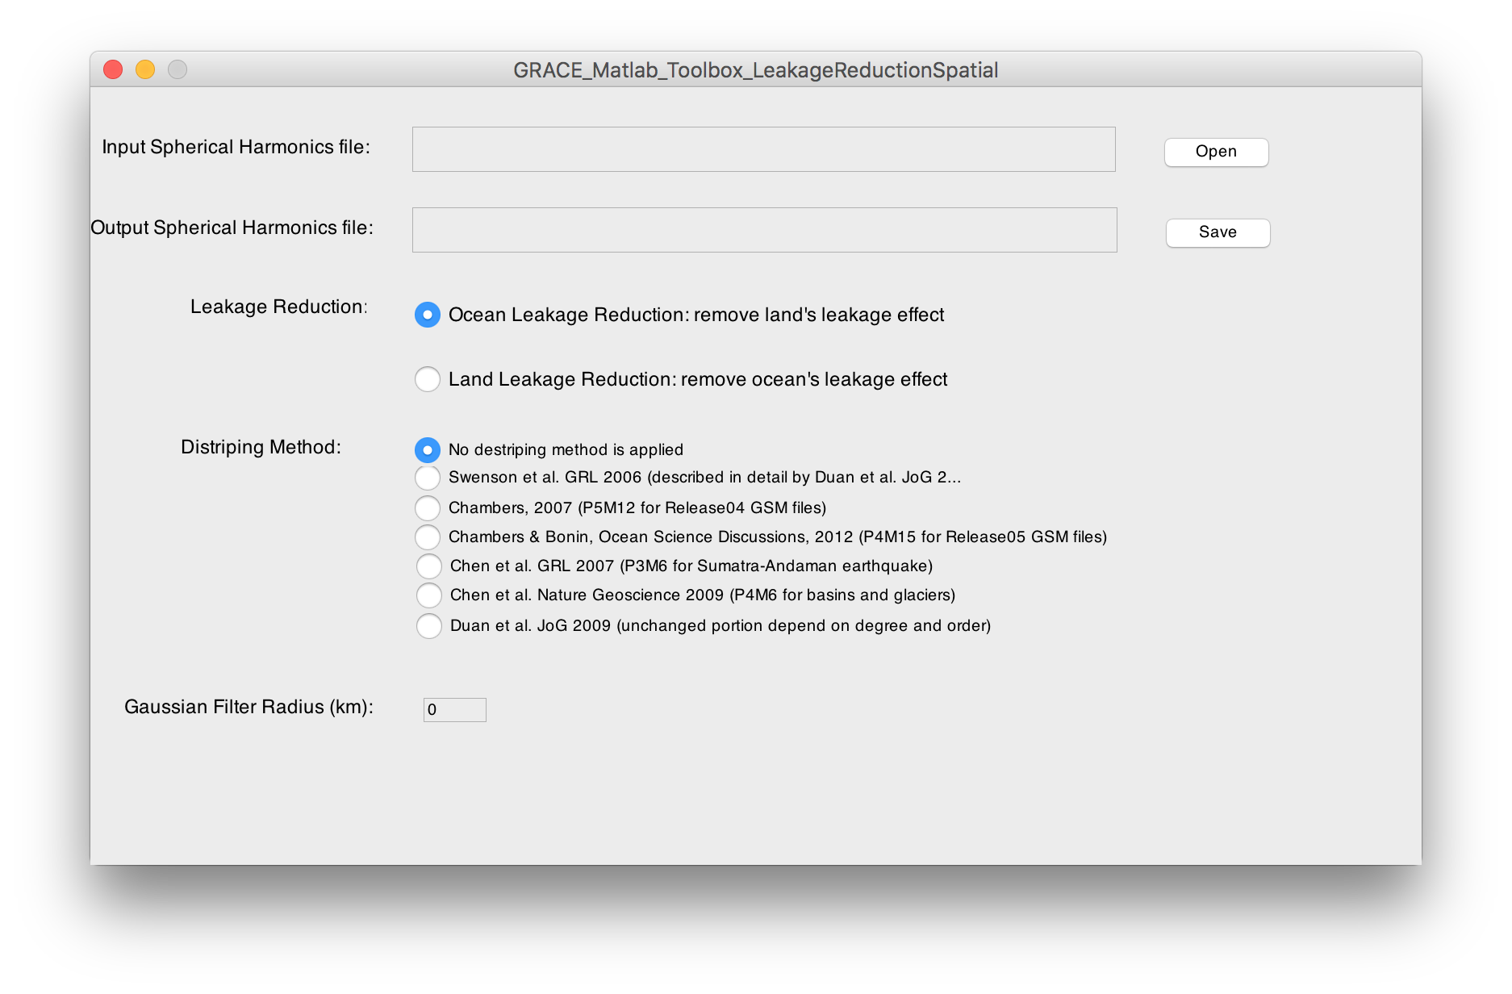

*Leakage reduction in the spatial domain*

Run “GRACE_Matlab_Toolbox.m” to open main GUI, click select the menu “Data Analysis” and click “Spherical Harmonic Analysis/Synthesis” to show a new GUI. This new GUI can also be shown by running “GRACE_Matlab_Toolbox_SHGrid.m” directly. As an example, we do spherical harmonic synthesis. Click Open and select the file “**cs_gsm_csr_swenson_2002_2014_fltr300km.mat**” created before. Click Save and choose the output directory and change the output file name if you want. Then a popup window will be shown for about one minute. Then the output file “**grid_data.mat**” will be saved in the specified directory.

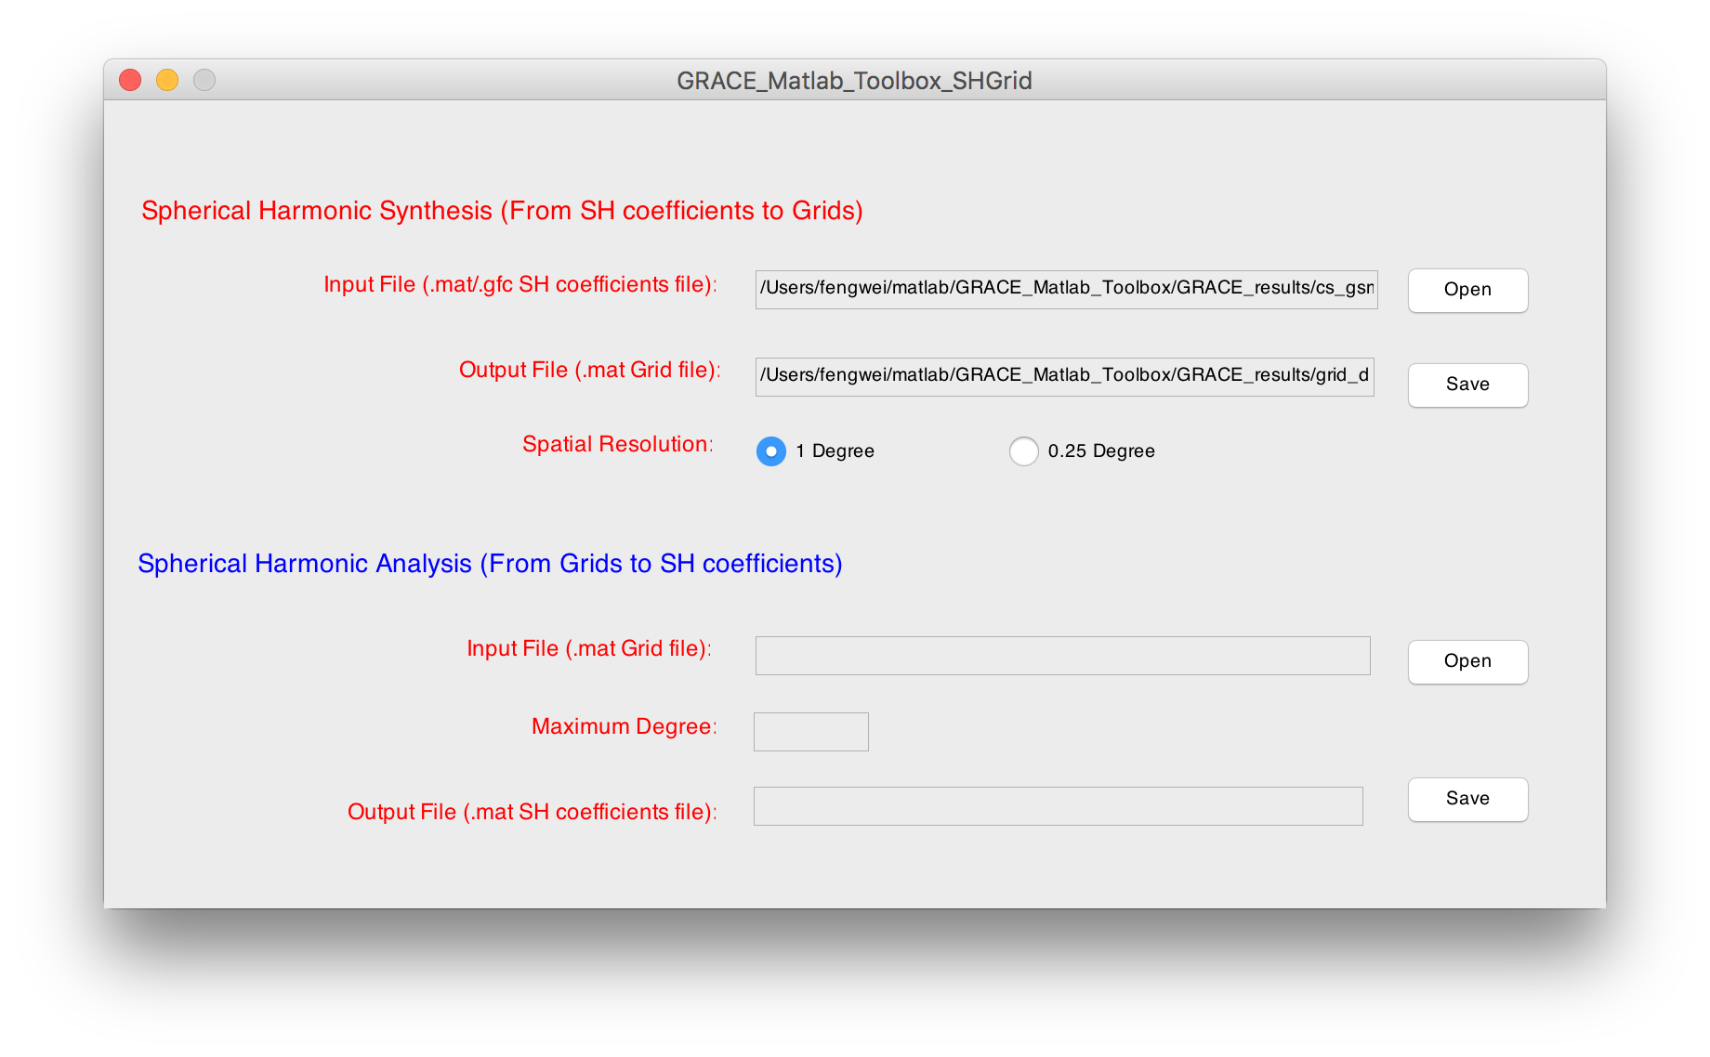

*Do spherical harmonic synthesis and analysis*

Run “GRACE_Matlab_Toolbox.m” to open main GUI, click select the menu “Data Analysis” and click “Grid2Series” to show a new GUI. This new GUI can also be shown by running “GRACE_Matlab_Toolbox_Grid2Series.m” directly. As an example, we Open the file “**grid_data.mat**” created before, and Open the boundary file “**amazon_new.bln**” in “./GRACE_data/boundary_files/”, then Open and select the output directory, save the output file “**time_series.mat**”. Keep in mind that the leakage corrections and rescaling process should be applied to get unbiased time series. More details can be found in the paper.

You can use the following scripts to show the output data:

load time_series.mat

plot(time,time_series*100,'-s');

xlabel('Year');

ylabel('Equivalent water height (cm)');

title('Mass variations in the Amazon from GRACE');

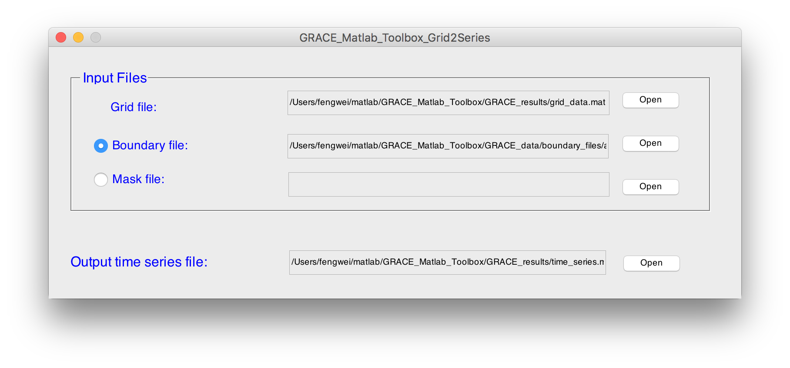

*Extracting regional time series of mass variation from the gridded file*

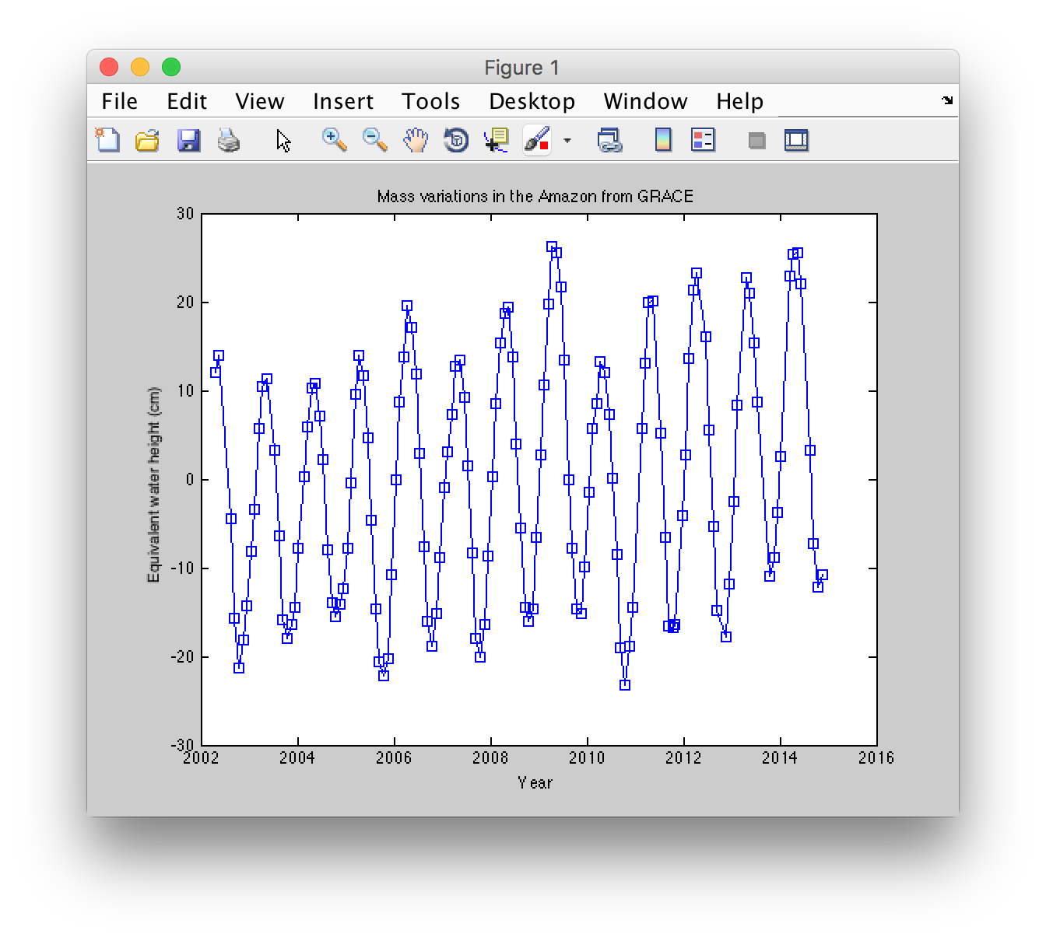

*Time series of mass variation in the Amazon*

Run “GRACE_Matlab_Toolbox.m” to open main GUI, click select the menu “Data Analysis” and click “Harmonic Analysis” to show a new GUI. This new GUI can also be shown by running “GRACE_Matlab_Toolbox_HarmonicAnalysis.m” directly. As an example, we do harmonic analysis to time series. Open the “**time_series.mat**” created before, and harmonic analysis will be done automatically. Seasonal amplitudes and phases and trend will be shown. Further, we do harmonic analysis in the spatial domain. Click Open and select “**grid_data.mat**” created before, and save the output files. You can output parts of or all the components. Here we output the trend.

You can plot the trend map using the following scripts:

load trend.mat

gmt_grid2map(trend*100,5,'cm/yr','Trend map of mass variations from GRACE')

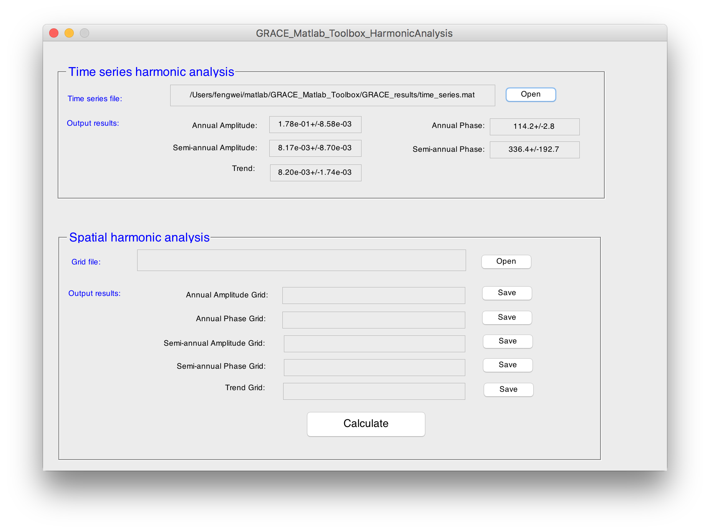

*Do harmonic analysis on time series*

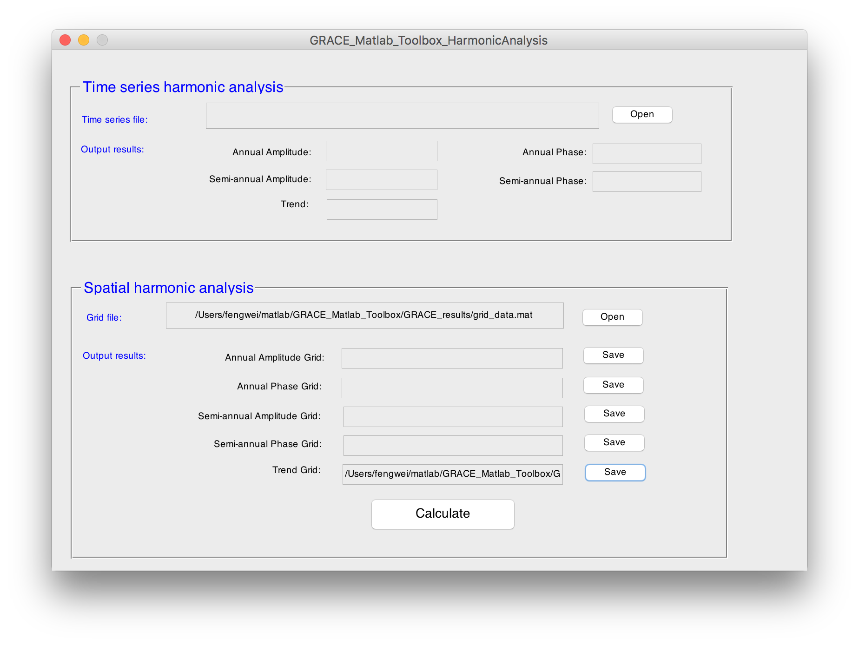

*Do harmonic analysis in the spatial domain*

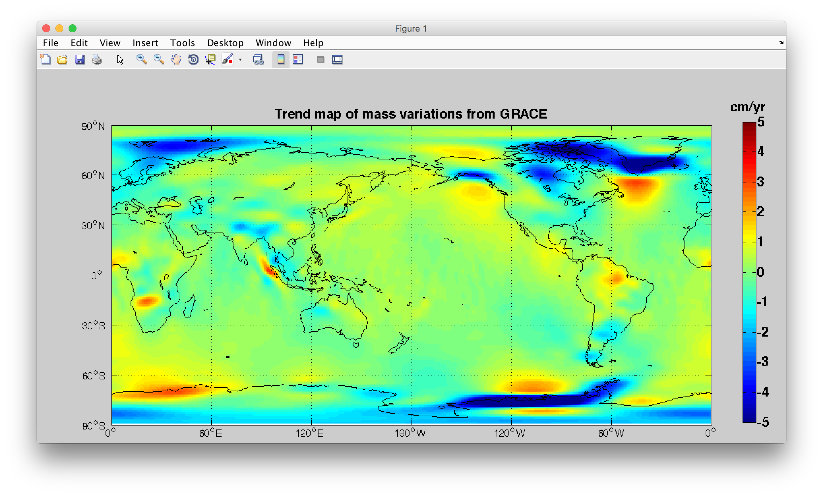

*Trend map of mass variation from GRACE (2002-2014)*

Notes: GUIs above only show parts of data processing functions in the GRAMAT. Users can use the functions directly to process GRACE level-2 data.