**Sinewave Sweep after 2019/03/26**

|  |  |
| --- | --- |
|  | sinewave |
| Spatial wavelength (um) ? | [75, 150, 225] |
| Spatial range (um) ? | 150? |
| Spatial wavelength (pixel) | [15, 30, 45] |
| Spatial range (pixel) | 30 |
| Spatial range (radius of SAC) | 4 |
| Spatial frequency (radius of SAC) | [1, 2, 3] |
| Temporal frequency (Hz) | [1/2, $\frac{\sqrt{2}}{2}$, 1, $\sqrt{2}$, 2, $2\sqrt{2}$, 4, $4\sqrt{2}$, 8, $8\sqrt{2}$] |
| Temporal frequency (frames) | 1/15 |
| Temporal duration (sec) | 5 |
| Temporal duration (frames) | 300 |

(Note: Radius of SAC is around 150 um. Go out to twice the radius.)

Total number of epochs = 10 TF * 3 SF * 2 Dir = 60

Estimated total experimental time = 60 epoch * (5 second trial + 1.5 second interleave) * 3 trials = 20 mins

Preliminary result (n = ??):

1. The largest mean response in SF=225, TF = 1~4, caused by non-zero mean luminance?
2. The direction selectivity is not strong.

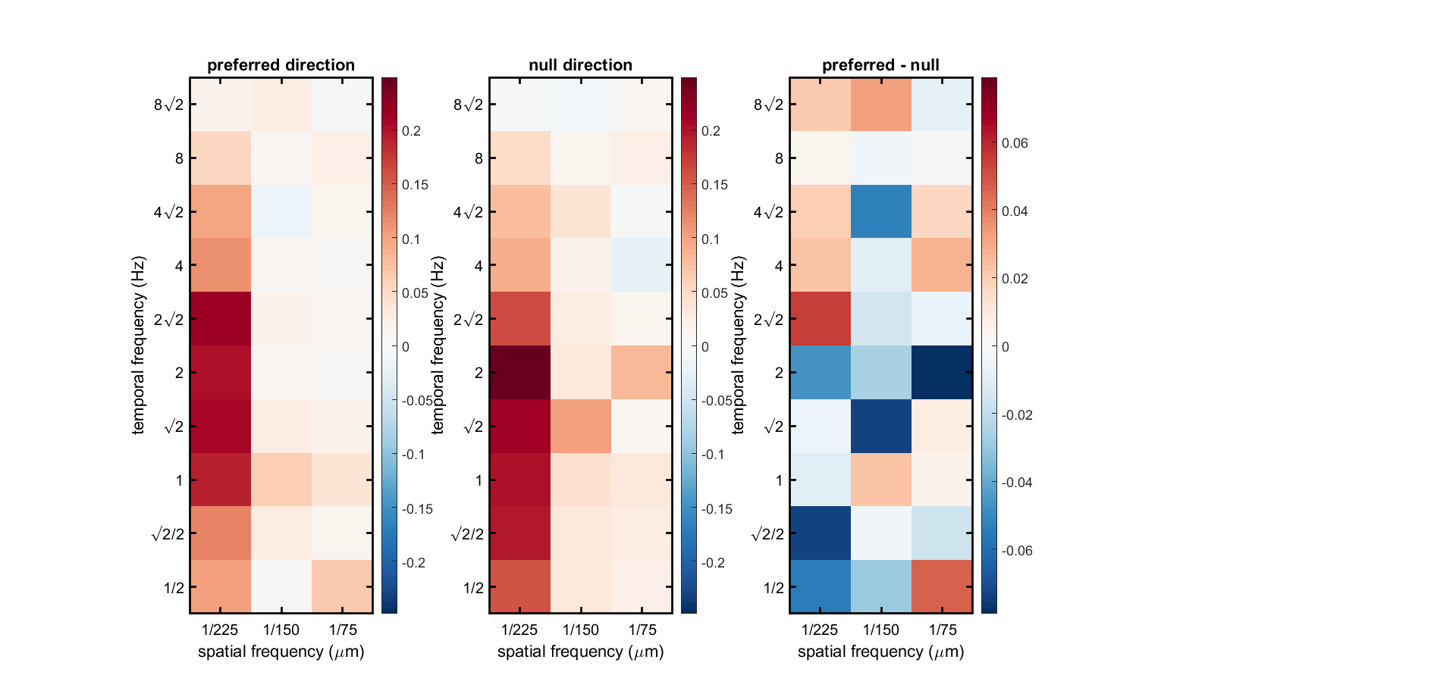

**Opponent stimulus after 2019/03/26**

|  |  |
| --- | --- |
|  | sinewave |
| Spatial wavelength (um) | 150 |
| Spatial range (um) | 150 |
| Spatial wavelength (pixel) | 30 |
| Spatial range (pixel) | 30 |
| Spatial range (radius of SAC) | 2 |
| Spatial wavelength (radius of SAC) | 1 |
| Temporal frequency (Hz) | 4 |
| Temporal frequency (frames) | 1/15 |
| Temporal duration (sec) | 5 |
| Temporal duration (frames) | 300 |
| Phase | 8 |

Total number of epochs = 8 Phases * 3 Dir = 24

Estimated total experimental time = 60 epoch * (5 second trial + 1.5 second interleave) * 3 trials = 8 mins

Estimated total experimental time = 60 epoch * (5 second trial + 1.5 second interleave) * 3 trials = 20 mins

Preliminary result (n = 3, average response is driven by one individual strange cell):

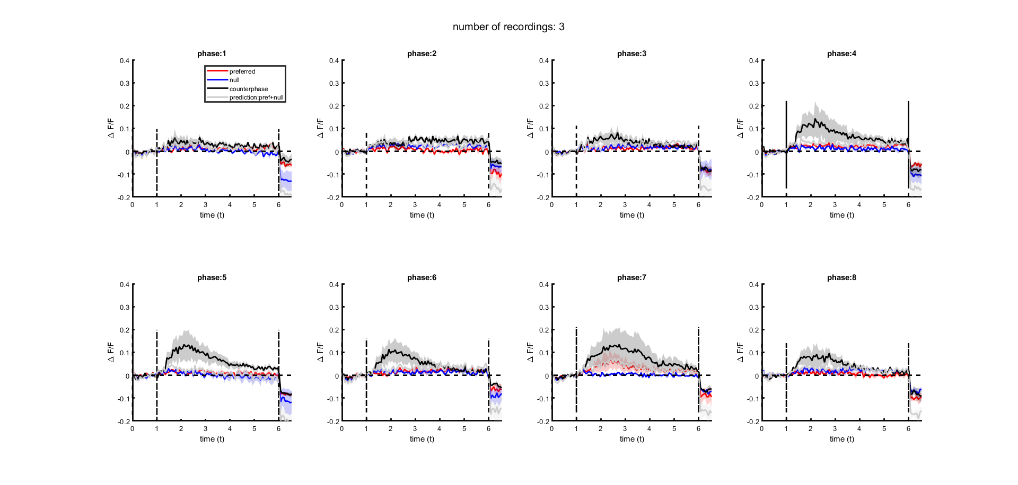

**Apparent Motion after 2019/03/26**

**Single bar: space**: 1 pixel, across 5 positions, (**um/pixel?**), 60 frames, 1 second

Number of epochs = 5 Positions * 2 Polarity = 10

**Apparent motion**: 2 nearby pixels, across 5 positions, 60 frames (first bar) + 45 frames (second bar)

Number of epochs = 4 Positions * 2 * 2 Polarity * 2 Directions = 32

**Simultaneous two bar**: 2 nearby pixels, across 5 positions, 60 frames (maybe 45 frames is enough).

Number of epochs = 4 Positions * 2 * 2 Polarity = 16

Estimated total experimental time = (10 + 32 + 16) * (1 second + 0.5 second interleave) * 3 trials = 4.5 min

Preliminary result: dropbox/BorghuisClark - SAC Calcium\analysis\2019_03_11/ApparentMotion

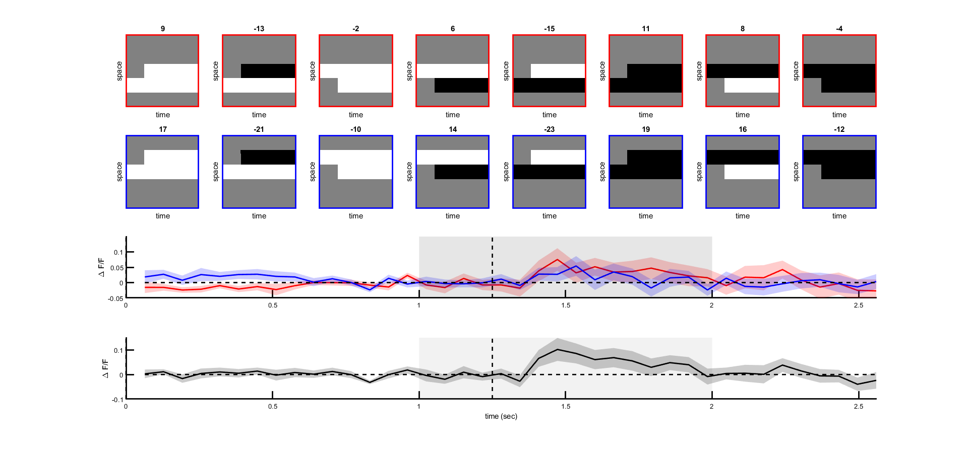

There is a small signal after averaging over polarity and direction.

**Scintillator after 2019/03/26**

|  |  |
| --- | --- |
|  | sinewave |
| Spatial range (um) ? |  |
| Spatial range (pixel) ? |  |
| Spatial offset (um) ? |  |
| Spatial offset (pixel) ? |  |
| Temporal offset (second) | [0, 1, 2, 3, 4, 5] * 0.05 |
| Temporal offset (frames) | [0, 1, 2, 3, 4, 5] |
| Temporal duration (second) | 15 second? |

Number of epochs = 6 Temporal offset * 2 Polarity * 2 Dir = 24

Estimated total experimental time = 24 * (15 second + 2 second interleave) * 3 trials = 21 min.

Preliminary result:

