Example Template for Data Analysis Project

Andreas Handel

2019-08-02

# Summary/Abstract

*Write a summary of your project.*

# Illustrating setup

*This section is only there to show how to insert results from other places in the project and how to cite figures and other references. Delete this whole section at some point.*

Figure 1 shows a data analysis workflow.

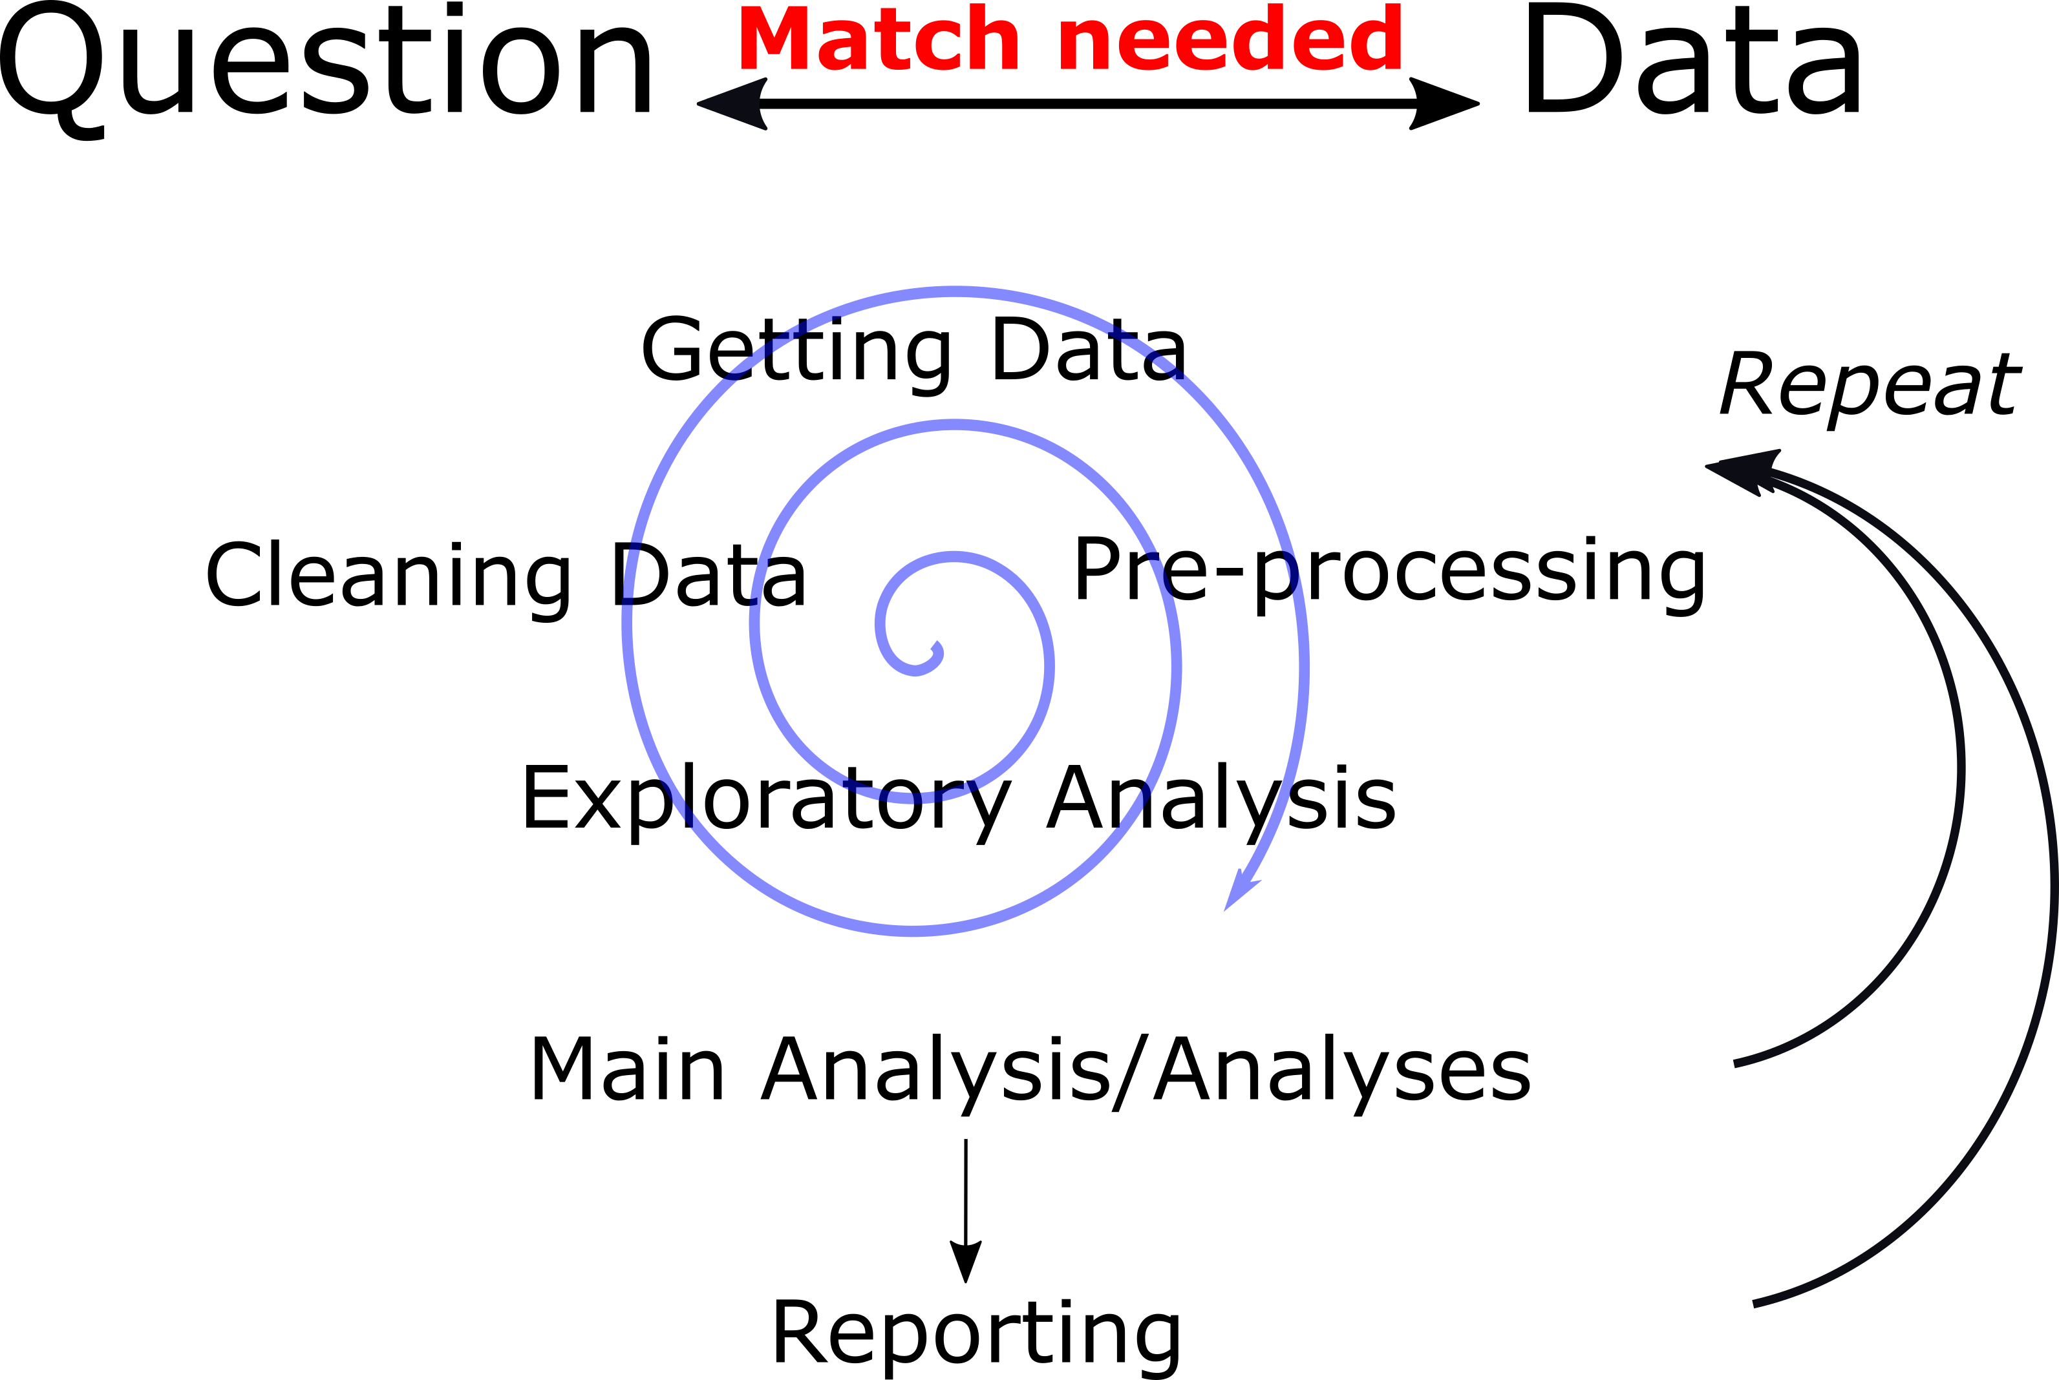

Figure 1: Conceptual figure of an analysis workflow.

This paper (Leek & Peng, 2015) has another flowchart figure which focuses on the analysis part. Note that this cited reference will show up at the end of the document, the reference formatting is determined by the CSL file specified in the YAML header. Many more style files for almost any journal [are available](https://www.zotero.org/styles). You also specify the location of your bibtex reference file in the YAML. You can call your reference file anything you like, I just used the generic word references.bib but giving it a more descriptive name is probably better.

# Introduction (required for part 1)

## General Background Information

*Provide enough background on your topic that others can understand the why and how of your analysis*

## Description of data and data source

*Describe what the data is, what it contains, where it is from, etc.*

## Questions/Hypotheses to be addressed

*State the research questions you plan to answer with this analysis*

# Methods and Results

*In most research papers, results and methods are separate. You can combine them here if you find it easier. You are also welcome to structure things such that those are separate sections.*

## Data aquisition

*As applicable, explain where and how you got the data. If you directly import the data from an online source, you can combine this section with the next.*

## Data import and cleaning

*Write code that reads in the file and cleans it so it’s ready for analysis. Since this will be fairly long code for most datasets, it might be a good idea to have it in one or several R scripts. If that is the case, explain here briefly what each file does. The files themselves should be commented well so everyone can follow along.*

## Univariate analysis

*Use a combination of text/tables/figures to explore and describe your data. You should produce plots or tables or other summary quantities for most of your variables. You definitely need to do it for the important variables, i.e. if you have main exposure or outcome variables, those need to be explored. Depending on the total number of variables in your dataset, explore all or some of the others.*

## Bivariate analysis

*Create plots or tables and compute simple statistics (e.g. t-tests, simple regression model with 1 predictor, etc.) to look for associations between your outcome(s) and each individual predictor variable*

## Full analysis

*Use one or several suitable statistical/machine learning methods to analyze your data and to produce meaningful figures, tables, etc. This might again be code that is best placed in one or several separate R scripts that need to be well documented. You can then load the results produced by this code*

# Discussion

## Summary and Interpretation

*Summarize what you did, what you found and what it means.*

## Strengths and Limitations

*Discuss what you perceive as strengths and limitations of your analysis.*

## Conclusions

*What are the main take-home messages?*

*Include citations in your Rmd file using bibtex, the list of references will automatically be placed at the end*

# References

Leek, J. T., & Peng, R. D. (2015). Statistics. What is the question? *Science (New York, N.Y.)*, *347*(6228), 1314–1315. <https://doi.org/10.1126/science.aaa6146>