## FAST-FOOD RESTAURANT MANAGEMENT SYSTEM

**BY**

**SULAIMAN MICHEAL OLOWOSALE**

**(N/CS/18/2771)**

**DEPERTMENT OF COMPUTER SCIENCE**

**SCHOOL OF PURE AND APPLIED SCIENCE**

**THE FEDERAL POLYTECHNIC ILARO, OGUN STATE. NIGERIA**

**DECEMBER, 2020**

**FAST-FOOD RESTAURANT MANAGEMENT SYSTEM**

**BY**

**SULAIMAN MICHEAL OLOWOSALE**

**(N/C/18/2771)**

**A PROJECT REPORT SUBMITTED IN PARTIAL FULFILLMENT OF THE REQUIREMENTS FOR THE AWARD OF NATIONAL DIPLOMA IN THE DEPARTMENT OF COMPUTER SCIENCE, SCHOOL OF PURE AND APPLIED SCIENCE, THE FEDERAL POLYTECHNIC,ILARO.**

**DECEMBER, 2020**

## CERTIFICATION

This is to certify that this research work titled “Fast-food Restaurant Management”, carried out by Sulaiman Micheal Olowosale under the supervision of Mr. S.A Oloruntoba, in the department of Computer Science, Federal Polytechnic Ilaro.

____________________________ ____________________

**MR. S.A OLORUNTOBA Date**

Supervisor

___________________________ ____________________

**MR. S.A OLORUNTOBA Date**

Head of Department

## DEDICATION

This project is dedicated to God Almighty for the abundant grace, wisdom, knowledge, skills given to me all through my life, especially during my stay in Federal Polythecnic Ilaro.

## ACKNOWLEDGEMENTS

All praise, glorification and adoration belong to Almighty God, the knowledgeable who seek knowledge from no one and bestow knowledge in all, to Him be honor and thanks for his divine assistance, help and guidance which made it possible for me to successfully complete my ND programme.

I sincerely acclaimed the effort of my beloved Mother Mrs. Lasisi Rashidat Oluwayemisi unquantifiable and immeasurable moral, spiritual and financial support right from my childhood till moment. May Almighty God sustain her life and give them good health to harvest the fruit of the tree she have planted. AMEN

I would like to express my gratitude to my brilliant and highly intellectual supervisor; Mr. S.A Oloruntoba for his guidance enabled me to know more about the project.

Finally, I acknowledge those who in one way or the other contributed immensely to the fulfillment and actualization of my dream. May almighty Allah in his infinite bless you all. Amen.

## ABSTRACT

The purpose of this project is to develop a Fast-food Resytaurant management system. It is a system thet will assist managers and administrators in managing restarants effectively and also a system that enabled customer to place their food order online at any time from any place. The reason to develop the system is to Reduce the workload in the present system and reduce time wasted in data processing. It provides a user-friendly web-page for displaying food menu and effective advertising of Paramount cuisine services products to the customers with cheaper cost. The system was designed and implemented using the HTML (Hypertext mark-up language), CSS (Cascading style sheet), PHP (Hypertext Pre-processor) and My SQL database. The system was developed using the Waterfall-model software development approach.

## TABLE OF CONTENT

Title Page  
Approval   
Certification   
Dedication  
Acknowledgment

Table of Content   
Abstract

**CHAPTER ONE1.0 INTRODUCTION**  
1.1 Background and Information Of The Study   
1.2 Statement Of The Problems   
1.3 Aim and Objectives Of The Study   
1.4 Significance Of The Study   
1.5 Scope Of The Study   
1.6 Limitations Of The Study   
1.7 Definition of terms

**CHAPTER TWO2.0 LITERATURE REVIEW**  
2.1 Theoretical and conceptual development  
2.2 History of fast-food restaurant   
2.3 Internal Organization case study  
2.4 Compare between existing systems 

**CHAPTER THREE3.0 RESEARCH METHODOLOGY AND ANALYSIS OF THE EXISTING SYSTEM**  
3.1 Description of the existing system   
3.2 Review of the existing system  
3.3 Review of the new system  
3.4 Requirement Elicitation   
3.5 Data flow diagram of the proposed system   
3.6 Methodology   
3.7 Technical tools used for the research   
3.8 Input and output design

**CHAPTER FOUR4.0 DESIGN, TESTING AND IMPLEMENTATION OF THE NEW SYSTEM**  
4.1 System Design  
4.2 System requirement  
4.3 Testing

4.4 System Implementation

**CHAPTER FIVE5.0 SUMMARY, CONCLUSION AND RECOMMENDATION**  
5.1 Summary   
5.2 Conclusion   
5.3 Recommendations

References   
Appendix

## CHAPTER ONE

## INTRODUCTION

## BACKGROUND AND INFORMATION OF THE STUDY

A computerized restaurant management system is a database system program that keeps a record of all transactions carried out in the restaurant daily. The system helps restaurant management to keep an adequate record of all transactions carried out by the restaurant and the database of the restaurant.

Various types of restaurants fall into several industry classifications based upon menu style, preparation methods, and pricing. Additionally, how the food is being served to customers helps to determine the classification.

Historically, the restaurant is referred to as places that provide tables where one sits down to eat the meal typically served by the waiter. Following the rise of food and restaurants, a Retronym for the older “standard” restaurant was created, sit-down restaurant. Most commonly, “sit-down restaurant” refers to a casual dining restaurant with a table service rather than a “diner”, where one orders food at a countertop. Sit-down restaurants are often further categorized, in North America, as “Family-style or casual dining”.

The term restaurant always means an eating establishment with table service, so the “sit-down” qualification is not usually necessary. Fast food and takeaway (take-out) outlets with counter are not normally referred to as restaurants. Outside North-America, the term fast casual dining restaurant, family-style and casual dining are not used and distinctions among different kinds are often not the same.

In France, for example, some restaurants are called “bistros” to indicate a level of casualness or trendiness, though some “bistros” are quite formal in the kind of food they serve and clientele they attract. Others are called “brasseries”, a term which indicates hours of services. “Brasseries” may serve food round the clock whereas “restaurants” usually only serve at set intervals during the day.

In Sweden, restaurants of many kinds are called “restauranger” but restaurants attached to bars or cafes are sometimes called “kok”, literally “kitchens” and sometimes a bar-restaurant combination is called a “Krog,” in English a “tavern.”

In dishing it out: In search of the restaurant experience, Robert (2002) Argues that all can be categorized according to a set of social parameters defined as opposites: high and low, cheap and dear, familiar and exotic, in the cuisine it offers to different kinds of customers, and so on.

Context is as important as the style and form: a taqueria is a more than familiar site in Guadalajara, Mexico low, cheap and dear, familiar and exotic, in the cuisine it offers to different kinds of, but it would be exotic in Albania. A Chris restaurant in North America may seem somewhat strange to a first-time visitor from India; but many are familiar with it as a large restaurant chain, albeit one that features a high price and a formal atmosphere.

With the new system, the customers would be able to order their food from the comfort of their offices, homes, hostels, and anywhere outside the town without queuing. The system will greatly make things easier for the restaurants, as the entire process of taking orders will be automated. Once an order is placed on the webpage that will be designed, it is placed into the database and then retrieved, in pretty much real-time, by a desktop application on the restaurant's end. Within this application, all items in the order will be displayed, along with their corresponding options and delivery details, in a concise and easy to read manner.

## STATEMENT OF PROBLEM

Sales and services are the fundamental tools in any business organization, the profit and loss depend on the detailed information on sales and services made in the decision making and implementation if accountability is not checked, then the business is sure to collapse, as a result in any retail and hospitality business there is a need for a system that gives feedback to the management to aid decision making, this is where computerized management information system comes handy.

Also, customers are not able to ask about the quality of food or ask for any specialized food. It is more difficult to ask for gluten-free or allergy-free foods with computerized ordering. Also, it is more possible for a customer to place an order, but never pick up the order which can lead to a waste of food and possibly a loss of profits

## AIM AND OBJECTIVE OF THE STUDY

The aim is to develop a reliable and sustainable system that will assist the restaurant by reducing the work of staff, waiters, and also to increase customer satisfaction and also design and Implementation of a computerized Restaurant Management Information System. While the objectives are:

1. To facilitate accurate processing and delivery of the order to customers.
2. To determine how a computerized management information system has facilitated an increase in productivity, and a decrease in paperwork, and the ability to analyze trouble spots.
3. To determine how the system will increase the level of services, quality, and customer satisfaction.
4. To determine how the system can lead the organization towards better decision making and building a competitive advantage over its competitors
5. To provide the customers with all the different categories of available products that they can choose and select from.
6. To create and manage an efficient database for storing, retrieval, and updating customers and order details.

## SIGNIFICANCE OF THE STUDY

The study is primarily aimed at increasing efficiency in operation, reducing time and running costs, monitoring the recording of the activities, and total administration in restaurants by introducing a computerized fast-food restaurant management system.

## SCOPE OF THE STUDY

The project work is narrowed down to Restaurant. It deals with the design, documentation, and implementation of a computerized fast-food restaurant management information system. The program will concentrate on keeping records of the total management activities. Customers will also be able to register view product menus and be able to have a visual confirmation that the order was placed correctly.

## LIMITATIONS OF THE STUDY

The system is limited to a few aspects like customer registration, food-ordering, and administration module (management of the whole activities performed in the restaurant).

## DEFINITION OF TERMS

### **Food**: Can be defined as an edible substance that human beings or animals eat or drink that supplies all the nutrients that will sustain maintain, and promote life and growth.

### **Customer:** A client who buys goods or services from a shop either online or not.

### **Restaurant:** (eating place) is a place where drinks and meals are served to customers.

### **Food:** Can be defined as an edible substance that human beings or animals eat or drink that supplies all the nutrients that will sustain, maintain, and promote life and growth.

### **Fast food:** Hot food that is served very quickly in a special restaurant and often taken away to be eaten.

* **Online ordering**: The Online Ordering System can be defined as a simple and convenient way for customers to purchase food online, without having to go to the restaurant

## CHAPTER TWO

## LITERATURE REVIEW

1. **THEORETICAL AND CONCEPTUAL DEVELOPMENT**

This chapter will contain a general understanding of the related review of literature on fast food restaurant and any other articles that explain the meaning it in detail, also this chapter will discuss the conceptual and theoretical development of restaurant management system which means the previous works and comparing between the existing systems. In the long run, this chapter will conclude.

An 18th-century Parisian chef, assumed by generations of historians to be the world's first restaurateur, is a figment of the French imagination, according to an American academic who spent four years trying to track him down.

In a newly published book which has provoked horror in the rarefied world of Parisian gastronomes, Rebecca Spang, who teaches at University College, London has challenged French historians to produce evidence to back up the claim that a Frenchman named Boulanger was responsible for inventing the country's best-loved social institution.

For more than 200 years Mr Boulanger has been credited with opening the world's first [Paris restaurant](http://www.telegraph.co.uk/travel/destination/france/paris/33402/Paris-restaurants.html) in 1765. But Miss Spang has been unable to find any evidence that he ever existed. "This man named Boulanger simply never appears in any of the sources that have been examined,"

The investigations are something of an embarrassment for some of France's most eminent food experts. The commercial activities of the elusive Mr Boulanger have been respectfully chronicled in countless histories of French cuisine, all of which may now need substantial revision.

According to the Guide Gourmand de la France, a standard reference work for French restaurants, Mr Boulanger set up his establishment in what is now the Rue du Louvre, in Paris's first arrondissement.

Above the front door, he is reported to have placed a sign stating: "Boulanger débite des restaurants divine" ("Boulanger provides divine sustenance"), so becoming the first businessman to use the word "restaurant" (albeit in its original meaning) to describe a place where food can be had as well as the first to offer a choice of dishes to customers. Below the sign, he was said to have added the Latin invitation: "Venite ad me omnes qui stomacho laboratis et ego vos restauro," ("Come to me, those who are famished, and I will give you sustenance").

The guide goes on to note that Mr Boulanger's most innovative dish was "sheep's feet in a white sauce" and attributed some of the success of the new restaurant to his beautiful wife, who allegedly attracted the admiring attention of the writer Diderot. Other sources are no less detailed. The Academic Dictionary of Gastronomes devotes a page to describing a legal battle between Mr Boulanger and the Parisian food guilds which attempted to outlaw the restaurant because it represented unfair competition.

## HISTORY OF FAST-FOOD RESTAURANT

A fast-food restaurant is a restaurant characterized by both food ready to eat quickly after ordering and by minimal service. One trait shared by all fast food establishments is that the customer pays for the food before consuming it. Often this food is referred to as fast food. The food in these restaurants is often cooked in bulk and in advance and kept warm or reheated on order.

Although fast-food restaurants are often viewed as a representation of modern technology, the concept of “ready-cooked food to go” is as old as cities themselves, unique variations are historical in various cultures. Ancient Roman cities had bread-and-olive stands, East Asian cultures feature noodle shops. Flatbread and falafel are ubiquitous in the Middle East. Popular Indian fast food delicacies include Vada Pav, Papri Chaat, Bhel-puri, Pani-puri, and Dahi Vada. In the French-speaking nations of West Africa, meanwhile, roadside stands in and around the larger cities continue to sell- as they have done for generations a range of ready to eat char-grilled meat sticks known locally as “brochettes” (not to be confused with the bread snack of the same name found in Europe).

The modern history of a fast food in America began on July 7, 1912 with the opening of a fast food restaurant called the Automat in New York. The Automat was a cafeteria with its prepared foods behind small glass windows and coin operated slots. Joseph Horn and Frank Hardart had already opened an Automat in Philadelphia but their Automat at Broadway and 13th street, in New York City, created a sensation and numerous Automat restaurants were quickly built around the country to deal with the demand. Automats remained extremely popular throughout the 1920’s and 1930’s. The company also popularized the notion of “take-out” food, with their slogan “less work for mother”. The American company White Castle is generally credited with opening the second fast food outlet in Topeka, Kansas in 1921, selling hamburgers for five cents apiece. White Castle later added five holes to each beef patty to increase its surface area and speed cooking times. White Castle was successful from its inception and spawned numerous competitors.

Mc Donald’s, the largest fast food chain in the world and the brand most associated with the term “fast-food” was founded as a barbeque drive-in in 1940 by Dick and Mac. After discovering that most of their profit came from hamburgers, the brothers closed their restaurant for 3months and reopened it in 1948 as a walkup stand offering a simple menu of hamburgers, French fries, shakes coffees and Coca-Cola, served in disposable paper wrapping. As a result, they were able to produce hamburgers and fries constantly, without waiting for customer orders, and could serve them immediately; hamburgers cost 15cents, about half the price at a typical dinner. The McDonald’s stand was the milkshake machine company’s biggest customer and a milkshake salesman named Ray Kroc travelled to California to discover the secret to their high-volume burger-and-shake operation. Kroc thought he could expand their concept, eventually buying the McDonald’s operation outright in 1961 with the goal of making cheap, ready-to-go hamburgers, French fries and milkshakes a nationwide business.

Brothers Richard and Maurice McDonald opened a barbecue drive-in in 1940, called McDonald’s, in the city of San Bernardino, California. In time they found out that the most of their profits came from hamburgers so they streamlined their production (called it "Speeded Service System") and started selling hamburgers, French fries, shakes, coffee, and Coca-Cola in paper containers. This allowed them to make hamburgers and fries without pause and waiting for orders from customers. Ray Kroc, salesman of the firm which sold equipment to McDonald’s, signed a franchise agreement with the brothers in 1954 and started the expansion of McDonald’s. Today, McDonald’s has more than 35,000 outlets in 119 countries and serves more than 68 million customers every day.

In 1953, two Miami, Florida businessmen, Keith J. Kramer and his wife's uncle Matthew Burns, opened an Insta-Burger King - a fast food restaurant that used cooking devices called Insta-Broilers. They made hamburgers and were so successful that they started franchising. They faltered in 1959 and were bought by their Miami, Florida franchisees, James McLamore and David R. Edgerton and renamed Burger King. In 1967, when they had over 250 outlets in United States, they were sold to the Pillsbury Company. It is today the second largest chain of hamburger fast food restaurants. Frederick "Fred" DeLuca opened "Pete's Super Submarines", a sandwich shop, in Bridgeport, Connecticut and started franchising the next year. They changed the name of the sandwich shop to “Subway” in 1968. Today they have more than 34,000 outlets all over the world.

## INTERNAL ORGANISATION CASE STUDY

## Peace House Restaurant

Peace House Restaurant which was established in 2005 by independent scholars is a private business which is categorically non-political, non-partisan and non-sectarian. Peace House Restaurant was established at a time when it’s hard to establish a business and could hardly get an opportunity to precede their business after wars due to scarcity of affordable and creditable tertiary business in Mogadishu. The business who stood for the establishment of peace house at the hardest time in the modern history of Somalia contributed a lot to the resilience of their country. The enthralling vision and mission peace house restaurant founders chose for this business will continue to inspire and motivate all the community to remain attached to it in the delivery of tertiary business that meets skill gaps among the rising generation in Somalia. Currently, more than 700employees are pursuing various levels programs in the Peace house restaurant. Peace house restaurant aims at providing food ordering and table reservation that are highly relevant to the market and social demands in its quest for better standards of living, justice, equity and good governance among Somali people. To achieve that superior objective together with the vision and the mission of Peace House restaurant, restaurants always seeks highly educated, committed, trustworthy, and disciplined personnel for all its administrative and business programs.

## 2.3.1.1 Innovation on Menu Displaying Device.

Bowen & Morris’s study (as cited in liwei & pinying, 2013) that the influence of technology toward restaurant industry is not only on how the products are produced but also how products are presented on the menu therefore, innovation on menu is an issue appealing to restaurant operators to explore. Menu has been considered as a marketing tool and printed advertisement since it conveys message to customers and affects sales directly. As the major source of information about a restaurant, ideally, a proper design menu will reinforce its image, set the guest’s expectation for the forthcoming meal in terms of food and service quality, and provide a good return. The study conducted by Reynolds et al. (2005) explored whether the fonts, colors, layout, and the design may be the critical factors affecting customer’s behavior and the results indicated that the current menu design techniques which cannot effectively attract customer’s attention would eventually affect the performance of the restaurant. Marketing may be required to increase the average check. This might be effectively achieved through the application of technology. Yet, whilst keenly seeking for technological assistance into operation, Piccoli, Spalding, and Ives (2001) pointed out that proper evaluation of customers, competitors, internal and external factors combined with technology would uncover many opportunities which could be used to increase the customer satisfaction within the context of hospitality industry. Their argument was supported by Dixon et al. (2009), who postulated that when restaurant operators are considering whether they should make investment in a specific new technology, they need to consider not only the costs and potential benefits of those innovations, but they also must understand customers‟ possible reactions to that technology. Concerning customer's perception toward the technological innovation of a restaurant, Dixon et al. (2009) surveyed a sample of restaurant customers‟ reactions to eleven technologies innovations, which were classified into five categories: 1) queue management (e.g., handheld order taking), 2) internet based (e.g., online-reservation, online ordering), 3) menu, 4), kiosks, and 5) payment related. Each addressed technology was found to provide benefits during stages of the dining process. It is noted that the respondents in this study seemed more comfortable with innovative technologies (e.g. electronic virtual menu in the tableside) in the early dining stage than with various payment options in the later stage. Particularly, the electronic virtual menu at tableside is of great interest to the respondents and is considered as the most valuable among the eleven technologies presented to them although only 27% of the participants had used it before. Nevertheless, this report was done in 2009 and the tablet-device was not as prevalent and advanced as the models of nowadays, it is worthy of exploring the updated innovation of menu devices and potential usage of electronic virtual menu with more insights.

Another study done by Buchanan (2011) examined whether the electronic tablet-based menu outperformed the traditional paper-based menu in terms of the ordering experience as well as to determine if such menus reported greater usability. The findings of this study were consistent with the statement that the use of technology did help to enhance the service quality. The results confirmed that the customers had a better experience when using the electronic tablet-based menu to order; furthermore, this study also specified that customers experienced greater usability with this type of high-tech menus than their counterparts who used the traditional menus. The current study aims to focus on investigating the effect of information provided by the computerized menu on customer satisfaction in a full-service restaurant and desires to explore the feasibility and potentiality of the computerized menu for practical application.

## COMPARE BETWEEN EXISTING SYSTEMS

## Before you can design a new system you must have a good understanding of the information flow of the existing system either manual or computer-based.

## 2.4.1 Current System

## The current system of the restaurant uses computer such as desktop system for the daily operations, although, the Desktop system is not up to-date enough to cover the existing need. The restaurant uses software programs such as MS-Excel for recording the employee data, customers’ data, order details etc. Whenever new employee is hired, his/her has to fill a work contract form that contains personal details of employee including his/her name, age, sex, date, address, profession, permanency/part-time, location, and also required customers details and order details, in a computer based software such as MS-EXCEL.

## 2.4.2 **New** System

The new system makes it easier to manage the employees and customers effectively. However, the web based restaurant management system will provide a working environment that will be flexible, efficient and user-friendly by affording ease of work with significant reduction of time. In a computer platform that many remote clients can access; the system will need more reliable security to uniform application in secure manner to the visitors of the site.

The administrators of the system will be able to manage their restaurants as well as their food items in restricted way so as to ensure proper security.

The current systems were developed using old technologies which makes them static and unchangeable. However we shall develop a new system with the latest versions of technologies to make it dynamic, fast and user-friendly.

## CHAPTER THREE

## SYSTEM ANALYSIS AND METHODOLOGY

## DESCRIPTION OF THE EXISTING SYSTEM

Many Restaurants stores and maintain their day to day transactions manually. But some of them are having automation system which is helping them to store the data. But such restaurants are storing the information about the orders and the customer information. They don’t have facility to store the information of feedbacks and favorite orders of customers over some period of time. Restaurants are having standalone applications so at one time they have the facility of many screens or many operations which is happening at one time. So, they are storing them and then at last, the restaurant managers will able to see the data of last day. The software which restaurants are using is very costly and their maintenance which is very high.

## REVIEW OF THE EXISTING SYSTEM

The existing system happens to be a non-computerized operating system were all operations are done manually by the waiter carrying paper and to take down the order of the customer or making an order over the counter. This leads to mistakes because the waiter might not understand what the customer had ordered therefore serving him/her a different menu. This could be so embarrassing because the customer might not take it lightly with the waiter which may lead to misunderstanding.

## 3.2.1 PROBLEMS OF EXISTING SYSTEM

Due to manual means being employed by the fast food restaurants, it is very difficult to satisfy the wants and needs of the customers. Most of the problems include:

* Mistakes are made when taking the orders of the customers
* The process of collecting customers’ purchases order is very tedious. This makes it impossible to deliver goods on time.
* It leads to lack of understanding between the customers and the employees.
* The record keeping system is poor. Loss of vital records has been reported in the past consequently. Besides, protecting the file system from unauthorized access is a problem that has defiled solution.
* Unnecessary time is wasted conveying information through the ladder of authority. Management at times seeks to get a copy of the customer’s order form and this may take a lot of time to obtain it.
* It causes reduction of production flow.

These are the major problems facing the existing system and would be corrected with the help of the proposed system.

## DESCRIPTION OF THE PROPOSED SYSTEM

The proposed system helps in many ways; it helps to do billing very easily. Account maintenance also becomes easier. They can keep track of their purchases of inventories, admin details, customer details, customer feedback, sales of foods, and account details etc. The system is provided with the facilities to find out the favorite food of the customers by the number of times ordered and also to find out the most active customer by the number of orders made on daily basis. It helps in managing data of orders, home delivery. To allow the customer to make order, view order and make changes before submitting their order and allow them make payment through.

* To provide interface that allows promotion and menu.
* To prevent interface that shows customers’ orders detail to front-end and delivery boys for delivering customers’ orders
* Tools that generate reports that can be used for decision making
* A tool that allows the management to modify the food information
* The system will also allow the management to update order status (delivered, canceled, cooking, etc.) and assign delivery boy to every order made.

## **3.3.1 ADVANTAGES OF THE PROPOSED SYSTEM**

This system will do the analyzing and storing of information either automatically or interactively. The proposed system will also have some other features such as:

* Accuracy in handling of data
* The volume of paper work will be greatly reduced.
* Fast rate of operation as in making the ordered food available and delivered on time.
* It can be accessed at any time
* Better storage and faster retrieval system
* Errors in the reports will be greatly minimized.

## 3.3.2 FEASIBILITY STUDY OF THE PROPOSED SYSTEM

This is an evaluation and analysis of the potential of the proposed project which is based on extensive investigation and research to support the process of decision making. It assesses the operational, technical and economic merits of the proposed project. The feasibility study is intended to be a preliminary review of the facts to see if it is worthy of proceeding to the analysis phase.

## Technical feasibility

This assessment is focused on gaining an understanding of the present technical resources of the organization and their applicability to the expected needs of the proposed system. It is an evaluation of the hardware and software and how it meets the needs of the proposed system. The essential questions that help in testing the technical feasibility of a system include the following:

* Is the project feasible within the limits of current technology?
* Does the technology exist at all?
* Is it available within given resource constraints?
* Is there enough manpower- programmers, testers & debuggers?
* Do the required software and hardware exist?

## Operational feasibility

Operational feasibility is the measure of how well the project will support the customer and the service provider during the operational phase. The essential questions that help in testing the technical feasibility of a system include the following:

* Is the project feasible to operate or not?
* Does current mode of operation provide adequate throughput and response time?
* Could there be a reduction in cost and or an increase in benefits?
* Does current mode of operation offer effective controls to protect against fraud and to guarantee accuracy and security of data and information?
* Does current mode of operation make maximum use of available resources, including people, time, and flow of forms?
* Are the current work practices and procedures adequate to support the new system?
* If the system is developed, will it be used?

## Economic feasibility

This assessment aims to determine the positive economic benefits to the organization that the proposed system will provide. It typically involves a cost/ benefits analysis and it’s the most frequently used method for evaluating the effectiveness of a new proposed system. Possible questions raised in economic analysis are:

* Is the system cost effective?
* Do benefits outweigh costs?

## 3.4 REQUIRMENT ELICITATION

The system will be designed to be user friendly. The user friendly and interactive interfaces design helps to achieve this by enabling customers to easily browse through the menus place orders with just a few clicks and also allows restaurant administration to quickly go through the orders as they are placed and produce the necessary items with minimal delay and confusion. The system will be simple to use.

## 3.4.1 Functional Requirements

Functional requirements define the capabilities and functions that a system must be able to perform successfully. The functional requirements of this fast food restaurant management system include:

* The system shall enable the customer to view the products menu, create an account, login to the system and place an order.
* The system shall display the food items ordered, the individual food item prices and the payable amount is calculated.
* The system shall prompt customer to confirm the meal order.
* The system shall provide visual confirmation of the order placement
* The system shall enable the manager to view, create, edit and delete food category and descriptions
* The system shall allow confirmation of pending orders.
* The system shall allow the manager to update additional information (description, photo, etc.) for a given food item.
* The system shall allow the manager to update price for a given food item.
* The system shall allow the administration to give bonus (wallet money) to customers of choice.

## 3.4.2 Non-Functional Requirements

A non-functional requirement is a requirement that specifies criteria that can be used to judge the operation of a system, rather than specific behaviors. Some of the non-functional requirements include:

* They should be sufficient network bandwidth
* Backup- provision for data backup
* Maintainability- easy to maintain
* Performance/ response time- fast response
* Usability by target user community- easy to use
* Expandability- needs to be future proof or upgradable
* Safety- should be safe to use

## 3.5 DATA FLOW DIAGRAM OF THE PROPOSED SYSTEM

**Start**

**Home**

**Select item type**

**Search food item**

**Select category**

**Select food item**

**Select quantity**

**View cart**

**Continue to checkout**

**Login**

**Sign in**

**No**

**Yes**

**Review order**

**Checkout**

**Exit**

Figure 3.1 Customer data flow diagram

**Login**

**Perform administrative actions**

**Manage orders**

**Manage customers**

**Manage dish**

**Manage banner**

**Manage delivery boys**

**Manage category**

**Manage admin users**

**Manage website settings**

Figure 3.2 Admin data flow diagram

## 3.6 METHODOLOGY

Research methodology has many research dimensions and methods. The scope of research methodology is wider than the research method. This is mainly adopted by the researcher in undertaking this research. The methodology is the underlying principles and rules that govern a system method, on the other hand it is a systematic procedure for a set of activities. Thus, from these definitions a methodology encompasses the methods used within a study.

According to (Business dictionary) Methodology is the specific procedures or techniques used to identify, select, process and analyze information about a topic. In a research paper, the methodology section allows the reader to critically evaluate a study’s overall validity and reliability.

Furthermore, methodology can be further explained as the theoretical part of the research and the reasons for the way the research has been designed. It explains the research question and why the question is important. It further explains the starting point, the directions and the possible implications of the research when it is completed.

## 3.6.1 SPECIFICATION AND JUSTIFICATION FOR THE SELECTED METHODOLOGY

A waterfall model under the software development life cycle (SDLC) is the methodology used to produce the fast food restaurant management system. It is used by system developers to produce or alter information systems or software.

It divides the development process into several stages or processes. After the completion of one stage, it will logically move to another stage. Sometimes moving back to the previous stage is necessary due to failure that occurs in current stage.

System design methods are a discipline within the software development industry which seeks to provide a framework for activity and the capture, storage, transformation and dissemination of information so as to enable the economic development of computer systems that are fit for purpose.

## 3.6.2 JUSTIFICATION FOR THE CHOSEN MODEL (WATERFALL)

The waterfall model is a sequential design process, often used in software development processes, in which progress is seen as flowing steadily downwards (like a waterfall) through the phases of Conception, Initiation, Analysis, Design, Construction, Testing and Maintenance. The researcher chose Waterfall model because of its certain advantages as can be seen below:

* This model is simple and easy to understand and use.
* The waterfall model is the oldest and most widely used paradigm for software engineering.

## Figure 3.3 Waterfall model

**Requirements**

**Design**

**Implementation**

**Verification**

**Maintenance**

## 3.7 TECHNICAL TOOLS USED FOR THE RESEARCH

The system will be designed using the programming languages known as software development tools preferred here as the development tools for the development of the new system and are classified into Front - End development tools, Back - End development tools and Web Server.

## 3.7.1 THE FRONT-END DEVELOPMENT TOOLS

The front - end manages everything that users virtually see first in their browser or application. Front-end developers are responsible for look and feel of a site, several front-end designing tools are available such as HTML, CSS and JavaScript will be discussed here in details as the preferred ones.

**HTML:** is an acronym for Hypertext Mark-up Language, is the predominant mark-up language for web pages. HTML is the basic building - blocks of webpage. HTML elements form the building blocks of all websites.

**CSS:** is an acronym for Cascading Style Sheets, a language that accompanies HTML, and defines the style of a website’s content, such as layout, colors, fonts, etc.

**JavaScript:** Is programming language used for more interactive elements like drop down menus, modal windows, and contact forms.

Together these essentials create everything that’s visually presented when you visit a webpage.

## 3.7.2 THE BACK-END DEVELOPMENT TOOLS

The back-end development refers to the server side of an application and everything that communicates between the database and the browser. Although lots of database programming languages exists such as PHP, MySQL, SQLITE, MSSQL, and so on and so forth, MYSQL is selected to be used as a database development tool for the new system.

Hypertext Pre-processor (PHP):according to (Matt Doyle) PHP is a programming language for building dynamic, interactive Web sites. As a general rule, PHP programs run on a Web server, and serve Web pages to visitors on request.

MySQL: is a database constructed to enable PHP and Apache to work together to access and display data in a readable format to a browser. It is a structure query language (SQL) server design for processing complex queries. MySQL allows many different tables from a particular database to be joined together for maximum speed and efficiency.

## 3.8 INPUT AND OUTPUT DESIGN

**Table 3.1: admin**

|  |  |  |  |
| --- | --- | --- | --- |
| **S/N** | **Field Name** | **Data Type** | **Size** |
|  | Id | int | 11 |
|  | name | varchar | 200 |
|  | username | varchar | 200 |
|  | email | varchar | 200 |
|  | password | varchar | 200 |

**Table 3.2: dish**

|  |  |  |  |
| --- | --- | --- | --- |
| **S/N** | **Field Name** | **Data Type** | **Size** |
|  | Id | int | 11 |
|  | category_id | int | 11 |
|  | dish | varchar | 200 |
|  | dish_details | varchar | 200 |
|  | image | varchar | 200 |
|  | type | varchar | 20 |
|  | status | int | 11 |
|  | added_on | timestamp |  |

**Table 3.3: orders**

|  |  |  |  |
| --- | --- | --- | --- |
| **S/N** | **Field Name** | **Data Type** | **Size** |
|  | Id | int | 11 |
|  | user_id | int | 11 |
|  | name | varchar | 200 |
|  | email | varchar | 200 |
|  | mobile | varchar | 200 |
|  | address | varchar | 200 |
|  | total_price | int | 11 |
|  | coupon_code | varchar | 20 |
|  | final_price | int | 11 |
|  | zipcode | int | 11 |
|  | delivery_boy_id | int | 11 |
|  | payment_status | varchar | 200 |
|  | payment_type | varchar | 200 |
|  | order_status | int | 11 |
|  | canceled_by | varchar | 200 |
|  | added_on | timestamp |  |

**Table 3.4: dish**

|  |  |  |  |
| --- | --- | --- | --- |
| **S/N** | **Field Name** | **Data Type** | **Size** |
|  | Id | int | 11 |
|  | name | varchar | 200 |
|  | email | varchar | 200 |
|  | password | varchar | 200 |
|  | status | int | 11 |
|  | added_on | timestamp |  |

**Table 3.5: wallet**

|  |  |  |  |
| --- | --- | --- | --- |
| **S/N** | **Field Name** | **Data Type** | **Size** |
|  | Id | int | 11 |
|  | user_id | int | 11 |
|  | amt | int | 20 |
|  | msg | varchar | 200 |
|  | type | varchar | 20 |
|  | payment_id | int | 50 |
|  | added_on | timestamp |  |

## CHAPTER FOUR

## SYSTEM DESIGN AND IMPLEMENTATION

## 4.1 SYSTEM DESIGN

System design is the process of defining the architecture, components, modules, interfaces, and data for a system to satisfy specified requirements. Systems design could be seen as the application of systems theory to product development. There is some overlap with the disciplines of systems analysis, systems architecture and systems engineering. System design provides the understandings and procedural details necessary for system implementation, which is recommended in the system study.

The system is designed with several interaction cues on each web page that makes up the web application (Fast Food Restaurant). These cues are well-defined such as to make several functionalities that the application exposes to collect, process and output data. Access to these functionalities is made possible by the well-designed user interface which embodies several technologies to process data. The application is built in a modular form where these functionalities are built into modules.

## 4.1.1 SUBSYSTEM DESIGN

## 4.1.1.1 CUSTOMERS SUBSYSTEM DESIGN [CLIENT SIDE]

**Figure 4.1 Client side**

## 4.1.1.2 ADMINISTRATOR SUBSYSTEM DESIGN [ADMIN SIDE]

**Fig. 4.2 Admin side**

## 4.2 SYSTEM REQUIREMENT

Computer system is made up of units that are put together to work as one in order to achieve a common goal. The requirements for the implementation of the new system are:

* The Hardware
* The Software

## Hardware Requirements

These are the physical component needed by the system to operate.

* 500mb of Ram(Minimum)
* Keyboard
* Mouse
* Printer
* Intel Pentium

## Software Requirements

* Processor speed- 1.30Hz and above
* Web browser
* Xampp control panel
* Operating system

## 4.3 TESTING

Testing is the process of executing a program or system with the intent of finding errors”. Simply testing involves the processes of verifying and validating the program or application. This is performed at the start of the system by the test team. It’s called black box testing. The system is tested in a controlled environment. The purpose of system testing is to validate an application’s accuracy and completeness in performing the function as designed. The system is tested through the following testing approaches.

## COMPONENT OF TESTING

**4.3.1.1 Unit Testing**

In this approach, each individual program modules of the system were tested separately.

* Testing the registration/login page to allow login
* Testing the add food and the category.
* Testing each component on the admin site.
* Testing each component on the customer site.

**4.3.1.2 Integration Testing**

In this approach, the program modules of the system were integrated and tested as the whole.

* The back button which leads you to the previously opened page,
* Checking whether the all buttons on the admin panel are working and displaying options.

**4.3.1.3 Regression Testing**

This approach involved checking to see if the addition of one feature is negatively affecting other features.

* Constantly inputting wrong data in login page causes the entire application to force close.

## 4.4 SYSTEM IMPLEMENTATION

System implementation deals with the testing and debugging of the implemented design of the software in process. Here, the choice of environment used is shown, the architecture used for the implementation is explained and the software is tested at each level of construction to test for efficiency and discover possible technical defects. The conversion of the software and documentation is also done at this level.

The choice of programming language depends on the system to be developed. However, the main aim of this project is to design and implement a web page for online food ordering, this focused the researcher on using HTML, CSS, PHP and MySQL as the standard programming tools for implementing the system.

## 4.4.1 SYSTEM DESCRIPTION

This system was designed in such a way that one can have an overview of the products sold by the Restaurant, get to know the different prices in which these products are sold to the public etc. This system can be access by the customers and some staffs of the manager of the Restaurant because some of the section requires a password to be entered.

## 4.4.2 THE USER INTERFACE DESIGN

This design is done using PHP scripting language with comprise many web pages. The index page would comprise of welcome note (i.e. welcome environment), the available foods, the payment form and some quick links as shown below.

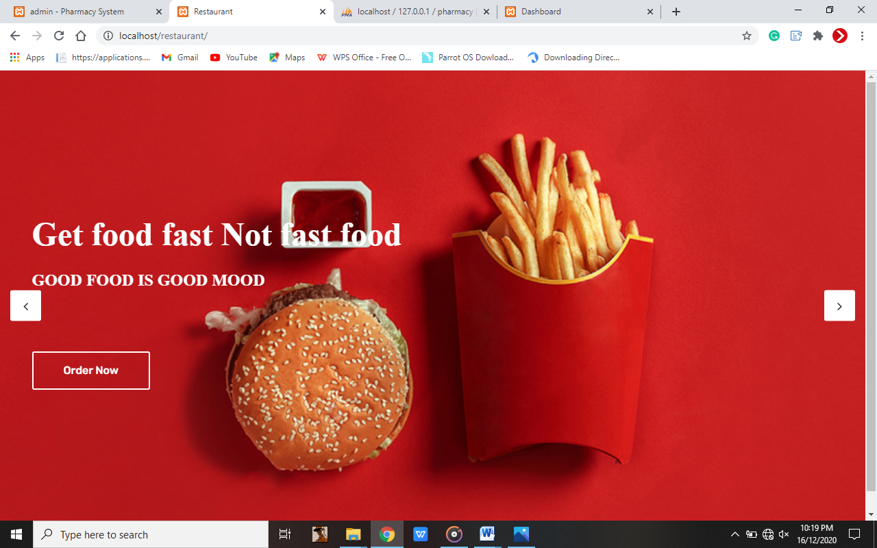

**Figure 4.3 Home page**

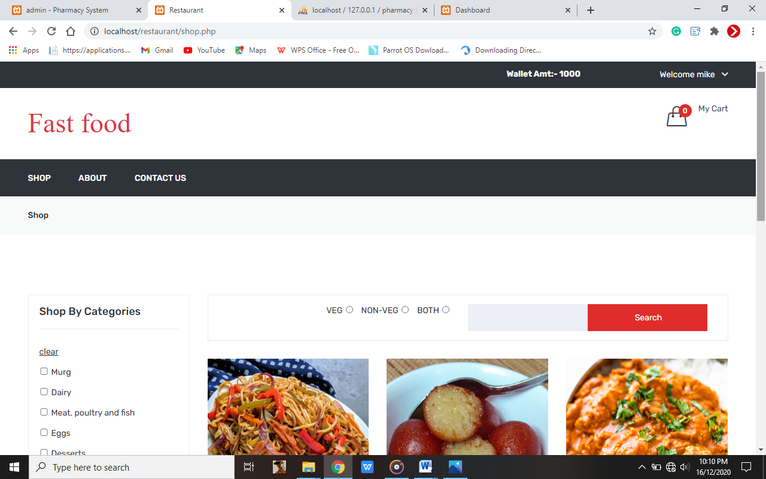

**Figure 4.4 Shop page**

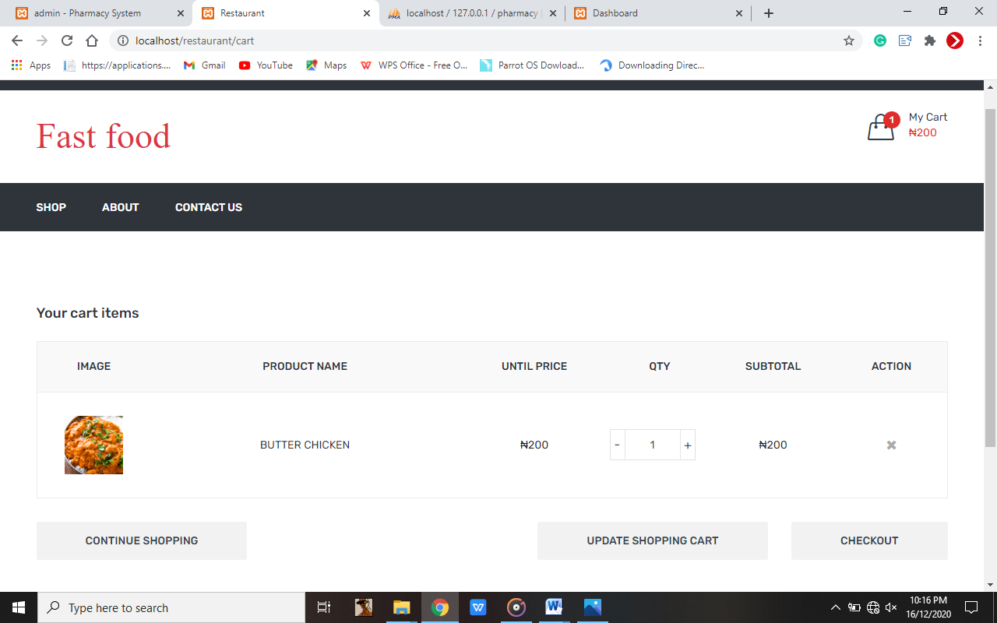

**Figure 4.5 Cart page**

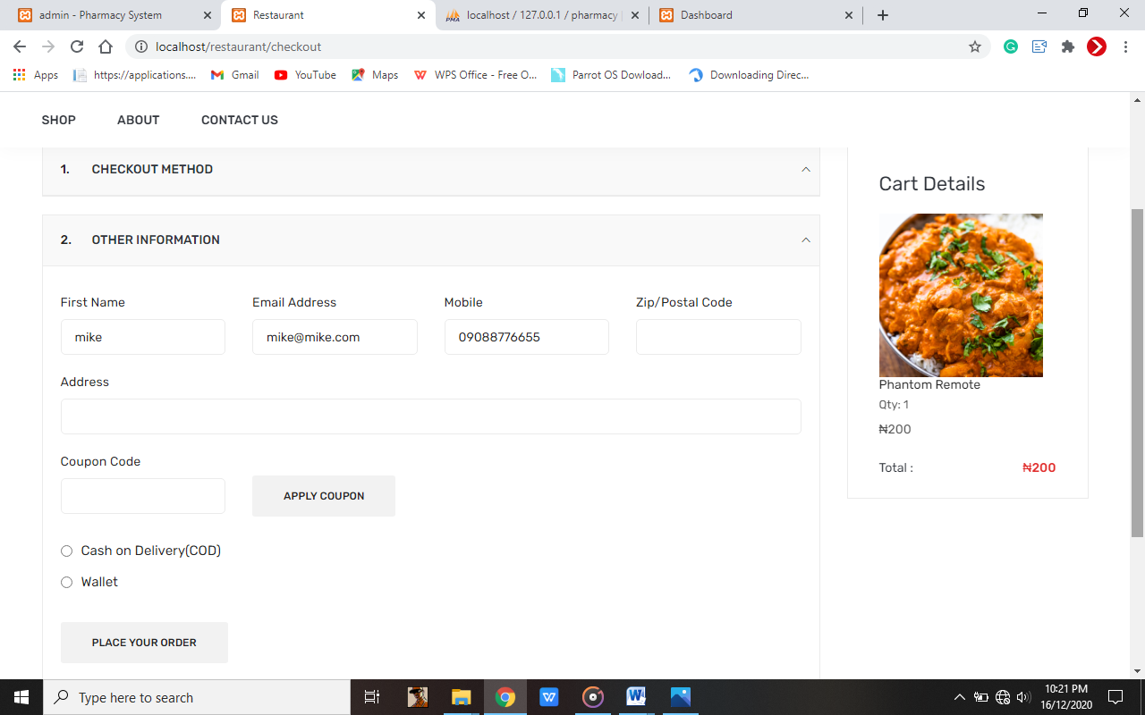

**Figure 4.6 Checkout page**

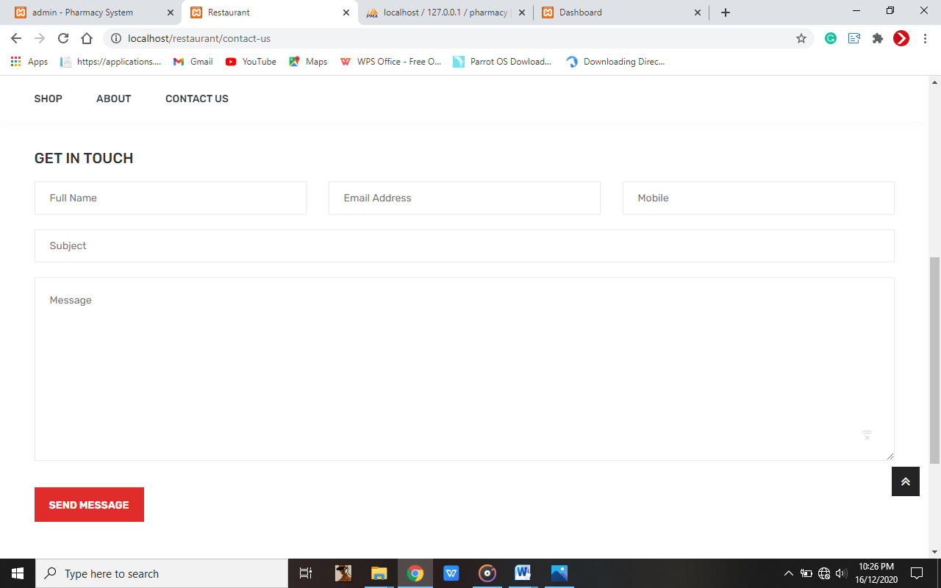

**Figure 4.7 Contact page**

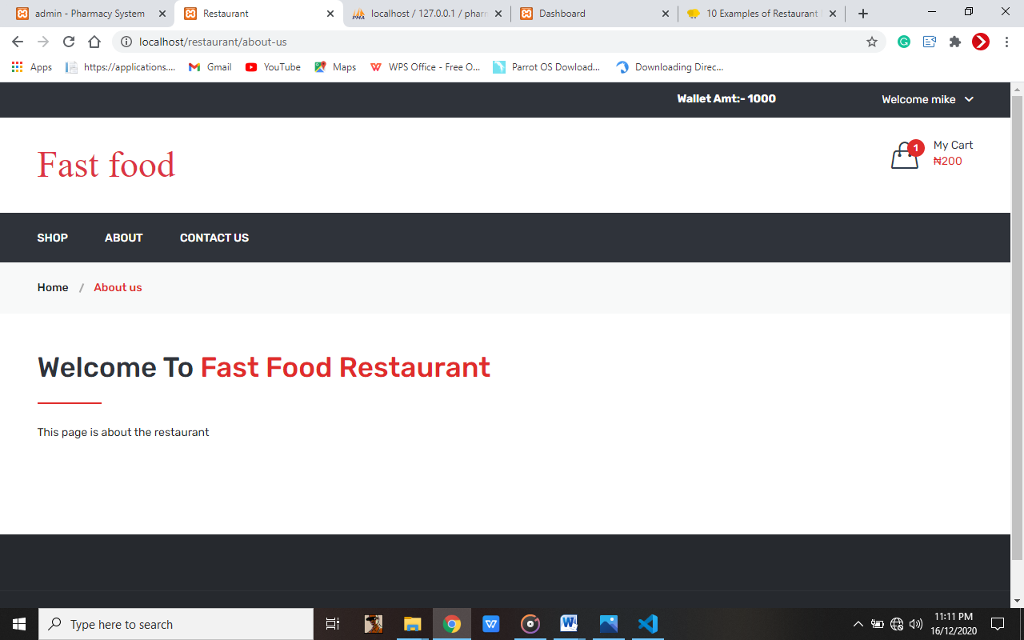

**Figure 4.8 About page**

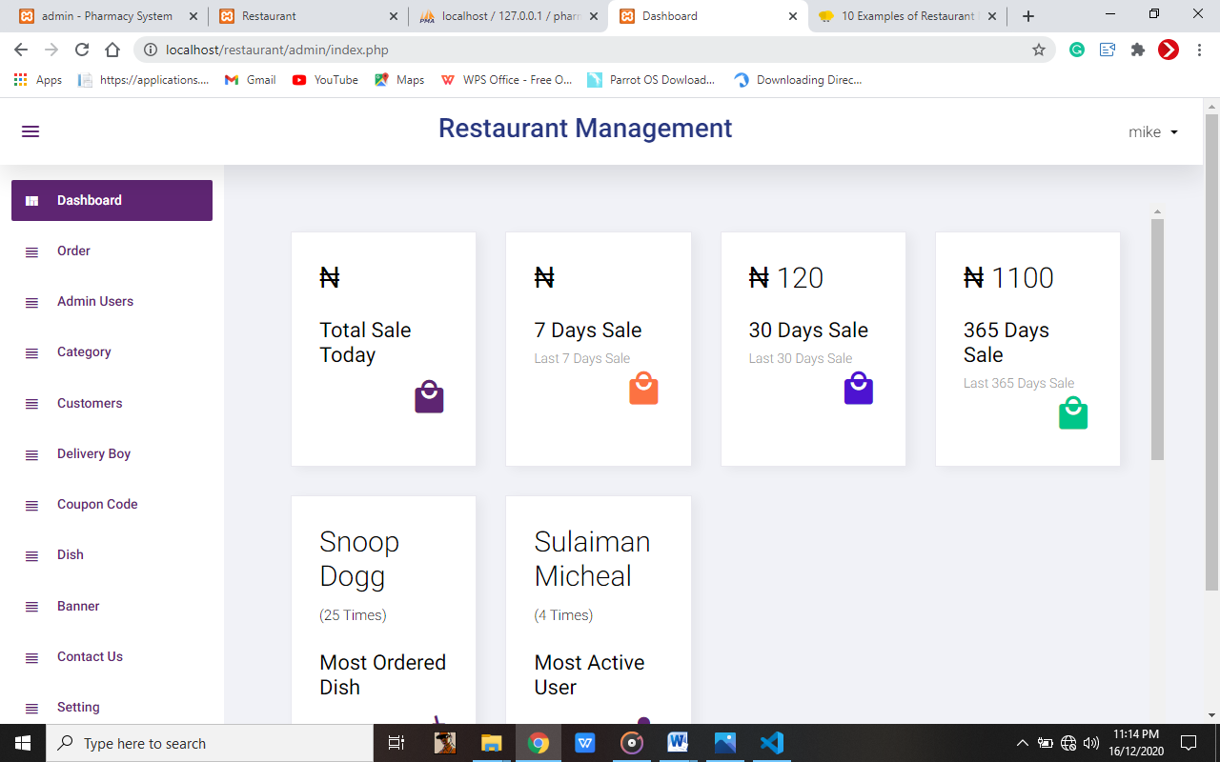

**Figure 4.9 Admin Section**

## CHAPTER FIVE

## SUMMARY, RECOMMENDTION AND CONCLUSION

## 5.1 SUMMARY

Chapter one briefly discussed on the history and development of Fast Food Restaurant, scope and limitations, significance, definition of some terms that was used in the chapters, aims and objectives and problems encountered with the manual system.

Chapter two discussed on many sections with the definition of Fast Food Restaurant, the theoretical development of Restaurant ordering system, the comparison between the current system and the proposed system, which this project is going to solve.

Chapter three discussed on the existing problem, proposed problem, functional requirement, non-functional requirement, method of data collection, methodology, technical tools used.

Chapter four discussed on the design and implementation of the project. It provides an overview of how the whole system was designed (both logically and physically) and implemented. At the end it presented in a diagrammatic representation of the system

At the end of this project work, I was able to design software that can successfully handle Fast Food Restaurant for Paramount cuisine services.

The aim of this research project is to develop a system that enables customers to order the food online from the restaurant and also enables the administrators to manage other operations going on in the restaurant. To achieve that, certain activities such as analysis, design, implementation, and testing were carried out, which lead to the formation of a new system. Fast Food Restaurant was developed after reviewing and analyzing the existing manual system at the investigation stage and control flow diagram to determine the requirements of the system. The design was implemented using HTML, PHP and MYSQL, for the database files. The web site starts with the home page, followed by login and user registration page and so on.

## 5.2 CONCLUSION

In conclusion, the project’s goal was achieved, which was design and implemented. The program was tested and it achieves the desired objectives. The application interface was made user friendly in such a way that even a novice computer user will not have difficulty in using the system.

However, a lot of challenges were faced during the process of implementing the system. Designing a system that will handle interactive communication between the system users and the system administrators is a time consuming and complex task. Also, while coding, an error might occur, either syntax or logical, getting away with such errors is not an easy task. The most challenging task is removing such errors, because a single error usually takes me an averagely some hours or a day before I find a way of overcoming the error.

## 5.3 RECOMMENDATIONS

The system would not be able to send some notification about any report to customer and once a customer’s order is placed, the order cannot be cancelled or edited. So as often happens, some ideas and improvements still remain to be completed. The following are the possible future work:

* Extend the system to allow cancellation of orders by the customers when needed.
* Send an order ready notification to customer.
* Add different payment option for the system like cash, PayPal and to allow save payment details for future use.

**REFERENCES**

Antoine Beauvilliers (1765). *The world’s first restaurant in paris :"****La Grande Taverne de Londres****".*

## [Rebecca L. Spang](https://www.hup.harvard.edu/results-list.php?author=3108) (January 4, 2020). *The invention of restaurants: Paris and Modern Gastronomic Culture, With a New Preface*

Joseph Horn and Frank Hardart (June 12, 1902). *The first Automat in United States, Philadephia  at 818 Chestnut St: Dining staple for a hard-working lunch crowd, unemployed songwriters, unemployed actors.*

Berenice Abbott (July 7, 1912). *New your Automat: Dining staple for a hard-working lunch crowd.*

Billy Ingram and Walter Anderson(1921). *White castle: Opened the second food outlet in Topeka, Kansas.*

Richard and Maurice McDonald (1940). *McDonald’s: First barbecue driven and walk-up stand offering hamburgers, shakes, fries etc.*

Kroc, Ray (1977). *Grinding it out: The Making of McDonald’s.* Chicago:

David R. Edgerton (1967). *Insta-burger king: Renamed Burger King*.

Bowen & Morris’s (2013). *Influence of technology on restaurants and how products are displayed on menu.*

Spalding, and Ives (2001). *Satisfaction of customers with the use of technogy, internam and external factors.*

## APPENDIX

**HOME**

<?php

include('database.inc.php');

include('function.inc.php');

include('constant.inc.php');

?>

<!doctype html>

<html class='no-js' lang='zxx'>

<head>

    <meta charset='utf-8'>

    <meta http-equiv='x-ua-compatible' content='ie=edge'>

    <title><?php echo FRONT_SITE_NAME ?></title>

    <meta name='viewport' content='width=device-width, initial-scale=1'>

    <link rel='stylesheet' href='assets/css/bootstrap.min.css'>

    <link rel='stylesheet' href='assets/css/animate.css'>

    <link rel='stylesheet' href='assets/css/owl.carousel.min.css'>

    <link rel='stylesheet' href='assets/css/font-awesome.min.css'>

    <link rel='stylesheet' href='assets/css/style.css'>

    <link rel='stylesheet' href='assets/css/responsive.css'>

    <script src='assets/js/vendor/modernizr-2.8.3.min.js'></script>

</head>

<body>

    <div class='slider-area'>

        <div class='slider-active owl-dot-style owl-carousel'>

            <?php

            $banner_res = mysqli_query($con, "select * from banner where status='1' order by order_number");

            while ($banner_row = mysqli_fetch_assoc($banner_res)) {

            ?>

                <div class='single-slider pt-210 pb-220 bg-img' style="background-image:url(<?php echo SITE_BANNER_IMAGE . $banner_row['image'] ?>);">

                    <div class='container'>

                        <div class='slider-content slider-animated-1'>

                            <h1 class='animated'><?php echo $banner_row['heading'] ?></h1>

                            <h3 class='animated'><?php echo $banner_row['sub_heading'] ?></h3>

                            <div class='slider-btn mt-90'>

                                <a class='animated' href="<?php echo $banner_row['link'] ?>"><?php echo $banner_row['link_txt'] ?></a>

                            </div>

                        </div>

                    </div>

                </div>

            <?php }

            ?>

        </div>

    </div>

    <script src='assets/js/vendor/jquery-1.12.0.min.js'></script>

    <script src='assets/js/bootstrap.min.js'></script>

    <script src='assets/js/imagesloaded.pkgd.min.js'></script>

    <script src='assets/js/isotope.pkgd.min.js'></script>

    <script src='assets/js/owl.carousel.min.js'></script>

    <script src='assets/js/plugins.js'></script>

    <script src='assets/js/main.js'></script>

</body>

</html>

**SHOP**

<?php

include("header.php");

$cat_dish = '';

$cat_dish_arr = array();

$type = '';

$search_str = '';

if (isset($_GET['cat_dish'])) {

    $cat_dish = get_safe_value($_GET['cat_dish']);

    $cat_dish_arr = array_filter(explode(':', $cat_dish));

    $cat_dish_str = implode(",", $cat_dish_arr);

}

if (isset($_GET['type'])) {

    $type = get_safe_value($_GET['type']);

}

if (isset($_GET['search_str'])) {

    $search_str = get_safe_value($_GET['search_str']);

}

$arrType = array("veg", "non-veg", "both");

?>

<div class="breadcrumb-area gray-bg">

    <div class="container">

        <div class="breadcrumb-content">

            <ul>

                <li><a href="shop.php">Shop</a></li>

            </ul>

        </div>

    </div>

</div>

<?php

if ($website_close == 1) {

    echo '<div style="text-align: center;margin-top: 50px;"><h3>';

    echo $website_close_msg;

    echo '</h3></div>';

}

?>

**CART**

<?php

include("header.php");

if ($website_close == 1) {

    redirect(FRONT_SITE_PATH . 'shop');

}

?>

<div class="cart-main-area pt-95 pb-100">

    <div class="container">

        <h3 class="page-title">Your cart items</h3>

        <div class="row">

            <div class="col-lg-12 col-md-12 col-sm-12 col-12">

                <form method="post">

                    <?php

                    $cartArr = getUserFullCart();

                    if (count($cartArr) > 0) {

                    ?>

                        <div class="table-content table-responsive">

                            <table>

                                <thead>

                                    <tr>

                                        <th>Image</th>

                                        <th>Product Name</th>

                                        <th>Until Price</th>

                                        <th>Qty</th>

                                        <th>Subtotal</th>

                                        <th>action</th>

                                    </tr>

                                </thead>

                                <tbody>

                                    <?php

                                    foreach ($cartArr as $key => $list) {

                                    ?>