**NETWORKING 1**

**2nd Semester, AY 2024-2025**PC 224: ASSIGNMENT

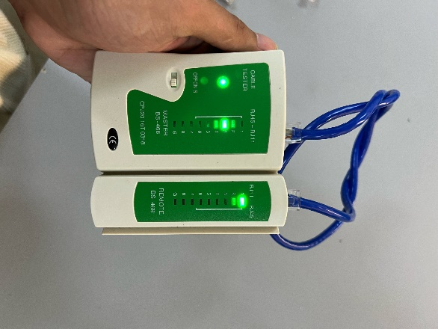 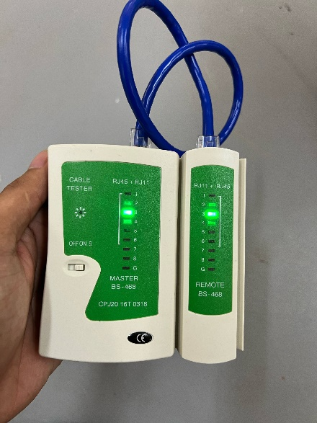

Using a LAN cable tester to check my straight-through and crossover cables made me realize just how crucial correct wiring is. At first, I thought making cables would be simple just match the colors and crimp the ends. But when I started testing them, I saw that even a single misplaced wire can cause the entire cable to fail.

With straight-through cables, the tester lights blinked in sequence on both ends, showing that everything was wired correctly. That was a satisfying moment it confirmed I had done the job right. For crossover cables, the lights followed a different pattern, which I learned was normal due to the way the wiring differs based on the devices being connected.

This hands-on activity taught me far more than just reading about it in a book. It reinforced the importance of following color standards, paying attention to detail, and double-checking my work. I also saw how valuable tools like the cable tester are they make it much easier to identify and fix problems.

In the end, building and testing LAN cables boosted my confidence. It may seem like a small task, but it's a fundamental part of creating reliable networks.

Rey Franz James S Pador BSIT – 2D