- Screenshot of: RDS SG inbound rule using source = sg-ec2-lab EC2 role attached /list output showing at least 3 notes
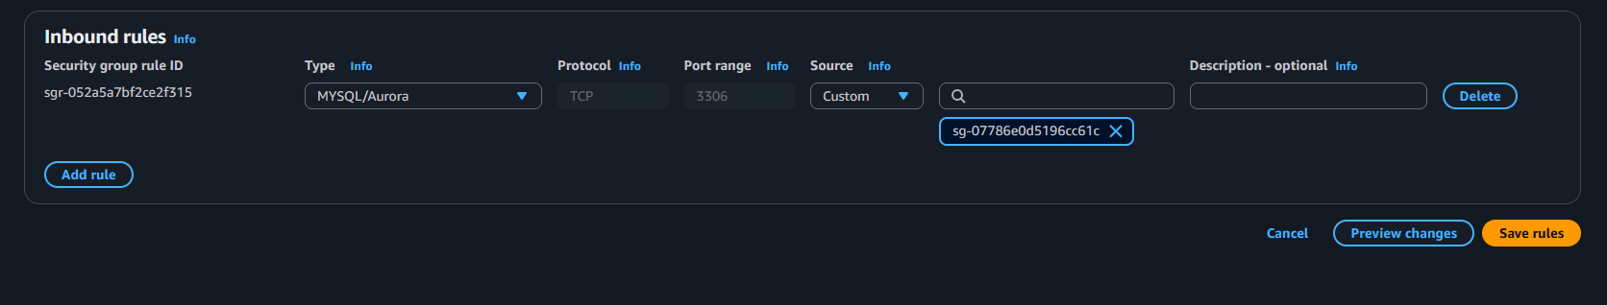

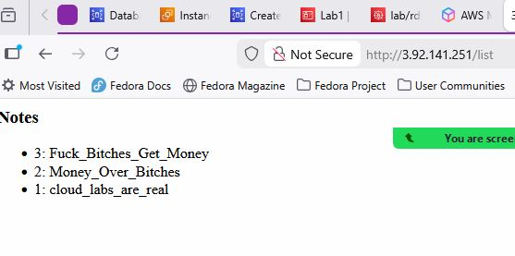

Short answers: A) Why is DB inbound source restricted to the EC2 security group? To protect it from the public network.
B) What port does MySQL use? 3306
C) Why is Secrets Manager better than storing creds in code/user-data? Enhanced security, improved manageablility.

Evidence for Audits

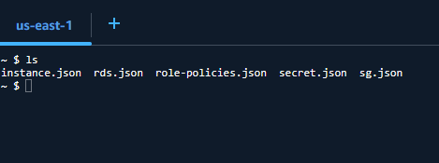

$ cat instance.json
{
"Reservations": [
{
"ReservationId": "r-0f386c841538bc2e1",
"OwnerId": "047719649044",
"Groups": [],
"Instances": [
{
"Architecture": "x86_64",
"BlockDeviceMappings": [
{
"DeviceName": "/dev/xvda",
"Ebs": {
"AttachTime": "2026-01-17T01:40:35+00:00",
"DeleteOnTermination": true,
"Status": "attached",
"VolumeId": "vol-0dd100841193c5dca"
}
}
],
"ClientToken": "b3eb5b90-3633-4923-9b64-0b287897a4c8",
"EbsOptimized": false,
"EnaSupport": true,
"Hypervisor": "xen",
"IamInstanceProfile": {
"Arn": "arn:aws:iam::047719649044:instance-profile/Lab1",
"Id": "AIPAQWHCQB4KK2MD6ZF65"
},
"NetworkInterfaces": [
{
"Association": {
"IpOwnerId": "amazon",
"PublicDnsName": "ec2-34-228-144-32.compute-1.amazonaws.com",
"PublicIp": "34.228.144.32"
},
"Attachment": {
"AttachTime": "2026-01-17T01:40:34+00:00",
"AttachmentId": "eni-attach-0e51edda13a690f4c",
"DeleteOnTermination": true,
"DeviceIndex": 0,
"Status": "attached",
"NetworkCardIndex": 0
},
"Description": "",
"Groups": [
{
"GroupId": "sg-067513742876a84f9",
"GroupName": "ec2-rds-1"
},
{
"GroupId": "sg-07786e0d5196cc61c",
"GroupName": "ec2_lab"
}
],
"Ipv6Addresses": [],
"MacAddress": "0a:ff:ea:50:eb:5f",
"NetworkInterfaceId": "eni-0f5830094cb8f3fef",
"OwnerId": "047719649044",
"PrivateDnsName": "ip-10-110-1-191.ec2.internal",
"PrivateIpAddress": "10.110.1.191",
"PrivateIpAddresses": [
{
"Association": {
"IpOwnerId": "amazon",
"PublicDnsName": "ec2-34-228-144-32.compute-1.amazonaws.com",
"PublicIp": "34.228.144.32"
},
"Primary": true,
"PrivateDnsName": "ip-10-110-1-191.ec2.internal",
"PrivateIpAddress": "10.110.1.191"
}
],
"SourceDestCheck": true,
"Status": "in-use",
"SubnetId": "subnet-0d1a329462561bfab",
"VpcId": "vpc-0441ed7fc80345565",
"InterfaceType": "interface",
"Operator": {
"Managed": false
}
}
],
"RootDeviceName": "/dev/xvda",
"RootDeviceType": "ebs",
"SecurityGroups": [
{
"GroupId": "sg-067513742876a84f9",
"GroupName": "ec2-rds-1"
},
{
"GroupId": "sg-07786e0d5196cc61c",
"GroupName": "ec2_lab"
}
],
"SourceDestCheck": true,
"Tags": [
{
"Key": "Name",
"Value": "ec2app"
}
],
"VirtualizationType": "hvm",
"CpuOptions": {
"CoreCount": 1,
"ThreadsPerCore": 1
},
"CapacityReservationSpecification": {
"CapacityReservationPreference": "open"
},
"HibernationOptions": {
"Configured": false
},
"MetadataOptions": {
"State": "applied",
"HttpTokens": "required",
"HttpPutResponseHopLimit": 2,
"HttpEndpoint": "enabled",
"HttpProtocolIpv6": "disabled",
"InstanceMetadataTags": "disabled"
},
"EnclaveOptions": {
"Enabled": false
},
"BootMode": "uefi-preferred",
"PlatformDetails": "Linux/UNIX",
"UsageOperation": "RunInstances",
"UsageOperationUpdateTime": "2026-01-17T01:40:34+00:00",
"PrivateDnsNameOptions": {
"HostnameType": "ip-name",
"EnableResourceNameDnsARecord": false,
"EnableResourceNameDnsAAAARecord": false
},
"MaintenanceOptions": {
"AutoRecovery": "default",
"RebootMigration": "default"
},
"CurrentInstanceBootMode": "legacy-bios",
"NetworkPerformanceOptions": {
"BandwidthWeighting": "default"
},
"Operator": {
"Managed": false
},
"InstanceId": "i-062a621de0a8a548d",
"ImageId": "ami-07ff62358b87c7116",
"State": {
"Code": 16,
"Name": "running"
},
"PrivateDnsName": "ip-10-110-1-191.ec2.internal",
"PublicDnsName": "ec2-34-228-144-32.compute-1.amazonaws.com",
"StateTransitionReason": "",
"AmiLaunchIndex": 0,
"ProductCodes": [],
"InstanceType": "t2.micro",
"LaunchTime": "2026-01-18T02:37:20+00:00",
"Placement": {
"AvailabilityZoneId": "use1-az4",
"GroupName": "",
"Tenancy": "default",
"AvailabilityZone": "us-east-1a"
},
"Monitoring": {
"State": "disabled"
},
"SubnetId": "subnet-0d1a329462561bfab",
"VpcId": "vpc-0441ed7fc80345565",
"PrivateIpAddress": "10.110.1.191",
"PublicIpAddress": "34.228.144.32"
}
]
}
]
}
$ cat rds.json
{
"DBInstances": [
{
"DBInstanceIdentifier": "labmysql",
"DBInstanceClass": "db.t4g.micro",
"Engine": "mysql",
"DBInstanceStatus": "available",
"MasterUsername": "admin",
"DBName": "labmysql",
"Endpoint": {
"Address": "labmysql.chgsq46osaah.us-east-1.rds.amazonaws.com",
"Port": 3306,
"HostedZoneId": "Z2R2ITUGPM61AM"
},
"AllocatedStorage": 20,
"InstanceCreateTime": "2026-01-17T01:58:08.021000+00:00",
"PreferredBackupWindow": "08:50-09:20",
"BackupRetentionPeriod": 1,
"DBSecurityGroups": [],
"VpcSecurityGroups": [
{
"VpcSecurityGroupId": "sg-086a00bb8f33797b1",
"Status": "active"
},
{
"VpcSecurityGroupId": "sg-0693ac05fe90b8d4e",
"Status": "active"
}
],
"DBParameterGroups": [
{
"DBParameterGroupName": "default.mysql8.0",
"ParameterApplyStatus": "in-sync"
}
],
"AvailabilityZone": "us-east-1a",
"DBSubnetGroup": {
"DBSubnetGroupName": "rds-ec2-db-subnet-group-3",
"DBSubnetGroupDescription": "Created from the RDS Management Console",
"VpcId": "vpc-0441ed7fc80345565",
"SubnetGroupStatus": "Complete",
"Subnets": [
{
"SubnetIdentifier": "subnet-07b4b1011b75004c7",
"SubnetAvailabilityZone": {
"Name": "us-east-1b"
},
"SubnetOutpost": {},
"SubnetStatus": "Active"
},
{
"SubnetIdentifier": "subnet-079840d9964aebb90",
"SubnetAvailabilityZone": {
"Name": "us-east-1f"
},
"SubnetOutpost": {},
"SubnetStatus": "Active"
},
{
"SubnetIdentifier": "subnet-06aba2e829740e89a",
"SubnetAvailabilityZone": {
"Name": "us-east-1a"
},
"SubnetOutpost": {},
"SubnetStatus": "Active"
},
{
"SubnetIdentifier": "subnet-08903cc2d24de559c",
"SubnetAvailabilityZone": {
"Name": "us-east-1e"
},
"SubnetOutpost": {},
"SubnetStatus": "Active"
},
{
"SubnetIdentifier": "subnet-0c2ac84019cf0d5b6",
"SubnetAvailabilityZone": {
"Name": "us-east-1d"
},
"SubnetOutpost": {},
"SubnetStatus": "Active"
}
]
},
"PreferredMaintenanceWindow": "tue:04:05-tue:04:35",
"UpgradeRolloutOrder": "second",
"PendingModifiedValues": {},
"LatestRestorableTime": "2026-01-18T03:05:00+00:00",
"MultiAZ": false,
"EngineVersion": "8.0.43",
"AutoMinorVersionUpgrade": true,
"ReadReplicaDBInstanceIdentifiers": [],
"LicenseModel": "general-public-license",
"StorageThroughput": 0,
"OptionGroupMemberships": [
{
"OptionGroupName": "default:mysql-8-0",
"Status": "in-sync"
}
],
"PubliclyAccessible": false,
"StorageType": "gp2",
"DbInstancePort": 0,
"StorageEncrypted": true,
"KmsKeyId": "arn:aws:kms:us-east-1:047719649044:key/fafe4c54-88d6-4c71-b9df-b85d6e3da091",
"DbiResourceId": "db-2J2OW2TX7O7HEHDJHAGHSUZ5FU",
"CACertificateIdentifier": "rds-ca-rsa2048-g1",
"DomainMemberships": [],
"CopyTagsToSnapshot": true,
"MonitoringInterval": 0,
"DBInstanceArn": "arn:aws:rds:us-east-1:047719649044:db:labmysql",
"IAMDatabaseAuthenticationEnabled": false,
"DatabaseInsightsMode": "standard",
"PerformanceInsightsEnabled": false,
"DeletionProtection": false,
"AssociatedRoles": [],
"MaxAllocatedStorage": 1000,
"TagList": [],
"CustomerOwnedIpEnabled": false,
"NetworkType": "IPV4",
"ActivityStreamStatus": "stopped",
"BackupTarget": "region",
"CertificateDetails": {
"CAIdentifier": "rds-ca-rsa2048-g1",
"ValidTill": "2027-01-17T01:56:44+00:00"
},
"DedicatedLogVolume": false,
"IsStorageConfigUpgradeAvailable": false,
"EngineLifecycleSupport": "open-source-rds-extended-support-disabled"
}
]
}

~ $ cat role-policies.json
{
"AttachedPolicies": []
}

~ $ cat secret.json
{
"ARN": "arn:aws:secretsmanager:us-east-1:047719649044:secret:lab/rds/mysql1-H9aF6a",
"Name": "lab/rds/mysql1",
"LastChangedDate": "2026-01-06T02:25:21.212000+00:00",
"LastAccessedDate": "2026-01-18T00:00:00+00:00",
"Tags": [],
"VersionIdsToStages": {
"495960c0-82dc-41b0-b002-a3f75554b3f4": [
"AWSCURRENT"
]
},
"CreatedDate": "2026-01-06T02:25:21.164000+00:00"
}
~ $ cat sg.json
{
"SecurityGroups": [
{
"GroupId": "sg-0693ac05fe90b8d4e",
"IpPermissionsEgress": [],
"VpcId": "vpc-0441ed7fc80345565",
"SecurityGroupArn": "arn:aws:ec2:us-east-1:047719649044:security-group/sg-0693ac05fe90b8d4e",
"OwnerId": "047719649044",
"GroupName": "rds-ec2-1",
"Description": "Security group attached to labmysql to allow EC2 instances with specific security groups attached to connect to the database. Modification could lead to connection loss.",
"IpPermissions": [
{
"IpProtocol": "tcp",
"FromPort": 3306,
"ToPort": 3306,
"UserIdGroupPairs": [
{
"Description": "Rule to allow connections from EC2 instances with sg-067513742876a84f9 attached",
"UserId": "047719649044",
"GroupId": "sg-067513742876a84f9"
}
],
"IpRanges": [],
"Ipv6Ranges": [],
"PrefixListIds": []
}
]
}
]
}
Why each rule exists
What would break if removed ? No traffic— Unwarranted internal or external access will be allowed to enter the database.
Why this role exists? To increase security.
Why it can read this secret? The IAM role was created for this purpose.
Why it cannot read others? Permission was not granted.

