- Screenshot of: RDS SG inbound rule using source = sg-ec2-lab EC2 role attached /list output showing at least 3 notes
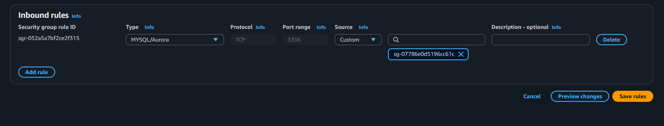

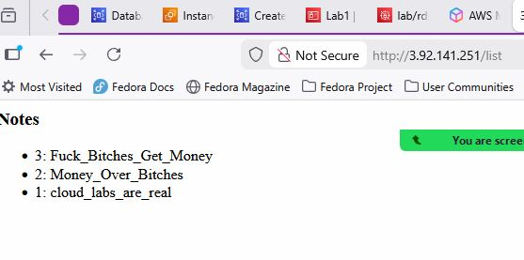

Short answers: A) Why is DB inbound source restricted to the EC2 security group? To protect it from the public network.
B) What port does MySQL use? 3306
C) Why is Secrets Manager better than storing creds in code/user-data? Enhanced security, improved manageablility.

Evidence for Audits

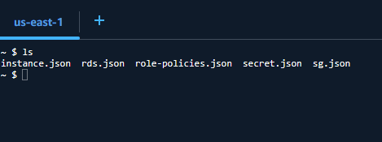

$ cat instance.json
{
"Reservations": [
{
"ReservationId": "r-0f386c841538bc2e1",
"OwnerId": "047719649044",
"Groups": [],
"Instances": [
{
"Architecture": "x86_64",
"BlockDeviceMappings": [
{
"DeviceName": "/dev/xvda",
"Ebs": {
"AttachTime": "2026-01-17T01:40:35+00:00",
"DeleteOnTermination": true,
"Status": "attached",
"VolumeId": "vol-0dd100841193c5dca"
}
}
],
"ClientToken": "b3eb5b90-3633-4923-9b64-0b287897a4c8",
"EbsOptimized": false,
"EnaSupport": true,
"Hypervisor": "xen",
"IamInstanceProfile": {
"Arn": "arn:aws:iam::047719649044:instance-profile/Lab1",
"Id": "AIPAQWHCQB4KK2MD6ZF65"
},
"NetworkInterfaces": [
{
"Association": {
"IpOwnerId": "amazon",
"PublicDnsName": "ec2-34-228-144-32.compute-1.amazonaws.com",
"PublicIp": "34.228.144.32"
},
"Attachment": {
"AttachTime": "2026-01-17T01:40:34+00:00",
"AttachmentId": "eni-attach-0e51edda13a690f4c",
"DeleteOnTermination": true,
"DeviceIndex": 0,
"Status": "attached",
"NetworkCardIndex": 0
},
"Description": "",
"Groups": [
{
"GroupId": "sg-067513742876a84f9",
"GroupName": "ec2-rds-1"
},
{
"GroupId": "sg-07786e0d5196cc61c",
"GroupName": "ec2_lab"
}
],
"Ipv6Addresses": [],
"MacAddress": "0a:ff:ea:50:eb:5f",
"NetworkInterfaceId": "eni-0f5830094cb8f3fef",
"OwnerId": "047719649044",
"PrivateDnsName": "ip-10-110-1-191.ec2.internal",
"PrivateIpAddress": "10.110.1.191",
"PrivateIpAddresses": [
{
"Association": {
"IpOwnerId": "amazon",
"PublicDnsName": "ec2-34-228-144-32.compute-1.amazonaws.com",
"PublicIp": "34.228.144.32"
},
"Primary": true,
"PrivateDnsName": "ip-10-110-1-191.ec2.internal",
"PrivateIpAddress": "10.110.1.191"
}
],
"SourceDestCheck": true,
"Status": "in-use",
"SubnetId": "subnet-0d1a329462561bfab",
"VpcId": "vpc-0441ed7fc80345565",
"InterfaceType": "interface",
"Operator": {
"Managed": false
}
}
],
"RootDeviceName": "/dev/xvda",
"RootDeviceType": "ebs",
"SecurityGroups": [
{
"GroupId": "sg-067513742876a84f9",
"GroupName": "ec2-rds-1"
},
{
"GroupId": "sg-07786e0d5196cc61c",
"GroupName": "ec2_lab"
}
],
"SourceDestCheck": true,
"Tags": [
{
"Key": "Name",
"Value": "ec2app"
}
],
"VirtualizationType": "hvm",
"CpuOptions": {
"CoreCount": 1,
"ThreadsPerCore": 1
},
"CapacityReservationSpecification": {
"CapacityReservationPreference": "open"
},
"HibernationOptions": {
"Configured": false
},
"MetadataOptions": {
"State": "applied",
"HttpTokens": "required",
"HttpPutResponseHopLimit": 2,
"HttpEndpoint": "enabled",
"HttpProtocolIpv6": "disabled",
"InstanceMetadataTags": "disabled"
},
"EnclaveOptions": {
"Enabled": false
},
"BootMode": "uefi-preferred",
"PlatformDetails": "Linux/UNIX",
"UsageOperation": "RunInstances",
"UsageOperationUpdateTime": "2026-01-17T01:40:34+00:00",
"PrivateDnsNameOptions": {
"HostnameType": "ip-name",
"EnableResourceNameDnsARecord": false,
"EnableResourceNameDnsAAAARecord": false
},
"MaintenanceOptions": {
"AutoRecovery": "default",
"RebootMigration": "default"
},
"CurrentInstanceBootMode": "legacy-bios",
"NetworkPerformanceOptions": {
"BandwidthWeighting": "default"
},
"Operator": {
"Managed": false
},
"InstanceId": "i-062a621de0a8a548d",
"ImageId": "ami-07ff62358b87c7116",
"State": {
"Code": 16,
"Name": "running"
},
"PrivateDnsName": "ip-10-110-1-191.ec2.internal",
"PublicDnsName": "ec2-34-228-144-32.compute-1.amazonaws.com",
"StateTransitionReason": "",
"AmiLaunchIndex": 0,
"ProductCodes": [],
"InstanceType": "t2.micro",
"LaunchTime": "2026-01-18T02:37:20+00:00",
"Placement": {
"AvailabilityZoneId": "use1-az4",
"GroupName": "",
"Tenancy": "default",
"AvailabilityZone": "us-east-1a"
},
"Monitoring": {
"State": "disabled"
},
"SubnetId": "subnet-0d1a329462561bfab",
"VpcId": "vpc-0441ed7fc80345565",
"PrivateIpAddress": "10.110.1.191",
"PublicIpAddress": "34.228.144.32"
}
]
}
]
}
$ cat rds.json
{
"DBInstances": [
{
"DBInstanceIdentifier": "labmysql",
"DBInstanceClass": "db.t4g.micro",
"Engine": "mysql",
"DBInstanceStatus": "available",
"MasterUsername": "admin",
"DBName": "labmysql",
"Endpoint": {
"Address": "labmysql.chgsq46osaah.us-east-1.rds.amazonaws.com",
"Port": 3306,
"HostedZoneId": "Z2R2ITUGPM61AM"
},
"AllocatedStorage": 20,
"InstanceCreateTime": "2026-01-17T01:58:08.021000+00:00",
"PreferredBackupWindow": "08:50-09:20",
"BackupRetentionPeriod": 1,
"DBSecurityGroups": [],
"VpcSecurityGroups": [
{
"VpcSecurityGroupId": "sg-086a00bb8f33797b1",
"Status": "active"
},
{
"VpcSecurityGroupId": "sg-0693ac05fe90b8d4e",
"Status": "active"
}
],
"DBParameterGroups": [
{
"DBParameterGroupName": "default.mysql8.0",
"ParameterApplyStatus": "in-sync"
}
],
"AvailabilityZone": "us-east-1a",
"DBSubnetGroup": {
"DBSubnetGroupName": "rds-ec2-db-subnet-group-3",
"DBSubnetGroupDescription": "Created from the RDS Management Console",
"VpcId": "vpc-0441ed7fc80345565",
"SubnetGroupStatus": "Complete",
"Subnets": [
{
"SubnetIdentifier": "subnet-07b4b1011b75004c7",
"SubnetAvailabilityZone": {
"Name": "us-east-1b"
},
"SubnetOutpost": {},
"SubnetStatus": "Active"
},
{
"SubnetIdentifier": "subnet-079840d9964aebb90",
"SubnetAvailabilityZone": {
"Name": "us-east-1f"
},
"SubnetOutpost": {},
"SubnetStatus": "Active"
},
{
"SubnetIdentifier": "subnet-06aba2e829740e89a",
"SubnetAvailabilityZone": {
"Name": "us-east-1a"
},
"SubnetOutpost": {},
"SubnetStatus": "Active"
},
{
"SubnetIdentifier": "subnet-08903cc2d24de559c",
"SubnetAvailabilityZone": {
"Name": "us-east-1e"
},
"SubnetOutpost": {},
"SubnetStatus": "Active"
},
{
"SubnetIdentifier": "subnet-0c2ac84019cf0d5b6",
"SubnetAvailabilityZone": {
"Name": "us-east-1d"
},
"SubnetOutpost": {},
"SubnetStatus": "Active"
}
]
},
"PreferredMaintenanceWindow": "tue:04:05-tue:04:35",
"UpgradeRolloutOrder": "second",
"PendingModifiedValues": {},
"LatestRestorableTime": "2026-01-18T03:05:00+00:00",
"MultiAZ": false,
"EngineVersion": "8.0.43",
"AutoMinorVersionUpgrade": true,
"ReadReplicaDBInstanceIdentifiers": [],
"LicenseModel": "general-public-license",
"StorageThroughput": 0,
"OptionGroupMemberships": [
{
"OptionGroupName": "default:mysql-8-0",
"Status": "in-sync"
}
],
"PubliclyAccessible": false,
"StorageType": "gp2",
"DbInstancePort": 0,
"StorageEncrypted": true,
"KmsKeyId": "arn:aws:kms:us-east-1:047719649044:key/fafe4c54-88d6-4c71-b9df-b85d6e3da091",
"DbiResourceId": "db-2J2OW2TX7O7HEHDJHAGHSUZ5FU",
"CACertificateIdentifier": "rds-ca-rsa2048-g1",
"DomainMemberships": [],
"CopyTagsToSnapshot": true,
"MonitoringInterval": 0,
"DBInstanceArn": "arn:aws:rds:us-east-1:047719649044:db:labmysql",
"IAMDatabaseAuthenticationEnabled": false,
"DatabaseInsightsMode": "standard",
"PerformanceInsightsEnabled": false,
"DeletionProtection": false,
"AssociatedRoles": [],
"MaxAllocatedStorage": 1000,
"TagList": [],
"CustomerOwnedIpEnabled": false,
"NetworkType": "IPV4",
"ActivityStreamStatus": "stopped",
"BackupTarget": "region",
"CertificateDetails": {
"CAIdentifier": "rds-ca-rsa2048-g1",
"ValidTill": "2027-01-17T01:56:44+00:00"
},
"DedicatedLogVolume": false,
"IsStorageConfigUpgradeAvailable": false,
"EngineLifecycleSupport": "open-source-rds-extended-support-disabled"
}
]
}

~ $ cat role-policies.json
{
"AttachedPolicies": []
}

~ $ cat secret.json
{
"ARN": "arn:aws:secretsmanager:us-east-1:047719649044:secret:lab/rds/mysql1-H9aF6a",
"Name": "lab/rds/mysql1",
"LastChangedDate": "2026-01-06T02:25:21.212000+00:00",
"LastAccessedDate": "2026-01-18T00:00:00+00:00",
"Tags": [],
"VersionIdsToStages": {
"495960c0-82dc-41b0-b002-a3f75554b3f4": [
"AWSCURRENT"
]
},
"CreatedDate": "2026-01-06T02:25:21.164000+00:00"
}
~ $ cat sg.json
{
"SecurityGroups": [
{
"GroupId": "sg-0693ac05fe90b8d4e",
"IpPermissionsEgress": [],
"VpcId": "vpc-0441ed7fc80345565",
"SecurityGroupArn": "arn:aws:ec2:us-east-1:047719649044:security-group/sg-0693ac05fe90b8d4e",
"OwnerId": "047719649044",
"GroupName": "rds-ec2-1",
"Description": "Security group attached to labmysql to allow EC2 instances with specific security groups attached to connect to the database. Modification could lead to connection loss.",
"IpPermissions": [
{
"IpProtocol": "tcp",
"FromPort": 3306,
"ToPort": 3306,
"UserIdGroupPairs": [
{
"Description": "Rule to allow connections from EC2 instances with sg-067513742876a84f9 attached",
"UserId": "047719649044",
"GroupId": "sg-067513742876a84f9"
}
],
"IpRanges": [],
"Ipv6Ranges": [],
"PrefixListIds": []
}
]
}
]
}

