VASYL ONUFRIYEV

** Part 1 START **

................

For size: 1 SHA-256-> 17667 MD5-> 76393 DIFF(MD5-SHA256)-> 58726 COLL TIME IN SECS (SHA256, MD5)-> (9223372036854775807, 241471654126812)

For size: 16 SHA-256-> 23329 MD5-> 79996 DIFF(MD5-SHA256)-> 56667 COLL TIME IN SECS (SHA256, MD5)-> (9223372036854775807, 230595830712905)

For size: 64 SHA-256-> 20817 MD5-> 87354 DIFF(MD5-SHA256)-> 66537 COLL TIME IN SECS (SHA256, MD5)-> (9223372036854775807, 211172288317759)

For size: 257 SHA-256-> 22584 MD5-> 86780 DIFF(MD5-SHA256)-> 64196 COLL TIME IN SECS (SHA256, MD5)-> (9223372036854775807, 212569072063949)

For size: 400 SHA-256-> 23396 MD5-> 86951 DIFF(MD5-SHA256)-> 63555 COLL TIME IN SECS (SHA256, MD5)-> (9223372036854775807, 212151028437965)

For size: 512 SHA-256-> 23599 MD5-> 86095 DIFF(MD5-SHA256)-> 62496 COLL TIME IN SECS (SHA256, MD5)-> (9223372036854775807, 214260341177879)

For size: 1024 SHA-256-> 23430 MD5-> 81645 DIFF(MD5-SHA256)-> 58215 COLL TIME IN SECS (SHA256, MD5)-> (9223372036854775807, 225938441713632)

For size: 4096 SHA-256-> 22985 MD5-> 87495 DIFF(MD5-SHA256)-> 64510 COLL TIME IN SECS (SHA256, MD5)-> (9223372036854775807, 210831979812669)

CPU-related specs: Z7 MOBO, i7 4790k CPU, 16GB 1333Hz RAM

** Part 1 END **

** Part 2 START **

Working on generating hashes...please wait

Results tally:

...

100101110 produces-> 07�ݛ�ʅ5�cJ<��� QY��1�D�'p��}�e (after 302 hashes, 8851251 ns) 29308.778146 ns/hash

111011001110111 produces-> 02(`�x�t�7�+��[bj�}���-�o (after 30327 hashes, 84832990 ns) 2797.276025 ns/hash

101000000010100000010101 produces-> 021�q?�^�x�|��B)�/`

���C�: �u (after 10496021 hashes, 25601933818 ns) 2439.203753 ns/hash

** Part 2 END **

** Part 3 START **

Starting iteration 0 of 10 of length 10 seconds

Starting iteration 1 of 10 of length 10 seconds

Starting iteration 2 of 10 of length 10 seconds

Starting iteration 3 of 10 of length 10 seconds

Starting iteration 4 of 10 of length 10 seconds

Starting iteration 5 of 10 of length 10 seconds

Starting iteration 6 of 10 of length 10 seconds

Starting iteration 7 of 10 of length 10 seconds

Starting iteration 8 of 10 of length 10 seconds

Starting iteration 9 of 10 of length 10 seconds

Starting iteration 0 of 10 of length 20 seconds

Starting iteration 1 of 10 of length 20 seconds

Starting iteration 2 of 10 of length 20 seconds

Starting iteration 3 of 10 of length 20 seconds

Starting iteration 4 of 10 of length 20 seconds

Starting iteration 5 of 10 of length 20 seconds

Starting iteration 6 of 10 of length 20 seconds

Starting iteration 7 of 10 of length 20 seconds

Starting iteration 8 of 10 of length 20 seconds

Starting iteration 9 of 10 of length 20 seconds

Starting iteration 0 of 10 of length 30 seconds

Starting iteration 1 of 10 of length 30 seconds

Starting iteration 2 of 10 of length 30 seconds

Starting iteration 3 of 10 of length 30 seconds

Starting iteration 4 of 10 of length 30 seconds

Starting iteration 5 of 10 of length 30 seconds

Starting iteration 6 of 10 of length 30 seconds

Starting iteration 7 of 10 of length 30 seconds

Starting iteration 8 of 10 of length 30 seconds

Starting iteration 9 of 10 of length 30 seconds

10 seconds: Input String: LHCHCIAFTWLAVHPQHHVFBBJSMHGACBHJRNBJVJKWECKUUYSQCBPMRKGJWSTDLNAR-> Hash String: L,=[ ‑�3譇W&r*gm_   
  
MuņzmcY-> Weight: 10314

20 seconds: Input String: MOLGOXMOVRDCFFXQDBYLNGXBCMDGTLRLNKNQHIGNJPJBTDMIFEUDJLVOQYSQEDLU-> Hash String: �<SA7�JK_M^h0UΰOaJc,mW-> Weight: 13373

~Y0�x"L-> Weight: 13449

** Part 3 END **

VASYL ONUFRIYEV

Part 1: CPU-related specs: Z7 MOBO, i7 4790k CPU, 16GB 1333Hz RAM

Collision times are in seconds and are displayed in (SHA256, MD5) format above in part 1.

Part 2:

Hash equation:

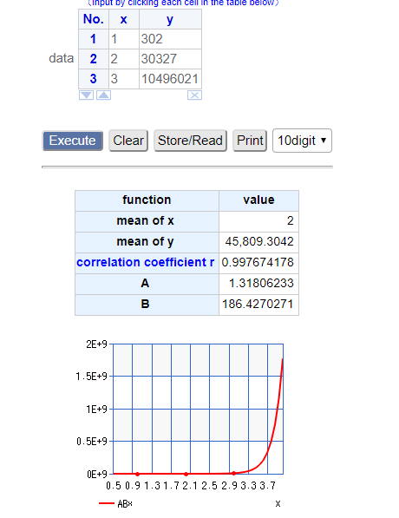

It will take THIS many hashes to get my full birthdate

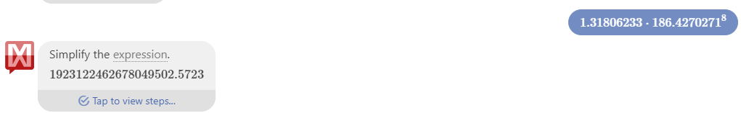

Assuming the fastest hash time I had,

2439.203753/hash

This means that it will take (1923122462678049502.5723 * 24309.203753)/10^9

Seconds to get my full birthday…which approximately is

46749.57578721 seconds

Which is approximately .54 of a day, or just over 12 hours.