Cloud formation worksheet
Reference layout for the Flutter application — screen-for-screen replica
SCREEN 1 OF 3 — ANIMATION TAB
Cloud formation
The sequence, animated

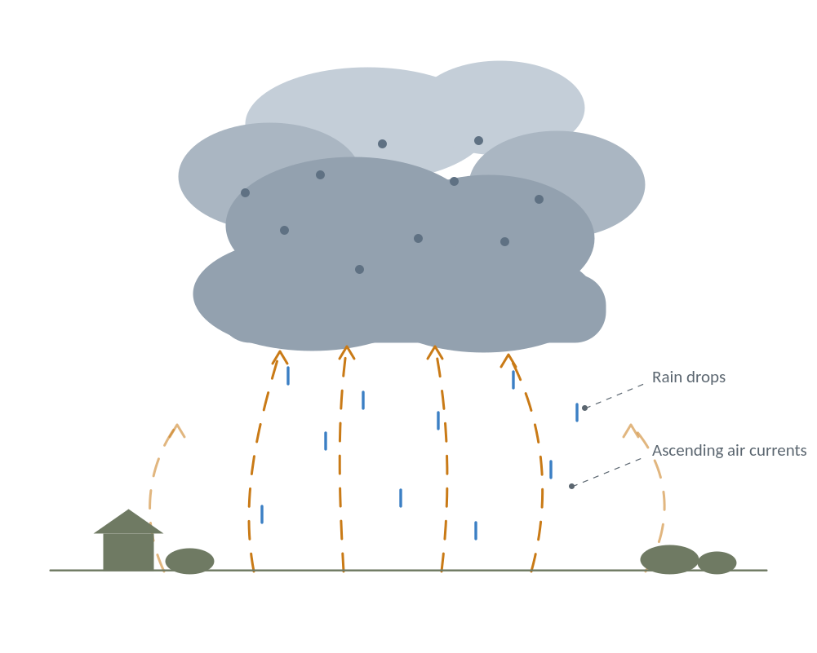
Fig. 17-11 — the formation of rain in a cumulonimbus cloud

❙❙ Pause 1 · Air rises 2 · Cooling 3 · Condensation 4 · Rain
Beat 4 · Rain
Drops grow too heavy for the updraft and fall through it as rain, while fresh moist air keeps feeding the cloud from below.

The amber currents keep running in every beat — the updraft does not stop while the storm lives.

Beat captions
1 · Air rises — sun-warmed air over the ground picks up water vapour and rises in convective currents.
2 · Cooling — as the current climbs it cools; the same absolute humidity now means a higher relative humidity.
3 · Condensation — at saturation the vapour can no longer stay a gas and condenses into microscopic droplets, the cloud.
4 · Rain — drops grow too heavy for the updraft and fall through it as rain, while fresh moist air keeps feeding the cloud from below.

SCREEN 2 OF 3 — QUESTIONS TAB
Cloud formation
Part 1 · Multiple choice

How a cloud is formed
Fig. 17-11 — the formation of rain in a cumulonimbus cloud
Air can hold only a limited amount of water vapour, and that limit falls as the air grows colder. So when warm, moist air is lifted — carried upward by a convective current over sun-heated ground, or forced up the slope of a mountain — it cools as it climbs, and its relative humidity rises even though it has gained no new moisture. At a certain height the air can no longer hold all the vapour it started with. The surplus condenses into a multitude of tiny water droplets, and that visible mass of droplets is what we call a cloud.

Choose the best answer | 4 questions

1 ASCENT
What lifts the moist air that builds a cloud?
○ A descending current of dry air
○ An ascending convective current, or a mountain slope
○ The weight of the water vapour itself

2 COOLING
The rising air gains no new moisture, yet its relative humidity rises. Why?
○ The maximum vapour the air can hold falls as it cools
○ The air absorbs vapour from the clouds above it
○ Pressure squeezes extra vapour into the parcel

3 CONDENSATION
A cloud is composed of —
○ invisible water vapour
○ a multitude of tiny water droplets
○ dust carried up from the ground

4 SATURATION
Condensation begins at the point where the air —
○ has cooled to the temperature of the ground
○ can no longer hold all the vapour it started with
○ has stopped rising altogether

Clear Check answers

SCREEN 3 OF 3 — BLANKS TAB
Atmospheric circulation
Part 2 · Fill in

Clouds as indicators of circulation
Fig. 17-11 — ascending currents and falling rain drops
Cloud formations are among the best indicators of atmospheric circulation. Their presence or absence does not influence the motion of air masses, but it makes that motion directly accessible to visual observation. The cumulus of a hot summer afternoon is the plainest case: each swelling tower marks a column of moist air ascending over warm ground. When such a tower grows into a cumulonimbus, the droplets inside it collide and merge until they are too heavy for the current that lifted them. They then fall back through the rising air as rain, so a single cloud shows both directions of the circulation at once.

Complete each sentence | 6 blanks

Type the missing word from the passage into each blank. Spelling is marked, capitals are not.
1 A cloud formation is a good of atmospheric circulation.
It points something out without causing it

2 Clouds do not influence the motion of air masses; they only make that motion accessible to visual .

3 Each swelling cumulus tower marks a column of moist air over warm ground.

4 Inside a cumulonimbus the droplets collide and with one another.

5 Rain falls when the drops have grown too for the current that lifted them.
The updraft can no longer support them

6 The drops fall back through the air, so one cloud shows both directions at once.

Clear Check answers

Answer key
Marking behaviour built into the application
Part 1 — multiple choice
1. An ascending convective current, or a mountain slope
2. The maximum vapour the air can hold falls as it cools
3. A multitude of tiny water droplets
4. Can no longer hold all the vapour it started with
Part 2 — blanks
1. indicator
2. observation
3. ascending (also accepts: rising)
4. merge (also accepts: coalesce, combine)
5. heavy
6. rising (also accepts: ascending)
Marking rules
Case is ignored, surrounding whitespace is trimmed, and a trailing full stop or comma is discarded before comparison. Listed synonyms count as correct. Every item carries a beat number (1 ascent, 2 cooling, 3 condensation, 4 rain) linking it back to the stage of the cloud-formation sequence it tests.

