Heat and temperature
Reference layout for the Flutter application — screen-for-screen replica of Figs. 4-8 and 4-9 and Tables 4-2 and 4-3
SCREEN 1 OF 4 — ANIMATION TAB
Heat and temperature
Figs. 4-8 and 4-9 · The figures, animated

Cryogenic cycle · 4-9 Plasma jet · 4-8
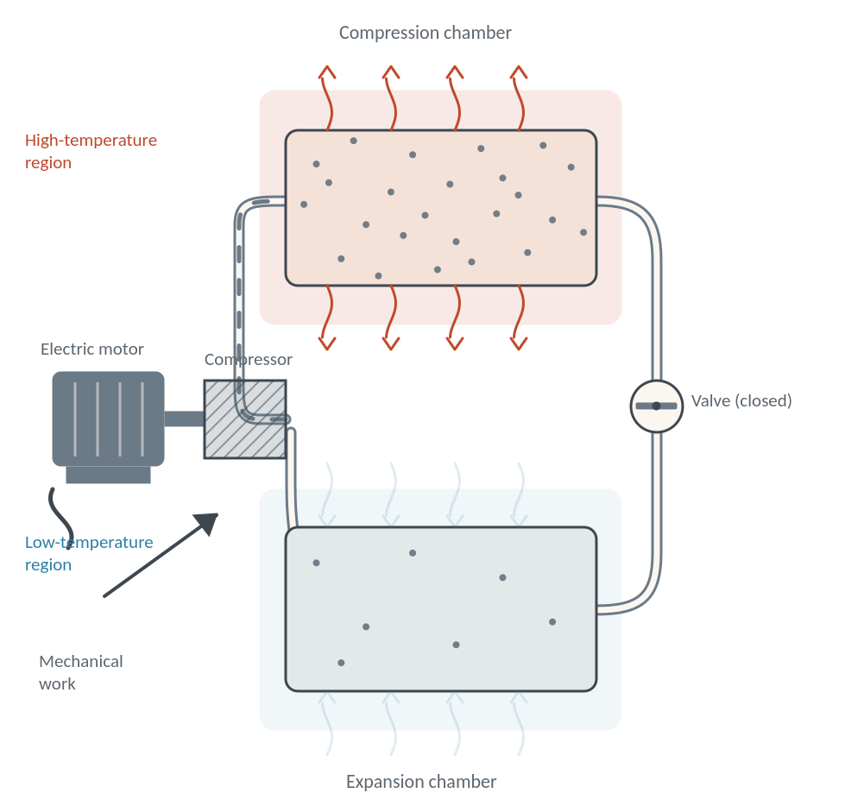
Beat 1 — compression. The valve is closed, the compressor drives gas into the upper chamber, and the compressed gas gives up its excess heat to the surroundings.

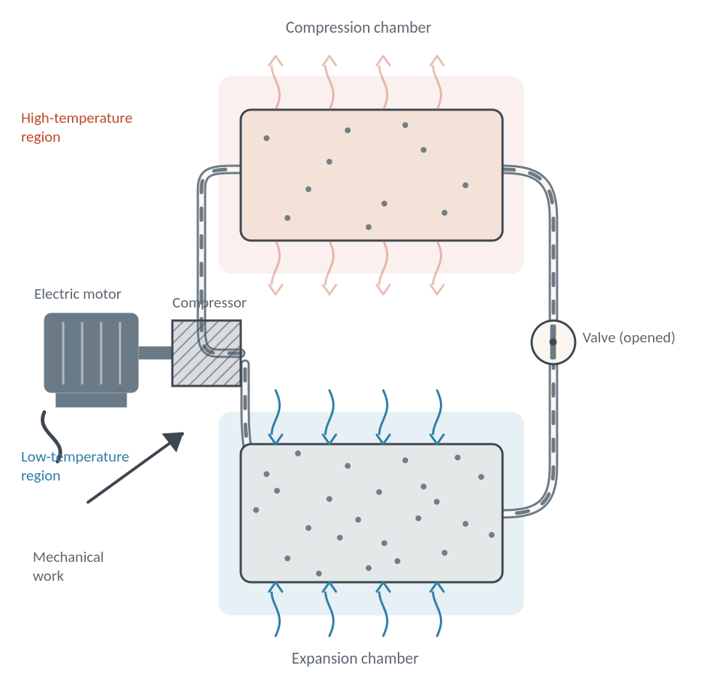
Beat 2 — expansion. The valve opens, the gas expands into the chamber below, cools, and draws heat in from the surroundings.

SCREEN 1 — CRYOGENIC CYCLE, THIRD BEAT
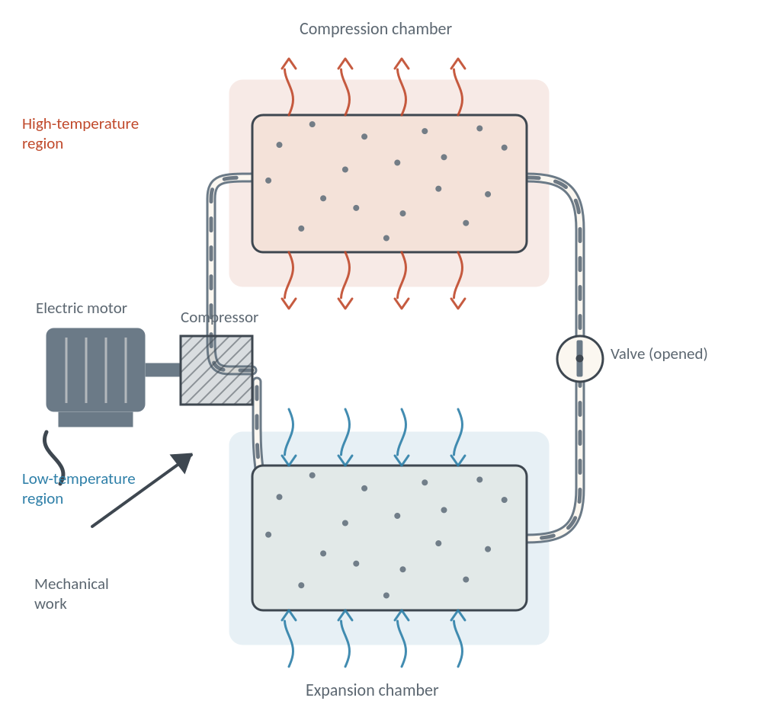
Beat 3 — the thermal pump. Compression and expansion run in sequence: heat is carried away from the expander and pumped into the compressor.

❙❙ Pause 1 · Compression 2 · Expansion 3 · Thermal pump
Beat 3 · Thermal pump
Run in sequence, compression and expansion make a thermal pump: heat is carried away from the expander and pumped into the compressor, which is why a refrigerator warms the kitchen while it cools the food.

Direction of heat flow is shown by wavy-tailed arrows, as in the figure. Nothing is destroyed or created — the heat is only moved.

SCREEN 1 — ANIMATION TAB, SECOND FIGURE
Cryogenic cycle · 4-9 Plasma jet · 4-8
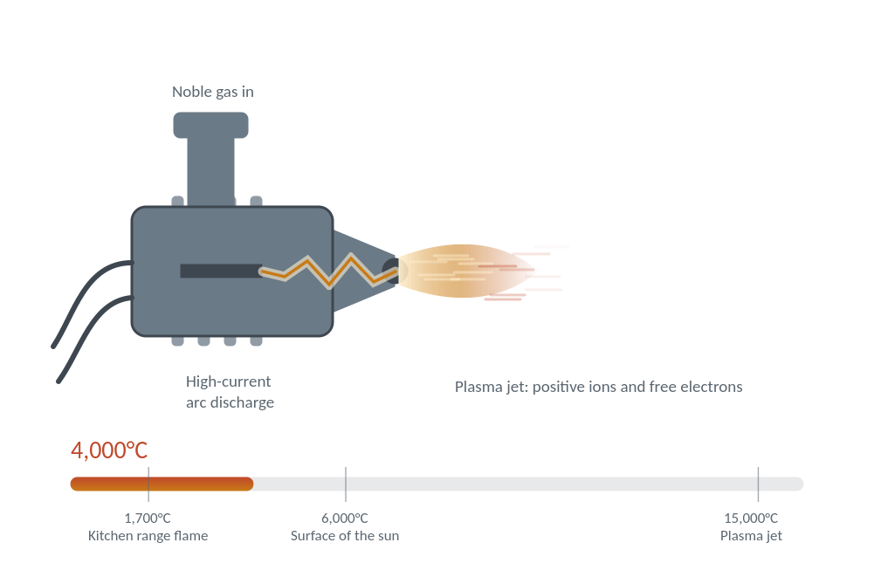
Beat 4 — arc struck. A stream of noble gas is blown through a high-current arc between the electrode and the nozzle, and begins to ionise.

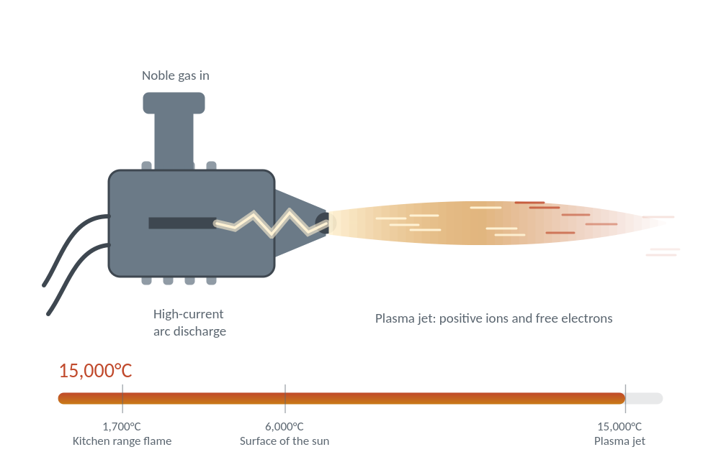
Beat 5 — plasma jet. At full current the gas is a plasma of positive ions and free electrons, and the jet reaches about 15,000°C.

Beat 5 · Plasma jet
At full current the gas becomes a plasma of positive ions and free electrons, and the jet reaches about 15,000°C — two and a half times the temperature of the sun’s surface.

The ruler beneath the torch places the jet against two familiar temperatures: a kitchen flame and the surface of the sun.

SCREEN 2 OF 4 — QUESTIONS TAB
Heat and temperature
Part 1 · Multiple choice

The principle of cryogenics
Fig. 4-9 — the principle of cryogenics
Very low temperatures are produced with cryogenic equipment, which works much like a refrigerator or a room air conditioner. It rests on one fact: compressed air escaping through a small opening gets cooler as it expands into a larger volume. Blow on your palm with your mouth wide open and the air feels warm; blow through pursed lips and it feels much cooler. In the apparatus an electrically driven compressor pumps gas from the expansion chamber up into the compression chamber while the valve joining them is closed. The compressed gas is heated above room temperature, and the excess heat escapes into the surroundings. When the valve is opened the gas expands again and sucks heat in from the surroundings. Repeated, the sequence works as a thermal pump that takes heat away from the expander and pumps it into the compressor.

Choose the best answer | 4 questions

1 COMPRESSION
While the valve between the chambers is closed, the gas in the compression chamber —
○ cools below room temperature and draws heat in
○ is heated above room temperature and loses heat to the surroundings
○ stays at room temperature because it cannot move

2 EXPANSION
What happens when the valve is opened?
○ The gas expands into the larger volume, cools, and absorbs heat from the surroundings
○ The gas is compressed further and gives up more heat
○ The gas escapes from the apparatus altogether

3 THERMAL PUMP
The sequence of successive compressions and expansions acts as a thermal pump that —
○ destroys the heat taken from the expander
○ carries heat from the expander and pumps it into the compressor
○ moves heat from the compressor down into the expander

5 PLASMA JET
A plasma jet reaches a temperature of about —
○ 1,700°C, the temperature of a kitchen range flame
○ 6,000°C, the temperature of the surface of the sun
○ 15,000°C, some two and a half times the temperature of the sun’s surface

Clear Check answers

SCREEN 3 OF 4 — BLANKS TAB
Heat and temperature
Part 2 · Fill in

Very hot and very cold
Fig. 4-8 — a plasma jet, and Table 4-3
Human beings are sensitive to a narrow band of temperature, but life endures far wider variations: algae in hot springs stand water close to boiling, while plant seeds are not killed by temperatures approaching absolute zero. The lowest temperature we meet in everyday life is that of dry ice, frozen carbon dioxide, at about −80°C, and the highest is the kitchen range flame at about 1,700°C. Engineering goes well beyond both. A plasma jet, produced by blowing a stream of noble gas through a high-current electric arc and consisting of positive ions and free electrons, reaches almost 15,000°C. At the other end of the scale, cryogenic equipment can first liquefy air and then freeze it into a solid block, and every other gas can be liquefied and frozen at lower temperatures still.

Complete each sentence | 6 blanks

Type the missing word from the passage into each blank. Spelling is marked, capitals are not.
1 A plasma jet is produced by blowing a stream of gas through a high-current electric arc.
Argon and helium are two of them

2 The jet consists of positive ions and free .

3 It reaches a temperature of almost °C.

4 The lowest temperature of everyday life is that of dry , frozen carbon dioxide.

5 Cryogenic equipment can first air and then freeze it into a solid block.

6 Plant seeds are not killed by temperatures approaching absolute .
The bottom of the temperature scale

Clear Check answers

SCREEN 4 OF 4 — TABLES TAB
Heat and temperature
Tables 4-2 and 4-3 · Reference

Gases · 4-3 Metals · 4-2
Table 4-3 · Liquefying and freezing points of gases
Substance | Liquefying point (°C) | Freezing point (°C)
Chlorine | -35 | -102
Oxygen | -183 | -218
Nitrogen | -196 | -210
Hydrogen | -253 | -259
Helium | -269 | -272

Cryogenic equipment can first liquefy air and then freeze it into a solid block. All other gases can be liquefied and frozen too, but at much lower temperatures — helium last of all, within four degrees of absolute zero.

In the application each row also carries a bar spanning its two readings on a common scale, so the gap between liquefying and freezing can be seen as well as read. The sort control orders the rows by temperature.
Table 4-2 · Melting and boiling points of metals
Substance | Melting point (°C) | Boiling point (°C)
Tin | 232 | 2260
Lead | 327 | 1620
Aluminium | 660 | 1800
Copper | 1083 | 2300
Iron | 1535 | 3000
Platinum | 1773 | 4300
Tungsten | 3370 | 5900

Answer key
Marking behaviour built into the application
Part 1 — multiple choice
1. Is heated above room temperature and loses heat to the surroundings
2. The gas expands into the larger volume, cools, and absorbs heat from the surroundings
3. Carries heat from the expander and pumps it into the compressor
4. 15,000°C, some two and a half times the temperature of the sun’s surface
Part 2 — blanks
1. noble
2. electrons
3. 15,000 (also accepts: 15000)
4. ice
5. liquefy (also accepts: liquify)
6. zero
Marking rules
Case is ignored, surrounding whitespace is trimmed, and a trailing full stop or comma is discarded before comparison. Listed alternatives count as correct. Every item carries a beat number — 1 compression, 2 expansion, 3 thermal pump, 4 arc struck, 5 plasma jet — and after marking each card shows a Watch beat N link that opens the animation tab at that beat, which also selects the right figure.

