**Data Flow Diagram**

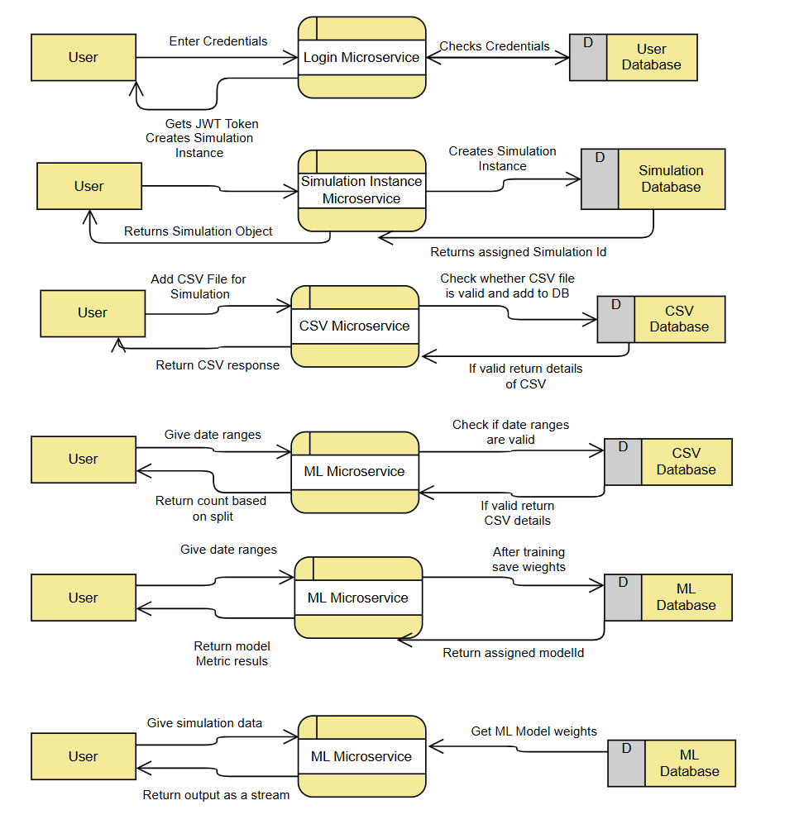

**Login Microservice:**1. The User inputs their login credentials (username and password). The

**System Architecture**

