DEMAND PATTERN-BASED WEEKLY SALES FORECASTING FOR TRAIL EDGE PRODUCTS

END SEM PROJECT REPORT

Submitted by

KARAN S – 20250418

in partial fulfilment for the award of the degree of

MASTER OF SCIENCE – DATA SCIENCE AND ARTIFICAL INTELLIGENCE



INDIAN INSTITUE OF SCIENCE EDUCATION AND RESEARCH TIRUPATI

MAY 2025

ACKNOWLEDGEMENT
First and foremost, I express my sincere gratitude to the Almighty for providing me with the strength and perseverance to successfully complete this project.

I would like to extend my heartfelt thanks to the Indian Institute of Science Education and Research Tirupati (IISER Tirupati) for providing an excellent academic environment and the necessary resources to carry out this work.

I am deeply grateful to my project guide, Dr. Raghunath O Ramabhadran, for his valuable guidance, insightful suggestions, and continuous encouragement throughout the course of this project. His support played a crucial role in shaping the direction and completion of this work.

I would also like to thank my peers and friends for their support and constructive discussions, which helped me refine my ideas. Finally, I extend my sincere appreciation to my family for their constant encouragement and support.

ABSTRACT
Demand forecasting plays a critical role in retail analytics by enabling efficient inventory management and reducing losses due to overstocking or stockouts. This project presents an AI-powered demand forecasting and decision support system developed for retail data analysis. The system utilizes historical product-level sales data along with external features such as promotional events, seasonal effects, and weather conditions to model demand patterns.
The project involves a structured pipeline starting from data preprocessing and exploratory analysis, followed by feature engineering techniques such as lag features and rolling statistics to capture temporal dependencies. Multiple machine learning models, including Random Forest and Gradient Boosting, are trained and evaluated using time-series validation strategies to ensure robust performance. The final model is used to generate weekly demand forecasts for individual products.
In addition to forecasting, an interactive chatbot interface is developed using FastAPI and Streamlit to allow users to query insights such as top-performing products, category-level trends, and forecast outputs. This enhances accessibility by enabling non-technical users to interact with the system intuitively.
The proposed system demonstrates how data-driven approaches can improve retail decision-making by combining predictive analytics with an interactive user interface, making it suitable for practical deployment and future scalability.

TABLE OF CONTENTS
S. No | Section Title | Page No
1 | Acknowledgement | 2
2 | Abstract | 3
3 | Motivation for the Work | 5
4 | Work Done Till Mid-Semester | 6
5 | Work Done Till End-Semester | 6
6 | Future Work | 7
7 | Graphics | 9
10 | Declaration | 10

MOTIVATION FOR THE WORK:

Accurate demand forecasting is essential in retail to optimize inventory management and reduce losses caused by overstocking and stockouts. Traditional methods often fail to capture complex patterns influenced by seasonality, promotions, and external factors. This project is motivated by the need to develop a data-driven system that can leverage historical sales data and external variables to generate reliable demand forecasts. Additionally, providing an interactive interface for querying insights enhances accessibility, enabling business users to make informed decisions efficiently without requiring technical expertise.

WORK DONE TILL MIDSEM

During the initial phase of the project, the primary focus was on understanding the dataset, preparing the data, and performing exploratory analysis to identify key patterns. The dataset consisted of product information, weekly sales data, and external features such as weather conditions, promotional events, and seasonal indicators. A thorough data understanding step was carried out to analyze the structure, relationships, and completeness of the dataset.
The preprocessing stage involved cleaning the raw data by handling missing values, removing duplicates, and ensuring consistency across different datasets. Date fields such as launch date and weekly timestamps were converted into appropriate datetime formats to enable time-based analysis. Numerical columns were validated to ensure correct data types, and categorical fields were standardized to maintain uniformity across records.
Following preprocessing, exploratory data analysis (EDA) was conducted to gain insights into sales patterns and product behavior. Category-wise and product-wise distributions were analyzed to identify high-performing segments. Weekly sales trends were examined to observe seasonality and fluctuations in demand over time. Additional analyses were performed to study the impact of discounts, returns, and inventory levels on sales performance.
The datasets were then merged into a unified structure combining product information, sales data, and external features. This integrated dataset enabled cross-analysis across multiple dimensions, such as category, time, and external conditions. Preliminary observations revealed that certain product categories consistently contributed higher sales, while external factors such as promotional events had a noticeable influence on demand.
Overall, the mid-semester work established a strong foundation by ensuring clean, structured data and generating meaningful insights through exploratory analysis. This phase was critical in identifying key variables and patterns that would later be used for feature engineering and predictive modeling in the subsequent stages of the project.

WORK DONE TILL ENDSEM:

In the second phase of the project, the focus shifted towards building a predictive system using advanced feature engineering and machine learning techniques. The cleaned and merged dataset from the earlier phase was used to construct meaningful features that capture temporal and behavioral patterns in the data. Time-based features such as year, month, and week were derived, along with lag features and rolling statistics to incorporate historical dependencies in demand.
Demand classification was introduced to categorize products based on their sales patterns, enabling better understanding of stable and variable demand segments. Although most products exhibited smooth demand behavior, this step helped structure the modeling approach.
Multiple machine learning models were implemented to forecast product-level demand. Baseline approaches such as naive forecasting and moving averages were initially used for comparison. Advanced models including Linear Regression, Random Forest, and Gradient Boosting were then trained on the engineered features. A time-series aware validation strategy was adopted to ensure that the models were evaluated in a realistic manner without data leakage.
Cross-validation was performed using time-based splits, and model performance was assessed using metrics such as Mean Absolute Error (MAE) and Root Mean Squared Error (RMSE). Based on evaluation results, the best-performing models were selected and used to generate weekly demand forecasts for each product.
In addition to forecasting, an interactive chatbot interface was developed to enhance usability. The system was built using FastAPI for the backend and Streamlit for the frontend. The chatbot allows users to query business insights such as top-performing products, category-level sales trends, and demand forecasts. A hybrid approach combining rule-based logic and lightweight language understanding was implemented to interpret user queries and return relevant results in the form of tables, charts, or textual responses.
The end-semester work resulted in a complete pipeline that integrates data processing, predictive modeling, and user interaction. This system demonstrates the practical application of machine learning in retail analytics and provides a foundation for scalable and user-friendly decision support tools.
Git Link : https://github.com/Classicalstracker/Demand_Project_Final-Project

FUTURE WORK :

While the current system provides a functional demand forecasting and decision support solution, several enhancements can be made to improve its accuracy, scalability, and usability. One of the primary areas of improvement is the adoption of advanced time-series models such as Long Short-Term Memory (LSTM) networks, Prophet, or other deep learning approaches. These models can capture complex temporal dependencies more effectively and may provide improved forecasting performance.
Another potential improvement is the integration of real-time data pipelines. Currently, the system operates on static datasets, but incorporating live data streams would allow continuous model updates and more accurate predictions. This would be particularly useful in dynamic retail environments where demand patterns change frequently.
The feature engineering process can also be extended by incorporating additional external variables such as economic indicators, competitor pricing, and regional trends. These factors could further enhance the predictive capability of the models. Additionally, addressing potential data leakage issues in feature construction and refining rolling calculations at a product level would improve model reliability.
From a system perspective, the chatbot interface can be enhanced by integrating more advanced natural language processing techniques. Using large language models with retrieval-based approaches can improve query understanding and enable more conversational interactions. This would make the system more intuitive and accessible to non-technical users.
Deployment is another important area for future work. The system can be hosted on cloud platforms to enable scalability and broader accessibility. A proper API-based architecture with authentication and user management can be implemented for enterprise use. Furthermore, adding visualization dashboards with interactive filters and export options would improve the overall user experience.
In summary, future work will focus on improving model accuracy, expanding data sources, enhancing user interaction, and deploying the system in a production-ready environment. These improvements will transform the current prototype into a robust and scalable solution suitable for real-world retail applications.

GRAPHICS :
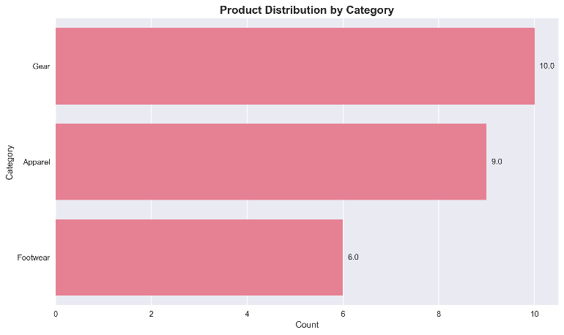

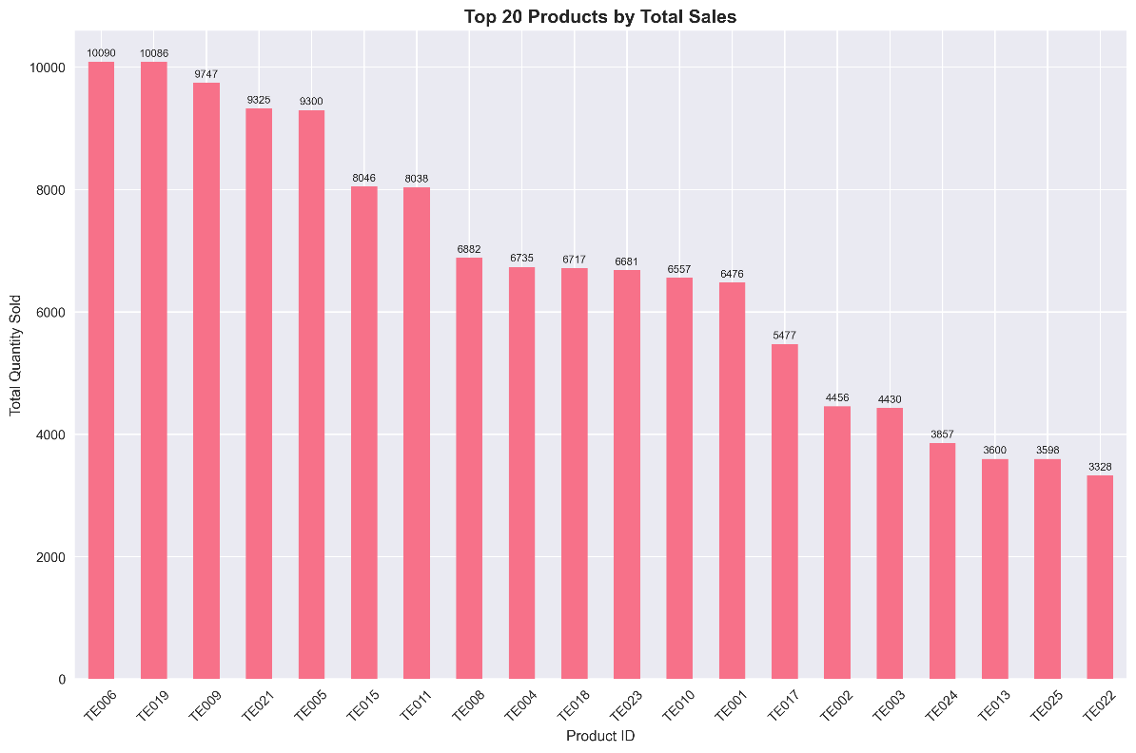
Gear has the highest number of products, making it the most represented category.

A few products (like TE006, TE019) dominate total sales, indicating strong top performers.
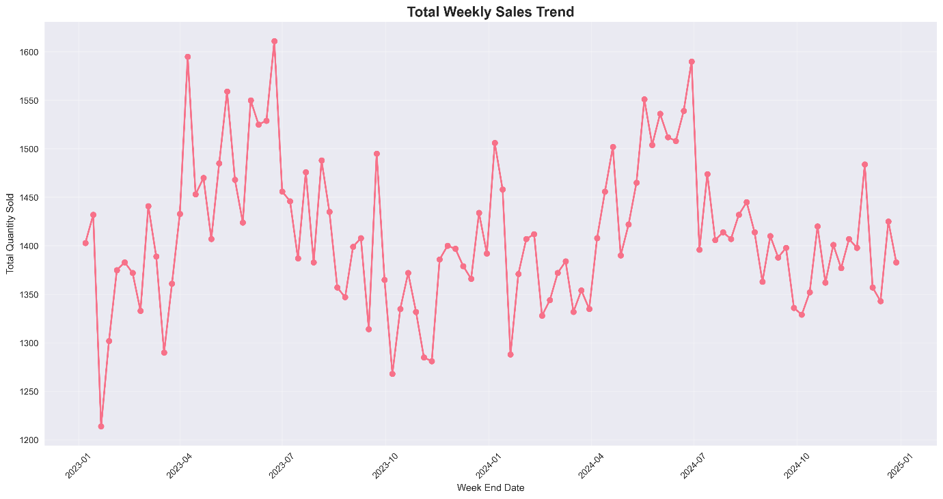
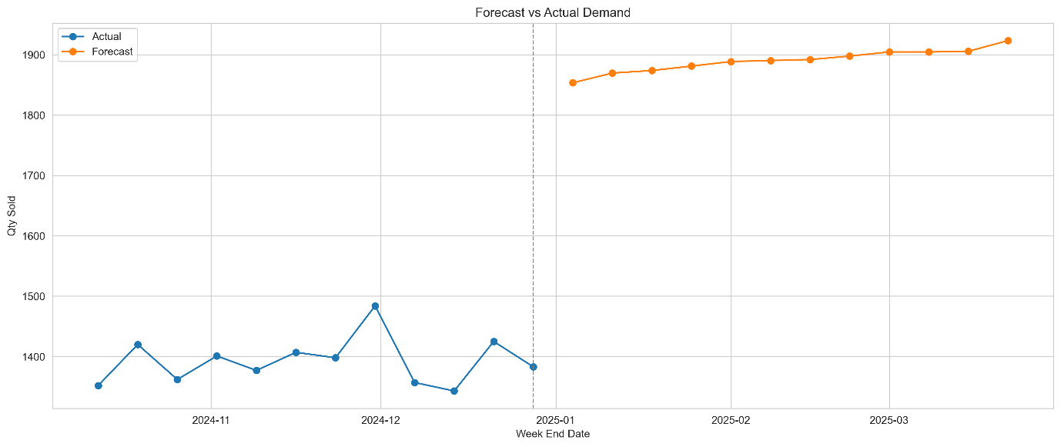
Sales fluctuate over time without a steady trend, showing the need for forecasting models

The model successfully captures the overall upward trend in future demand predictions.
Declaration:
I hereby declare that the idea for this project is my original idea. The report is also original, and I give my consent to check this report for similarity and plagiarism.
Name: Karan S
Roll No : 20254018

