**Documentation for toolbox script**

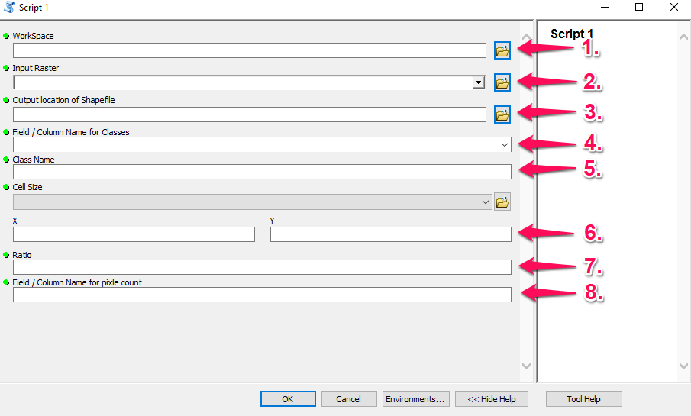

1. **Workspace:** This is the location where your files should be located for this tool. (Data Type = Workspace)
2. **Input Raster:** This is the raster layer that you want to use (Data Type = Raster layer)
   1. Has to be a classified raster image (has to have an attribute table)
3. **Output location of Shapefile:** This is where you want you output shapefile to be located at (Data Type = Shapefile)
   1. Make sure this is in the same location as your Workspace that you specified above
4. **Field /Colum Name for Classes:** This is the field name / column name in your attribute table in which you class are located at (Data Type = String)
   1. Make sure to spell the field name / column name exactly as it is in the attribute table
5. **Class Name:** This is the class name that you want to look for in the raster layer that you specified (Data Type = String)
   1. Make sure to spell the class name exactly as it is in the attribute table
6. **X & Y:** This is the size of the box that you want to search through the raster as in a moving window (Data Type = Cell Size XY)
   1. Make sure to check your **Liner Units** **(**Right click your raster layer >**Properties>Source>**Scroll down to **Liner Units)**
   2. Make sure not to put anything into the drop down menu
7. **Ratio:** This is the threshold ratio that you want to have in the moving window to either be outputted in the shapefile or not to be outputted in the shape file (Data Type = String)
   1. Must be between 0-1, so it must be a decimal value
8. **Field / Column Name for pixel count:** This is the field name / column name in your attribute table in which has the total amount of cells per class in it
   1. Make sure to spell the field name / column name exactly as it is in the attribute table

**Example Use of the toolbox**

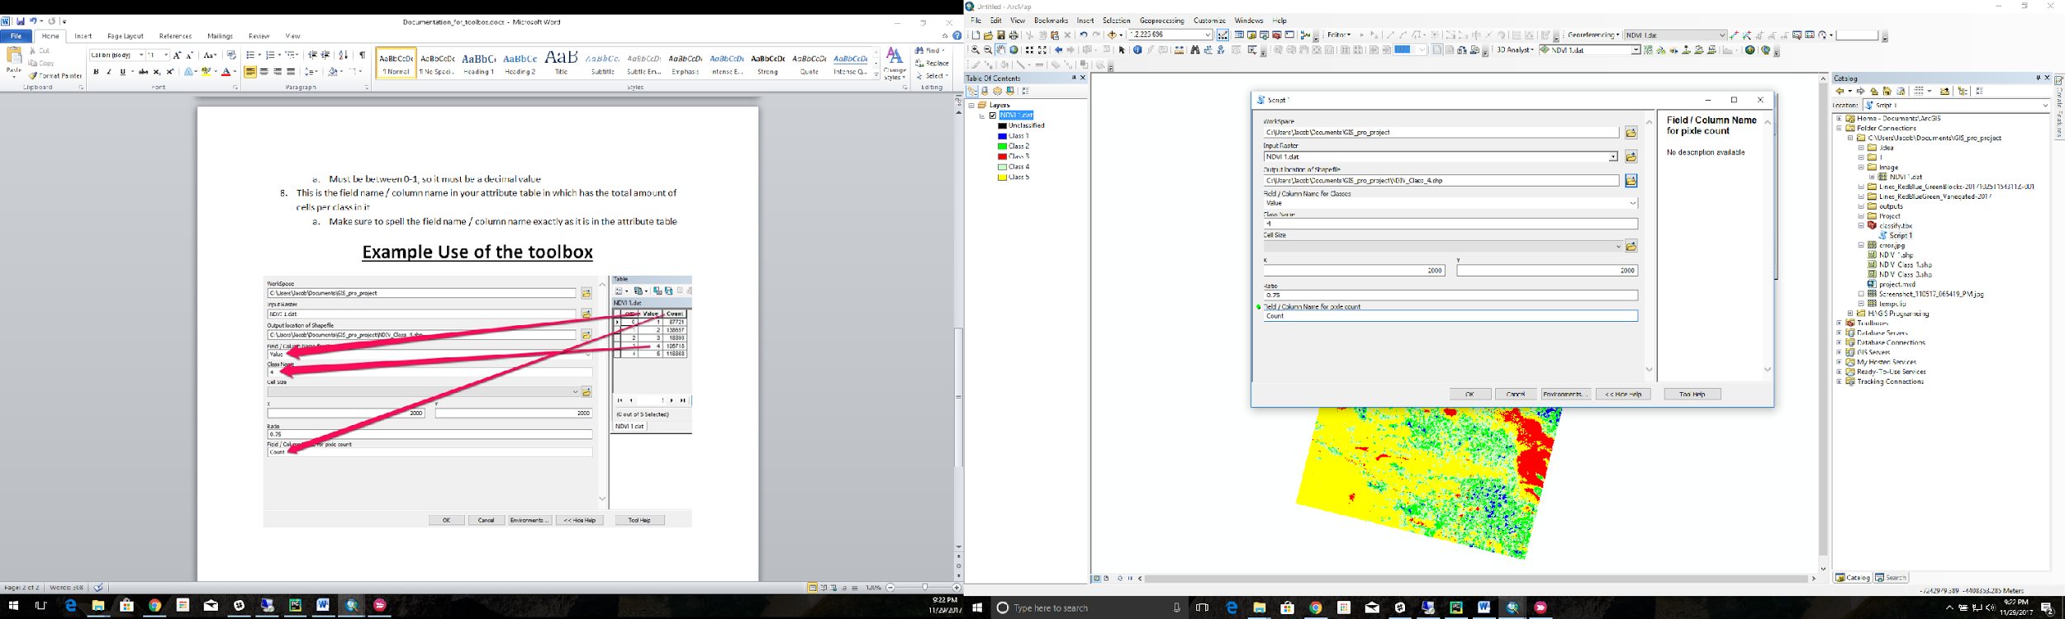

This is the information that you need from the Attribute table of you classified raster and where it goes into the toolbox.

