Nepal College of Information Technology
Balkumari, Lalitpur
Level: Bachelor Year: 2013
Program: BE (SE), Day F.M: 100
Course: Engineering Math-I P.M: 45
Time: 3hrs
Candidates are required to give their answers in their own words as far as practicable.
The figures in the margin indicate full marks.

Attempt all the questions.

- a. If 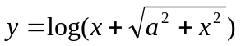 prove that . 7
OR
A function is defined as follows
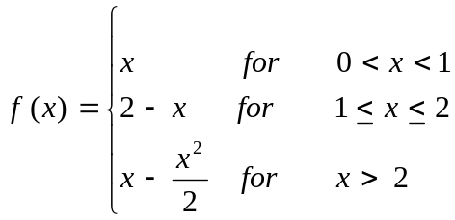
Is 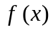 continuous at x = 1 and x = 2? Does 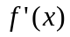 exist for these values?
b. State and prove Cauchy Mean value theorem. Also verify Cauchy Mean value theorem for
f(x) =x, g(x) = 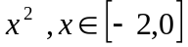 8

2. a. Evaluate 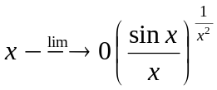 8
b. If 40 square feet of sheet metal are to be used in the construction of an open tank with a square
base. Find the dimension in order that its capacity is greatest. 7
OR
Find the radius of curvature of + = at the point where y=x cuts it.
3. Evaluate any three: 3*5 =15
a)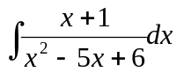 b)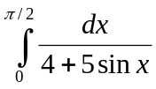
c) 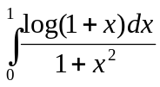 d) 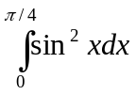
4. a. Find the area included between the curve x2=4y and the line x = 4y-2. 7
b. Find the reduction formula for cos^{n}xdx and evaluate the integral cos⁷xdx. 8
OR
Approximate the integral 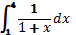 with n=4 using Trapezoidal and Simpson’s rule.
5. a. Define scalar triple product and prove geometrically that scalar triple product represents the
volume of the parallelepiped. Also prove that in a scalar triple product the position of dot and
cross can be interchanged. 8
b. Define vector triple product and show that 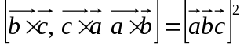. 7
6. a. Define conic section by their eccentricity and classify them. Derive standard equation of parabola
y² = 4ax. 7
b. Show that the line lx + my + n = 0 touches the hyperbola 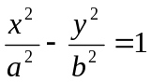 if 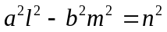. 8

7. Attempt all the questions 5*2=10
- Find the domain and range of the function y=
- Evaluate 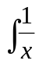 log x dx
- Find the arc length of the curve y=x² , -1 ≤ x ≤ 2
- Find vertex,, line of symmetry and focus of 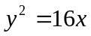
- If 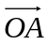=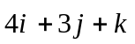, 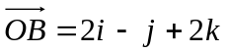, find projection of 

