Name: - Aakash Sharma

Sec/Group: - IOT_609/B

UID: - 22BCS15230

1. Maximum Depth of Binary Tree

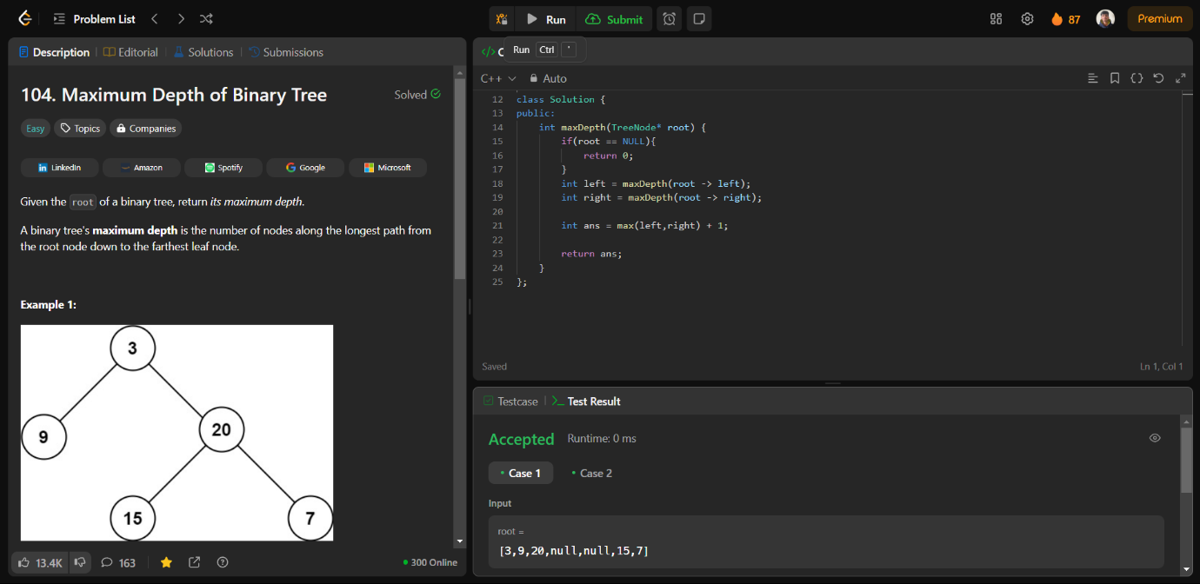

1. Validate Binary Search Tree

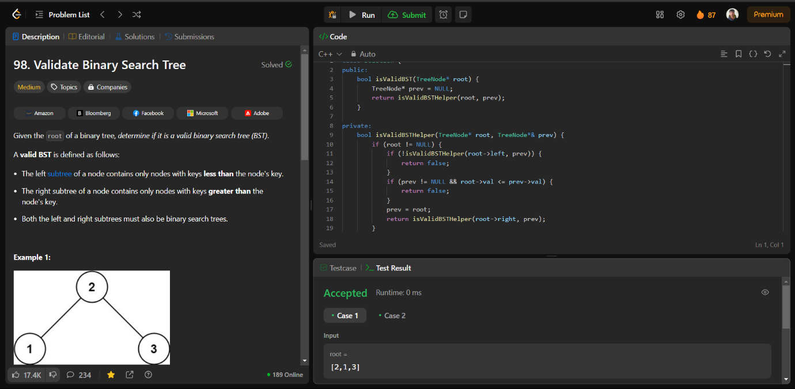

1. Symmetric Tree

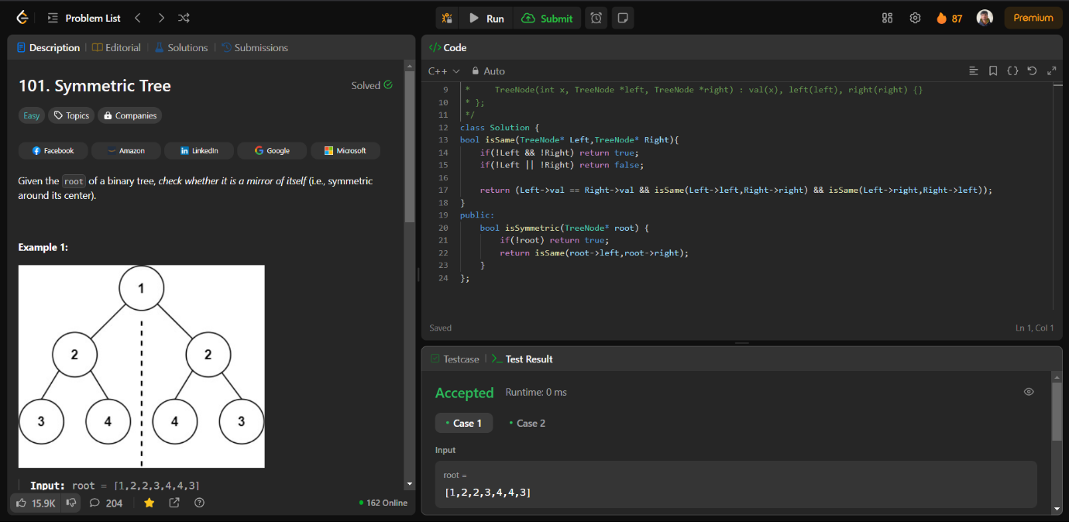

1. Binary Tree Level Order Traversal

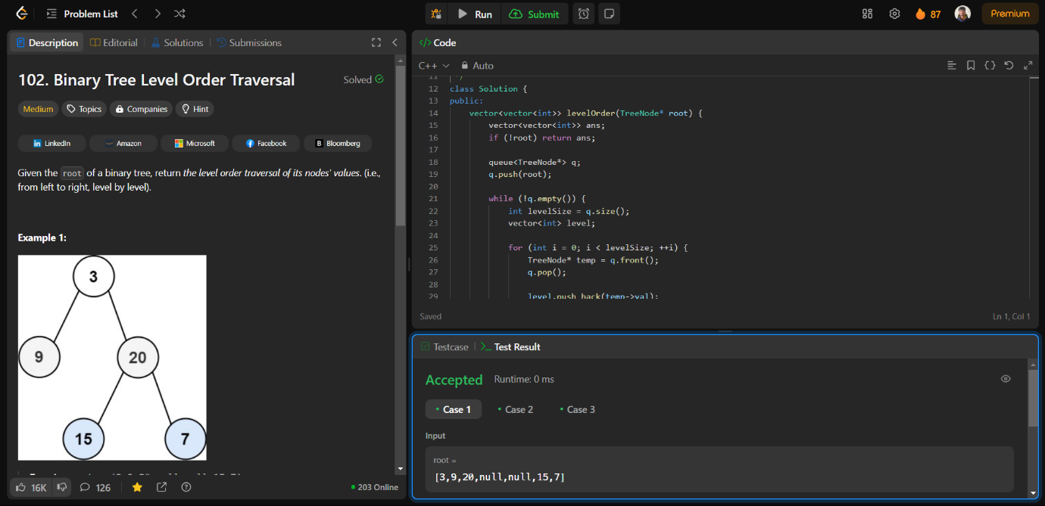

1. Convert Sorted Array to Binary Search Tree

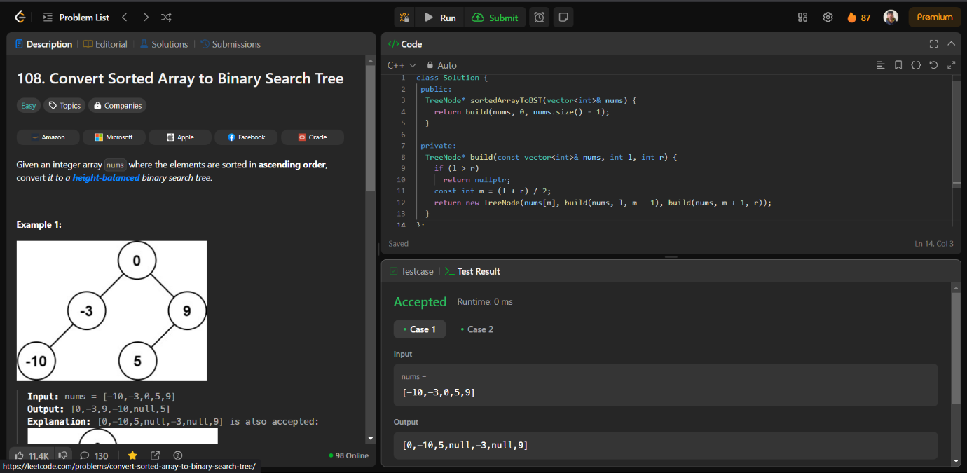

1. Binary Tree Inorder Traversal

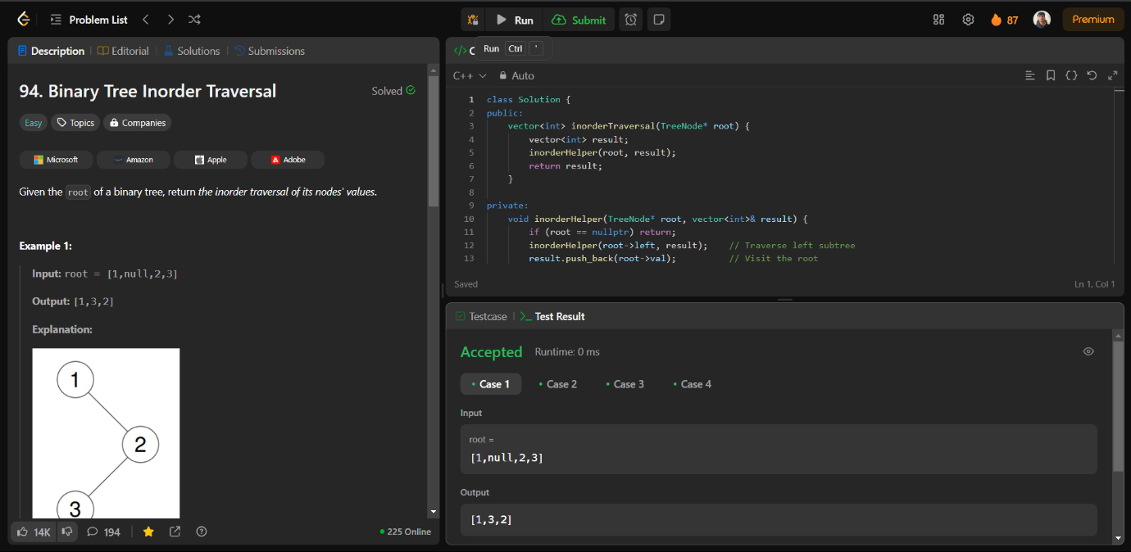

1. Binary Zigzag Level Order Traversal

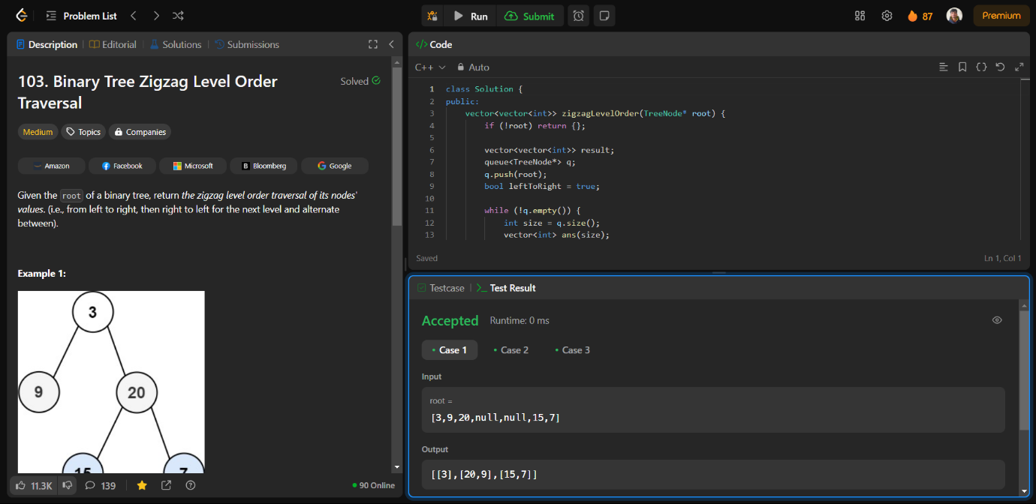

1. Construct Binary Tree from Inorder and Postorder Traversal

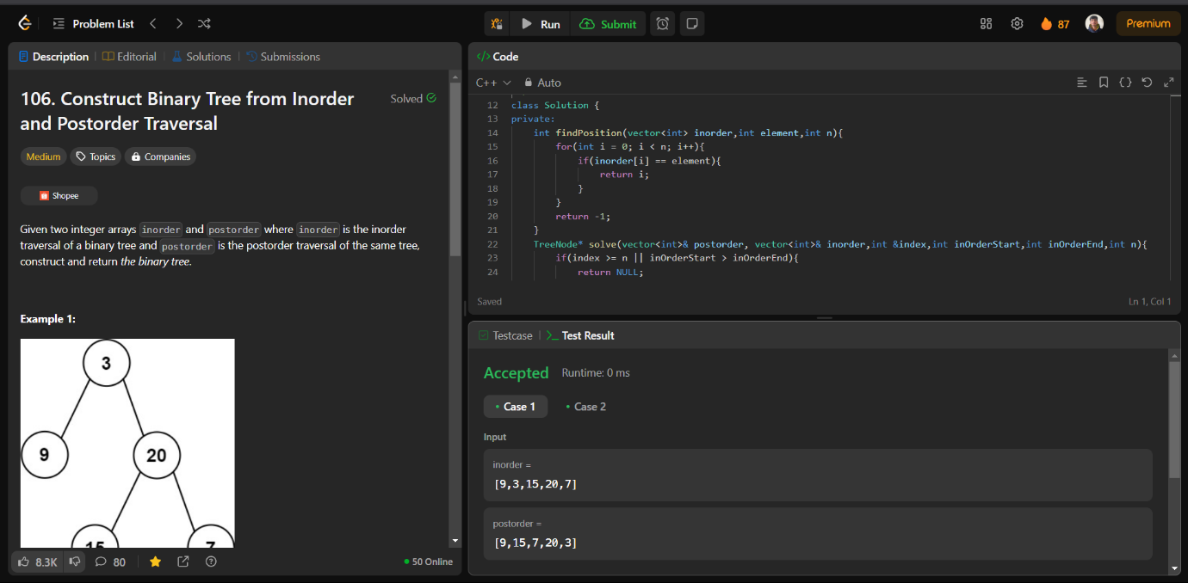

1. Kth Smallest element in a BST

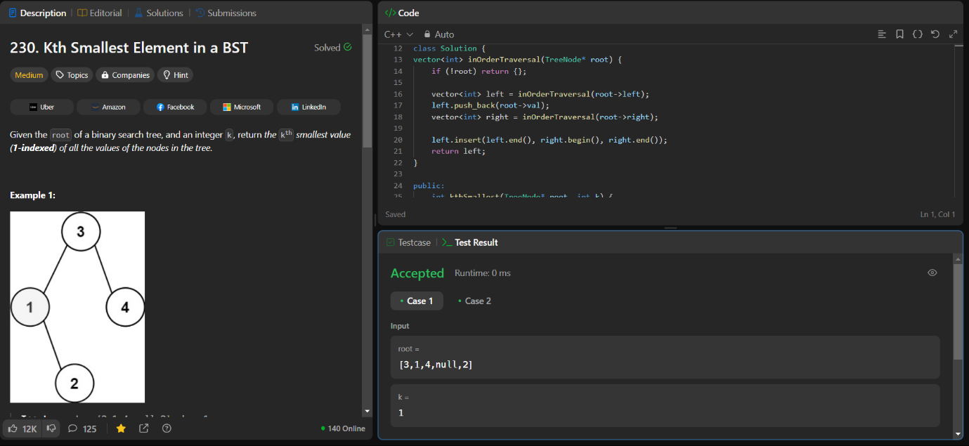

1. Populating Next Right Pointers in Each Node

